https://clinicaltrialssuite-qa2.nci.nih.gov:8443/c3pr/pages/study/editStudy?studyId=117
Build: v2.3_RC1_BuildLife_11068
Browser: IE8, Firefox (IE7 not tested)
USR: ccts_rez_all_su
Role: Supplemental Study Info. Manager, Study Site Participation Admin.
Study QA Manager
Study Calendar Template Builder
Study Team Admin.
Study Creator

Steps to reproduce:

- Login to the C3PR using ccts_rez_all_su.
- Go to Study and create study
- Save & Continue.
- Go to “Stratification” page, and try to add question and answers.
- Save it.
- Click “Generate Stratum Groups” button.
- Click “Edit Stratification Criteria” button to edit.
- Receive this message “Stratum Groups will be deleted. Do you want to proceed? which is misleading message to the user. In this case, user can delete the “Stratum Groups “by clicking “Ok” button, while user could edit instead.

Please set attached screen shots for more details.

Thank you,
Reza Mehri

1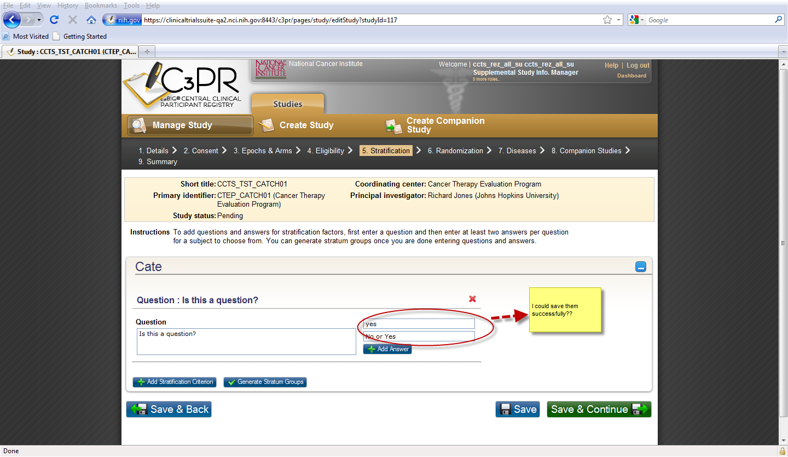
2
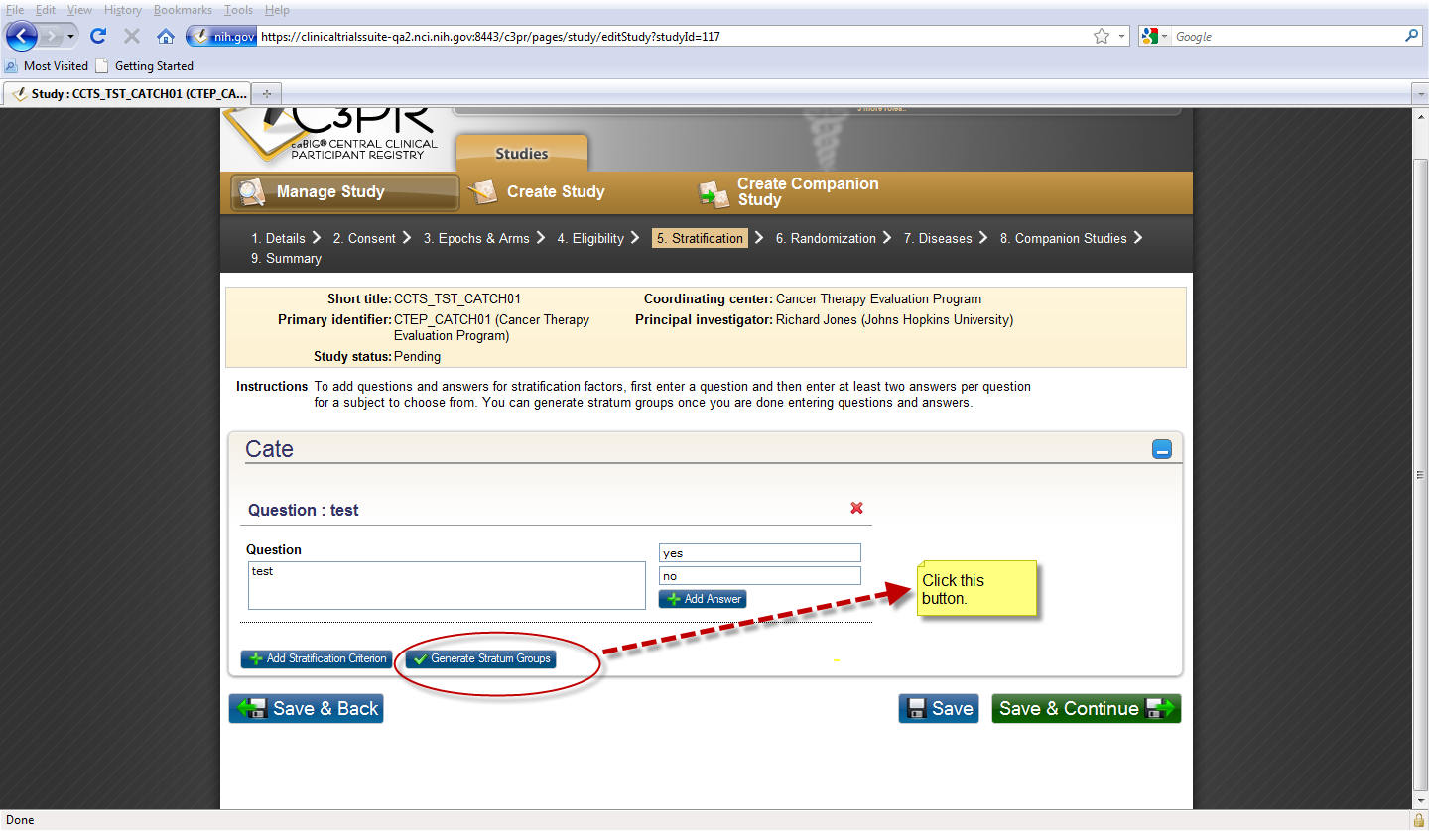

3
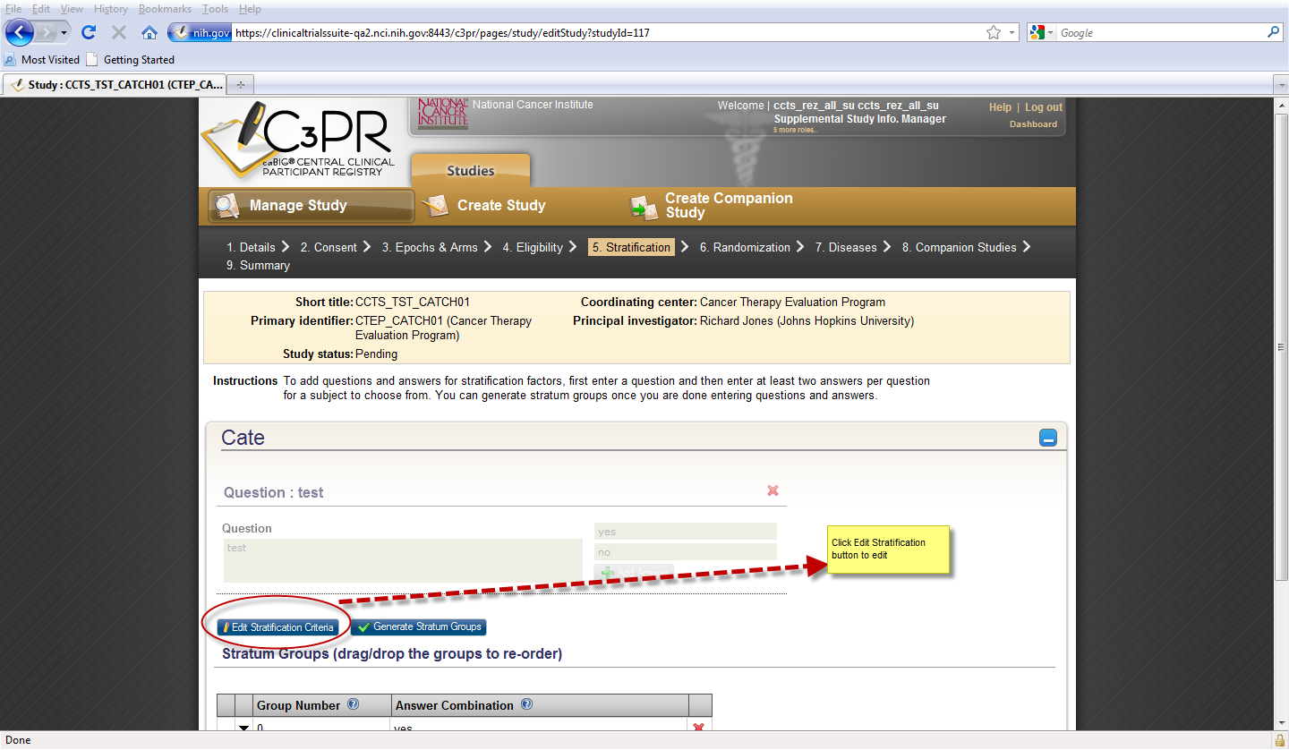

4
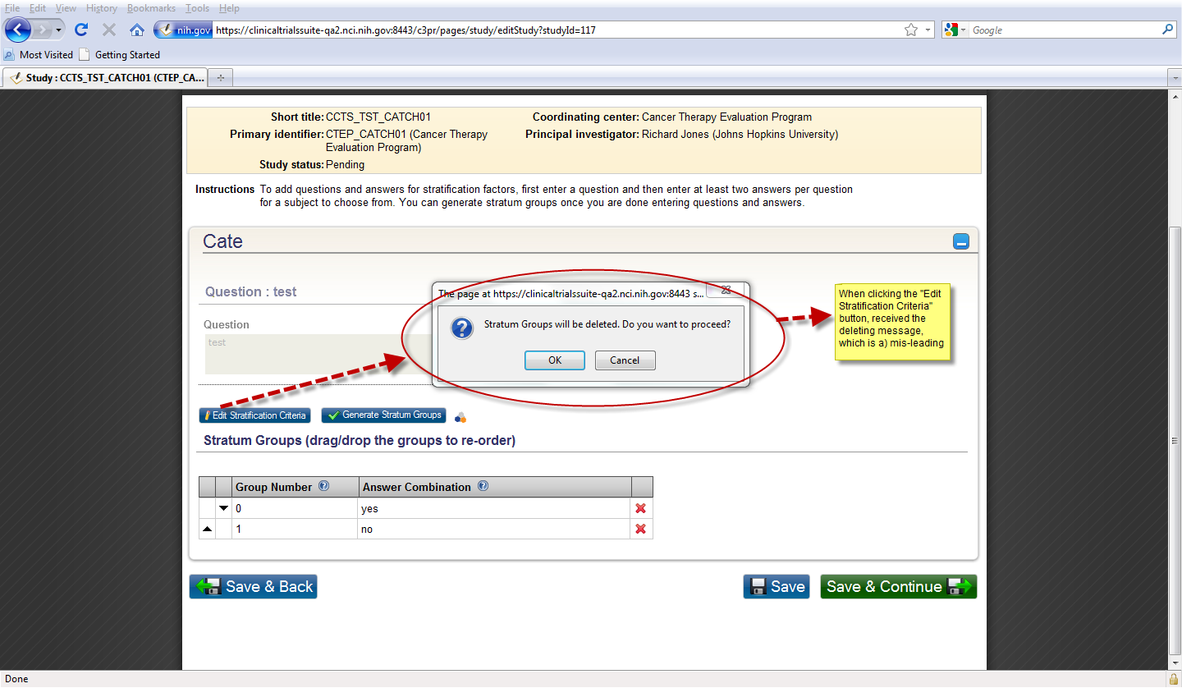
5
