NCS Navigator Cases

End User Guide

Rev 3.1

|  |  |
| --- | --- |
| Rev 1 | First reviewed draft |
| Rev 2 | Record breakoffs, edit contacts & events |
| Rev 3 | Release 1.0.2 |
| Rev 3.1 | Reflects App Name Change |

Table of Contents

Background 3

Description 3

Patient Study Calendar 3

Requirements 3

Important terms 3

Event Workflow 4

The Application 5

Logging in 5

Title bar 5

Welcome page 5

Scheduled Events 5

Actions 6

Managing a Participant 7

How Do I… 9

Get help? 9

Know what event to perform next? 9

Perform an event? 11

Record a breakoff? 14

Move a participant from Lo to Hi? 15

Manage coordinator workload? 15

Close an Event without making a new Contact? 16

Record a Contact without Administering an Instrument? 17

Create a Case Status Report? 17

Report bugs, change requests, or new features? 17

# Background

## Description

The NCS Navigator is an information management system that facilitates case management, data and specimen collection, and reporting for the National Children's Study. NCS Navigator Cases is the central component that users will access when searching for upcoming activities, entering data, or managing cases. This guide will describe how to use NCS Navigator Cases.

## Patient Study Calendar

The Patient Study Calendar (PSC) manages the scheduling and tracking of the state of events. In most cases, data between these systems is exchanged behind the scenes, and the user of NCS Navigator Cases is not required to access PSC directly. Exceptions to this workflow and descriptions of how to perform necessary functions within PSC will also be described in this guide.

## Requirements

In order to use NCS Navigator, users must have:

1. Firefox version 3.6 or later.
2. a username and password provided by the Study Center.
3. a URL to NU’s SSL VPN. This provides an encrypted channel between IT infrastructure at Northwestern University and off-campus resources.

## Important terms

|  |  |
| --- | --- |
| Person | A Person is an individual who may provide information on a participant. All individuals contacted are Persons, including those who may also be Participants. (from MDES v2.0) |
| Participant | A Participant is a living Person who has provided Study data about her/himself or a NCS Child. S/he may have been administered a variety of questionnaires or assessments, including household enumeration, pregnancy screener, pregnancy questionnaire, etc. Once born, NCS-eligible babies are assigned Participant IDs. Every Participant is also a Person. (from MDES v2.0) |
| Contact | Staff makes Contact with a Person pursuant to a protocol – either one of the recruitment schemas or a Study assessment protocol. The scope of a Contact may include one or more Events, one or more Instruments in an Event and one or more Specimens that some Instruments collect. (from MDES v2.0) |
| Event | An Event is a set of one or more scheduled or unscheduled, partially executed or completely executed data collection activities with a single subject. The subject may be a Household or a Participant. All activities in an Event have the same subject. (from MDES v2.0) |
| Instrument | An Instrument is a scheduled, partially executed or completely executed questionnaire or paper form. An Instrument can also be an Electronic Health Record or a Personal Health Record. (from MDES v2.0) |
| TSU | The Tertiary Sampling Unit refers to the list of dwelling units whose inhabitants are eligible to participate in the High Intensity segment. |

## Event Workflow

An event begins with a person being contacted. One or more of the instruments that make up the event are administered. The contact ends when the interviewer has finished a particular session with the person. The event is not complete until all of the required instruments have been collected. Therefore, multiple contacts may be needed to complete an event. Conversely, some circumstances may allow for multiple events to be completed in a single contact.



# The Application

## Logging in

Logging in is a two-step process. The first step sets up the SSL VPN, a secure connection from a workstation to the NCS Navigator environment. The second step is logging in to the application itself.

1. Use netid and password to login to the NU SSL VPN at <https://www.vpn.northwestern.edu>
2. Select “NCS GCSC Navigator Cases” from your list of Web Bookmarks.
3. You are now presented with the NUBIC Central Login page. Enter your netid and password here.
4. You are now logged in.

## Title bar

Each page within NCS Navigator Cases has a title bar that presents a link back to the welcome page, a display of the current page, and links to see help or frequently asked questions. Of particular interest, the "Help" link provides insight into the functionality of the page that is currently loaded.

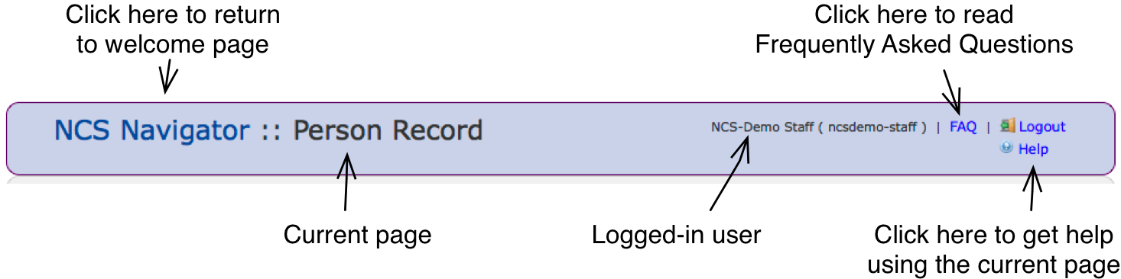

## Welcome page

The Welcome page is loaded in response to a successful login, and is accessible from any other page by clicking the "NCS Navigator" text in the Title bar. The features of this page are contained in two tabs: Scheduled Events and Actions.

### Scheduled Events

This tab is loaded by default and shows all of the upcoming events for the next six weeks for the user who is logged in.

### Actions

The second tab has a list of available actions.

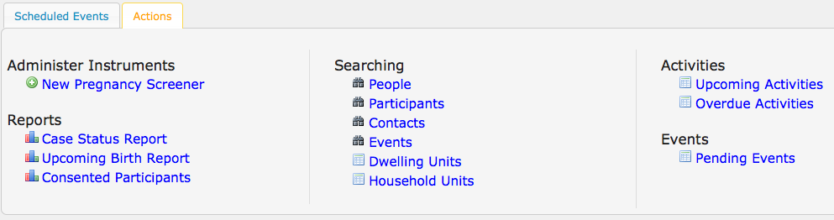

#### Administer Instruments

If a newly discovered eligible woman needs to be added to the participant population, initiate the process by completing a New Pregnancy Screener for the participant.

#### Reports

The list of available reports appears here.

**Case Status Report** – user can enter in the time period for the report and click 'Generate Report' to download the case status report file.

**Upcoming Birth Report** – displays an on-screen list of pregnant participants and their due dates.

**Consented Participants** – displays an on-screen list of the total participant consents. User can drill down on each to pull a list of the participants.

#### Searching

Click on the appropriate link to use on-screen searches to find People, Participants, or other items in the database.

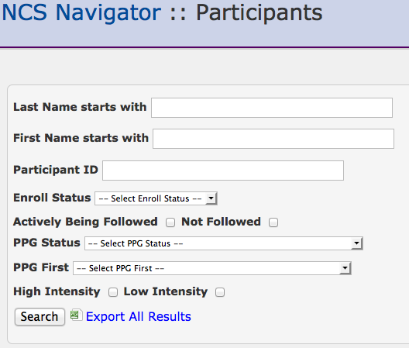

## Managing a Participant

NCS Navigator offers a few ways to get to the Participant Record. Click on the name or ID of the participant from the list of Scheduled Events on the Welcome page, or use the People or Participant searches available from the "Actions" tab described briefly above.

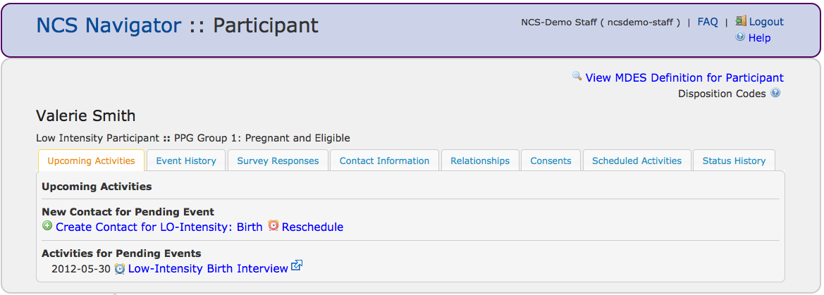

#### Upcoming Activities

Upcoming Activities are listed on-screen under event categories, such as:

***New Contact for Pending Event***

***Activities for Pending Events***

***Schedule Next Event***

***Perform Next Event***

#### Event History

Displays a table that lists event history and completion information. Event and Date are listed in descending order by date. Event completion information: Type, Date, Start, End, and Disposition.

#### Survey Responses

If this person answered questions for a survey, you will find a link to that survey here.

#### Contact Information

Addresses, Telephone Numbers, Email Addresses

#### Relationships

Lists all the relationships with other people in the application.

#### Consents

Displays a table that lists all the consents that have been completed. The information lists: Type, Consent Given, Consent Date, Who Consented, Consent Withdrawn Date, and Who Withdrew.

#### Scheduled Activities Lists scheduled activities by date, ascending order.

#### Status History

This page lists internal state transitions of the Participant as well as the PPG Status History both PPG First and subsequent PPG Status records.

# How Do I…

# Get help?

#### On-screen help

In the upper right corner of each page is a link labeled “Help.” Click this link to learn about the features of the current page. You will not lose any data that you have already entered on the page.

#### Support email address

Email questions to the NCS Navigator support team… (TODO: fill this in when we have an email address)

#### Help Desk site

Call the NCS Help desk… (TODO: fill this in when we have a number)

#### Help Desk website

Sign up for an account with the NCS Navigator Helpdesk site to be able to submit problems, change requests, or feature requests. https://code.bioinformatics.northwestern.edu/issues/projects/show/ncsnavhelpdesk

# Know what event to perform next?

One of the primary functions of the NCS Navigator is to keep study personnel informed of upcoming events. When deciding what events to perform next, follow these two workflows:

#### Upcoming scheduled events

1. After logging into NCS Navigator Cases, you will be presented with the Welcome Page. (If you are already logged in, click the NCS Navigator link in the title bar.) This page presents a list of upcoming events for the participants who have been assigned to you.
2. Decide which event you will perform next, and click on the name or ID of the corresponding participant.

You will be presented with the Upcoming Activities tab of the Participant page. This page will provide a link to create a new contact for any pending events.  
 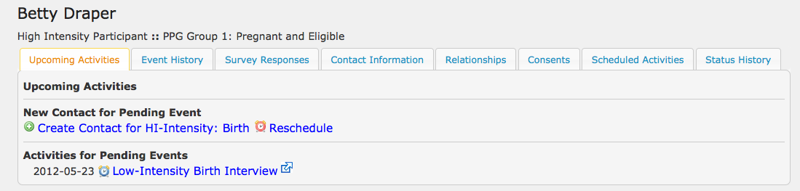

1. Alternatively, access events that were begun previously by selecting the Events History tab. In the following example, the Low Intensity Data Collection event has not been completed.

Link to create new contact

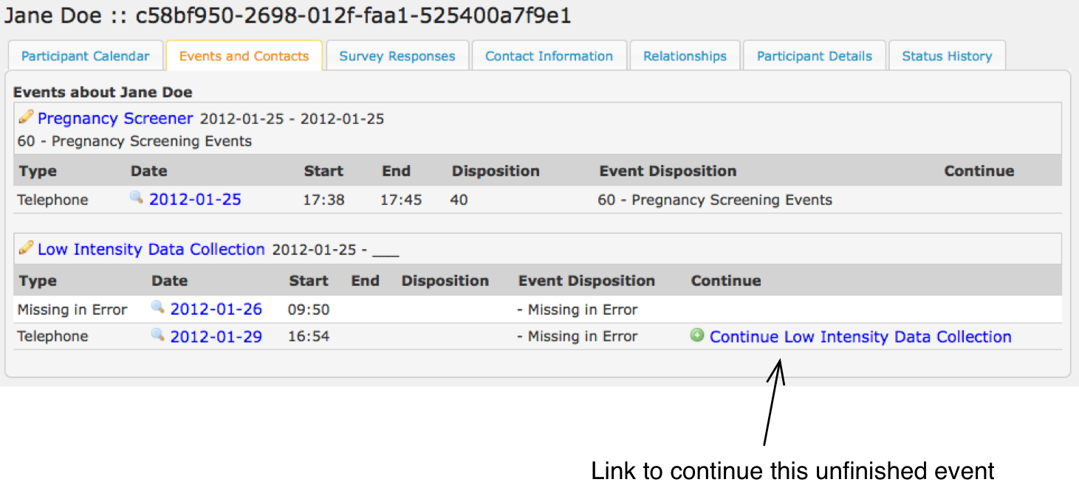

#### Past due activities

In a perfect world, there would never be any past due activities. These activities should be addressed as soon as possible.

1. After logging into NCS Navigator Cases, you will be presented with the Welcome Page. (If you are already logged in, click the NCS Navigator link in the title bar.)
2. Click on the Actions tab.
3. Under Activities, click the Overdue Activities link.
4. You will be presented with a list of all participants who have past due activities.
5. Select the name or ID of the person for whom you will next take action, and you will be presented with the Participant page as in step 3 above, Upcoming Activities.

# Perform an event?

When it is time to perform an event, you will open a contact from either the Upcoming Activities or Event History tabs from the Participant page.

1. Click the link to create a contact for a new event or to continue an existing one. (See figures above)
2. Fill out the brief form to initiate the contact. Only complete the end time if the contact will not continue.   
     
   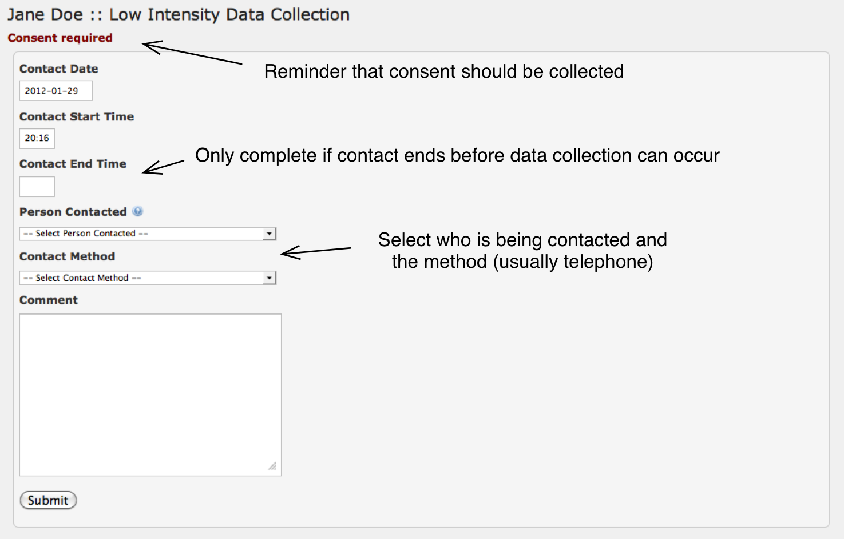
3. You will be presented with a list of instruments to be completed and data to be collected. For the event in this example, the participant should be presented with a list of consents (shown with the green ‘+’ icon) as well as a single instrument (shown with the pencil icon), the Low-Intensity Interview.  
     
   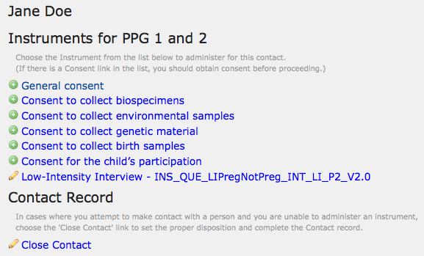
4. For each consent in the list, read the consent document to the participant and record the data in the form corresponding to the consent.
5. To administer an instrument, click on the name of the instrument.
6. Most of the question text is read to the participant as a script. Sections that should not be read directly are enclosed in brackets or appear in italics.
7. Many questions are dependent upon the answers to other questions. These “hidden” questions will appear as needed as answers are recorded.
8. When filling in the time stamp fields, the “Now” button in the lower left corner of the date/time selection will quickly fill in the current date and time. To access this feature, simply click inside the Time Stamp field.   
     
   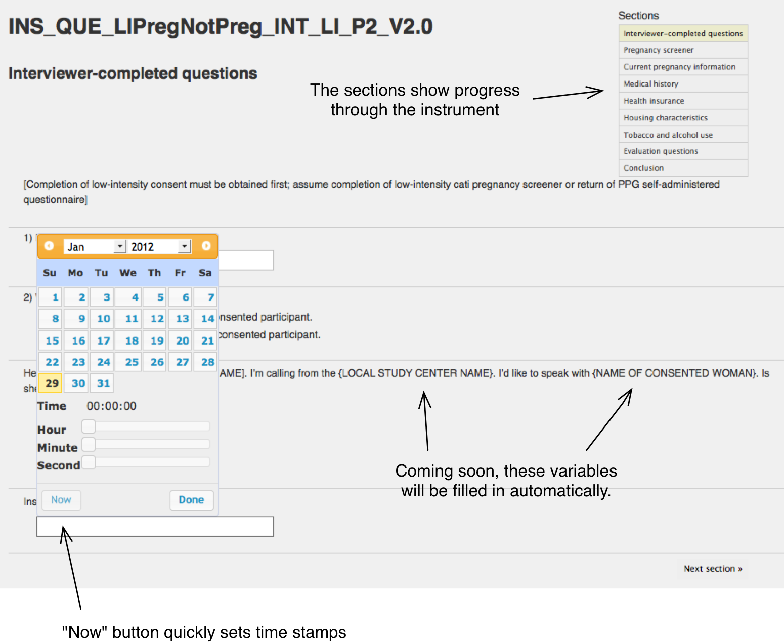
9. At the conclusion of the instrument, click “Finish,” and you will be presented with a final form to close the instrument. All of the fields are prefilled except for the Instrument Status field. Ensure that the fields are all correctly completed, especially Instrument Status and Breakoff, before clicking “Submit.”
10. When all instruments have been completed, you will be shown forms for closing the contact and event. If another event is available to take place, an option to continue to another event will also be presented.  
     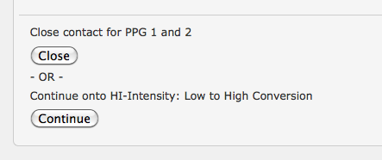
11. Selecting “Continue” will make one or more additional instruments available.
12. Selecting “Close” will end this contact (and close the event, if all activities were completed and the event was given a closed disposition) and take you to the Person Record page.

# Record a breakoff?

A contact ending before the administration of an instrument is finished should be recorded as a “breakoff.” Instrument responses are saved as they are recorded, so a breakoff will not result in data loss. The instrument should be completed at a later date. To record a breakoff in the middle of an instrument:

1. Click on the Conclusion box of the list of sections.  
     
   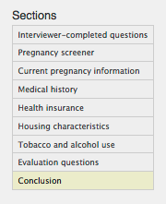
2. Click the text that reads, “Click here to finish.”
3. Complete the Finalize Instrument form by recording the Instrument Status as “Partial” and the Breakoff as “Yes.”
4. To close the Contact and Event, set the disposition for both to “In Progress/Partial with insufficient information.” The Event should also be set to Breakoff as “Yes.”
5. Click “Close” to end the Contact and leave the Event in a pending state.

## Move a participant from Lo to Hi?

Participants in PPG 1 or 2 and dwelling in a TSU should be invited to join the Hi Intensity segment. This process is initiated from the Person Record page for the given participant. This page is loaded by clicking on the name of the participant from the welcome page, the past due activities page, or from the search results for either persons or participants.

1. From the Person Record, women in PPG 1 or 2 who are in the Low Intensity segment will have a button that enables the interviewer to schedule a Low-to-High conversion event.  
     
   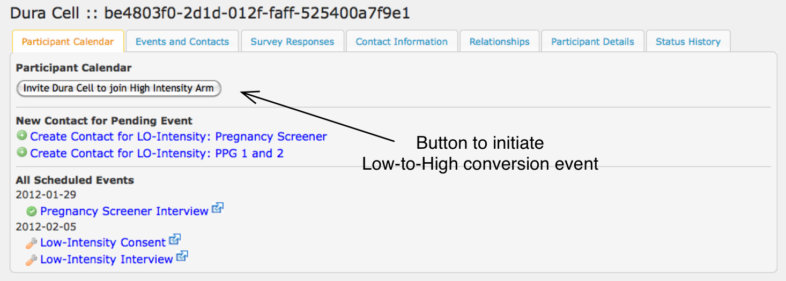
2. Pressing this button will prompt you to verify that the participant is living in the TSU. As of version 0.0.5, NCS Navigator is not able to determine this automatically. (TODO: determine TSU-based eligibility automatically)
3. Confirming that the conversion should take place automatically removes the LO-Intensity activities and instead schedules the proper Hi-Intensity events.
4. Click “Create Contact for …” in order to begin the workflow for performing an event as described in “Perform an Event?” above.

## Manage coordinator workload?

NCS Navigator associates a participant with a particular interviewer. (TODO: allow multiple interviewers per participant) A Supervisor can change this association within the Patient Study Calendar (PSC) component of NCS Navigator. Participants are moved from one coordinator to another.

1. Login to PSC: <https://navcal-demo.greaterchicagoncs.org/pages/admin/team>
2. Click the “Reassign # subjects” link that is associated with the user to whom the participants are currently assigned.
3. As in the figure below, use the checkboxes to select the participants that should be moved and the dropdown to select the staff member to whom they should be assigned. Use the “All for NCS Hi-Lo” checkbox if you want to move all participants from one staff member to another.   
     
   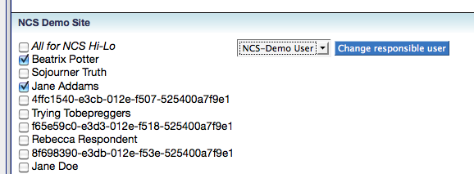

## Close an Event without making a new Contact?

In rare cases, Event records need to be edited without using the standard workflow. NCS Navigator Cases provides an interface for managing the operational data elements surrounding an event without creating a new contact or administering an instrument.

1. Find the Person Record page for the person with the Event that needs to be closed or otherwise edited.
2. Click the “Events and Contacts” tab.
3. Click on the name of the event that you want to modify.
4. Edit the Event as needed and click Submit.

## Record a Contact without Administering an Instrument?

If a contact is started, but no instruments are administered:

1. Click “Close Contact” at the bottom of the Event page.
2. Complete the Contact and Event forms with the proper dispositions to indicate that the event is still “In Progress/Partial with insufficient information.”
3. Click “Close” at the bottom of the page.

## Create a Case Status Report?

1. From the Welcome page of NCS Navigator Cases, select the Actions tab.
2. Click the Case Status Report link.
3. Specify the desired date range for the report and submit it.
4. Currently, the report downloads as a CSV. (TODO: provide a UI for this)

## Report bugs, change requests, or new features?

Please use the NCS Navigator Helpdesk site to log all issues. This will help us tremendously with our planning.

<https://code.bioinformatics.northwestern.edu/issues/projects/ncsnavhelpdesk/issues/new>

Users with a Northwestern University netid should request an account directly from Sean Whitaker, [s-whitaker@northwestern.edu](mailto:s-whitaker@northwestern.edu). All others may request an account by clicking “Register” in the upper right corner of the Help Desk site.