NCS Navigator Field

End User Guide

|  |  |
| --- | --- |
|  | First reviewed draft |

Table of Contents

Background 3

Description 3

Getting Started 3

Workflow 3

Walkthrough 3

# Background

## Description

The NCS Navigator is an information management system that facilitates case management, data and specimen collection, and reporting for the National Children's Study. NCS Navigator Field (Field) is a component of this suite that is an iOS-based application (AKA iPad App) capable of collecting data while not connected to the internet.

## Getting Started

Your iPad will come preloaded with all of the software that you need to perform field data collection with NCS Navigator. The software on your iPad is managed remotely by servers at the Northwestern University Biomedical Informatics Center (NUBIC). You will connect your iPad to the internet via Wi-Fi on a daily basis in order to find updates from the management server, push data that was collected to the Core application, and pull updates to participant event schedules.

## Workflow

This workflow will ensure that the central server and the iPads stay in sync as much as possible:

1. Sync the iPad each morning to ensure that your participant schedules are up to date.
2. Complete any data collection events for that day..
3. Whenever you enter data, sync the iPad at your next opportunity.
4. Repeat steps 1 - 3.

# Walkthrough

The first time that you launch the application (by touching the icon for it on the iPad screen), the application will appear to be blank. Since the application does not know of any upcoming events, it has none to display.

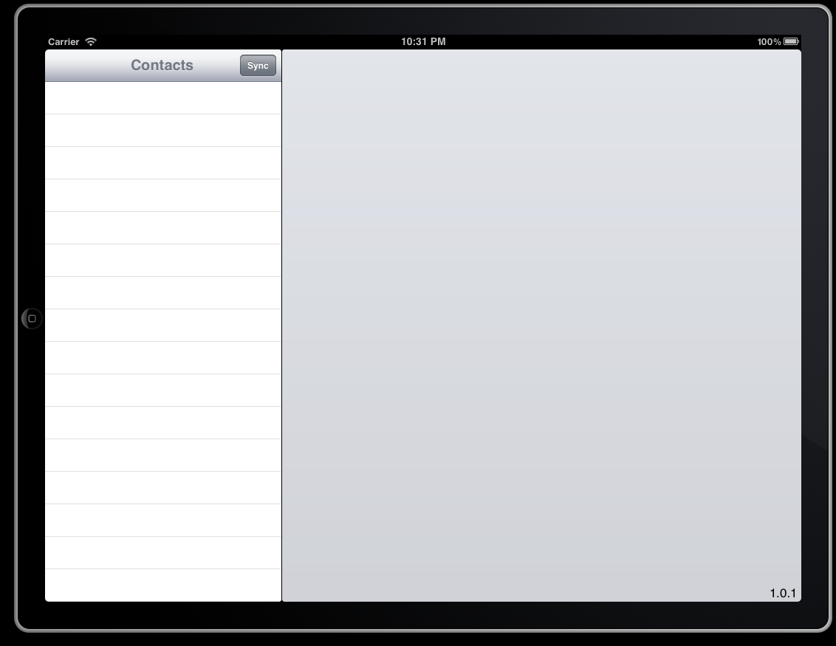

This may also happen after performing a sync if there are no upcoming events scheduled for your participants. Press the "Sync" button in order to initiate contact with the NCS Navigator server.

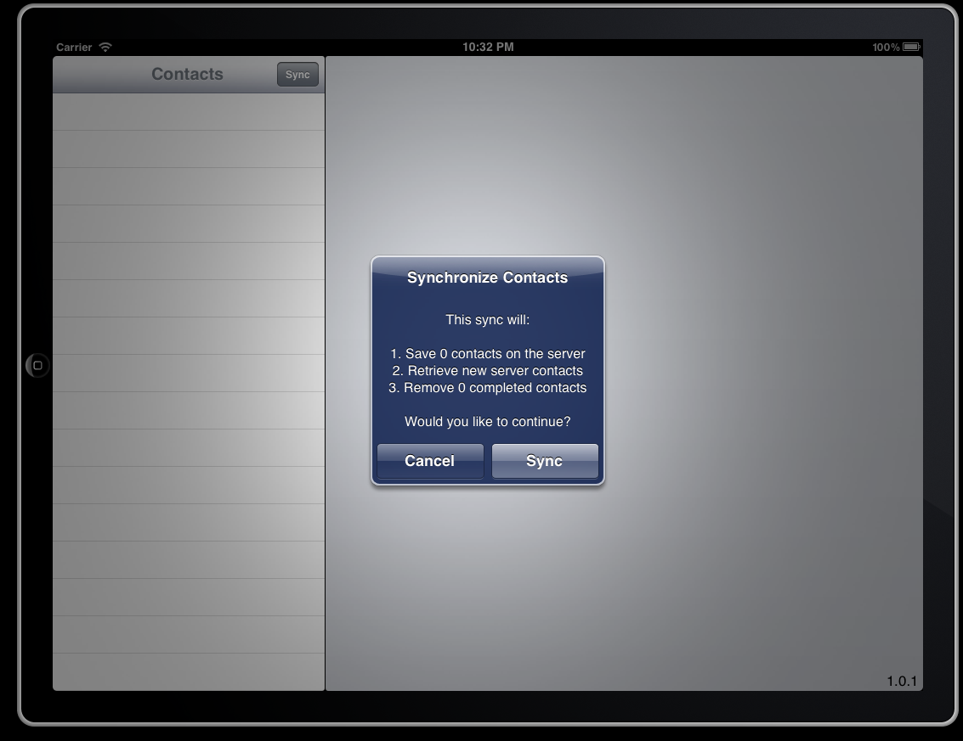

A confirmation screen will present you with a detailed list of the actions that will occur as part of the sync. Since you are just getting started, you will not have any contacts to sync. Press "Sync" to continue.

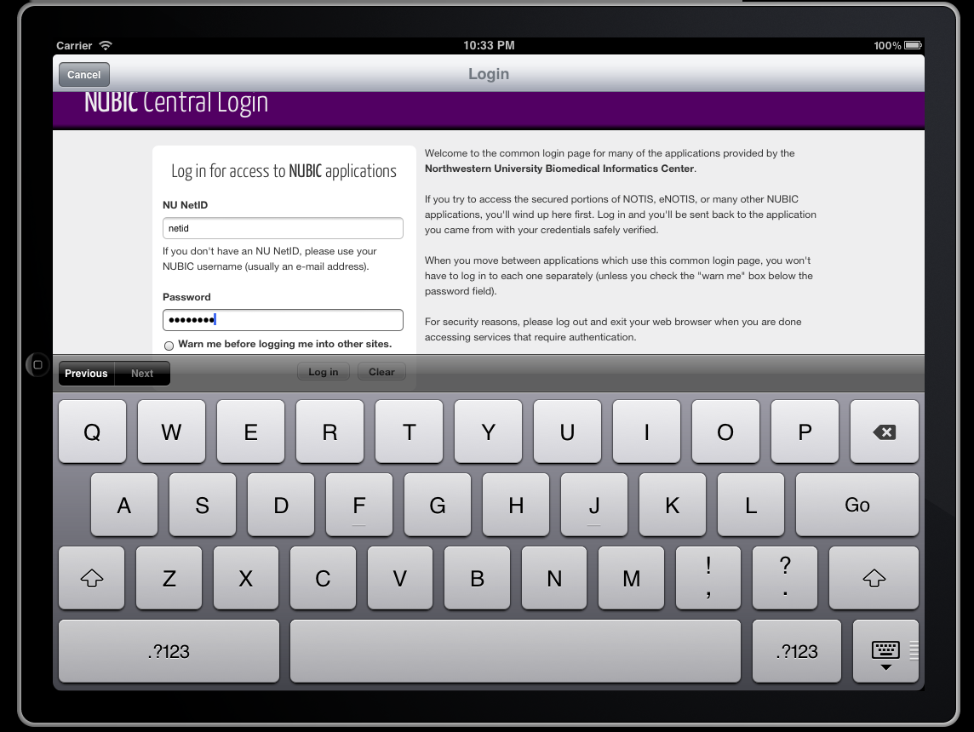

You will be prompted for a username and password. Use your Northwestern University netid to login.

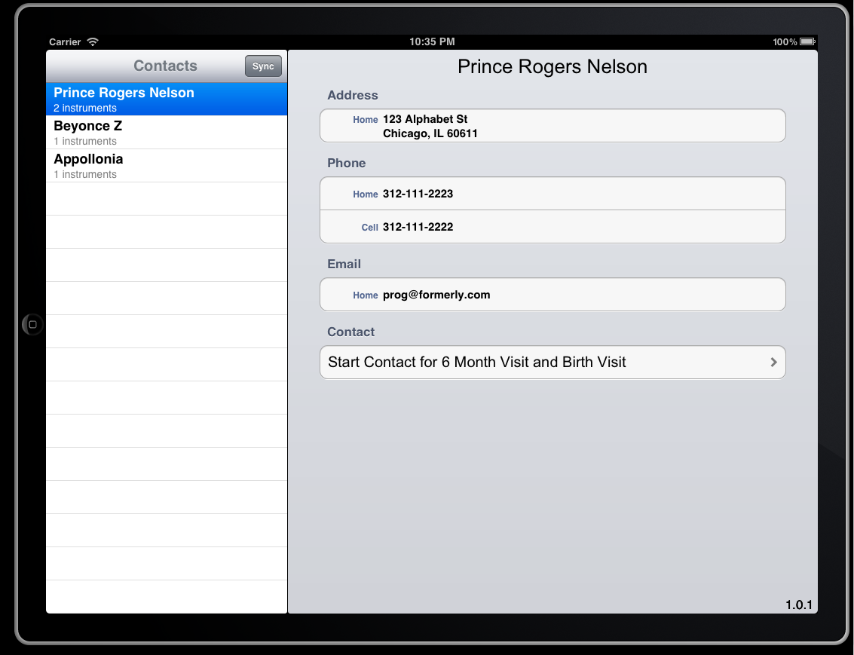

The application will then be loaded with upcoming contacts, and the corresponding participants will be listed along the left side of the screen. The sync process is completed, so you are now working "offline," meaning that your next actions do not require an internet connection.

Touch one of the participant names to view details for the participant. At the bottom of the details, you will find buttons to begin the contact for an event.

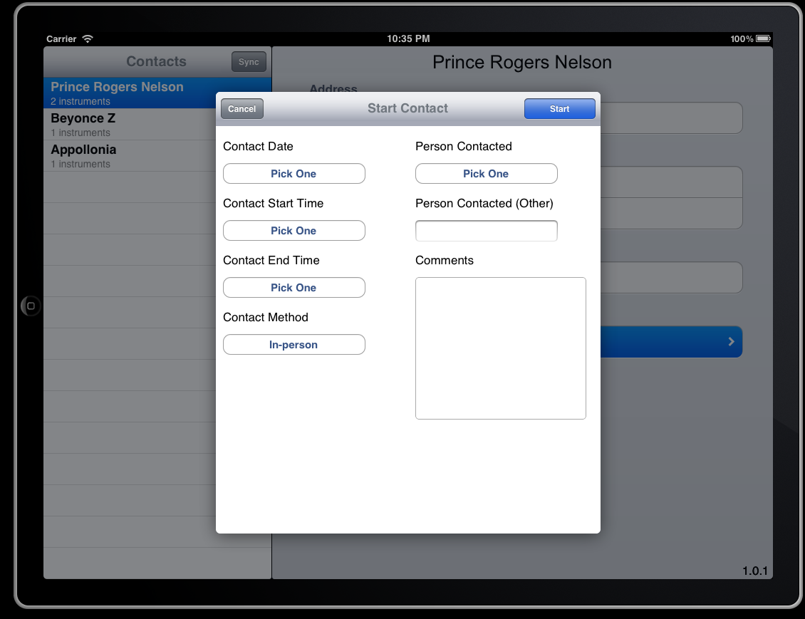

Complete the required information for beginning a contact: Contact Date, Contact Start Time, and Contact Method. The Contact End Time should only be filled out if the contact will not continue (for example, if it were completed).

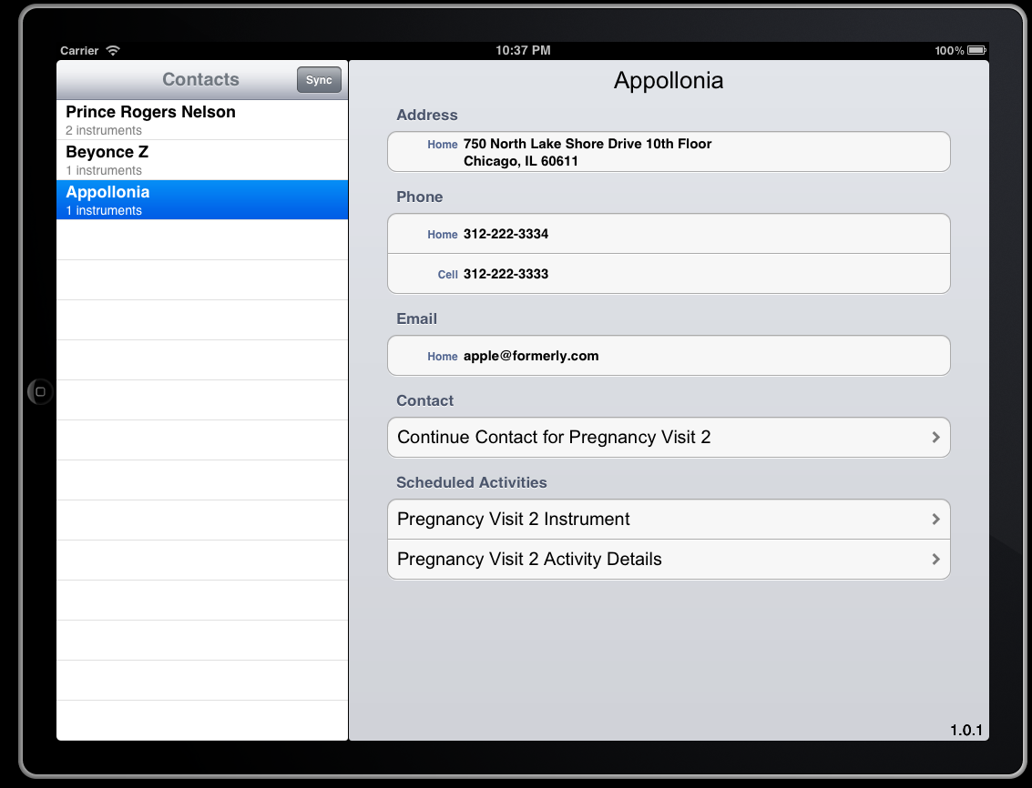

Initiating the contact will cause any activities that are part of the same event to appear. Select the one that you wish to complete next.

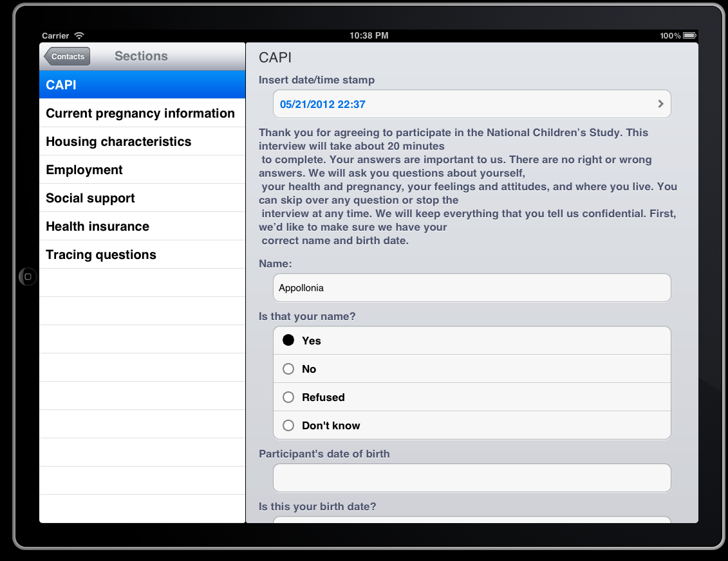

Complete the instruments as you would normally do inside the Core web application, except that you will need to use your finger instead of a mouse.

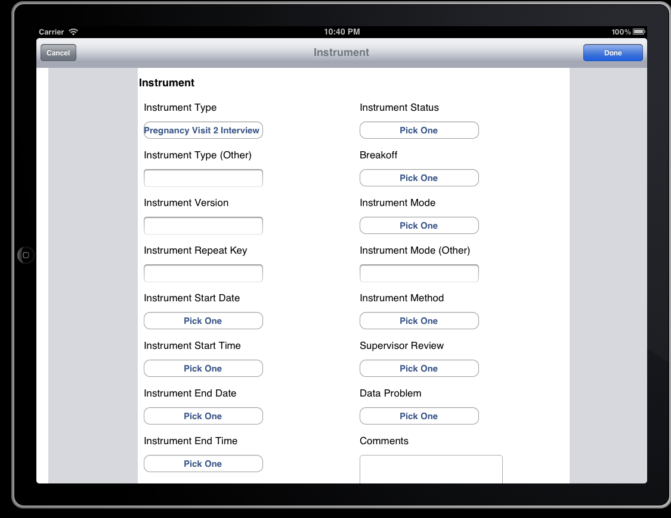

At the conclusion of the instrument, you will be asked a complete a form to closeout the instrument. Likewise, you will need to close out the event and contact.

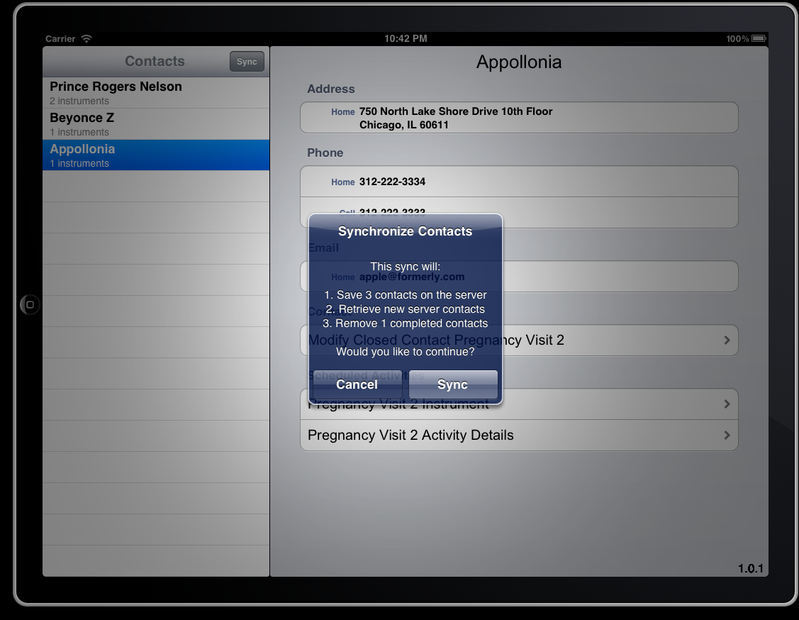

Once you have completed your data collection activities for a day, find a Wi-Fi connection and sync again.

In the example above, we now see that some contacts are being pushed to the server, and the one that is considered to be complete will subsequently be removed from the iPad completely.

The process of finding events, performing events, and sending event data back to the server is now complete.