**NCS Navigator**

**Ops**

**User Manual**

**TABLE OF CONTENTS (page numbers to be inserted at a later date)**

**GENERAL INFORMATION**

Description

4 Main Sections

My Information

Time and Expense

Outreach Activities

Admin

**STEP BY STEP GUIDE**

Login

My Information

General Information

Certificate and Training

Time and Expense

Data Collection Task

Management Task

Outreach Activities

Add New Outreach Activities

Admin

Manage Staff Details

User Administration

**APPENDIX**

Data Dictionary

Staff Type Description

Management Task Type Description

# GENERAL INFORMATION

* Ops is a web based data management system designed to provide an easy way to collect staff operational data (including staff demographic information, time, expenses and activities records) and to submit this data to the VDR for MDES reporting.
* Ops manages user access to NCS navigator.
* The staff operational data then can be used to produce reports and to conduct data analysis at each Study Center.
* There are 4 main sections in Ops: My Information, Time and Expenses, My Information, Outreach Activities, and Admin.
  + ‘My Information’ : records staff demographic information, certificate and training information.
  + ‘Time and Expense’: records staff task/activities, time and expenses.
  + ‘Outreach Activities’: records outreach events/activities information.
  + ‘Admin’: controls Ops access privilege, manage overall user data.

## ‘My Information’

* Records staff demographic information, certificate and training information.
* As a first step, every user involved in the NCS must input data in this section.
* Consists of two sub fields: General Information, Certificates and Training.
  + General Information
    - * Enter user’s general information including Name, Email, Netid, Study center, Staff type, Hourly rate and other demographic information.
  + Certificates and Training
    - * Enter user’s certificates or training information.

## ‘Time and Expense’

* Records staff task/activities, time and expenses information.
* Every user involved in NCS project must input data in this section.
* Consists of two sub fields: Data Collection Task and Management Task.
  + Data collection Task
    - * All Field staff, Phone staff, Biological specimen collector, or Specimen processor should input data using this tab.
  + Management Task
    - * All Managers (not Field staff, Phone staff, Biological specimen collector, or Specimen processor) should input data using this tab.

** If you have multiple roles, you will be able to see both the ‘Data Collection Task’ and ‘Management Task’ tabs. Depending on the type of task you perform, you will input your task/time/expense information using corresponding tabs.

## ‘Outreach Activities’

* Records outreach events/activities information, including time, expenses, type of activity, etc. .
* All users who are involved in ‘Outreach activities’ should input data in this field.

## ‘Admin’

* Controls Ops access privileges and manages the overall quality of user data input, allowing Administrators to view staff entries.
* Only User Administrators or Staff Supervisors will have access to this field.
* Consists of two sub fields: Manage Staff Details and Administer User Accounts.
  + Manage Staff Details
    - * All Staff Supervisors can be granted access to this tab by the Administrator/s.
      * In this section, Staff Supervisors and User Administrators can view and edit Staff’ general information, such as name, staff type, hourly rate, etc.
  + Administer User Accounts
    - * All User Administrators have access to this tab.
      * In this section, User Administrators view and edit User information and manage User access privileges.

# STEP BY STEP GUIDE

## Login

* Go to [insert SC specific URL]<https://staffportal.greaterchicagoncs.org>. Click on the ‘Login’ button, you will be directed to the NUBIC central login page.

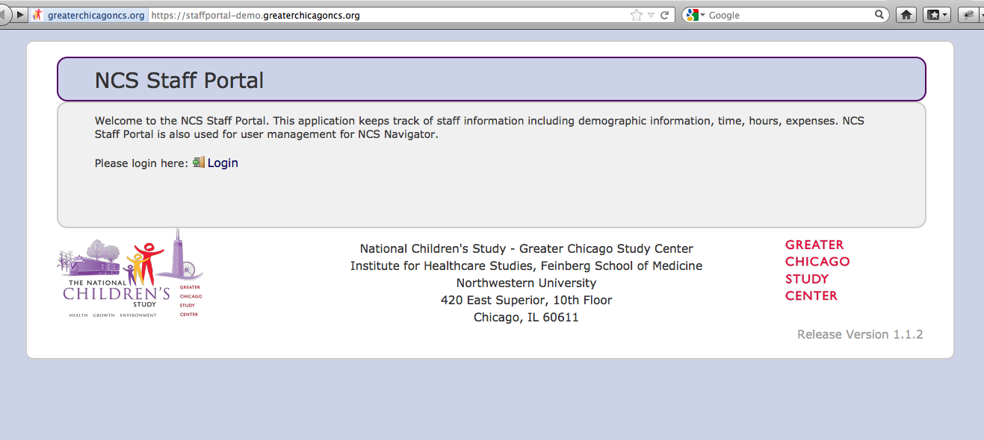

* Enter your NetID and Password.

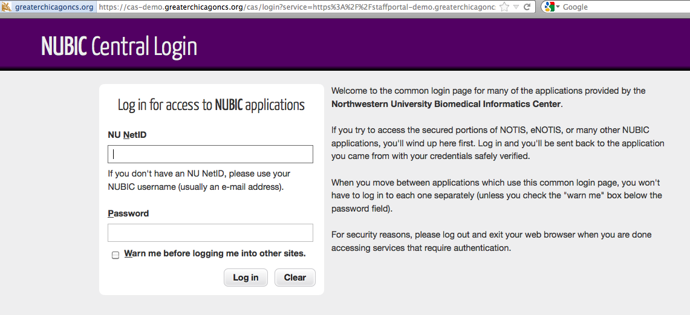

* Once you login, you will see two, three or four tabs on top of the page, depending on your access privilege. Each tab represents 4 main sections of the Ops.

(1) 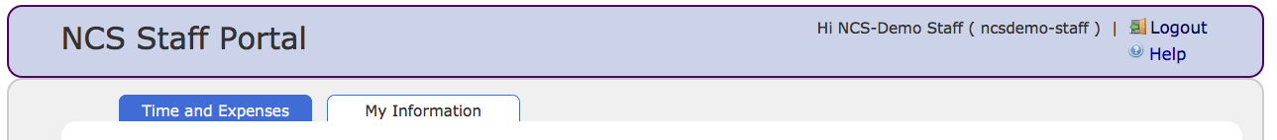

(2)

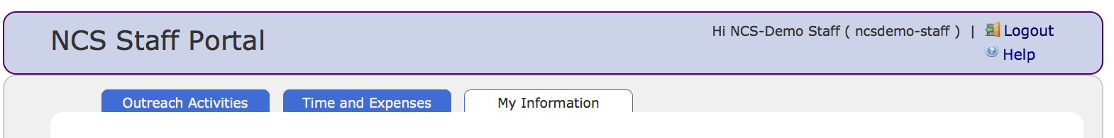

(3)

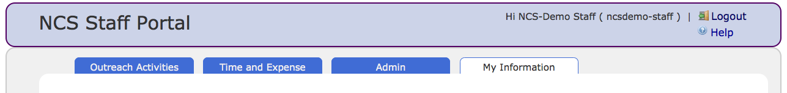

## MY INFORMATION

* The My Information tab is located on the far right. When you click on it, you will see two sub tabs, ‘General Information’, and ‘Certificate and Training’ in the left column. My Information page includes staff demographic information, certificate and training information.

**HELP**

In header section you will see the help button, which will show the help text for the particular page.

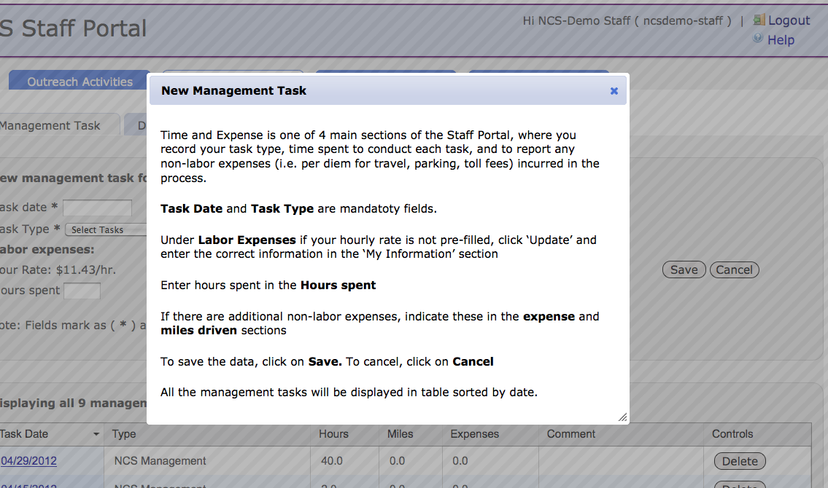

### GENERAL INFORMATION

* + Click on the ‘Edit’ button on the bottom of the page which will enable you to input your basic information.

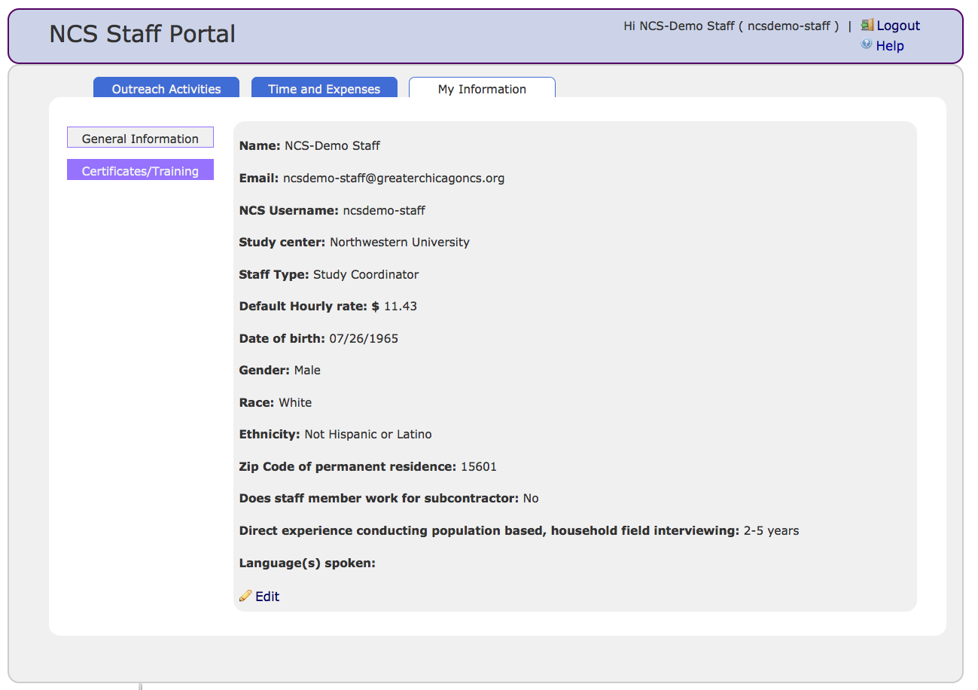

* + Name, Email NU NetID and Study Center will be in default setting. All the other information should be entered by individual users. More detailed descriptions of each item are provided in APPENDIX🡪 Data Dictionary or Staff Type Description section (page xx).

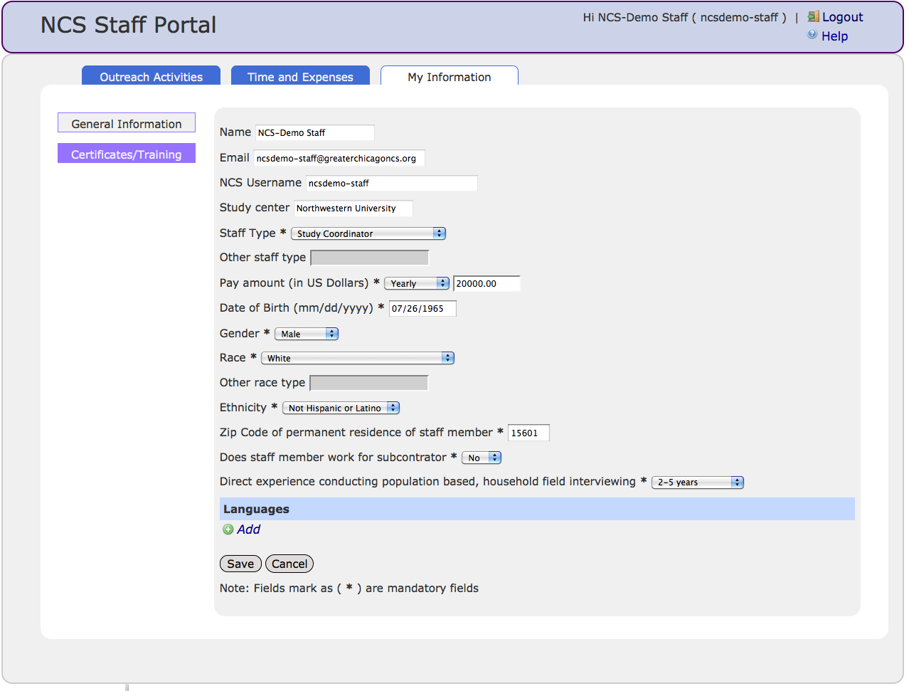

* + Be sure to save the information using the ‘Save’ button on the bottom of the page.
  + As specified on the bottom of the page, all fields marked as (*) are mandatory fields.

### CERTIFICATE AND TRAINING

* + The second sub tab below the ‘General Information’ is the ‘Certificate and Training’ tab where you can enter your certificate/training information. A detailed description of each field is provided in APPENDIX🡪 Data Dictionary (page 3-4).

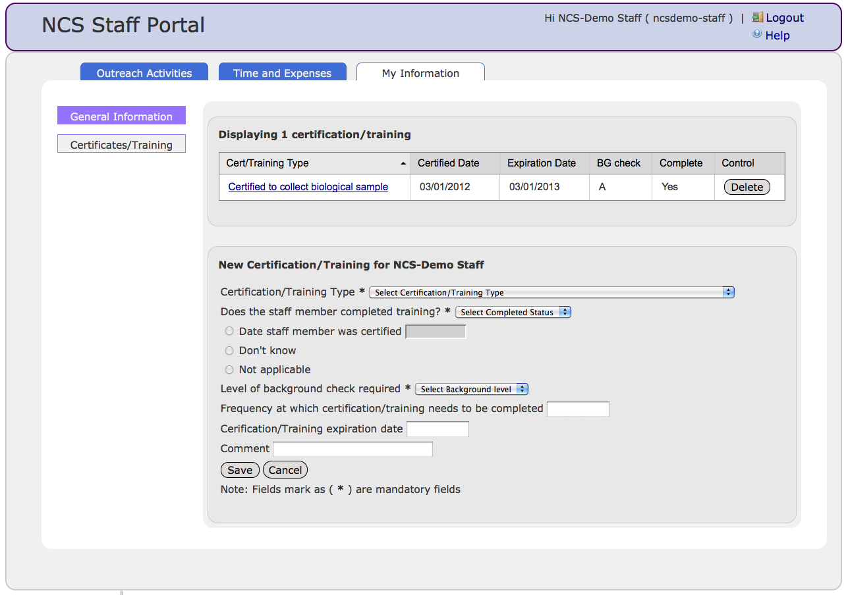

## TIME AND EXPENSE

* Time and Expense is one of four main sections of Ops. In this section, task type, time spent to conduct each task, and non-labor expenses (i.e. per diem for travel, parking, toll fees) incurred in the process of the activity are reported.
* When the Time and Expense tab is clicked, you will see either one of two sub tabs, ‘Management Task’ or ‘Data Collection Task’ or both, depending on your staff role/s and the task type.

### MANAGEMENT TASK

* + Select ‘Task Date’ in the drop down calendar.
  + Select ‘Task Type’ from the drop down menu. A more detailed description of ‘Task Type’ is provided in APPENDIX 🡪 Data Dictionary (page 5-6) and Management Task Type Description. (page 15-16)
  + Under ‘Labor Expenses’, if your hourly rate is not pre-filled, click ‘Update’ and enter the correct information in the ‘My Information’ section.
  + Enter number of hours spent for the task in the ‘Hours spent’ box (either per day or weekly).
  + If there are additional non-labor expenses, indicate these in the ‘expense’ and ‘miles driven’ sections.
  + Click ‘Save’.
  + Previously saved information will be displayed in the window below in the ‘Listing Management Tasks’ table.

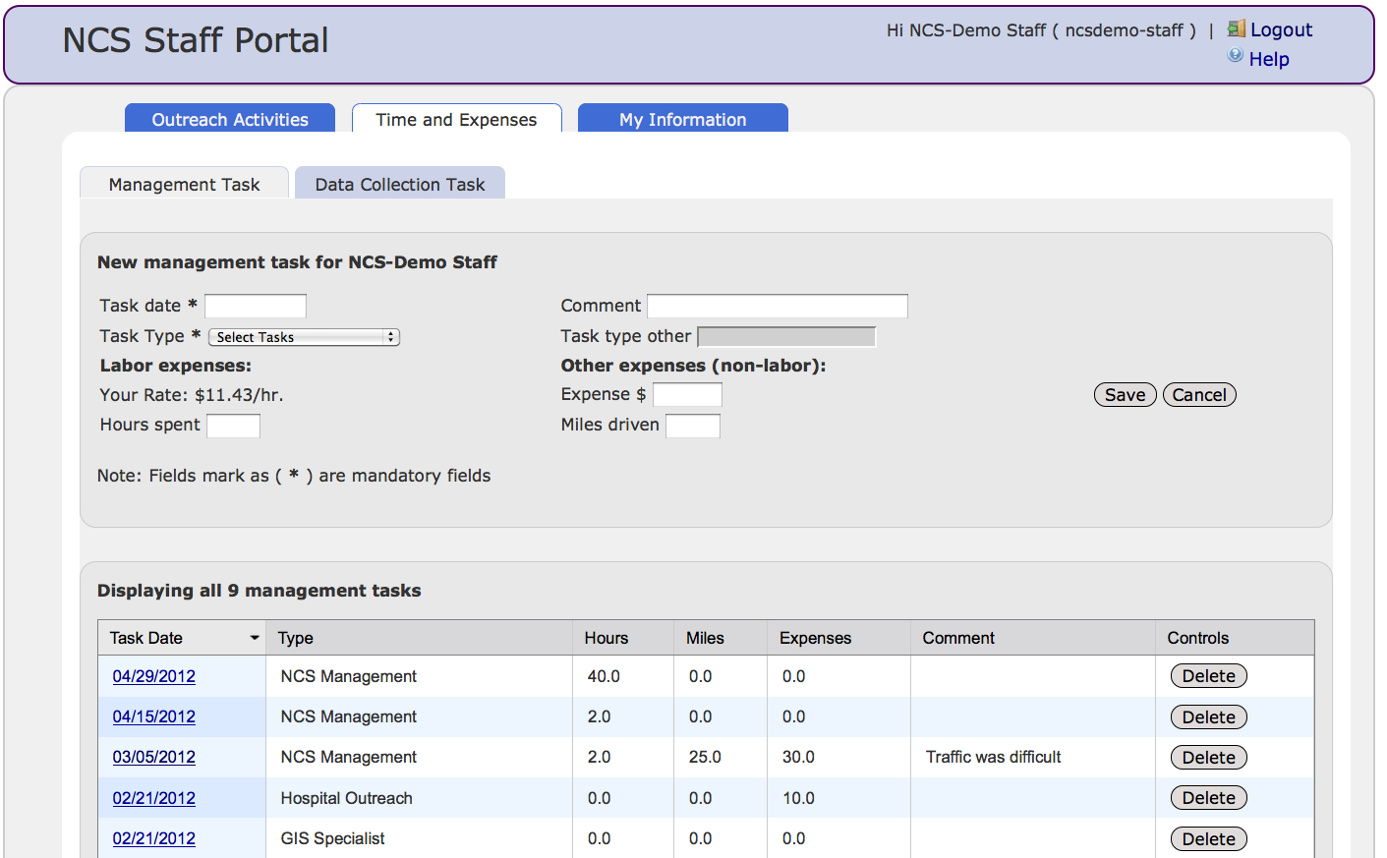

### DATA COLLECTION TASK

* + Select ‘Task Date’ in the drop down calendar.
  + Select ‘Task Type’ from the drop down menu. A more detailed description of ‘Task Type’ is provided in APPENDIX 🡪 Data Dictionary (page 5-6) and Management Task Type Description. (page 16-17)
  + Enter ‘Total Number of Cases’.
  + Under ‘Labor Expenses’, if your hourly rate is not pre-filled, click ‘Update’ and enter the correct information in the ‘My Information’ section.
  + Enter hours spent in the ‘Hours spent’ box.
  + If there are additional non-labor expenses, indicate these in the ‘expense’ and ‘miles driven’ sections.
  + Click ‘Save’.
  + Previously saved information will be displayed below in the ‘Listing Management Tasks’ table.

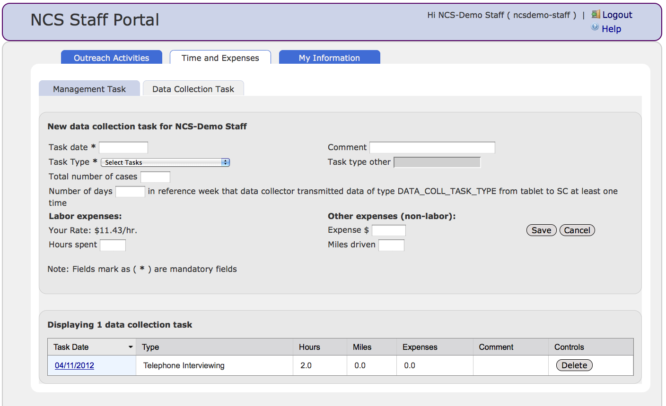

## OUTREACH ACTIVITIES

* Outreach Activities is one of four main sections of Ops where you record any information related to outreach events and activities. Please refer to APPENDIX 🡪 Data Dictionary (p20-26) for detailed description of each field.

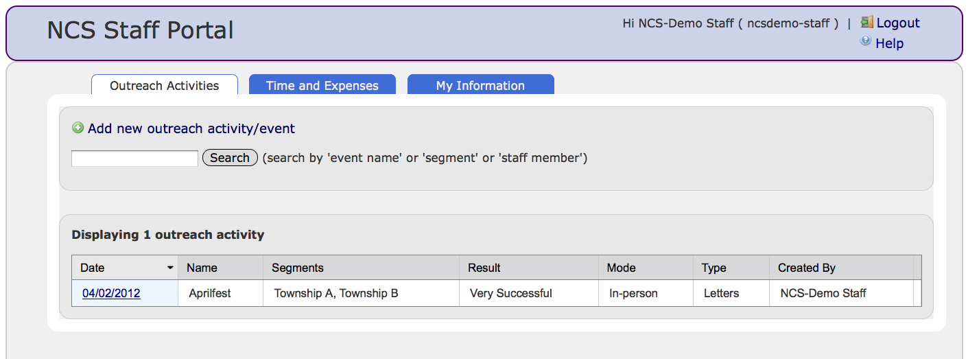

* Click on the ‘Outreach Activities’ tab
* To enter a new outreach activity, click on ‘New outreach activity/event’.

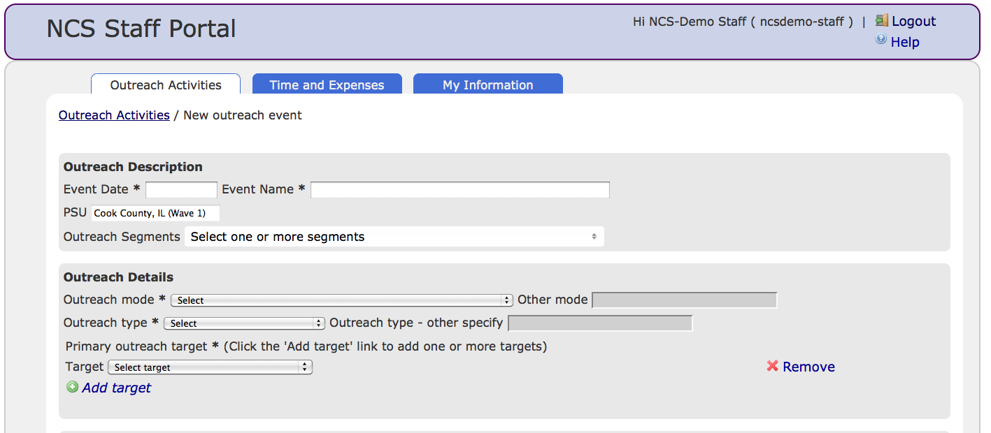

* Under ‘Outreach Description’:
  + Select ‘Event Date’ (use event start date) using the drop down calendar and enter ‘Event Name’.
  + If applicable, enter ‘PSU’ and/or ‘Outreach Segments’
* Under ‘Outreach Details’:
  + Select ‘Outreach Mode’, ‘Outreach Type’ and ‘Target’.
* Under ’Outreach Quantity:’
  + Enter ‘Number of printed material distributed’ and ‘Number of attendees’.
  + If study center has any giveaway items to capture, there will be a section for giveaway items with quantity. To add more than one, click on ‘Add giveaway item’.
  + Enter ‘Non-labor cost to conduct outreach’.

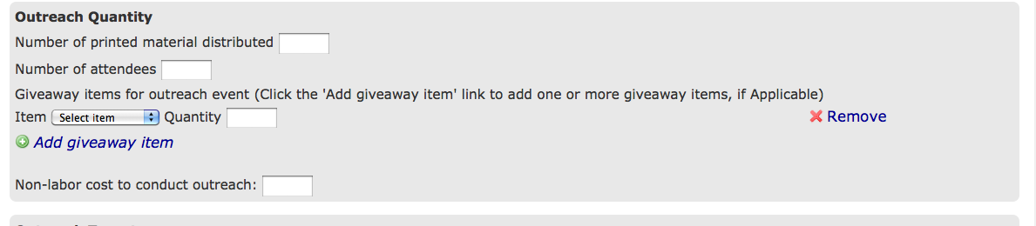

* Under ‘Outreach Targets’:
  + Indicate if the outreach effort was tailored to a specific group. If yes:
    - Indicate if the outreach was language specific.
    - Indicate if the outreach was targeted to a specific cultural group.
    - Select targeted cultural group.
  + Indicate if the outreach was targeted to a specific racial group.
* Under ‘Outreach Evaluation’:
  + Indicate the success of the outreach activity by selecting the appropriate response from the drop-down menu.
  + Select the ‘Outreach Evaluation’ type from the drop down menu.
* Under ‘Outreach Staff Information:’
  + Enter the number of staff required for event.
  + Indicate staff members participating in the outreach event.
  + If applicable, click the 'Add staff member' link to add one or more staff members.
* Click ‘Save.’
* To cancel the form entries and exit, click on ‘Exit without save’.

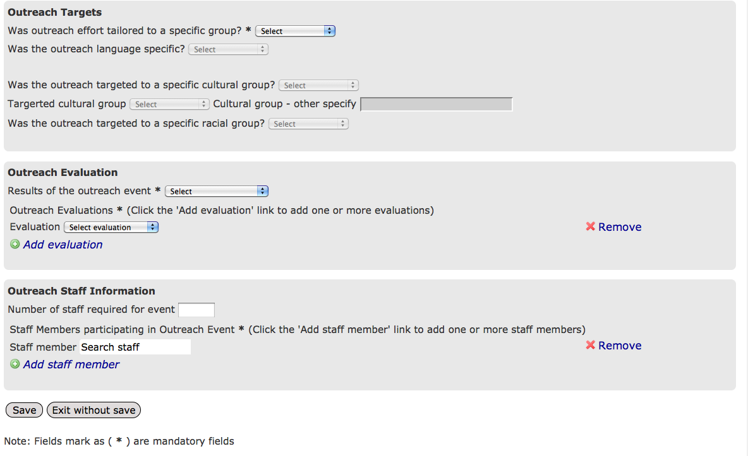

## ADMIN

* This last section of Ops is used to coordinate Ops access privilege and manage overall quality of user data input. When you click on this section, you will see two sub tabs depending on your role and task: Manage Staff Details and Administer User Accounts.
* If you are a Staff Supervisor you will see ‘Manage Staff Details’. If you are a User Administrator, you will see ‘Administer User Accounts’. If you are both, then you will have access to both sub tabs.

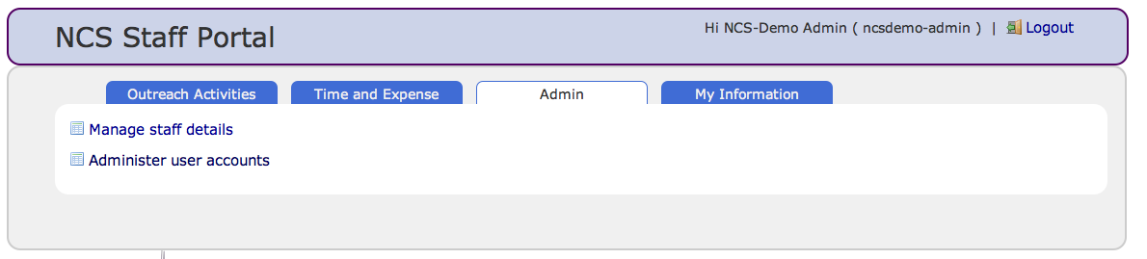

### MANAGE STAFF DETAILS

* + The manage staff details page has search section where supervisor can search any staff by first name, last name or username. Result will be shown in the table sorted by username. Table lists all the staff sorted by their usernames by default. Tables shows name, NCS staff type and control button whether each user should receive a reminder email (a weekly email that sent to Ops users who have not input any Time/Expense data during that week). Supervisor can uncheck the button if some staff doesn’t want to get any reminder email.

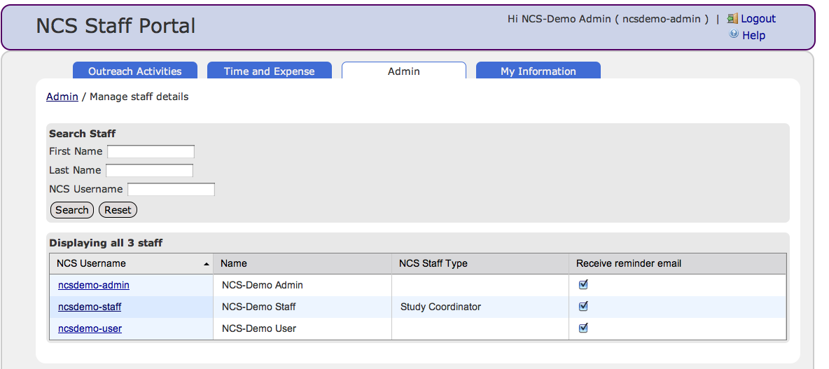

* + Staff Supervisors can click on the user NetIDs in the list and access and edit individual user’s general information and certificate/training information.
  + Staff Supervisors also have access to ‘Staff Entries’ tab under ‘Time and Expense’. When you click on ‘Staff Entries’ tab, there is a table that displays the most recent time and expense entries by user. The table is arranged by users (task) start date, their name, time, miles and expense information. For each record, there is a ‘delete’ button on the right for any corrections.

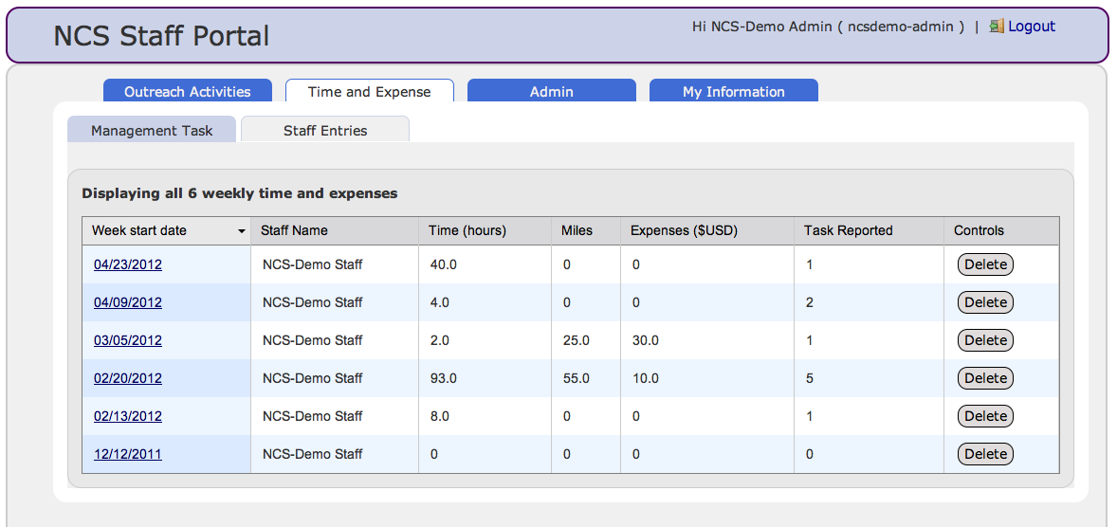

### ADMINISTER USER ACCOUNTS

* + The second sub tab of ‘Admin’ section is ‘Administer User Accounts’. Only User Administrator can access this page. This page has search section where user administrator can search any user by first name, last name or username. Result will be shown in the table sorted by username. Table lists all the users sorted by their usernames by default. A table also shows name, roles in NCS Navigator and status (active/disabled) to the NCS Navigator for all the users

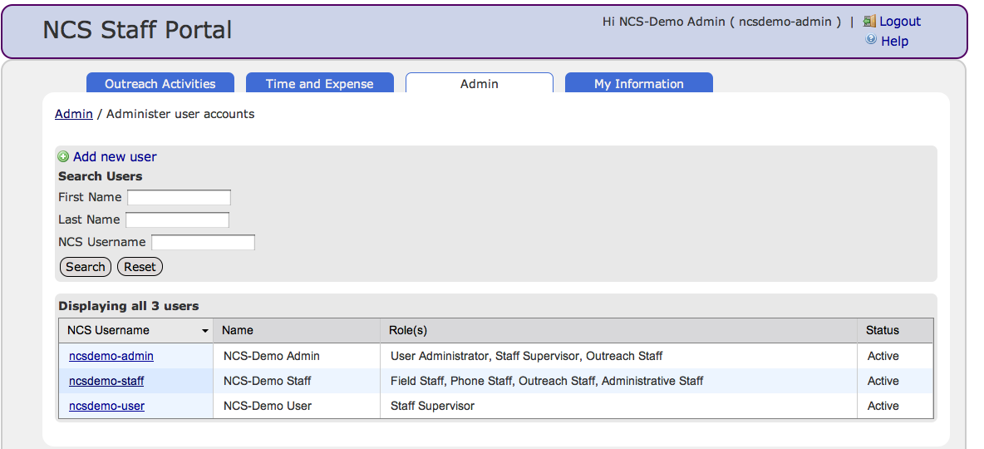

**To add a new user**,

1. Click on the ‘Add new user’ tab.

There are many sections to this page.

* General Information:
  + This section requires general information for the user like first name, last name, emails id, username, which will be use for authentication. User Administrator requires above information for each new user.
  + Some other information includes Staff Id, Inactive Date and External User.
    - Staff Id will be auto generated UUID for user. If you have any existing staff that has used other application for time and task entries, you might want to assign them an existing staff id retrieve from VDR submission.
    - One can set user’s inactive date if user’s inactive date of NCS is known or User is no longer working with NCS and want to make that user disabled in NCS Navigator.
    - If any user is not using Ops for their time and expense, but still needs access to the NCS navigator, then mark the user as external user to NCS Navigator.
* Role(s):
  + User administrator can assign particular role(s) to the user. One user can have multiple roles to NCS navigator.

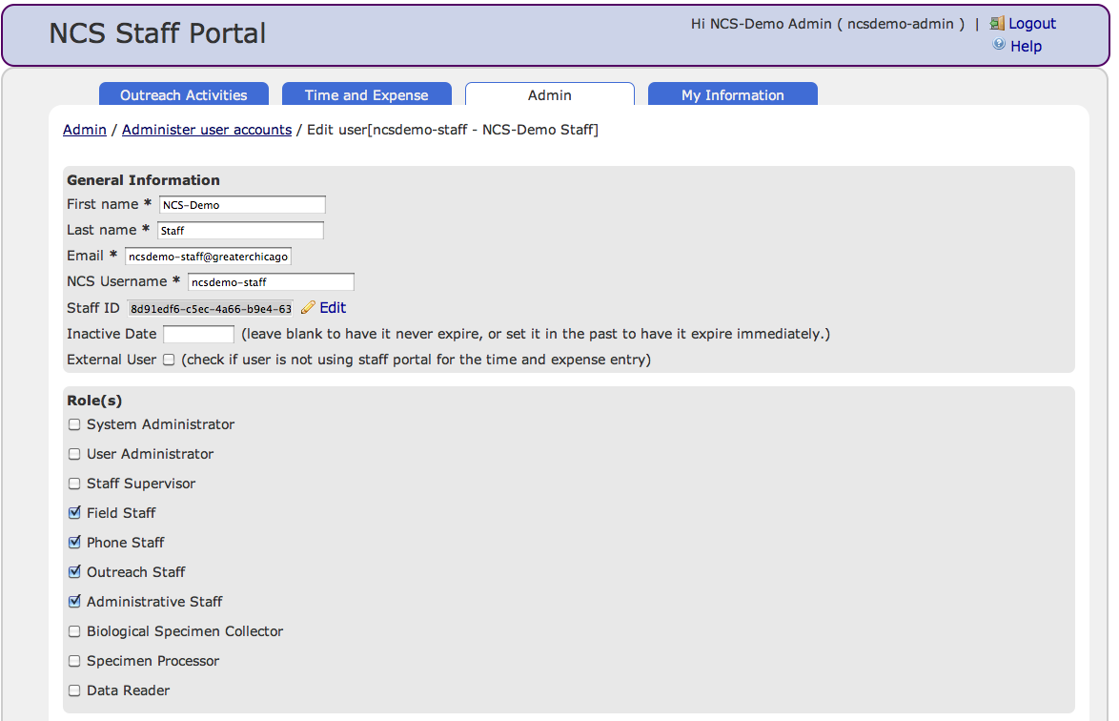

* Supervisees
  + This section will be display for only staff supervisor user. If any user assigned Staff Supervisor role initially, user become default supervisor and will have access to all the staff data. If you want to limit some staff supervisor access to limited staff only instead of all the staff, you can limit their scope here.
  + To make access limited for particular staff, you can add staff member. For multiple staff, you can add more staff. So this staff supervisor user will have access to the assigned staff only.
  + This section will not be available for new user page, but will available to staff supervisor edit user page.

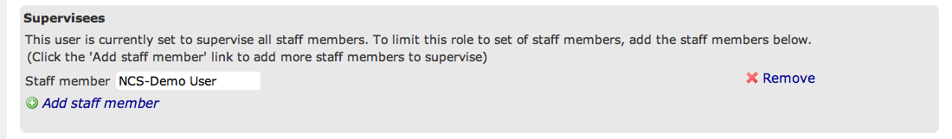

* Supervisors(s)
  + This section will display the supervisor(s) for that particular user. Supervisor can be default supervisor, which has access to all the staff, or assigned supervisor, which will have limited staff access to particular staff only.



**Edit user**

User Administrator can also view and edit existing user information and their access privilege by clicking on user’s username listed in the table on the first page.

**OPS USER MANUAL**

**APPENDIX.**

**DATA DICTIONARY**

**MY INFORMATION**

| **My Information** | | | |
| --- | --- | --- | --- |
|  | **Variable** | **Definition / Description** | **Remarks** |
| **General Information** | Name | User name |  |
| Email | Default email |  |
| NetID | Default |  |
| Study Center | Default = Northwestern University |  |
| Staff Type | Select from the following: **(See p28 ,‘Staff Type Description)**   * Principal Investigator * Co-Investigator * Study Coordinator * Community Outreach * Hospital Outreach * Provider Outreach * IRB Member/Management/Coordinator * Site Office Administration * Field Management Staff * Field Staff * Telephone Center Management * Telephone Center Staff * Informatics Management * Data Management * Other staff type not listed above |  |
| Default Hourly rate | Hourly or Yearly rate; only need to input this information once; |  |
| Date of birth | User date of birth |  |
| Gender | Choose from the following:   * Male * Female * Both * Unknown |  |
| Race | Choose from the following:   * White * Black or African American * American Indian or Alaska Native * Asian * Native Hawaiian or Other Pacific Islander * Multi-racial * Refused * Other * Unknown |  |
| Ethnicity | Select from the following:   * Hispanic or Latino * Not Hispanic or Latino * Refused * Unknown |  |
| Zip code of permanent residence | Specify zipcode |  |
| Does staff member work for subcontractor | Yes or No |  |
| Direct experience conducting population based, household field interviewing | Select from the following:   * Less than 1 year * 2-5 years * 6 or more years * Not applicable |  |
| Language(s) spoken | Select language(s) you speak from the following:   * English * Spanish * Arabic * Chinese * French * French Creole * German * Italian * Korean * Polish * Russian * Tagalog * Vietnamese * Urdu * Punjabi * Bengali * Farsi * Refused * Other * Unknown | Multiple can be selected at the same time; |
| **Certificates / Training** | Certification / Training Type | Select from the following:   * Certified to conduct specific assessment * Certified to collect biological sample * Certified to administer informed consent * Certified to collect environmental sample * Certified to complete household enumerations * Certified to do listing * Certified to collect physical measure * Certified to administer PPG follow-up calls * Certified to administer the first pregnancy visit * Certified to administer the second pregnancy visit * Certified to complete pregnancy screenings * Certified to administer the pre-pregnancy visit * Certified to do recruitment with providers * General certification to administer telephone interviews * General certification to administer in-person questionnaires * Certified to administer the birth visit * Certified to do Combined Listing and Enumeration. * Certified for NCS employment-Human Subjects Protection * Certified for NCS employment-NIH IT Security * Certified for NCS employment-Background Investigation * Certified in Shipping of Dangerous Goods (IATA Training) and Certified as a Phlebotomist |  |
| Did the staff member complete training? | Yes or No |  |
| * If Yes, then | Select from the following:   * Date (mm/dd/yyyy) * Don’t know (you don’t know the date of certification) * NA |  |
| Level of background check required | Select from the following; **(See ‘ NCS Institutional Staff Certification Plan_GCSC’)**   * A * B * C * D |  |
| Frequency at which certification/training needs to be completed | Frequency at which certification/training needs to be completed (character up to 10 max) |  |
| Certification/Training expiration date | Specify certification/training expiration date |  |
| Comment | Any comments can be added here  (e.g., if there is a gap of 3 months, must be recertified) |  |

**TIME AND EXPENSES**

| **Time and Expense : Arranged by Task type** | | | |
| --- | --- | --- | --- |
|  | **Variable** | **Definition / Description** | **Remarks** |
| **General**  **(Management Task / Data Collection Task)** | Task Date | Task start date ; if entered weekly, the date of first day of time period should be entered |  |
| Comment | Any relevant comment related to current task |  |
| Task Type | Select from the following: **(See p29 -30,‘Task Type Description’)**   * NCS Management * Study Coordination * Hospital Outreach * Provider Outreach * IRB Management * Site Office Management * Informatics Management * Community Outreach * Subcontract Oversight * GIS Specialists * Other |  |
| Task Type Other | Describe ‘Other’ task type |  |
| **Labor expenses** | Your Rate | Automatically filled based on your rate entered in ‘My Information’ page. |  |
| Hours Spent | Specify the number of hours staff member spent on management task; Total hours entered must not exceed 40 hours/week or the number of hours you bill to the NCS; |  |
| **Other expense (non-labor)** | Expenses | Expense incurred by staff member using NCS funds – any expense that is billed to NCS (i.e., per diem for travel,  parking, tolls, mileage); this information needs to be calculated manually until the Ops is programmed to sum; |  |
|  | Miles Driven | Miles traveled by staff member for NCS during the ‘task’ |  |
| **\*Data Collection Task ONLY** | Total Number of Cases | Total number of cases Data Collector worked with during the time reported; |  |
| **\*Data Collection Task ONLY** | Number of days in reference week that data collector transmitted data of type DATA_COLL_TASK_TYPE from tablet to SC at least one time | Number of days in reference week/time that data collector transmitted data type indicated; |  |
|  |  |  |  |

**OUTREACH ACTIVITIES**

| **Outreach Activities/ Events** | | | |
| --- | --- | --- | --- |
|  | **Variable** | **Definition / Description** | **Remarks** |
| **Outreach Description** | Event Date | Event start date; an outreach event is any event or action where outreach and engagement is taking place; this can include distribution of fliers/materials, attendance at a community meeting, fair, block party, civic engagement, etc; a multiple day event should have two event forms entered (e.g., entered twice with each distinct date); events also include advertisement and marketing buys and material purchases, including brochures, posters, buttons, etc; |  |
| Event Name | Specify the event name |  |
| PSU | Default = Cook County (Wave1) |  |
| Outreach segments | Select from the following:   * Input SC segment names | Multiple can be selected at the same time; |
| **Outreach Details** | Outreach Mode | Select from the following:   * In-Person * Telephone * Mail * Email * Web * Social networking Media (e.g., Internet, Facebook, My Space, blogs, etc) * Fax * Network TV * Cable TV * Movie theaters * Radio * Print * Other |  |
| * If ‘Other’ Mode | If how this outreach activity was executed (mode) is not included in table, select ‘other’ option and describe how this outreach activity was executed. * If this outreach activity was executed using several modes, select ‘other’ option and describe all the ways this outreach activity was executed. |  |
| Outreach Type | Select from the following:   * Letters * Brochures * Postcards * DVDs * NCS National Website * NCS Local Website * Partner/Supporter Website * Flyers * Posters * Fact-Sheets * Door tags * Yard Signs * Window clings * Car magnets * Newsletters * ‘Paycheck stuffer’ * Billboards * Public Service Announcements * Paid Advertising |  |
| * If ‘Other’ Type | If the type of outreach activity is not included in the table, select ‘other’ option and enter type. * If used several types of outreach, select ‘other’ option and describe all outreach types. |  |
| Primary outreach target(s) | Select from the following:   * Dwelling Unit- Unknown eligibility * Eligible Dwelling Unit * Known Resident – Unknown eligibility * Eligible Resident – Not enrolled * Eligible Resident – Reused participation * Enrolled Participant * Participant who withdrew from NCS * Spouse/Partner of Eligible Resident * Extended family of Eligible Resident * Building manager * Homeowner’s’ association * Other Gatekeeper of Eligible Resident * Community Advisory Board * Prenatal care provider * Pediatrician * Other health care provider * Hospital administrator * Other Hospital Gatekeeper * Public Health Agency | Multiple can be selected at the same time; |
| **Outreach Quantity** | Numbers of printed materials distributed | Specify combined number  (e.g. brochures, letters, posters) |  |
| Numbers of attendees | Specify number of attendees |  |
| Giveaway items (Type + Quantity) for outreach event | Select from the following:   * Bags * Bibs * Coloring Books * Frisbees * Hats * Magnets * Other * Pencils * Pens * Screws Drivers * Sticky Notes * T-Shirts * Wallets * Water Bottles * Other | Multiple can be selected at the same time; |
|  | Non-Labor cost to conduct outreach | Enter any cost incurred during the outreach activity/event. (eg. Material cost. Exclude any travel expenses) |  |
| **Outreach Targets** | Was outreach effort tailored to a specific group? | Yes or No; This refers to racial/ethnic/cultural groups and not professional groups. |  |
| Was the outreach language specific? | Yes or No; If you select ‘No’, the default language will be English. |  |
| * If ‘Yes’, then | Select from the following:   * English * Spanish * Arabic * Chinese * French * French Creole * German * Italian * Korean * Polish * Russian * Tagalog * Vietnamese * Urdu * Punjabi * Bengali * Farsi * Refused * Other * Unknown | Multiple can be selected at the same time; |
| Was the outreach targeted to a specific cultural group? | Yes , No or Legitimate Skip |  |
| * If ‘Yes’, then | Select from the following:   * Mexican * Puerto Rican * Columbian * Dominican * El Salvadorian * Jamaican * Guatemalan * Cuban * Haitian * Chinese * Philippine * Japanese * Korean * Vietnamese * Russian * Orthodox Jews * Indian * Pakistani * Irish * Italian * Arabic * Chaldean * Other * Not applicable |  |
| * If ‘Other’ from the list | Specify other targeted cultural group not included in the above list |  |
| Was the outreach targeted to a specific racial group? | Yes , No or Legitimate Skip |  |
|  | * If ‘Yes’, then | Select from the following:   * White * Black or African American * Asian * Native Hawaiian or Other Pacific Islander * Multi-Racial * Other * Not applicable | Multiple can be selected at the same time; |
| **Outreach Evaluation** | Results of the outreach activity | Select from the following: (*Note: Success is judged vis a vis established objects for the event.)   * Very Successful * Moderately Successful * Not Successful |  |
| Outreach evaluations | Select from the following:   * Focus groups * Surveys * In-depth interviews * Intercept interviews * Other | Multiple can be selected at the same time; |
|  | * If ‘Other’, then | Explain here that outreach events were judged via event objectives. |  |
| **Outreach Staff Information** | Number of staff required for event | Specify number of staff required for outreach event |  |
| Staff Members participating in Outreach Event | Enter names of the staff member participating in this outreach event | Multiple can be selected at the same time; |

**ADMIN**

| **Admin** | | | |
| --- | --- | --- | --- |
|  | **Variable** | **Definition / Description** | **Remarks** |
| **Manage Staff Details** | NetID | Default |  |
| Name | User Name |  |
| NCS Staff Type | Staff Type entered by each user in ‘My Information’ section. **(See p17 , Staff Type)** |  |
| Receive Reminder Email | A weekly reminder email sent out to users who have not input or completed Time/Expense information. This button will control whether users should receive reminder email or not. |  |
|  |  |  |
| **Administer User Accounts**   * **General Information** * **Roles** | NetID | Default |  |
| Name | User Name |  |
| Roles | **(See p33 , Roles)** |  |
|  |  |  |
| First Name | - |  |
| Last Name | - |  |
| Email | - |  |
| NU NetID | Default |  |
| Staff ID | Auto generated UUID. For existing staff using other application for MDES data, already assigned Staff Id can be enter. |  |
| Inactive Date | Inactive date for NCS project. This will make user inactive and will not allowed to use NCS navigator. Any inactive user information will be in Ops, but no new further information will be added/edited by that user. |  |
| External User | If any user is not using Ops for time and expense entry or other information but will be using NCS Navigator, user can be marked as external user to Ops. |  |
|  |  |  |
|  |  |  |

**‘STAFF TYPE’ DESCRIPTION**

|  |  |
| --- | --- |
|  |  |
| **STAFF TYPE** | **DESCRIPTION** |
| Principal Investigator | Individual oversees all aspects of the Study Center contract |
| Co-Investigator | Individual oversees sampling and collection of data, as well as clinical research operations |
| Study Coordinator | Individual oversees all aspects of study implementation, coordination, and management of field operations; sometimes named Study Manager, Study Director |
| Community Outreach | Individual is responsible for public relations, community outreach and engagement; develops culturally acceptable awareness campaigns |
| Hospital Outreach | Individual is responsible for outreach and engagement with hospitals in which study participants may give birth |
| Provider Outreach | Individual is responsible for outreach and  engagement to providers |
| IRB Member/Management/Coordinator | Individual works closely with the local Institutional Review Board (IRB) to submit/update IRB submissions, obtain IRB-approval of materials prior to circulation |
| Site Office Administration | Individual oversees daily administrative duties of the study site such as overseeing and conducting case management, scheduling study visit appointments |
| Field Management Staff | Individual is responsible for directly overseeing all field interviewers and/or listers collecting study data |
| Field Staff | Individual is responsible for in-field data collection of study data |
| Telephone Center Management | Individual is responsible for directly overseeing all call or telephone center staff and operations |
| Telephone Center Staff | Individual is responsible for all telephone data collection and tracking of participants |
| Informatics Management | Individual provides technical support as well as overall monitoring and management of information technology activities |
| Data Management | Individual is responsible for the monitoring and reporting of data activities such as QA/QC checks, management and documentation of coding |
| Other | This refers to a staff type not listed above (e.g., Office Administrator) |

**‘MANAGEMENT TASK TYPE’ DESCRIPTION**

|  |  |
| --- | --- |
|  |  |
| STAFF TYPE | DESCRIPTION |
| NCS Management | Includes duties that may be carried out by the Principal Investigator or Co-Investigators: Provides leadership to every aspect of NCS conduct – setting priorities, guidance and expectations for the field, administrative and IT aspects; represents the study to the community, institutions, the Program Office, and Contract Office; |
| Study Coordination | Includes duties carried out by Study Coordinator, Study Manager, Study Director: Oversight of study implementation, field and study center operations, coordination with subcontractors, completion of reporting and deliverables, budgeting and contracts, etc.; |
| Hospital Outreach | Includes duties that are carried out by the Hospital Liaison, Study Coordinator or Compliance Coordinator: Conducts outreach and engagement to hospitals where participants may deliver, secures agreements for conduct of hospital-based data collection; |
| Provider Outreach | Includes duties that are carried out by a Provider Liaison: Conducts outreach and engagement to providers; |
| IRB Management | Includes duties that are carried by the IRB Specialist: Provides IRB with agreed upon monitoring reports, works with local IRB and submits updates to IRB, tracks statuses and approvals, etc.; includes time spent on hospital IRBs; |
| Site Office Management | Includes duties that are carried out by a Site Office Administrator: Oversees and conducts case management, schedules study visit appointments; |
| Informatics Management | Includes duties that are carried out by the IT Coordinator: Provides technical support and overall monitoring and management of information technology activities; |
| Data Management | Includes duties that are carried out by the Data Manager: Monitors and reports data activities (e.g., QA/QC checks, management and documentation of coding); |
| Community Outreach | Includes all activities focused on community engagement and awareness, including engagement with community stakeholders, organizations, businesses, faith based organizations, schools, civic organizations, schools/educations, etc; includes participation in community and county events such as health fairs, after school events, civic meetings, etc.; also includes procurement and planning of advertising and marketing purchases and material purchases; |
| Subcontract Oversight | Includes all duties related to the management, coordination, and execution of subcontracts and agreements with consultants; |
| GIS Specialist | N/A |
| Other | This refers to a management task type not listed above; |

**‘DATA COLLECTION TASK TYPE’ DESCRIPTION**

|  |  |
| --- | --- |
|  |  |
| STAFF TYPE | DESCRIPTION |
| Field Management | Includes field data collection coordination, supervision of field and call center workers, quality assurance/validation; |
| Phone Center Management | Includes coordination of all telephone interviews, call backs, etc.; supervision of phone center and phone center staff; |
| Telephone Interviewing | Set up appointments, conduct telephone interviews; |
| Mail out Preparation | Prepare and conduct mailings; |
| Independent Listing | Conduct listing; |
| Household Enumeration | Conduct household enumeration; |
| Pregnancy Screening | Conduct the pregnancy screener, following all protocols; |
| Informed Consent | Conduct informed consent, following all protocols; |
| Pre-Pregnancy Visit | Conduct data collection for the Pre-pregnancy visit; |
| 1st Pregnancy Visit | Conduct data collection for the 1st Pregnancy Visit, following all protocols; |
| 2nd Pregnancy Visit | Conduct data collection for the 2nd Pregnancy Visit, following all protocols; |
| Birth Visit | Conduct data collection for the Birth Visit, following all protocols; |
| Listing Concurrent with Enumeration | Enumerate and list; |
| Other | Other; |

**USER ROLES**

|  |  |
| --- | --- |
| ROLES | DESCRIPTION |
| User Administrator | Creates users and assigns users to roles |
| Staff Supervisor | Views and edits staff data and assignments of participants to staff |
| Field Staff | Collects environmental samples and data on participants through CAPIs or CATIs |
| Phone Staff | Collects data on participants through administration of CATIs |
| Biological Specimen Collector | Collects specimens from a participant |
| Specimen Processor | Receives, processes, and ships specimens (has no contact with participants) |
| Administrative Staff | Records time and expenses only |
| Data Manager | Sees all data but is not able to edit data |
| Outreach Staff | Records outreach activities and time and expenses (does not have access to instruments) |