NUCATS PILOT GRANT WEB SUBMISSION INSTRUCTIONS

Step 1: Log in. Go to https://grants.nubic.northwestern.edu and log in with your NU netID and password. On successful log-in you will see the central projects page (see below). From this page you can see open grant competitions, links to submit and/or edit applications to open competitions, a link to edit your profile and information about any past grant submissions.

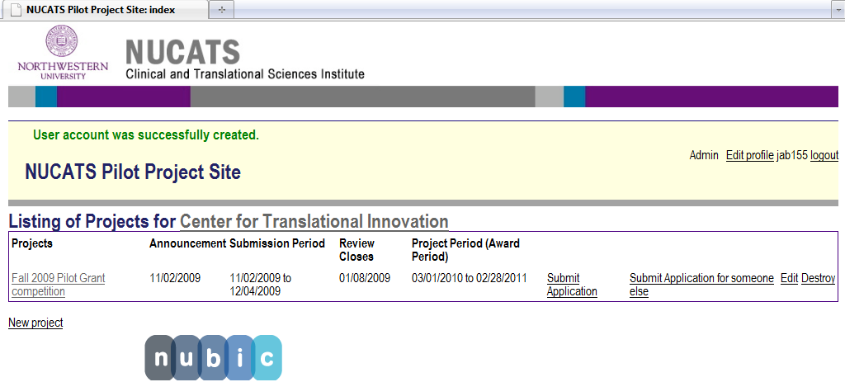

Step 2: Click on “Submit Application.” For first time users this will bring you first to your profile page (below). Your name, title and contact information will be pre-populated with information from the Northwestern directory. Please correct any inaccurate information and update blank fields. You must enter an NIH eCommons ID before an application will be accepted.

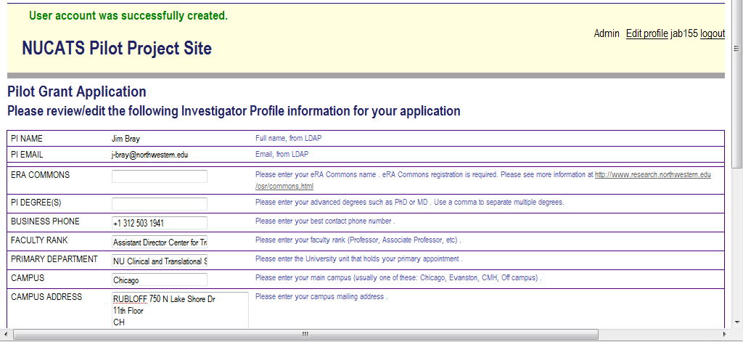

Note: You may also submit an application for someone else, which is useful for administrators. In this event you will be taken to a similar profile page that displays information associated with your netID. Simply enter in the netID of the PI and hit the “refresh” button to fill out a profile page for the PI.

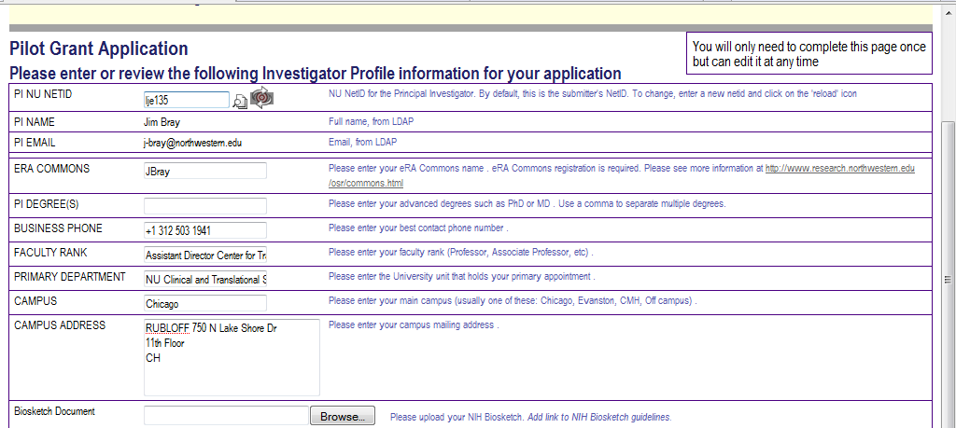

Step 3: Fill out the grant application page. For returning users, clicking on “submit an application” will take you directly to the project submission page. Please fill in all the requested information. Your research administrator and effort approver (Dept or Division Chair) netIDs are required. Click on the directory lookup icon to look them up in the NU directory (you must be using a computer on the NU network or logged into the NU VPN to access full directory information).

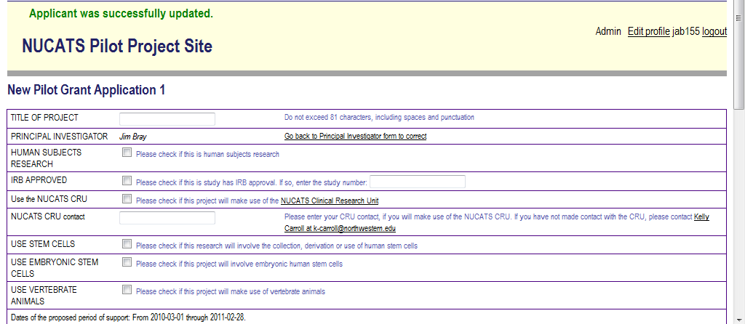
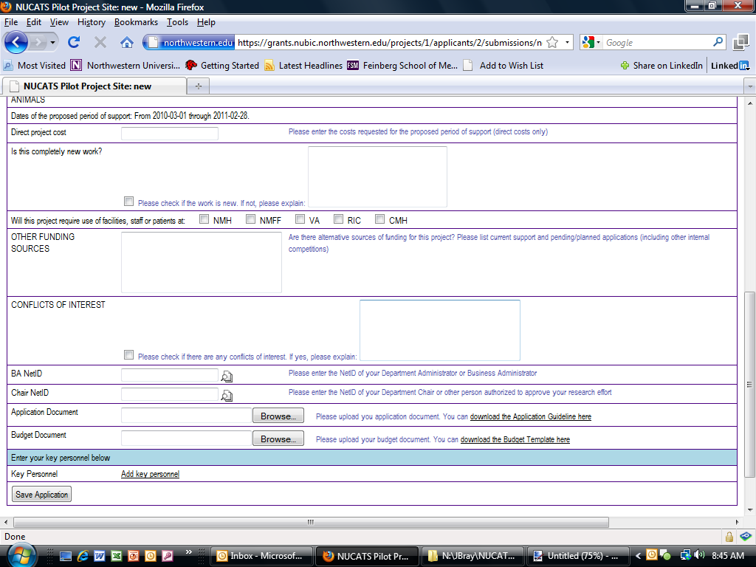

The main body and the budget pages of your proposal should be uploaded as separate documents. You can download the blank template forms by clicking on the links next to the upload buttons. Please follow the instructions for these sections. Failure to do so may delay review or be cause for rejection.

Step 4: Save your submission. You will be notified of any errors on the web based form (but not attachments). You can not submit the application until all errors are addressed but you may save and edit your application at any time.

Step 5: Submit your application. When your application is finalized, please click the submit button. You may be notified of deficiencies in the main body or budget section of the proposal in the days following submission. If necessary you may be asked to provide corrections/updates.

Step 6: Track your application progress. You may return to the site after the submission period has closed to track the progress of your application, including when it has been accepted as complete, when it is under review, and when the review process has finished. Note: the competition may not yet be finished when your reviews are complete – it may take several weeks to finalize/notify awardees.

Applicants will also be able to view reviewer comments after announcement of awardees. All awardees will be notified by phone or email. Unsuccessful applicants will be notified by email. Grant applications and reviewer comments will remain on the system until the user deletes them. NUCATS will provide ample advance notice to all users if this policy changes.

