**MLOPS Assignment 1 Report**

**Introduction**

Forked repository:

<https://github.com/tysam-code/hlb-CIFAR10>

Our repository:

<https://github.com/NUCES-ISB/i192014-i191976>

This repository contains code for training and testing convolutional neural networks (CNNs) on the CIFAR-10 dataset using the HLB (Hessian-based Line Search with BFGS) optimizer. The code is written in PyTorch, which is a popular deep learning framework.

**GitHub Actions**

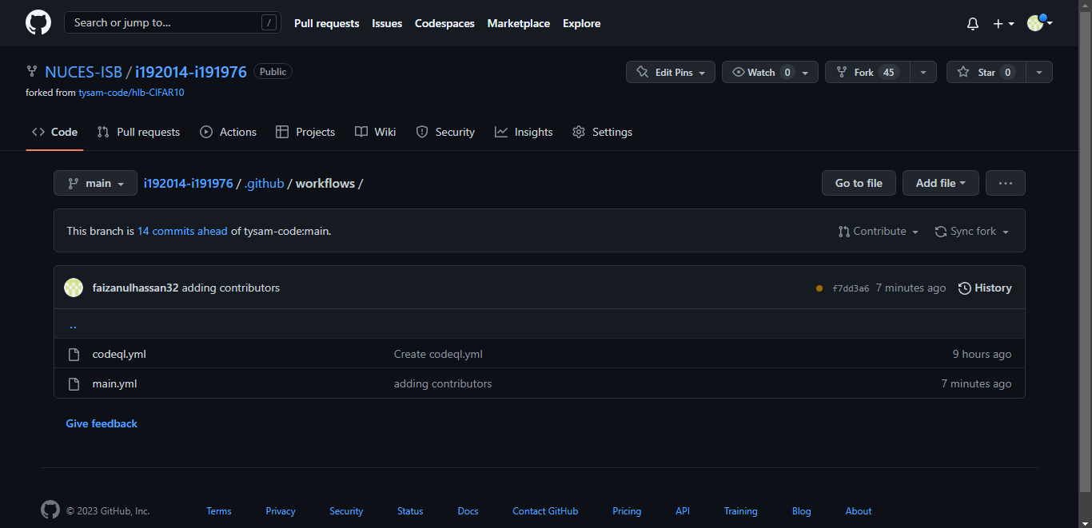

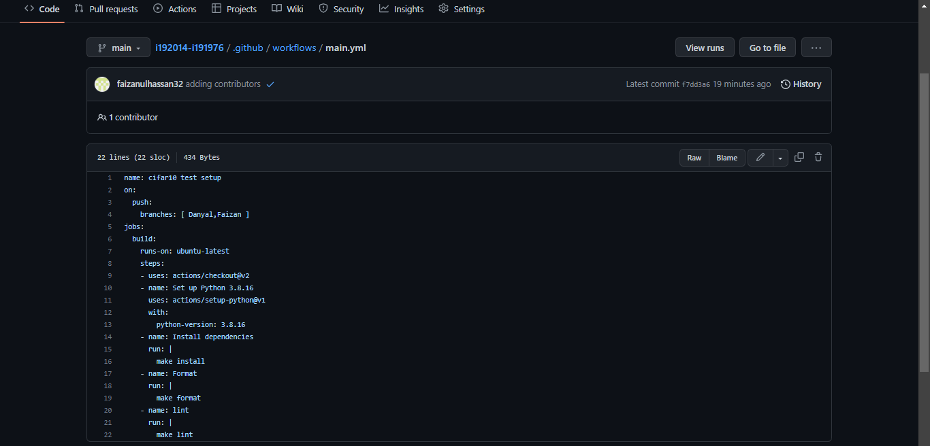

The above image is of yml file that resides in the main branch and we have added both members as collaborators so we can perform changes on both ends.

Moreover we have made different targets such as install dependencies, format and lint which would perform certain actions as shown below in the github actions tab.

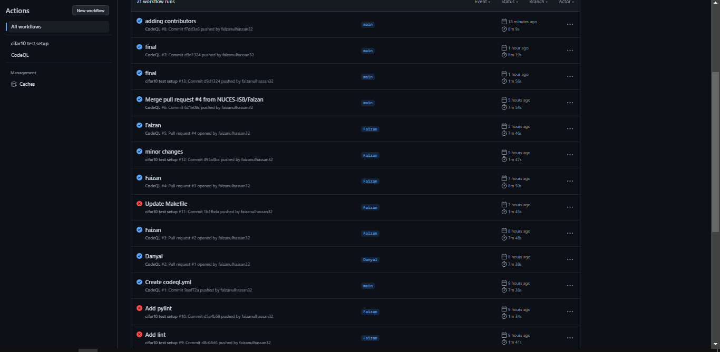

Here we can see that certain actions were failed in the beginning which were corrected and then the jobs in the yml file were passed successfully which is marked as a blue tick.