Final Exam

**Software Construction & Development Lab**

Course Instructor

**Ms. Zoya Sumbul**

Submitted By

|  |
| --- |
| **Riyaan Tariq** |
| **21i-1101** |

Section

**SE-P**

Date

**Wednesday, June 5, 2024**

Spring 2024



**Department of Software Engineering**

FAST – National University of Computer & Emerging Sciences

Islamabad Campus

# Final Exam

1. Github cloned

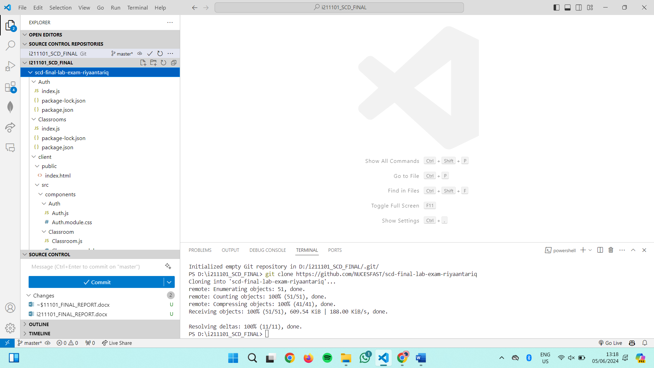

1. Dockerfiles created (port 1101 in client file, 11011, 11012,11013 in the following ones as 1101 is my roll number and 1,2,3 are added after)

