Dela cruz, Kurt David R.

BSIT – 3107

ACTIVITY 2

1. 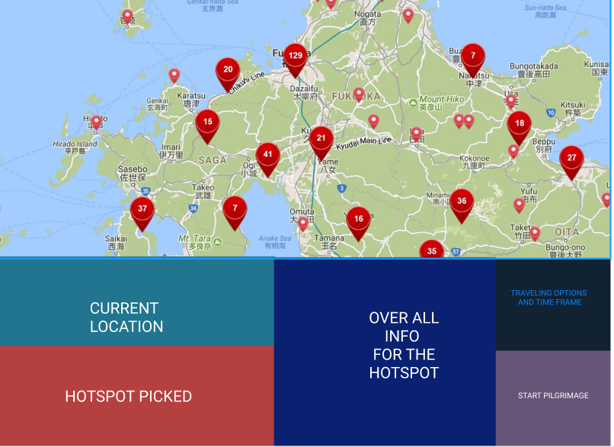

With this I Decided to create a automatic pilgrimage route finder and tracker. This product supposedly will use the users GPS to define his/her current location after that the product will automatically show hotspot of different pilgrim location in the area then upon clicking o the indicator of the hotspot it will show its general info the travelling options and time frame with relevance to the user’s current location and of course a directional guide until the user has arrived on the destination.

* In this activity I instinctively thought of other ways to travel then I thought “what are my previous experiences that made me say “well that’s a problem” “

1. With plants on the table all I can think of is appeal to the hearts and minds of those concern with the current condition of the earth. Selling plants tend to produce unwanted wastes like plastics and such by coordinating with the store I got in touch with into making their plant selling for environment friendly I can put in some good words they will surely stand atop more than most garden plant selling sites.
2. Effectiveness, memorability and utility. I would like to focus on these three for measuring its quality using usability goals. First effectiveness, as mentioned its task is to find, recommend and guide pilgrims to their dream pilgrimage location and that’s exactly how its process generally work, no more no less. Next is memorability, over all the product would only have six buttons and with each usage of a button it pops up exactly as it says without totally leaving the interface thus making very easy for the user to use understand and remember. Last will be utility, the product would only do three tasks locate suggest and navigate with this utility of the product is surely upheld. Then there’s the user experience goal, I would like to use satisfying to measure the products quality through user experience.