SCHOOL OF COMPUTER SCIENCE AND ARTIFICIAL INTELLIGENCE |  |  |  |  | DEPARTMENT OF COMPUTER SCIENCE ENGINEERING
Program Name: B. Tech |  |  |  | Assignment Type: Lab |  |  | Academic Year: 2025-26
Course Coordinator Name |  |  |  | Dr. Jagjit Singh Dhatterwal
Instructor(s) Name |  |  |  | Dr. Jagjit Singh Dhatterwal
Course Code |  |  | 21CS127 | Course Title |  | Blockchain Engineering
Year/Sem |  |  | III/II | Regulation |  | R22
Date and Day  of Assignment |  |  |  | Time(s)
Duration |  |  | 2 Hours | Applicable to  Batches
Assignment Number: 03/12
 | Q. No. | Question |  |  |  |  |  | Expected Time  to complete
 | 1 | Interacting with DeFi Protocols (Testnet)  Objective  To interact with a decentralized finance (DeFi) protocol on a blockchain testnet by writing and executing a smart contract that deposits and withdraws tokens, demonstrating basic DeFi operations without real funds.  Requirements  - Install Node.js and npm  - Install VS Code  - Install VS Code extensions:  - Solidity  - Hardhat  - Use a testnet (Sepolia / Goerli / Mumbai)  - Create a smart contract and a script to interact with a DeFi protocol (mock lending contract)  - Use functions for deposit and withdrawal  - Test interactions using test tokens  - Add inline comments explaining the logic  Tools & Technologies  - Solidity  - Hardhat  - JavaScript (Node.js)  - Ethereum Testnet (Sepolia)  - MetaMask (Testnet account)  Practical Description  In this practical, we simulate interaction with a DeFi protocol by creating a simple lending contract where:  - Users can deposit ETH  - Users can withdraw ETH  - Contract tracks balances internally  This represents how DeFi protocols like Aave or Compound work on testnets.

Code:

import tkinter as tk
from tkinter import messagebox
# -------------------------------
# Backend Logic
# -------------------------------
class MockDeFi:
def __init__(self):
self.balances = {}
def deposit(self, user, amount):
if amount <= 0: return False, "Enter valid deposit"
self.balances[user] = self.balances.get(user, 0) + amount
return True, f"Deposited {amount} ETH"
def withdraw(self, user, amount):
if user not in self.balances: return False, "No account found"
if self.balances[user] < amount: return False, "Insufficient balance"
self.balances[user] -= amount
return True, f"Withdrawn {amount} ETH"
def get_balance(self, user):
return self.balances.get(user, 0)
defi = MockDeFi()
current_user = ""
# -------------------------------
# Functions
# -------------------------------
def login():
global current_user
val = entry_user.get().strip()
if val == "":
messagebox.showerror("Connection Error", "Please enter a wallet address")
else:
current_user = val
label_user.config(text=f"Active Wallet: {current_user}", fg="#10b981")
status_label.config(text="Status: Wallet Connected", fg="#3b82f6")
update_balance()
def deposit_money():
if not current_user:
messagebox.showwarning("Access Denied", "Please CONNECT your wallet first")
return
try:
amount = float(entry_amount.get())
success, msg = defi.deposit(current_user, amount)
if success:
status_label.config(text=f"Status: {msg}", fg="#10b981")
entry_amount.delete(0, tk.END)
update_balance()
else:
messagebox.showwarning("Warning", msg)
except ValueError:
messagebox.showerror("Input Error", "Enter a valid numeric amount")
def withdraw_money():
if not current_user:
messagebox.showwarning("Access Denied", "Please CONNECT your wallet first")
return
try:
amount = float(entry_amount.get())
success, msg = defi.withdraw(current_user, amount)
if success:
status_label.config(text=f"Status: {msg}", fg="#ef4444")
entry_amount.delete(0, tk.END)
update_balance()
else:
messagebox.showwarning("Warning", msg)
except ValueError:
messagebox.showerror("Input Error", "Enter a valid numeric amount")
def update_balance():
balance = defi.get_balance(current_user)
label_balance.config(text=f"{balance:.4f} ETH")
# -------------------------------
# UI Utilities
# -------------------------------
def draw_gradient(event=None):
canvas.delete("gradient")
width = canvas.winfo_width()
height = canvas.winfo_height()
for i in range(height):
r = int(15 + (25 - 15) * (i / height))
g = int(23 + (35 - 23) * (i / height))
b = int(42 + (55 - 42) * (i / height))
color = f"#{r:02x}{g:02x}{b:02x}"
canvas.create_line(0, i, width, i, fill=color, tags="gradient")
canvas.tag_lower("gradient")
# -------------------------------
# Main Application
# -------------------------------
root = tk.Tk()
root.title("DeFi Simulator Pro - v2.0")
root.geometry("500x650")
canvas = tk.Canvas(root, highlightthickness=0)
canvas.pack(fill="both", expand=True)
canvas.bind("<Configure>", draw_gradient)
# Card UI Layout [cite: 93-94]
card = tk.Frame(canvas, bg="#1e293b", padx=20, pady=20)
card.place(relx=0.5, rely=0.5, anchor="center", width=340, height=520)
# Balance Display [cite: 96-101]
tk.Label(card, text="TOTAL ASSETS", font=("Arial", 9, "bold"), bg="#1e293b", fg="#94a3b8").pack()
label_balance = tk.Label(card, text="0.0000 ETH", font=("Arial", 28, "bold"), bg="#1e293b", fg="#10b981")
label_balance.pack(pady=(5, 25))
# Wallet Section [cite: 103-117]
tk.Label(card, text="WALLET ADDRESS", font=("Arial", 7, "bold"), bg="#1e293b", fg="#64748b").pack()
entry_user = tk.Entry(card, bg="#0f172a", fg="white", insertbackground="white", relief="flat", width=30, justify="center", font=("Courier", 10))
entry_user.pack(pady=5, ipady=8)
btn_connect = tk.Button(card, text="CONNECT WALLET", command=login, bg="#3b82f6", fg="white", font=("Arial", 9, "bold"), relief="flat", width=26, cursor="hand2")
btn_connect.pack(pady=(5, 10))
label_user = tk.Label(card, text="Active Wallet: None", font=("Arial", 8), bg="#1e293b", fg="#94a3b8")
label_user.pack()
tk.Frame(card, height=1, width=280, bg="#334155").pack(pady=25)
# Transaction Section [cite: 121-138]
tk.Label(card, text="TRANSACTION AMOUNT (ETH)", font=("Arial", 7, "bold"), bg="#1e293b", fg="#64748b").pack()
entry_amount = tk.Entry(card, bg="#0f172a", fg="white", insertbackground="white", relief="flat", width=25, justify="center", font=("Arial", 14, "bold"))
entry_amount.pack(pady=8, ipady=10)
btn_frame = tk.Frame(card, bg="#1e293b")
btn_frame.pack(pady=10)
tk.Button(btn_frame, text="DEPOSIT", command=deposit_money, bg="#10b981", fg="white", font=("Arial", 10, "bold"), relief="flat", width=12, height=2, cursor="hand2").grid(row=0, column=0, padx=8)
tk.Button(btn_frame, text="WITHDRAW", command=withdraw_money, bg="#ef4444", fg="white", font=("Arial", 10, "bold"), relief="flat", width=12, height=2, cursor="hand2").grid(row=0, column=1, padx=8)
# Dynamic Status Bar
status_label = tk.Label(card, text="Status: Awaiting Connection", font=("Arial", 8, "italic"), bg="#1e293b", fg="#64748b")
status_label.pack(pady=(20, 0))
root.mainloop()

Output:
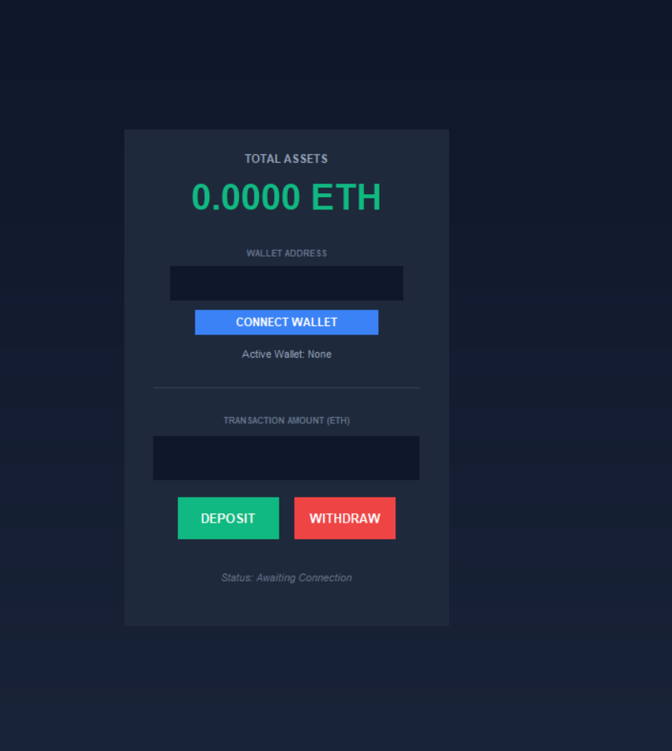

Output 2 :
