SCHOOL OF COMPUTER SCIENCE AND ARTIFICIAL INTELLIGENCE |  |  |  | DEPARTMENT OF COMPUTER SCIENCE ENGINEERING
Program Name: B. Tech |  |  | Assignment Type: Lab |  | Academic Year: 2025-26
Course Coordinator Name |  |  | Dr. Jagjit Singh Dhatterwal
Instructor(s) Name |  |  | Dr. Jagjit Singh Dhatterwal
Course Code |  | 21CS127 | Course Title | Blockchain Engineering
Year/Sem |  | III/II | Regulation | R22
Date and Day  of Assignment |  |  | Time(s)
Duration |  | 2 Hours | Applicable to Batches
Assignment Number: 1/12
Q. No. | Question |  |  |  | Expected Time  to complete
1 | Exploring Layer 2 – Testnet Objective  To understand and explore Layer 2 blockchain networks by deploying and interacting with a simple smart contract on a Layer 2 Testnet (e.g., Polygon Mumbai / Arbitrum Sepolia), and observe reduced gas fees and faster transactions compared to Layer 1.  Requirements  - Basic understanding of blockchain and smart contracts  - MetaMask wallet installed (browser extension)  - Testnet ETH/MATIC from faucet  - VS Code (with Solidity extension installed)  - Node.js and npm installed  - Hardhat development framework  Tools & Technologies Used  - Blockchain Type: Layer 2 Testnet  - Network: Polygon Mumbai Testnet (or Arbitrum Sepolia)  - Language: Solidity  - Framework: Hardhat  - Wallet: MetaMask  Execution Key is:- 0x742d35Cc6634C0532925a3b844Bc454e4438f44e

Code:
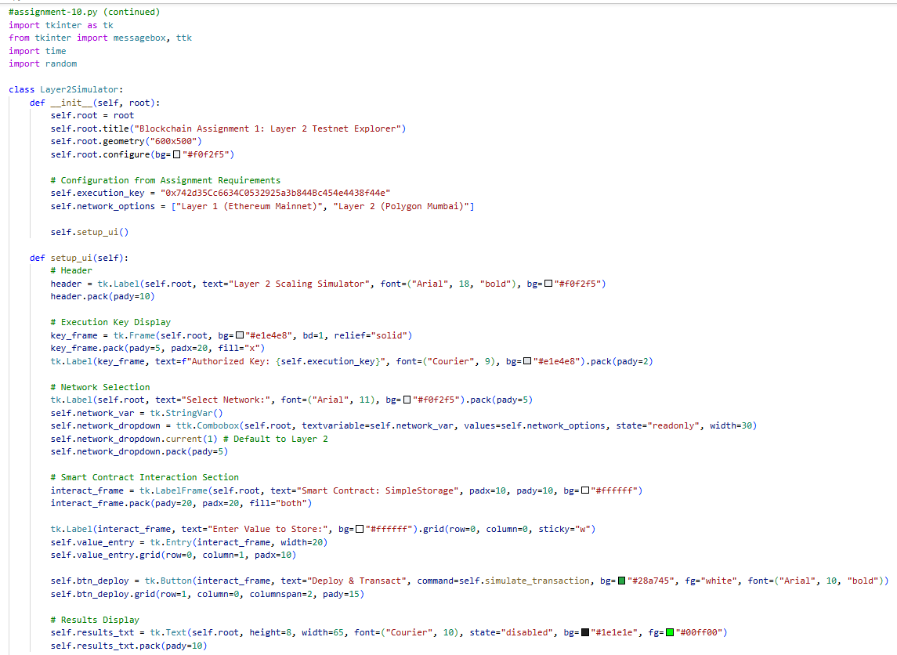
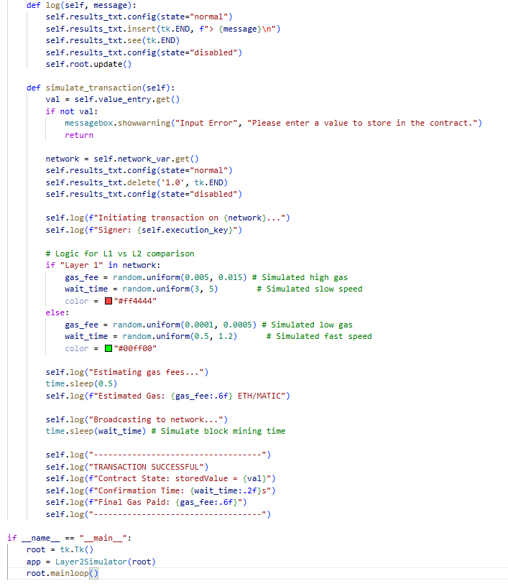

Output:

