**Current Issues in Cities and Suburbs**

**Kayleigh Ward**

**Spatial Mapping with Tableau: Installing the Software**

This handout details how to install the Tableau software, which is a data-visualization creating software, specifically for mapping and data analytics.

Tableau is a part of the Salesforce product suite, but it is available for **free** to .edu email accounts. Please follow the links below: you will need to input your .edu email address as well as “Northeastern University”

**For Students:** <https://www.tableau.com/academic/students>

**For Instructors**: <https://www.tableau.com/academic/teaching>

You will receive an email with:

* a key that can be used to activate Tableau **twice**
* links to download Tableau

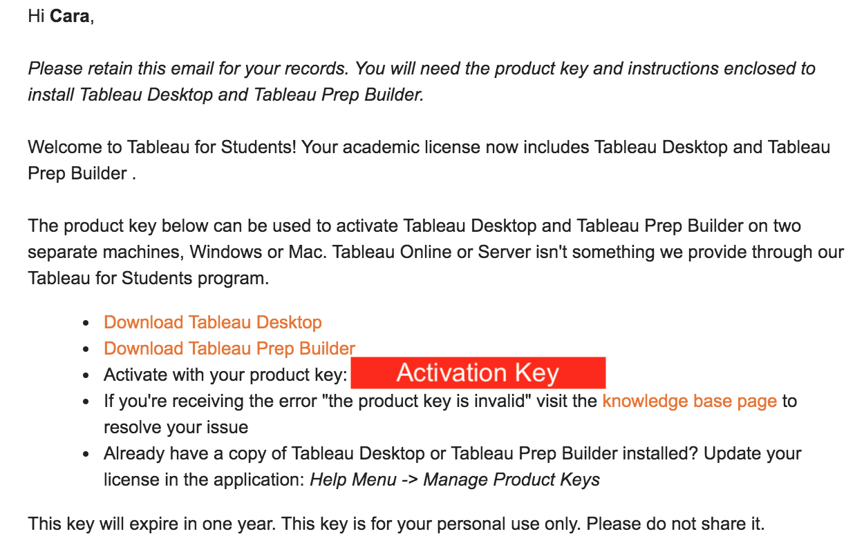

Download Tableau as you would any other software on your operating system and input the activation key provided in your email when prompted.

Once downloaded, install Tableau as you would any other software on your operating system. When it asks for a “free trial,” click the top that says you have a product key input the key provided in the email when prompted.