**Qualitative Coding with NVivo: Installing the Software**

This is an illustrated step-by-step guide on how to install the qualitative coding software NVivo, available for **free** for all Northeastern University students.

1. Go to the link <https://prod-web.neu.edu/wasapp/SoftwareDistribution/secure/index.jsp>
2. Log into your myNortheastern account when prompted (you can also reverse the order of steps 1 and 2).
3. Scroll down and select Nvivo_12 for either Mac or Windows depending on your operating system. 
4. Read the License Agreement and click ‘Accept.’
5. Select ‘Installer’ and click ‘Continue’ 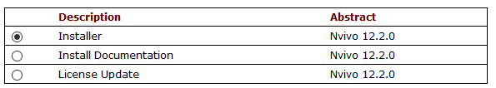
6. Click ‘Download.’ You will need to input the **license key** during installation, so leave this page open, print it out, write down the key, or take a picture/screenshot of it, or copy/paste it.
7. Install the NVivo file you downloaded as you would any other application and input the license key when prompted.