№ 8 Laboratory work. VLAN technology, network segmentation and configuration.

Purpose of the work: to create a network consisting of two independent virtual subnets
- VLAN – Virtual local area network
- Switch within a switch. VLAN helps to combine computers into a single network at the link level, even if they are physically connected to different switches. (2-OSI layer)
Advantages:
- Helps to structure the network
- Used to ensure security
- Used for aggregation
- Reduces the amount of broadcast traffic

Port types:
- • Access Port-for connecting end devices
- • Trunk port-for connections between switches
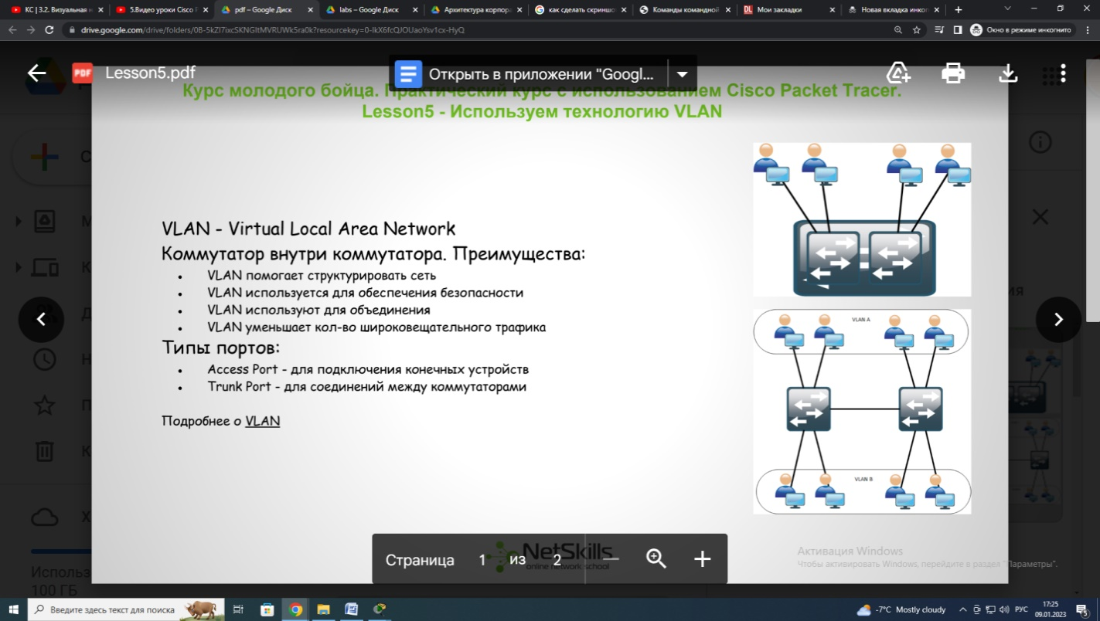
Single Switch Circuit:
1. Create VLAN
2. Define Access Ports
Two Switch Circuit:
1. Create VLAN
2. Define Access Ports
3. Define Trunk Ports
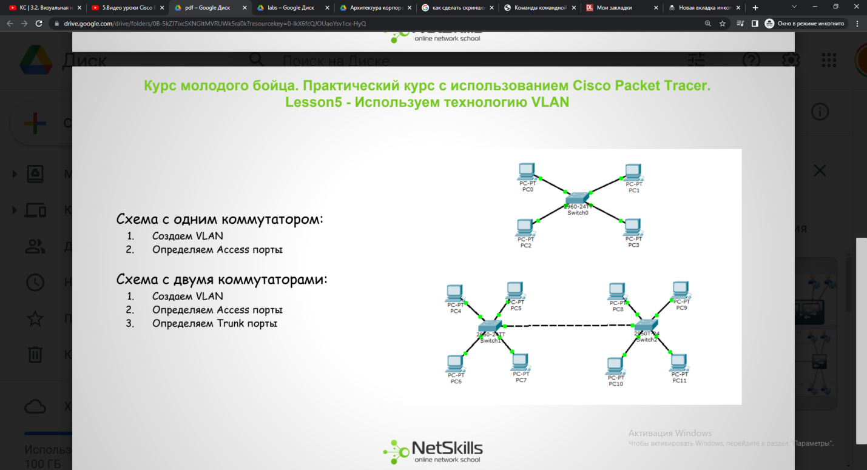

VLANs can only be configured on managed switches, which can be accessed remotely via the console or using protocols such as Telnet/SSH. Or using a web interface or specialized software.
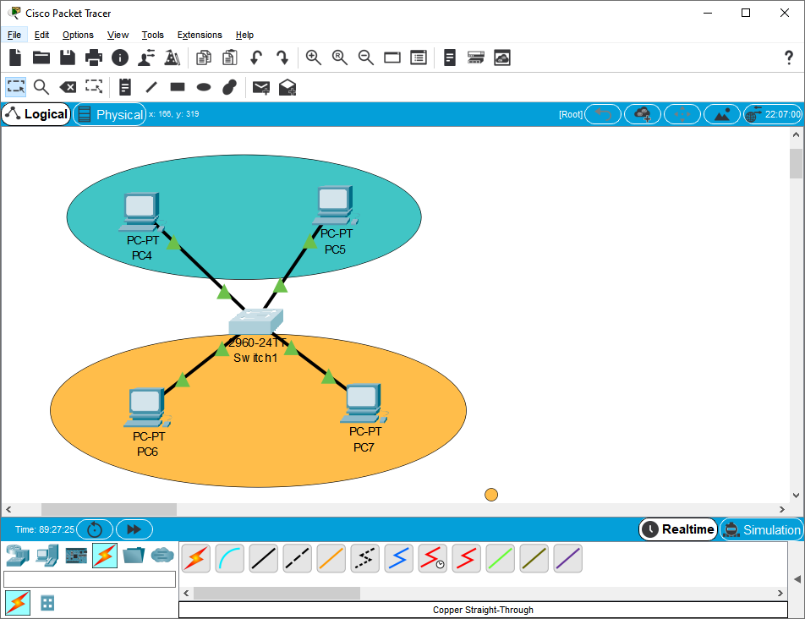
Fig. 9.1 VLAN scheme

We assemble the circuit as in the picture and enter the switch console.
We enter the privileged mode. Then the global configuration mode.
We need to define VLAN in which there will be data users.
By default, all switch ports are located in VLAN-1, we need to define them in another. To do this, first create VLAN-2, give it a name and proceed to setting up interfaces. To do this, we move the mouse to the connection and see which switch ports the PC is connected to. Accordingly, we need to define these ports in the newly created VLAN. To do this, we go into the settings of the fastethernet0/1 interface, determine whether this port operates in access mode.
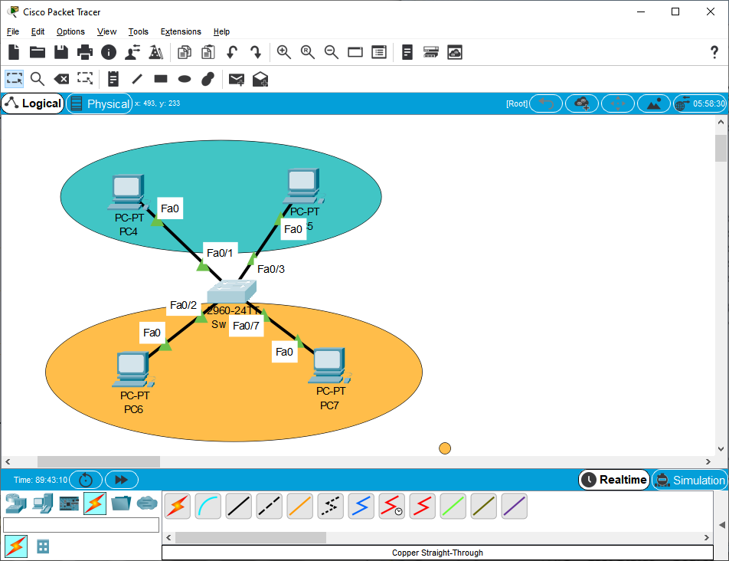
Fig. 9.2 Switch ports
Switch>en
Switch#conf t
Enter configuration commands, one per line. End with CNTL/Z.
Switch(config)#
Switch(config)#vlan 2
Switch(config-vlan)#
Switch(config-vlan)#name buh
Switch(config-vlan)#exit
Switch(config)#
Switch(config)#int
Switch(config)#interface fa
Switch(config)#interface fastEthernet 0/1
Switch(config-if)#swi
Switch(config-if)#switchport mod
Switch(config-if)#switchport mode ac
Switch(config-if)#switchport mode access
Switch(config-if)#sw
Switch(config-if)#switchport acc
Switch(config-if)#switchport access vl
Switch(config-if)#switchport access vlan 2
Switch(config-if)#
Switch(config-if)#exit
Switch(config)#

Switch(config)#int fa0/3
Switch(config-if)#sw
Switch(config-if)#switchport mo
Switch(config-if)#switchport mode acc
Switch(config-if)#switchport mode access
Switch(config-if)#sw
Switch(config-if)#switchport acc
Switch(config-if)#switchport access vlan 2
Switch(config-if)#
Switch(config-if)#end
Switch#
%SYS-5-CONFIG_I: Configured from console by console

Switch#

You can verify the work done using the show VLAN command. Here we can see that the first default vlan is present on all Cisco switches, fa0/1, and is displayed on all other ports except fa0/3.
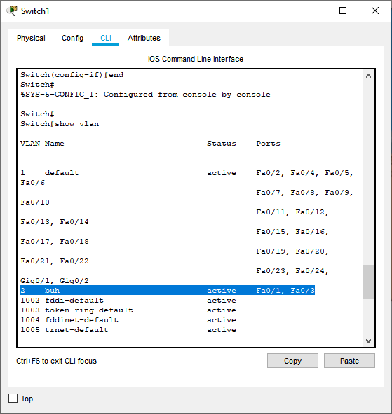
Fig. 9.3 show VLAN command

Switch>en
Switch#conf t
Enter configuration commands, one per line. End with CNTL/Z.
Switch(config)#vl
Switch(config)#vlan 3
Switch(config-vlan)#name users
Switch(config-vlan)#exit
Switch(config)#int
Switch(config)#interface fa0/2
Switch(config-if)#sw
Switch(config-if)#switchport mo
Switch(config-if)#switchport mode acc
Switch(config-if)#switchport mode access
Switch(config-if)#sw
Switch(config-if)#switchport ac
Switch(config-if)#switchport access vlan 3
Switch(config-if)#exit
Switch(config)#int fa0/7
Switch(config-if)#sw
Switch(config-if)#switchport mo
Switch(config-if)#switchport mode ac
Switch(config-if)#switchport mode access
Switch(config-if)#sw
Switch(config-if)#switchport ac
Switch(config-if)#switchport access vl
Switch(config-if)#switchport access vlan 3
Switch(config-if)#end
Switch#
%SYS-5-CONFIG_I: Configured from console by console

Switch#show vlan brief
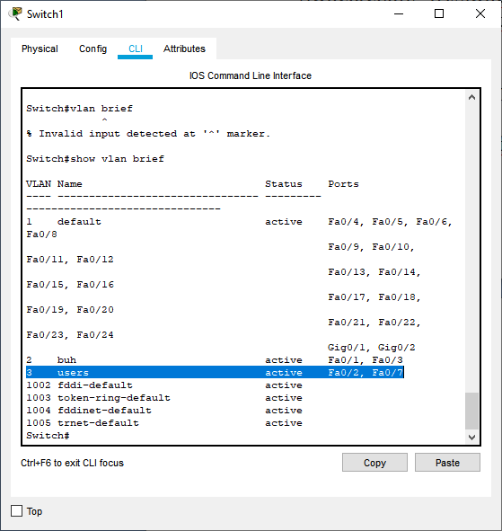
Fig. 9.4 Creating a VLAN

PC->Desktop->IP Configuration
Show the vlan number in the second octet of the IP address.

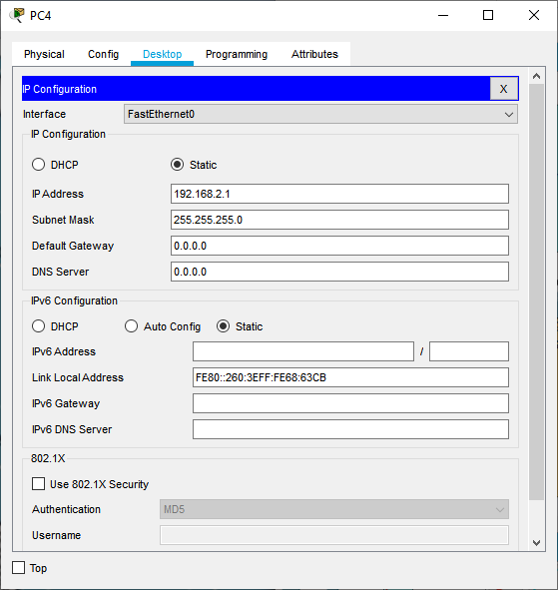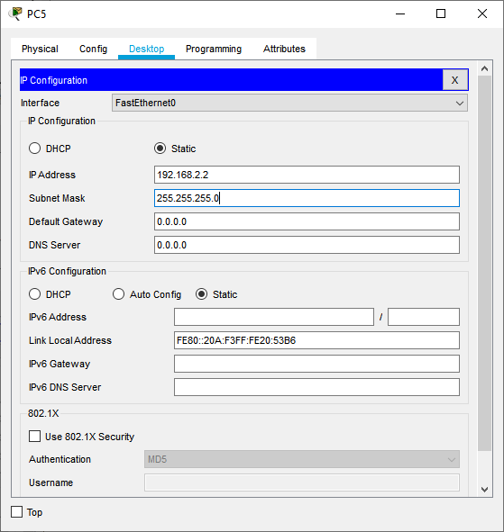
Fig. 9.5 Assigning IP addresses
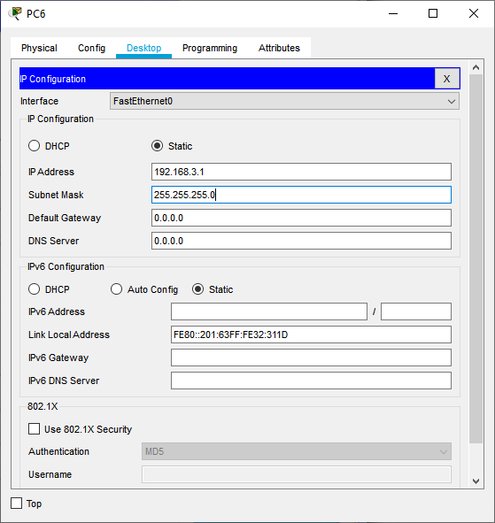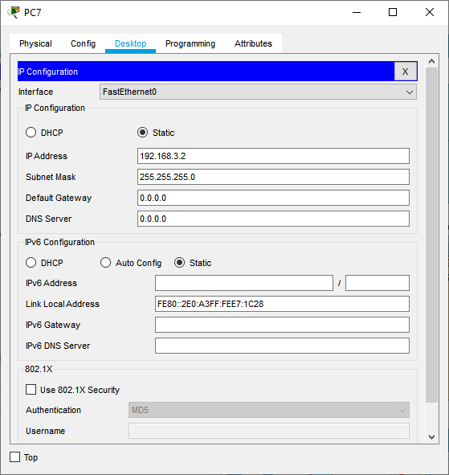
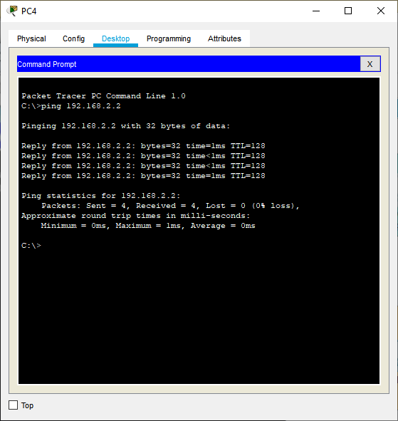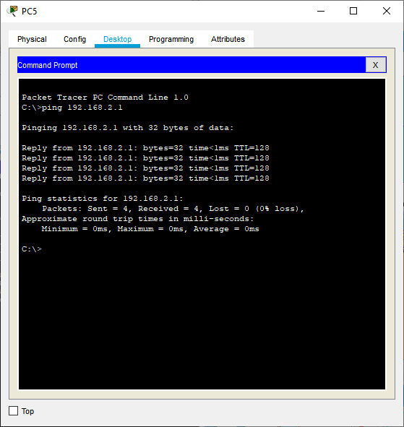
Fig. 9.6 Checking the connection
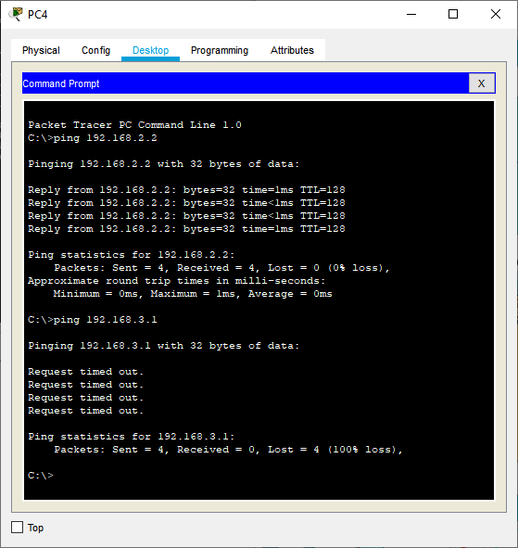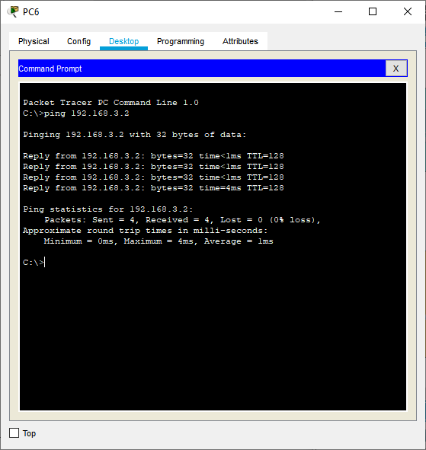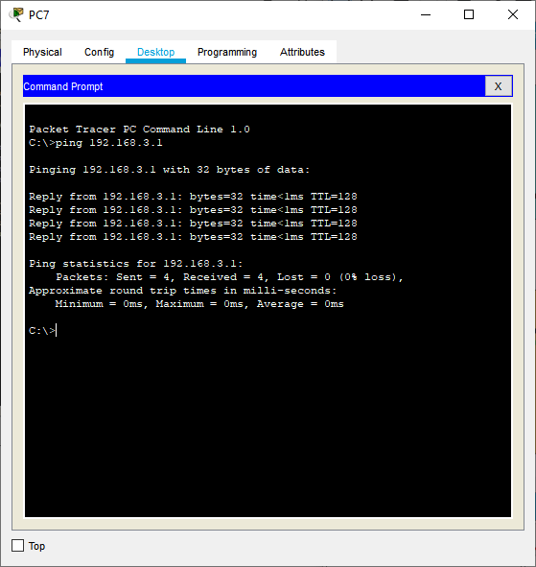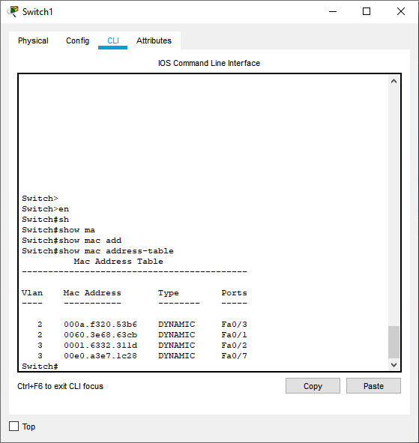
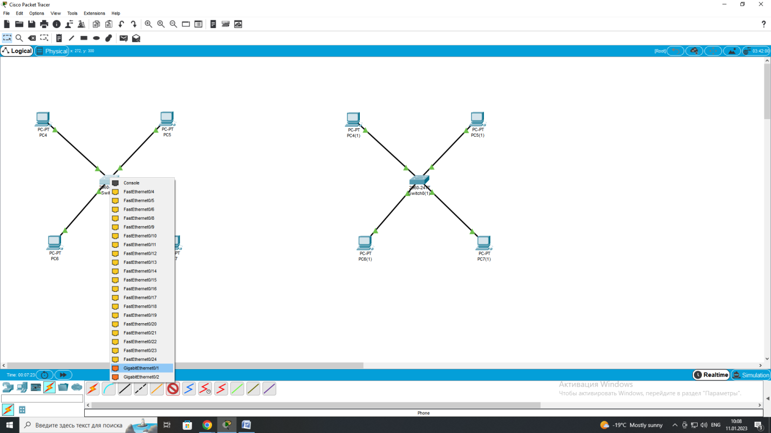
Fig. 9.7 Circuit with two switches
It is best to use the most productive ports to connect switches.
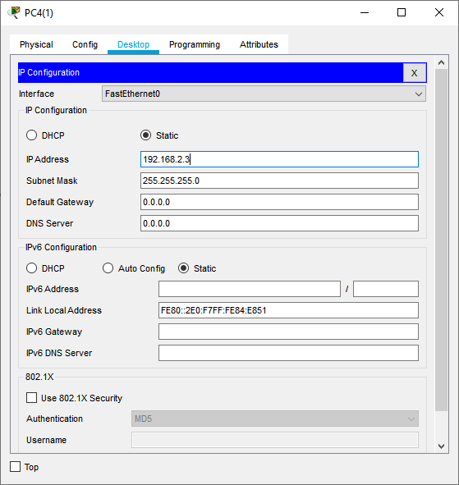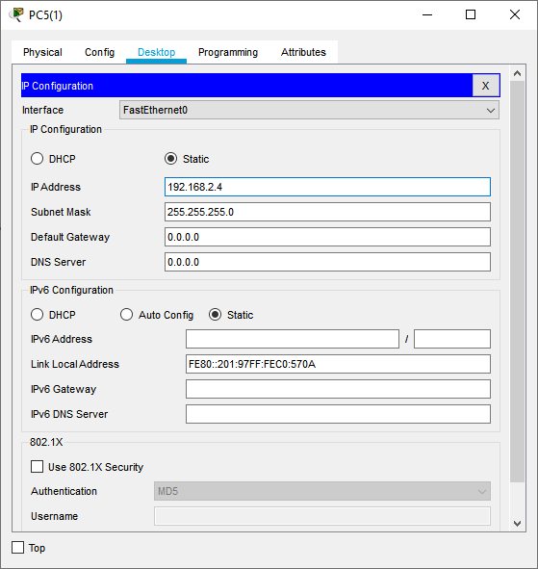
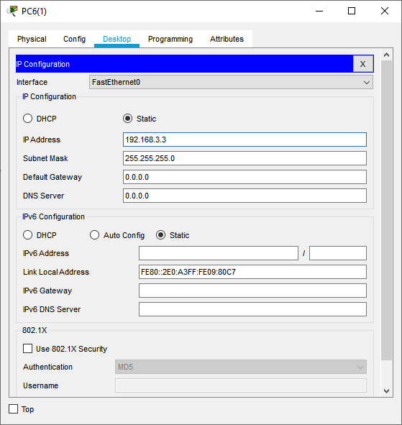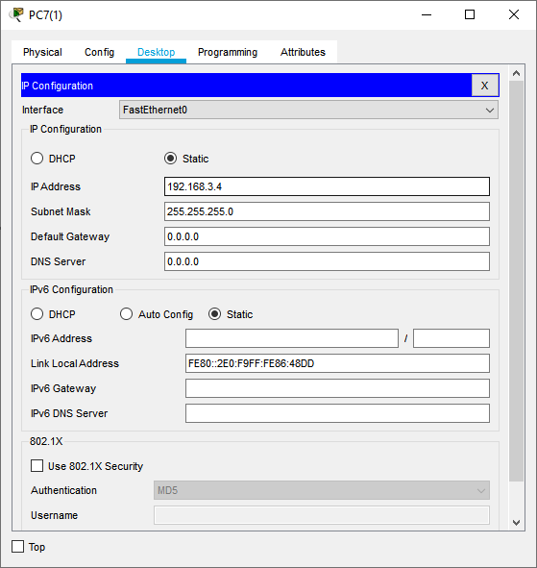
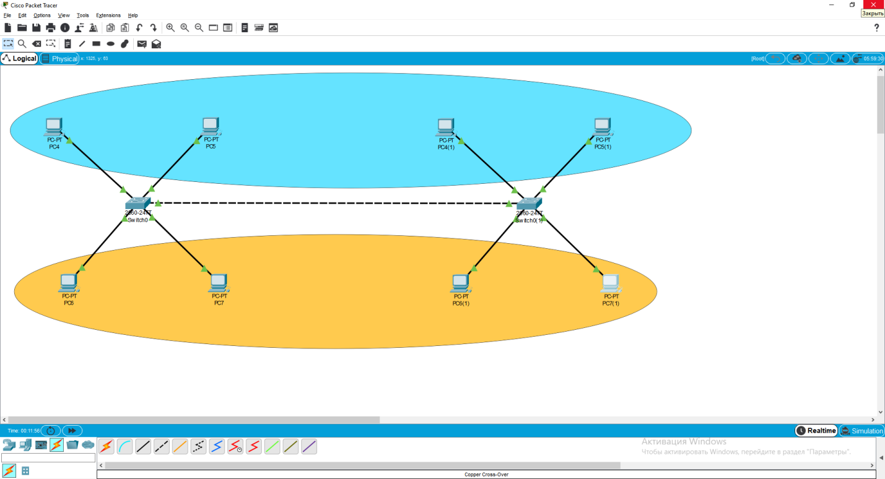
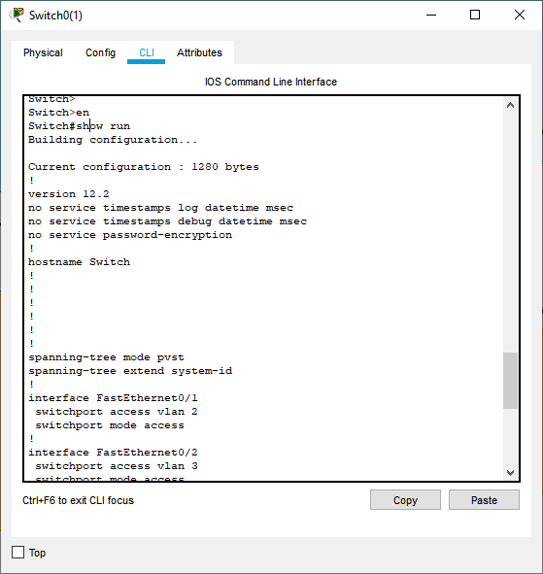

Now we need to set up a Trunk port. A Trunk port allows us to divide a physical connection into multiple segments. We will use Gigabit Ethernet as a Trunk port.
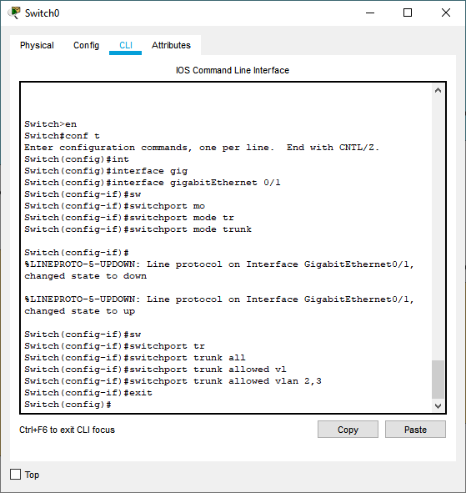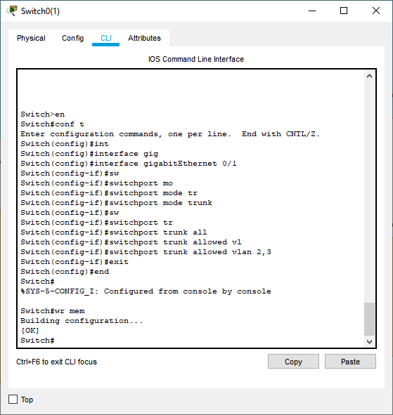
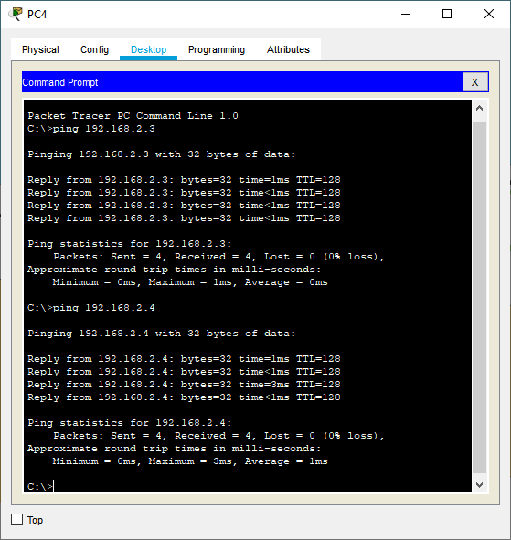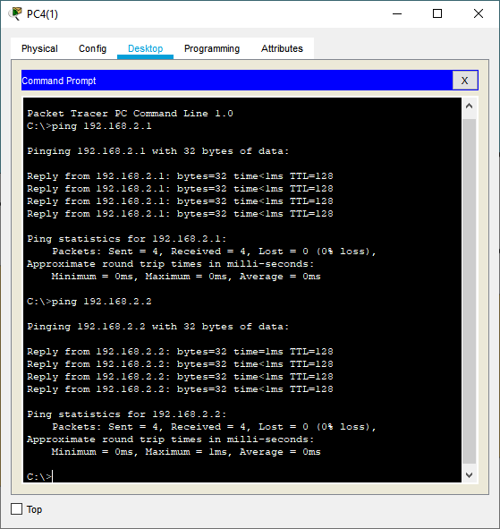
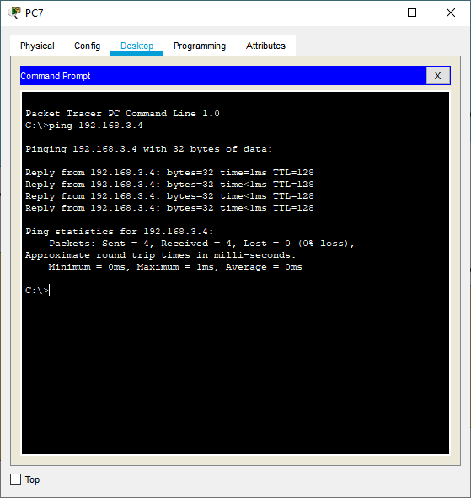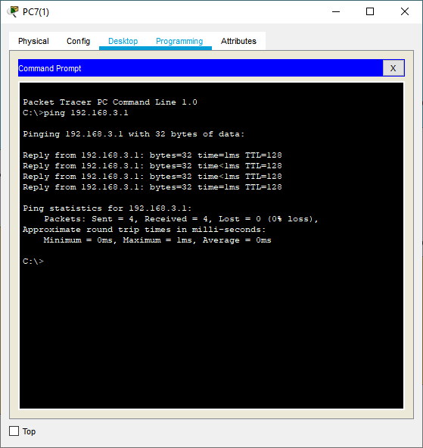
We will remove the Trunk Port from VLAN 3 and try to ping VLAN 3.
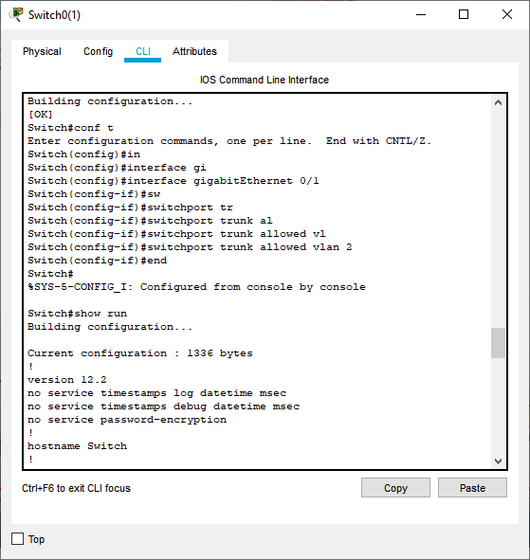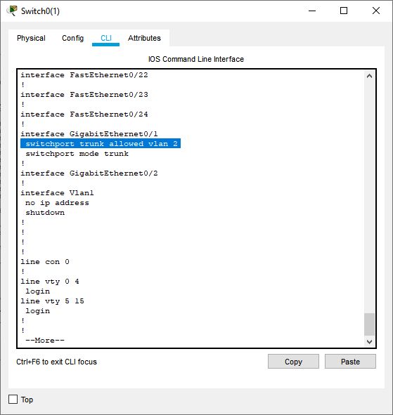
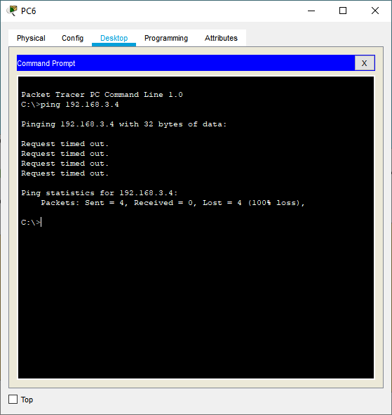

Laboratory work 9. Reconfiguring VLANs for security and segmentation.

Purpose of the work: Create VLAN on the switch, configure IP addresses and check the connection between PCs on different VLANs.

Solution: 1. On the switch, create a VLAN: Switch# vlan 10 Switch# vlan 20

1. Assign ports to appropriate VLANs:
- VLAN 10: PC1, PC2
- VLAN 20: PC3, PC4
- Layer 2 switch connects to Router-on-a-Stick for inter-VLAN routing.

2. Creating a VLAN on a Switch
Switch# configure terminal
Switch(config)# vlan 10
Switch(config-vlan)# name VLAN10
Switch(config-vlan)# vlan 20
Switch(config-vlan)# name VLAN20
Switch(config-vlan)# exit

3. Assigning PC ports to appropriate VLANs
- PC1 and PC2 → VLAN 10 (fa0/1, fa0/2)
- PC3 and PC4 → VLAN 20 (fa0/3, fa0/4)

Switch# interface range fa0/1 - 2
Switch(config-if)# switchport mode access
Switch(config-if)# switchport access vlan 10
Switch(config-if)# exit

Switch# interface range fa0/3 - 4
Switch(config-if)# switchport mode access
Switch(config-if)# switchport access vlan 20
Switch(config-if)# exit

4. Setting up a trunk between a switch and a router
Port gig0/1 on the switch connects to the router. We make it a trunk to transmit traffic of both VLANs.
Switch# interface gig0/1
Switch(config-if)# switchport mode trunk
Switch(config-if)# switchport trunk allowed vlan 10,20
Switch(config-if)# exit

5. Configuring a Router for VLAN (Router-on-a-Stick)
On the router, we create subinterfaces for VLAN 10 and VLAN 20:
Router# configure terminal
Router(config)# interface gig0/1.10
Router(config-subif)# encapsulation dot1Q 10
Router(config-subif)# ip address 192.168.10.1 255.255.255.0
Router(config-subif)# exit

Router(config)# interface gig0/1.20
Router(config-subif)# encapsulation dot1Q 20
Router(config-subif)# ip address 192.168.20.1 255.255.255.0
Router(config-subif)# exit

Router(config)# exit

6. Setting up IP addresses on PCs
On each PC, manually set the IP address and gateway:

VLAN 10 (192.168.10.0/24)
PC1: 192.168.10.2 / 255.255.255.0, Gateway: 192.168.10.1
PC2: 192.168.10.3 / 255.255.255.0, Gateway: 192.168.10.1
VLAN 20 (192.168.20.0/24)
PC3: 192.168.20.2 / 255.255.255.0, Gateway: 192.168.20.1
PC4: 192.168.20.3 / 255.255.255.0, Gateway: 192.168.20.1

7. Checking the settings

Checking the VLAN on the switch

- Switch# show vlan brief

VLAN | Name | Status | Ports
10 | VLAN10 | active | Fa0/1, Fa0/2
20 | VLAN20 | active | Fa0/3, Fa0/4

Checking the trunk

- Switch# show interfaces trunk

Checking IP interfaces on the router

- Router# show ip interface brief

Connection test
On PC1 (192.168.10.2) we execute:

- ping 192.168.20.2

Here is a step-by-step description of the diagram:
1 Devices:
- 1 x Router (2811 / 1941)
- 1 x Switch (2960 / 2950)
- 4 x PC (PC-PT)
2 Connections:
- PC1 → Fa0/1 (Switch)
- PC2 → Fa0/2 (Switch)
- PC3 → Fa0/3 (Switch)
- PC4 → Fa0/4 (Switch)
- Switch (Gig0/1) → Router (Gig0/0) (cable "copper straight-through")
3 VLAN and Routing Configuration
- VLAN 10: PC1 и PC2
- VLAN 20: PC3 и PC4
- Trunk between Switch (Gig0/1) ↔ Router (Gig0/0)
- Subinterfaces on router for VLAN 10 и VLAN 20

№ 10 Laboratory work. VLAN and Network Security.
Purpose of the work: Study and practical application of VLAN technologies to improve network security, as well as setting up basic measures to protect network equipment.
Equipment and software:
• Cisco Packet Tracer or real network equipment.
• One Cisco switch (for example, 2960).
• Two PCs (PC1 and PC2) connected to different VLANs.
• One router (optional, for inter-VLAN routing).
• Connecting cables.

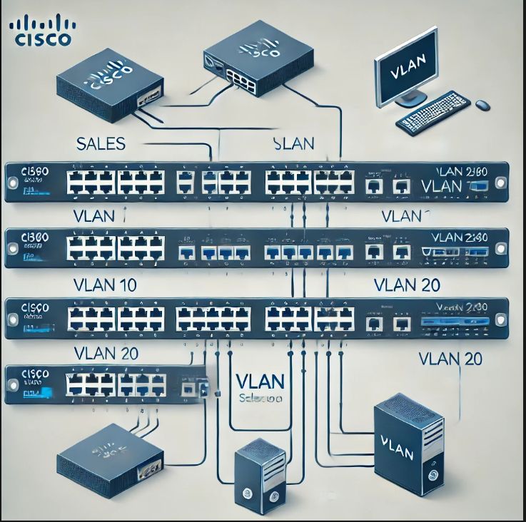
Fig. 10.1 VLAN scheme

1. Setting up VLAN

Creat VLAN:
Switch# configure terminal
Switch(config)# vlan 10
Switch(config-vlan)# name Sales
Switch(config-vlan)# exit
Switch(config)# vlan 20
Switch(config-vlan)# name IT
Switch(config-vlan)# exit

Assigning VLANs to Ports:
Switch(config)# interface FastEthernet0/1
Switch(config-if)# switchport mode access
Switch(config-if)# switchport access vlan 10
Switch(config-if)# exit

Switch(config)# interface FastEthernet0/2
Switch(config-if)# switchport mode access
Switch(config-if)# switchport access vlan 20
Switch(config-if)# exit

2. Setting up a trunk port
Switch(config)# interface FastEthernet0/24
Switch(config-if)# switchport mode trunk
Switch(config-if)# switchport trunk allowed vlan 10,20
Switch(config-if)# exit

3. Checking the connection
- Assign IP addresses to devices in the appropriate VLANs.
- Use the ping command to test connectivity.
- Expected result: PCs in one VLAN should not be able to ping devices in another VLAN.

4. Configuring VLAN Security
- Disabling unused ports:
Switch(config)# interface range FastEthernet 0/3-23
Switch(config-if-range)# shutdown
- Enabling Port Security:
Switch(config)# interface FastEthernet0/1
Switch(config-if)# switchport port-security
Switch(config-if)# switchport port-security maximum 2
Switch(config-if)# switchport port-security violation restrict
Switch(config-if)# exit

5. Setting up access protection

Setting a password for privileged mode:
Switch(config)# enable secret strongpassword

Console Access Protection:
Switch(config)# line console 0
Switch(config-line)# password consolepass
Switch(config-line)# login
Switch(config-line)# exit

Protecting virtual terminals (Telnet/SSH):
Switch(config)# line vty 0 4
Switch(config-line)# password vtypass
Switch(config-line)# login
Switch(config-line)# exit

Enabling password encryption:
Switch(config)# service password-encryption

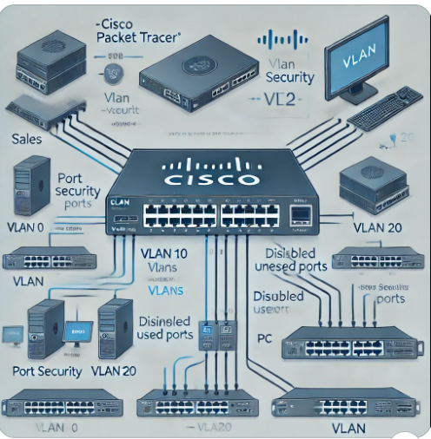

Laboratory work 11. Elimination of loops using STP (Spanning Tree Protocol).

Objective: to create a fault-tolerant Ethernet network using the spanning tree protocol

Let's imagine that we have 2 layers, switch 1 is located at layer 1, and the second at layer 2. We need to combine these two layers into one local area network. To do this, we need to connect these two switches via a link/communication channel. If we use only one connection, then in the event of any problems with this channel, we will not be able to quickly restore the network. For this, backup links are used.

Methods for organizing fault-tolerant communication channels:
• Link redundancy. Traditional redundant topology. --- If we have 2 links, only one of them is working. And the second is in reserve.
• Channel aggregation - combining several physical channels into one logical one.
Switching cycle. Problems caused by:
• Broadcast storms
• Multiple frame copies
• Multiple loops
Spanning Tree Protocol (STP):
• Layer 2 PROTOCOL of the OSI model
• Protection against loops in the network
• Automatic channel reservation
• Convergence time 30-50 seconds
• Alternatives: RSTP, MSTP (less than a second)
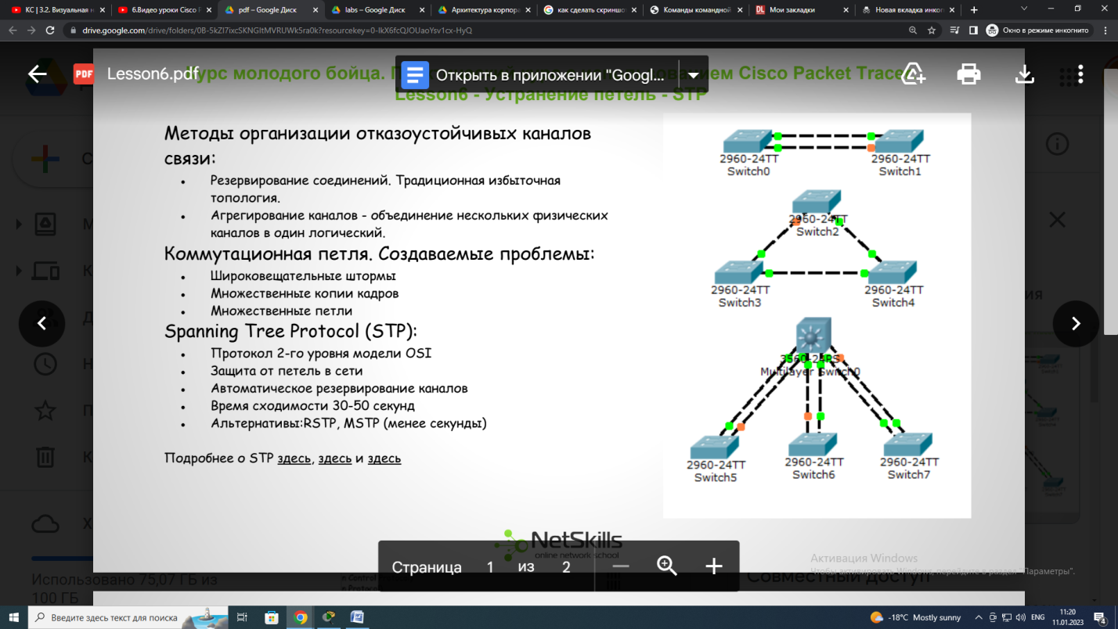
Operation algorithm:
1. Root Bridge is selected
The root switch ports become designated/projected ports and enter the transport state. All root switch ports receive and transmit packets.
2. Non-root root port is selected
switch
3. Destination port selection
Port states:
1. Blocking
2. Listening
3. Learning
4. Forwarding
Basic commands:
• spanning-tree vlan X priority
• spanning-tree vlan X root primary
• spanning-tree mode rapid-pvst

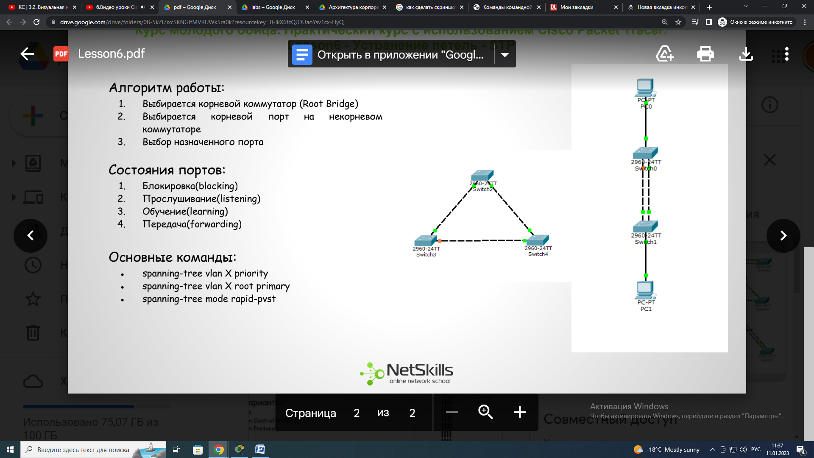
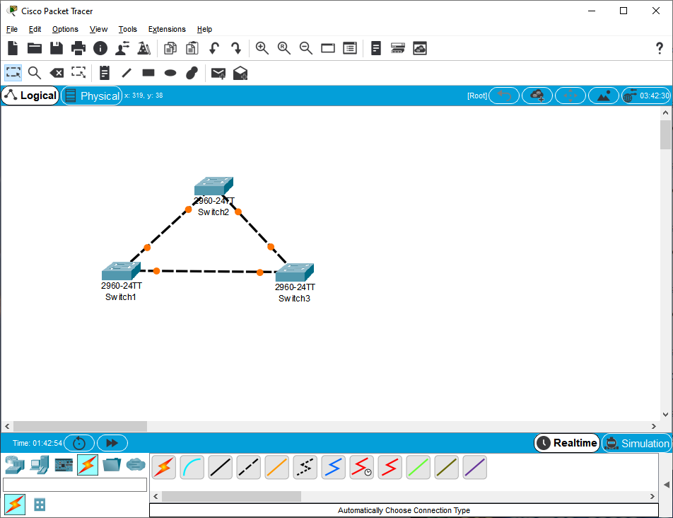
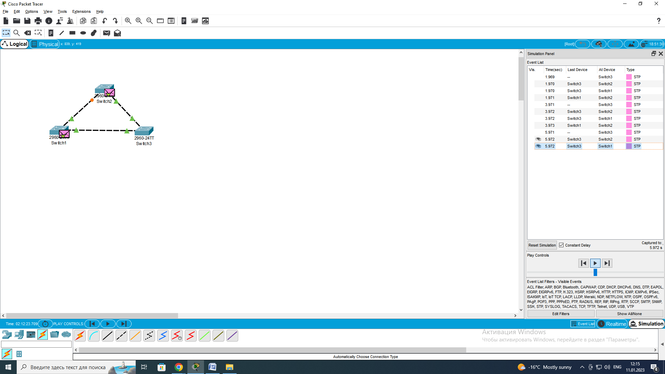

To determine which switch is the root, go to the switch console and check

Switch>en
Switch#show spa
Switch#show spanning-tree
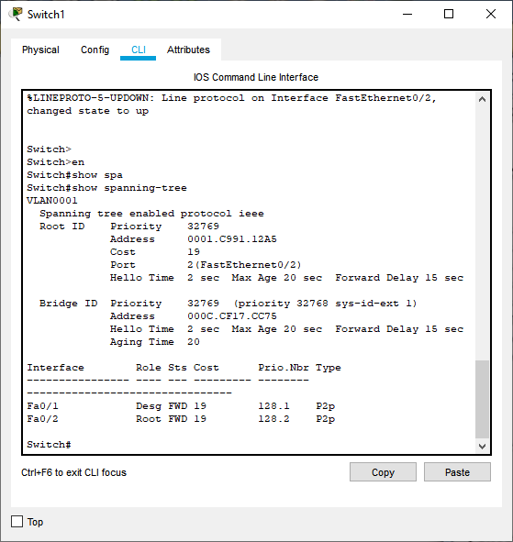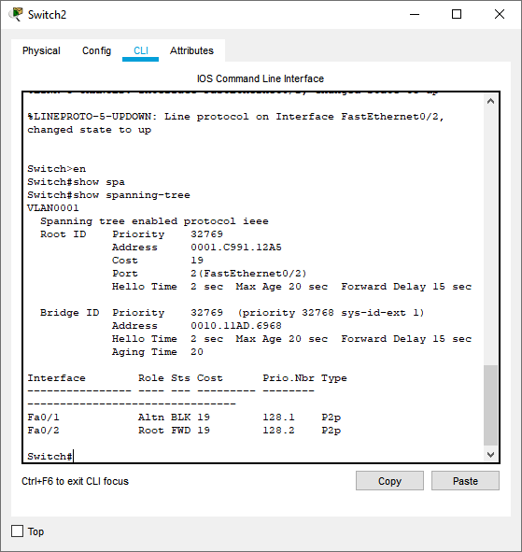
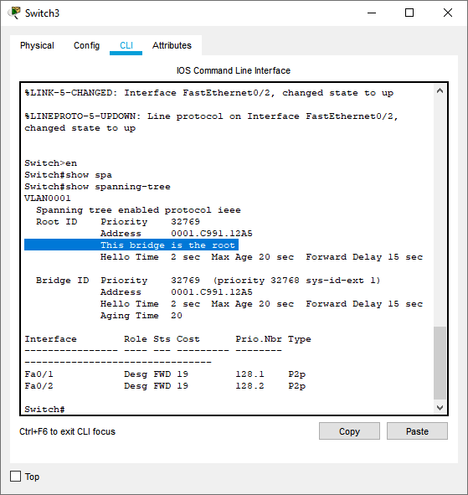

Here we can see that Switch 3 is the root switch.
Now we will check the operation of the STP protocol, it really works. Let's try to disable Fa0/2 on Switch 3. To do this, go to global configuration mode and enter this data.

Switch>
Switch>en
Switch#sh
Switch#show spa
Switch#show spanning-tree
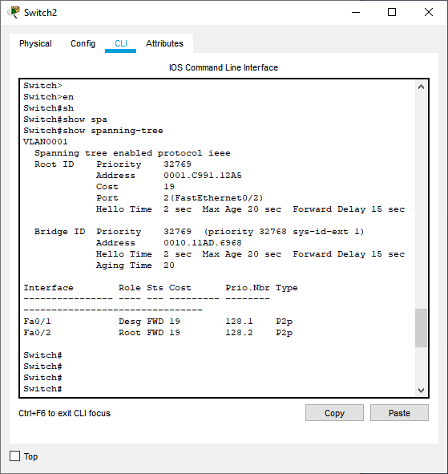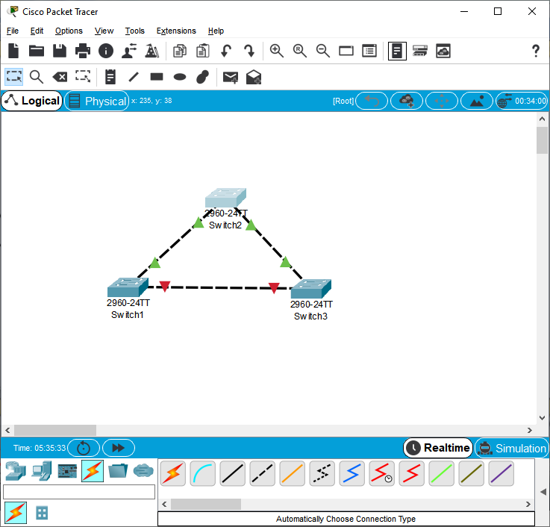
We collect a new scheme. We give the ip addresses of the computer.
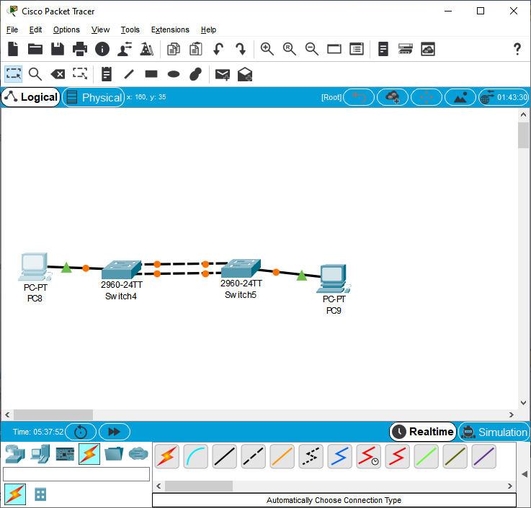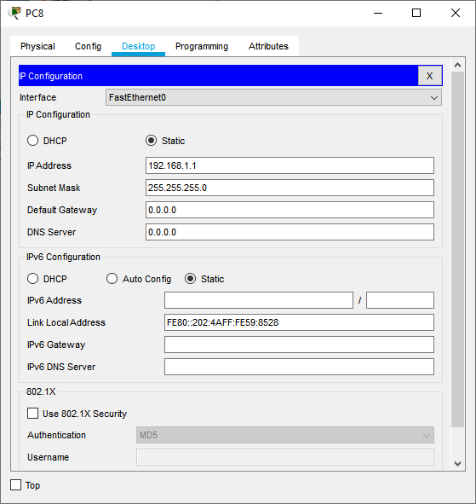
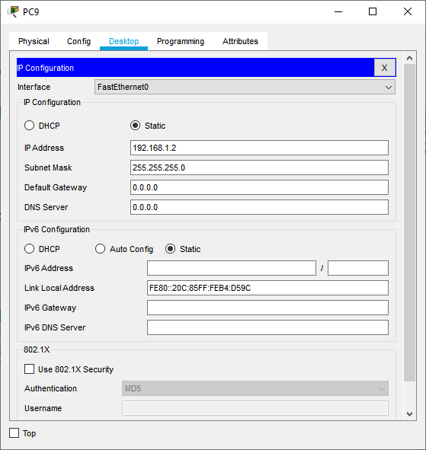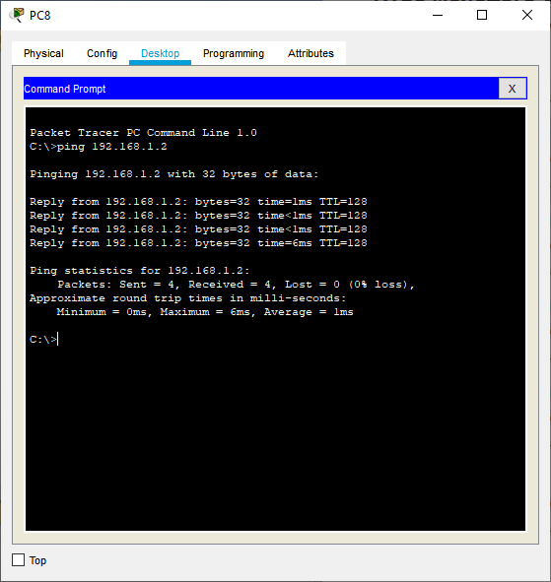
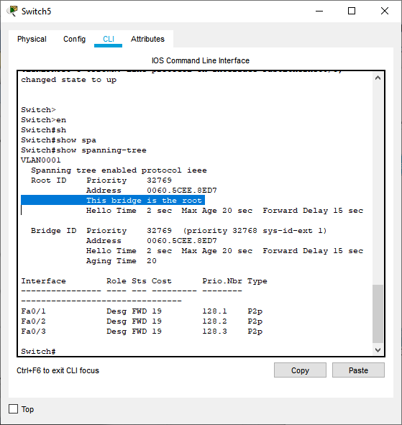
This switch is our root and all its ports are in forwarding mode. Now let's see how STP uptime affects the user. To do this, we will disable port Fa0/1 on switch 4.
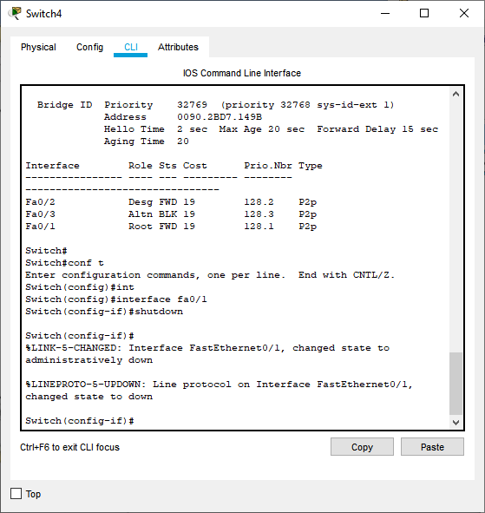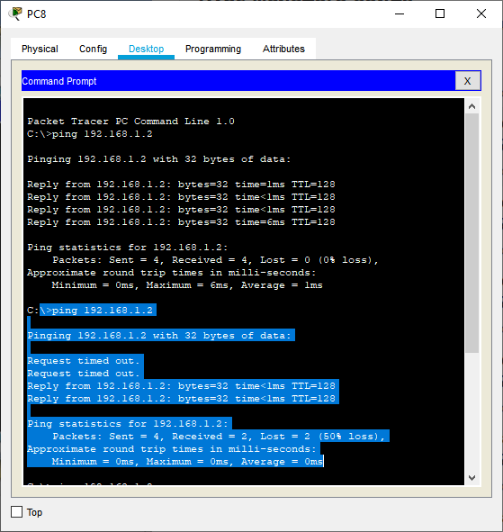
As we can see from the rice. the client connection was literally 15-20 C. to reduce the port switching time, the rstp (rapid stp) protocol is used.
To set up rstp, go to the console of the first switch, in our case switch 4.

Switch(config-if)#
Switch(config-if)#
Switch(config-if)#exit
Switch(config)#
Switch(config)#spa
Switch(config)#spanning-tree mo
Switch(config)#spanning-tree mode rap
Switch(config)#spanning-tree mode rapid-pvst
Switch(config)#
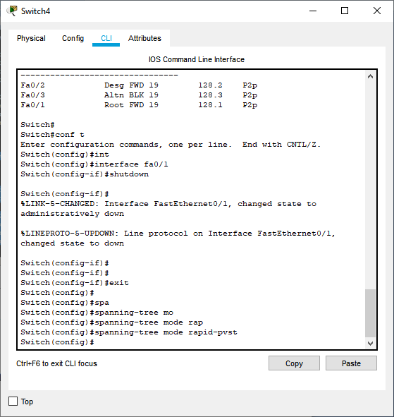
To check, disable port Fa0/1 again on another switch.
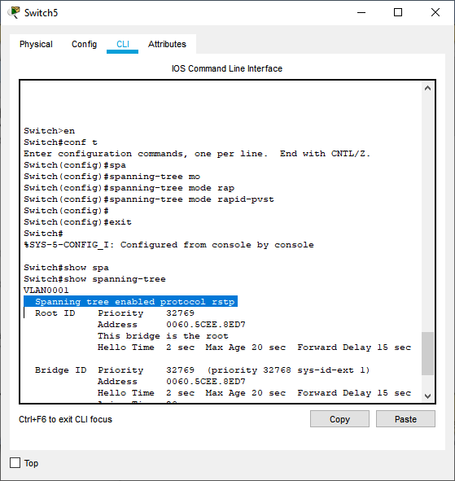
After switch-4 is restored, it can be observed that switching occurs immediately.
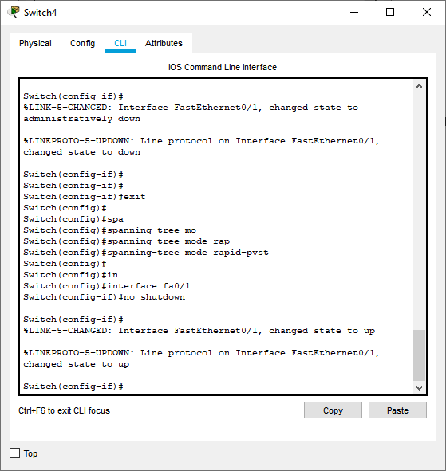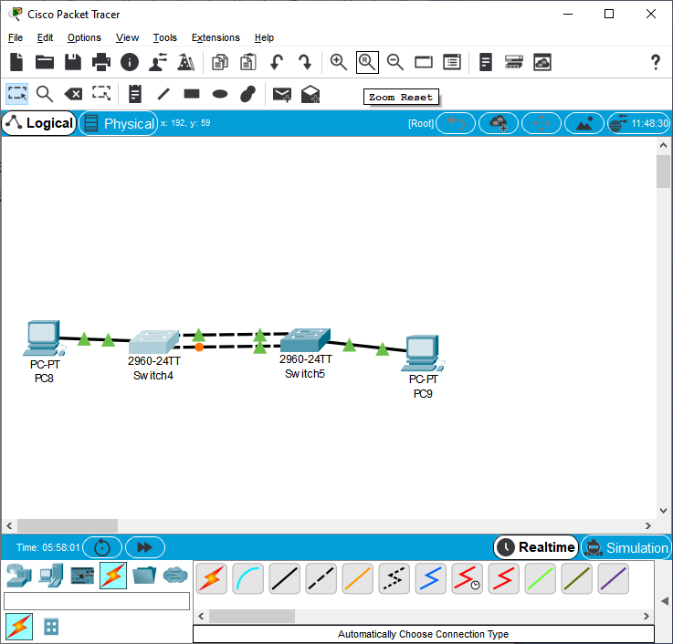

Next, we check the connection to the PC. Then turn off the port again to check the transition to another channel.

Laboratory work 12. Install and optimize STP for network setup.

Objective
- To install and configure Spanning Tree Protocol (STP) for a network setup.
- To optimize STP for faster convergence and efficient redundancy.
- To compare STP, RSTP, and MSTP in terms of performance.
- To test and verify the STP operation using Packet Tracer.

Theoretical Background

Why STP is Needed in Redundant Networks
When multiple switches are connected in a network with redundant links, switching loops can occur, leading to:
- Broadcast Storms – Excessive traffic that can overwhelm the network.
- Multiple Frame Copies – Causes unnecessary bandwidth usage.
- MAC Table Instability – Switches receive frames on different ports, leading to confusion.

Types of Spanning Tree Protocols
Protocol | Convergence Time | Features
STP (802.1D) | 30-50 sec | Standard version, slow convergence
RSTP (802.1w) | <1 sec | Rapid convergence, better performance
MSTP (802.1s) | <1 sec | Multiple spanning trees for different VLANs

STP Optimization Techniques
- Root Bridge Selection
  - The switch with the lowest Bridge ID (Priority + MAC) becomes the Root Bridge.
  - Manually configure Root Bridge to ensure stability.
- PortFast (For access ports)
  - Bypasses STP states Blocking → Listening → Learning and directly moves to Forwarding.
  - Used for end devices like PCs, printers.
- BPDU Guard (Prevents rogue switches)
  - Blocks ports if they receive Bridge Protocol Data Units (BPDUs).
  - Prevents unauthorized STP manipulations.
- UplinkFast and BackboneFast
  - UplinkFast speeds up convergence for edge switches.
  - BackboneFast improves reconvergence in case of indirect link failures.
- Rapid PVST+ (Per VLAN Spanning Tree)
  - Faster RSTP-based protocol that allows independent STP instances per VLAN.

Practical Tasks

Task 1: Creating a Network with Redundant Links
- Open Packet Tracer and add:
  - 3 switches (SW1, SW2, SW3)
  - 4 PCs (PC1, PC2, PC3, PC4)
- Connect the switches in a triangle:
  - SW1 ↔ SW2
  - SW2 ↔ SW3
  - SW3 ↔ SW1 (creates a loop)
- Connect PCs to SW2 and SW3.

Task 2: Configuring and Optimizing STP

Step 1: Set the Root Bridge
By default, switches select the Root Bridge dynamically. To ensure stability, set SW1 as the Root Bridge:
configure terminal
spanning-tree vlan 1 root primary
exit

Verify:
show spanning-tree vlan 1

Step 2: Enable Rapid STP (RSTP)
configure terminal
spanning-tree mode rapid-pvst
exit

Check STP mode:
show spanning-tree summary

Step 4: Enable BPDU Guard (Prevent Unauthorized Switches)
interface fastEthernet 0/1
spanning-tree bpduguard enable
exit

Step 5: Verify STP Configuration
Check blocked ports:
show spanning-tree active

View STP root bridge:
show spanning-tree root

Check BPDU Guard status:
show spanning-tree interface fastEthernet 0/1 detail

Task 3: Testing STP Optimization
- Before enabling RSTP, disconnect and reconnect redundant links.
  - Observe delayed convergence (~30 sec).
- After enabling RSTP, repeat the test.
  - Observe fast convergence (<1 sec).
- Verify Root Bridge election using:
show spanning-tree root
- Check port states and confirm which ports are blocked:
show spanning-tree interface fastEthernet 0/1

Self-Assessment Questions
- What is the main purpose of STP?
- How does RSTP improve convergence over classic STP?
- What does the Root Bridge do in STP?
- How does BPDU Guard enhance network security?
- What is the advantage of using Rapid PVST+?

Laboratory work 13. Install and configure DNS, DHCP, and Web network services.

Objective : Learn how to set up DNS, DHCP, and Web network services

Create the network diagram shown in the figure.
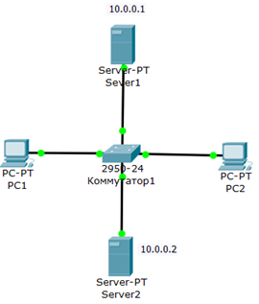
Figure 13.1. Network diagram
Our task is to configure server 1 as a DNS server and web server2 as a DHCP server. Recall that the work of the DNS server is to translate domain names into IP address servers. The DHCP server allows you to organize pools for automatic configuration of network interfaces, that is, it provides automatic distribution of IP addresses between computers on the network. In other words, in our case, computers receive IP addresses thanks to the DHCP server 2 service and, for example, open a site on server1.
Configure the server and DHCP IP addresses on the computer Go to the configuration of PC1 and PC2 and set the IP parameter DHCP server Fig. 6.
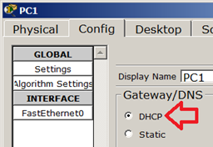
Figure 13.2. Setting IP on PC1
In the server configuration, set the IP parameters: Server1-10.0.0.1 (Fig. 13.2), Server2 – 10.0.0.2 (Fig. 13.3). The subnet mask is automatically set to 255.0.0.0.
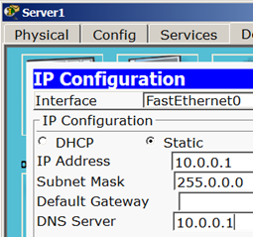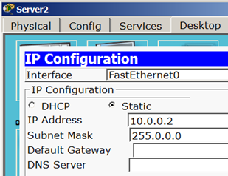
Figure 13.2, 13.3.

Setting up DNS and HTTP services on Server1
In the Server 1 configuration, go to the DNS tab and set two resource records (Resource Records) in the direct DNS zone.
Term. A DNS zone is a part of the domain name tree (including resource records) that is hosted as a unit on a domain name server (DNS server). In the direct lookup zone, a domain name query is answered in the form of an IP address. In the reverse lookup zone, we learn the domain name of the computer.
First, in a resource record like a record, associate the domain name of the computer server1.yandex.ru with its IP address 10.0.0.1 and click the Add button, and enable the On-image switch. 9.

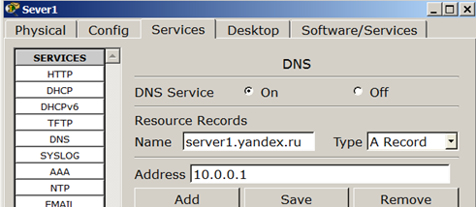
Figure 13.4. Inserting a resource record of type A record
Next, associate the site name with the server in a CNAME resource record and click the Add button - Figure 13.5
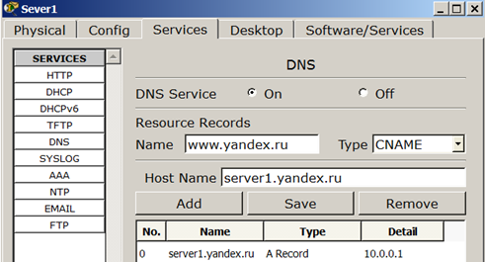
Figure 13.5. Inserting a CNAME resource record
The result should look like this (Figure 13.6).
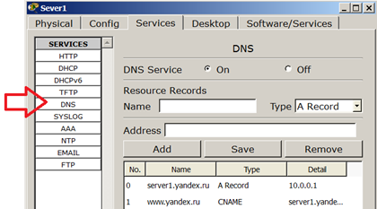
Figure 13.6. DNS service in a live zone
Now install the HTTP service. In the Server 1 configuration, go to the HTTP tab and create the site's home page (Fig. 13.7).
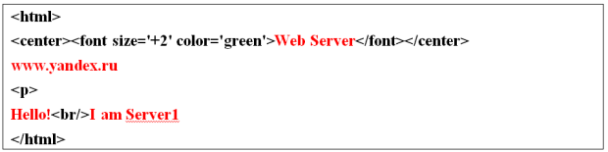
Figure 13.7. Home page of the site
On Server1, open a command prompt and check that the DNS service is working. To check if the DNS server zone is working properly, enter the Server > nslookup command. If everything is configured correctly, you will receive a response to the query indicating the domain name of the DNS server on the network and its IP address (Fig. 13.8).
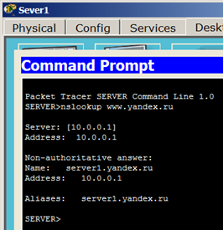
Figure 13.8. DNS service in the DNS direct zone on Server1 is correctly configured
Note. The nslookup command is used to determine the IP address by domain name (and vice versa).
Setting up DHCP service on Server 2
Go to the configuration of Server 2 and set up DHCP service on the DHCP tab. To do this, enter the new pool values, set the switch to On and click the save button - Figure 13.9
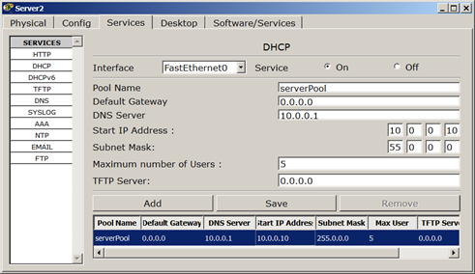
Figure 13.9. Setting up a DHCP server

Checking the operation of clients
Enter the host configurations of PC1 PC2 and configure the TCP/IP protocol at the command line. To do this, reset (clear) the old IP address settings with the command PC> ipconfig /release (Fig. 13.10).
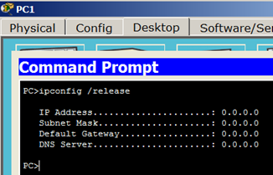
Figure 13.10. Removing IP address configuration for all adapters

Note: The ipconfig /release command sends a message to the dhcprelease server to release the current DHCP configuration and remove the IP address configuration for all adapters (if the adapter is not installed). This switch disables TCP/IP for adapters configured to obtain IP addresses automatically.
Now get new options from the DHCP server using the command PC> ipconfig /renew (Fig. 13.11).
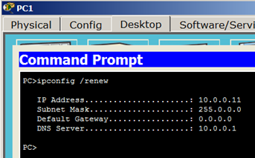
Figure 13.11. Configuration TCP/IP client protocol from DHCP server
Do the same for PS2 (Fig. 11.12).

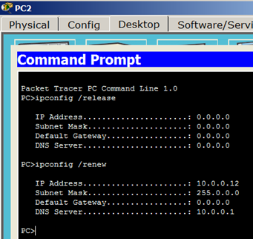
Fig. 13.12. PC2 received an IP address from the DHCP server SERVER2
It remains to check the operation of the web server Server1 and open the site in the browser on PC1 or PC2 (Fig. 11.13).
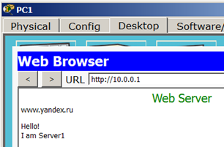
Figure 13.13. Testing HTTP service on Server1

Laboratory work 14-15. Creating and configuring wireless networks. Expanding wireless networks: security and optimization.

Objective: Create a wireless network like Wi-Fi
Create a local area network model consisting of a regular home Wi-Fi router and a router that mimics your Internet provider. Use a Fast Ethernet interface. Connect an additional user device, such as a laptop. Install the Wi-Fi module (wpc300n) on the laptop.
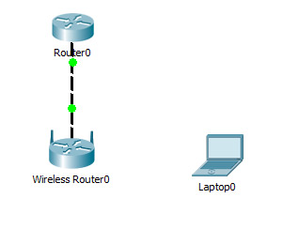
Figure 14.1. Communication topology

Model installation
1) Router0 provider router settings:
Router>en
Router#
Router#conf t
Enter configuration commands, one per line. End with CNTL/Z.
Router (config)#int fa0/0
Router (config-if)#ip address 210.1 255.255.255.252
Router (config-if)#no shutdown
Router (config-if)#
%LINK-5-CHANGED: Interface FastEthernet0/0, changed state to up
%%LINEPROTO-5-UP DOWN: Line protocol on Interface FastEthernet0/0, changed state to up
Router (config-if)#end
Router#
%SYS-5-CONFIG_I: Configured from console by console
Router#wr mem
Building configuration...
[OK]

2) Wireless Router0 home wi-Fi router settings
are performed via the web interface.
The previous setting in the Setup tab is shown in the figure.
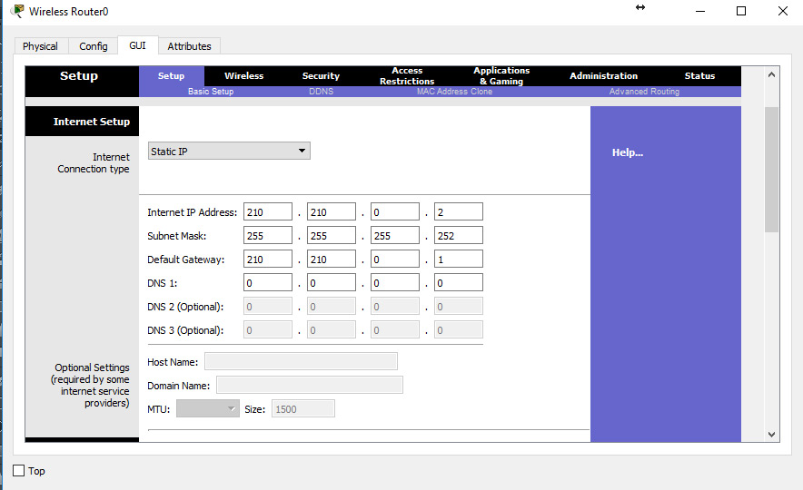
Figure 14.2. Router configuration

Network Setup
Choose the default IP address 192.168.0.1, 24-bit mask 255.255.255.0, DHCP server allowed, start distribution from 192.168.0.100 and that's it. Then don't forget to save the settings, click the button at the bottom of the save Settings form.
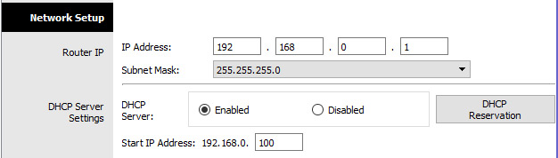
Figure 14.3. Setting up a local network

Settings on the Wireless tab, i.e. wi-fi. We select the basic settings for wifi: mode (mode), we choose mixed (mixed); network identifier (SSID) — netskills; channel width (radio Band) — auto; frequency — 1-2.412 HGz; network visibility (SSID Broadcast) — visible (enabled). Save the settings.

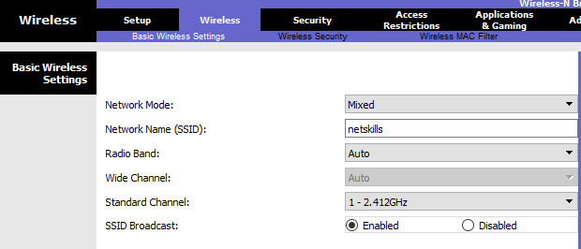
Figure 14.4. Wireless communication protocol

Go to the Wireless Security tab. Select WPA2 Personal encryption mode, AES encryption algorithm, and a password of at least 8 characters for the selected encryption mode. Save.
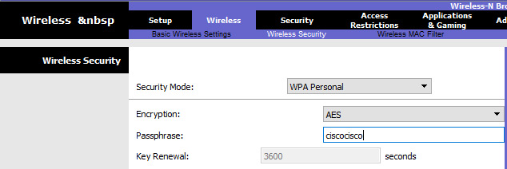
Figure 12.4. Wireless communication protocol

3) Installing a Wi-Fi adapter on a laptop. Desktop tab->PC Wireless->Connect. We will look at the available networks. Click the Connect button to connect to the Net skills network.

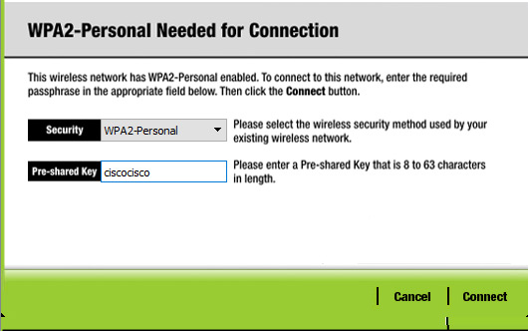
Figure 14.6. Installing a Wi-Fi adapter
If the settings are made correctly, a dashed line will appear between the wi-fi router and the laptop, as in the picture.

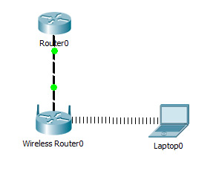
Figure 14.7. Establishing a wireless connection

To check the correctness of the settings, let's type the ipconfig command on the laptop. From the picture you can see that the DHCP server assigned the correct ip 192.168.0.100 Ping the gateway (wi-Fi router) and the address of the Internet provider. From the picture you can see that the ping is working in both cases.

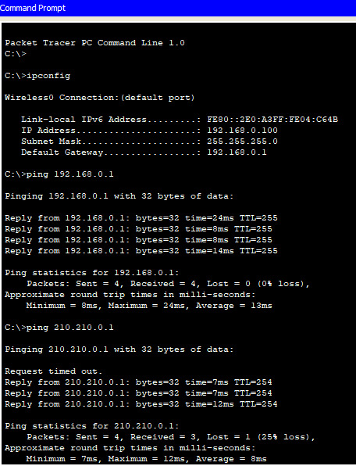
Figure 14.8. Checking the correctness of the parameters

Connect all equipment with appropriate cables.
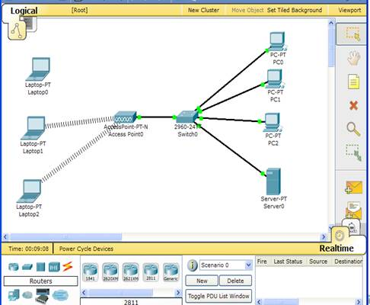
Figure 14.1 - connection diagram

Server setup.
Server-Config-DHCP-on
Start IP Address: 192.168.1.2
Subnet mask: 255.255.255.0
Save
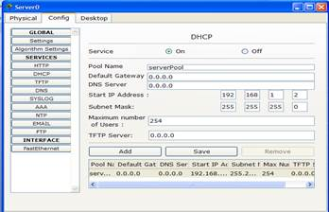
Figure 14.2 server installation
Server-Desktop-IP Configuration
IP Address 192.168.1.1
Mask 255.255.255.0
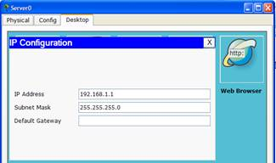
Figure 14.3 Configuring the IP address

PC setup
PC2-Desktop-IP Configuration-DHCP
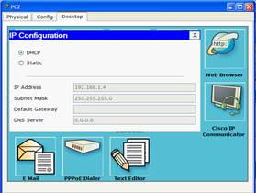
Figure 14.4 Configuring the IP address

Repeat for all PCs.
Laptop-Phisical
- Turn off the power..
- Linksys select expansion board -WPC300N and install it.
- Turn on the power.
Setting up an access point
Access Point-Cpnfig-Interface-Port 1
Wep-1234567891
SSID-CISCO
Last Wireless device setup
Laptop-Desktop:
PC Wirless-Connect-Wep Key- 121234567891
IP Configuration –DHCP
- check the connection
Laptop-Command Prompt-Ping 192.168.1.2
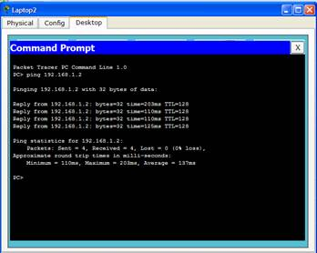
Figure 14.5 Command line
Laptop-Web Brouser
URL-HTTP://192.168.1.1
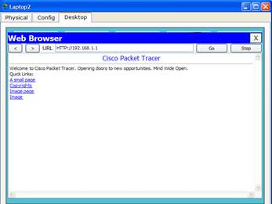
Figure 13.6. check the connection again.
Laptop-Desktop-Command Prompt-Ping 192.168.1.4
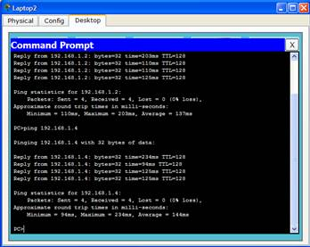
Figure 14.7 Command line

