POSTMAN ADD NEW MC

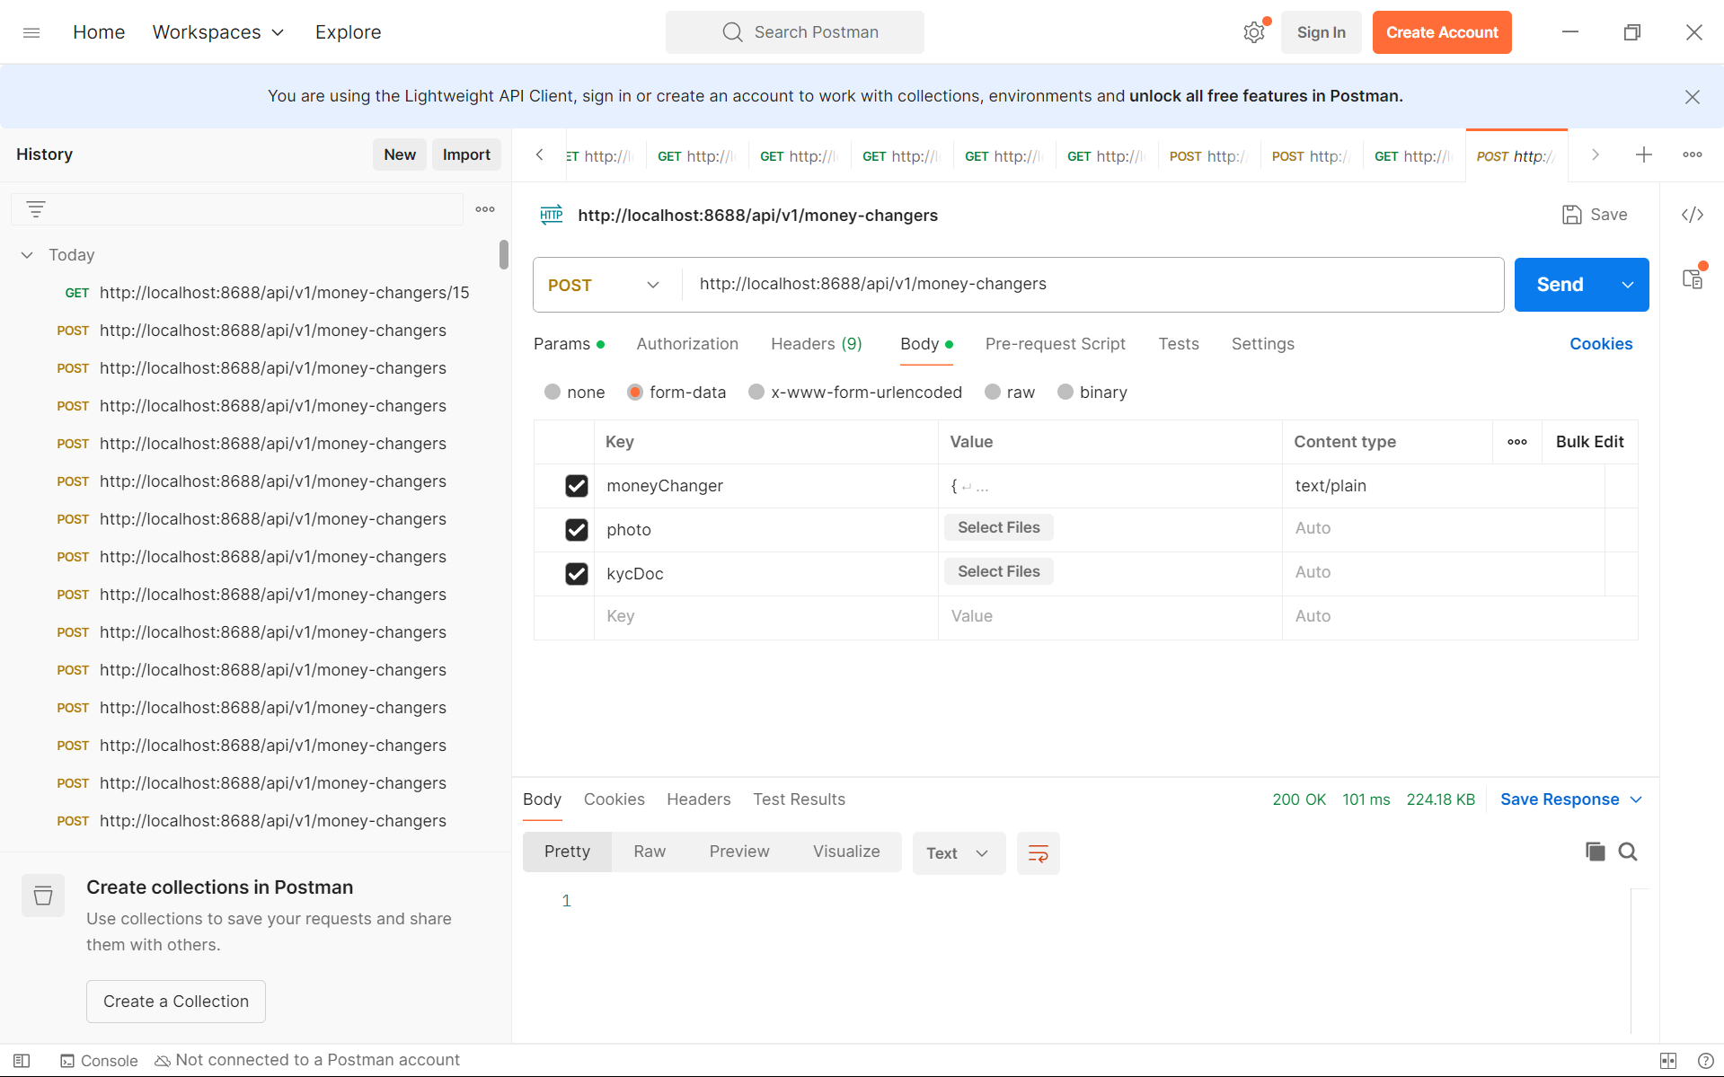

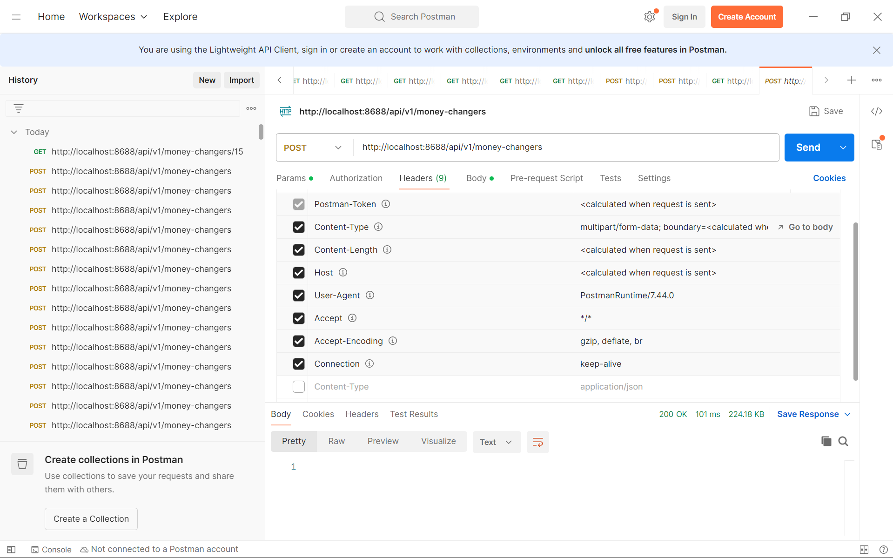

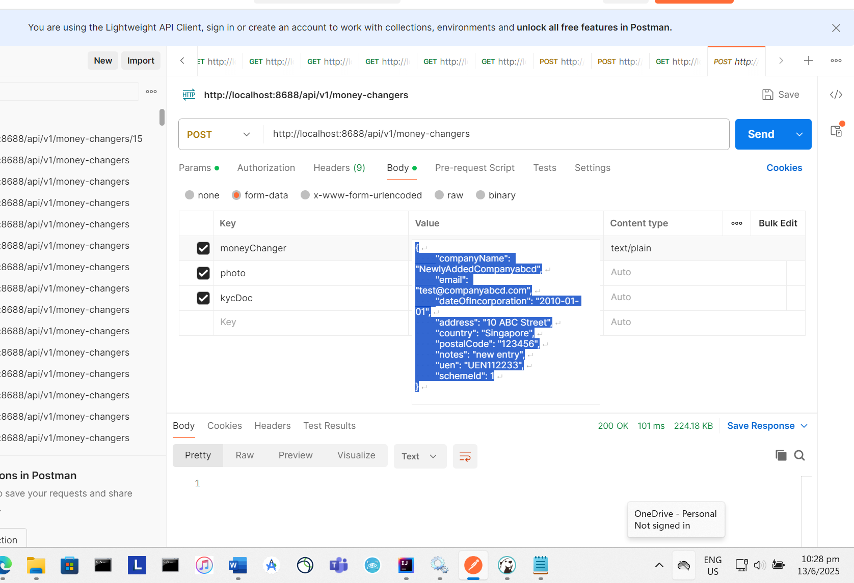

{

"companyName": "NewlyAddedCompanyabcd",

"email": "test@companyabcd.com",

"dateOfIncorporation": "2010-01-01",

"address": "10 ABC Street",

"country": "Singapore",

"postalCode": "123456",

"notes": "new entry",

"uen": "UEN112233",

"schemeId": 1

}

GET SINGLE MC

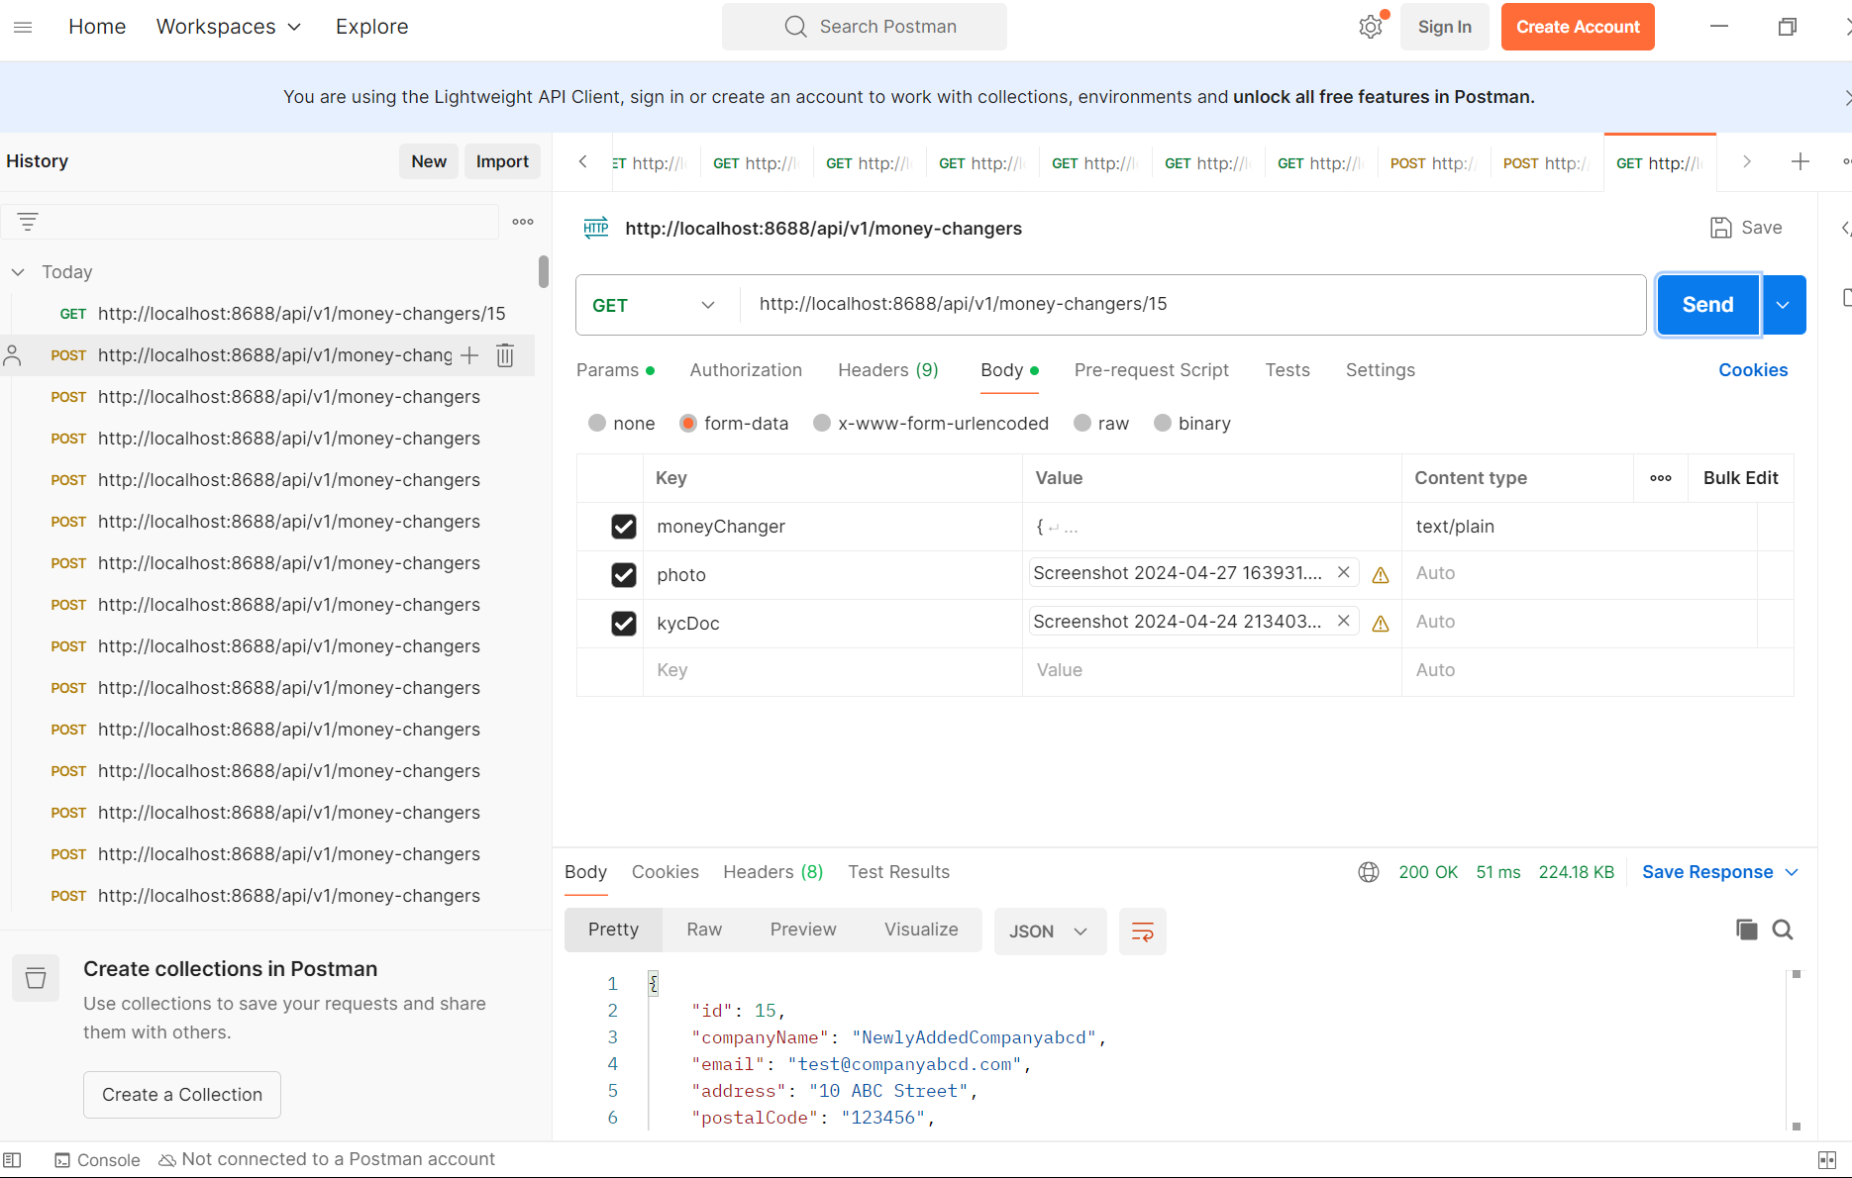

PUT SINGLE MC

(same as POST contents, just that different command instead of POST, now it is PUT)

