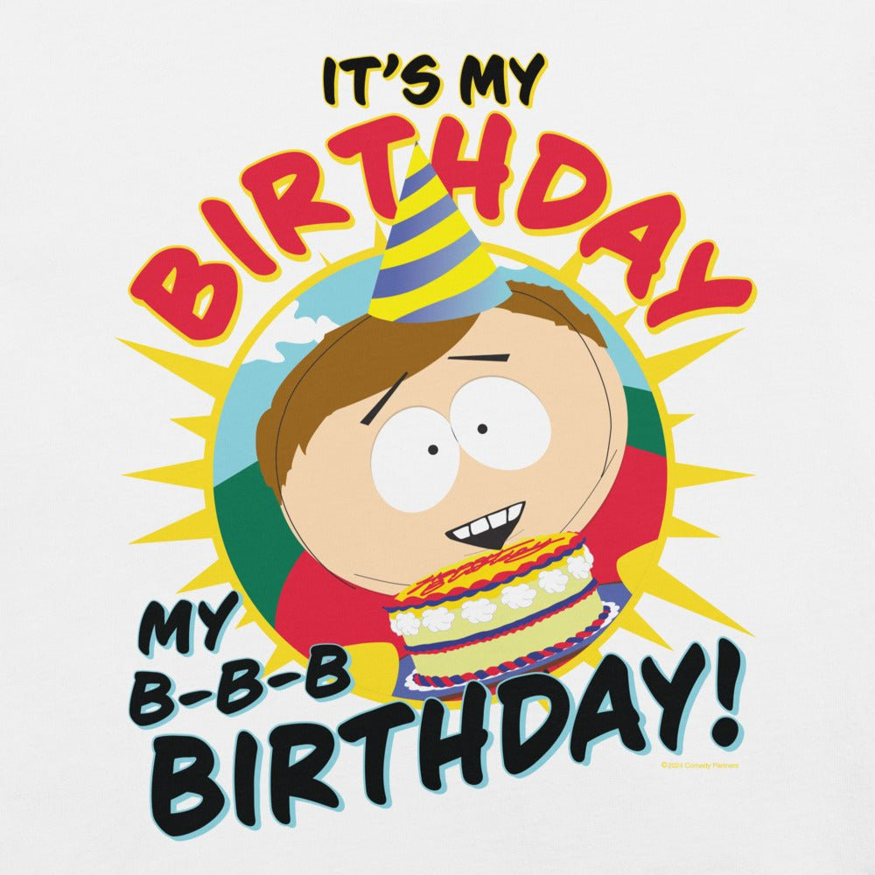

CARTMAN’s Birthday Celebration
When: July 1st
Where: 28201 E. Bonanza St (Next to Butters House)

