**Weather Pattern Correlation**

This was a brief project to demonstrate the power of data to visualize how features of the weather are affected by distance from the Earth’s equator. Although it seems intuitive that on average temperature should increase as one approaches the equator – after all, there’s a reason for the name The Tropics -- this project provides solid evidence of exactly that.

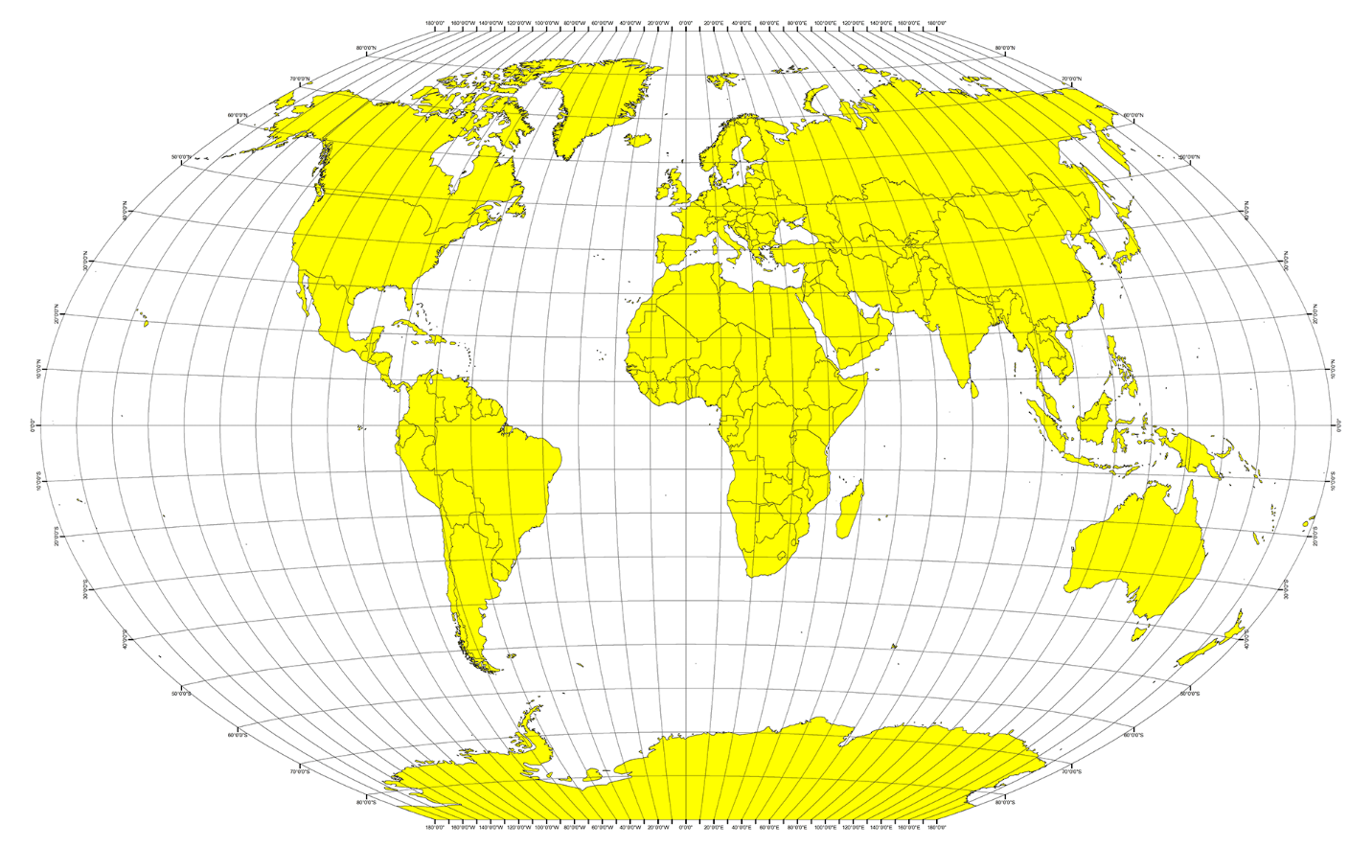

**Methodology**

For this project, we examined the weather of 500+ randomly selected cities across the world of varying distance from the equator. We focused on four weather attributes: temperature, humidity, cloud cover, and wind speed. , these measurements were sampled only all within about an hour

Using Python and the OpenWeatherMap API, these measurements were sampled only all within about an hour. So measurements are neither compensated for time of day or time of year, which necessarily skews the ability to inference. However, we did timestamp the measurements, so at some future point we could compensate for time of day and time of year.

**Observations**

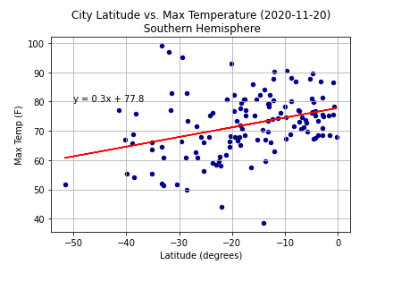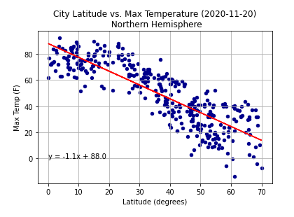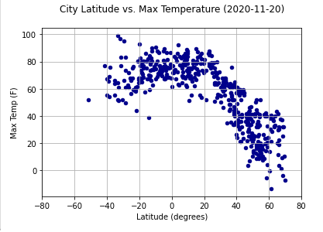

1. This exercise provides visual and quantitative evidence that the earth tends to get hotter toward the equator. The scatter plots for City Latitude vs. Temperature (2020-11-20), and for same variables by just Northern Hemisphere and then by just Southern Hemisphere, provide reasonable evidence that temperature and certain other weather conditions change with distance from the equator. We note that the best time of the year to measure the temperature differential by latitude would be on the Spring or Fall Equinox, when the Sun is exactly above the Equator and day and night are of equal length in Northern and Southern Hemispheres. However, we didn't have the luxury of being able to gather temperatures on those dates or to take multiple weather readings around the world over a year long period, which would have given us another method of capturing information that could cancel out effects of the earth's axis running at a 22 degree angle to the solar ecliptic. That said, with the understanding that it is now two months since the Fall Equinox, what we find is that in the Northern Hemisphere, currently in the Fall season, the scatter plot shows a relatively tight concentration of temperature-latitude data points that describe temperatures falling as latitudes increase from the equator toward the poles (north pole in this case). The Southern Hemisphere temperature-latitude data points also describe a falling off as latitudes increase from the equator toward the poles (south pole in this case). But the Southern Hemisphere's rate of falling off is both not as great and seems less tightly concentrated as that for the Northern Hemisphere. The Northern Hemisphere temperature-latitude slope we calculated is -1.1 while the Southern Hemisphere temperature-latitude slope we calculated is 0.3. The difference likely reflects the longer duration of daylight in the Southern Hemisphere, but to prove this hypothesis, we would probably want to study more temperature readings at more dates through the year. And maybe through some number of years. We also observe that the latitude of cities in our sample in the Southern Hemisphere is relatively more tightly concentrated; they range generally between 0 degrees (equator) and 40 degrees South. By contrast, latitude of cities in our sample in the Northern Hemisphere is relatively more spread out; they range generally between 0 degrees (equator) and 70 degrees North. We also note that the Northern Hemisphere has 68% of the Earth's land by area, while the Southern Hemisphere has 32%, and that the land makes up only 29% of the planet's crustal surface. We believe this reflects the study methodology of selecting a random sample of cities, and then taking temperatures for them. We believe a further important major factor for consideration is that large bodies of water generally tend to take longer to heat or to cool than does the land. The temperatures of such large bodies of water affect ambient weather conditions not only over the water but also certainly over coastal regions and very likely well beyond. The ratio of land surface area to water surface area in the Northern Hemisphere is 7:10 while that ratio is 3:10 in the Southern Hemisphere.
2. 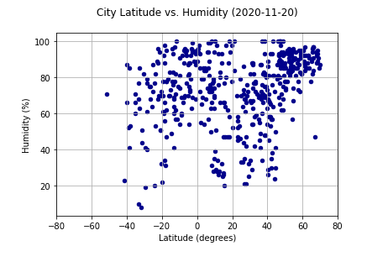The scatter plots City Latitude vs. Humidity (2020-11-20) by total earth and then for each hemisphere separately seemed somewhat to describe a similar effect as for temperature. The closer the latitude to the equator the higher the mean and median humidity measurement. Or at least one could say the fewer outliers with low humidity. However, the Northern Hemisphere deviated from this inferential rule of thumb. Above about 40 degrees North, humidity measurements concentrated at increasingly higher measurements (approaching 100 percent, the maximum). One other aspect should be mentioned. At least visually, the humidity-latitude scatter concentrations did not track or concentrate as strongly as they did the temperature-latitude plots. Separately, we note that none of the weather readings we gathered reported any measurements above 100%, which would have called into question their veracity.
3. 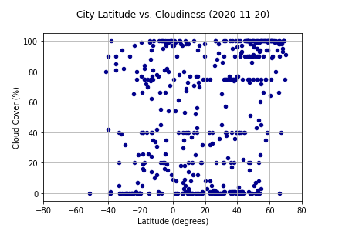The scatter plots City Latitude vs. Cloudiness (2020-11-20) by total earth and then for each hemisphere separately seemed less conclusive. There were also patterns in the data that seem to be methodology driven. Concentrations at 100%, 75%, 40%, 20%, and 0% suggest that cloud cover readings may be human eyeballed rather than measured by radar or some other optical measurement, in that these seem to reflect quantified translations of the way that cloud cover is typically reported: cloudy, clear, partly cloudy, etc.
4. 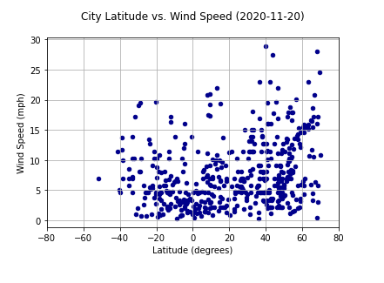The exercise also had us run plots and calculate regression lines for wind speed. These include the scatter plots City Latitude vs. Wind Speed (2020-11-20) by total earth and then for each hemisphere separately. The regression lines suggest a gradual, slight, but not insignificant increase in average wind speed as latitude increases from the equator. The Southern Hemisphere slope was 0.8 while the Northern Hemisphere slope was 0.1, suggesting the wind speed increases at a greater rate in the Southern Hemisphere. We speculate that this correlates to the season of the year, in that greater sunlight hours in the Southern Hemisphere energizes average wind speed more greatly than regions of the earth with shorter sunlight hours. It could also possibly represent the greater proportion of water surface area to land surface area in the Southern Hemisphere, with fewer mountains as a percentage of total surface area to impede or slow wind. The final observation here is that there may be evidence of the trade winds imbedded in the data. I speculate these are popping out in the outliers in slight concentrations around certain latitudes. Since the trade winds at specific latitudes tend to move either east-to-west or west-to-east, there would seem to be a slightly higher average wind speed since in other areas of the world, wind direction shifts quite a bit more, with correspondingly significant disruption to average wind speed.
5. 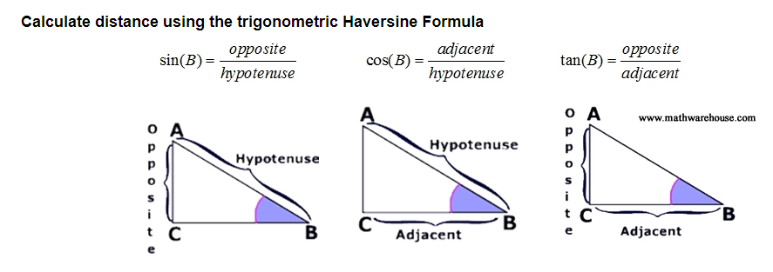Since 71% (we used 2/3 as the approximation in the Jupyter Notebook) of the surface area of the globe is water, there is a likelihood that 71% of the choices made by randomly selecting geocoordinates will be somewhere other than on land, which means that at least 71% of the cities selected by using random coordinates will be clustered on shorelines. Bottom line, the real task is to randomly select geocoordinates only for the 29% of the planet surface that is land. Our solution rejected any cities that were greater than 60 miles from the randomly chosen geocoordinates. This required us to measure the distance from the randomly chosen geocoordinates to the nearest city selected. We used the trigonomic Haversine Formula to calculate these distances. The original search for the nearest city involved 1,500 random geocoordinates. This yielded just over 200 cities that were less than or equal to 60 miles from the original random geocoordinates. As a result, we # expanded our random geocoordinates set by a factor of 2x or higher to increase the odds of selecting at least 500 target cities that were within the maximum 60-mile search radius. So, we reran the next time with 3,500 random geocoordinates.