NUbots – Sebastian Brooker
Part 1: Running Nusight

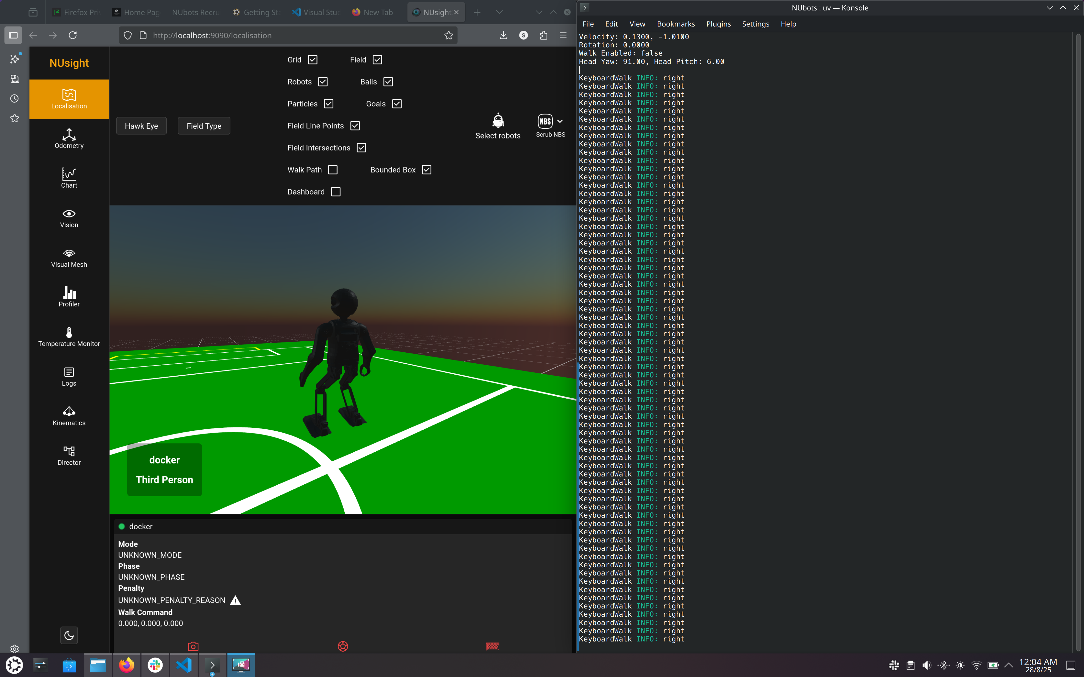

Part 2: System Overview
The following report is a short overview of an autonomous, soccer – playing robot.
To minimize stress on the motors in the system, all components of the robot should be chosen with weight in consideration. The rechargeable batteries used should be Lithium because it is lightweight and physically smaller in comparison to agm or sla batteries. Depending on the current draw of the whole system, the battery capacity should be able to supply the power draw for at least the duration of a game. Materials such as aluminum alloys or carbon fiber reinforced plastics are good choices for their strength, weight, and workability.
Staying balanced is a very complicated task when it comes to moving humanoid robots. This is best tackled by making sure the center of mass is as low as possible, and the ‘feet’ have a very large surface area. Therefore, the bottom half should be made of heavier materials in relation to the top half. If the legs are made of aluminum, the body and head should be made of some type of lightweight polymer. The ‘arms’ of the robot should act as a counterweight to help maintain the robot’s balance as well.
The robot needs to be able to act autonomously. At a high level, an embedded microprocessor is likely necessary to determine when and where to move. It could use data from various sensors, feed this data into a filter to reduce noise, then a localisation model. Once the state probabilities have been calculated, the behaviour and control algorithm can determine what to do next. It will also need a model of the robot itself, using inverse kinematics it can decide what the individual actuators should be to reach the desired states.
Safety precautions are necessary to minimize repair time and cost. In the event something goes wrong, a physical emergency stop button should be available to cut power to all actuators. The data from the sensors can also be used to detect when a fault has occurred, which should initiate a new control law. Diodes to restrict directional current flow and accessible fuses or circuit breakers should be implemented where appropriate. For easier recognition and replacement, these should be accessible from the outside, and accompanied by small led’s to indicate which fuse had been blown.
Shifting the weight to each leg would also be a hard task. As one leg is raised the weight would shift towards that leg, and a rocking motion will begin. Therefore, the walking movement should start with small steps and gradually grow larger. This also means the max speed of the robots is a function of how well it can manage this momentum. This could be reduced by a sliding counterweight inside the ‘body’ of the robot.
It should be able to interact with the ball once it is close enough. Using the same counter weight as mentioned earlier, the centre of mass should be made to be directly above one of the legs, to free one for movement. One way to generate force for a kick is to preload energy in a spring or an elastomer before releasing, however this will take more time then simply activating a servo motor. Therefore depending on the circumstance, both mechanisms could be incorporated.
Goalkeepers have different rules to a field player, they are allowed to use their full body to obstruct the path of the ball. Goalkeepers will need to know how to dive and save the ball. The program to determine when to do this, needs to quickly calculate the velocity and direction of the ball. It will trigger a motion that lays the robot down with there arms stretched to the left or right depending on the ball’s direction. This movement can be performed by a separate motion component. We need to be careful though as the keeper might not need to dive and will end up on the ground for no reason.
It is important to not constrain ourselves to humanoid assumptions. Without considering the rules, the joints of the robot could be reversible to avoid the time taken to turn the robot around, for example, the head could rotate 360 degrees, and the knees could bend in both directions. Robots could communicate with each other, so all bots know where the ball even if only one can ‘see’ it. Granted these abilities are probably covered in the rules, however it is still important to be aware of assumptions.

