SAMSUNG
Big Data Course
Capstone Project
Action Plan
HandAI Vietnamese Handwriting Recognition System
Nguyen Van Duy Manh · Tran Hoai Nam
Baseline delivery period 01–30 September 2026
For students Instructor review required
©2023 SAMSUNG. All rights reserved.
Samsung Electronics Corporate Citizenship Office holds the copyright of this document.
This document is protected by copyright law. Reprint and reproduction require permission.
Use outside the Samsung Innovation Campus curriculum requires written consent from the copyright holder.

1 Project Overview
Thirty-day delivery plan with traceable source images and actual app results
HandAI converts photographed Vietnamese handwriting into line-level text while preserving the reviewer’s control over segmentation and the final transcription. The plan prioritizes traceable evidence, human verification and a reproducible handoff over unsupported headline accuracy claims.
Course | Big Data Course
Team | HandAI · Nguyen Van Duy Manh · Tran Hoai Nam
Project title | HandAI - Vietnamese Primary School Handwriting Recognition System
Goal | Deliver a mobile-to-AI handwriting workflow that preserves raw OCR, optional language advice and the human-selected result.
Primary users | Students, teachers and reviewers who need inspectable line segmentation and editable transcription.
Decision authority | The human reviewer confirms or edits each line. The system does not perform automated grading.
1.1 Planned workflow
CAPTURE | → | REVIEW LINES | → | CRNN + CTC | → | AI ADVICE | → | VERIFY
1.2 Prototype evidence
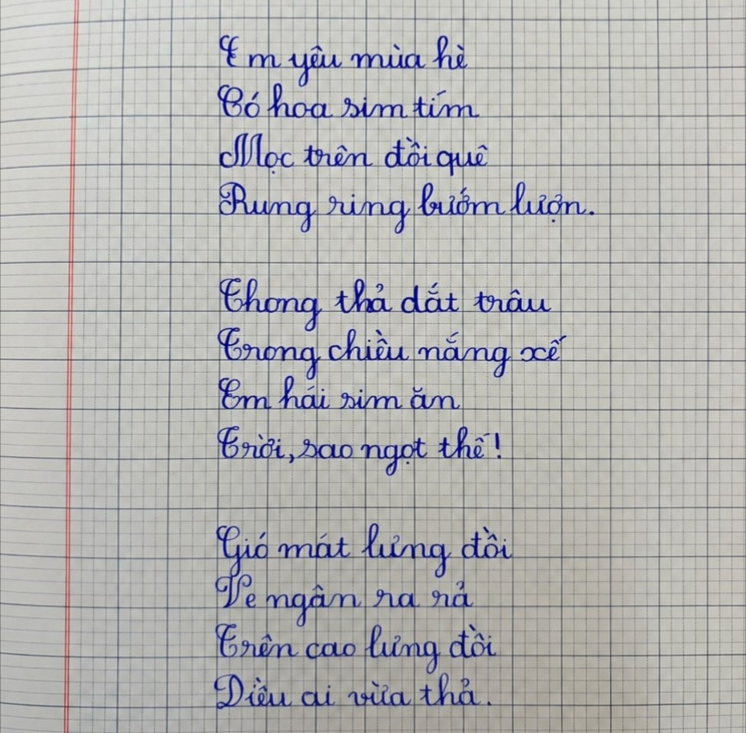  Actual stored source image · original proportions | 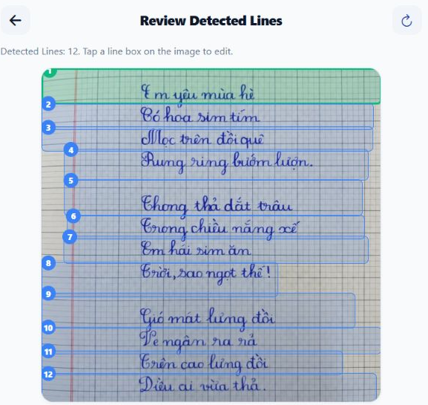  Actual app line review · 12 returned boxes
Source: actual persisted page image | Actual app trial 400b509c-bded-44c0-add3-f3f74ee102c4

2 Method and Evidence Baseline
Model handoff evidence, provisional local candidates and the actual app demonstration retain separate scopes
2.1 Implementation method
Step | Stage | Action | Evidence
1 | Acquire and crop | Camera or gallery input; preserve orientation and crop coordinates. | Page image and crop metadata
2 | Detect lines | Preprocess ruled notebook images and return editable line boxes. | Reviewed line regions
3 | Recognize | Run the packaged CRNN with CTC decoding on each confirmed crop. | Raw text, measured CRNN score and CRNN_CTC_SOFTMAX provenance
4 | Advise | Request actual image-backed provider suggestions; retain model/status provenance and honest unavailable states. | Optional candidates
5 | Verify | Keep raw text, select a suggestion, edit manually or skip the line. | Final text and decision source
6 | Measure | Score OCR and actual AI output on the same explicit references; retain unavailable states. | Exact matches; corpus CER/WER; image/line denominators

2.2 Verified baseline and claim boundaries
Evidence | Recorded value | Source | Use rule
Training split | 59,462 samples | Model manifest | Recorded handoff evidence
Validation split | 500 samples | Model manifest | Recorded split; not a new test run
Model result | CER 11.3388% at step 16,900 | Checkpoint manifest | Primary recorded model metric
Local collection | 510 line candidates | Local manifests | All provisional and pending review
Actual app audit | 1 image / 1 GUI trial / 12 references.  OCR 6/12 (50.00%); Groq 7/12 (58.33%).  Raw CER 4.12%, WER 18.75%; AI CER 2.58%, WER 10.42%. | Persisted GUI trial · 2 Oct 2026 | One development image. References entered in app analytics after inference; not an independent test. Groq improved 4 lines, damaged 3; Gemini unavailable.

2.3 Acceptance criteria
- One traceable notebook sample can be followed from image and detected lines to raw CRNN output, reviewer action and final stored decision.
- Raw OCR, advisor suggestions and final human text remain separate fields with visible provenance.
- Recognition Summary separates original OCR and AI-only stages, exposes image/line/reference counts and keeps history on a separate page with selected/all deletion and incomplete-record cleanup.
- General recognition accuracy and automated grading or retraining are not claimed. Any OCR-versus-AI change is limited to the disclosed image and reference lines.

3 Thirty-Day Delivery Plan
Thirty-day capstone schedule aligned with the editable WBS · 01–30 September 2026
Phase | Days | Dates | Workstream | Owner | Primary output | Quality gate
1 | D1-D5 | 01-05 Sep | Planning and evidence audit | Both | Approved scope, stakeholder needs, research questions, architecture and evidence map | Scope and claims reviewed
2 | D6-D12 | 06-12 Sep | Data and image pipeline | Both | Reviewed manifests, preprocessing, crop mapping, line detector and overlay QA | Line boxes visually checked
3 | D13-D20 | 13-20 Sep | Recognition and advisor integration | Tran Hoai Nam | Versioned CRNN inference, decoding, error review and guarded advisor provenance | Raw and advised text kept separate
4 | D21-D26 | 21-26 Sep | Mobile, backend and verification | Both | Integrated capture-to-result workflow, feedback, consent and live metric rules | End-to-end sample reviewed
5 | D27-D30 | 27-30 Sep | Evaluation and delivery | Both | Frozen evidence, regression QA, synchronized documents and final capstone package | Claim-safe handoff complete

3.1 Review checkpoints
Gate | Review | Exit condition
D5 | Scope and evidence boundary | Confirm goals, excluded claims, metrics, architecture and responsibilities
D12 | Segmentation review | Inspect real notebook overlays and diacritic preservation
D20 | Inference and provenance | Check checkpoint identity, raw output, error notes and provider status labeling
D26 | Integrated workflow | Run one traceable mobile-to-backend-to-AI review path and verify inclusion rules
D30 | Final handoff | Validate all six deliverables as one consistent package

3.2 Baseline timeline
Day | D1 | D2 | D3 | D4 | D5 | D6 | D7 | D8 | D9 | D10 | D11 | D12 | D13 | D14 | D15 | D16 | D17 | D18 | D19 | D20 | D21 | D22 | D23 | D24 | D25 | D26 | D27 | D28 | D29 | D30
Phase | 1 | 1 | 1 | 1 | 1 | 2 | 2 | 2 | 2 | 2 | 2 | 2 | 3 | 3 | 3 | 3 | 3 | 3 | 3 | 3 | 4 | 4 | 4 | 4 | 4 | 4 | 5 | 5 | 5 | 5

4 Detailed Actions D1 to D15
Daily outputs and evidence for planning, data preparation and the start of recognition integration
Day | Action | Owner | Deliverable | Evidence gate
D1 | Define the user problem and Big Data course objective | Nguyen Van Duy Manh | Problem statement | User need and course alignment stated
D2 | Map stakeholders and the human review workflow | Nguyen Van Duy Manh | Workflow map | Decision authority remains with reviewer
D3 | Define research questions, scope and exclusions | Both | Scope baseline | Unsupported claims listed as out of scope
D4 | Audit dataset, checkpoint and evidence sources | Both | Evidence inventory | 59,462 / 500 and checkpoint identity recorded
D5 | Freeze architecture, metrics and acceptance criteria | Both | Planning gate record | Scope and evidence boundary approved
D6 | Review local handwriting sources and manifests | Both | Source review notes | Local candidates remain provisional
D7 | Validate manifests, consent and integrity fields | Nguyen Van Duy Manh | Data integrity checklist | No candidate is treated as verified by default
D8 | Establish the image preprocessing baseline | Tran Hoai Nam | Normalization pipeline | Illumination and ruling treatment documented
D9 | Implement crop and coordinate mapping | Tran Hoai Nam | Crop mapping | Image and review coordinates align
D10 | Integrate automatic line detection | Tran Hoai Nam | Detected line boxes | Boxes remain editable before OCR
D11 | Review overlays and Vietnamese diacritics | Nguyen Van Duy Manh | Visual QA evidence | Missed and merged lines recorded
D12 | Complete the segmentation checkpoint | Both | Segmentation gate record | Representative overlays inspected
D13 | Verify model, vocabulary and checkpoint identity | Tran Hoai Nam | Versioned inference manifest | Runtime matches the recorded handoff
D14 | Integrate packaged CRNN inference | Tran Hoai Nam | CRNN service path | Raw prediction stays traceable
D15 | Expose CTC decoding and raw line output | Tran Hoai Nam | Raw outputs | Confidence is not labeled as accuracy

Daily evidence routine
Capture | Check | Record | Escalate
Input, output and artifact identity | Acceptance criterion for the day | Decision, issue and evidence source | Any blocker that threatens the next gate

5 Detailed Actions D16 to D30
Daily outputs and evidence for recognition review, integration, evaluation and delivery
Day | Action | Owner | Deliverable | Evidence gate
D16 | Analyse recognition errors and confidence limits | Both | Error review log | Keep raw scores, edits and uncertainty limits
D17 | Add guarded cloud advisor requests | Tran Hoai Nam | Advisor requests | Provider and model provenance visible
D18 | Preserve provider status and decision source | Tran Hoai Nam | Provider availability | No local candidate labeled cloud AI
D19 | Review advisor safety and provenance | Both | Advisor QA record | Raw OCR is never overwritten
D20 | Complete the inference and provenance checkpoint | Both | Integration gate record | Real provenance; unavailable output stays null
D21 | Connect mobile capture to backend and AI service | Both | Integrated request path | One image reaches detection and recognition
D22 | Persist page, crops and multiline trial | Tran Hoai Nam | Trial record | Stored IDs and image references resolve
D23 | Implement result polling and line review | Nguyen Van Duy Manh | Review interface | Pending advice merges without losing edits
D24 | Record feedback, consent and eligibility | Nguyen Van Duy Manh | Human verification flow | Eligibility does not trigger training
D25 | Implement paired reporting and separate history controls | Both | Reporting evidence | Same references; selected/all history deletion
D26 | Complete the end-to-end workflow checkpoint | Both | Integrated gate record | Traceable sample passes the full review flow
D27 | Freeze metrics and the evidence register | Both | Evidence freeze | All reported values have a declared source
D28 | Run regression, visual QA and claim review | Both | QA record | No fabricated or stale evidence remains
D29 | Synchronize all six submission artifacts | Both | Cross-document review | Names, dates, metrics and limits agree
D30 | Package six files and complete sign-off | Both | Final capstone package | Six files render and cross-check cleanly

Finalization routine
Evidence | Visual QA | Consistency | Handoff
Verify every reported count and metric | Render and inspect every page or slide | Cross-check names, dates and claim boundaries | Package only the six reviewed final files

6 Roles, Risks and Quality Controls
Ownership is explicit while integration and final review remain shared
Owner | Primary responsibilities | Accountability
Nguyen Van Duy Manh | Scope and evidence review; line-review UX; feedback provenance; report and visual QA | Planning, verification and delivery evidence
Tran Hoai Nam | Preprocessing and line detection; CRNN integration; advisor orchestration; backend and AI runtime | Image-to-text implementation
Both | Architecture decisions; integration checkpoints; live analytics rules; regression and final handoff | End-to-end integrity

6.1 Risk register
Risk | Trigger | Mitigation | Owner
Unverified accuracy | Few usable external references | Exclude ineligible lines; show an explicit empty state; freeze an independent test manifest | Both
Diacritic or line loss | Detached marks, ruled paper or merged lines | Keep overlays editable and inspect representative failure cases | Tran Hoai Nam
Advisor over-correction | Suggestion changes a correct raw output | Preserve raw text, provenance and the reviewer’s selected result | Both
Privacy and consent | Notebook images may contain personal content | Require consent and integrity checks before dataset eligibility | Nguyen Van Duy Manh
Evidence drift | Screenshots or numbers no longer match code or data | Trace every claim to a source image, persisted provider output or checkpoint manifest; identify the evaluation denominator. | Both
Schedule compression | Late integration leaves insufficient QA time | Use D5, D12, D20, D26 and D30 as hard review gates | Both

6.2 Reporting rules
- Use CER 11.3388% only as the recorded checkpoint result on the declared 500-sample validation split.
- Keep the 510 local candidates separate from the model split and label them pending review.
- Report raw OCR, advisor-assisted text and final human text as distinct outputs.
- Only tagged measured OCR scores are aggregated. They remain uncalibrated; provider-reported scores and human edits do not become OCR accuracy or AI gain.
6.3 Six-file delivery checklist
File | Purpose | Final check
Final report | Narrative, architecture, evidence and limitations | Render all pages; remove placeholders; verify figures
Defense deck | Twenty-slide defense narrative | Render all slides; check legibility, crops and metric consistency
Evaluation sheet | Official scoring form plus evidence reference | Keep evaluator score, comments, dates and signatures blank
WBS | Editable 30-day ownership and timeline | Validate dates, status list, print area and timeline fills
Action plan | Scope, method, daily actions, risks and approvals | Match project evidence and retain instructor review fields
Presentation script | Slide-by-slide speaking notes for all 20 slides | Match the final deck sequence, facts and limitations

7 Instructor Review and Approval
The project team completes the plan; official assessment remains with the instructor
7.1 Planned review record
Review area | Gate | Decision | Date
Scope and evidence boundary | D5 | □ Approved □ Revise
Data and line-detection evidence | D12 | □ Approved □ Revise
Recognition and advisor provenance | D20 | □ Approved □ Revise
Integrated review workflow | D26 | □ Approved □ Revise
Final six-file package | D30 | □ Approved □ Revise

7.2 Instructor comments
7.3 Sign-off
Team representative | Instructor / evaluator | Date
Name and signature | Name and signature | DD / MM / YYYY

