Big Data Course
Capstone Project
Final Report

For students (instructor review required)

ⓒ2023 SAMSUNG. All rights reserved.
Samsung Electronics Corporate Citizenship Office holds the copyright of this document.
This document is a literary property protected by copyright law so reprint and reproduction without permission are prohibited.
To use this document other than the curriculum of Samsung Innovation Campus, you must receive written consent from copyright holder.

HandAI - VIETNAMESE PRIMARY SCHOOL
HANDWRITING RECOGNITION SYSTEM

30/09/2026

PROJECT TEAM
Nguyen Van Duy Manh
Tran Hoai Nam

CONTENTS
1. Introduction 1
1.1 Background and motivation 1
1.2 Problem statement 1
1.3 Objectives 1
1.4 Scope 2
1.5 Research questions and contribution 2
2. System Workflow & Architecture 2
2.1 User workflow 2
2.1.1 Processing and live analytics interface 3
2.2 Recognition result and verification 3
2.3 Major system components 4
2.4 System architecture 4
2.4.1 High-level architecture 5
2.4.2 End-to-end data flow 5
2.4.3 Runtime boundaries and access control 5
3. AI Recognition Pipeline 5
3.1 Image acquisition 5
3.2 Preprocessing 5
3.3 Line detection 6
3.4 Recognition and decoding 6
3.5 Verification 6
4. Dataset & CRNN Model 6
4.1 Dataset overview 6
4.2 Data governance 6
4.3 CRNN model 7
4.3.1 Packaged recognition model 7
4.3.2 Architecture 7
4.3.3 Training evidence 7
4.3.4 Interpreting training and validation evidence 8
4.4 Local collection and data preparation 8
5. AI Correction & Human Verification 8
6. Evaluation & Error Analysis 9
6.1 Analytics scopes 9
6.2 Core metrics 10
6.3 Evidence-supported performance reporting 10
6.4 Error analysis 11
6.5 Post-recognition evaluation 12
6.6 Protocol for a reproducible comparison 12
6.7 Actual app case study · 2 October 2026 13
6.7.1 Every raw and AI line, including worsening 13
6.7.2 Actual OCR scores and counted errors 14
6.7.3 Traceability and app evidence 15
7. Experiment Tracking & Reproducibility 16
7.1 Reproducibility record 16
7.2 Evidence sources and references 16
8. Limitations & Future Work 17
8.1 Current limitations 17
8.2 Future roadmap 18
8.3 Conclusion 18
9. Team Member Review and Comment 19
10. Instructor Review and Comment 20

1. Introduction
IMAGE | → | PREPROCESS | → | LINE DETECTION | → | CRNN | → | AI CORRECTION
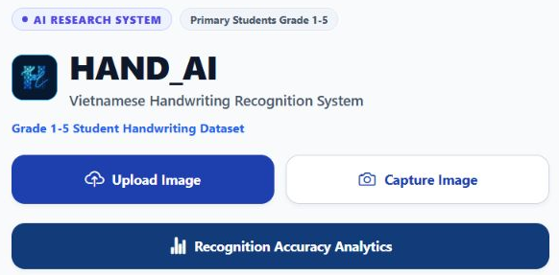
Figure 1. Current HandAI app entry screen, captured from the actual Expo web application on 2 October 2026. [10, 11]

1.1 Background and motivation
Vietnamese handwriting recognition must preserve tone marks and vowel modifiers that may be faint, detached or merged with notebook ruling. Variation in stroke formation, spacing, slant and character connectivity motivates line-level recognition with explicit human review. Primary-school use is the application target; grade-specific recognition quality still requires a separately verified benchmark.

1.2 Problem statement
The core problem is to transform photographs of handwritten Vietnamese notebook pages into reliable line-level text while preserving diacritics and remaining robust to ruled paper, camera skew, uneven illumination and early-grade handwriting variation. The system must also expose enough evidence to explain errors and trace results back to the model and dataset version used.

1.3 Objectives
- Build line-level Vietnamese handwriting recognition using CRNN + CTC.
- Preserve Vietnamese accents through preprocessing and line-detection design.
- Use guarded contextual AI correction without replacing the CRNN as the core recognizer.
- Provide CER, WER and exact-line match metrics, while keeping model confidence separate from correctness.
- Record dataset, model, experiment and trial provenance to support reproducible evaluation.

1.4 Scope
In scope | Out of scope
Mobile capture/upload, crop, preprocessing and line review | Math problem solving
CRNN handwriting recognition and CTC decoding | Automated teacher grading
AI correction, human arbitration and analytics | Student learning-management workflow
Dataset/model versioning and experiment tracking | Generalized accuracy or learning gains without independent evaluation

1.5 Research questions and contribution
The study asks whether line segmentation can preserve detached Vietnamese marks, how well the packaged CRNN transfers to photographed notebook lines, and when contextual correction helps or harms transcription. These questions require matched predictions and independent references, rather than a comparison of dashboard percentages.
The implemented contribution is an integrated recognition-and-review prototype with traceable model artifacts. CRNN combines convolutional features, recurrent sequence modeling and CTC [8]. HandAI adapts this approach to its Vietnamese line workflow; it does not claim a new recognition architecture or demonstrated superiority over transformer HTR such as TrOCR [9].

2. System Workflow & Architecture

2.1 User workflow
CAPTURE / UPLOAD | → | CROP | → | REVIEW LINES | → | RUN OCR | → | VERIFY RESULT
The mobile workflow takes a camera or gallery image through cropping, line-box review, recognition and transcription review. Users can move, resize, add or delete detected line boxes before submission. Each result preserves the raw OCR text, advisor suggestions and the selected transcription. [10]
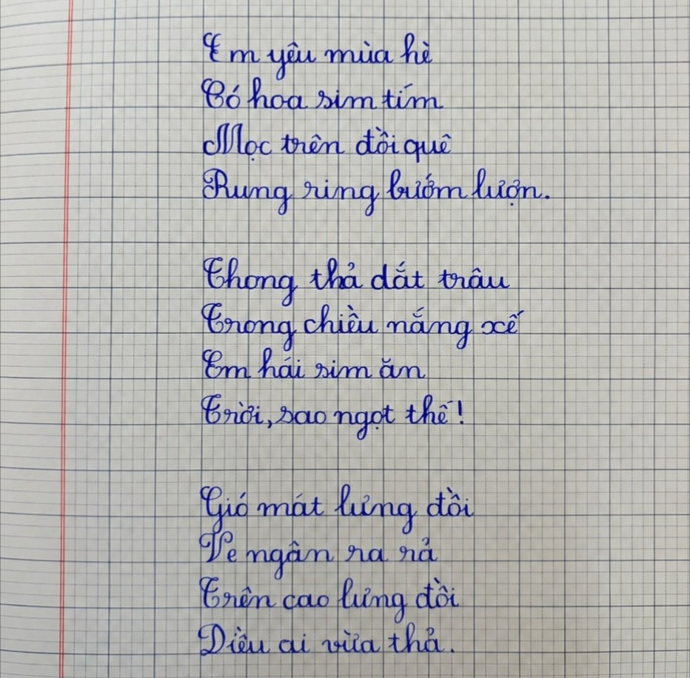  Figure 2. JPEG submitted by the app, exported unchanged from storage. | 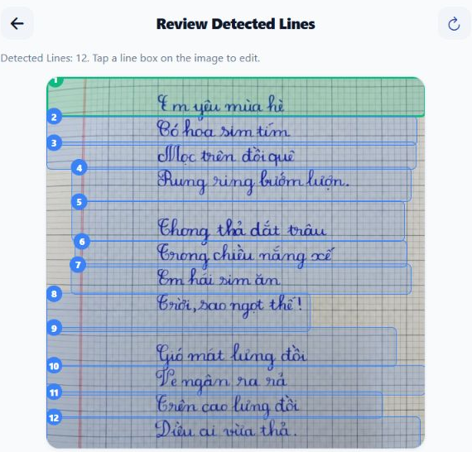  Figure 3. Actual app line review: 12 regions; original proportions.

2.1.1 Processing and live analytics interface
The processing view separates image preparation, line detection, OCR, optional AI review and completion. A progress indicator describes workflow state. Recognition Summary now separates the original OCR stage and the AI-only stage, states its image/session/line denominators and links to a dedicated history page. [4, 10]
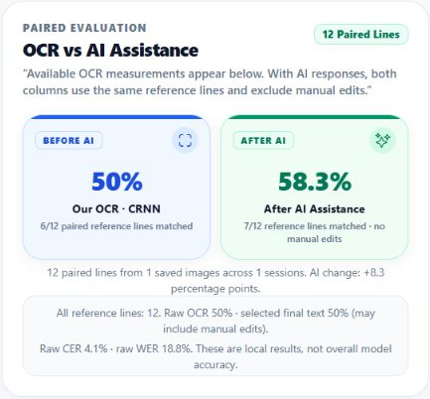  (a) Actual paired OCR–AI card: 6/12 and 7/12. | 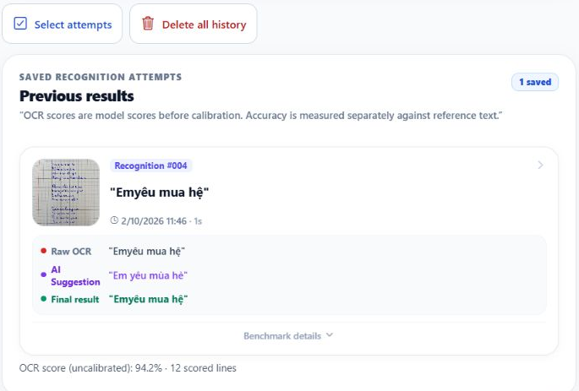  (b) Actual separate history: one complete saved attempt.
Figure 4. Actual app comparison card and stored recognition record from trial 400b509c-bded-44c0-add3-f3f74ee102c4. Captures are crops of the running app, without redrawing text or line boxes. [11]

2.2 Recognition result and verification
- The owner image was uploaded through the app, confirmed as a full-page crop and processed by the existing HandAI API. The app returned 12 line regions; no line boxes were manually added, moved or deleted. The submitted JPEG and all 12 stored line crops were exported from MinIO, with byte hashes checked against the backend records. This GUI trial reuses the actual detector response for the same image hash; it does not force a canonical transcription. [11]
- Actual Groq document review returned qwen/qwen3.8-27b output for all 12 lines. Gemini returned unavailable and its text/score fields remain null. Against the same 12 image-transcribed references, raw OCR matched 6 lines and Groq matched 7. Four wrong lines became correct, while three correct lines became wrong. Raw OCR and AI text are retained exactly as returned; no human-edited text is included in the AI stage. [11]
  Figure 5. Actual stored crop 1: raw “Emyêu mua hệ”, Groq “Em yêu mùa hè”. | 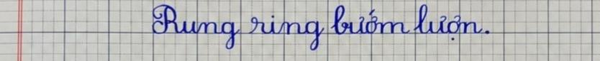  Figure 6. Actual stored crop 4: raw “Rung ring”, Groq “Rung rinh”.

2.3 Major system components
Component | Technology | Role
Mobile application | React Native 0.86.3 / Expo ~57.0.19 | Capture, crop, line review, result verification and analytics UI
Backend gateway | Java 21 / Spring Boot 3.3.6 | Image ingestion, audit flow, storage coordination and AI-service relay
AI runtime | Python / FastAPI; package validated on Python 3.13.9 | Computer-vision preprocessing and model inference
Image processing | OpenCV | Illumination normalization, thresholding, ruling suppression and deskew
Recognition | PyTorch CRNN + CTC | Line-level Vietnamese handwriting recognition
Storage | PostgreSQL + MinIO | Structured provenance/audit data and object storage
AI correction | Groq + Google Gemini | Optional actual-image cloud review; unavailable providers keep null scores and suggestions

2.4 System architecture
HandAI separates the mobile client, Java backend, Python AI service, persistence and client analytics. CRNN inference runs in the AI service. PostgreSQL holds trials and line records; MinIO holds original pages and line crops. Completed non-sample device sessions feed the report. Only finite, tagged CRNN scores are eligible for confidence aggregation; usable references and actual AI candidates are required for paired performance. [2–5, 10]

2.4.1 High-level architecture
Mobile client | Backend gateway | AI service
Capture, crop and review line boxes | Store original page/crops and trial records | Actual CRNN inference and CTC decoding
Raw text, actual suggestions and selected result | Preserve score provenance and feedback | Groq/Gemini receive original image; missing output stays unavailable
Paired report and separate history controls | PostgreSQL records; MinIO image bytes | Uncalibrated model scores; optional self-reported provider scores
Figure 7. Native editable runtime architecture. Advisor review receives the actual stored image; missing provider output remains unavailable. Sources: current model code, OCR API, multiline service and mobile analytics. [1–5, 10]

2.4.2 End-to-end data flow
IMAGE | → | PREPROCESS | → | SEGMENT | → | CRNN + CTC |  | → | AI / HUMAN | → | METRICS
A cropped page is sent through the backend for line detection. The user adjusts returned boxes and submits a multiline trial. The service stores page/crop bytes, preserves raw OCR scores and provenance, and reuses detection output or calls line recognition. Background advisors receive the actual stored page image after its SHA-256 is checked, so a missing page cannot be replaced by a fabricated image. [3, 5, 10]

2.4.3 Runtime boundaries and access control
The OCR provider defaults to CPU unless OCR_DEVICE selects another device. OcrMultilineService processes up to 30 confirmed lines, saves image objects and line records, and launches runBackgroundAdvisors asynchronously. The mobile result screen polls at one-second intervals for up to eight checks while advice is pending. These are implementation limits, not measured latency or throughput. [2, 5, 10]
HandAI has a guest demonstration route: /api/v1/handai/** is public, while /api/v1/ocr/** requires the student role. The multiline controller defaults privacy confirmation to true. Line feedback checks verdict, consent, domain, test status, verified text and stored-image integrity before setting training eligibility. Eligibility records do not trigger model training, and deployment needs explicit consent and access controls. [5]

3. AI Recognition Pipeline

3.1 Image acquisition
The application accepts camera or gallery input. EXIF orientation is handled before downstream coordinate mapping so crop and line positions refer to the correctly oriented image.

3.2 Preprocessing
The documented OpenCV pipeline applies Gaussian blur, illumination/background normalization using a 35×35 background estimate, Otsu inverted thresholding, horizontal ruling suppression and deskew within approximately ±10°.

3.3 Line detection
User crop coordinates are mapped to image pixels to remove irrelevant margins. The line detector uses body/satellite clustering so detached Vietnamese diacritics can remain associated with the correct text line instead of being discarded as noise.

3.4 Recognition and decoding
On the CRNN inference path, line images are resized to RGB [3, 64, 1024] and standardized using ImageNet channel statistics. Four convolutional blocks produce 128 sequence steps; one bidirectional LSTM and a linear classifier produce 320-class logits. Greedy CTC is the checkpoint decoder; beam search provides alternatives. Trial creation may reuse a previously computed detection response for the same image hash. The measured GUI trial records this reuse explicitly; preset canonical transcription is disabled. [1–3, 5, 11]

3.5 Verification
Optional Groq and Gemini review uses the actual document image and raw lines. Missing configuration, unavailable responses and invalid scores remain explicitly unavailable. The previous canonical Local-Advisor branch that filled both provider fields with preset high scores has been removed. Any available provider score is labeled AI_SELF_REPORTED and is not a calibrated OCR accuracy estimate. [3, 5]
ACQUIRE | → | NORMALIZE | → | DETECT LINES | → | CRNN | → | CTC | → | AI CORRECT | → | EVALUATE

4. Dataset & CRNN Model

4.1 Dataset overview
The model manifest records 59,462 training samples and 500 validation samples from Viet-Handwriting-OCR-v2, totaling 59,962. These are handoff metadata, not a recount of the full upstream corpus. HandAI-v1.2 is a dashboard registry label; its grade distribution and dataset totals are not independently established by that label. [1, 4]
Property | Evidence-supported description
Declared split total | 59,962 samples = 59,462 + 500 [1]
Grade coverage | Primary-school target; grade distribution unverified
Training split | 59,462 samples, as declared in the manifest
Validation split | 500 samples, as declared in the manifest
Split seed | 42; random split in the manifest

4.2 Data governance
- Source manifests, hashes and trial records support traceability. Full-corpus image/character counts, annotation coverage and duplicate rates still require the upstream manifests and an independent audit.
- SHA-256 supports file identity and duplicate checks. A perceptual-hash deduplication pipeline and its corpus-wide results have not been demonstrated.
- The handoff manifest states image-disjoint PASS. This is a recorded assertion; the complete training and validation manifests are needed to reproduce the overlap check.
- The manifest marks writer-disjointness UNKNOWN; generalization to unseen writers is therefore not established.
- Privacy must be assessed per endpoint and dataset. Pilot feedback has privacy and eligibility checks, but public HandAI routes and permissive consent defaults remain. Cropping alone does not demonstrate PII removal. [5]

4.3 CRNN model

4.3.1 Packaged recognition model
The checkpoint manifest identifies Vietnamese-Handwriting-OCR-Full version 1.0.0, with 5,962,560 parameters and artifact best_cer.pth. CRNN-v1.2-PyTorch is a client registry label and should not replace the artifact identity. The checkpoint SHA-256 was verified against the manifest. [1, 4]
IMAGE  3×64×1024 | → | CNN  FEATURES | → | SEQUENCE  128 STEPS | → | BiLSTM  256-D | → | LINEAR  320 | → | CTC  TEXT

4.3.2 Architecture
Stage | Specification | Purpose
Input | [B, 3, 64, 1024] | Standardized RGB handwriting-line batch
CNN | 4 Conv2d + GroupNorm(8, C) + ReLU; 3 pooling stages | Extract visual stroke and diacritic features
CNN output | [B, 512, 8, 128] | Spatial feature map
Sequence reshape | 128 time steps × 4096 | Convert 2D features into left-to-right sequence
BiLSTM | 1 layer; hidden=128 per direction; dropout 0.2 after LSTM | Model preceding and following sequence context
Linear | 256 → 320 classes | Character-class logits
CTC | blank index 0 | Alignment-free sequence decoding
Beam search | width 15; top-k 5 | Candidate generation; not a measured gain over greedy

4.3.3 Training evidence
- Manifest: best checkpoint at step 16,900; official validation CER 11.3388% on the declared 500-sample validation set.
- Manifest: early stopping at step 18,901; this is a different step from the selected checkpoint.
- Manifest: loss at the best step 0.4518. Training was not rerun for this report. [1]

4.3.4 Interpreting training and validation evidence
Recorded measurement | Value | Evidence scope
Official validation CER | 11.3388% | Declared 500-sample split; best step 16,900
Comparable training CER | 8.66182% | Training subset; size not recorded
Reevaluated validation CER | 11.19701% | Same checkpoint step 16,900
Comparable CER gap | 2.5352 pp | Reevaluation gap; not a zero-overfitting result
Loss at best step | 0.4518 | Recorded training loss; no new training
Figure 8. Native editable checkpoint evidence from model_manifest.json. Official validation CER, comparable-step reevaluation and loss retain their separate measurement scopes; no training was rerun. [1]
At the comparable checkpoint step 16,900, the recorded training-subset CER is 8.66182% and reevaluated validation CER is 11.19701%, a gap of 2.5352 percentage points (about 2.54). The training-subset size is not stated. This is not evidence of zero overfitting, and the official best validation CER of 11.3388% remains a separate handoff metric. Five smoke samples are not an independent test set. Arithmetic evaluation remains BLOCKED_DATASET. [1]

4.4 Local collection and data preparation
The owner_173 quarantine collection is separate from the declared training corpus. A direct count of source_manifest.csv gives 173 source records: 169 marked usable and 4 rejected, across 72 source_group values. These groups are not verified writer or student identities. The manifest records file hashes, image dimensions, blur, brightness and quality labels. [6]
Local collection count | Observed source manifest
Source records | 173
Usable / rejected images | 169 / 4
Source-group labels | 72; not verified writer identities
Line candidates | 510; all PENDING; verified text empty
Figure 9. Native editable counts from the local quarantine manifests. These are provisional candidate counts, separate from model training, validation and the app case study. [6]
All 510 line candidates have review_status=PENDING and empty verified_text. Their category labels are preliminary, not human-verified ground truth. The next data step is annotation and quality review, followed by deduplication and split assignment; these records must not be counted as a validated benchmark or training gain. [6]
The data-management aspect is the linked lifecycle of image objects, metadata, line crops, labels, model artifacts and evaluation records. Current evidence demonstrates a prototype data pipeline. It does not establish distributed processing scale, production throughput or completed automated retraining.

5. AI Correction & Human Verification
The workflow keeps raw OCR, actual advisor suggestions and human-selected text distinct. A CRNN score carries CRNN_CTC_SOFTMAX provenance; provider-reported scores carry AI_SELF_REPORTED provenance. Untagged legacy scores, non-finite/out-of-range values and unavailable provider scores are not shown as measurements. Feedback verdicts and consent/integrity checks retain their existing eligibility role; no retraining is triggered. [3, 5, 10]
Control | Purpose
Provider provenance | Only actual provider responses retain their provider/model provenance; no local suggestion is copied into two provider fields.
Consensus and evidence rules | Agreement is a review signal; exact correctness still requires the reference image/text.
Configured edit ratio 0.35 | A post-corrector setting, not proof that every endpoint and fallback enforces the same limit.
Visible decision source | Retain raw text, advisor suggestion and human-selected text as separate stages.
Fallback behavior | Missing configuration or provider failure remains UNAVAILABLE. Raw CRNN output is retained; no preset confidence is supplied.

6. Evaluation & Error Analysis

6.1 Analytics scopes
Scope | Purpose
Trial Analytics | Inspect one trial and its line records, references, edits and decision sources.
Global Analytics | Legacy cross-session summary; retained for existing exports and trial views.
Research Analytics | Filter completed non-sample sessions and compute verified line metrics from the local history store.
Completed non-sample sessions supply activity counts. OCR confidence is averaged only over finite scores in [0,1] with CRNN_CTC_SOFTMAX provenance; the scored-line count is shown. Exact-line accuracy and corpus CER/WER require usable references. Paired OCR/AI metrics use the same eligible lines with actual provider candidates, with manual edits kept outside the AI stage. The summary states images, sessions, processed lines and scored references. [4, 10]

6.2 Core metrics
Metric | Definition
CER | Character-level Levenshtein substitutions + deletions + insertions divided by reference character count.
Complement of CER | 100 − CER% is a display score, not exact character accuracy; edit distance can exceed reference length.
WER | Token-level edits divided by reference token count. State tokenization; Vietnamese whitespace units are not always linguistic words.
Complement of WER | 100 − WER% is not exact word-match accuracy. A display clamp must not hide the original WER.
Line Accuracy | Exact full-line match under the stated normalization. The measured receipt uses NFC, whitespace normalization, and preserves case/punctuation.
Confidence | Arithmetic mean of peak softmax probability per emitted non-blank CTC character, rounded to 4 decimals. Uncalibrated; not whole-line correctness probability.

6.3 Evidence-supported performance reporting
The primary recorded model result remains validation CER 11.3388% at checkpoint step 16,900 on the declared 500-sample validation split. This model-handoff measurement remains separate from device-session analytics, whose values vary with the completed live records stored on the device. [1, 4, 10]
Recognition Summary contains paired original-OCR and AI-stage columns and the data scope behind each value. Recognition History is a separate page with selected deletion, deletion of all records and cleanup of incomplete legacy entries. Detail preserves the input image and every stored line, including raw OCR, provider suggestion, selected final text and decision source. Missing legacy evidence is not reconstructed. [4, 10]
Evidence | Value or scope | Interpretation
Checkpoint manifest | Validation CER 11.3388% | Existing model-handoff evidence
Live completed sessions | Non-sample records on the current device | Image/session counts, processed lines, measured OCR-score counts and recorded request time
Verified line records | Separately provided reference text | Original OCR accuracy/CER/WER; AI-only comparison requires real candidates on the same lines
No usable reference | Value unavailable | Em dash or explanatory empty state; no fallback score
The two accuracy columns use the same 12 reference lines with actual recorded Groq candidates. Raw OCR is 6/12 (50.00%) and AI-only text is 7/12 (58.33%), a change of +8.33 percentage points. The current selected text was left as raw OCR and is a separate 6/12 result. App displays round these values to 50%, 58.3% and +8.3 pp. Section 6.7 retains the exact counts and edit totals. [11]
Actual live analytics and stored evidence
(a) Actual paired summary; same 12 image-transcribed reference lines.
(b) Actual saved history with image, raw OCR, AI suggestion and selected text.
Figure 10. Actual app OCR–AI summary and separate Recognition History. The UI uses one saved image, one session and 12 explicit reference lines from the actual GUI trial. [11]
A separately transcribed image reference can support this image-specific audit. It does not make the image an independent test set: the owner image and transcription have already been used in project development. Section 6.6 therefore remains the protocol for a separate frozen research comparison. [11]

6.4 Error analysis
The evaluation retains direct character and token edit counts for each raw and AI line. The following taxonomy describes categories for a future reviewed diagnostic assignment; it is not an observed error-frequency chart or an implemented empty Error Insights panel. No category frequencies are inferred from the screenshot. [4, 11]
Category | Interpretation
NO_ERROR | Prediction matches the verified reference.
LOW_IMAGE_QUALITY | Blur, weak contrast, glare or capture quality dominates.
SEGMENTATION_FAILURE | Detected line/crop does not isolate the intended handwriting.
VIETNAMESE_TONE_ERROR | Difference in tone or diacritic marks; distinguish tone marks from vowel-shape modifiers.
SIMILAR_CHARACTER_CONFUSION | Potential confusion between visually similar characters or strings; examples are illustrative.
MISSING_CHARACTER | Character deletion.
EXTRA_CHARACTER | Character insertion.
WORD_SUBSTITUTION | Predicted lexical unit differs from the reference word.
The measured app export supports exact matches and Levenshtein edits for all 12 lines. It also exposes newly corrected and newly damaged lines. Per-token minimum, P10 and entropy were not retained in the backend DTO for this trial; earlier offline diagnostic values are not substituted. The recorded CRNN per-line scores remain available in Section 6.7. [11]

6.5 Post-recognition evaluation
Explicit references, user confirmations and missing-reference states remain distinguishable. Recognition Summary now uses explicit reference text for a meaningful stage comparison, instead of substituting the selected result as independent truth. Scientific claims still require a frozen external reference, with raw OCR, AI-only output and the human result exported separately. [4, 10]
Research contribution
HandAI links real input images, CRNN output, actual advisor responses and human review. The current one-image study measures both correction and damage; generalization or superiority over other recognizers needs an independent test set.

6.6 Protocol for a reproducible comparison
Freeze a test manifest with image and line hashes, independent reference text and writer/group identifiers where available. Record Unicode normalization, whitespace/tokenization rules and exclusions before scoring. Keep this set separate from training, model selection, canonical fixtures and prompt examples. The local pending collection is not eligible until its references are reviewed.
Stage | Output evaluated | Purpose
A — raw CRNN | Text before any advisor or human edit | Recognition baseline
B — AI-only | Actual provider candidate before any human editing | Incremental correction effect
C — final human | Text after user review | End-to-end workflow result
Score A, B and C against the same reference. Compute corpus CER/WER from total edit counts and total reference units; report exact-line matches with numerator and denominator. Report newly corrected and newly damaged lines, provider/fallback counts and paired uncertainty intervals. Express the raw-to-final difference in percentage points and report relative change only when its denominator and interpretation are explicit.
Latency evaluation must state hardware, image/line size, warm-up, batch size and included processing/network/cloud stages. The app records about 1 s for this trial-creation request, excluding its earlier line-detection request and later background advisor work. The recorded Groq document-review call took 5.59 s. These single-request timings are not median/p95 latency or end-to-end throughput. OCR scores remain uncalibrated. [11]

6.7 Actual app case study · 2 October 2026
One owner image was uploaded through the real app and persisted as trial 400b509c-bded-44c0-add3-f3f74ee102c4. The backend stores the source page and 12 line crops; the export checks all 13 SHA-256 values against MinIO bytes. Groq returned an actual HTTP 200 document-review response; Gemini was unavailable. No generated photograph, redrawn overlay, imported QA-history receipt or preset local advisor is used as evidence. [11]
References were transcribed from the visible owner image and entered with the app’s separate “Add reference text” controls after inference. They did not change the raw OCR, provider candidates or selected text and were not supplied to the advisors. This image has been used in project development; independent human reference verification and unseen-writer evaluation remain pending.
Same-reference measurement | Our OCR / CRNN | Actual Groq candidate
Image / session / reference lines | 1 / 1 / 12 | Same 1 / 1 / 12
Exact-line match | 6/12 = 50.00% | 7/12 = 58.33%
Corpus CER | 8/194 = 4.1237% | 5/194 = 2.5773%
Corpus WER | 9/48 = 18.7500% | 5/48 = 10.4167%
Change in exact match | Baseline | +8.3333 percentage points
Corrected / damaged lines | — | 4 corrected / 3 newly wrong
Human edits included | 0 | 0
Scoring: Unicode NFC, trim and collapse whitespace, preserve case and punctuation. CER/WER use total edits divided by total reference characters/tokens, not an average of line percentages. Vietnamese whitespace tokens are not necessarily linguistic words. App values are rounded to one decimal; the native tables retain exact numerators and denominators.

6.7.1 Every raw and AI line, including worsening
The actual provider fixes lines 1, 3, 4 and 9, but makes correct lines 6, 7 and 10 incorrect. Lines 5 and 8 remain incorrect. All selected texts were left as raw OCR (6/12); this separate final-selection stage is not presented as AI performance.
# | Raw OCR | Actual Groq text | Image reference
1 | Emyêu mua hệ | Em yêu mùa hè | Em yêu mùa hè
2 | Có hoa sim tím | Có hoa sim tím | Có hoa sim tím
3 | Mọc trên đôi quê | Mọc trên đồi quê | Mọc trên đồi quê
4 | Rung ring bướm lượn. | Rung rinh bướm lượn. | Rung rinh bướm lượn.
5 | Chong thả dắt trâu | Chong thả dắt trâu | Thong thả dắt trâu
6 | Trong chiều nắng xế | Trong chiếu nắng xế | Trong chiều nắng xế
7 | Em hái sim ăn | Em hái sim ần | Em hái sim ăn
8 | Triời, sao ngọt thế! | Trời, sao ngọt thê! | Trời, sao ngọt thế!
9 | Gió mát lưng đôi | Gió mát lưng đồi | Gió mát lưng đồi
10 | Ve ngân ra rả | Ve ngan ra rả | Ve ngân ra rả
11 | Trên cao lưng đồi | Trên cao lưng đồi | Trên cao lưng đồi
12 | Diều ai vừa thả. | Diều ai vừa thả. | Diều ai vừa thả.

6.7.2 Actual OCR scores and counted errors
The score is the arithmetic mean of peak softmax probability at emitted non-blank CTC characters, rounded in the service. It is not the probability that the whole line is correct. Every score below is tagged CRNN_CTC_SOFTMAX. Provider scores are AI_SELF_REPORTED and remain separate: even a 99% self-reported AI score can accompany a wrong candidate.
# | OCR score | Raw exact | AI exact | Raw char/token edits | AI char/token edits
1 | 83.31% | No | Yes | 3 / 4 | 0 / 0
2 | 97.34% | Yes | Yes | 0 / 0 | 0 / 0
3 | 94.46% | No | Yes | 1 / 1 | 0 / 0
4 | 97.55% | No | Yes | 1 / 1 | 0 / 0
5 | 93.93% | No | No | 1 / 1 | 1 / 1
6 | 95.68% | Yes | No | 0 / 0 | 1 / 1
7 | 96.92% | Yes | No | 0 / 0 | 1 / 1
8 | 92.21% | No | No | 1 / 1 | 1 / 1
9 | 91.17% | No | Yes | 1 / 1 | 0 / 0
10 | 95.87% | Yes | No | 0 / 0 | 1 / 1
11 | 96.98% | Yes | Yes | 0 / 0 | 0 / 0
12 | 94.75% | Yes | Yes | 0 / 0 | 0 / 0
Mean recorded OCR score: 94.1808% over 12 scores; range 83.31%–97.55%. Exact-line accuracy is 50.00%, illustrating the difference between model certainty and correctness. A separate calibration set and reliability evaluation are still required. Min-token/P10/entropy values were not persisted for this app trial and are not filled with earlier offline values.

6.7.3 Traceability and app evidence
Recorded parameter | Actual source
Trial / source | 400b509c-bded-44c0-add3-f3f74ee102c4 / GALLERY
Created time | 02 Oct 2026, 11:42:20 ICT (04:42:20 UTC)
App channel | Expo web GUI; genuine app/API records, not a physical-phone capture
Input / segmentation | 932 × 916 JPEG; 12 regions from the actual same-image detection cache
Raw recognizer | Packaged CRNN; RGB 3 × 64 × 1024; greedy CTC; CPU
Actual provider | Groq qwen/qwen3.8-27b: 12 SUCCESS; Gemini: 12 UNAVAILABLE
Reference storage | 12 explicit app-local references; backend feedback refs remain null
Stored source SHA-256 | 861275dd8f5f225cc3863047dedfb01627a9ebe681193455ff32c57d110fd17e
Model artifact | Existing best_cer.pth; manifest SHA checked separately; trial hash fields are empty
Training / overrides | No training; no preset local advisor; canonical runtime override disabled
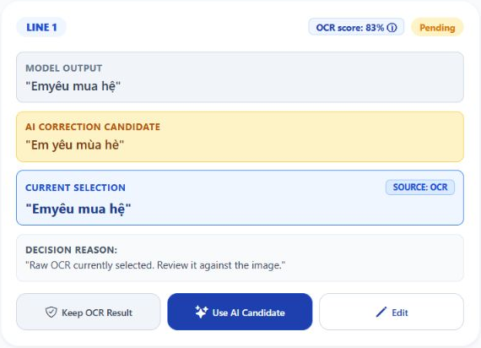
Figure 11. Actual app line 1: raw OCR, real Groq suggestion and the untouched current OCR selection. Original screenshot pixels are cropped only. [11]
Receipt files include actual_gui_receipt.json, actual_gui_trial_api_response.json, actual_gui_trial_database.json, actual_gui_scored_metrics.json and actual_gui_line_results.csv. Original page/crops and complete app screenshot contexts accompany the package. Existing validation CER 11.3388% on the declared 500-sample split remains separate model-handoff evidence.

7. Experiment Tracking & Reproducibility
Backend trial records and client session history preserve line images, raw output, advisor fields and feedback. The separate Recognition History page supports deleting selected sessions or all sessions, with confirmation, and cleaning incomplete legacy records. Deletion recomputes local report scope from remaining sessions. The receipt exported for this report is a fixed evidence artifact and remains separate from editable local history. [4, 5, 10, 11]
Tracked evidence | Examples
Dataset | Dataset ID plus immutable split manifests; dashboard labels alone are insufficient
Model | Manifest model/version + checkpoint and vocabulary hashes
Experiment | Registry entry plus actual run configuration, timestamps and outputs
Checkpoint integrity | best_cer.pth SHA-256 verified against the manifest [1]
Trial metadata | Image/line IDs, dimensions, preprocessing and execution-path metadata
Evaluation | Independent reference, stage-specific outputs, counts and inclusion rules

7.1 Reproducibility record
This revision combines the existing model handoff with an actual GUI-created trial on 2 October 2026 and the current working-tree report/history/confidence fixes. The app upload, actual API/SQL response, MinIO images, provider HTTP outcome and 12-line scoring export form a linked receipt. No model training or new 500-sample benchmark was performed. [11]
Verified checkpoint SHA-256: a807eaa763a4471bc057b9545a3521612423214858d50b1ef42b7baf28de0941. Reproduction also requires the vocabulary, runtime dependencies, preprocessing/decoding settings, immutable split files and per-sample outputs. The legacy evaluation/run_evaluation.py targets an arithmetic pipeline and is not evidence of a completed HandAI 500-line experiment.

7.2 Evidence sources and references
[1] ai-service/models/ocr/crnn_vi_handwriting_v1/model_manifest.json and best_cer.pth. Model identity, split counts, handoff metrics and artifact hash.
[2] ai-service/app/ocr/model.py and crnn_provider.py. CNN/BiLSTM architecture, preprocessing, decoding and execution device.
[3] ai-service/app/api/ocr.py and app/ocr/uncertainty_estimation.py. Actual line detection, image-backed advisor requests, nullable score provenance and removal of the preset local-advisor fallback.
[4] apps/mobile/src/services/analytics/handAiAnalyticsStore.ts and handAiDashboardMetrics.ts. Trial scoring, reference-status rules, persistence, live-session filtering and corpus metric aggregation.
[5] backend/src/main/java/com/mathvisionkids/api/: config/SecurityConfig.java; ocr/multiline/HandAiOcrController.java and OcrMultilineService.java. Guest routing, image storage, trial creation, background advice, feedback and training eligibility.
[6] datasets/quarantine/owner_173/hwtext_v1/source_manifest.csv and line_candidates.csv. Direct counts of local source images, candidate categories and review status.
[7] Owner-supplied source poem and original phone screenshots. The current measured evidence uses the same owner image uploaded through the app; source images are not generated by AI.
[8] Shi, B., Bai, X. and Yao, C. (2015). An End-to-End Trainable Neural Network for Image-based Sequence Recognition and Its Application to Scene Text Recognition. https://arxiv.org/abs/1507.05717
[9] Li, M. et al. (2021). TrOCR: Transformer-based Optical Character Recognition with Pre-trained Models. https://arxiv.org/abs/2109.10282
[10] apps/mobile/src/app/handai-analytics.tsx, evaluation-history.tsx, (tabs)/index.tsx, crop.tsx, ocr-pilot/multiline-review.tsx and multiline-result.tsx; screens/HandAiTrialAnalyticsScreen.tsx; services/api/ocrPilotService.ts; services/analytics/handAiDashboardMetrics.ts; components/ocr/OCRProgressLoader.tsx. Current routing, line editing, stored-image evidence, polling, progress and live analytics states.
[11] evidence/actual_gui_receipt.json, actual_gui_trial_api_response.json, actual_gui_trial_database.json, actual_gui_scored_metrics.json and per-line CSV. Actual GUI trial 400b509c-bded-44c0-add3-f3f74ee102c4; MinIO page/crop hashes, actual Groq response and original app captures. References were read from the owner image and entered through the app after inference; independent human validation remains pending.

8. Limitations & Future Work

8.1 Current limitations
- Generalization to primary-school grades and difficult handwriting is not established by a dedicated independent benchmark. The current evidence does not support a general 90%+ accuracy claim.
- Faint Vietnamese diacritics can be lost under poor illumination or weak stroke contrast.
- Arithmetic-specific evaluation is underrepresented / blocked by insufficient arithmetic lines in the current corpus.
- Direct resizing to 64×1024 can distort handwriting lines with extreme aspect ratios.
- Cloud correction depends on provider availability and can introduce new errors. This trial has 12 actual Groq responses and unavailable Gemini output. Groq corrected four lines but damaged three; agreement and high self-reported confidence do not prove handwriting correctness.
- Writer-disjoint evaluation is unresolved, and screenshot scores do not establish reproducible experiment results.

8.2 Future roadmap
Direction | Expected improvement
ONNX Runtime / CoreML | Future work: evaluate device inference and latency; currently CRNN runs in the AI service.
Arithmetic-specific fine-tuning | Future work: obtain consented, verified arithmetic data before any training.
Aspect-ratio-preserving right padding | Future work: compare padding against fixed resizing with matching evaluation conditions.
Stronger sequence architectures | Future work: compare transformer HTR with the same data, decoding policy and compute budget.
Expanded evaluation corpus | Future work: independent references, writer-aware splits and difficult-handwriting subsets.
Next evidence milestone | Required output
Freeze an independent test set | New writer/image manifest and fixed split hashes
Verify references | Human-confirmed line transcriptions with provenance
Score matching stages | Raw OCR, actual AI-only text and human-final text separately
Evaluate uncertainty | Calibration, confidence intervals and repeated latency runs
Pilot preparation | Privacy, access controls and deployment review
Figure 12. Planned evidence roadmap. These are future milestones, not completed retraining or a new independent benchmark.

8.3 Conclusion
HandAI delivers an integrated Vietnamese handwriting workflow with editable line segmentation, traceable CRNN scores, optional actual AI review and complete stored-line inspection. On one actual app image with 12 image-transcribed references, raw OCR matched 6 lines and real Groq output matched 7 (+8.33 pp). Raw CER is 8/194 and WER 9/48; AI CER is 5/194 and WER 5/48. This is a development-image case study, separate from the declared 500-sample checkpoint evidence, and does not establish general recognition accuracy. [11]

9. Team Member Review and Comment
NAME | REVIEW AND COMMENT
Nguyen Van Duy Manh
Tran Hoai Nam

10. Instructor Review and Comment
CATEGORY | SCORE | REVIEW AND COMMENT
IDEA | __/10
APPLICATION | __/30
RESULT | __/30
PROJECT  MANAGEMENT | __/10
PRESENTATION & REPORT | __/20
TOTAL | __/100

