3D Slicer Module
Installation & Setup Guide
PETCTQuantAnalysis v2 • UreterPostProcess
For first-time users of 3D Slicer

ℹ️ Platform Note
These modules were developed and tested on Windows 10/11. If you are on macOS or Linux, the steps are the same but some file paths will look different (use forward slashes and your OS home directory).

1. Install the following Extensions

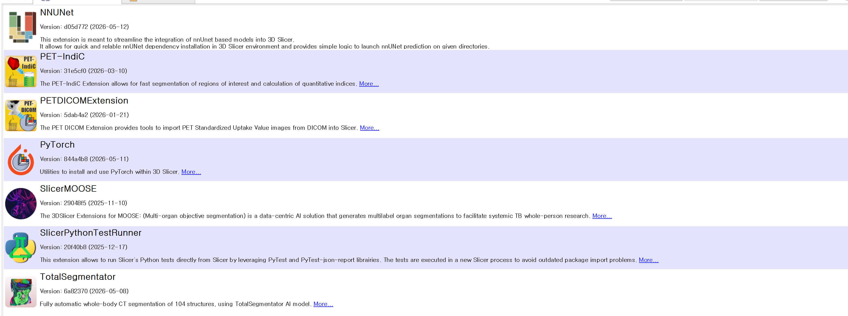

2. Install Required Python Packages Into Slicer

Copy and paste the following block into the Python Interactor and press Enter. It will install all packages in one go:

import subprocess, sys
pkgs = ['openpyxl', 'pydicom', 'scipy', 'numpy']
for pkg in pkgs:
subprocess.check_call([sys.executable, '-m', 'pip', 'install', pkg])
print(f'Installed: {pkg}')
print('All done!')

Wait for all four packages to finish. You will see a confirmation line for each one.

Package | Purpose | Used By
openpyxl | Read and write Excel (.xlsx) output files | PETCTQuant v2
pydicom | Read DICOM header tags (patient ID, dose, weight, injection time) | PETCTQuant v2
scipy | Image resampling (map_coordinates) for voxel space transformations | UreterPostProcess
numpy | Array operations on 3D voxel data (usually pre-installed, included for safety) | Both modules

ℹ️ Note on numpy
numpy is usually already bundled with Slicer, but including it in the install command is safe and ensures you have a compatible version.

3. Initialise the DICOM Database
This is the most common cause of the error importDicom produced no new series UIDs. Slicer’s DICOM database must be open before any module can import DICOM files. Currently we have added a fix but just in case it fails to read the directory.

Check if a Persistent Database Location already exists
By default, Slicer stores DICOM metadata in a temporary folder that may be cleared. To set a permanent location:
- Go to: Edit → Application Settings → DICOM.
- Under Database location, click the folder icon and choose a permanent path (e.g. C:/SlicerDICOM).
- Click OK and restart Slicer.
- 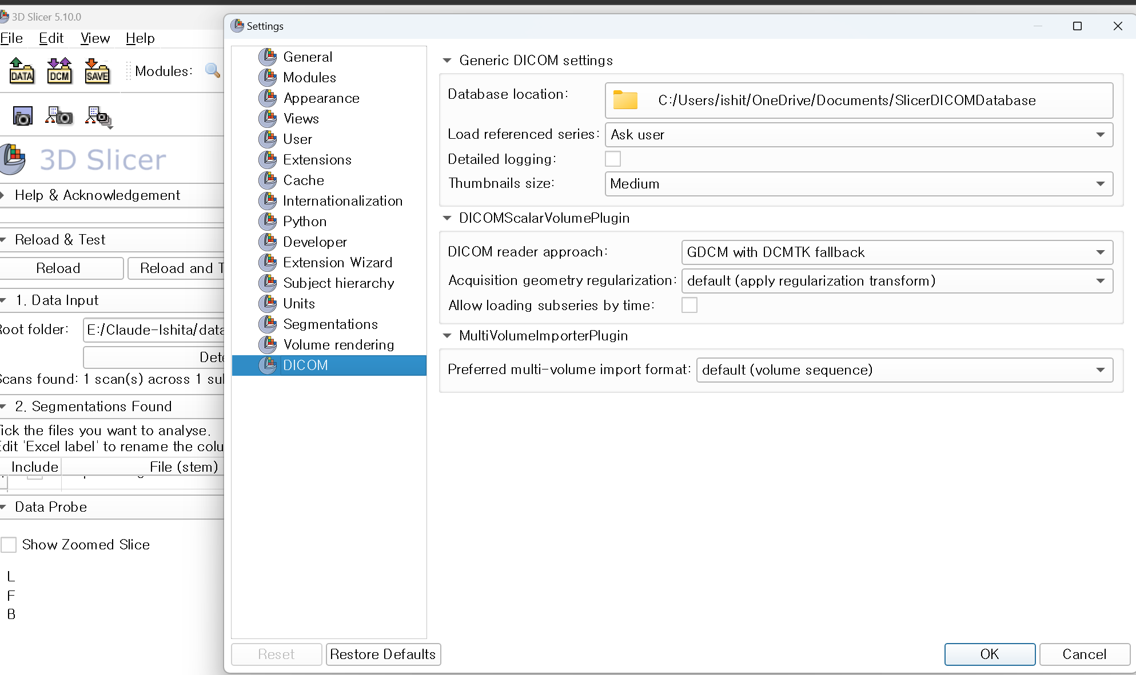

5. Add the Module Files to 3D Slicer
3D Slicer does not load Python scripts automatically. You must tell it where to find your module files.

5.1 Place the Files in a Good Location
Copy both module files to a folder that has no spaces in its path. This avoids path-handling bugs on Windows.

📁 Path Naming Rule
GOOD: C:\SlicerModules\extension\ BAD: C:\KU PET CT MS\extension\ (spaces in path cause errors)

The two files you need are:
- PETCTQuantAnalysis_v2.py
- UreterPostProcess.py
Now there are two methods to load them correctly. You can choose either.
Method 1: Drag and drop the python files into 3D slicer

Method 2: Register the Module Path in Slicer
- In Slicer, go to: Edit → Application Settings → Modules.
- Under Additional module paths, click the ➕ Add button.
- Browse to the folder containing the .py files (e.g. C:\SlicerModules\extension) and click Select Folder.
- Click OK.
- Slicer will prompt you to restart. Click Restart Now.

✓ One-Time Setup
You only need to do this ONCE. After Slicer restarts, it will remember this path in all future sessions.

5.3 Verify the Modules Loaded
- After restarting, go to: Modules → Quantification → PET/CT Quantitative Analysis v2.
- Also check: Modules → Segmentation → Ureter Post-Process.
If either module is missing, see the Troubleshooting section at the end of this guide.

6. Expected Data Folder Structure
Both modules expect your patient data to be organised in a specific folder layout. If the structure is wrong, the modules will report missing folders and skip patients.

6.1 PETCTQuantAnalysis v2
root_folder/
├── CT/
│ ├── MSP0001_2025-07-09_CT/ ← Contains *.dcm files
│ └── MSP0002_2025-08-15_CT/
├── PET/
│ ├── MSP0001_2025-07-09_PET/ ← Contains *.dcm files
│ └── MSP0002_2025-08-15_PET/
└── Segments/
├── MSP0001_2025-07-09_Seg/ ← Contains *.nii.gz files
└── MSP0002_2025-08-15_Seg/

Folder naming rule: {SubjectID}_{YYYY-MM-DD}_{Modality}
- SubjectID: any alphanumeric string (e.g. MSP0001)
- Date: must be in YYYY-MM-DD format (e.g. 2025-07-09)
- Modality: must be exactly CT, PET, or Seg (case-sensitive)

[Refer Video tutorial on how to run the modules]

8. Understanding Log Messages
3D Slicer prints many messages to its log and Python console. Most are harmless. This table explains the ones you are likely to see:

Message | Severity | What to do
libpng warning: iCCP: known incorrect sRGB profile | Harmless | A Slicer icon PNG has a slightly malformed colour profile. Does not affect any functionality. Ignore it.
GetModuleHomeDirectory: failed to compute module home directory | Harmless | Slicer fires this warning early in loading before it resolves the path. If the module appears in the Modules menu, it loaded successfully.
QSqlQuery::prepare: database not open / SQLITE ERROR: Unable to fetch row | Action needed | DICOM database is not open. Open the DICOM Browser first (Modules → DICOM). See Section 3.
importDicom produced no new series UIDs | Action needed | The DICOM database is not open (most common), or the folder contains no valid DICOM files. Open DICOM Browser first. Confirm .dcm files exist in the PET folder.
ModuleNotFoundError: No module named 'openpyxl' | Action needed | Package not installed into Slicer's Python. Run the pip install block in Section 3 and restart Slicer.

9. Troubleshooting

Module does not appear in the Modules menu
- Check the path you added in Application Settings has no typos.
- Confirm the path contains no spaces (rename folder if needed).
- Check the Python Console for any import errors when Slicer loads.
- Make sure both .py files are directly in the folder you registered, not in a subfolder.

Module appears but clicking Start does nothing / crashes
- Open the Python Interactor (View → Python Interactor) and watch the console while running.
- Look for red error lines that name the specific failure and report it. I will check the cause of the bug and fix it.

Excel output file is created but all rows show errors
- Check that the PET folder name matches the pattern exactly: {ID}_{YYYY-MM-DD}_PET.
- Confirm DICOM files are present inside each PET subfolder (not zipped or in further subfolders).

scipy or numpy errors during UreterPostProcess
- Re-run the pip install block from Section 2 in the Python Interactor.
- Restart Slicer after installation.

File rename blocked — 'file is open in another program'
- Close 3D Slicer completely before renaming any folder in the data path or module path.
- If it still fails, open Task Manager → Resource Monitor → CPU tab, search the folder name under Associated Handles, and end the locking process.

10. Quick-Start Checklist
Use this checklist for every new installation:

☐ | 3D Slicer 5.6+ installed
☐ | QuantitativeReporting extension installed via Extensions Manager
☐ | openpyxl, pydicom, scipy, numpy installed via Slicer Python Interactor
☐ | Both .py files placed in a folder with no spaces in its path
☐ | Folder path registered under Edit → Application Settings → Modules → Additional module paths
☐ | Slicer restarted after registering the module path
☐ | Both modules confirmed visible in the Modules menu
☐ | DICOM Browser opened (Modules → DICOM) before each session of running the modules

For additional help, check the Python Console in Slicer (View → Python Interactor) for detailed error messages.

