Check your code. There must be a dead loop.

Refer attached file:

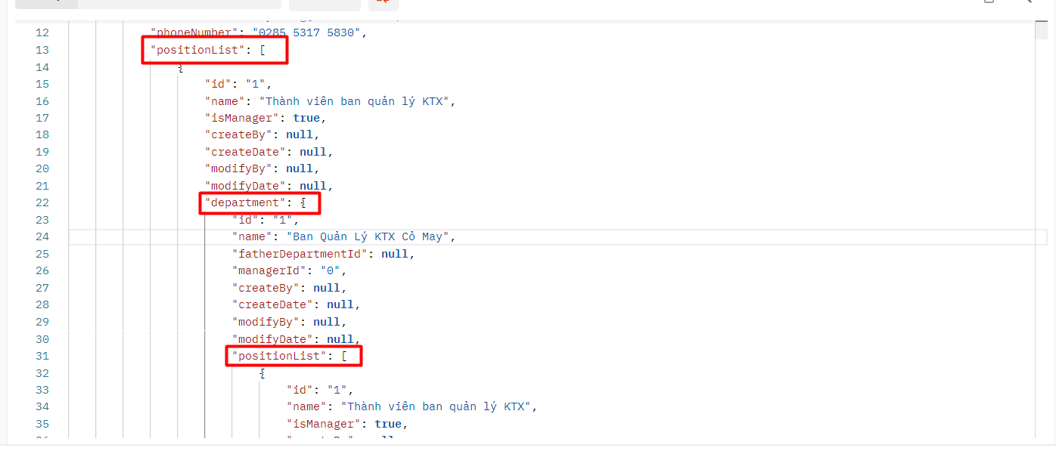



**Solution:**

**Example:**

**In this case:**

**Use @JsonBackReference in relationship variable in Department.java and Position.java**

