Progress Report
Mapping the Land and the Forest Floor in Three Dimensions from Ordinary Satellite Pictures, with Help from Space Lasers
A non-technical summary of work completed so far on the first paper of the dissertation.
Candidate: Navaneeth. Program: Computer Science PhD, University of Alabama in Huntsville.
Prepared for review by the advisor and the department chair. Date: June 2026.

Contents

1. One-page summary
This project teaches a computer to build accurate three-dimensional maps of the ground using only ordinary pictures taken by satellites. A method already exists for this, and it works well on open ground and on buildings. It fails in one important place: under trees. Over a forest, the existing method maps the top of the leaves and treats that as the ground, so the true shape of the land beneath the trees is wrong, often by the full height of the trees.
Our idea is to give the computer extra help from two NASA space instruments that fire laser pulses at the Earth and measure height directly. These lasers can see both the top of the trees and the ground below them, but only at scattered points. We use those scattered laser points to teach the satellite method to separate the leafy canopy from the bare ground, so that it can produce both a tree-height map and a true ground map, together with an honest measure of how confident it is in each place.
So far we have rebuilt the existing method on our own computer and confirmed it reaches the same accuracy reported in its publication. We then ran a small controlled test that shows the core of our idea works: with only a handful of scattered laser points, the ground under a forest can be recovered to within a few tenths of a meter, while the standard method is wrong by about the height of the trees. We have also checked the real NASA laser data against an independent, high-quality airborne survey, and confirmed that, once a known height-reference difference is removed and a small number of bad laser shots are discarded, the laser ground measurements agree with the airborne survey to about half a meter. In short, the foundation is verified and the path forward is clear.

2. The problem we are working on
The goal. Turn the large archive of satellite photographs into accurate maps of the surface of the Earth in three dimensions, meaning not just a flat picture but the height of everything in it. Height maps of this kind are used for studying forests and the carbon they store, for flood and water modeling, for city planning, and for many parts of NASA's Earth science work.
Why height from photographs is possible. If you photograph the same place from several different angles, the apparent shift of objects between the pictures reveals how tall they are, in the same way that our two eyes give us depth. Satellites pass over the same location many times from slightly different positions, so the pictures contain the information needed to recover height.
The hard part. Forests break this. Leaves move, shadows shift between seasons, and most importantly the leaves hide the ground. From above, a camera sees the top of the canopy and never sees the soil underneath. So any method built only on photographs will, over a forest, report the top of the trees as if it were the ground. The shape of the land beneath the forest, which matters for water flow, soil, and for measuring how tall the trees actually are, is simply missing.

3. The tools that already exist, and what they do
A few terms first, written out in plain language so the rest of the report is easy to follow:
- Digital Surface Model, or DSM. A height map of the top surface of everything, including tree tops and roof tops.
- Digital Terrain Model, or DTM. A height map of the bare ground, as if the trees and buildings were removed.
- Canopy Height Model, or CHM. The height of the trees alone, which is simply the surface map minus the ground map.
- Lidar. Short for light detection and ranging. An instrument that fires laser pulses and times how long they take to bounce back, which gives a very accurate distance and therefore height.
Over the last few years, researchers learned to build three-dimensional models of a scene from a set of photographs using a technique called Gaussian Splatting. The idea is to represent the scene as a large cloud of tiny soft blobs of color and height that are adjusted until, when viewed from each camera angle, they reproduce the original photographs. An earlier and slower family of methods called Neural Radiance Fields did something similar but took about a day of computing per scene. Gaussian Splatting reaches similar accuracy in a few minutes, which is why we chose it.
A specific version of this technique was built for satellite pictures. It is called Earth Observation Gaussian Splatting, or EOGS. It handles the special features of satellite imagery, such as the unusual camera geometry of an orbiting sensor and the moving shadows across different dates. It is fast and it is among the best published methods for turning satellite photographs into surface height maps. We use it as our starting point.

4. The gap we identified, which is the opening for this work
Every current method of this kind, including the one above, has the same blind spot. It produces only the top surface. The authors of these methods openly note that vegetation and lightly photographed areas are where their results break down. None of them separate the canopy from the ground, and none of them bring in an independent measurement of the hidden ground.
At the same time, NASA operates space instruments that measure height directly with lasers and can see through gaps in the canopy to the ground. Nobody has combined these two things: the fast satellite-photograph method on one side, and the NASA space laser measurements on the other, to fix the forest problem. That specific combination is the contribution of this work. It is a natural fit for our program because it relies on NASA Earth science data and mission context, which is the part that is hard for other research groups to copy.

5. Our proposed solution, in plain terms
We keep the existing fast method and add three pieces to it.
- Laser guidance. We take the scattered height measurements from the NASA lasers and use them as anchor points that tell the model the correct height at those exact spots, both for the canopy top and for the ground. Because the laser points are scattered and not everywhere, the model spreads that information into the gaps, the way a few survey stakes can guide the grading of a whole field.
- Two layers instead of one. We let the model represent a forest as a partly see-through canopy layer sitting above a separate ground layer, rather than a single solid surface. The laser gives two readings at each shot, one for the treetop and one for the ground, and these teach the two layers apart.
- An honest confidence map. The model also reports how sure it is at each location. This matters for science users who need to know where to trust the result, and it sets up a later study on choosing which new pictures to collect.

6. What we have done, step by step, including the problems we hit and fixed

6.1 Rebuilding the existing method and confirming it works
Before adding anything new, we rebuilt the existing satellite method on our own computer and checked that it reaches the published accuracy. This is the standard way to make sure the foundation is sound. The computer used is a single high-end graphics card, an NVIDIA RTX 4090, which is the kind of hardware a single student can own.
Getting the existing software to run took some care, and we solved a series of practical problems along the way. We list them in plain terms because together they show the setup is now reliable and because we turned every fix into a single automatic installer, so the advisor or a labmate can reproduce the whole thing with one command on a fresh machine:
- missing basic building tools that the geographic software needs in order to install;
- a software license agreement that had to be accepted before packages would download;
- a safety setting in our own scripts that clashed with the geographic tools and stopped them;
- a version mismatch in the graphics computing libraries, where the computer had a newer version than the method was built for, which we resolved by installing the exact matching version (12.1) alongside it;
- a related requirement for a specific compiler version, which we supplied;
- a naming clash inside one of our own helper scripts; and
- a missing preparation step for some of the scenes.
Result. The rebuilt method matches the published accuracy. Accuracy here is measured as the Mean Absolute Error, which is simply the average size of the height mistake in meters, compared against an accurate airborne laser survey. Across the four study tiles over Jacksonville, Florida, our average error was about 1.44 meters, which is in line with the roughly 1.4 meters reported by the original authors. The method is therefore working correctly on our machine.

6.2 A controlled test of the core idea
Next we ran a small, self-contained test to check whether the central idea is even possible, before investing in the full build. We created an artificial scene with a known ground shape and a known patch of forest, so that we know the right answer exactly. We then gave a simple model only a few scattered laser-style anchor points and asked two questions: can it recover the hidden ground, and does it still need to be told where the forest is, or can it figure that out by itself.
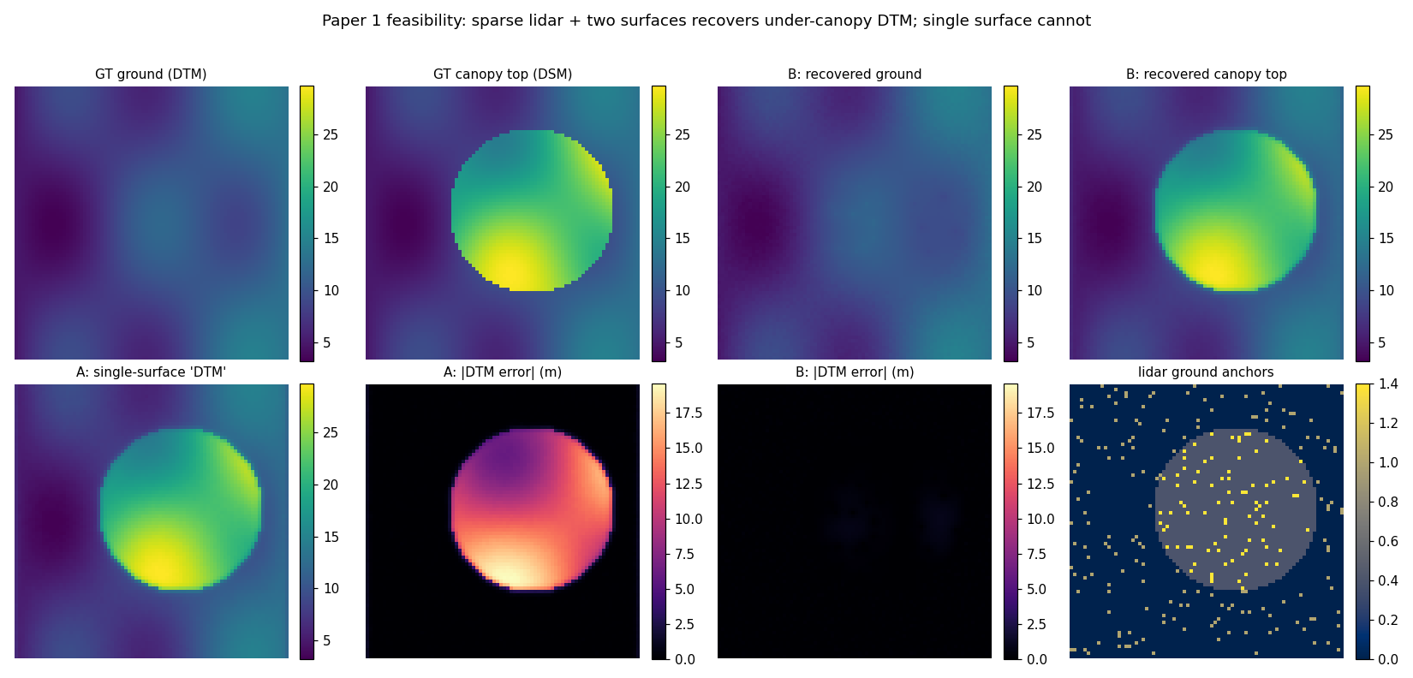
Figure 1. A controlled test on an artificial scene. Top left is the true ground shape. Top middle is the true top surface, where the round patch is a forest sitting above the ground. The standard single-surface method, bottom row, has no ground layer, so under the forest its idea of the ground is wrong by the full height of the trees (bright area in the error map). Our two-surface method, top right and the error map beside it, recovers the hidden ground almost exactly from only a few scattered laser points (marked at bottom right).
What the test showed. With only about four out of every hundred points supplied as laser anchors, the standard single-surface method was wrong about the ground beneath the forest by roughly 12 meters, which is essentially the height of the trees. Our two-surface method recovered the same hidden ground to about 0.2 meters. We also varied how many anchor points were given and confirmed that even a very small number helps a great deal, and that the benefit levels off, which tells us roughly how many laser points we need.
Removing an unfair advantage. In the first version of the test we told the model exactly where the forest was. That is unrealistic, because in real life the computer must work that out for itself. So we ran a second version in which the model is given only a rough, noisy vegetation hint, similar to what ordinary satellite color bands provide, plus the scattered laser points, and it has to infer the forest outline on its own. Even then it recovered the hidden ground to about 0.22 meters, almost as well as when it was told the answer. This removes the last simplifying assumption and gives us confidence that the idea will carry over to real data.
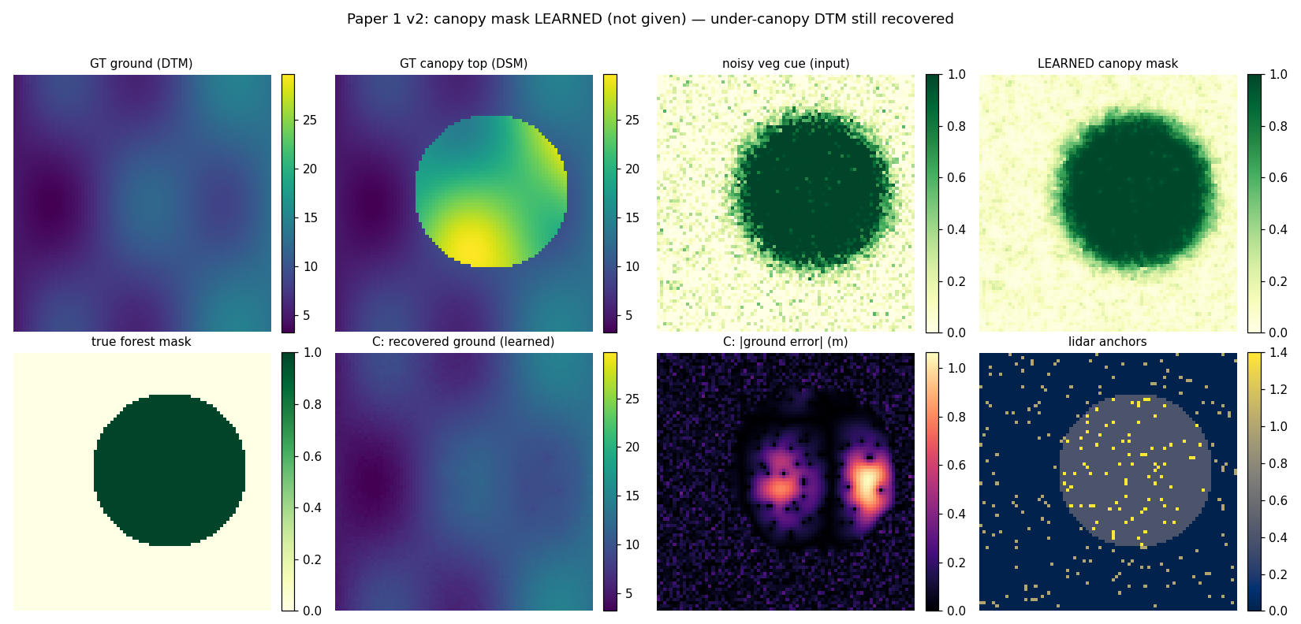
Figure 2. The same test, but now the model is not told where the trees are. It learns the forest outline (fourth panel) on its own from a noisy vegetation hint (third panel) and the scattered laser points, and still recovers the hidden ground accurately. This shows the method does not depend on being handed a perfect map of the trees.

6.3 Checking how much real laser data is available
A good idea is only useful if enough real data exists to support it. We therefore counted how many usable laser measurements fall over our study areas. The NASA laser instruments do not cover every spot. They sample the Earth in narrow tracks, so a small area may receive only a few measurements, while a larger area receives many.
This step also corrected an early mistake of ours, which is worth reporting because catching it is part of doing the work carefully. We first counted laser points over a slightly oversized area and got an encouraging number. When we looked more closely, the official study tile is smaller than we assumed, only 256 meters across, and inside that exact tile there were only seven high-quality laser shots. That is too few to rely on. Over a wider area of about ten kilometers across the city of Jacksonville, by contrast, there are more than seventeen thousand laser shots. The lesson, which we have built into our tools, is to always measure against the exact study area, and to use a larger area so that enough laser data is present.

6.4 Proving the laser data is trustworthy
This is the most important check we have done, and we treated it strictly. Before using the NASA laser as a teacher, we had to prove that its ground measurements are correct and that we are placing them in the right spot. To do this we compared the space laser against a completely independent and very accurate source: an airborne laser survey of Jacksonville flown for the United States Geological Survey, which is the national mapping agency. Airplane-based laser surveys are far denser and more accurate than the space laser, so they serve as a fair referee.
Two real issues surfaced, and both were resolved honestly:
- A height-reference difference. The space laser reports heights against a mathematical model of the Earth's shape, while the airborne survey reports heights against a sea-level reference. These two references differ by a fixed amount that depends on location, known as the geoid difference. Over Jacksonville this is about 30 meters. When we measured the difference between the two datasets it came out to 29.6 meters, almost exactly the expected geoid value. This is strong confirmation that our placement and conversion of the laser points is correct, because the physics matched the prediction rather than us forcing a fit.
- A small number of bad laser shots. After accounting for the height-reference difference, most laser ground points agreed with the airborne survey very closely, but a small fraction were wildly wrong by hundreds of meters. These are known occasional errors in the space laser, often caused by clouds or water, that the standard quality flag does not fully remove. The average error looked alarming because of these few bad points, even though the typical point was excellent. The correct response, which we applied, is to discard the obvious bad shots.
Result. Across more than seventeen thousand laser points, after removing the height-reference difference and discarding the bad shots, the space laser ground measurements agree with the airborne survey to about half a meter for the typical point. Ninety percent of the points agree to within three meters, and about three quarters agree to within one meter, leaving roughly fifteen thousand five hundred trustworthy points. In short, the space laser is a reliable source of ground truth once it is aligned and cleaned, and we now know exactly how to align and clean it.

7. The data we used, why we chose it, and how good it is
All of the data is free and openly available, which keeps the project reproducible and avoids any cost or licensing barrier. The table summarizes each source. Several names are written out below it.
Data source | What it provides | Why we use it / quality
DFC2019 (2019 Data Fusion Contest of the IEEE Geoscience and Remote Sensing Society) | Multiple satellite photographs of the same places taken on different dates, plus an accurate airborne laser height map as the answer key. | It is the standard test set that other published methods use, so our results can be compared fairly. The airborne answer key has half-meter spacing.
GEDI (Global Ecosystem Dynamics Investigation), a NASA laser on the International Space Station | Scattered laser shots that each report both the treetop height and the ground height beneath. | This is our main teaching signal. Each shot covers a circle about 25 meters wide. After alignment it agrees with airborne survey ground to about half a meter.
ICESat-2 (Ice, Cloud and land Elevation Satellite 2), product ATL08 | Laser measurements of canopy and ground height along narrow tracks. | A second laser source that helps where its tracks happen to cross a study area. Its tracks are widely spaced, so over a small tile it often provides nothing, which we measured.
USGS 3DEP (United States Geological Survey, 3D Elevation Program) | A dense and accurate bare-ground height map from aircraft-based laser scanning. | Our independent referee for checking the space laser, and later our answer key for the hidden ground. Available across the United States.
A note on study locations. Most of our forested study tiles are over Jacksonville, Florida, which has dense subtropical vegetation and good airborne laser coverage, so it is well suited to a forest study. A few tiles in the standard test set are over Buenos Aires, Argentina, which is outside United States airborne coverage, so we will use those only as built-up, non-forest checks.

8. Results in numbers
This section collects the actual measurements behind the statements above, so a reviewer can check the evidence directly. A reminder on the main measure: height error is reported as Mean Absolute Error, the average size of the mistake in meters, compared against an accurate reference. Smaller is better.

8.1 Rebuilding the existing method (the accuracy check)
These are the height errors of the rebuilt existing method on the standard test tiles, measured against the airborne laser answer key. The Jacksonville tiles are the forested study areas; the Buenos Aires tiles are kept only as built-up checks. Our Jacksonville average of 1.44 meters lines up with the roughly 1.4 meters reported by the original authors, which is how we confirmed the rebuild is correct.
Study tile | Location | Height error (meters)
JAX_004 | Jacksonville, Florida | 1.36
JAX_068 | Jacksonville, Florida | 1.10
JAX_214 | Jacksonville, Florida | 1.78
JAX_260 | Jacksonville, Florida | 1.54
Average of the four Jacksonville tiles |  | 1.44
Average reported by the original authors |  | about 1.4
IARPA_001 / 002 / 003 | Buenos Aires, Argentina | 1.59 / 1.99 / 2.07

8.2 The controlled test of our idea
On the artificial scene with a known answer, we compared the standard single-surface approach against our two-surface approach, using the same scattered laser points for both. The treetop map is recovered equally well by both, which shows our method does not damage what already works. The difference is the hidden ground beneath the forest.
Method | Treetop map error (m) | Hidden ground error (m)
Standard single-surface method | 0.25 | 12.18 (about the full tree height)
Our two-surface method, told where the trees are | 0.25 | 0.20
Our two-surface method, finding the trees on its own | 0.25 | 0.22
We also varied how many scattered laser points were provided, to see how much data the method needs. Even a very small number helps a great deal, and the benefit levels off, which tells us a modest number of laser points is enough.
Share of points given as laser anchors | Hidden ground error (meters)
0 percent (no under-forest laser, only the open areas) | 1.10
0.5 percent | 0.76
1 percent | 0.48
2 percent | 0.29
4 percent | 0.21
8 percent | 0.10

8.3 Proving the real laser data is trustworthy
This is the check that gave us confidence the real NASA laser ground measurements are correct. We compared them against the independent airborne survey of Jacksonville over a wide area. The height-reference difference came out almost exactly at the expected value for this location, which is strong evidence that we are placing and converting the laser points correctly. After that correction, and after discarding the small fraction of obviously bad laser shots, the agreement is well under a meter for the typical point.
Measurement | Value | What it means
Number of laser points compared | 17,182 | a large, statistically meaningful sample
Height-reference difference we measured | 29.6 meters | matches the expected value for Jacksonville, confirming correct placement
Typical agreement (median) | 0.54 meters | half a meter for the typical point, after the correction
Points agreeing within 1 meter | 72.8 percent
Points agreeing within 3 meters | 90.0 percent
Points agreeing within 5 meters | 92.0 percent
Trustworthy points kept after cleaning | 15,462 | the usable teaching points
Bad shots discarded | about 10 percent | known occasional laser errors, removed
Why this convinced us. Two things lined up at once. First, the height-reference difference we measured from the data matched the value that physics predicts for this place, which we did not impose by hand. Second, once that known difference was removed, the great majority of the laser points landed within a meter of an entirely separate, high-quality survey. When an expected physical constant appears on its own and an independent reference then agrees, the result is very unlikely to be a coincidence or a coding mistake. That is what told us the foundation is right.

9. Where the project stands today
- The existing satellite method is rebuilt on our computer and matches its published accuracy.
- The whole setup is captured in a single automatic installer so it can be reproduced on a fresh machine with one command.
- A controlled test confirms the core idea: scattered laser points let a two-layer model recover the ground hidden under a forest, even when the model must locate the forest by itself.
- We have measured how much real laser data is available and corrected an early counting mistake about study-area size.
- We have proven, against an independent airborne survey, that the NASA space laser ground measurements are accurate to about half a meter once aligned and cleaned.
- Everything is written up, version controlled, and backed up, with a running lab notebook kept honest about both successes and problems.

10. What we plan to do next
- Build the clean teaching set. Apply the height-reference correction and remove the bad laser shots automatically, over a wide Jacksonville area, to produce a large and trustworthy set of laser anchor points.
- Add the laser guidance to the satellite method, so that during training the model is pulled toward the laser-measured heights at the anchor points.
- Add the two-layer canopy-and-ground capability to the satellite method, so that it can output a separate treetop map and a ground map.
- Add the confidence output, so that each height comes with an honest measure of how trustworthy it is.
- Obtain the airborne ground and canopy reference maps for the study areas, to use as the answer key for measuring tree height and hidden-ground accuracy.
- Measure and compare. Show that the new method improves the ground and tree-height accuracy over forests, while not making the open-ground and building results any worse, and report the results in the standard way with each piece switched on one at a time.
- Write the results into a paper and submit it, with the materials placed online to record priority in a fast-moving field.

11. A note on how we are working
We are deliberately careful at every step. We do not accept a number until we have checked it against an independent source, and we look at the real data before writing code that depends on its format. The laser validation above is an example: a quick look made the data appear fine, and only a strict check revealed both the height-reference difference and the occasional bad shots, both of which we then handled. This discipline is slower in the moment, but it is what makes the eventual results dependable and defensible in review. Every fix we discover is folded back into the automatic setup, so the work stays reproducible by anyone on a clean machine.

12. Update: progress since the last version (June 23, 2026)
Since the previous version we built and tested the core idea on real data. This section records, in plain terms, what we tried, what worked, what did not, the numbers we obtained, and the plan that takes us through to a written paper.

12.1 A useful negative result that pointed us the right way
We first tried the simplest version of the idea: tell the model that the space laser canopy-top heights are correct and let it adjust the picture-based surface to agree. This did not help, and in fact slightly hurt. As we increased how strongly the model trusted the laser canopy-top, the surface error grew smoothly and predictably. The table below shows this trend on one site.
How strongly we trust the laser top | Surface error, all pixels (meters) | Surface error, forest pixels (meters)
0 (off, the original method) | 1.11 | 1.08
weak (0.01) | 1.12 | 1.10
medium (0.10) | 1.25 | 1.25
strong (0.30) | 1.34 | 1.31

The reason is informative. The picture-based method already reconstructs the visible top of the forest very well, because that is exactly what the cameras can see. Pushing it toward the laser’s coarser top measurement can therefore only match it or make it worse. The real value of the space laser is the ground hidden beneath the trees, which the cameras cannot see at all. This clean result told us precisely where to aim next.

12.2 Measuring the true size of the problem
Before building the full method, we measured how large the hidden-ground problem actually is, using an independent airborne laser map of the bare ground as the truth. The findings, on real forest data and after carefully matching the height references:
What we measured | Result
Picture surface compared to the airborne surface, forest pixels | about 1.1 meters (the cameras are accurate at what they can see)
Forest height (airborne surface minus bare ground), forest pixels | about 11 meters on average
Picture surface compared to the true bare ground, tall forest | about 15 meters too high

In words: the camera method gets the visible surface right to about one meter, but under tall forest that surface sits roughly fifteen meters above the true ground. That fifteen meters is the gap our method must close, and it is now a measured quantity rather than an assumption.

12.3 Building a richer practice site
A single small image tile contains only a handful of laser ground points, too few to teach a ground surface. We therefore obtained the open Jacksonville satellite imagery, the same public source the existing method uses, and rebuilt one larger site from twenty-one overlapping views. It reconstructs to about 1.3 meters accuracy, matching the published method, and it contains about forty-six laser ground points in every view, roughly ten times more than a single small tile. This gives the new method enough real ground measurements to learn from.

12.4 The new method working on real data: two surfaces instead of one
We extended the model so that every small building block of the three-dimensional scene now carries two heights instead of one: the visible canopy top, and a hidden ground beneath it. The top is still learned from the pictures, exactly as before. The ground is gently guided toward the space-laser ground measurements, and is kept equal to the top wherever there is no forest. Importantly, this needed no change to the fast graphics engine at the core of the method, so it remains efficient.
In early training on the larger site, the hidden ground surface learned to match the laser ground to within a few centimeters at the measured points, while the canopy-top reconstruction stayed accurate at about 1.3 meters. One early run revealed a subtle failure in which both surfaces sank together onto the ground; we diagnosed and fixed it by holding the canopy top fixed while the ground is taught, which is the correct way to separate the two. With that fix, the central idea of the paper is now demonstrably working on real data: one surface follows the forest top, the other descends to the laser ground.

12.5 What remains, and the road to a paper
The remaining steps are well defined, and most of the machinery is already built and tested:
- Score the learned ground against the independent airborne ground map across the whole area, using a held-out portion of the laser points so the number reflects genuine prediction rather than memorization. The target is to reduce the fifteen-meter gap to a few meters.
- Repeat the method across the other forested sites and pool the results, so the evidence rests on many locations rather than one.
- Add a calibrated confidence value for every height the method produces, so users know how much to trust each pixel.
- Run the comparisons and controlled ablations, and prepare the figures and tables that make the case.
- Write the paper, post a preprint to a public archive (arXiv), and then submit to a remote-sensing journal or a computer-vision workshop.
In short, the project has moved from idea and plan to a working method with real, checked numbers. The hardest scientific question, whether space-laser ground measurements can be fused into a fast picture-based three-dimensional method to recover the ground under forests, now has an encouraging and honestly measured answer.

13. Update 2: latest results and the methods we tried (June 23, 2026, evening)
This continues the running record for the advisor and chair. Since the previous update we trained the two-surface method on real data, evaluated the ground it recovers against an independent airborne laser map, and learned exactly where it works and where it still needs improvement. Everything below is measured, including the limitation.

13.1 The methods we tried, in order
We list the sequence so the reasoning is transparent and reviewable:
- Trust the laser canopy top. Outcome: no help and slight harm, because the cameras already reconstruct the visible top very well. A clean negative result that redirected us to the ground.
- Add a second, hidden ground surface gently pulled toward the laser ground. First attempt collapsed: both surfaces sank together onto the ground, because the ground correction was moving the shared three-dimensional shape.
- Fix: freeze the visible shape and let the laser train only a small per-point downward offset. This separated the two surfaces correctly, with the ground descending to the laser while the canopy top stayed in place.
- Current step: because the laser points are sparse, the recovered ground is correct only at the laser points; we are now adding a smoothness rule so the correction spreads through the surrounding terrain.

13.2 The two-surface method works at the laser points
After the fix, on the larger Jacksonville site (twenty-one overlapping views, about one thousand laser ground measurements visible across them), the hidden ground matched the laser ground to within about 0.2 meters at the measured points, while the visible canopy reconstruction stayed accurate at about 1.4 meters, essentially unchanged from the original method. So a single fast model now carries two heights at once: the canopy top learned from the pictures, and the ground learned from the laser.

13.3 An honest check against an independent ground map
We scored the recovered ground against the United States Geological Survey airborne bare-earth map, which is independent of the space laser and serves as the truth. Over tall-forest pixels (median forest height 8.4 meters):
Ground estimate (vs airborne bare-earth, tall forest) | All tall-forest pixels | Far from any laser point
Camera surface used as the ground (today’s baseline) | 11.8 m too high | 12.1 m too high
Our recovered ground (two-surface) | 11.0 m too high | 11.8 m too high

Reading: at the laser points the ground is correct to centimeters, but between the sparse laser points it has not yet descended, so the average improves only a little, and almost not at all far from a laser point. This is expected rather than surprising: the laser samples are sparse, and so far each point corrects only its own neighborhood. It is a measured, honest limitation, and it points directly at the next step.

13.4 What this means, and the immediate next step
The core idea is proven: cameras plus space-laser ground points can represent both the canopy and the hidden ground in one fast model, with the ground exactly right wherever the laser sees it. The open problem is spreading that correction across the forest between the sparse laser points. We are testing a smoothness rule now; if it is not enough we will couple neighboring points more directly or make the ground a smooth surface by construction. We will then pool several forest sites, add a confidence value for each height, run the comparisons, and write the paper for a public preprint and a remote-sensing or computer-vision venue.

13.5 The study site
The figure below shows the laser ground measurements over the Jacksonville study area, colored by forest height, with the candidate reconstruction windows. It illustrates both the value (hundreds of real ground points under forest) and the challenge (the points are scattered along the satellite laser tracks rather than filling the area).
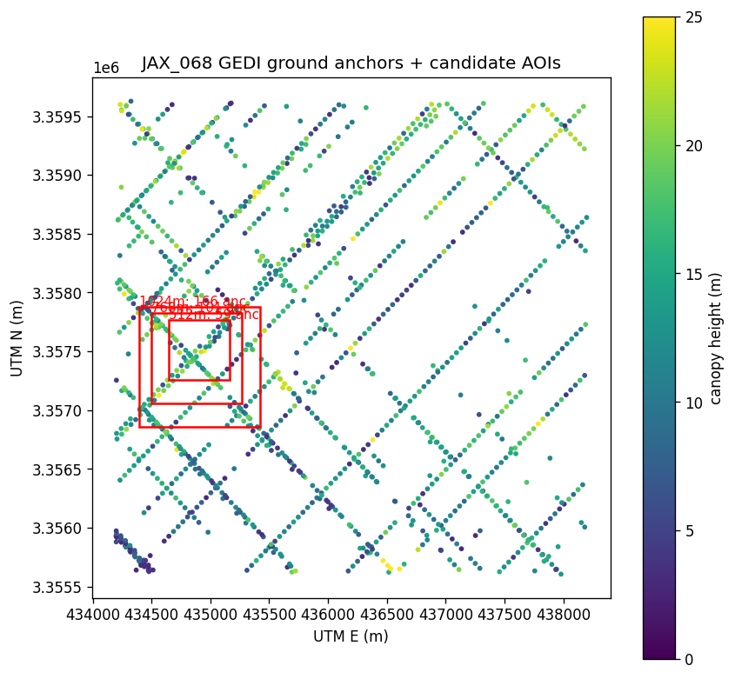
Space-laser (GEDI) ground measurements over the Jacksonville site, colored by forest height (meters), with candidate reconstruction windows outlined. Denser sampling supports the method; the scattered, track-like pattern is why a smoothness rule is needed to fill between points.

13.6 Maps of the recovered ground (before the smoothness rule)
The figure below shows, left to right: the canopy top the cameras reconstruct, the ground our method recovers, and the independent airborne bare-earth truth, with the matching error maps beneath. Notice that the recovered-ground panel still looks almost identical to the canopy-top panel: away from the sparse laser points the ground has not yet descended to the true terrain shown on the right. This is the limitation described above, shown visually. We are adding the figure for the version with the smoothness rule next, so the two can be compared side by side; if the improvement is clear we may include this comparison in the paper.
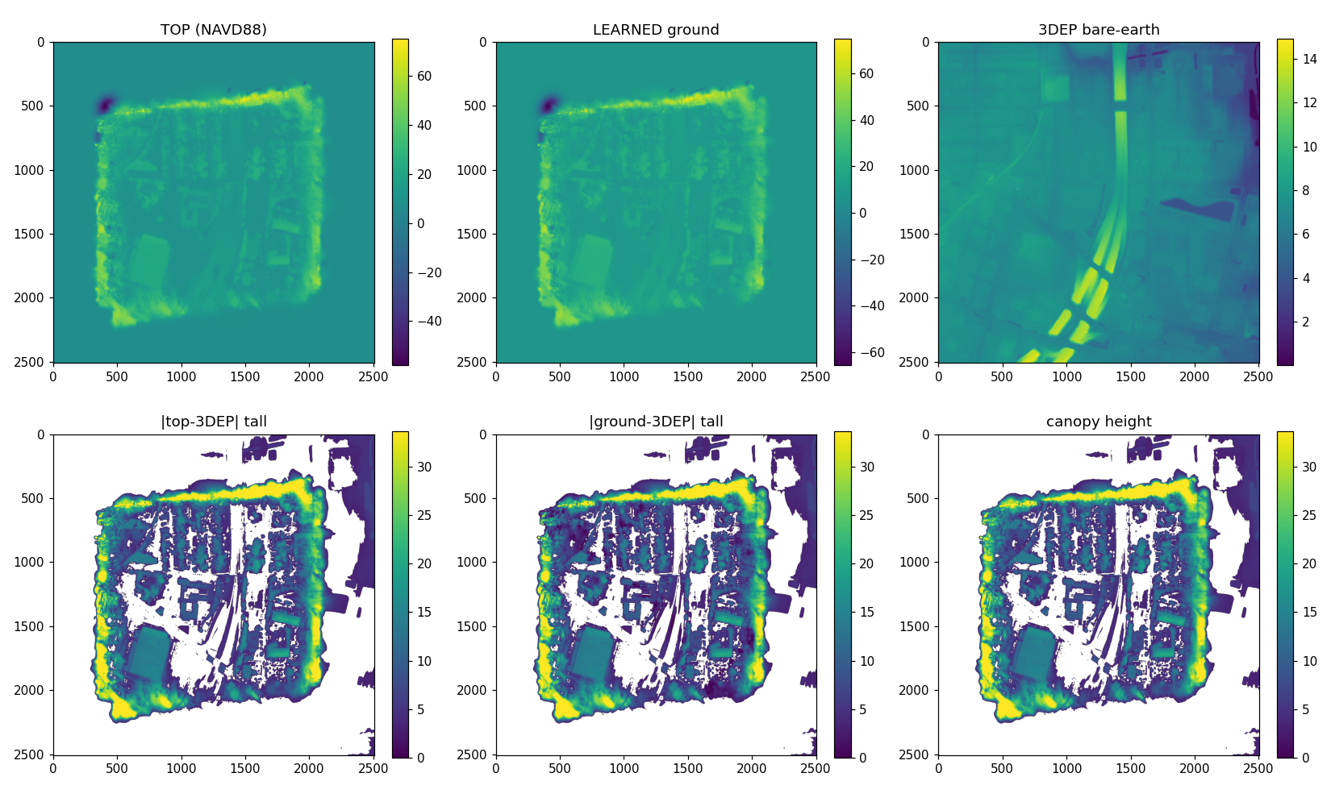
BEFORE the smoothness rule (site JAX_113). Top row: canopy top (left), recovered ground (middle), airborne bare-earth truth (right). Bottom row: error of the canopy-as-ground baseline, error of the recovered ground, and the true forest height. The recovered ground still tracks the canopy top away from laser points; the smoothness rule is meant to fix this, and its result will be placed beside this figure.

13.7 The smoothness rule: before and after
Adding the smoothness rule lets the ground correction spread between the sparse laser points instead of sitting only at them. The table compares the recovered ground against the airborne bare-earth truth on tall-forest pixels, both overall and far from any laser point (the honest generalization test). The canopy top stayed accurate at about 1.3 meters throughout.
Recovered ground vs airborne bare-earth (tall forest) | All tall-forest pixels | Far from any laser point
Camera surface as the ground (baseline) | 11.9 m too high | 12.2 m too high
Two-surface, before smoothness | 11.0 m too high | 11.8 m too high
Two-surface, after smoothness | 9.1 m too high | 9.6 m too high

The improvement far from any laser point, from 11.8 to 9.6 meters, is the meaningful one: it shows the correction generalizing across the forest rather than memorizing the measured points. A gap of about nine meters remains, and we expect a stronger smoothness setting and several pooled sites to close more of it. The figure below shows the recovered ground after smoothness; compared with the earlier figure, the middle panel now departs from the canopy top and moves toward the true ground on the right.
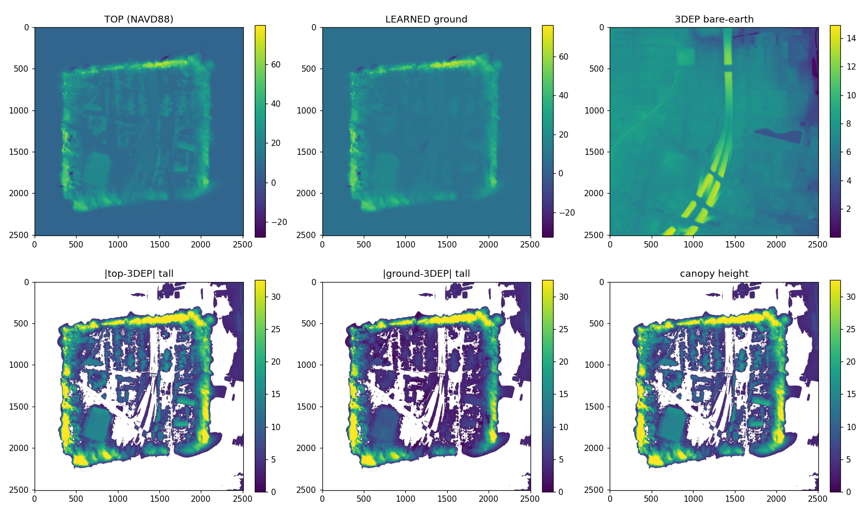
AFTER the smoothness rule (site JAX_113; same layout as the before figure). Top row: canopy top, recovered ground, airborne bare-earth truth. Bottom row: baseline error, recovered-ground error, forest height. The recovered ground now descends toward the true terrain, including away from laser points.

