**Escape The It**

**Chemistry-Biology**



**MADE BY**

Escape The It

**REPOSITORY**

Escape The IT

Table of contents

**Escape The It** 1

TABLE OF CONTENTS 2

PROJECT IDEA 3

TEAM MEMBERS 3

STAGES OF THE PROJECT 3

PERFORMED TASKS 3

BLOCK DIAGRAM 4

FUTURE IDEAS 4

PROJECT IDEA

**The project aims to create a game based on educational travelling.**

TEAM MEMBERS

|  |  |
| --- | --- |
| Name | Role in the team |
| Aleksander Kostov | Scrum Trainer |
| Ivaylo Stoyanov | Back-end developer |
| Nikolay Despotov | Back-end developer |
| Denislav Bratoevski | Front-end developer |
| Andrey Mutlu | Designer |

STAGES OF THE PROJECT

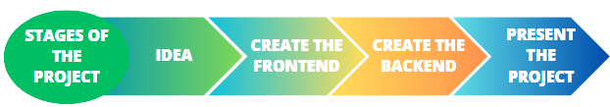

PERFORMED TASKS

|  |  |
| --- | --- |
|  | Performed tasks |
| 1 | Create the map  The map has six rooms and four shops and final room |
| 2 | Create a main menu  Our main menu appears just after you open the game |
| 3 | Create the movements of the player and the teacher that follows you  The game has a main character which moves when u press some keyboard buttons and also it has teacher that if you make a mistake starts following you |
| 4 | Create the different minigames  On the map you have minigames which you can do if you want to escape |
| 5 | Finalize project  Clear the code and add comments |
| 6 | Create the projects README  In the README of our project, you can see a brief description of our project |
| 7 | Last touches  In the end, we created the Documents and Wiki of our project. |

BLOCK DIAGRAM

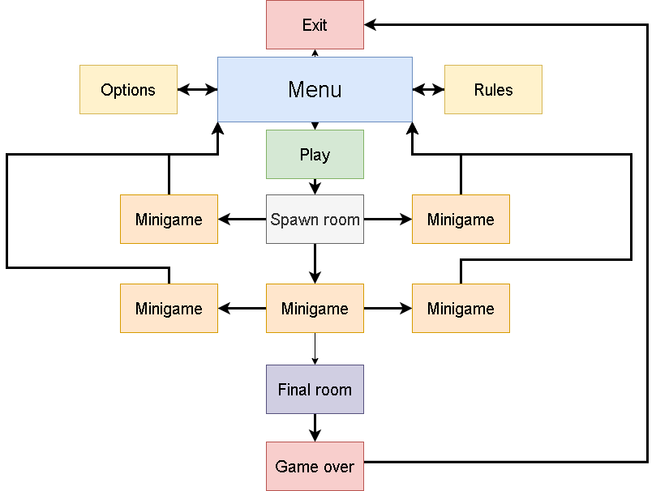

FUTURE IDEAS

|  |  |
| --- | --- |
|  | Future ideas |
| 1 | Add other levels |
| 2 | Create a play mode where you can play from other devices and multiplayer |