# Kiểm tra thực hành kỳ 2022.2

## **Bài tập.**Xây dựng chương trình, hàm main

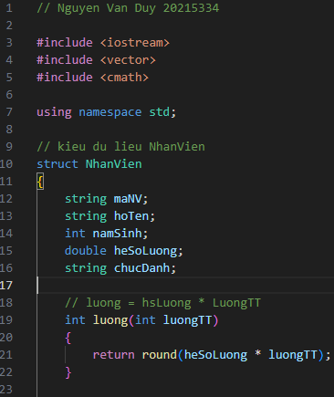

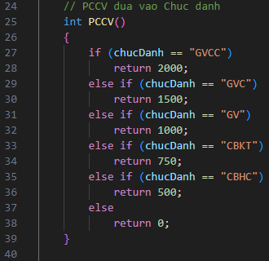

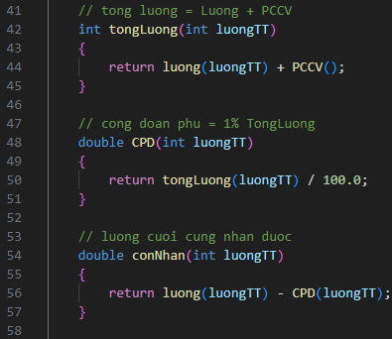

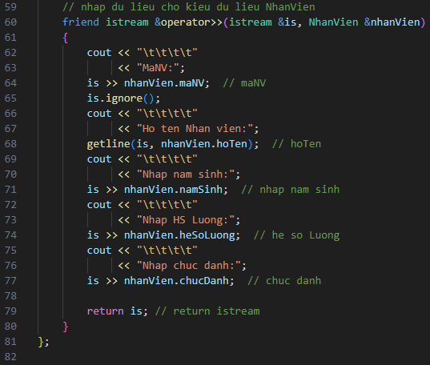

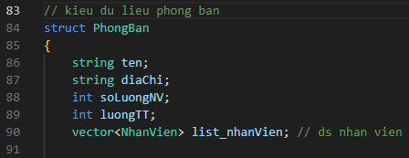

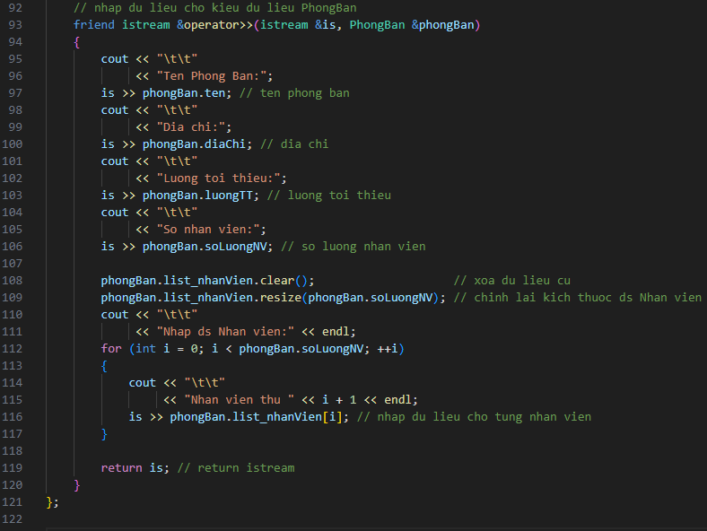

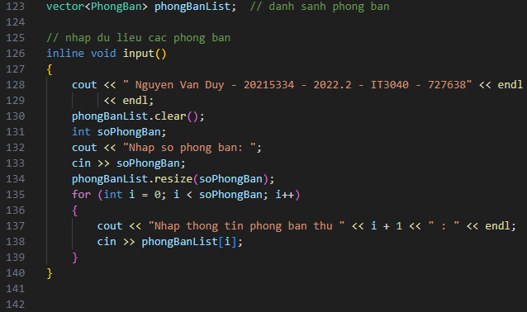

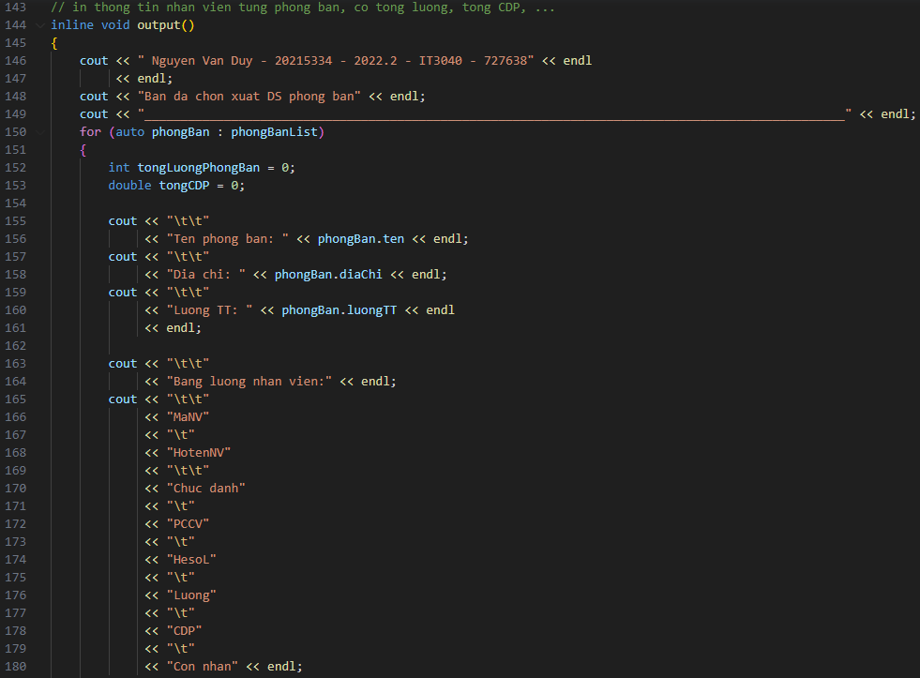

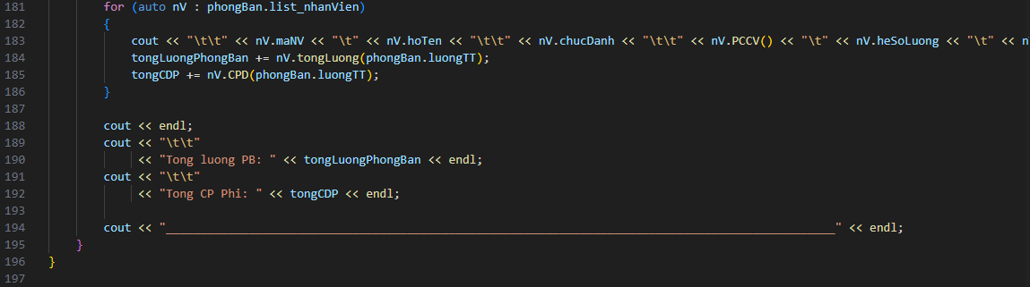

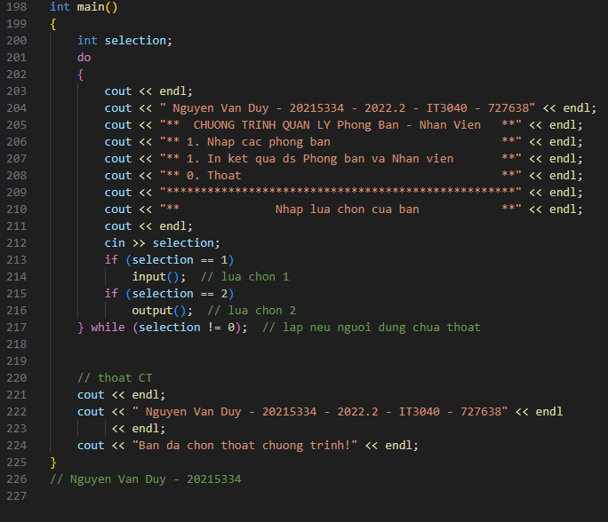

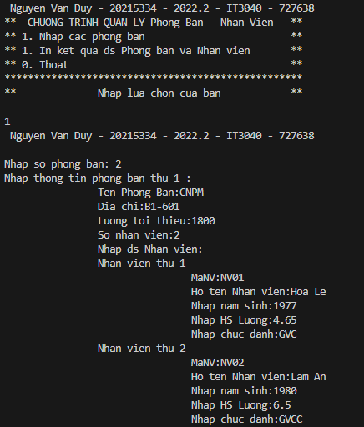

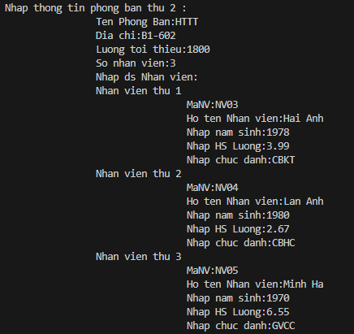

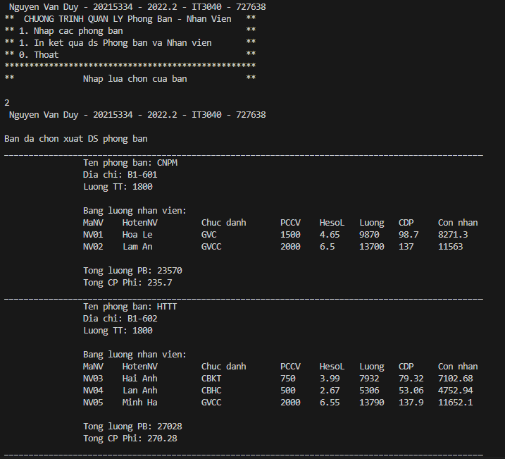

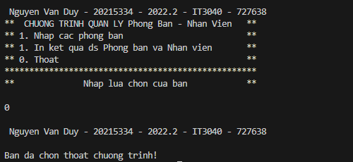

// Nguyen Van Duy 20215334

#include <iostream>

#include <vector>

#include <cmath>

using namespace std;

// kieu du lieu NhanVien

struct NhanVien

{

string maNV;

string hoTen;

int namSinh;

double heSoLuong;

string chucDanh;

// luong = hsLuong * LuongTT

int luong(int luongTT)

{

return round(heSoLuong * luongTT);

}

// PCCV dua vao Chuc danh

int PCCV()

{

if (chucDanh == "GVCC")

return 2000;

else if (chucDanh == "GVC")

return 1500;

else if (chucDanh == "GV")

return 1000;

else if (chucDanh == "CBKT")

return 750;

else if (chucDanh == "CBHC")

return 500;

else

return 0;

}

// tong luong = Luong + PCCV

int tongLuong(int luongTT)

{

return luong(luongTT) + PCCV();

}

// cong doan phu = 1% TongLuong

double CPD(int luongTT)

{

return tongLuong(luongTT) / 100.0;

}

// luong cuoi cung nhan duoc

double conNhan(int luongTT)

{

return luong(luongTT) - CPD(luongTT);

}

// nhap du lieu cho kieu du lieu NhanVien

friend istream &operator>>(istream &is, NhanVien &nhanVien)

{

cout << "\t\t\t\t"

<< "MaNV:";

is >> nhanVien.maNV; // maNV

is.ignore();

cout << "\t\t\t\t"

<< "Ho ten Nhan vien:";

getline(is, nhanVien.hoTen); // hoTen

cout << "\t\t\t\t"

<< "Nhap nam sinh:";

is >> nhanVien.namSinh; // nhap nam sinh

cout << "\t\t\t\t"

<< "Nhap HS Luong:";

is >> nhanVien.heSoLuong; // he so Luong

cout << "\t\t\t\t"

<< "Nhap chuc danh:";

is >> nhanVien.chucDanh; // chuc danh

return is; // return istream

}

};

// kieu du lieu phong ban

struct PhongBan

{

string ten;

string diaChi;

int soLuongNV;

int luongTT;

vector<NhanVien> list_nhanVien; // ds nhan vien

// nhap du lieu cho kieu du lieu PhongBan

friend istream &operator>>(istream &is, PhongBan &phongBan)

{

cout << "\t\t"

<< "Ten Phong Ban:";

is >> phongBan.ten; // ten phong ban

cout << "\t\t"

<< "Dia chi:";

is >> phongBan.diaChi; // dia chi

cout << "\t\t"

<< "Luong toi thieu:";

is >> phongBan.luongTT; // luong toi thieu

cout << "\t\t"

<< "So nhan vien:";

is >> phongBan.soLuongNV; // so luong nhan vien

phongBan.list_nhanVien.clear(); // xoa du lieu cu

phongBan.list_nhanVien.resize(phongBan.soLuongNV); // chinh lai kich thuoc ds Nhan vien

cout << "\t\t"

<< "Nhap ds Nhan vien:" << endl;

for (int i = 0; i < phongBan.soLuongNV; ++i)

{

cout << "\t\t"

<< "Nhan vien thu " << i + 1 << endl;

is >> phongBan.list_nhanVien[i]; // nhap du lieu cho tung nhan vien

}

return is; // return istream

}

};

vector<PhongBan> phongBanList; // danh sanh phong ban

// nhap du lieu cac phong ban

inline void input()

{

cout << " Nguyen Van Duy - 20215334 - 2022.2 - IT3040 - 727638" << endl

<< endl;

phongBanList.clear();

int soPhongBan;

cout << "Nhap so phong ban: ";

cin >> soPhongBan;

phongBanList.resize(soPhongBan);

for (int i = 0; i < soPhongBan; i++)

{

cout << "Nhap thong tin phong ban thu " << i + 1 << " : " << endl;

cin >> phongBanList[i];

}

}

// in thong tin nhan vien tung phong ban, co tong luong, tong CDP, ...

inline void output()

{

cout << " Nguyen Van Duy - 20215334 - 2022.2 - IT3040 - 727638" << endl

<< endl;

cout << "Ban da chon xuat DS phong ban" << endl;

cout << "_________________________________________________________________________________________________" << endl;

for (auto phongBan : phongBanList)

{

int tongLuongPhongBan = 0;

double tongCDP = 0;

cout << "\t\t"

<< "Ten phong ban: " << phongBan.ten << endl;

cout << "\t\t"

<< "Dia chi: " << phongBan.diaChi << endl;

cout << "\t\t"

<< "Luong TT: " << phongBan.luongTT << endl

<< endl;

cout << "\t\t"

<< "Bang luong nhan vien:" << endl;

cout << "\t\t"

<< "MaNV"

<< "\t"

<< "HotenNV"

<< "\t\t"

<< "Chuc danh"

<< "\t"

<< "PCCV"

<< "\t"

<< "HesoL"

<< "\t"

<< "Luong"

<< "\t"

<< "CDP"

<< "\t"

<< "Con nhan" << endl;

for (auto nV : phongBan.list_nhanVien)

{

cout << "\t\t" << nV.maNV << "\t" << nV.hoTen << "\t\t" << nV.chucDanh << "\t\t" << nV.PCCV() << "\t" << nV.heSoLuong << "\t" << nV.tongLuong(phongBan.luongTT) << "\t" << nV.CPD(phongBan.luongTT) << "\t" << nV.conNhan(phongBan.luongTT) << endl;

tongLuongPhongBan += nV.tongLuong(phongBan.luongTT);

tongCDP += nV.CPD(phongBan.luongTT);

}

cout << endl;

cout << "\t\t"

<< "Tong luong PB: " << tongLuongPhongBan << endl;

cout << "\t\t"

<< "Tong CP Phi: " << tongCDP << endl;

cout << "_________________________________________________________________________________________________" << endl;

}

}

int main()

{

int selection;

do

{

cout << endl;

cout << " Nguyen Van Duy - 20215334 - 2022.2 - IT3040 - 727638" << endl;

cout << "** CHUONG TRINH QUAN LY Phong Ban - Nhan Vien **" << endl;

cout << "** 1. Nhap cac phong ban **" << endl;

cout << "** 1. In ket qua ds Phong ban va Nhan vien **" << endl;

cout << "** 0. Thoat **" << endl;

cout << "***************************************************" << endl;

cout << "** Nhap lua chon cua ban **" << endl;

cout << endl;

cin >> selection;

if (selection == 1)

input(); // lua chon 1

if (selection == 2)

output(); // lua chon 2

} while (selection != 0); // lap neu nguoi dung chua thoat

// thoat CT

cout << endl;

cout << " Nguyen Van Duy - 20215334 - 2022.2 - IT3040 - 727638" << endl

<< endl;

cout << "Ban da chon thoat chuong trinh!" << endl;

}

// Nguyen Van Duy - 20215334