1. HTML > BODY

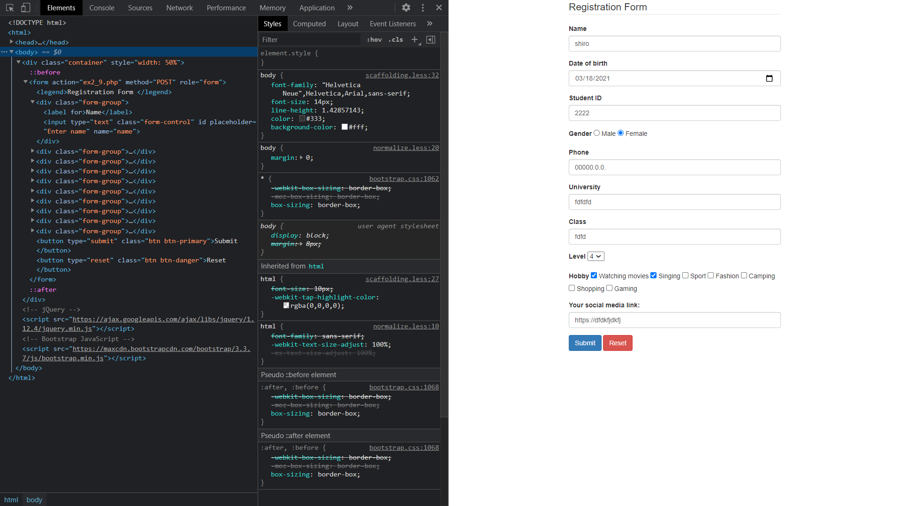

Overall structure:

* BODY:
  + DIV.container
    - FORM
      * DIV.form-group
      * BUTTON.btn.btn-primary
      * BUTTON.btn.btn-danger

1. HTML > BODY > DIV.container

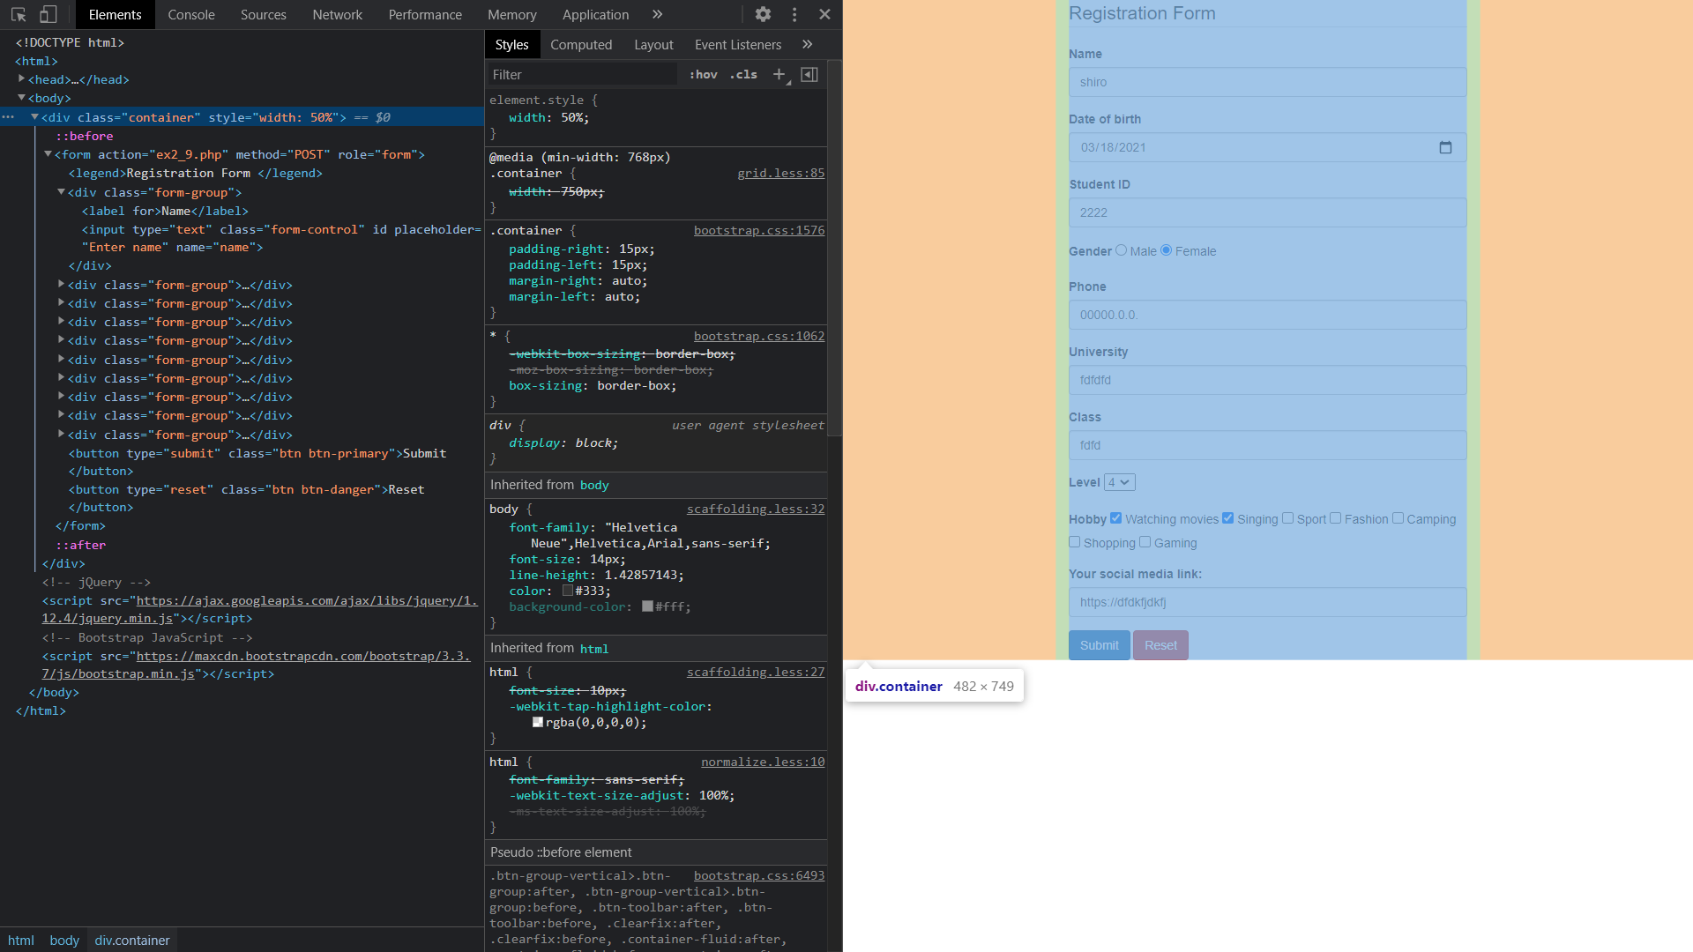

* This is a DIV tag with class name as “container”. It will wrap our form for the sake of clear structure.
* The css element of this tag is already declared in bootstrap

1. HTML > BODY > DIV.container > FORM

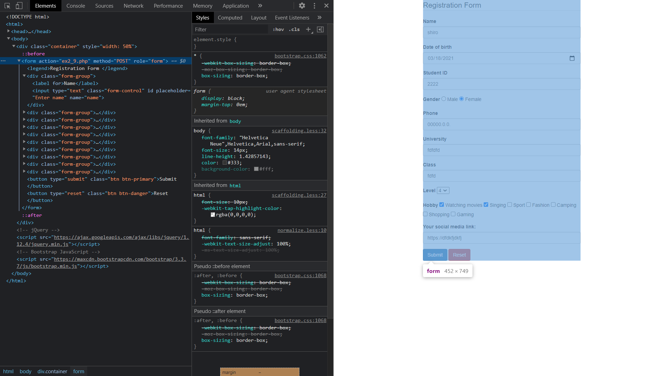

* This form is used for submitting user’s personal information to “ex2_9.php” through POST method
* Because there’s no declared css for this form, the size of this form will match the size of the container

1. HTML > BODY > DIV.container > FORM > DIV.form-group
   1. Name input

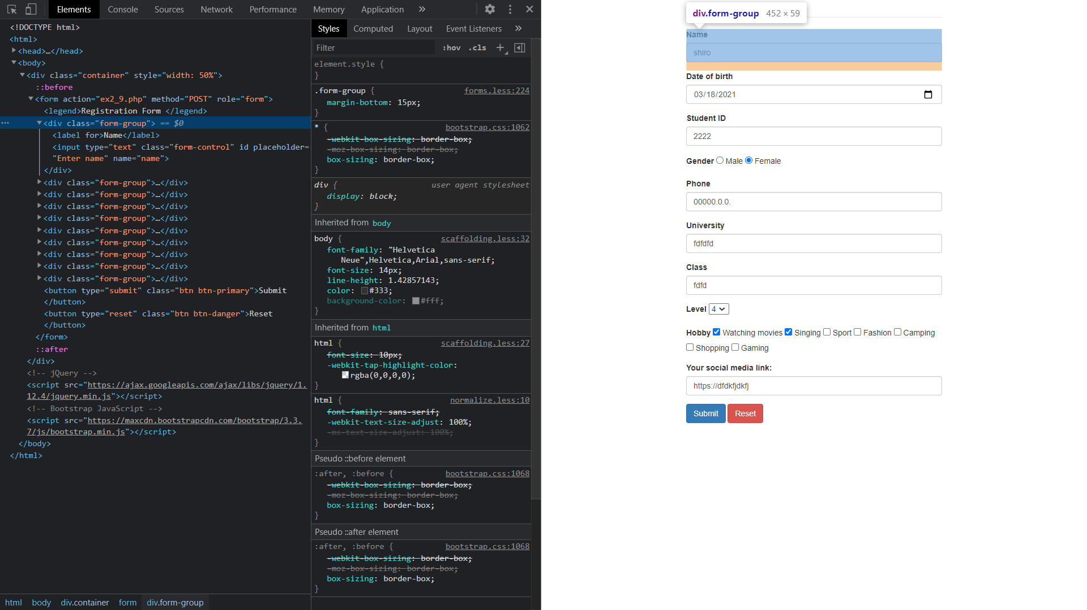

We use a div with class named “form-group” for wraping an input for user

* LABEL tag is used for inform which information user need to enter. In this case it is “Name”
* INPUT tag is used for creating an input for user
  + type=“text”: single-line text field
  + class=“form-control”
  + placeholder=“Enter name”: if user hasn’t entered anything, the input will display “Enter name”
  + name=“name”: attribute “name” specified as “name”. This will be helpful for form submission
  1. Date input

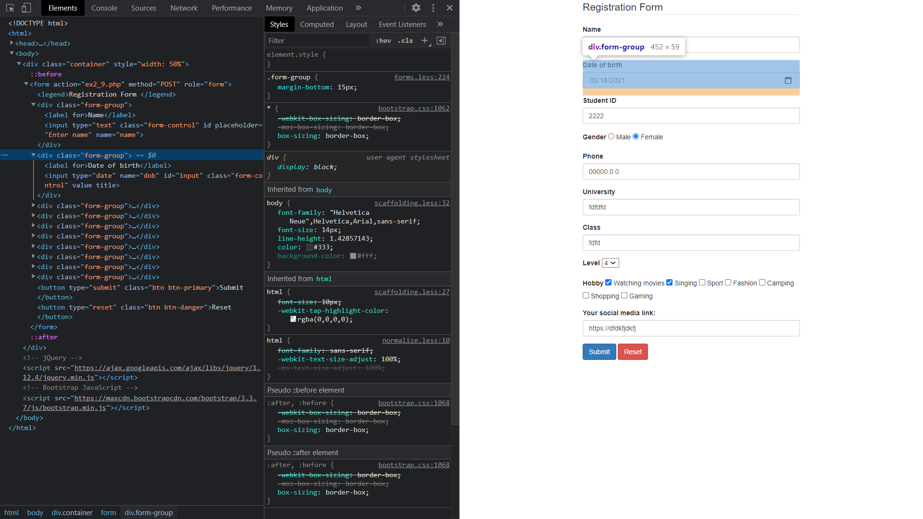

We still use a div with class named “form-group” for wraping a date input

* INPUT tag has attributes as following:
  + type=“date”: date picker
  + class=“form-control”
  + name=“dob”: attribute “name” specified as “dob”. This will be helpful for form submission
  + id=“input”: used for adding css from id input
  1. Gender input

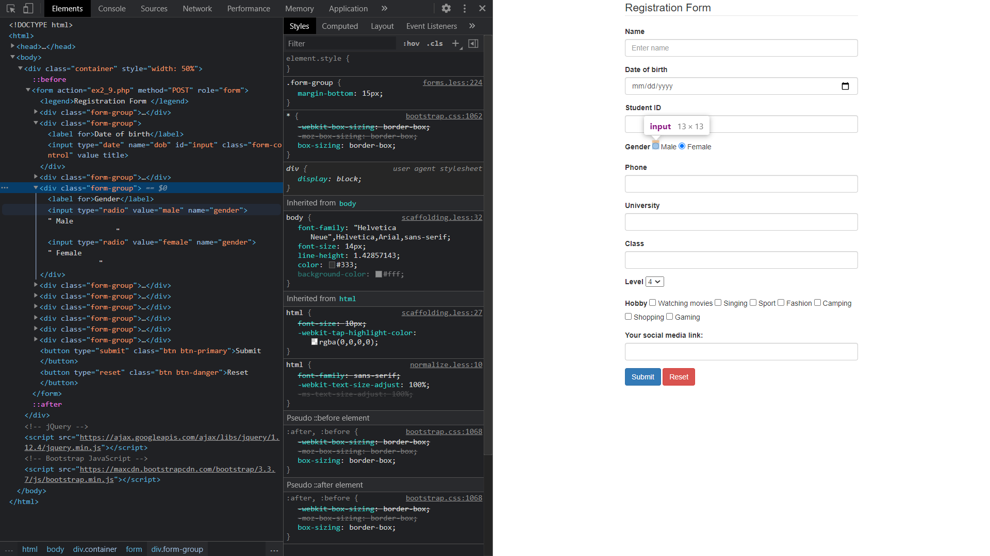

We still use a div with class named “form-group” for wraping a gender input

* First INPUT tag has attributes as following:
  + type=“radio”: radio button
  + name=“gender”: attribute “name” specified as “gender”. If there’s multiple radio input with same name, user can only choose 1
  + value=“male”: In DOM element we receive in “ex2_9.php”, the gender object will has value of “male” if user pick this radio input
  1. Select input

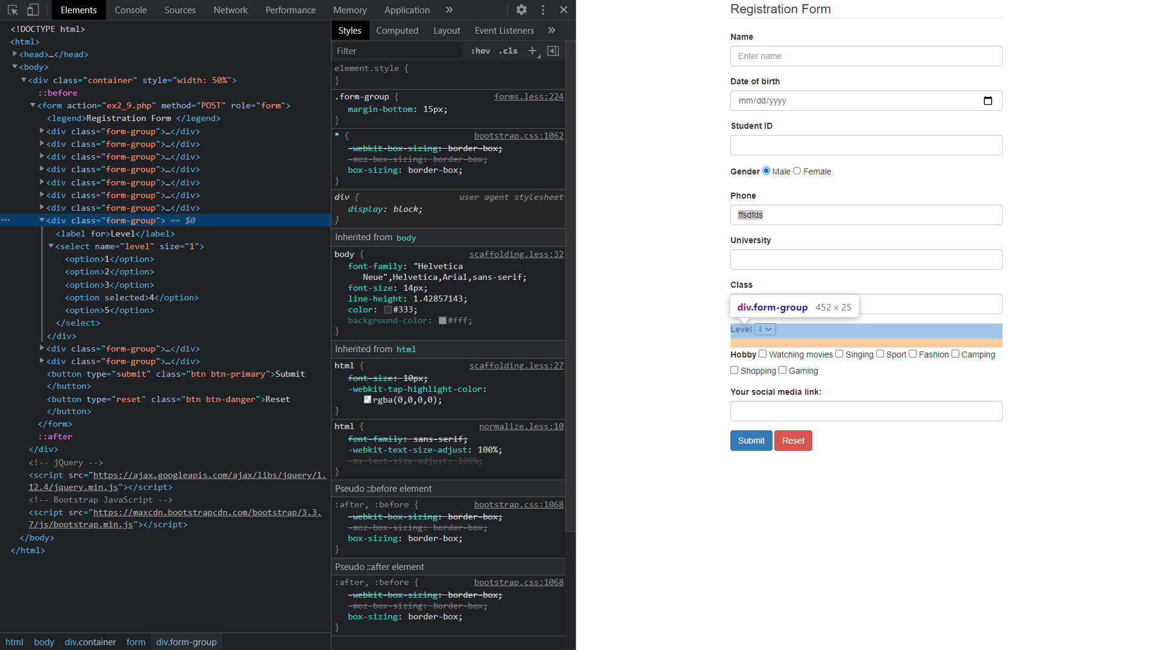

We still use a div with class named “form-group” for wraping select tag

* SELECT tag has attributes as following:
  + size=“1”: number of visible options in drop-down list
  + name=“level”: attribute “name” specified as “level”. This will be helpful in form submission extracting stage in “ex2_9.php”
  + Wrap multiple OPTION tags
    - OPTION tag: define option in SELECT tag
    - Attribute SELECTED: display the selected value at first (when page is just loaded)
  1. Checkbox input

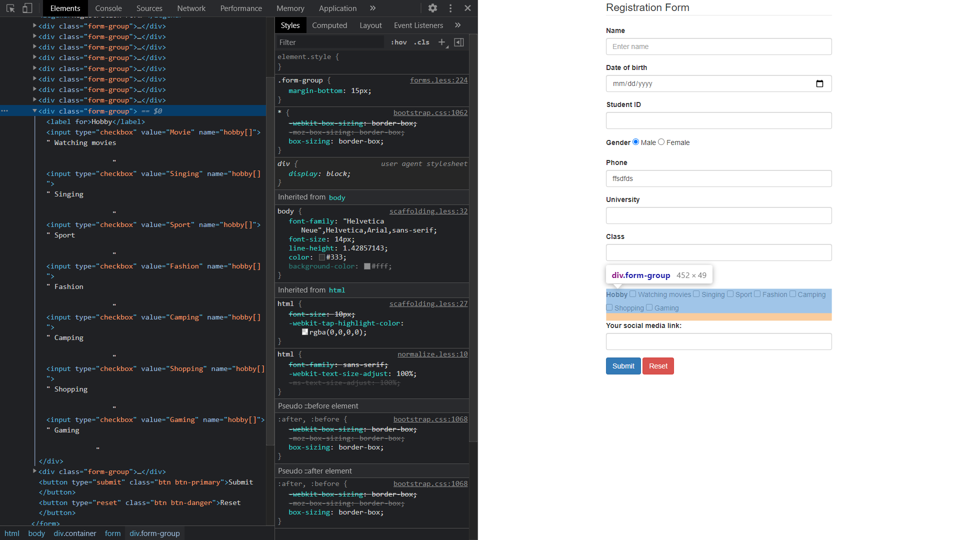

We still use a div with class named “form-group” for wraping checkbox input

* INPUT tag has attributes as following:
  + type=“checkbox”: defines checkbox
  + value=“Movie”: value of user’s option if user choose this checkbox
  + name=“hobby[]”: attribute “name” specified as “hobby[]”. This will be helpful in form submission extracting stage in “ex2_9.php”
  + User can choose multiple checkbox. Hence, form will group choosen option from checkbox with same attribute NAME

1. Form submission
   1. Submit & Reset button

* BUTTON tag with type=“submit” will submit all information within the form to “ex2_9.php” by declared method
* BUTTON tag with type=“reset” will empty all input field. With this button, user has no need for reloading page
  1. Request packet

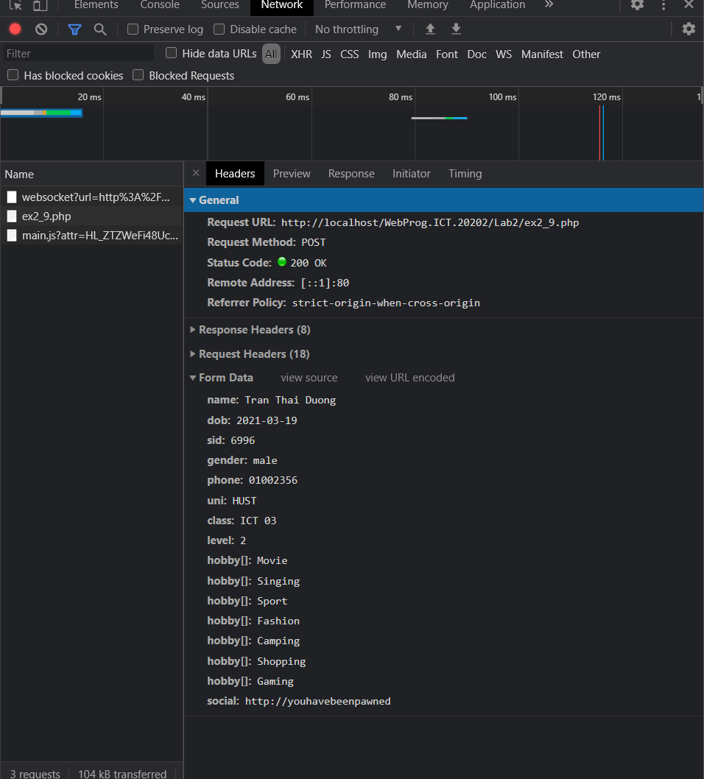

As we can see here, user information has been sent to “ex2_9.php” inside Form Data

* 1. Form received in ex2_9.php

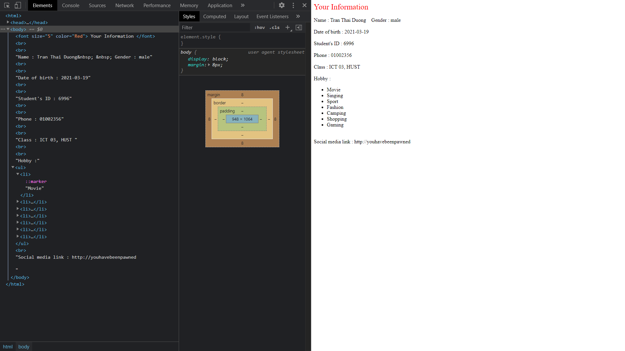

“ex2_9.php” will receive data through “$_POST” and display to user screen

* For example, to achieve name:

$name = $_POST["name"];