1. HTML > BODY

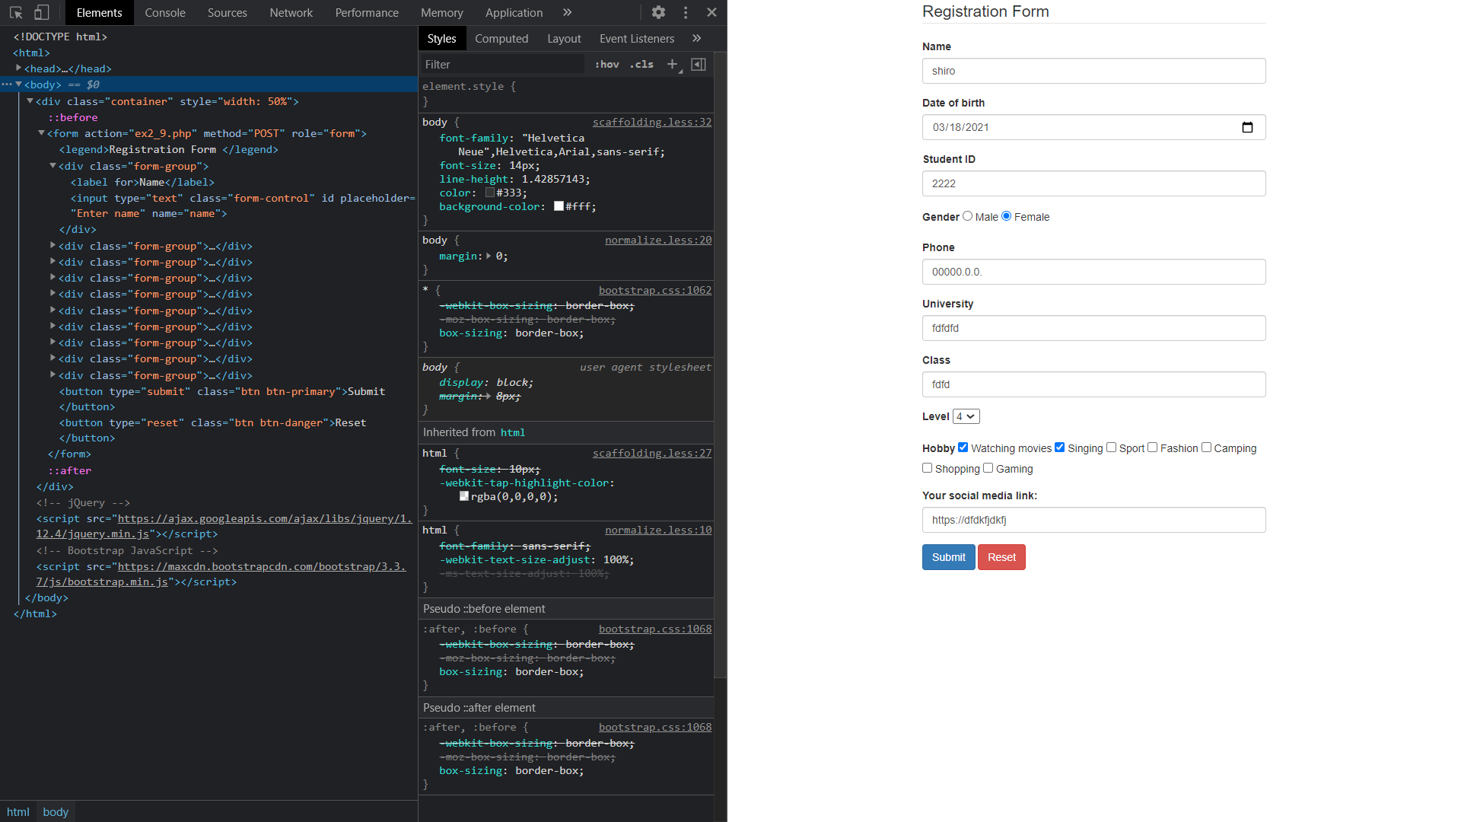

Overall structure:

* BODY:
  + DIV.container
    - FORM
      * DIV.form-group
      * BUTTON.btn.btn-primary
      * BUTTON.btn.btn-danger

1. HTML > BODY > DIV.container

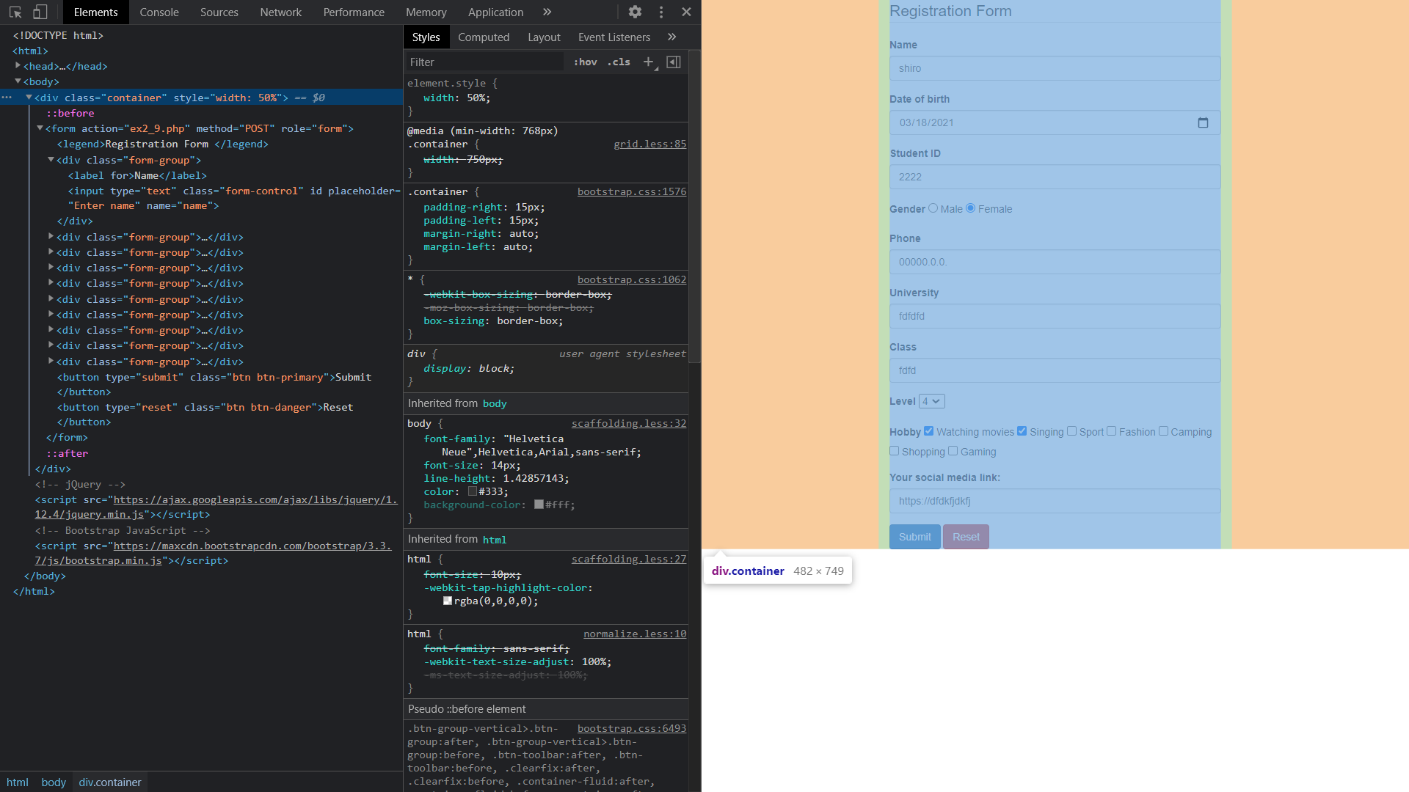

* This is a DIV tag with class name as “container”. It will wrap our form for the sake of clear structure.
* The css element of this tag is already declared in bootstrap

1. HTML > BODY > DIV.container > FORM

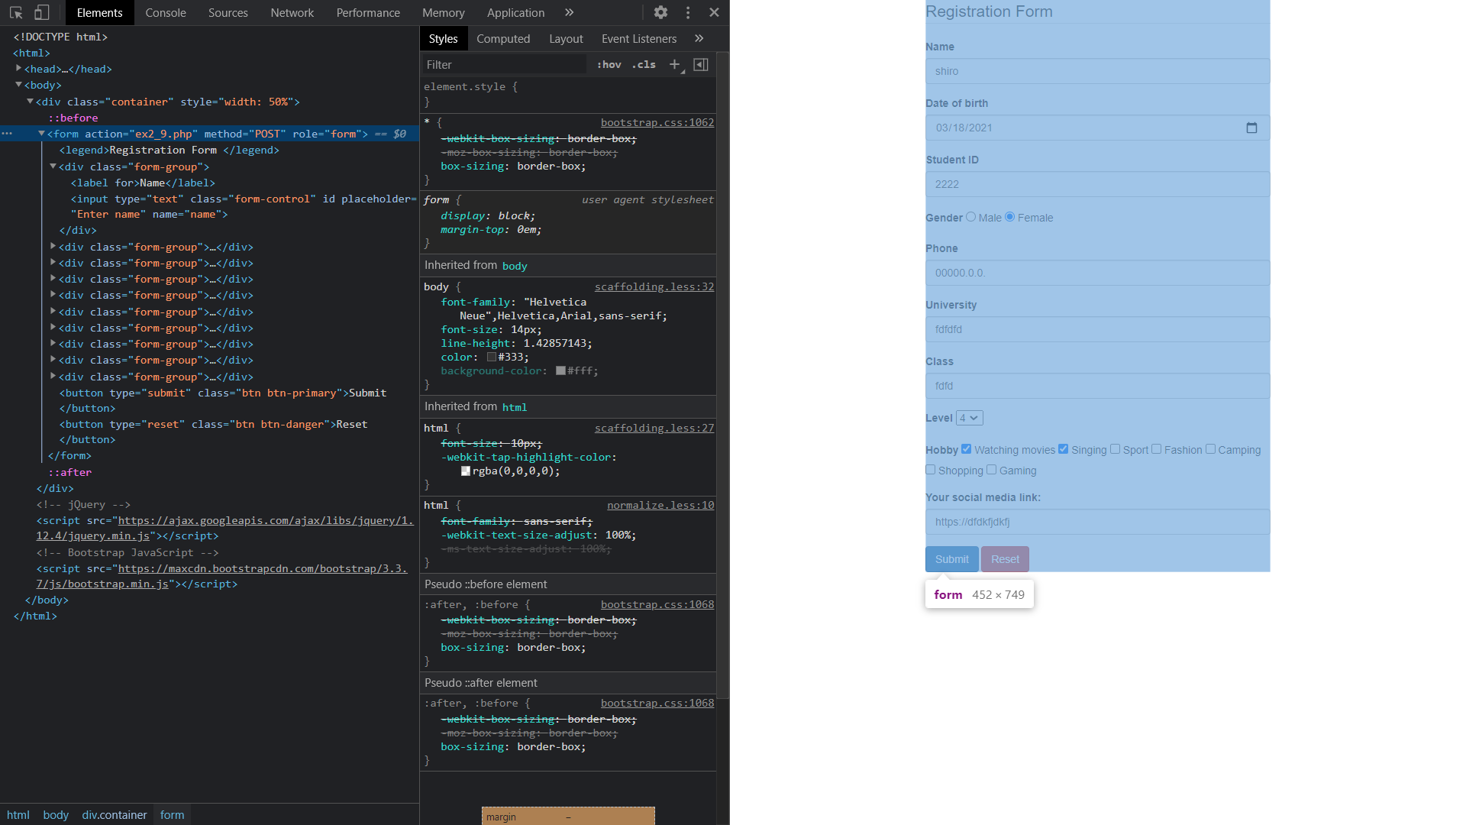

* This form is used for submitting user’s personal information to “ex2_9.php” through POST method
* Because there’s no declared css for this form, the size of this form will match the size of the container

1. HTML > BODY > DIV.container > FORM > DIV.form-group
   1. Name input

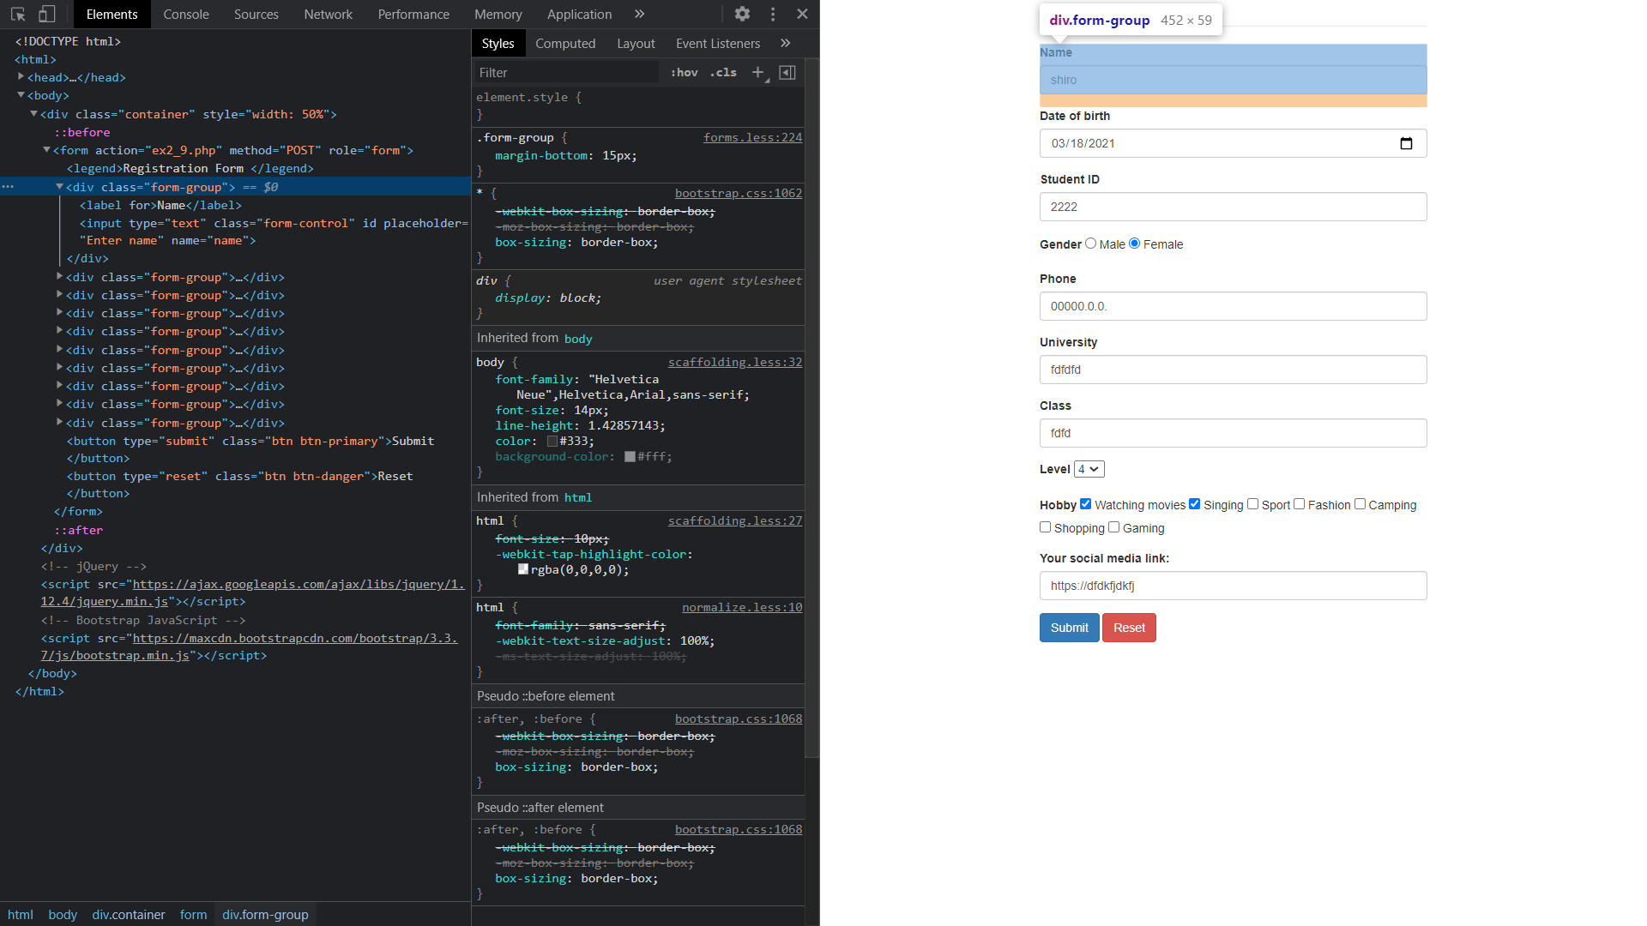

We use a div with class named “form-group” for wraping an input for user

* LABEL tag is used for inform which information user need to enter. In this case it is “Name”
* INPUT tag is used for creating an input for user
  + type=“text”: single-line text field
  + class=“form-control”
  + placeholder=“Enter name”: if user hasn’t entered anything, the input will display “Enter name”
  + name=“name”: attribute “name” specified as “name”. This will be helpful for form submission
  1. Date input

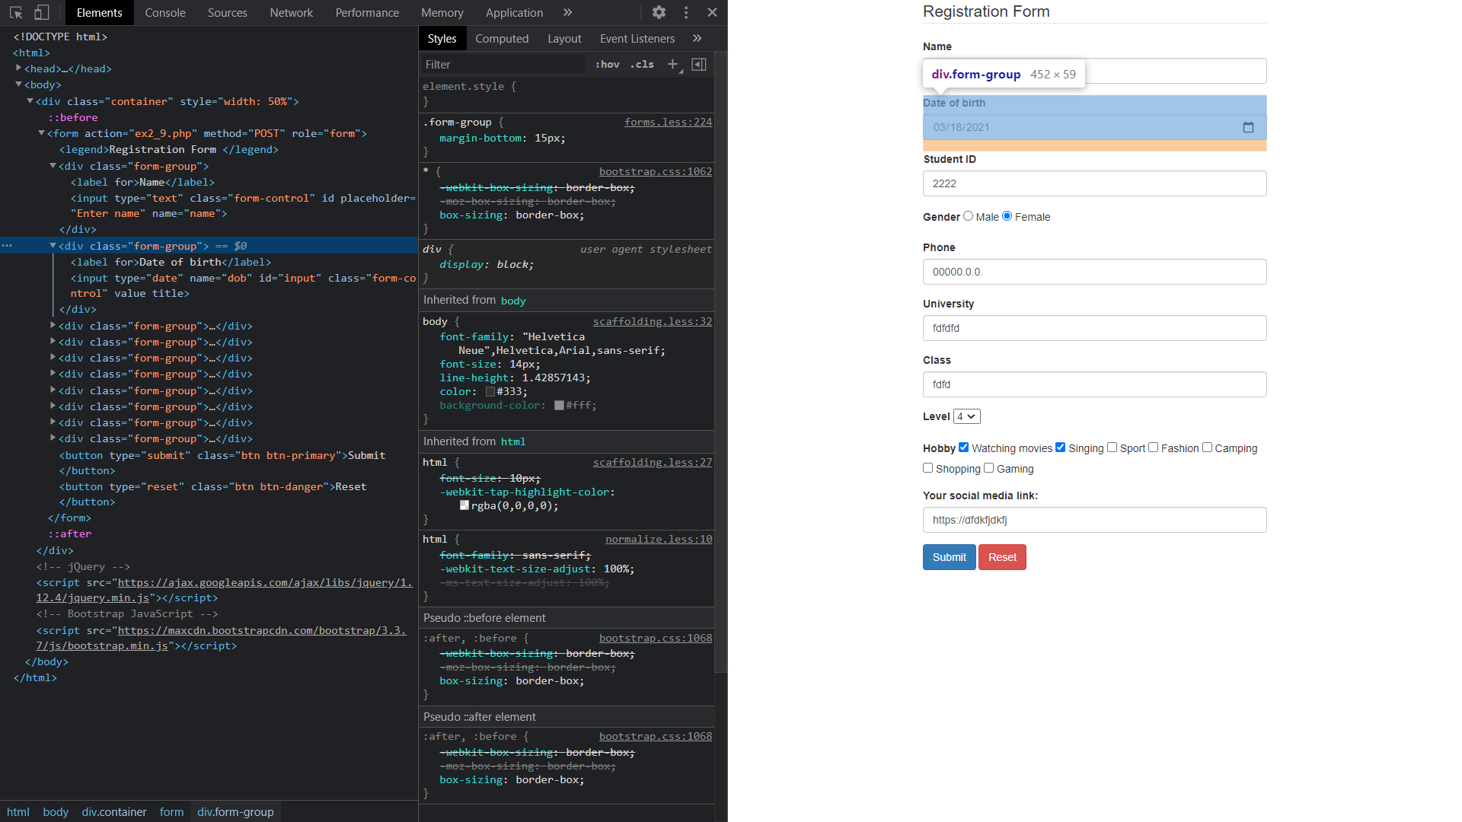

We still use a div with class named “form-group” for wraping a date input

* INPUT tag has attributes as following:
  + type=“date”: date picker
  + class=“form-control”
  + name=“dob”: attribute “name” specified as “dob”. This will be helpful for form submission
  + id=“input”: used for adding css from id input

