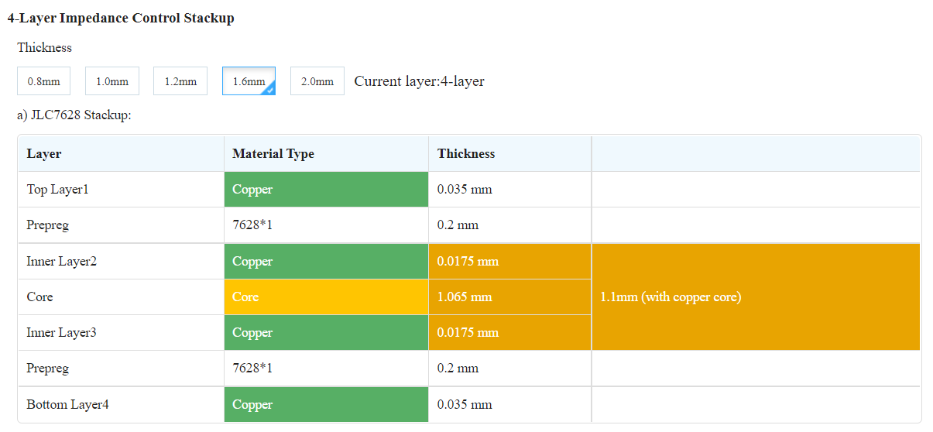

Using standard JLCPCB 1.6mm stackup, <https://cart.jlcpcb.com/impedance>

All tolerances +/- 10%

|  |  |  |  |  |  |  |
| --- | --- | --- | --- | --- | --- | --- |
| Single Ended | DEZ | SEZ | LW | LineGap | Ref (above) | Ref (below) |
| TOP |  | 50 | 0.1016 |  |  | L2 |
| BOTTOM |  | 50 | 0.1016 |  | L3 |  |

Target impedance for USB pairs is 90 Ohm. Target impedance for HDMI pairs is 100 Ohm.

|  |  |  |  |  |  |  |
| --- | --- | --- | --- | --- | --- | --- |
| Differential (edge) | DEZ | SEZ | LW | LineGap | Ref (above) | Ref (below) |
| TOP | 85 |  | 0.2 | 0.102 |  | L2 |
| TOP | 90 |  | 0.18 | 0.102 |  | L2 |
| TOP | 95 |  | 0.1524 | 0.102 |  | L2 |
| TOP | 100 |  | 0.1524 | 0.1524 |  | L2 |
| TOP | 105 |  | 0.1524 | 0.179 |  | L2 |
| BOTTOM | 85 |  | 0.2 | 0.102 | L3 |  |
| BOTTOM | 90 |  | 0.18 | 0.102 | L3 |  |
| BOTTOM | 95 |  | 0.1524 | 0.102 | L3 |  |
| BOTTOM | 100 |  | 0.1524 | 0.1524 | L3 |  |
| BOTTOM | 105 |  | 0.1524 | 0.179 | L3 |  |