## Stopping by Woods on a Snowy Evening, By Robert Frost

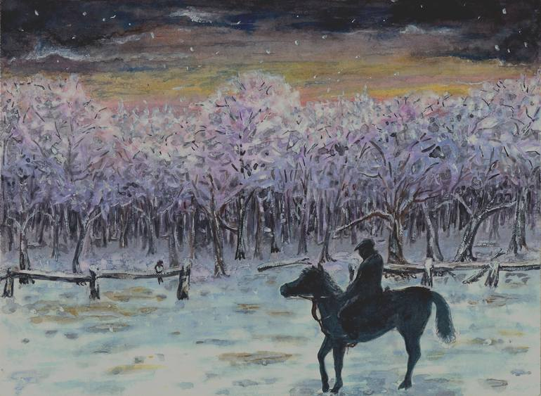

Figure 1: Snowy Woods

Whose woods these are I think I know. His house is in the village though; He will not see me stopping here; To watch his woods fill up with snow.

My little horse must think it queer; To stop without a farmhouse near; Between the woods and frozen lake; The darkest evening of the year.

He gives his harness bells a shake; To ask if there is some mistake. The only other sound’s the sweep; Of easy wind and downy flake.

The woods are lovely, dark and deep, But I have promises to keep, And miles to go before I sleep,  And miles to go before I sleep.

## Frost’s Collections

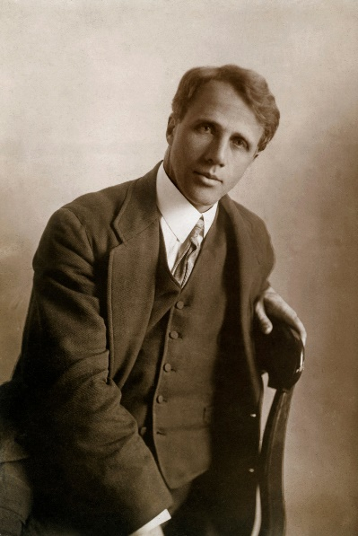

Figure 2: Robert Frost

|  |  |  |
| --- | --- | --- |
| # | Collection | Year |
| 1 | A Boy's Will | 1913 |
| 2 | North of Boston | 1914 |
| 3 | Mountain Interval | 1916 |
| 4 | New Hampshire | 1923 |
| 5 | West Running Brook | 1928 |
| 6 | A Further Range | 1937 |
| 7 | A Witness Tree | 1942 |
| 8 | In the Clearing | 1962 |
| 9 | Steeple Bush | 1947 |
| 10 | An Afterword | unknown |