Testing Document
A sample document with headings and placeholder text

Introduction
This is a placeholder document that can be used for any purpose. It contains some
headings and some placeholder text to fill the space. The text is not important and contains
no real value, but it is useful for testing. Below, we will have some simple tables and charts
that we can use to confirm Ingest is working as expected.

Table 1

This table describes some animals, and some activities they might be doing in specific
locations.
Animal | Activity | Place
Giraffe | Driving a car | At the beach
Lion | Putting on sunscreen | At the park
Cat | Jumping onto a laptop | In a home office
Dog | Chasing a squirrel | In the front yard

Chart 1
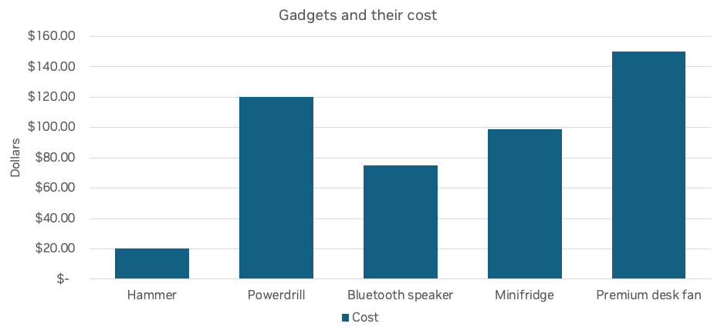
Section One
This is the first section of the document. It has some more placeholder text to show how
the document looks like. The text is not meant to be meaningful or informative, but rather to
demonstrate the layout and formatting of the document.
- This is the first bullet point
- This is the second bullet point
- This is the third bullet point
Section Two
This is the second section of the document. It is more of the same as we’ve seen in the rest
of the document. The content is meaningless, but the intent is to create a very simple
smoke test to ensure extraction is working as intended. This will be used in CI as time goes
on to ensure that changes we make to the library do not negatively impact our accuracy.

Picture
Below, is a high-quality picture of some shapes.

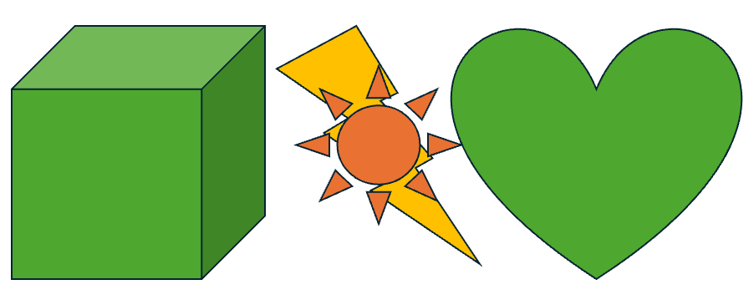
Chart 2

This chart shows some average frequency ranges for speaker drivers.

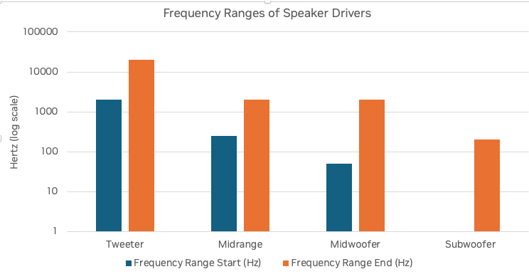
Conclusion

This is the conclusion of the document. It has some more placeholder text, but the most
important thing is that this is the conclusion. As we end this document, we should have
been able to extract 2 tables, 2 charts, and some text including 3 bullet points.

