**Testing Document**

A sample document with headings and placeholder text

## Introduction

This is a placeholder document that can be used for any purpose. It contains some

headings and some placeholder text to fill the space. The text is not important and contains

no real value, but it is useful for testing. Below, we will have some simple tables and charts

that we can use to confirm Ingest is working as expected.

## Table 1

This table describes some animals, and some activities they might be doing in specific

locations.

| Animal | Activity | Place |
| --- | --- | --- |
| Giraffe | Driving a car | At the beach |
| Lion | Putting on sunscreen | At the park |
| Cat | Jumping onto a laptop | In a home office |
| Dog | Chasing a squirrel | In the front yard |

## Chart 1

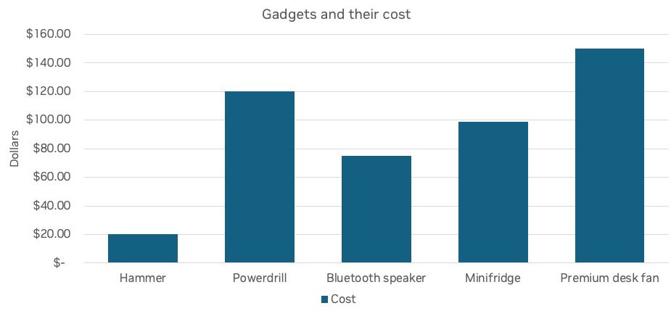

**Section One**

This is the first section of the document. It has some more placeholder text to show how

the document looks like. The text is not meant to be meaningful or informative, but rather to

demonstrate the layout and formatting of the document.

* This is the first bullet point
* This is the second bullet point
* This is the third bullet point

Section Two

This is the second section of the document. It is more of the same as we’ve seen in the rest

of the document. The content is meaningless, but the intent is to create a very simple

smoke test to ensure extraction is working as intended. This will be used in CI as time goes

on to ensure that changes we make to the library do not negatively impact our accuracy.

## Picture

Below, is a high-quality picture of some shapes.

## Chart 2

This chart shows some average frequency ranges for speaker drivers.

## Conclusion

This is the conclusion of the document. It has some more placeholder text, but the most

important thing is that this is the conclusion. As we end this document, we should have

been able to extract 2 tables, 2 charts, and some text including 3 bullet points.

