Netzwerkmanagement

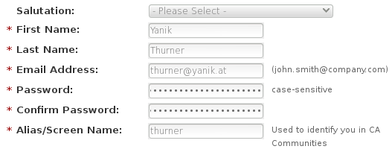
CA Registration



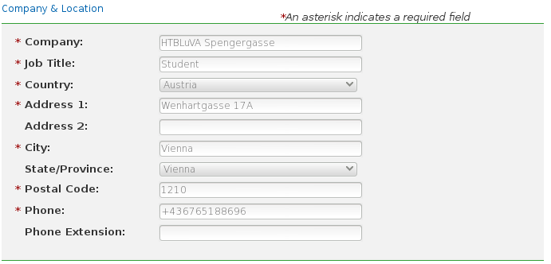
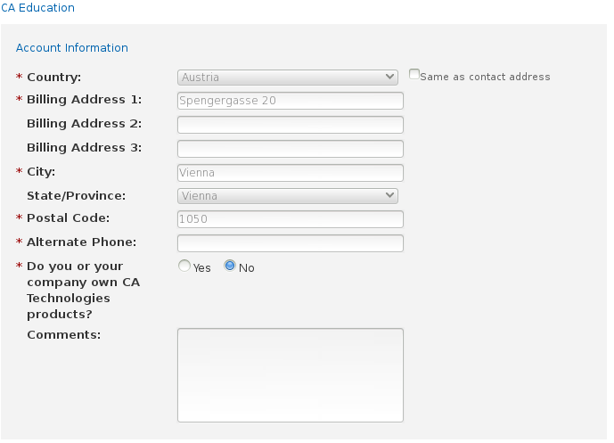
*Alternate Phone: +43 1 546 15 0

CA Unified Infrastructure Management
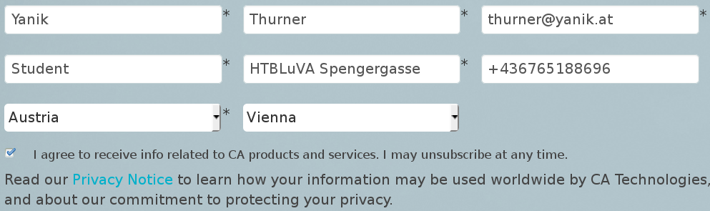

Butt fuck it we will use prtg/mrtg

