Untitled

# TIME SERIES ANALYSIS OF MARC

library(forecast)

## Registered S3 method overwritten by 'quantmod':  
## method from  
## as.zoo.data.frame zoo

library(ggplot2)  
library(readr)

This is the code for reading the data.

MARC <- read_csv("~/R/SPP/CSV/MARC.csv", col_types = cols(Week = col_date(format = "%Y-%m-%d")))  
marc <- ts(MARC[,2], freq=365.25/7, start=2015+219/365.25)  
marc %>%  
 autoplot()

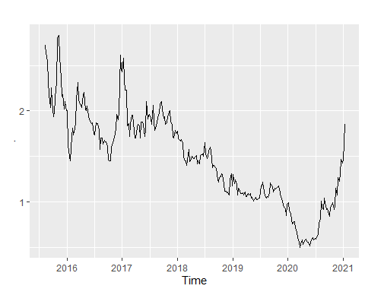

plot(decompose(marc))

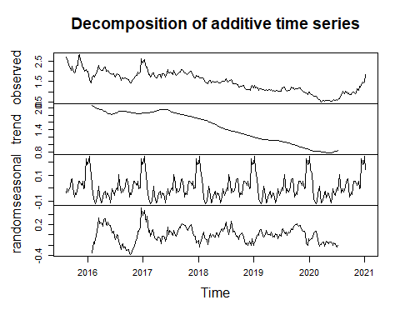

training_marc <- subset(marc, end=length(marc)-1)  
test_marc <- subset(marc, start=length(marc)-1)  
fc_training_marc<-forecast(training_marc)  
fc_training_marc %>%  
 forecast(h=26) %>%  
 autoplot() +autolayer(test_marc)

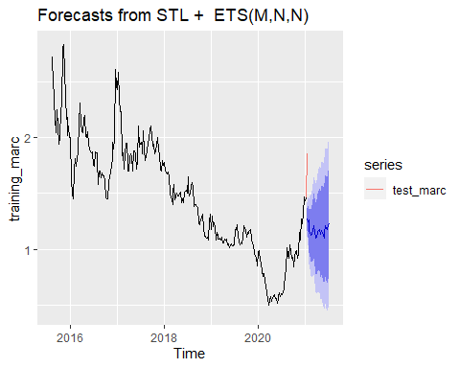

fc_training_marc

## Point Forecast Lo 80 Hi 80 Lo 95 Hi 95  
## 2021.023 1.269631 1.1713020 1.367961 1.119249508 1.420013  
## 2021.042 1.246737 1.1100614 1.383412 1.037709754 1.455764  
## 2021.062 1.262025 1.0955206 1.428530 1.007378509 1.516672  
## 2021.081 1.160132 0.9682998 1.351963 0.866750194 1.453513  
## 2021.100 1.148386 0.9341259 1.362646 0.820703368 1.476069  
## 2021.119 1.123325 0.8887019 1.357947 0.764500150 1.482149  
## 2021.138 1.134365 0.8809469 1.387783 0.746795482 1.521935  
## 2021.157 1.168163 0.8971905 1.439136 0.753746187 1.582580  
## 2021.177 1.210642 0.9231277 1.498156 0.770926799 1.650357  
## 2021.196 1.157035 0.8538265 1.460244 0.693317387 1.620753  
## 2021.215 1.101729 0.7835475 1.419911 0.615112135 1.588347  
## 2021.234 1.108445 0.7759139 1.440976 0.599882541 1.617007  
## 2021.253 1.147382 0.8010483 1.493717 0.617710078 1.677055  
## 2021.272 1.163579 0.8039247 1.523233 0.613535290 1.713622  
## 2021.292 1.176121 0.8035782 1.548664 0.606365849 1.745876  
## 2021.311 1.136599 0.7515551 1.521643 0.547725033 1.725473  
## 2021.330 1.167937 0.7707430 1.565132 0.560480951 1.775394  
## 2021.349 1.154151 0.7451262 1.563177 0.528601317 1.779701  
## 2021.368 1.137062 0.7164984 1.557626 0.493865454 1.780259  
## 2021.387 1.099302 0.6674685 1.531135 0.438869763 1.759734  
## 2021.407 1.144901 0.7020461 1.587756 0.467612947 1.822189  
## 2021.426 1.207819 0.7541724 1.661465 0.514026612 1.901611  
## 2021.445 1.187452 0.7232283 1.651676 0.477482882 1.897422  
## 2021.464 1.172396 0.6977936 1.646999 0.446554202 1.898238  
## 2021.483 1.214403 0.7296086 1.699198 0.472973862 1.955833  
## 2021.502 1.231306 0.7364944 1.726118 0.474556790 1.988056  
## 2021.522 1.215565 0.7108996 1.720230 0.443746091 1.987383  
## 2021.541 1.282121 0.7677572 1.796484 0.495469692 2.068772  
## 2021.560 1.264229 0.7403134 1.788145 0.462969148 2.065489  
## 2021.579 1.260357 0.7270262 1.793687 0.444698227 2.076015  
## 2021.598 1.310416 0.7678021 1.853030 0.480559608 2.140273  
## 2021.617 1.270286 0.7185122 1.822060 0.426420844 2.114151  
## 2021.637 1.263954 0.7031388 1.824770 0.406260895 2.121648  
## 2021.656 1.304966 0.7352200 1.874711 0.433614921 2.176316  
## 2021.675 1.327232 0.7486632 1.905800 0.442387473 2.212076  
## 2021.694 1.325207 0.7379174 1.912497 0.427024951 2.223389  
## 2021.713 1.272237 0.6763233 1.868151 0.360865689 2.183608  
## 2021.732 1.201667 0.5972227 1.806112 0.277249101 2.126086  
## 2021.752 1.223929 0.6110421 1.836815 0.286599583 2.161257  
## 2021.771 1.250416 0.6291734 1.871660 0.300307237 2.200526  
## 2021.790 1.292399 0.6628809 1.921917 0.329634249 2.255163  
## 2021.809 1.351336 0.7136218 1.989050 0.376036338 2.326635  
## 2021.828 1.335589 0.6897542 1.981424 0.347869805 2.323309  
## 2021.847 1.311031 0.6571472 1.964914 0.311002297 2.311059  
## 2021.867 1.320138 0.6582763 1.982000 0.307907751 2.332369  
## 2021.886 1.303169 0.6333951 1.972942 0.278838516 2.327499  
## 2021.905 1.307735 0.6301147 1.985355 0.271404274 2.344065  
## 2021.924 1.288503 0.6030988 1.973908 0.240267652 2.336739  
## 2021.943 1.437662 0.7445335 2.130791 0.377613435 2.497711  
## 2021.962 1.441450 0.7406558 2.142245 0.369677525 2.513223  
## 2021.982 1.439756 0.7313520 2.148161 0.356345287 2.523168  
## 2022.001 1.459676 0.7437161 2.175636 0.364709737 2.554643  
## 2022.020 1.269631 0.5461681 1.993095 0.163189820 2.376073  
## 2022.039 1.246737 0.5158211 1.977653 0.128897705 2.364576  
## 2022.058 1.262025 0.5237061 2.000344 0.132863561 2.391187  
## 2022.077 1.160132 0.4144568 1.905806 0.019720451 2.300543  
## 2022.097 1.148386 0.3954016 1.901371 -0.003204296 2.299976  
## 2022.116 1.123325 0.3630752 1.883574 -0.039376631 2.286026  
## 2022.135 1.134365 0.3668938 1.901836 -0.039380980 2.308111  
## 2022.154 1.168163 0.3935123 1.942814 -0.016563142 2.352890  
## 2022.173 1.210642 0.4288521 1.992432 0.014997506 2.406287  
## 2022.192 1.157035 0.3681460 1.945925 -0.049466845 2.363538  
## 2022.211 1.101729 0.3057790 1.897680 -0.115571745 2.319031  
## 2022.231 1.108445 0.3054708 1.911419 -0.119598034 2.336488  
## 2022.250 1.147382 0.3374208 1.957344 -0.091346993 2.386112  
## 2022.269 1.163579 0.3466649 1.980493 -0.085783208 2.412941  
## 2022.288 1.176121 0.3522892 1.999953 -0.083821007 2.436063  
## 2022.307 1.136599 0.3058827 1.967316 -0.133872105 2.407070  
## 2022.326 1.167937 0.3303686 2.005506 -0.113013565 2.448888  
## 2022.346 1.154151 0.3097618 1.998541 -0.137230964 2.445534  
## 2022.365 1.137062 0.2858824 1.988242 -0.164704809 2.438829  
## 2022.384 1.099302 0.2413620 1.957241 -0.212803888 2.411407  
## 2022.403 1.144901 0.2802300 2.009572 -0.177499103 2.467301  
## 2022.422 1.207819 0.3364452 2.079192 -0.124832142 2.540470  
## 2022.441 1.187452 0.3094036 2.065501 -0.155407277 2.530312  
## 2022.461 1.172396 0.2876992 2.057093 -0.180631090 2.525423  
## 2022.480 1.214403 0.3230842 2.105722 -0.148751565 2.577558  
## 2022.499 1.231306 0.3333908 2.129222 -0.141936979 2.604550  
## 2022.518 1.215565 0.3110775 2.120052 -0.167729107 2.598858  
## 2022.537 1.282121 0.3710862 2.193155 -0.111186350 2.675428  
## 2022.556 1.264229 0.3466712 2.181787 -0.139054755 2.667513  
## 2022.576 1.260357 0.3362978 2.184415 -0.152869271 2.673582  
## 2022.595 1.310416 0.3798794 2.240953 -0.112716921 2.733549  
## 2022.614 1.270286 0.3332933 2.207279 -0.162720726 2.703293  
## 2022.633 1.263954 0.3205272 2.207382 -0.178893074 2.706802  
## 2022.652 1.304966 0.3551246 2.254806 -0.147690849 2.757622  
## 2022.671 1.327232 0.3709976 2.283466 -0.135202159 2.789666  
## 2022.691 1.325207 0.3625998 2.287815 -0.146973824 2.797388  
## 2022.710 1.272237 0.3032758 2.241198 -0.209661226 2.754135  
## 2022.729 1.201667 0.2263714 2.176963 -0.289919126 2.693254  
## 2022.748 1.223929 0.2423164 2.205541 -0.277317710 2.725175  
## 2022.767 1.250416 0.2625063 2.238327 -0.260461832 2.761295  
## 2022.786 1.292399 0.2982081 2.286589 -0.228084599 2.812882  
## 2022.806 1.351336 0.3508823 2.351790 -0.178725899 2.881398  
## 2022.825 1.335589 0.3288894 2.342289 -0.204025315 2.875204  
## 2022.844 1.311031 0.2981011 2.323960 -0.238111349 2.860173  
## 2022.863 1.320138 0.3009953 2.339281 -0.238506448 2.878783  
## 2022.882 1.303169 0.2778278 2.328509 -0.264954865 2.871292  
## 2022.901 1.307735 0.2762117 2.339258 -0.269843723 2.885313  
## 2022.921 1.288503 0.2508128 2.326194 -0.298507386 2.875514  
## 2022.940 1.437662 0.3938189 2.481505 -0.158758233 3.034082  
## 2022.959 1.441450 0.3914689 2.491432 -0.164357683 3.047258  
## 2022.978 1.439756 0.3836507 2.495862 -0.175417841 3.054931  
## 2022.997 1.459676 0.3974600 2.521892 -0.164843297 3.084196

fc_marc<-forecast(marc)  
fc_marc %>%  
 forecast(h=26) %>%  
 autoplot()

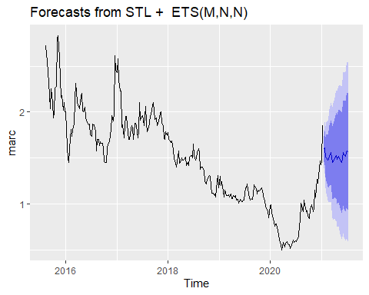

fc_marc

## Point Forecast Lo 80 Hi 80 Lo 95 Hi 95  
## 2021.042 1.598249 1.4628797 1.733619 1.391219429 1.805279  
## 2021.062 1.613621 1.4311895 1.796053 1.334615931 1.892627  
## 2021.081 1.511812 1.2920588 1.731565 1.175728438 1.847896  
## 2021.100 1.500152 1.2484467 1.751857 1.115202145 1.885101  
## 2021.119 1.475176 1.1950446 1.755306 1.046752331 1.903599  
## 2021.138 1.486301 1.1802859 1.792316 1.018291158 1.954311  
## 2021.157 1.520185 1.1902275 1.850142 1.015558701 2.024811  
## 2021.177 1.562749 1.2103959 1.915102 1.023871417 2.101627  
## 2021.196 1.509228 1.1357463 1.882709 0.938037147 2.080419  
## 2021.215 1.453678 1.0601306 1.847224 0.851799485 2.055556  
## 2021.234 1.460149 1.0474442 1.872853 0.828971656 2.091326  
## 2021.253 1.498845 1.0677692 1.929920 0.839571559 2.158118  
## 2021.272 1.514800 1.0660427 1.963557 0.828485059 2.201115  
## 2021.292 1.527103 1.0612758 1.992931 0.814681520 2.239525  
## 2021.311 1.487343 1.0049904 1.969695 0.749648514 2.225037  
## 2021.330 1.518445 1.0200590 2.016831 0.756229485 2.280660  
## 2021.349 1.504423 0.9904485 2.018397 0.718367101 2.290478  
## 2021.368 1.487097 0.9579404 2.016254 0.677821774 2.296372  
## 2021.387 1.449101 0.9051328 1.993068 0.617173641 2.281027  
## 2021.407 1.494396 0.9359591 2.052834 0.640340308 2.348452  
## 2021.426 1.557011 0.9844199 2.129602 0.681308559 2.432713  
## 2021.445 1.536341 0.9498892 2.122793 0.639440171 2.433242  
## 2021.464 1.520982 0.9209408 2.121023 0.603298220 2.438666  
## 2021.483 1.562685 0.9493086 2.176061 0.624606823 2.500763  
## 2021.502 1.579284 0.9528099 2.205757 0.621174687 2.537393  
## 2021.522 1.563237 0.9238881 2.202585 0.585437409 2.541036  
## 2021.541 1.629487 0.9774735 2.281501 0.632318147 2.626657  
## 2021.560 1.611290 0.9468080 2.275772 0.595052479 2.627528  
## 2021.579 1.607377 0.9306131 2.284141 0.572355939 2.642398  
## 2021.598 1.657140 0.9682708 2.346010 0.603605224 2.710676  
## 2021.617 1.616714 0.9159056 2.317523 0.544919875 2.688508  
## 2021.637 1.610085 0.8974954 2.322674 0.520273409 2.699896  
## 2021.656 1.650798 0.9265782 2.375017 0.543199550 2.758396  
## 2021.675 1.672765 0.9370583 2.408471 0.547598785 2.797931  
## 2021.694 1.670441 0.9233840 2.417498 0.527915760 2.812967  
## 2021.713 1.617172 0.8588940 2.375450 0.457485990 2.776858  
## 2021.732 1.546303 0.7769287 2.315677 0.369646737 2.722959  
## 2021.752 1.568265 0.7879132 2.348616 0.374820067 2.761709  
## 2021.771 1.594453 0.8032381 2.385668 0.384394124 2.804512  
## 2021.790 1.636127 0.8341578 2.438097 0.409620732 2.862634  
## 2021.809 1.694757 0.8821371 2.507377 0.451962244 2.937551  
## 2021.828 1.678703 0.8555335 2.501872 0.419773922 2.937632  
## 2021.847 1.653837 0.8202144 2.487460 0.378921191 2.928753  
## 2021.867 1.662637 0.8186542 2.506621 0.371876385 2.953399  
## 2021.886 1.645360 0.7911057 2.499615 0.338890582 2.951830  
## 2021.905 1.649619 0.7851789 2.514059 0.327571913 2.971666  
## 2021.924 1.630080 0.7555371 2.504623 0.292582005 2.967578  
## 2021.943 1.778931 0.8943652 2.663497 0.426104252 3.131758  
## 2021.962 1.782412 0.8878997 2.676923 0.414373675 3.150449  
## 2021.982 1.780382 0.8759987 2.684766 0.397247007 3.163517  
## 2022.001 1.799967 0.8857833 2.714150 0.401843861 3.198089  
## 2022.020 1.812744 0.8888301 2.736658 0.399739630 3.225748  
## 2022.039 1.598249 0.6646719 2.531826 0.170465965 3.026032  
## 2022.058 1.613621 0.6704458 2.556797 0.171158744 3.056084  
## 2022.077 1.511812 0.5591008 2.464523 0.054765901 2.968858  
## 2022.097 1.500152 0.5379656 2.462338 0.028615072 2.971688  
## 2022.116 1.475176 0.5035735 2.446777 -0.010761502 2.961113  
## 2022.135 1.486301 0.5053404 2.467262 -0.013948840 2.986551  
## 2022.154 1.520185 0.5299206 2.510449 0.005706484 3.034663  
## 2022.173 1.562749 0.5632353 2.562263 0.034124720 3.091373  
## 2022.192 1.509228 0.5005167 2.517939 -0.033462818 3.051919  
## 2022.211 1.453678 0.4358194 2.471536 -0.103002196 3.010357  
## 2022.231 1.460149 0.4331928 2.487105 -0.110444882 3.030742  
## 2022.250 1.498845 0.4628388 2.534851 -0.085589667 3.083279  
## 2022.269 1.514800 0.4697901 2.559810 -0.083404680 3.113004  
## 2022.288 1.527103 0.4731350 2.581072 -0.084802108 3.139009  
## 2022.307 1.487343 0.4244596 2.550226 -0.138196776 3.112882  
## 2022.326 1.518445 0.4466893 2.590200 -0.120663738 3.157553  
## 2022.346 1.504423 0.4238363 2.585009 -0.148191478 3.157037  
## 2022.365 1.487097 0.3977203 2.576474 -0.178960833 3.153155  
## 2022.384 1.449101 0.3509727 2.547228 -0.230341090 3.128542  
## 2022.403 1.494396 0.3875554 2.601237 -0.198370751 3.187163  
## 2022.422 1.557011 0.4414942 2.672528 -0.149024677 3.263046  
## 2022.441 1.536341 0.4121850 2.660498 -0.182907354 3.255590  
## 2022.461 1.520982 0.3882214 2.653743 -0.211425867 3.253390  
## 2022.480 1.562685 0.4213543 2.704015 -0.182829563 3.308199  
## 2022.499 1.579284 0.4294167 2.729151 -0.179286025 3.337853  
## 2022.518 1.563237 0.4048660 2.721607 -0.208338381 3.334812  
## 2022.537 1.629487 0.4626448 2.796330 -0.155044303 3.414019  
## 2022.556 1.611290 0.4360066 2.786574 -0.186150875 3.408731  
## 2022.576 1.607377 0.4236830 2.791071 -0.202926828 3.417681  
## 2022.595 1.657140 0.4650653 2.849216 -0.165981142 3.480262  
## 2022.614 1.616714 0.4162867 2.817142 -0.219181193 3.452610  
## 2022.633 1.610085 0.4013330 2.818836 -0.238541490 3.458711  
## 2022.652 1.650798 0.4337492 2.867846 -0.210517310 3.512113  
## 2022.671 1.672765 0.4474464 2.898083 -0.201198048 3.546728  
## 2022.691 1.670441 0.4368788 2.904004 -0.216129721 3.557012  
## 2022.710 1.617172 0.3753909 2.858953 -0.281968184 3.516312  
## 2022.729 1.546303 0.2963283 2.796277 -0.365368181 3.457974  
## 2022.748 1.568265 0.3101208 2.826408 -0.355900227 3.492429  
## 2022.767 1.594453 0.3281638 2.860742 -0.342169278 3.531076  
## 2022.786 1.636127 0.3617157 2.910539 -0.312917085 3.585172  
## 2022.806 1.694757 0.4122453 2.977268 -0.266675297 3.656189  
## 2022.825 1.678703 0.3881136 2.969292 -0.295083054 3.652489  
## 2022.844 1.653837 0.3551917 2.952483 -0.332269685 3.639944  
## 2022.863 1.662637 0.3559569 2.969318 -0.335757943 3.661033  
## 2022.882 1.645360 0.3306654 2.960055 -0.365292141 3.656013  
## 2022.901 1.649619 0.3269297 2.972309 -0.373259812 3.672498  
## 2022.921 1.630080 0.2994158 2.960744 -0.404995256 3.665155  
## 2022.940 1.778931 0.4403113 3.117551 -0.268311238 3.826173  
## 2022.959 1.782412 0.4358549 3.128968 -0.276969117 3.841792  
## 2022.978 1.780382 0.4259071 3.134857 -0.291108740 3.851873  
## 2022.997 1.799967 0.4375909 3.162342 -0.283607266 3.883541  
## 2023.016 1.812744 0.4424850 3.183003 -0.282886245 3.908374

tail(marc)

## Time Series:  
## Start = 2020.92744695414   
## End = 2021.02327173169   
## Frequency = 52.1785714285714   
## Price  
## [1,] 1.23  
## [2,] 1.31  
## [3,] 1.47  
## [4,] 1.43  
## [5,] 1.46  
## [6,] 1.85

min(marc)

## [1] 0.5

max(marc)

## [1] 2.83

which.min(marc)

## [1] 242

bestfit_marc <- list(aicc=Inf)  
for(i in 1:25)  
{  
 fit_marc <- auto.arima(marc, xreg=fourier(marc, K=i), seasonal=FALSE)  
 if(fit_marc$aicc < bestfit_marc$aicc)  
 bestfit_marc <- fit_marc  
 else break;  
}

summary(bestfit_marc)

## Series: marc   
## Regression with ARIMA(0,1,0) errors   
##   
## Coefficients:  
## S1-52 C1-52 S2-52 C2-52  
## 0.0153 -0.0100 -0.0405 0.0275  
## s.e. 0.0767 0.0756 0.0383 0.0380  
##   
## sigma^2 = 0.01202: log likelihood = 226.06  
## AIC=-442.12 AICc=-441.91 BIC=-423.89  
##   
## Training set error measures:  
## ME RMSE MAE MPE MAPE MASE  
## Training set -0.00324123 0.1086631 0.07240871 -0.3693647 4.806698 0.1827946  
## ACF1  
## Training set 0.009124097

fc_arima_marc <- forecast(bestfit_marc, xreg=fourier(marc, K=2, h=26))  
plot(fc_arima_marc)

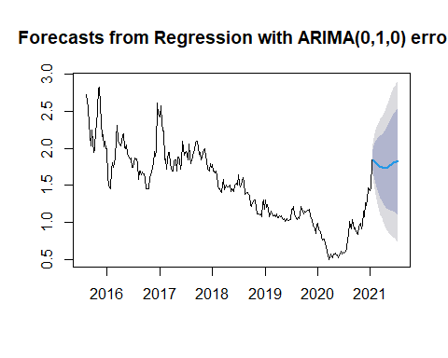

fc_arima_marc

## Point Forecast Lo 80 Hi 80 Lo 95 Hi 95  
## 2021.042 1.844268 1.703769 1.984768 1.6293926 2.059144  
## 2021.062 1.835859 1.637162 2.034555 1.5319787 2.139739  
## 2021.081 1.825188 1.581835 2.068540 1.4530125 2.197363  
## 2021.100 1.812796 1.531796 2.093795 1.3830444 2.242547  
## 2021.119 1.799314 1.485148 2.113481 1.3188380 2.279791  
## 2021.138 1.785435 1.441283 2.129587 1.2590996 2.311771  
## 2021.157 1.771867 1.400140 2.143594 1.2033599 2.340375  
## 2021.177 1.759300 1.361907 2.156693 1.1515403 2.367060  
## 2021.196 1.748364 1.326866 2.169863 1.1037377 2.392991  
## 2021.215 1.739596 1.295298 2.183895 1.0601002 2.419093  
## 2021.234 1.733409 1.267425 2.199394 1.0207475 2.446071  
## 2021.253 1.730070 1.243365 2.216775 0.9857188 2.474420  
## 2021.272 1.729685 1.223106 2.236263 0.9549400 2.504430  
## 2021.292 1.732197 1.206496 2.257898 0.9282060 2.536188  
## 2021.311 1.737387 1.193234 2.281539 0.9051773 2.569596  
## 2021.330 1.744890 1.182891 2.306888 0.8853873 2.604392  
## 2021.349 1.754215 1.174920 2.333509 0.8682601 2.640170  
## 2021.368 1.764777 1.168687 2.360866 0.8531368 2.676417  
## 2021.387 1.775928 1.163505 2.388352 0.8393072 2.712549  
## 2021.407 1.786999 1.158666 2.415332 0.8260462 2.747952  
## 2021.426 1.797335 1.153485 2.441185 0.8126512 2.782018  
## 2021.445 1.806335 1.147333 2.465336 0.7984790 2.814191  
## 2021.464 1.813487 1.139675 2.487299 0.7829799 2.843994  
## 2021.483 1.818397 1.130093 2.506702 0.7657261 2.871068  
## 2021.502 1.820812 1.118314 2.523310 0.7464338 2.895190  
## 2021.522 1.820632 1.104221 2.537042 0.7249768 2.916286

fit_marc1 <- auto.arima(marc, xreg=fourier(marc, K=1), seasonal=FALSE)  
fit_marc2 <- auto.arima(marc, xreg=fourier(marc, K=2), seasonal=FALSE)  
fit_marc3 <- auto.arima(marc, xreg=fourier(marc, K=3), seasonal=FALSE)  
fit_marc4 <- auto.arima(marc, xreg=fourier(marc, K=4), seasonal=FALSE)  
fit_marc5 <- auto.arima(marc, xreg=fourier(marc, K=5), seasonal=FALSE)  
fit_marc6 <- auto.arima(marc, xreg=fourier(marc, K=6), seasonal=FALSE)  
fit_marc7 <- auto.arima(marc, xreg=fourier(marc, K=7), seasonal=FALSE)  
fit_marc8 <- auto.arima(marc, xreg=fourier(marc, K=8), seasonal=FALSE)  
fit_marc9 <- auto.arima(marc, xreg=fourier(marc, K=9), seasonal=FALSE)  
fit_marc10 <- auto.arima(marc, xreg=fourier(marc, K=10), seasonal=FALSE)  
fit_marc11 <- auto.arima(marc, xreg=fourier(marc, K=11), seasonal=FALSE)  
fit_marc12 <- auto.arima(marc, xreg=fourier(marc, K=12), seasonal=FALSE)

aics<-c(AIC(fit_marc1),AIC(fit_marc2),AIC(fit_marc3),AIC(fit_marc4),AIC(fit_marc5),AIC(fit_marc6),AIC(fit_marc7),AIC(fit_marc8),AIC(fit_marc9),AIC(fit_marc10),AIC(fit_marc11),AIC(fit_marc12))  
plot(aics)

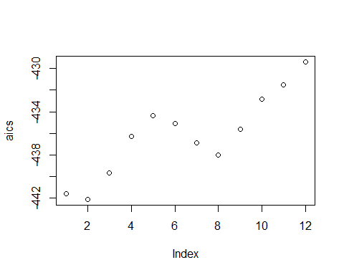

fc_marc1 <- forecast(fit_marc1, xreg=fourier(marc, K=1, h=26))  
plot(fc_marc1)

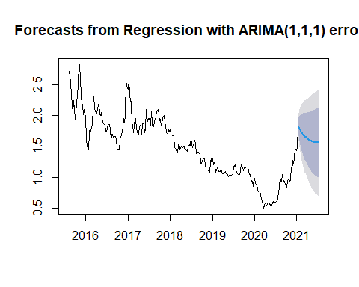

fc_marc1

## Point Forecast Lo 80 Hi 80 Lo 95 Hi 95  
## 2021.042 1.821930 1.6813080 1.962552 1.6068672 2.036993  
## 2021.062 1.796092 1.6003997 1.991784 1.4968066 2.095377  
## 2021.081 1.772279 1.5362287 2.008330 1.4112710 2.133287  
## 2021.100 1.750314 1.4816437 2.018983 1.3394184 2.161209  
## 2021.119 1.730040 1.4337239 2.026356 1.2768636 2.183216  
## 2021.138 1.711325 1.3908877 2.031763 1.2212582 2.201393  
## 2021.157 1.694056 1.3521454 2.035966 1.1711490 2.216962  
## 2021.177 1.678133 1.3168209 2.039446 1.1255537 2.230713  
## 2021.196 1.663475 1.2844249 2.042525 1.0837680 2.243181  
## 2021.215 1.650009 1.2545887 2.045430 1.0452656 2.254753  
## 2021.234 1.637676 1.2270259 2.048327 1.0096408 2.265712  
## 2021.253 1.626423 1.2015091 2.051338 0.9765731 2.276274  
## 2021.272 1.616205 1.1778537 2.054557 0.9458043 2.286607  
## 2021.292 1.606982 1.1559073 2.058058 0.9171225 2.296842  
## 2021.311 1.598718 1.1355418 2.061894 0.8903511 2.307085  
## 2021.330 1.591379 1.1166476 2.066110 0.8653400 2.317418  
## 2021.349 1.584933 1.0991290 2.070737 0.8419600 2.327906  
## 2021.368 1.579349 1.0829010 2.075797 0.8200974 2.338600  
## 2021.387 1.574595 1.0678859 2.081303 0.7996505 2.349539  
## 2021.407 1.570638 1.0540120 2.087264 0.7805268 2.360749  
## 2021.426 1.567444 1.0412110 2.093676 0.7626402 2.372247  
## 2021.445 1.564976 1.0294171 2.100534 0.7459096 2.384042  
## 2021.464 1.563195 1.0185661 2.107823 0.7302571 2.396132  
## 2021.483 1.562059 1.0085939 2.115525 0.7156070 2.408511  
## 2021.502 1.561525 0.9994366 2.123613 0.7018851 2.421164  
## 2021.522 1.561544 0.9910298 2.132058 0.6890179 2.434070

accuracy(fc_marc)

## ME RMSE MAE MPE MAPE MASE  
## Training set -0.004080631 0.09374382 0.06768971 -0.3982707 4.674086 0.1708815  
## ACF1  
## Training set 0.06558882

accuracy(fc_arima_marc)

## ME RMSE MAE MPE MAPE MASE  
## Training set -0.00324123 0.1086631 0.07240871 -0.3693647 4.806698 0.1827946  
## ACF1  
## Training set 0.009124097

accuracy(fc_marc1)

## ME RMSE MAE MPE MAPE MASE  
## Training set -0.005976993 0.1087577 0.07268126 -0.6039648 4.848226 0.1834826  
## ACF1  
## Training set 0.03667086