- Infinite Impulse Response (IIR) filters – DC Blocker Block

- Single Pole Recursive filter

Single Pole Recursive low-pass filter:
$$y\left[n\right]=x\left[n\right]∗a_{0}+y\left[n−1\right]∗b_{1}$$
Trong đó:
- $$a_{0}=1−x$$
- $$b_{1}=x$$

Single Pole Recursive high-pass filter:
$$y\left[n\right]=a_{0}∗x\left[n\right]−\left(a_{1}∗x\left[n−1\right]+b_{1}∗y\left[n−1\right]\right)$$
- $$a_{0}={\left(1+x\right)}/2$$
- $$a_{1}={−\left(1+x\right)}/2$$
- $$b_{1}=x$$

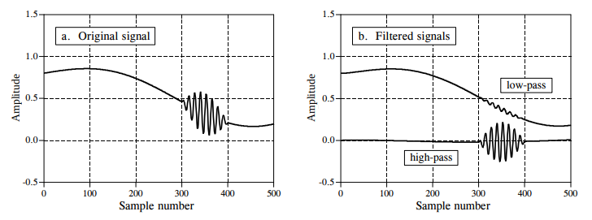

- Phương pháp xác định các hệ số

- ...

- Frequency Shift
- Resampler
- Automatic Gain Control
- Root Raised Cosine
- Costas Loop
- Clock Recovery

