Evidence-Grounded Anomaly Detection and Attribution
in Financial Time Series via Modular Embedder–Detector Architectures

[Author Name(s)]
[Institution]
[Course / Submission Date]

Abstract
Abnormal financial events—price spikes, volatility bursts, and regime shifts—frequently coincide with identifiable external catalysts, yet pose significant tail risks that current detection systems fail to adequately explain. Existing anomaly detectors act as black boxes, returning scores without identifying which timesteps drive the anomaly, which features are primary contributors, or which real-world events constitute verifiable causes. This paper presents an evidence-grounded anomaly detection and attribution framework that addresses all three. We systematically evaluate a modular Embedder → Detector architecture—pairing three SOTA time-series embedders (iTransformer, TimesNet, PatchTST) with two transformer-based detectors (Anomaly Transformer, TranAD)—trained on a large-scale dataset of 500 tickers across 11 sectors. Models are evaluated against a rigorous dual-substrate benchmark comprising real trading data and mathematically stationary synthetic data (via Ornstein-Uhlenbeck processes), stratified across three difficulty tiers. Explanations are generated via a three-layer interpretability stack: feature-level attribution (Integrated Gradients), temporal anatomy (Monte Carlo TimeSHAP), and event-grounding (LLM-ranked news retrieval). Results reveal that embedder choice is architecture-conditional, with the Anomaly Transformer achieving peak performance in its native configuration (F1 = 0.614). Furthermore, the two detectors exhibit fundamentally complementary profiles: TranAD excels at point anomaly recall but suffers a severe substrate penalty on synthetic data, while the Anomaly Transformer maintains robust contextual recall that widens as complexity increases. XAI analysis traces this divergence to a structural difference in temporal focus: TranAD concentrates 71% of its attribution mass on the terminal timestep, whereas the Anomaly Transformer distributes attention across the full lookback window—enabling evidence-grounded explanations that link model internals to verifiable market catalysts.

1. Introduction
Anomaly detection in financial time series is a high-stakes problem. Abnormal price behaviour—sudden spikes, volatility bursts, gap returns, and prolonged regime shifts—frequently coincides with identifiable external catalysts and carries significant tail risk for portfolio managers, risk systems, and regulatory oversight. Yet despite the practical urgency, most deployed anomaly detection systems operate as black boxes: they return a scalar anomaly score but provide no mechanism for understanding why a flagged event was anomalous, which features of the time series drove the detection, or what real-world events plausibly caused it.
Recent advances in transformer-based time-series modelling have produced a generation of powerful anomaly detectors—notably the Anomaly Transformer and TranAD—alongside a parallel family of general-purpose time-series embedders (iTransformer, TimesNet, PatchTST) designed to learn rich temporal representations. A natural question arises: does prepending a SOTA embedder to a transformer-based anomaly detector improve detection quality? And if so, does the answer depend on the detector architecture? These questions have received little systematic attention. Existing benchmarks typically evaluate detectors in isolation, without controlling for the upstream representation, making it difficult to attribute performance differences to architectural choices versus data characteristics.
Evaluation methodology presents a further challenge. Most anomaly detection benchmarks rely on a single data substrate—either real-world data with imprecise or absent ground truth labels, or fully synthetic data that may not reflect realistic market microstructure [Wu & Keogh, 2021; Liu & Paparrizos, 2024]. Neither alone is sufficient: real data provides ecological validity but makes precision and recall ambiguous, while synthetic data provides clean labels but may not capture the distributional properties that make financial anomalies difficult to detect. Furthermore, existing benchmarks rarely disentangle the effect of data substrate from anomaly type, making it difficult to isolate where model failures originate [Wu & Keogh, 2021; Liu & Paparrizos, 2024].
Finally, even when detection performance is well-characterized, the interpretability of the detection mechanism is typically neglected. Understanding how a model detects an anomaly—which features it relied on, which timesteps in the lookback window were most influential, and whether the detection corresponds to a verifiable real-world event—is essential for deploying anomaly detection in any high-accountability setting.
This paper addresses all three gaps. We make the following contributions:
A systematic embedder–detector pairing study. We evaluate six Embedder→Detector combinations—pairing iTransformer, TimesNet, PatchTST, and a no-embedder baseline with Anomaly Transformer and TranAD—trained on 500 tickers across 11 market sectors spanning a decade of daily trading data, using eight stationary engineered features per timestep (e.g., volatility-normalized returns and momentum oscillators). We find that embedder benefit is architecture-conditional: the Anomaly Transformer performs best without an upstream embedder, while TimesNet provides meaningful gains for TranAD on point anomaly recall. More fundamentally, the two detectors exhibit complementary behavioral profiles that persist across all encoder configurations, with implications for architecture selection in practice.

A dual-substrate, difficulty-stratified evaluation benchmark. We construct two distinct test substrates: 25 real tickers selected for minimal organic anomaly contamination, and fully synthetic data generated via Ornstein-Uhlenbeck log-price processes to guarantee mathematical stationarity. Both substrates undergo a rigorous anomaly injection protocol—covering point, contextual, and collective anomaly types across Easy, Medium, and Hard difficulty tiers—with OHLCV integrity constraints enforced throughout. This design enables clean separation of substrate and difficulty effects, and surfaces a critical finding: TranAD-based models incur a severe synthetic substrate penalty, achieving high precision on real data but collapsing in recall on mathematically pure environments—a warning for researchers who evaluate exclusively on organic market data.

A three-layer XAI pipeline for evidence-grounded anomaly attribution. For the two best-performing models, we apply Integrated Gradients to identify which engineered features drove each detection, Monte Carlo TimeSHAP to decompose anomaly scores across the temporal lookback window, and LLM-ranked news retrieval to ground each flagged event in verifiable real-world catalysts. Applied jointly to the same events, these three layers produce a complete, human-interpretable account of each anomaly—linking model internals to market microstructure features and external news narratives. We adopt the term evidence-grounded to distinguish this post-hoc attribution approach from multimodal architectures that ingest text and numerical data jointly.

The remainder of this paper is organized as follows. Section 2 reviews related work on time-series anomaly detection, transformer-based embedders, and XAI for financial systems. Section 3 describes the data collection, feature engineering, and anomaly injection pipeline. Section 4 presents the model architectures and training procedure. Section 5 reports experimental results. Section 6 presents the XAI analysis. Section 7 discusses findings, limitations, and future directions.

2. Related Work

2.1 Transformer-Based Time-Series Anomaly Detection
Early deep learning approaches to time-series anomaly detection relied on autoencoders and LSTMs to model normal behaviour, flagging deviations as anomalies via reconstruction error [Malhotra et al., 2016; Park et al., 2018]. Transformer architectures introduced richer temporal dependency modelling, with several designs adapted specifically for anomaly detection. TranAD [Tuli et al., 2022] employs an adversarial training objective with a two-stage transformer that amplifies reconstruction error for anomalous inputs, achieving strong point anomaly detection through sharp threshold behaviour. The Anomaly Transformer [Xu et al., 2022] takes a fundamentally different approach, introducing an association discrepancy mechanism that contrasts a learned prior association with series-wise self-attention—anomalies are detected not by reconstruction error magnitude but by the divergence between these two attention distributions. These two architectures represent distinct detection philosophies—threshold-based terminal-state detection versus distributed temporal association—and form the detector backbone of this work.

2.2 Time-Series Representation Learning
A parallel line of work has focused on learning general-purpose temporal representations that can be transferred to downstream tasks. PatchTST [Nie et al., 2023] segments time series into local patches before applying self-attention, capturing local semantic structure while reducing sequence length. TimesNet [Wu et al., 2023] transforms 1D temporal sequences into 2D representations via FFT-based period detection, enabling convolutional processing of temporal-frequency structure. iTransformer [Liu et al., 2024] inverts the conventional transformer design by applying self-attention across variates rather than timesteps, prioritising multivariate correlation over temporal ordering. While these embedders have demonstrated strong performance on forecasting and classification benchmarks, their effect as upstream representation modules for anomaly detection has not been systematically studied—a gap this paper directly addresses.

2.3 Anomaly Detection in Financial Markets
Financial time-series anomaly detection has been approached from statistical, machine learning, and deep learning perspectives. Classical methods including GARCH-family models and extreme value theory have long been used to model volatility regimes and tail events [Engle, 1982; McNeil & Frey, 2000]. More recent work has applied isolation forests, autoencoders, and one-class SVMs to detect anomalous trading behaviour [Cao et al., 2019; Ahmed et al., 2016]. While transformer-based architectures have recently achieved state-of-the-art results in financial forecasting [Zhou et al., 2021], their extension to anomaly detection is often hampered by the scarcity of high-fidelity ground truth labels. This lack of controlled labeling has led to a growing critique of existing benchmarks, which frequently suffer from biased evaluation metrics and the "illusion of progress" created by point-adjustment strategies [Wu & Keogh, 2021; Liu & Paparrizos, 2024]. This work addresses these methodological risks by constructing a dual-substrate benchmark with mathematically guaranteed labels.

2.4 Explainability for Time-Series Anomaly Detection
Explainability methods for time-series models broadly divide into feature attribution and temporal attribution approaches. Integrated Gradients [Sundararajan et al., 2017] provides axiomatic feature-level attribution by integrating gradients along a path from a baseline to the input, satisfying completeness and sensitivity properties. However, gradient-based methods often struggle to capture the evolving temporal granularity required for sequential data [Bento et al., 2021]. To address this, TimeSHAP extends the SHAP framework to sequential models by decomposing predictions across timesteps, enabling a "temporal anatomy" of the detection. Finally, LLM-based post-hoc explanation has emerged as a method to ground model internals in natural language narratives [Kroeger et al., 2023]. This work combines all three—feature (IG), temporal (TimeSHAP), and event-grounded (LLM) layers—to produce a complete interpretability picture that aligns model sensitivity with real-world market catalysts.

3. Methodology

3.1 Training Data Collection and Feature Engineering
Training data was collected for approximately 500 equity tickers distributed across 11 market sectors using the yfinance API, covering the period January 2015 to January 2025. Daily OHLCV bars were retrieved for each ticker, yielding approximately 2,500 trading days per series after alignment.
Each OHLCV series was transformed into eight stationary engineered features. Five features are derived directly from OHLCV data: log return f₁ = log(Cₜ/Cₜ₋₁), overnight gap return f₂ = log(Oₜ/Cₜ₋₁), Parkinson intraday volatility f₃ = √[(1/4ln2)·log(Hₜ/Lₜ)²], volume z-score f₄ computed over a 20-day rolling window, and market-adjusted relative return f₅ = f₁ − rₜᵐ where rₜᵐ is the log return of the S&P 500 benchmark. Three momentum and volatility oscillators are additionally computed from the Close series: RSI-14 (f₆), MACD histogram (f₇, difference between 12- and 26-period EMAs minus a 9-period signal line), and Bollinger Band width (f₈ = 4σ₂₀/μ₂₀). This feature set captures four distinct dimensions of market behaviour: directional momentum (f₁, f₂, f₇), volatility regime (f₃, f₈), volume activity (f₄), and relative positioning (f₅, f₆). All features were computed after anomaly injection to prevent engineered signals from contaminating the frozen baseline used for injection scaling.
Features were scaled using a RobustScaler fitted on the first 80% of each ticker's training series, making the scaler robust to outliers in the held-out validation portion. For test data, a separate RobustScaler was fitted on the first 315-day warm-up buffer (252 + 63 trading days) of each injected series to avoid look-ahead bias.

3.2 Test Data Construction
Real substrate. Candidate tickers from the training universe were first screened for stationarity using a dual test: the Augmented Dickey-Fuller test must reject the unit root hypothesis (p < 0.05) and the KPSS test must simultaneously fail to reject stationarity (p > 0.05). Surviving tickers were then ranked by a composite stability score:
S = 0.4·H + 0.3·CV_σ + 0.3·(Z_max/10)
where H is the Hurst exponent estimated via log-log regression of standard deviation against lag (lags 2–99), CV_σ is the coefficient of variation of 21-day rolling return volatility, and Z_max is the maximum absolute z-score of log returns. Lower scores indicate more stable, mean-reverting behaviour. The 25 tickers with the lowest composite scores were selected as the real test substrate, minimizing the risk that organic market anomalies contaminate injected ground truth labels.
Synthetic substrate. Twenty-five synthetic tickers were generated de novo using an Ornstein-Uhlenbeck log-price process, guaranteeing mathematical stationarity and zero natural anomalies by construction. The OU dynamics follow:
log pₜ = log pₜ₋₁ + θ(μ − log pₜ₋₁) + σ_OU · εₜ, εₜ ~ N(0,1)
with parameters θ = 0.03, μ = 5.0, σ_OU = 0.015. Open, High, and Low prices were derived from the Close series with small multiplicative noise to produce valid OHLCV candles. A synthetic market benchmark (SPY_SYN) was generated under the same process to enable relative return computation. Each synthetic ticker was assigned a unique random seed derived from a shared base seed of 42 for reproducibility.

3.3 Anomaly Injection Pipeline
Both substrates underwent identical anomaly injection before feature engineering. The pipeline injects three anomaly archetypes—Point, Contextual, and Collective—across three difficulty tiers, producing six labeled test sets per substrate.
Baseline computation. To prevent recursive inflation, injection magnitudes are scaled against an immutable baseline: a 21-day rolling standard deviation of log returns computed on the unaltered raw series and frozen prior to any modification. A noise floor of 10⁻⁵ is applied to prevent degenerate scaling in periods of near-zero volatility.
Temporal safety. Injection indices are sampled uniformly from an eligible window that excludes a 63-trading-day boundary buffer at each end. A 30-day cooldown is enforced between events via rejection sampling, with a 100-attempt limit per placement to avoid infinite loops. Multi-day anomalies apply a 3-day linear taper at window boundaries to eliminate seam artifacts.
Point anomalies are single-day log-return shocks scaled by the frozen σ, followed by a 5-day exponential volume decay (mult_t = 1 + (V₀ − 1)e^(−0.5t)) to mimic post-shock market digestion. Contextual anomalies expand the daily High-Low range by a variance multiplier while preserving the directional sign of (Close − Open) and exactly preserving doji candles. Collective anomalies inject persistent directional drift in log-return space with gravity suspension (window mean subtracted) to neutralize the mean-reverting baseline; the autocorrelation shuffle is enabled at Hard difficulty to destroy the characteristic zigzag pattern of mean-reverting series.
Difficulty tiers parameterize each archetype as follows:

Anomaly Type | Easy | Medium | Hard
Point (±σ) | 6.0 – 8.0 | 4.0 – 6.0 | 2.5 – 4.0
Contextual (variance ×) | 4.0 – 5.0 | 2.5 – 4.0 | 1.5 – 2.5
Collective (σ/day) | 1.0 – 1.5 | 0.5 – 1.0 | 0.2 – 0.5
Table 0. Difficulty tier parameters for each anomaly archetype.

Target injection density is 6% of total rows per ticker, distributed equally across the three archetypes. An OHLCV integrity engine enforces four constraints after every injection: High ≥ max(Open, Close), Low ≤ min(Open, Close), all prices clamped above a hard floor of 10⁻⁴, and Volume ≥ 0. A programmatic sanity check verifies all constraints hold before export. Ground truth is stored as three binary columns (Is_Anomaly_Point, Is_Anomaly_Contextual, Is_Anomaly_Collective) enabling per-type evaluation.

3.4 Model Architecture
All models follow a modular Embedder → Detector pipeline. The embedder optionally transforms the raw 8-dimensional feature sequence before passing it to the anomaly detector. All models operate on input windows of length T = 96 timesteps.
Embedders. Three SOTA time-series embedders were evaluated alongside a no-embedder baseline. TimesNet [Wu et al., 2023] applies FFT-based period detection to transform the 1D sequence into a 2D temporal-frequency representation processed by inception-style convolutions (d_model = 32, d_ff = 64, top-k = 3 frequencies, 2 layers), projecting the output to a 32-dimensional sequence. PatchTST [Nie et al., 2023] segments the input into overlapping patches of length 16 with stride 8 and applies multi-head self-attention (d_model = 64, d_ff = 256, 8 heads, 3 layers). iTransformer [Liu et al., 2024] inverts the attention mechanism to operate across variates rather than timesteps (d_model = 64, d_ff = 256, 8 heads, 3 layers).
Detectors. Anomaly Transformer [Xu et al., 2022] computes an association discrepancy between a learned prior association and series-wise self-attention; anomaly scores are derived from the KL divergence between these two distributions (d_model = 64, d_ff = 256, 8 heads, 3 layers, λ = 0.0002). TranAD [Tuli et al., 2022] uses a two-stage adversarial transformer that amplifies reconstruction error for anomalous inputs, enabling sharp threshold-based detection (d_model = 64, d_ff = 256, 8 heads). When an embedder precedes TranAD, the feature dimension and feed-forward width are adjusted to match the embedder output dimensionality. Both detectors were implemented faithfully from their original repositories to ensure reproducibility.

3.5 Training Procedure
All models were trained on the full 500-ticker dataset using an 80/20 chronological train/validation split. Training used the Adam optimizer with learning rate 10⁻⁴, batch size 256, dropout 0.15, and a maximum of 15 epochs with early stopping (patience 5, minimum delta 10⁻⁵). The optimal checkpoint for each model variant was selected as the epoch achieving the highest mean F1 across all six test sets. Two threshold strategies were evaluated for converting continuous anomaly scores to binary predictions: Peak Over Threshold (POT), an extreme value theory approach that fits a generalized Pareto distribution to score exceedances, and a fixed percentile threshold at the 98th percentile of calibration scores. Final metrics are reported as averages across both strategies to reduce threshold-strategy bias.

3.6 Explainability Pipeline
The two best-performing model variants were subjected to a three-layer attribution analysis applied to the ten highest-scoring anomaly events per ticker per detector across NVDA, TSLA, and INTC.
Feature attribution (Integrated Gradients). IG [Sundararajan et al., 2017] was computed using Captum with a zero baseline, n_steps = 100, and internal batch size 1. Feature-level importance was aggregated as mean absolute attribution across the temporal window, yielding a per-feature ranking for each event.
Temporal attribution (TimeSHAP). Monte Carlo TimeSHAP [Bento et al., 2021] decomposed each anomaly score into per-timestep Shapley values using n = 50 random permutations of all T = 96 timesteps, with a feature-wise mean baseline and inner batch size 64. A recency concentration metric—the fraction of total |φ(t)| mass in the final 20% of the window (timesteps 76–95)—was computed for each event as a model-level temporal receptive field indicator.
Event attribution (LLM-ranked news retrieval). News headlines surrounding each flagged event were retrieved from the GDELT API using a 72-hour lookback and 24-hour lookahead window. Headlines were passed to Gemini 3.1 Flash-Lite (model identifier: gemini-3.1-flash-lite-preview) [Google DeepMind, 2026] with a structured prompt requesting ranked attribution scores (0–10) and directional labels (positive/negative/neutral) for each headline, along with a synthesizing summary. Requests were processed asynchronously in batches of 15, with a 65-second inter-batch pause to respect API rate limits.

4. Experiments and Results

4.1 Experimental Setup
Models are evaluated on six test sets spanning two substrates (Real, Synthetic) and three difficulty tiers (Easy, Medium, Hard). The primary metric is the F1 score (harmonic mean of precision and recall). Secondary metrics include AUROC, precision, and recall decomposed by anomaly type (Point, Contextual, Collective). All metrics are averaged across two threshold strategies—Peak Over Threshold (POT) and 98th-percentile—to reduce threshold-selection bias. For each model variant, results are reported at the epoch achieving the highest mean F1 across all six test sets. Note that evaluations use the Point Adjustment (PA) protocol inherited from the original Anomaly Transformer and TranAD repositories; reported recall values should therefore be interpreted as upper bounds, particularly for contextual and collective anomaly types. This limitation is discussed further in Section 7.

4.2 Overall Detection Performance
Table 1 reports cross-model performance at each variant's optimal epoch. Figure 1 (Appendix A) illustrates the anomaly score series and price reconstruction for each selected ticker under both detectors. The no-embedder Anomaly Transformer achieves the highest overall F1 (0.614) and the most balanced precision/recall profile. TimesNet + TranAD ranks third overall but achieves the highest AUROC (0.677) and the highest single-condition F1 of any model (0.804 on Synthetic Easy). The iTransformer + Anomaly Transformer combination is the clear outlier: it is the only variant that degrades monotonically from epoch 1, reaching its peak F1 of 0.475 at initialization and declining continuously thereafter—a strong signal of architectural incompatibility between iTransformer's variate-first attention and the Anomaly Transformer's temporal association discrepancy mechanism.
It is worth noting that TranAD-based models display dense anomaly flagging on NVDA and TSLA during their respective high-volatility regimes (visible in Figure 1, Appendix A). This behaviour reflects a distribution shift between the broad, sector-balanced training distribution and the regime-change characteristics of individual high-growth equities, rather than a simple architectural failure—a point discussed further in Section 7.

Model Variant | Best Ep. | F1 | AUROC | Precision | Recall
None + Anomaly Transformer | 8 | 0.614 | 0.671 | 0.690 | 0.556
PatchTST + Anomaly Transformer | 8 | 0.587 | 0.651 | 0.675 | 0.521
TimesNet + TranAD | 8 | 0.574 | 0.677 | 0.698 | 0.551
PatchTST + TranAD | 15 | 0.534 | 0.656 | 0.723 | 0.481
iTransformer + TranAD | 6 | 0.512 | 0.644 | 0.719 | 0.473
None + TranAD | 10 | 0.510 | 0.650 | 0.744 | 0.455
TimesNet + Anomaly Transformer | 9 | 0.496 | 0.650 | 0.609 | 0.421
iTransformer + Anomaly Transformer | 1 | 0.475 | 0.549 | 0.587 | 0.401
Table 1. Cross-model performance at optimal epoch, sorted by F1 descending. Best result per column in bold (top row).

4.3 Embedder Effects
Embedder benefit is architecture-conditional and in several cases negative. For the Anomaly Transformer, the no-embedder baseline outperforms all three embedder variants, suggesting that the detector's internal association discrepancy mechanism is sufficient to capture temporal dependencies in this feature space. PatchTST provides the closest result (F1 0.587), while TimesNet and iTransformer both degrade performance—iTransformer catastrophically so.
For TranAD, the picture is more nuanced. TimesNet provides a meaningful lift on Synthetic Easy (F1 0.804 vs 0.731 for no-embedder TranAD) and achieves the highest AUROC of any combination. PatchTST + TranAD shows steady improvement through epoch 15 without converging, suggesting its ranking (4th) may be artificially depressed by the training epoch budget. iTransformer + TranAD performs acceptably but offers no advantage over the simpler alternatives.
The consistent underperformance of iTransformer across both detectors warrants specific attention. iTransformer's inversion of the attention mechanism—applying self-attention across variates rather than timesteps—appears fundamentally misaligned with anomaly detection tasks that require precise temporal localization. When paired with the Anomaly Transformer, this produces destructive interference with the temporal association discrepancy; when paired with TranAD, the damage is less severe but the variate-first representation still offers no benefit.

4.4 Substrate and Difficulty Analysis
Figure 1 reports F1 by substrate and difficulty tier at each model's optimal epoch. Two structural patterns emerge clearly.
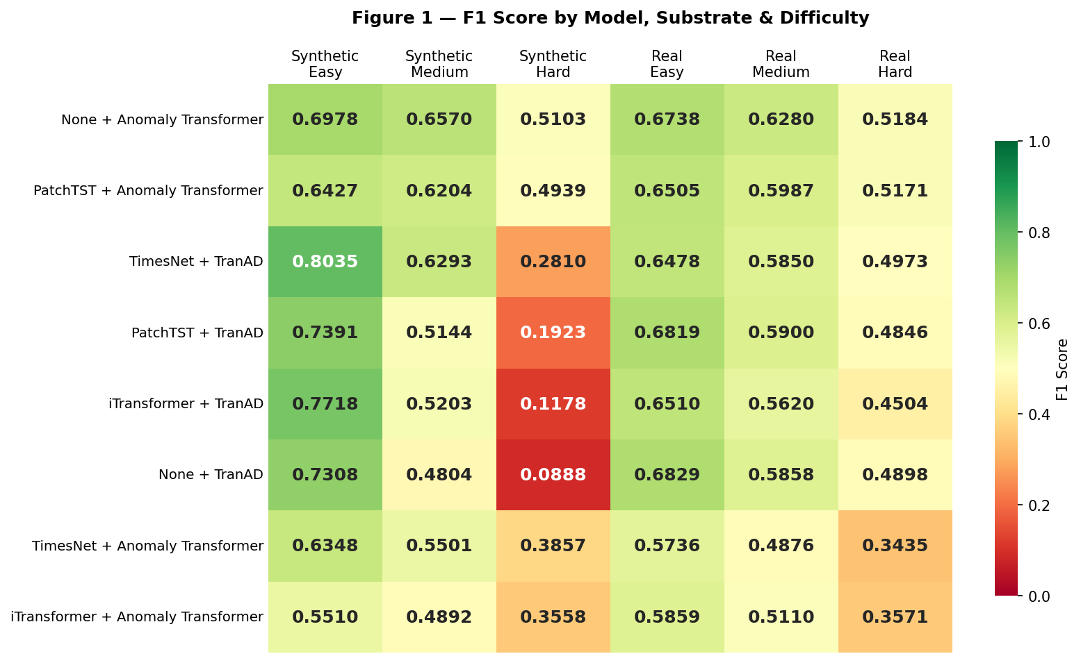

The first pattern is a synthetic substrate penalty specific to TranAD-based models. On Real Easy, all TranAD variants achieve F1 between 0.648 and 0.683—competitive with Anomaly Transformer variants. On Synthetic Hard, the same models collapse to F1 between 0.089 and 0.281, while Anomaly Transformer variants retain F1 between 0.344 and 0.510. This asymmetry is not explained by difficulty alone: TranAD models retain substantially higher Real Hard performance (0.450–0.682) than Synthetic Hard performance, confirming the penalty is substrate-mediated rather than purely complexity-driven. The most likely explanation is that TranAD's threshold mechanism, which relies on sharp reconstruction error boundaries, is calibrated to the irregular noise structure of real market data and over-suppresses detections on the lower-variance, mathematically stationary synthetic series.
The second pattern is Anomaly Transformer consistency. The no-embedder AT variant is the only model that remains in the F1 ≥ 0.51 band across all six test conditions simultaneously, with an Easy-to-Hard degradation of 0.171—the smallest drop of any model. TranAD-based models exhibit degradation of 0.283–0.427, concentrated on the synthetic substrate.

4.5 Anomaly Type Analysis
Table 2 reports recall by anomaly type and difficulty tier, pooled across AT-based and TranAD-based variants. The interaction between detector architecture, anomaly type, and difficulty is the most diagnostically rich finding in the quantitative evaluation.

Difficulty | AT Point | TranAD Point | AT Contextual | TranAD Contextual | AT Collective | TranAD Collective
Easy | 0.374 | 0.923 | 0.836 | 0.893 | 0.353 | 0.390
Medium | 0.341 | 0.747 | 0.753 | 0.664 | 0.291 | 0.166
Hard | 0.304 | 0.464 | 0.468 | 0.265 | 0.256 | 0.193
Table 2. Pooled recall by anomaly type and difficulty tier (AT-based vs TranAD-based variants).
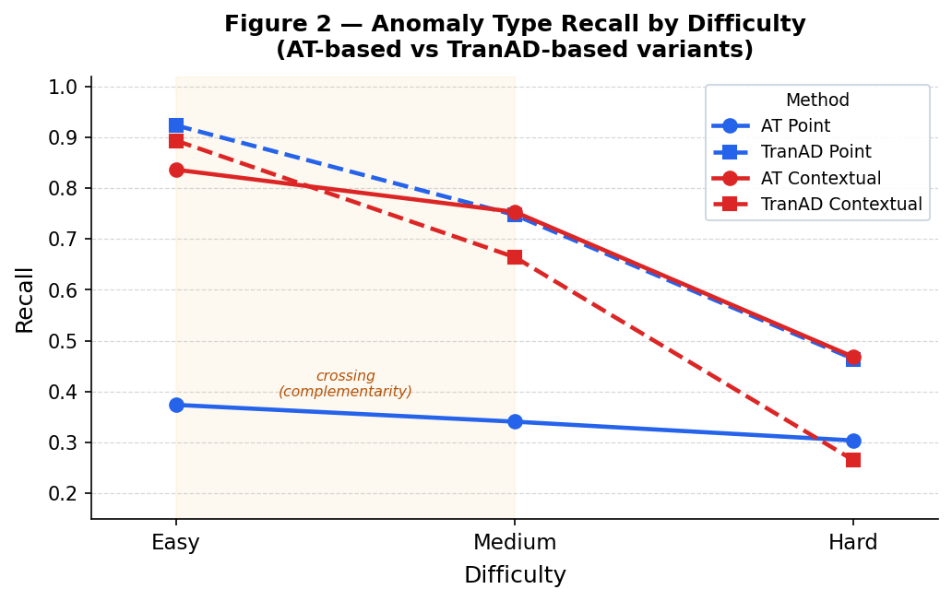
Point anomaly recall. TranAD dominates AT across all difficulty tiers, but the advantage compresses sharply with complexity: +0.549 on Easy, +0.406 on Medium, +0.161 on Hard. TranAD's point recall superiority is a low-difficulty property that nearly disappears under Hard injection conditions.
Contextual anomaly recall. The AT/TranAD relationship inverts across difficulty. On Easy, TranAD leads AT (0.893 vs 0.836). On Medium, AT pulls ahead (+0.089). On Hard, AT leads by +0.203 (0.468 vs 0.265). Critically, TranAD's contextual recall drops 69% from Easy to Hard, while AT's drops only 44%. AT's contextual specialization is a robustness property that is invisible at Easy difficulty and emerges precisely where it is most needed.
Collective anomaly recall. Neither detector exceeds 0.457 under any condition, and both decline with difficulty. This uniform ceiling is inconsistent with an architectural explanation—different architectures would be expected to hit different ceilings—and is more consistent with a context-window constraint. TranAD-based models exhibit a pronounced substrate asymmetry on Hard collective recall: near-zero on Synthetic Hard (0.000–0.049) versus substantially higher on Real Hard (0.288–0.437). Collective recall should therefore not be used as an architectural differentiator under a fixed 96-timestep window.

5. XAI Analysis

5.1 Feature Attribution (Integrated Gradients)

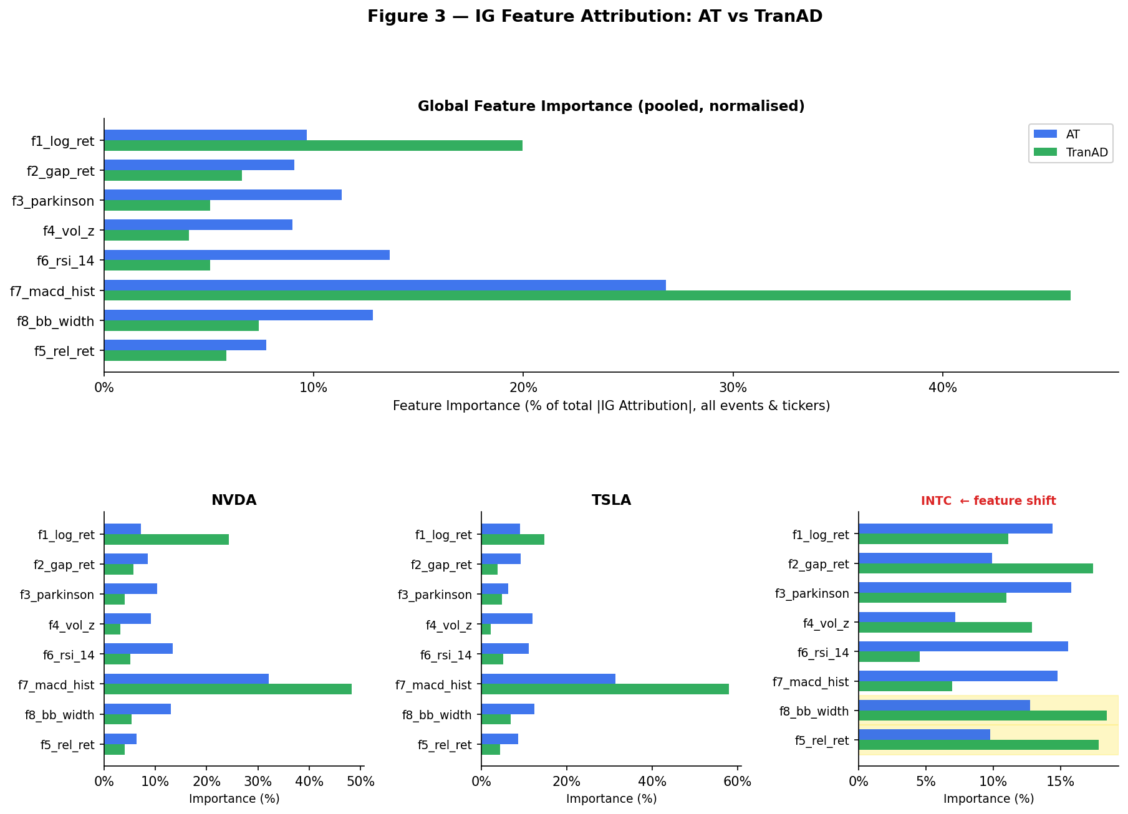
IG analysis reveals a consistent and architecturally coherent feature hierarchy across both detectors. The MACD histogram (f₇) is the dominant attribution feature in 11 of 15 AT events and 8 of 10 TranAD events across NVDA and TSLA, confirming that both architectures anchor detection primarily on momentum divergence rather than raw price returns or volume. This is interpretively coherent: anomalous equity events in high-growth names tend to manifest as sustained breaks from the prevailing momentum regime, which the MACD histogram directly captures as divergence between fast and slow exponential moving averages.
Two systematic deviations from this pattern are diagnostically significant. First, macro panic events—specifically the COVID-19 crash of March 2020—produce a feature leadership shift from f₇ to Bollinger Band width (f₈) in AT and RSI-14 (f₆) in TSLA, both of which are volatility saturation indicators rather than directional momentum signals. This switch is internally consistent: the COVID crash was a volatility-regime event, not a momentum-divergence event, and AT's feature pathway correctly reflects this structural difference.
Second, INTC events produce an entirely distinct feature profile in TranAD. Rather than f₇, TranAD's INTC detections are led by relative return (f₅) and overnight gap return (f₂)—features that capture idiosyncratic underperformance and post-close information shocks. This shift maps directly onto the structural difference between INTC's anomaly type and those of NVDA/TSLA: Intel's anomalous events are earnings-driven gap shocks occurring after market close, not sustained momentum breakouts. TranAD's IG feature leadership thus acts as an implicit classifier of anomaly type, with practical implications for alert routing: a f₅/f₂-led TranAD alert warrants immediate post-earnings review, while an f₇-led alert warrants trend-continuation assessment.
A gradient saturation failure was identified in AT's analysis of the INTC August 2, 2024 event—despite receiving AT's highest INTC score (1.003), all IG attributions collapse to near-zero (max 10⁻⁶). This is consistent with gradient blocking through AT's partially detached prior normalization path and indicates a known limitation of the association discrepancy mechanism under extreme sequence conditions. Notably, TranAD produces clear attribution for the same event (f₅ = 0.041), confirming the failure is AT-specific rather than data-driven.

5.2 Temporal Attribution (TimeSHAP)

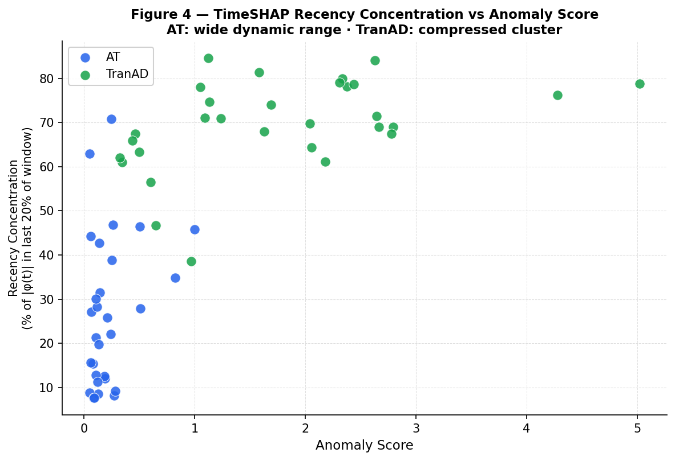

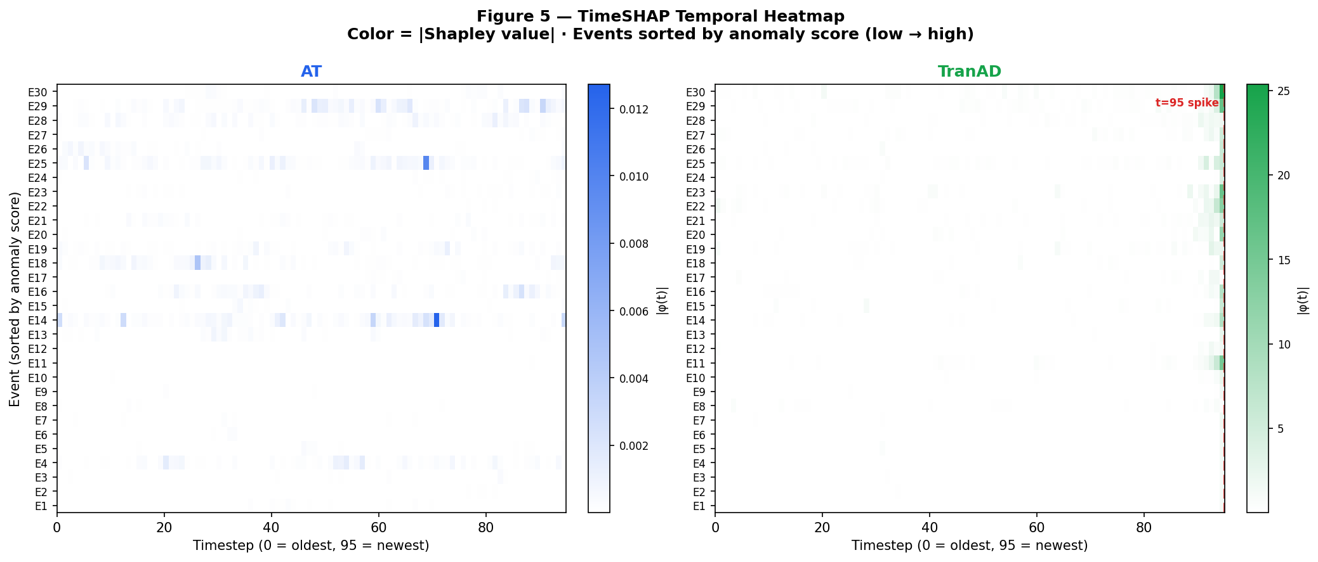TimeSHAP analysis reveals structurally distinct temporal receptive fields between the two detectors. Across all 40 analyzed events, AT exhibits a mean recency concentration of 26% (range 4%–66%), while TranAD exhibits a mean of 71% (range 43%–83%). This difference is not merely quantitative—it reflects fundamentally different detection mechanisms.
TranAD's compressed recency range and consistently dominant terminal timestep (t=95) Shapley values confirm its architectural identity as a terminal-state anomaly detector. In four of five NVDA TranAD events, t=95 carries Shapley values one to two orders of magnitude larger than any other position, accompanied by large negative values at t=92–94—a spike-then-suppression signature that reflects the adversarial second-stage architecture amplifying the terminal deviation against the immediately preceding context as a comparison baseline.
AT's wide recency range is the more diagnostically useful signal. Events with very low recency concentration (4.0%–9.4% for NVDA earnings events) indicate AT is integrating a multi-week demand narrative across the full lookback window; events with high recency (66.3% for the COVID crash) indicate AT correctly identifies a sudden, self-contained shock. This dynamic range means AT's recency concentration is informative about event type: low recency implies a slow-buildup anomaly, high recency implies an abrupt shock.
TranAD's windowed detection provides a compensating strength: the resolution of multi-day events into per-session Shapley profiles. Applied to the October–November 2021 TSLA gamma squeeze, TranAD resolves four distinct anomalous sessions across six trading days, with t=95 Shapley magnitudes tracking the lifecycle of the squeeze chronologically (+6.18 → +6.35 → +16.58 → +11.84). This temporal anatomy of a sustained event is not available from AT's point-level detection, which collapses the same period into a single flagged date.

5.3 Event Attribution (LLM-Ranked News Retrieval)
The LLM attribution layer grounds model detections in verifiable real-world catalysts, providing the third dimension of the evidence-grounded explanation. Three case studies illustrate the pipeline's behaviour across a spectrum of attribution clarity.
Strong corroboration — NVDA August 5, 2024 (AT score: 0.827). This event, AT's highest-scored detection in the dataset, receives unambiguous news attribution. The 72-hour retrieval window captures three concurrent negative catalysts: reports of design flaws in NVDA's Blackwell GPU architecture, a DOJ antitrust probe announcement, and a Japan-led global equity rout. The LLM correctly identifies the Blackwell delay as the primary driver (score 9/10) and the macro rout as amplifying context. This corroboration is reinforced by the TimeSHAP structure: AT's dominant Shapley timestep (t=52) aligns with the mid-window period surrounding the design flaw reports, and IG confirms f₇ leadership consistent with a momentum-reversal event.
Partial corroboration — INTC August 2, 2024 (TranAD score: 1.628). The LLM correctly identifies Intel's catastrophic Q2 2024 earnings release—a 26% single-day decline, 60% dividend cut, and 15,000-person layoff announcement—as the primary driver (score 10/10). However, the IG layer simultaneously reveals AT's gradient saturation failure on this event, meaning the model cannot explain its own detection through feature attribution. The two layers therefore provide complementary and partially contradictory information: news attribution is maximally clear while feature attribution is maximally opaque. This asymmetry demonstrates the value of running all three layers jointly—a single-layer explanation would be either over-confident (news only) or uninformative (IG only).
Temporal ambiguity — NVDA January 27, 2025 (AT score: 0.510). The DeepSeek launch event presents a case where news attribution is clear but temporal attribution reveals additional complexity. The LLM correctly identifies the DeepSeek open-source model release as the primary catalyst—responsible for a reported $593 billion single-day market capitalization decline. However, AT's TimeSHAP profile shows distributed attention across the full window (t=21, t=82, t=5 as top contributors, recency 24.8%), suggesting the model was reading prior AI-capex narrative tension accumulated over the preceding weeks alongside the immediate shock. The news attribution identifies the trigger; the temporal attribution reveals that the model detected a prepared fault line, not just the earthquake.

6. Discussion and Limitations

6.1 Discussion
The central finding of this work is that embedder benefit for transformer-based anomaly detection is architecture-conditional and, in several cases, negative. The Anomaly Transformer's internal association discrepancy mechanism appears self-sufficient for capturing temporal dependencies in an 8-feature stationary panel—additional upstream representation learning either provides marginal improvement (PatchTST) or actively degrades performance (iTransformer, TimesNet). For TranAD, the picture is more nuanced: TimesNet provides a meaningful lift under clean, low-complexity conditions, but no embedder configuration resolves TranAD's fundamental sensitivity to distribution shift. The practical implication is that practitioners deploying transformer-based anomaly detectors on equity data should not assume that prepending a SOTA embedder will improve detection quality—the detector architecture itself is the stronger determinant of performance.
The behavioral complementarity between the two detectors is the most actionable finding for deployment. AT and TranAD are not competing solutions to the same problem—they solve structurally different detection problems. TranAD's point anomaly recall advantage (+0.549 on Easy difficulty) makes it the right choice when the primary concern is detecting sharp, sudden shocks such as flash crashes or gap-down earnings events. AT's contextual recall advantage, which widens precisely as injection complexity increases (+0.203 on Hard), makes it the right choice when the concern is detecting sustained regime deviations that accumulate over days or weeks. The XAI analysis makes this complementarity mechanistically explicit: TranAD's terminal-state focus and sharp gradient amplification are well-suited to point detection but poorly suited to contextual integration, while AT's distributed temporal attention naturally encodes multi-week narratives.
The distribution shift behaviour observed in TranAD's analysis of NVDA and TSLA warrants careful interpretation. The dense anomaly flagging during NVDA's 2023–2026 AI-driven hypergrowth period and TSLA's post-2021 high-volatility regime is not straightforwardly an architectural failure. A model trained on a sector-balanced dataset of 500 tickers learns a broad definition of normal market behaviour; a ticker that undergoes a structural regime change—sustained exponential growth, extraordinary retail-driven volatility—will appear genuinely anomalous relative to that baseline throughout its regime-change period. INTC, which experienced a downward structural shift rather than explosive upward growth, exhibits less severe flagging, supporting this interpretation. This behaviour has a practical implication: general-purpose anomaly detectors trained on broad market data should be expected to over-flag regime-change tickers during their transition period, and ticker-specific or regime-aware calibration should be considered for production deployment.
The three-layer XAI pipeline demonstrates that feature attribution, temporal attribution, and event attribution provide non-redundant information. The INTC August 2024 case study is the clearest illustration: news attribution is maximally informative while AT's IG layer simultaneously fails completely, and TranAD's IG provides clear feature-level attribution. No single layer alone gives a complete picture; the value of the pipeline lies precisely in their combination.

6.2 Limitations
Methodological and Evaluation Limitations. The most significant methodological limitation is the use of the Point Adjustment protocol, inherited from the original Anomaly Transformer and TranAD repositories, in which any prediction within an anomaly window receives full credit. This protocol has been identified as a source of substantial evaluation inflation, particularly for contextual and collective anomaly types where windows span 10–20 days [Wu & Keogh, 2021; Liu & Paparrizos, 2024], and reported recall values should be treated as upper bounds rather than true detection rates. Compounding this, all comparisons are internal to the eight Embedder→Detector variants—the absence of external baselines such as Isolation Forest or One-Class SVM means the absolute performance figures cannot be anchored against simpler approaches. All results are additionally reported from single training runs without multiple random seeds, meaning observed performance differences between variants cannot be assessed for statistical significance. Finally, all models were trained and evaluated exclusively on US equities; the architecture-conditional findings may not generalize to continuous markets such as FX and cryptocurrency, or to fixed income, where microstructure behaviour differs fundamentally.
Interpretability Limitations. The Integrated Gradients attributions use a zero feature vector as the baseline, which carries no direct economic interpretation—the resulting attributions quantify each feature's contribution relative to a hypothetical world where all features are simultaneously zero, rather than relative to a normal trading day. Replacing this with a feature-wise mean of normal trading periods would make attributions economically interpretable as anomaly-relative deviations and represents the single highest-leverage improvement to the XAI pipeline. A related limitation affects the Anomaly Transformer specifically: the partially detached prior normalization path in the association discrepancy computation blocks gradient flow under certain extreme sequence conditions, producing the gradient saturation failure observed on the INTC August 2024 event. TimeSHAP Shapley values were estimated using n=50 random permutations per event, producing non-negligible Monte Carlo variance at window length T=96; reported temporal attribution values should be interpreted as estimates with implicit uncertainty. Finally, the LLM news attribution layer uses a 24-hour lookahead window beyond the anomaly date. While appropriate for post-hoc root-cause analysis—the intended use case—this design precludes real-time deployment at the moment of detection; a production system would require restricting retrieval to t ≤ 0.
Benchmark and Data Limitations. The Easy, Medium, and Hard injection tiers are artificial constructs whose correspondence to the actual difficulty distribution of real market anomalies is unverified. Hard-tier parameters—particularly for collective anomalies (0.2–0.5σ per day)—may reduce injected signals to levels indistinguishable from normal return noise, raising the question of whether Hard collective detection failure reflects a model limitation or an injection design artifact. More broadly, the synthetic injection procedure cannot replicate all conditions that produce real anomalies: liquidity constraints, cross-asset contagion, and microstructure effects are absent by construction. The collective recall ceiling observed across all models—no variant exceeds 0.457 under any condition—is consistent with a 96-timestep context-window constraint rather than an architectural limitation, and should not be reported as an architectural differentiator until evaluated under extended window lengths. Finally, the 8-feature panel relies exclusively on Level 1 OHLCV data, omitting options-market signals such as implied volatility and put/call ratios, as well as Level 2 order-flow features such as bid-ask spread and tick imbalance. Anomaly events driven by derivatives markets—such as the TSLA gamma squeeze—are observable only through their price-side manifestation in the current feature set, limiting both detection sensitivity and attribution depth.

7. Conclusion
This paper presented an evidence-grounded anomaly detection and attribution framework for financial time series, systematically evaluating a modular Embedder→Detector architecture across a rigorous dual-substrate benchmark and augmenting detection outputs with a three-layer interpretability stack. The central empirical finding is that embedder benefit is architecture-conditional: the Anomaly Transformer performs best in its native configuration without an upstream embedder, while TimesNet provides selective gains for TranAD under clean, low-complexity conditions. More fundamentally, the two detector architectures exhibit complementary behavioral profiles that persist across all embedder configurations—TranAD excels at point anomaly recall but collapses on contextual anomalies under hard injection conditions and incurs a systematic synthetic substrate penalty, while the Anomaly Transformer maintains robust contextual recall that widens precisely as anomaly complexity increases and generalizes consistently across substrates. These findings suggest that the choice between detector architectures should be driven by the anticipated anomaly type distribution in the deployment environment rather than by aggregate benchmark performance alone.
The XAI analysis reveals that these behavioral differences are mechanistically grounded. TranAD's concentration of 71% of temporal attribution mass on the terminal timestep identifies it architecturally as a terminal-state detector—well-suited to sharp threshold events but structurally unable to encode multi-week narratives. The Anomaly Transformer's distributed temporal attention, with recency concentration ranging from 4% to 66% depending on event type, functions as an implicit classifier of anomaly structure. At the feature level, MACD histogram dominance across both models confirms that momentum divergence is the primary signal through which both architectures perceive equity anomalies in growth-oriented tickers, while the shift to gap return and relative return features in INTC events demonstrates that the attribution layer can implicitly classify anomaly type and enable targeted alert routing. Together, these three attribution layers produce a complete, human-interpretable account of each flagged event, grounding statistical model outputs in both market microstructure features and verifiable real-world catalysts.
Several limitations bound the scope of these conclusions. Point Adjustment evaluation inflation means reported recall values are upper bounds; the absence of external baselines leaves absolute performance figures unanchored; and the restriction to US equities limits generalizability to other asset classes. The difficulty-stratified injection tiers, while methodologically rigorous, are artificial constructs whose correspondence to real market anomaly severity remains unverified. Future work should address these limitations through PA-free evaluation protocols, extended context windows to probe the collective recall ceiling, ticker-specific or regime-aware threshold calibration to mitigate distribution shift on regime-change equities, and enrichment of the feature set with options-market and order-flow signals. The incorporation of macroeconomic variables and SEC filing data into the attribution pipeline—as originally envisioned but not realized in this work—remains a promising direction toward a fully multimodal evidence-grounded anomaly explanation system.

References
[1] Bento, J., et al. (2021). TimeSHAP: Explaining Recurrent Models through Sequence Perturbations. KDD 2021.
[2] Cao, L., et al. (2019). Detecting Financial Fraud Using Machine Learning: Winning the War Against Imbalanced Data. ICAIF.
[3] Engle, R.F. (1982). Autoregressive Conditional Heteroscedasticity with Estimates of the Variance of United Kingdom Inflation. Econometrica, 50(4), 987–1007.
[4] Liu, S. & Paparrizos, J. (2024). Elephant in the Room: Towards a Reliable Time-Series Anomaly Detection Benchmark. NeurIPS 2024.
[5] Liu, Y., et al. (2024). iTransformer: Inverted Transformers Are Effective for Time Series Forecasting. ICLR 2024.
[6] Lundberg, S.M. & Lee, S. (2017). A Unified Approach to Interpreting Model Predictions. NeurIPS 2017.
[7] Malhotra, P., et al. (2016). LSTM-based Encoder-Decoder for Multi-sensor Anomaly Detection. ICML Workshop 2016.
[8] McNeil, A.J. & Frey, R. (2000). Estimation of Tail-Related Risk Measures for Heteroscedastic Financial Time Series. Journal of Empirical Finance, 7(3-4), 271–300.
[9] Nie, Y., et al. (2023). A Time Series is Worth 64 Words: Long-term Forecasting with Transformers. ICLR 2023.
[10] Park, D., et al. (2018). A Multimodal Anomaly Detector for Robot-Assisted Feeding Using an LSTM-based Variational Autoencoder. IEEE Robotics and Automation Letters.
[11] Sundararajan, M., Taly, A. & Yan, Q. (2017). Axiomatic Attribution for Deep Networks. ICML 2017.
[12] Tuli, S., et al. (2022). TranAD: Deep Transformer Networks for Anomaly Detection in Multivariate Time Series Data. VLDB 2022.
[13] Wu, H., et al. (2023). TimesNet: Temporal 2D-Variation Modeling for General Time Series Analysis. ICLR 2023.
[14] Wu, R. & Keogh, E. (2021). Current Time Series Anomaly Detection Benchmarks are Flawed and are Creating the Illusion of Progress. IEEE TKDE.
[15] Xu, J., et al. (2022). Anomaly Transformer: Time Series Anomaly Detection with Association Discrepancy. ICLR 2022.
[16] Zhou, H., et al. (2021). Informer: Beyond Efficient Transformer for Long Sequence Time-Series Forecasting. AAAI 2021.
[17] Kroeger, N., Ley, D., Krishna, S., Agarwal, C. & Lakkaraju, H. (2023). Are Large Language Models Post Hoc Explainers? NeurIPS 2023 Workshop on Robustness of Few-shot and Zero-shot Learning in Foundation Models. arXiv:2310.05797.
[18] Google DeepMind. (2026). Gemini 3.1 Flash-Lite Model Card. Retrieved from https://deepmind.google/models/model-cards/gemini-3-1-flash-lite/

Appendix A: Analysis Figures
Figures A1–A6 present the full three-panel analysis plots (anomaly score, log return deviation, and price reconstruction with anomaly spans) for each ticker-model combination. These figures illustrate the qualitative behavioral differences between the Anomaly Transformer and TranAD discussed in Sections 4 and 5.
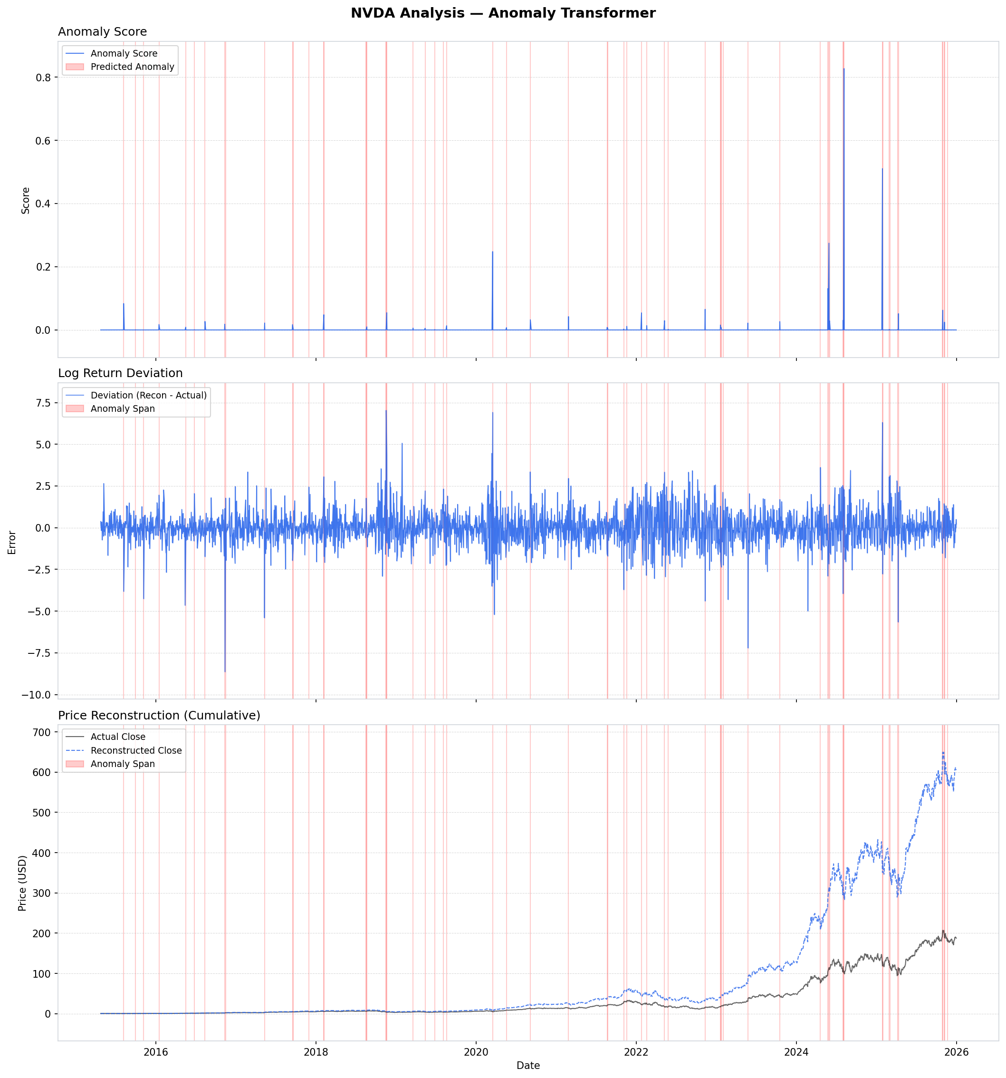
Figure A1. NVDA analysis under the Anomaly Transformer. Top: anomaly score series with flagged regions. Middle: log return deviation (reconstructed − actual). Bottom: actual vs reconstructed close price with anomaly spans. Note the sparse, event-driven flagging pattern and the score spike at August 2024 (Blackwell delays + DOJ probe) and January 2025 (DeepSeek).

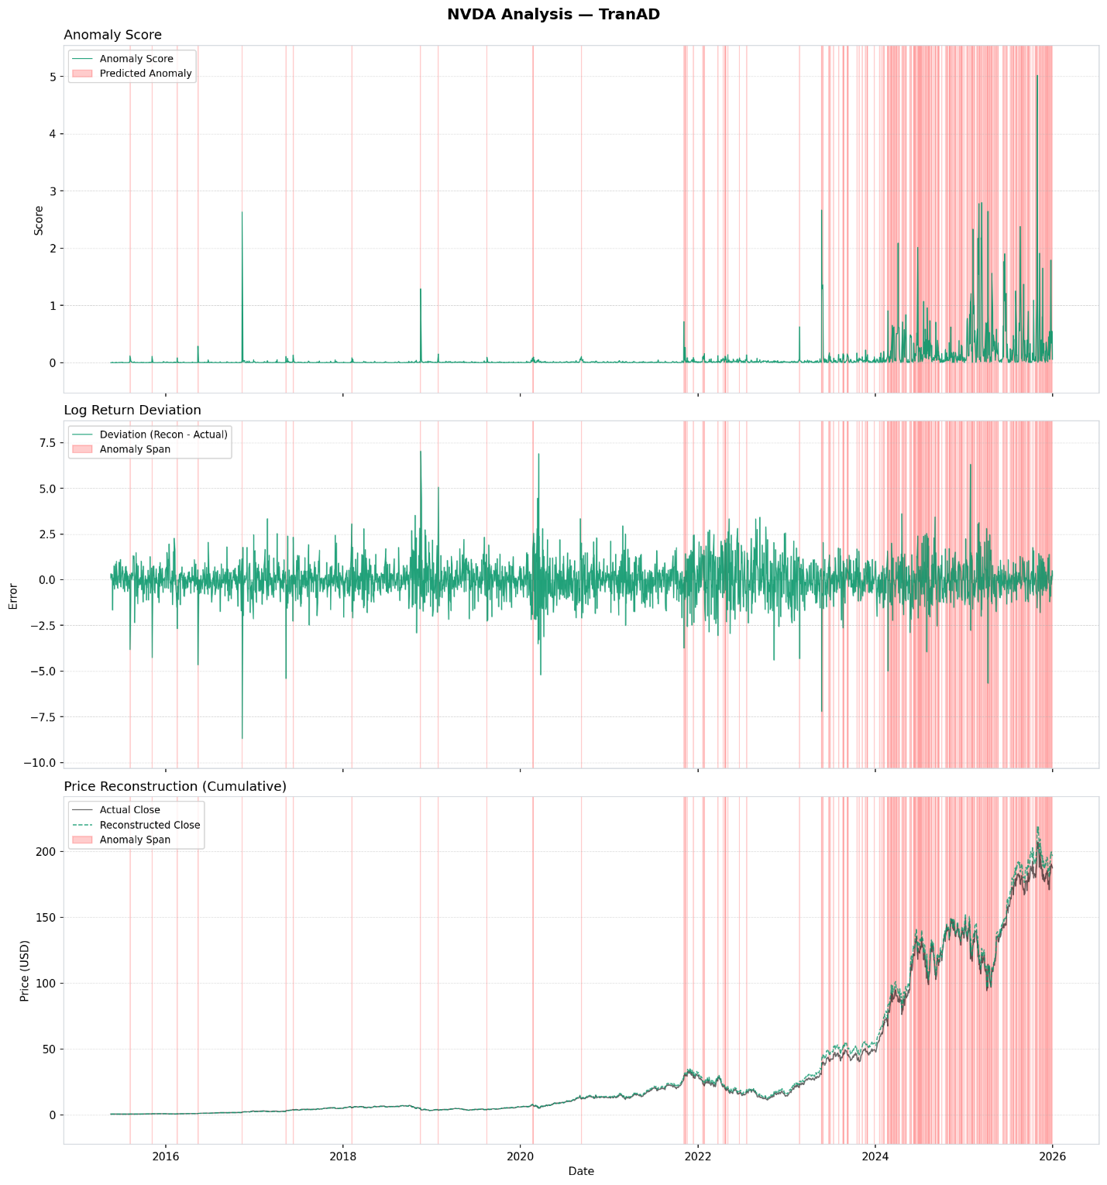Figure A2. NVDA analysis under TranAD. Note the dense flagging beginning in 2023 during NVDA's AI-driven hypergrowth regime, reflecting a distribution shift between the broad training distribution and regime-change ticker behaviour rather than an architectural failure.

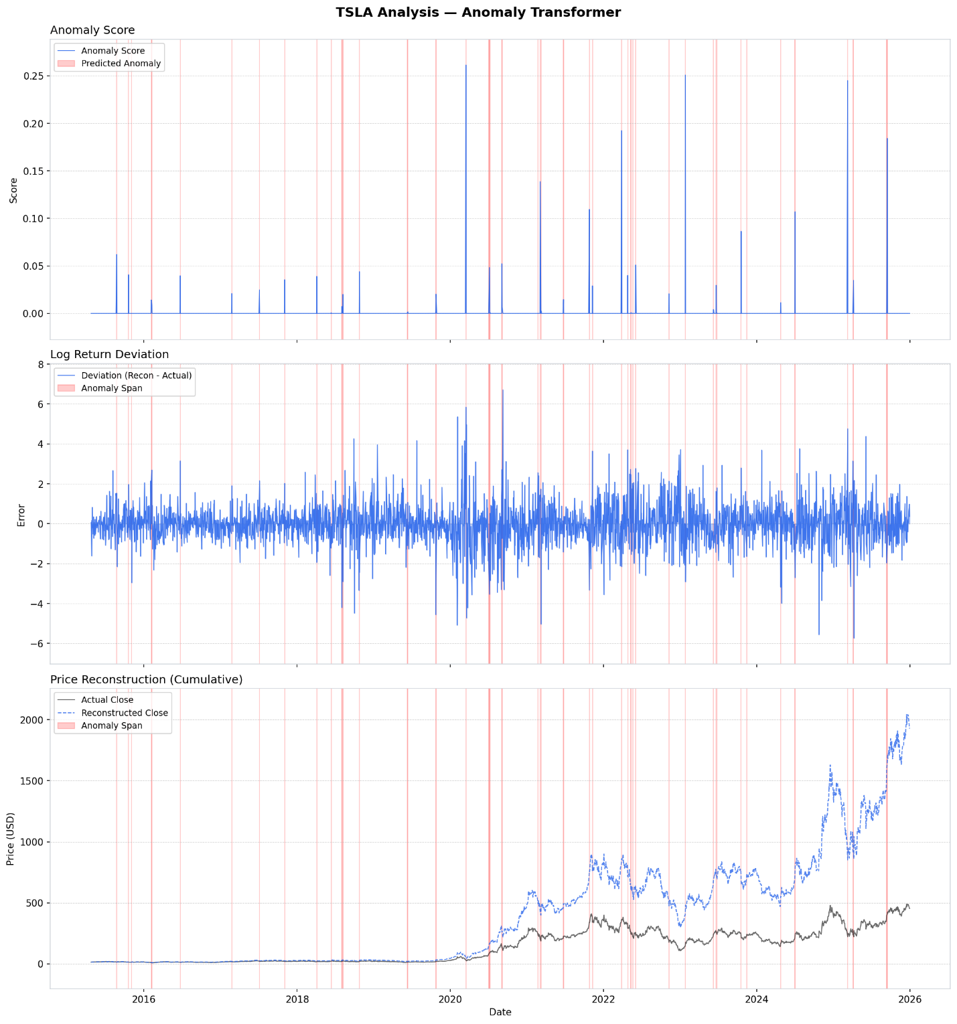
Figure A3. TSLA analysis under the Anomaly Transformer. Sparse discrete score spikes correspond to identifiable events: COVID crash (March 2020), Hertz deal period (October–November 2021), and the March 2025 brand crisis event.

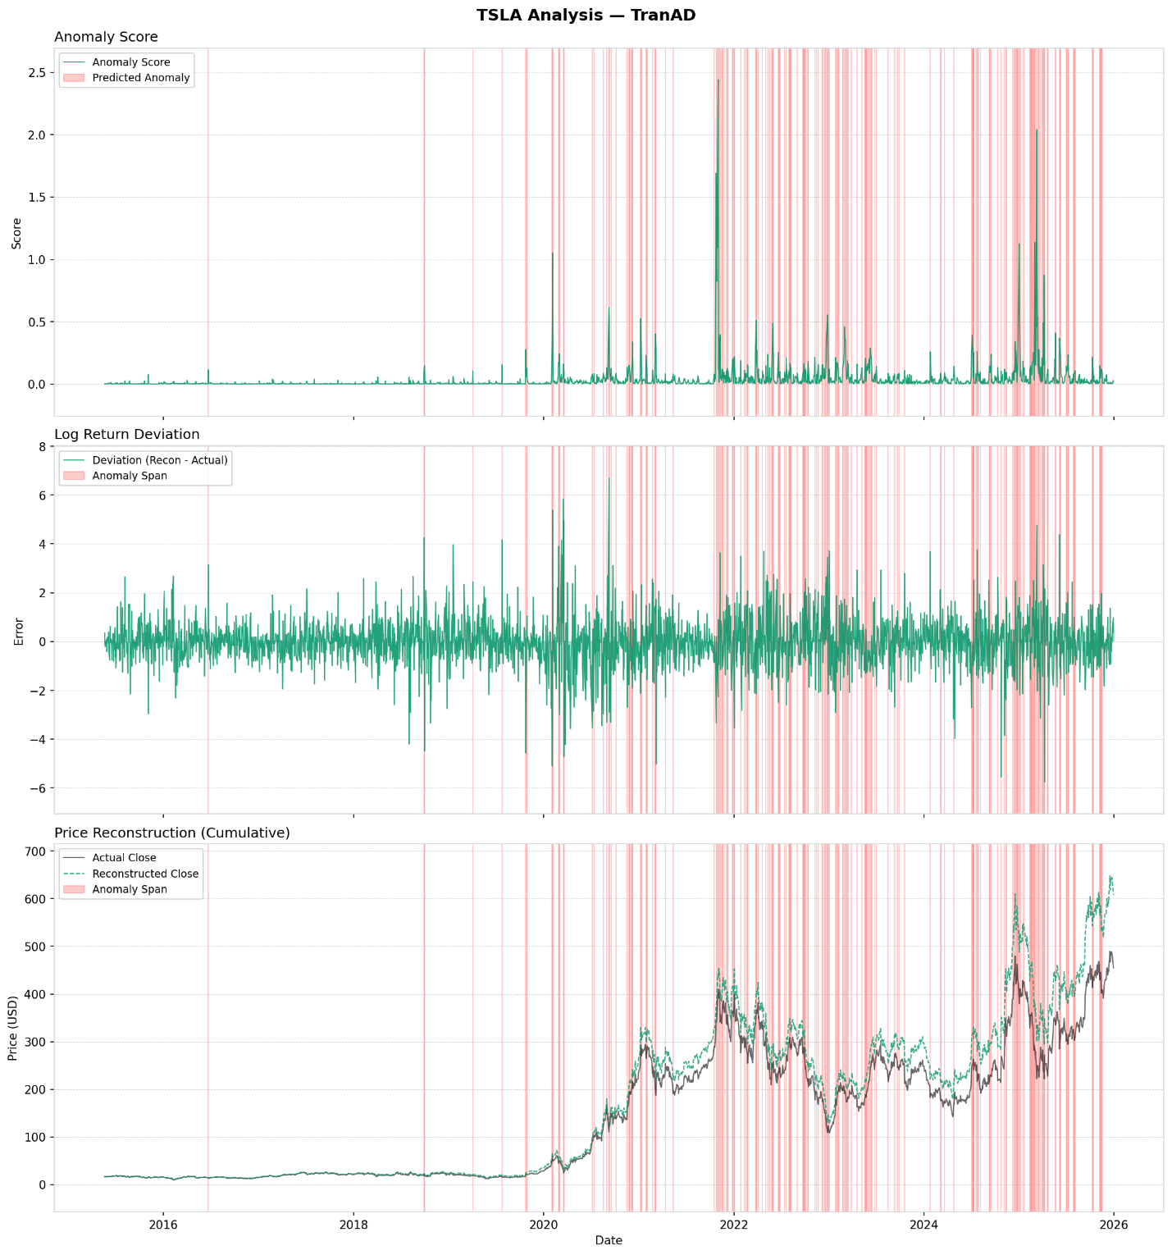
Figure A4. TSLA analysis under TranAD. Broad flagging from 2021 onward corresponds to TSLA's elevated volatility regime following the Hertz deal and post-2020 retail-driven momentum period.
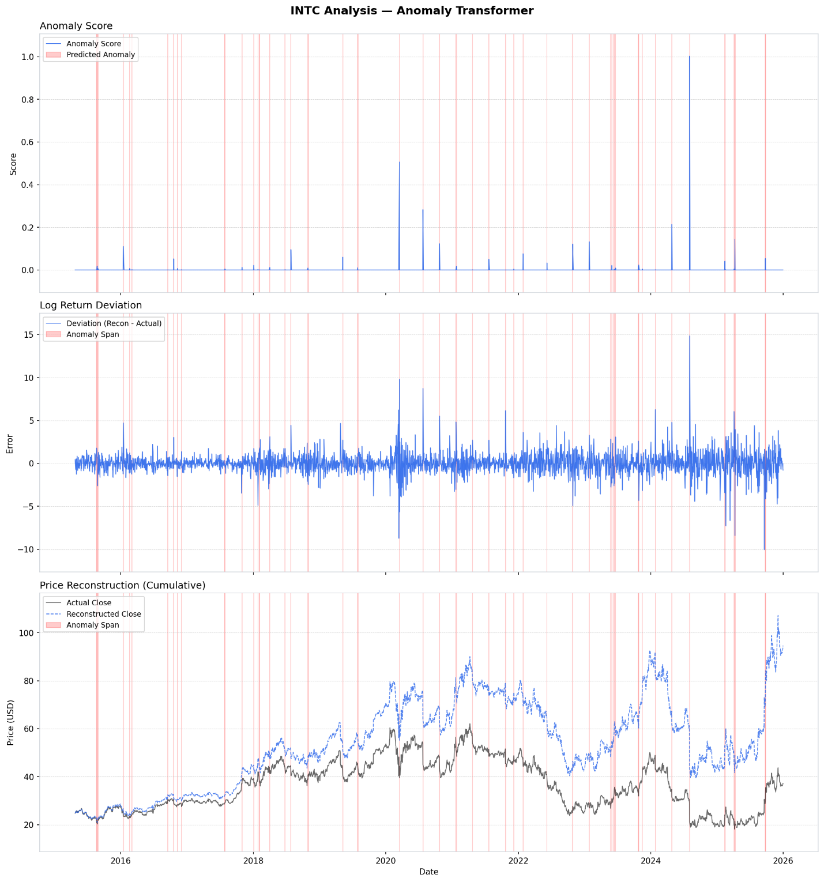
Figure A5. INTC analysis under the Anomaly Transformer. The highest-scored event (August 2024, score = 1.003) corresponds to Intel's catastrophic Q2 earnings; this event also exhibits the gradient saturation failure discussed in Section 5.1.
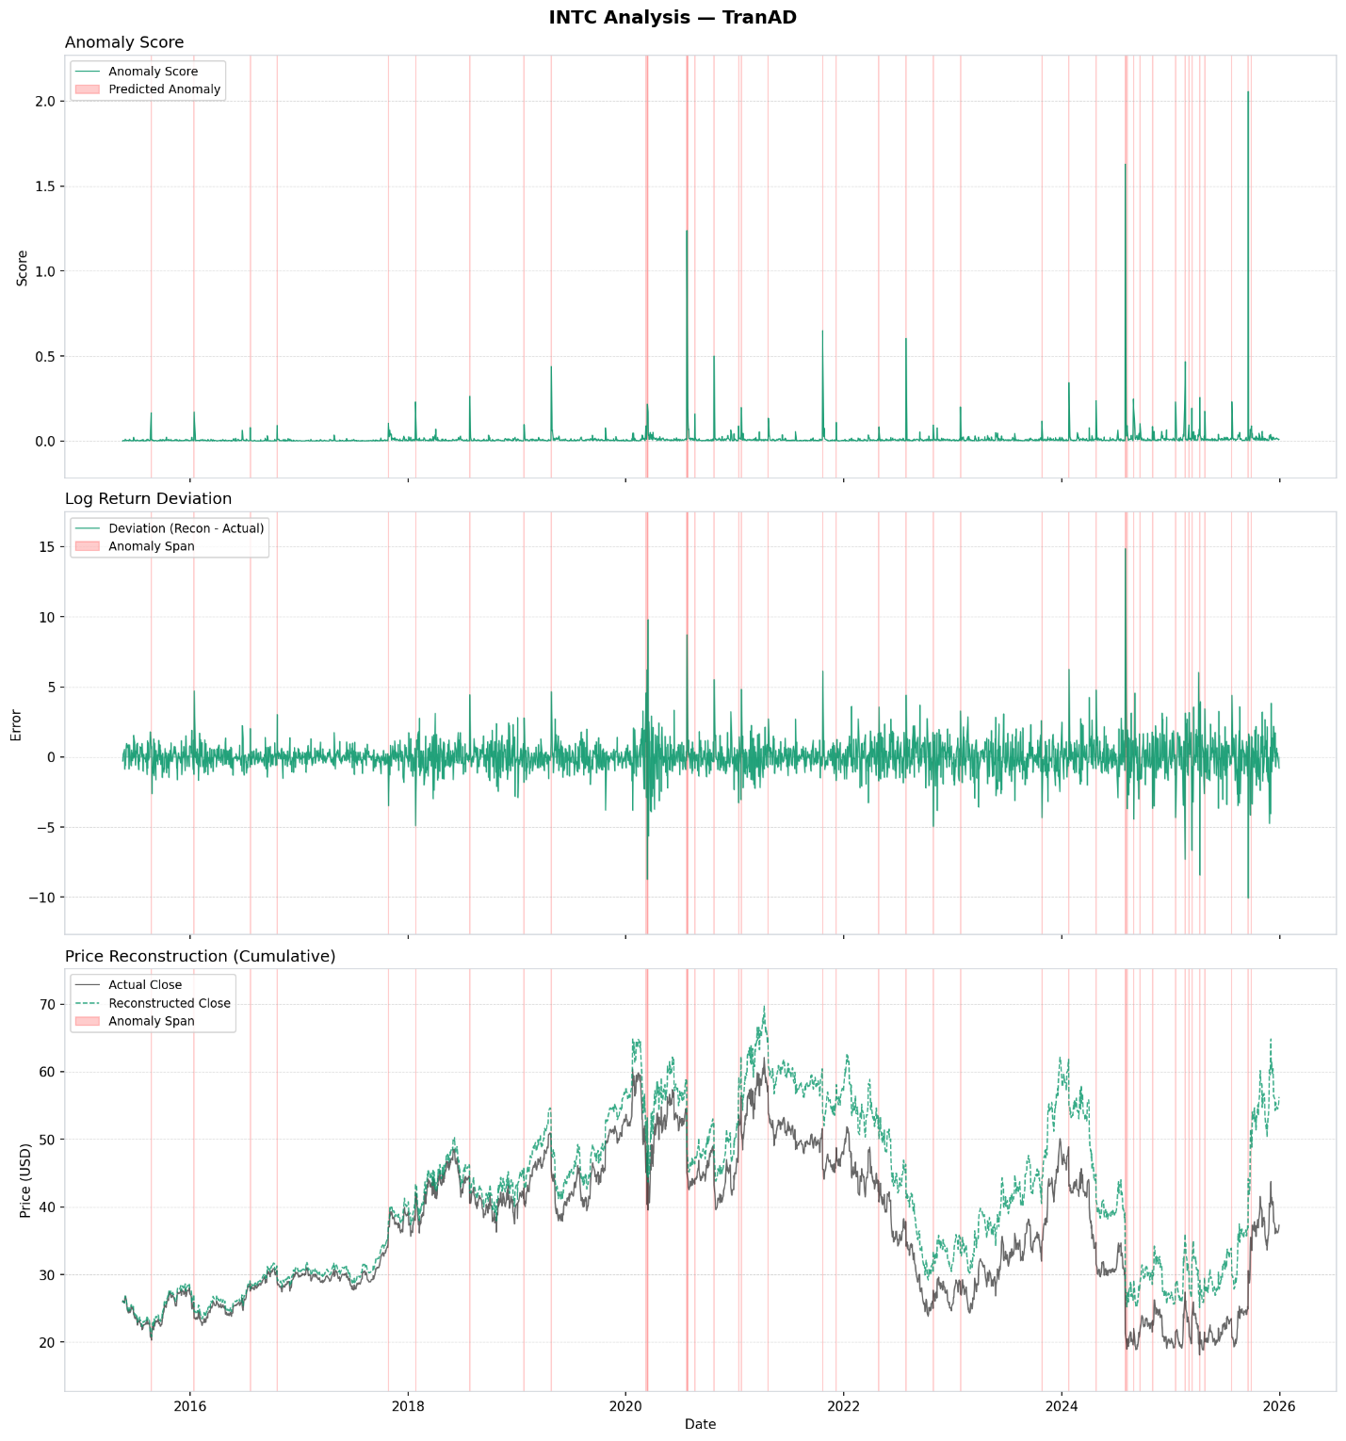
Figure A6. INTC analysis under TranAD. Unlike NVDA and TSLA, INTC shows more measured flagging without a broad regime-change over-flagging pattern, consistent with Intel's gradual fundamental decline rather than explosive upward growth.

