<Project Name>

Use-Case Specification

Version 1.0

Revision History

| **Date** | **Version** | **Description** | **Author** |
| --- | --- | --- | --- |
|  |  |  |  |
|  |  |  |  |
|  |  |  |  |
|  |  |  |  |

Table of Contents

1. Use-case Model 4

2. Use-case Specifications 4

2.1 Use-case: Add a product to cart 4

2.2 Use-case: Create a new account 5

# Use-case Model

[*Put an image of the use-case diagram modeling all use-cases in this section*]

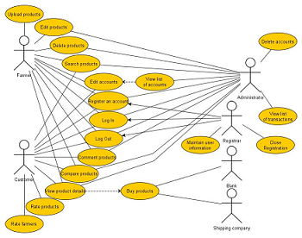

# Use-case Specifications

## Use-case: Add a product to cart

| Use case Name | Add a product to cart. |
| --- | --- |
| Brief description | This use case describes how the Customer can buy a product. |
| Actors | Customer |
| Basic Flow | 1. At the homepage, the user enters keywords on the ‘Search’ field 2. Users clicks on ‘Search’ button to start searching a product 3. System displays the products found 4. User clicks ‘Add to cart’ button on the expected product 5. System adds a new product to shopping cart 6. System displays the quantity of all products in the cart to the user |
| Alternative Flows | **Alternative flow 1: User cannot find products searched**   1. From #1 of the basic flow, user enters another term 2. Continue step #2 in the basic flow     **Alternative flow 2: Shopping cart has already had the product**   1. From #5 of the basic flow, system increases the quantity of the product 2. Continue step #6   **Alternative flow 3: …** |
| Pre-conditions | User goes to homepage at [www.hailua.com.vn](http://www.hailua.com.vn) |
| Post-conditions | The user successfully adds new item to the cart or increases quantity of the existing item in the cart. |

## Use-case: Create a new account

....