Sri Lanka Institute of Advanced Technological Education.
Higher National Diploma in Information Technology.



Final Repot

“Online Courses Learning App”

By

Name : N.R.N.V.Sandeepani
Register Number : ANU/IT/2021/F/91

Supervisor
Mrs. W.A.S Wickremasinghe

Academic Year: 2021
Year: 2
Semester: 2

DECLARATION

We do heraldry declare that the work reported in this project report was exclusively me under the supervision of Mrs.Anoma the Department of Information Technology in Advanced Technology in Advanced Technological Institute- Anuradhapura Sri Lanka. It describes the result of our work except where due reference has been made in the text. No part of this project report has been submitted earlier or concurrently for the same or any other diploma.

……………………….. ………………………..
Date Signature

Certified By:
Supervisor Name:
…………………………………………………………………………………………………

Date:………………….. Signature:………………

Name of the Head:
…………………………………………………………………………………………………

Date: ……………………….. Signature:……………………..

ACKNOWLEDGEMENT

It’s a great pleasure for us to take this opportunity to deliver our worthy thanks for those who have been our guardians and supporters to successfully complete this system. We are pleased to deliver our since gravitate to our supervisor Mrs. Anoma for his continuous guidance and support throughout the development.
It’s our duty to thank our head of department of HNDIT. Mrs. D.M.N.K Dissanayake for her continuous guidance to this project. It’s our bond to be thanking our demonstrators of the department of IT, for their support and continuous supervision.
It’s a great pleasure to remind our Institute, Advanced Technological Institute Anuradhapura which gave me the permission to develop this project. Finally, I would like to mention all the non-academic staff members and my friends for their great help towards finding information for my project.

ABSTRACT

This report presents the design and implementation of a comprehensive course learning application introduces "EduPlus," a novel application developed to enhance the educational experience for both administrators and users. The application serves as a versatile platform where administrators can effortlessly manage and add a variety of learning resources, including PDFs, quizzes, videos, and Zoom sessions.
Users of the application are provided with an intuitive interface to access and engage with these resources. They can attempt quizzes, view PDFs and videos, participate in Zoom sessions, and subsequently view their results. The system is designed to track user progress, allowing users to view certificates of completion for relevant courses, thereby acknowledging their accomplishments.

TABLE OF CONTENTS.
1. Interdiction
1.1. Project Introduction
1.2. Background of the current project
1.3. Aims and Objective
1.3.1. Aims
1.3.2. Objective
1.4. Scope of the project
1.4.1. Services provided by the end system
1.4.2. End Result of the project
1.4.3. Condition under which the project will be executed
1.4.4. Constraints of the project
1.4.5. Acceptance Criteria
2. Methodology and design
2.1. Existing system
2.2. Functional Requirements
2.2.1. User case diagram
2.2.1.1. User case 01
2.2.1.2. User case 02
2.2.1.3. User case 03
2.2.1.4. User case 04
2.2.1.5. User case 05
2.2.1.6. User case 06
2.2.1.7. User case 07
2.2.1.8. User case 08
2.3.Non-Functional Requirements
2.4.Feasibility Study
2.4.1.Technical Feasibility
2.4..2.Operational Feasibility
2.4.3.Economic Feasibility
2.5.System Specification
2.5.1.Hardware Specification
2.5.2.Software Specification
3. Development
3.2. Project Development Principles.......................................................................
3.3. Get the system users involved..........................................................................
3.4. Establish phases and activities..........................................................................
3.5. Establish standards...........................................................................................
3.6. Manage the process and projects......................................................................
3.7. Justify systems as capital investments...............................................................
3.8. GUI …………………………………………………………………………..
4. Testing
4.2. Testing Methodology (Types).........................................................................
4.3. White Box Testing..........................................................................................
5. Implementation
5.1. Installation guide............................................................................................

6. Conclusion & future work
6.1.Evaluation and Conclusion………………………………………………………..
6.2. Future work ………………………………………………………………………
7. References

1. INTRODUCTION
1.1. Project Introduction
In response to the dynamic shift towards digital education and the increasing need for accessible and flexible learning solutions, this proposal aims to introduce an innovative Online Learning platform. With a commitment to revolutionizing the education, in this project goal is to create a user-centric platform that facilitates seamless, engaging, and personalized learning experiences for a diverse range of learners.
Online learning has revolutionized traditional education, offering flexibility, accessibility, and personalized learning experiences. As the world embraces digital transformation, the demand for effective online educational tools continues to grow. Online Learning Courses App seeks to contribute to this evolution by providing a user-friendly and feature-rich platform for quizzes, assessments, and improve knowledge.[4]
The Online Learning Courses App is designed for student to enhance the online learning experience by offering a versatile and intuitive platform for participating in courses.
1.2. Background of the current project
In the era of digital education, online learning courses apps have become indispensable tools for both students and educators. These apps offer a diverse range of courses, enabling learners to access high-quality education from anywhere at any time.
One such app is the Online Learning Hub. This comprehensive platform provides a wide array of courses across various subjects and disciplines. It offers interactive lessons, quizzes, and assignments, catering to diverse learning styles and preferences. [1]
Another notable app is EduConnect. This user-friendly platform seamlessly connects students with instructors and course materials. It offers personalized learning experiences tailored to individual needs and preferences. [2]
Moreover, the Studocu: Study Notes & Sharing app stands out for its flexibility and accessibility. This platform hosts a vast library of courses, ranging from academic subjects to professional development modules. [3]

1.3. Aims and Objective
1.3.1. Aims
The Online Learning Courses App is designed for student to enhance the online learning experience by offering a versatile and intuitive platform for participating in courses. The primary focus is to facilitate interactive assessments that promote knowledge retention and engagement.
1.3.2. Objective
- To start attending the quiz, read pdf, join the live zoom session and you tube video in the subject categories.
- To answers are or wrong and also can see the answers of each.
- To participate for the exam quiz.
- To generate unique certificate for students.
- To create a user-friendly interface.

1.4.Scope of the project
“Online Course Learning” android application is a mobile application developed to attempt the courses online. The application will be developed using android studio and flutter language. It will allow to user to view course subjects, attempt course and quiz, show Pdf, user can see their certificates
1.4.1. Services provided by the end system
  - Ability to easily attempted courses from any convenient location.
  - Ability to attempted courses online without payment.
  - Ability to attempted quiz online.
  - Ability to attempted zoom session and access the YouTube videos.
  - Ability to get the certificates
.
1.4.2. End Result of the project
After login a system is provide the courses category relevant learning resources such as available live zoom session links, pdf, you tube video links and quiz, the user selects a course and after complete the course receive a unique valid certificate relevant a course.
1.4.3. Condition under which the project will be executed
- The project is developed using android studio and flutter programming languages.
- The project will be completed within the given time frame.
- The project will be thoroughly tested before development.
- The project will then address functional and non-functional requirements.

1.4.4. Constraints of the project
- “Online courses learning” application works only on android devices.
- This application requires an email service to function.
- This app works only when data is enabled on the device.

1.4.5. Acceptance Criteria
- Teacher (admin) Login: Teacher successfully logs in using a valid username and password.
- Student (User) Login: Operator successfully logs in using a valid username and password.
- Student Identification:The app allows the teacher to identify students accurately (using student register numbers or Barcodes).
- Attendance Marking:The teacher can mark attendance for each student (present, absent).
- Data Recording:Attendance data is saved securely within the app or synced with a database system.

2. METHODOLOGY AND DESIGN
2.1. Existing system
2.2. Functional Requirements
Admin is the primary user responsible for Adding the learning Resources. They will use the app to add the quiz, video, pdf, zoom session and potentially submit the data.
- User Login: Allows authorized operators (User) to access the app using a secure login mechanism (username and password).
- Admin Login: Allows authorized admin to access the app using a secure login mechanism (username and password).
- Learning Recourses: Enables the admin to add quizzes and learning resources for user in a course .
- Data Storage: The app securely stores attendance data locally on the device or transmits it to a central server for storage and potential retrieval.
- Generate Certificate: The app can generate Certificate summarizing student attempt course (course name ,score , student name, etc.).

2.2.1. Use Case diagram
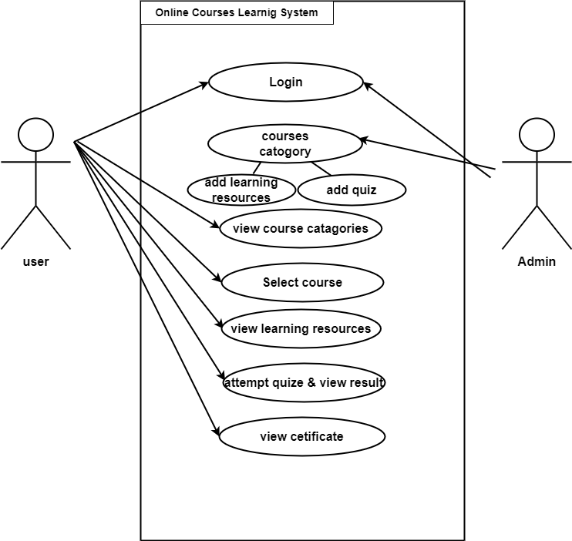
Use case 1
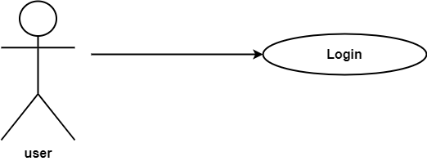

Use Case Name | Login
Actor | User
Overview | Log in to the user
Pre-conditions | 1. User must log into the application  2. Go to the login option
Description | 1. Update profile details
Alternative flows | 1. Need valid Gmail, if it is not valid user cannot get verification code  2. password must numbers, letters, symbols at less than 8  3. It cannot be empty, if it is empty, it generates an error
Additional Descriptions | First user needs to login with user’s correct  details, if user correctly login user can view pdf and quiz
Post condition | Direct go to the home page

Use case 2
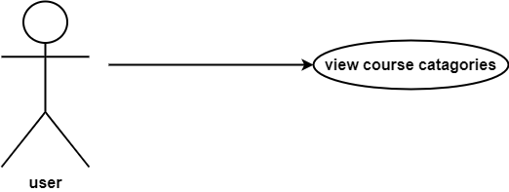

Use case Name | View courses categories
Actor | User
Over view | View the courses
Pre-condition | - User must login into the application
Description | - Users showing categories of courses  - Users showing names of courses
Alternative flows
Additional Description
Post conditions | Direct go to course content page .

Use case 3
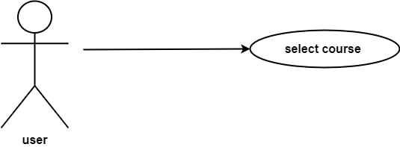

Use case name | Select course
Actor | User
Overview | Select the courses.
Pre-condition | User must login into application.  User view courses categories.
Description | - Users showing the course names.  - Select one course.
Alternative flows
Additional Description
Post condition | Direct go to the course details page.

Use case 4
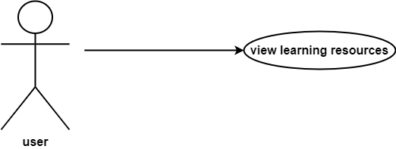

Use case name | View learning resources
Actor | User
Overview | can view the available live zoom session links, pdf, you tube video links related course.
Pre-condition | - User must login into application.  - User must select the course category.
Description | - Users showing the pdf relevant course.  - User Can read the pdf  - User can join the zoom session.  - User can access the you tube videos.
Alternative flows
Additional Description
Post condition | User can access the pdf , zoom session, YouTube video and direct go to the quiz page.
Use case 5
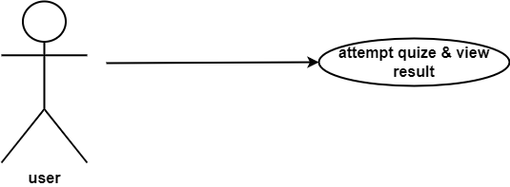

Use case name | Attempted quiz and view result
Actor | User
Overview | Users can attempt the quiz and their can see the result
Pre-condition | - User must login into application  - User must select the course category  - User read the pdf relent course
Description | - User to showing quiz  - User can attempt the quiz  - Showing the result for quiz
Alternative flows | Check the quiz answers are correct or not correct.
Additional Description | Result will be displayed.
Post condition | will show the message” Successfully completed the course” and direct go to the certificate page

Use case 6
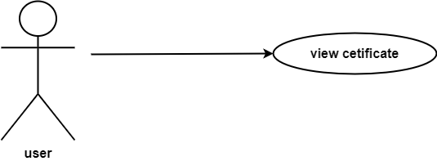

Use case name | View certificate
Actor | User
Overview | View the certificate.
Pre-condition | - User must login into application.  - user must read the pdf relevant the course.  - user must be attempted for the quiz.
Description | - Showing certificate.  - User fill the his/her name on the certificate.
Alternative flows
Additional Description
Post condition | Direct go to the course home page

Use case 7
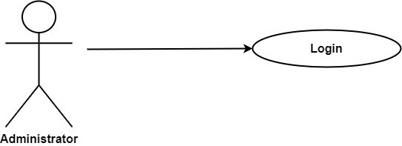

Use case name | Login
Actor | Administrator
Overview | Login into the administrator
Pre-condition | 1. admin must log into the application
Description | 1. Administrator update the database  2. Add course  3. Add pdf  4. Add quiz
Alternative flows | 1. if the user’s name and password are  incorrect showing error message
Additional Description
Post condition | Direct go to the administrator home page

Use case 8
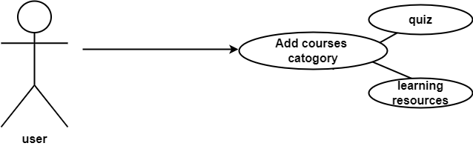

Use case name | Add course category
Actor | Administrator
Overview | Add course category to the application
Pre-condition | - admin must log into the application  - Go to the add course category option
Description | - Add course category name  - Add pdf  - Add zoom session links  - Add you tube video links  - Add quiz
Alternative flows
Additional Description
Post condition | Direct go to the administrator home page

2.3.Non-Functional Requirements
- Usability -
- All user s and admin can enter the system by entering their username and password.
- Fields should be designed to appropriately assist users in filling in the fields.

- Security -
- When exiting the application, all the user’s information is saved in the database and removed from the application.
- Invalid or empty inputs are not accepted and error messages are displayed in case of such input.

- Performance –
- The system can be entered and run smoothly without any interruption.
- Safety -
- Stores all users information and payment data securely so that no other user can see it.

- Maintainability -
- When a user enters his information is saved in the database.
- When the same user logs in again, he will be shown a new interface.
- Uploading new course to the system as soon as they are released.

2.4.Feasibility Study
Below are the resources I used to complete the project.
- Technical Feasibility
- Hardware resources
- Using computer
- Using wifi router

- Software resources
- Using Android studio
- Using vscode
- Pdf reader
- Web browser
- Flutter SDK
- Dart SDK

- Other requirement
- An internet connection

- Economic Feasibility

Pay per human hourly rate = Rs. 222.23

Hours worked per day = 4 hour

Hours worked per month = 4 hour * 30 days
= 120 hour

Number of months worked = 120 hour * 6 months
= 720 hour
Total = 730 hour * 222.23
= Rs. 167,227.9

3. Development

3.2 Project Development Principles
When developing this Mobile Application, there should be follow system development principles will involve developing the project with a suitable method.

Principles of the system development project
01 | Get the system users involvement
02 | Establish phases and activities
03 | Use a problem-solving approach
04 | Establish standards
05 | Manage the process and projects
06 | Document throughout the development
07 | Justify systems as capital investments
08 | Design systems for growth and change
09 | Divide and conquer

So, the above points are the common project development principles. also, the above principles will help to manage and develop the Mobile application project with an appropriate manner

3.3 Get the system users involved
This is one of the important process because get the system user involved that means, the involvement of the project or system development is very important to create the project in a successfully method.
The user involvement will make the project a successful one in the future. User Involvement or Involvement creates System Possession and leads to User Receiving and User Satisfaction. Owners and users will live with the system.
3.4 Establish phases and activities
This principle is the best way to develop the project with a suitable method. How System Development Life Cycle helps to manage and develop the project like this and there are principle steps need to follow. These are, Scope definition, Logical Design, Problem Analysis, Physical Design and Integration, Requirement Analysis, Construction and Testing, Decision Analysis and Implementation and Delivery.
This all steps can clever to develop the project with appropriate method. This Establish phases and activities principle is the same way of following the System Development Life Cycle methodology for the system development projects. This principle will help to manage the project without any problems and helps to develop the project with a proper way.

Establish standards

One of the important principles of project development for every project have their own standards of developing. Establish the standard software configurations that are used in organization. Include operating systems and other application software and procedures for how we distribute, support, and control the use of this software establish standard configurations for clients and servers.
3.6 Manage the process and projects
All projects have a particular life cycle that involves starting the project, organizing and preparing, loud out the work and closing the project. real world projects will have initiation, performing, and closure processes all happening at the same time but since them in inaccessibility can help, we to focus on what needs to be done at particular points in a project.

3.7 Justify systems as capital investments
Another significant principle of project development. This project also needs to follow this source to manage the cost and capital venture to develop the project. It means the developer require to perform the cost analysis and all. Then only we can able to manage the project’s development cost and all.

  - GUI
User Login Page User Register Page
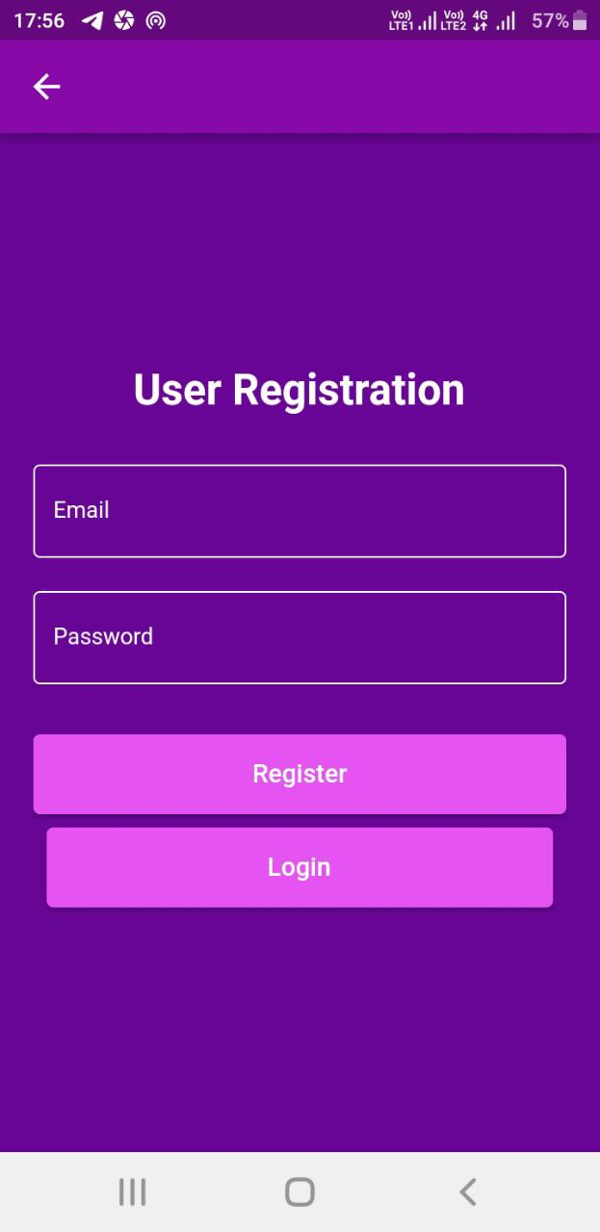
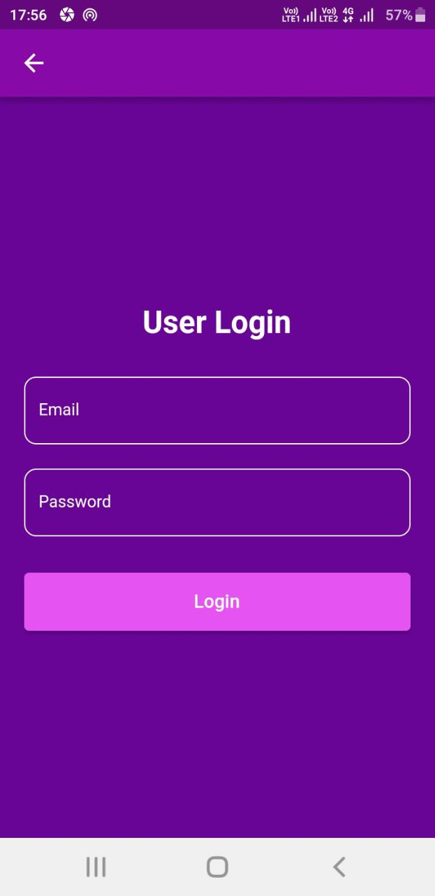

Home Page Learning Resources Page
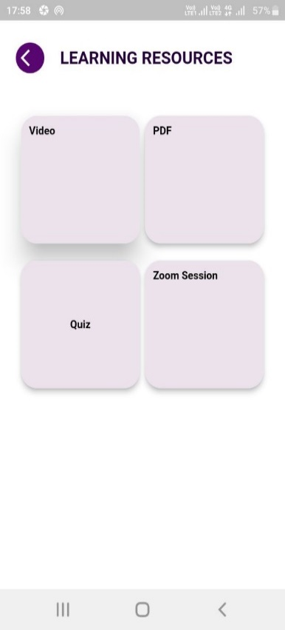
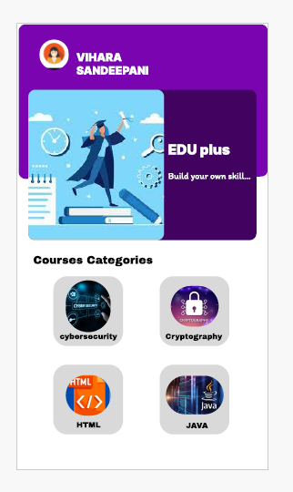
Quiz Page Result View
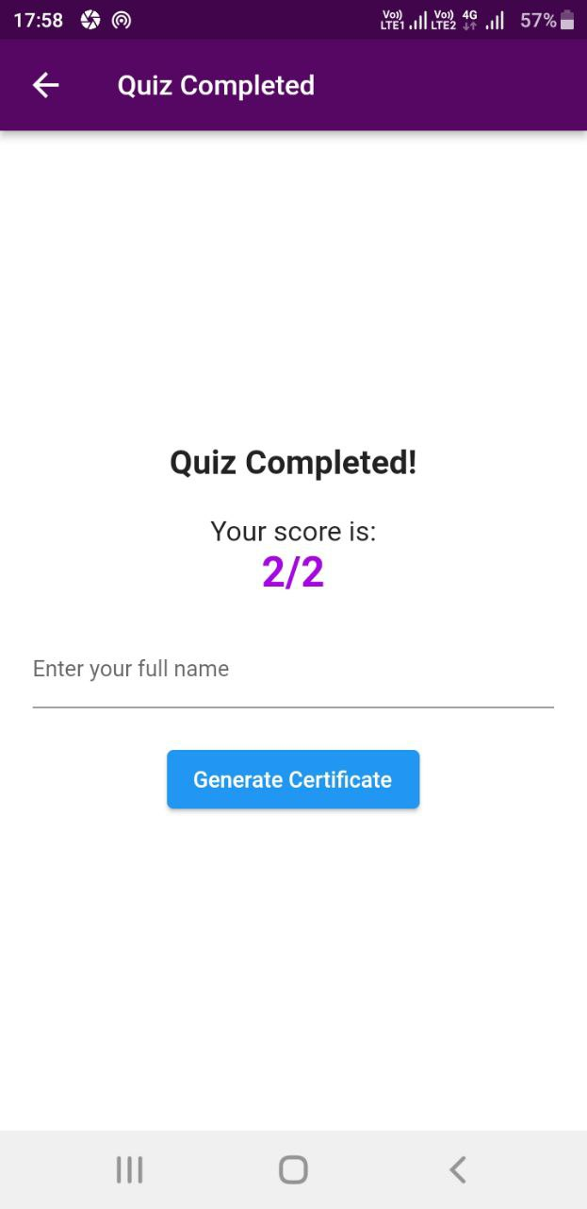
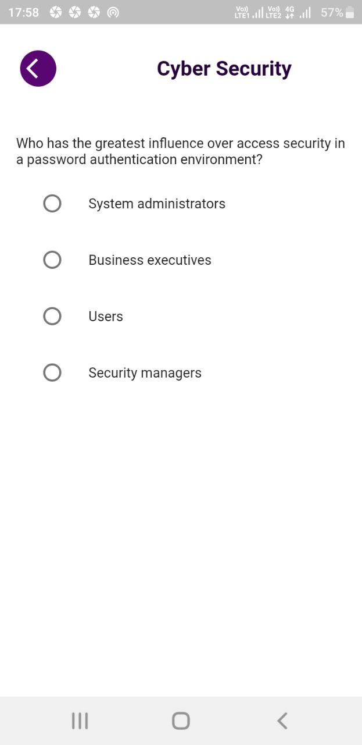

Pdf page Certificate Page
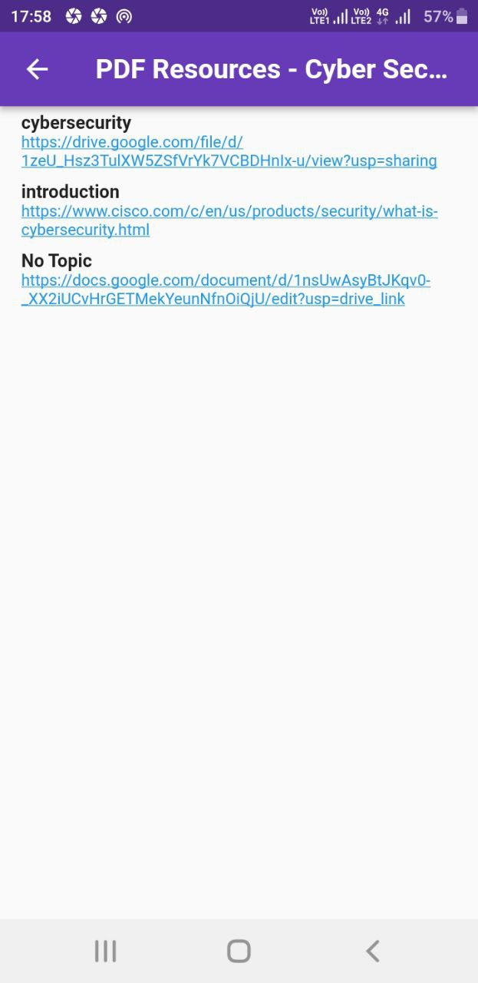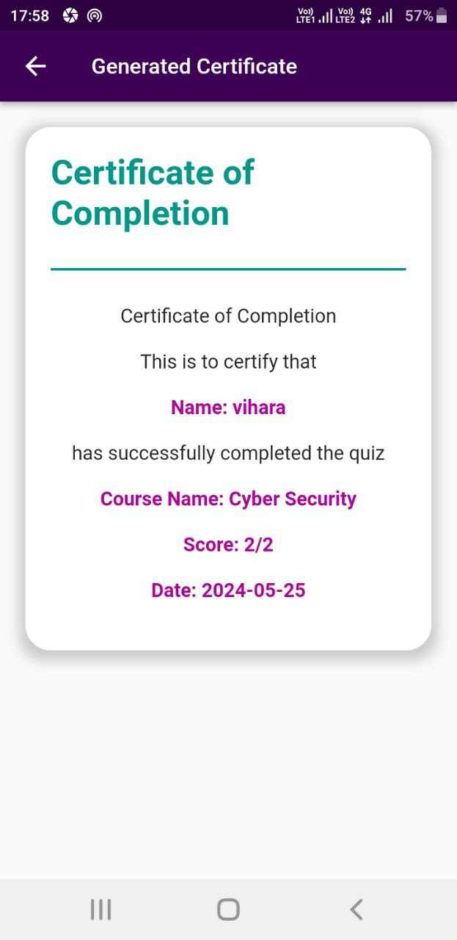
Admin Home Page Add Video Page
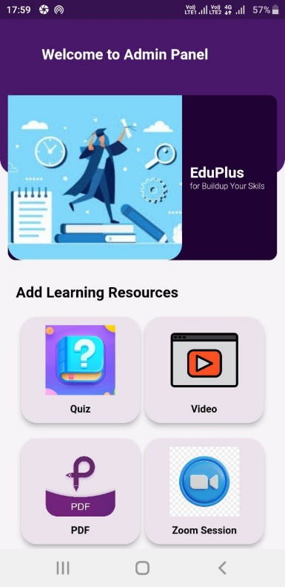
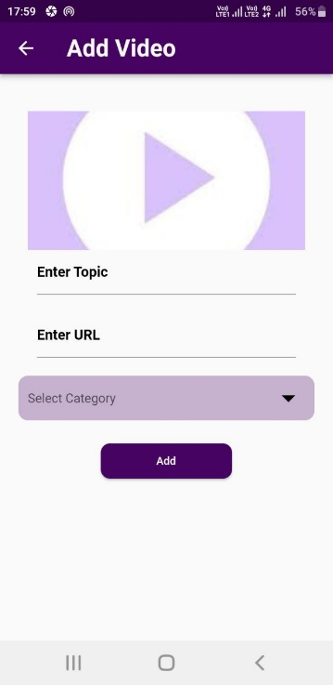
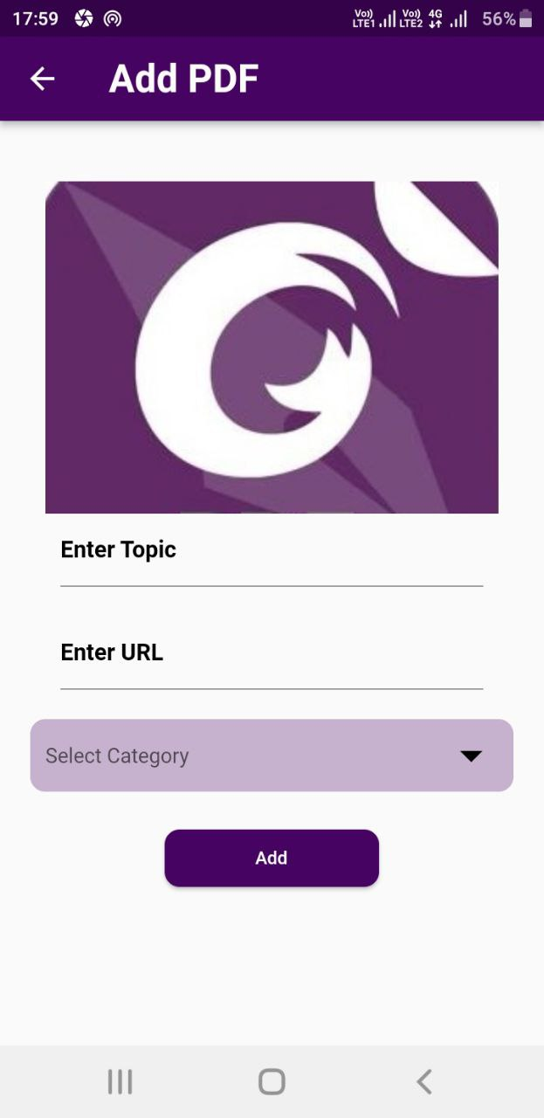
Add quiz Page Add pdf page
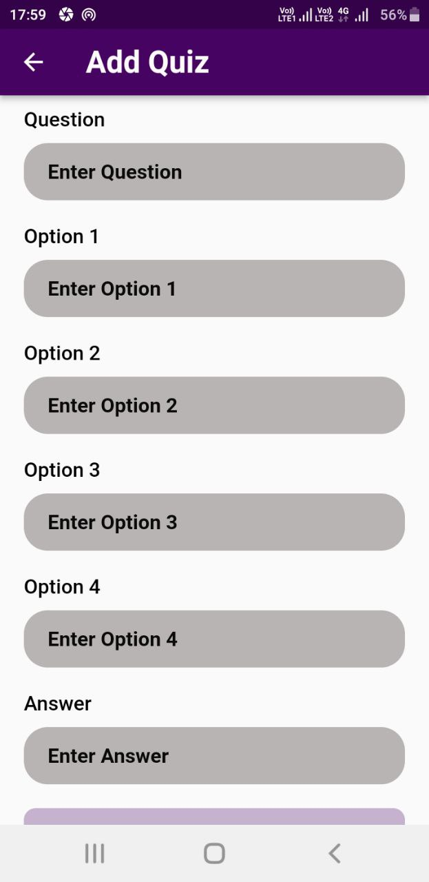

4. TESTING

4.2 Testing Methodology (Types)
Test cases are developed using various test techniques to achieve more effective testing. By this, web-based completeness is provided and conditions of testing which get the greatest probability of finding errors are chosen. So, testers do not guess which test cases to choose, and test techniques enable them to design testing conditions in a systematic way. Also, if one combines all sorts of existing test techniques, one will obtain better results rather if one uses just one test technique. Software can be tested in two ways, in another words, one can distinguish two different methods:
1. Black box testing
2. White box testing.

4.3 White Box Testing
White box testing concerned with testing the implementation of the program. The intent of structural is not to exercise all the inputs or outputs but to exercise the different programing and data structure used in the program. This structural testing aims to achieve test cases that will force desire coverage of different structures.Two types of path testing are statement testing overage and branch testing coverage The White Box testing strategy, the internal workings

Test Plan
Testing process starts with a test plan. This plan identifies all the testing related activities that must be performed and specifies the schedules, allocates the resources and specified guidelines for testing. During the testing of the unit the specified test cases are executed and the actual result compared with expected output. The final output of the testing phase is the test report and the error report.

Module Name | Login
Test Case ID | Test_01
Tester Name | Vihara
Test Case Description | To check login functionality of course learning app
Prerequisites | 1. Stable internet connection
Prerequisites | 2. Mobile devices(Android,IOS,Emulator,etc..)
Tester's Name | Vihara
Environmental information | 1. OS : Windows/Linux/Mac
Environmental information | 2. System : Laptop/Desktop
Test Scenario | Checking that after entering the correct username and password, the user can login

Test Case ID | Test Steps | Test Input | Expected Results | Actual Results | Status | Comments
1 | 1. Enter Email | viha@gmail.com | User Logged in successfully! | User Logged in successfully! | Pass | No issues found
1 | 2. Enter Password | 123abcd
1 | 3. Click on Login
2 | 1. Enter Email | viha@gmail.com | Failed to  log in! | Failed to  log in! | Pass | No issues found
2 | 2. Enter Password | 123abcd
2 | 3. Click on Login
3 | 1. Enter Email | viha@gmail.com | Failed to  log in! | Failed to  log in! | Pass | No issues found
3 | 2. Enter Password | @Adfdk8gy
3 | 3. Click on Login
4 | 1. Enter Email | admin@gmail.com | Admin Logged in successfully! | Admin Logged in successfully! | Pass | No issues found
4 | 2. Enter Password | 123456
4 | 3. Click on Login
5 | 1. Enter Email | admin@gmail.com | Failed to  log in! | Failed to  log in! | Pass | No issues found
5 | 2. Enter Password | 86gh43
5 | 3. Click on Login
6 | 1. Enter Email | - | Please enter your email and password | Please enter your email and password | Pass | No issues found
6 | 2. Enter Password | -
6 | 3. Click on Login
7 | 1. Enter Email | viha@gmail.com | Please enter your password | Please enter your password | Pass | No issues found
7 | 2. Enter Password | -
7 | 3. Click on Login

Unit Testing
Each individual module has been tested against the requirement.

5. IMPLEMENTATION
5.1. Introduction
Implementation refers to the process of translating a plan or design into action, putting it into effect, and making it a reality. In the context of software development or system deployment, implementation refers to the actual execution and deployment of the system based on the defined requirements and design specifications.
Implementation phase will describe how to the actual system is developed using previously mentioned designs. Here we discuss the technology, tools and methods used on development the actual system.

5.2 Installation guide
This is the installation guide for install the Android studio with flutter framework for converting the system design to executable program.
- Android studio
- Flutter framework
5.3. Hardware and Software Requirements
Under this topic hardware and software requirements of Development environment and user environment are listed. We have used several hardware and software devices to complete our group project, movie ticket booking application for successfully, in that process we used some hardware and software requirements to achieve following tasks.
- Easy to use
- Easy to develop the system
- Save time
- To accomplish system goals effectively

06. Evaluation and Conclusion
Evaluation
The Eduplus app has demonstrated significant in addressing the evolving needs of modern education. Through a meticulous focus on user-centric design and functionality, the platform has successfully created a seamless and engaging learning environment. The implementation of versatile tools for quizzes and assessments enhances the interactive learning experience, making it more effective and enjoyable for students. The platform's adaptability to diverse learning styles and needs, coupled with its emphasis on accessibility and flexibility, aligns well with the global shift towards digital education. Early user feedback highlights the app's intuitive interface and the value it adds in facilitating personalized learning paths. However, continuous evaluation and iteration based on user input and technological advancements will be crucial in ensuring the app remains at the forefront of educational innovation. Overall, the project marks a significant step forward in leveraging digital solutions to improve knowledge acquisition and educational outcomes.
Conclusion
The Eduplus App represents a significant step forward in the realm of digital education. By prioritizing user experience, accessibility, and personalization, this platform addresses the evolving needs of modern learners. The app's innovative features, including quizzes, assessments, and interactive content, aim to enhance knowledge retention and engagement. As the demand for flexible and effective online learning solutions continues to rise, the Online Learning Courses App is poised to make a meaningful impact in the educational landscape. By empowering students with the tools they need to succeed in a digital age, this project not only supports individual growth but also contributes to the broader goal of accessible and equitable education for all..
6.1. Future Work
- Hope to make all users can download their certificate like a pdf.
- Hope to develop a stage to all users can present their problems
- Hoping to develop courses in any language for all users

- Reference

[1] “Learning Hub Tanzania - Apps on Google Play,” play.google.com. https://play.google.com/store/apps/details?id=com.tanzania.learning.hub (accessed Mar. 12, 2024).

‌ [2] “Educonnect - Apps on Google Play,” play.google.com. https://play.google.com/store/apps/details?id=com.edunext.educonnect (accessed Mar. 12, 2024).

‌ [3] “Studocu: Study Notes & Sharing - Apps on Google Play,” play.google.com. https://play.google.com/store/apps/details?id=com.studocu.app (accessed Mar. 12, 2024).

‌ [4] “GLOBIS Unlimited,” GLOBIS Unlimited. https://globisunlimited.com/?campaignid=20494514803&adgroupid=161311107348&keyword=free%20training%20courses%20online&device=c&network=g&placement&adposition&gad_source=1&gclid=Cj0KCQjw-r-vBhC-ARIsAGgUO2CXYbpXXDplyL6h1fPKDrRop0YE_d9shbr4VSI3dcfJ8qQ-a-zC-p. (accessed Mar. 12, 2024).

[1] “Learning Hub Tanzania - Apps on Google Play,” play.google.com. https://play.google.com/store/apps/details?id=com.tanzania.learning.hub (accessed Mar. 12, 2024).

‌ [2] “Educonnect - Apps on Google Play,” play.google.com. https://play.google.com/store/apps/details?id=com.edunext.educonnect (accessed Mar. 12, 2024).

‌ [3] “Studocu: Study Notes & Sharing - Apps on Google Play,” play.google.com. https://play.google.com/store/apps/details?id=com.studocu.app (accessed Mar. 12, 2024).

‌ [4] “GLOBIS Unlimited,” GLOBIS Unlimited. https://globisunlimited.com/?campaignid=20494514803&adgroupid=161311107348&keyword=free%20training%20courses%20online&device=c&network=g&placement&adposition&gad_source=1&gclid=Cj0KCQjw-r-vBhC-ARIsAGgUO2CXYbpXXDplyL6h1fPKDrRop0YE_d9shbr4VSI3dcfJ8qQ-a-zC-p. (accessed Mar. 12, 2024).

[1] “Learning Hub Tanzania - Apps on Google Play,” play.google.com. https://play.google.com/store/apps/details?id=com.tanzania.learning.hub (accessed Mar. 12, 2024).

‌ [2] “Educonnect - Apps on Google Play,” play.google.com. https://play.google.com/store/apps/details?id=com.edunext.educonnect (accessed Mar. 12, 2024).

‌ [3] “Studocu: Study Notes & Sharing - Apps on Google Play,” play.google.com. https://play.google.com/store/apps/details?id=com.studocu.app (accessed Mar. 12, 2024).

‌ [4] “GLOBIS Unlimited,” GLOBIS Unlimited. https://globisunlimited.com/?campaignid=20494514803&adgroupid=161311107348&keyword=free%20training%20courses%20online&device=c&network=g&placement&adposition&gad_source=1&gclid=Cj0KCQjw-r-vBhC-ARIsAGgUO2CXYbpXXDplyL6h1fPKDrRop0YE_d9shbr4VSI3dcfJ8qQ-a-zC-p. (accessed Mar. 12, 2024).

