Sri Lanka Institute of Advanced Technological Education.
Higher National Diploma in Information Technology.



System Requirement Specification

“Online Courses Learning App”

By

Name : N.R.N.V.Sandeepani
Register Number : ANU/IT/2021/F/91

Supervisor
Mrs. W.A.S Wickremasinghe

Academic Year: 2021
Year: 2
Semester: 2

Table of content

- Introduction…………………………………………………………………….…….03
- Scope of the project…….…………………………………………………………….04
- Functional requirements…………………………………………………………..05-06
- Use-case Diagrams
Use case 01…………………………………………………………………...07
Use case 02…………………………………………………………………...08
Use case 03…………………………………………………………………...09
Use case 04……………………………………………………………..…….10
Use case 05…………………………………………………………………...11
Use case 06…………………………………………………………………...12
Use case 07…………………………………………………………………...13
Use case 08…………………………………………………………………...14
- Nonfunctional requirements………………………………………………………….15
- Software requirements & Hardware requirements…………………………………...16

- Introduction

This "Online Course learning App" is a platform design to provide users with access to a diverse range of educational materials, courses, and resources through digital means. This Software Requirements Specification (SRS) document outlines the functional and non-functional requirements necessary for the development and implementation of the “Online Course learning App”.

The primary goal of this App is to offer an intuitive and user-friendly interface that allows individuals to conveniently explore, enroll in, and engage with various educational courses tailored to their interests and needs. Whether users are looking to enhance their skills, pursue new hobbies, or further their education, the “Online Course Learning App” aims to provide a comprehensive and accessible learning experience.

- Scope of the project

Characteristics of the products:
“Online Course Learning” android application is a mobile application developed to attempt the courses online. The application will be developed using android studio and flutter language. It will allow to user to view course subjects, attempt course and quiz, show Pdf, user can see their certificates.
  - Services provided by the end system:
  - Ability to easily attempted courses from any convenient location.
  - Ability to attempted courses online without payment.
  - Ability to attempted quiz online.
  - Ability to attempted zoom session and access the YouTube videos.
  - Ability to get the certificates

  - End result of the project:
After login a system is provide the courses category relevant learning resources such as available live zoom session links, pdf, you tube video links and quiz, the user selects a course and after complete the course receive a unique valid certificate relevant a course.

  - Under which conditions the project will be executed:
- The project is developed using android studio and flutter programming languages.
- The project will be completed within the given time frame.
- The project will be thoroughly tested before development.
- The project will then address functional and non-functional requirements.

  - Constraints of the project
- “Online courses learning” application works only on android devices.
- This application requires an email service to function.
- This app works only when data is enabled on the device.

  - Assumptions related to the project:
By entering the correct information and select the course online, user will be displayed at the available live zoom session links, pdf, you tube video links and quiz relevant course, after completed course see the certificate whether it has been issued and used.

  - Acceptance criteria:
- Users must first log in and provide correct information and Correct email address must be entered.
- When course is complete correctly displayed in the message box and certificate.
- Functional requirements

using the internet all students are able to access the courses learning system. The active
characters of this system are:
1. User
2. Admin
User
1. Users can login.
When a user enters the system, username and password must be entered. Users must first login
and provide correct information and Correct email address must be entered.
2. User can select courses
Once the user enters the online course learning system, they access the information bar of the courses being screened. All subject resources and show quiz are displayed here.

3. User can view learning resource
The user will be able to know the information about courses categories will be screened. After the user selected a course user can see all learning resources relevant course such as available live zoom session links, pdf, you tube video links.
4. User can attempt the quiz and view result

The user will be able to know the information about courses categories will be screened. After the user selected a course user attempt quiz relevant course and they can see their results.
5. User can view certificate.
The user after the attempted quiz will generate the message “successful completed course”. User can access their certificate.

Admin
1. Admin can login.
When logging into the admin system, the user’s name and password must be entered. Then the system can be accessed.

2. Admin can add to course categories.
Admin can add a course category. Admin enter information like courses name, courses language, pdf, quiz, time etc.

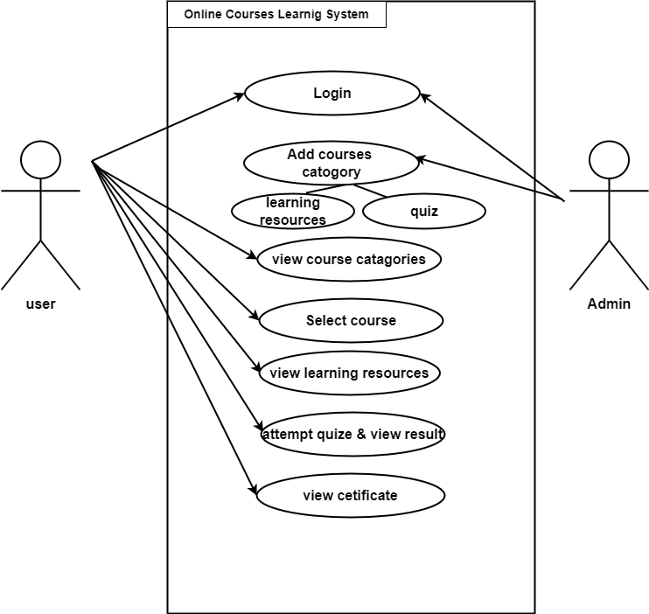
Use case 1
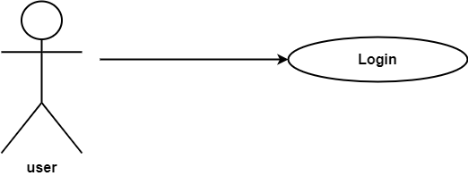

Use Case Name | Login
Actor | User
Overview | Log in to the user
Pre-conditions | 1. User must log into the application  2. Go to the login option
Description | 1. Update profile details
Alternative flows | 1. Need valid Gmail, if it is not valid user cannot get verification code  2. password must numbers, letters, symbols at less than 8  3. It cannot be empty, if it is empty, it generates an error
Additional Descriptions | First user needs to login with user’s correct  details, if user correctly login user can view pdf and quiz
Post condition | Direct go to the home page

Use case 2
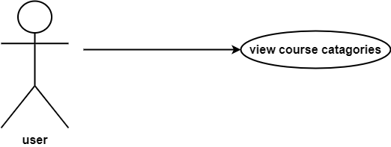

Use case Name | View courses categories
Actor | User
Over view | View the courses
Pre-condition | - User must login into the application
Description | - Users showing categories of courses  - Users showing names of courses
Alternative flows
Additional Description
Post conditions | Direct go to course content page .

Use case 3
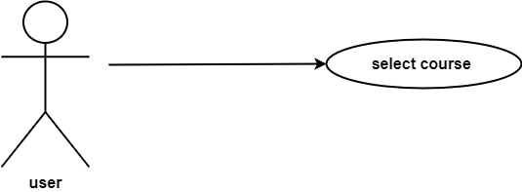

Use case name | Select course
Actor | User
Overview | Select the courses.
Pre-condition | User must login into application.  User view courses categories.
Description | - Users showing the course names.  - Select one course.
Alternative flows
Additional Description
Post condition | Direct go to the course details page.

Use case 4
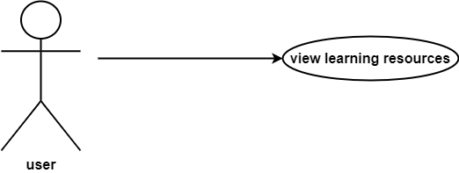

Use case name | View learning resources
Actor | User
Overview | can view the available live zoom session links, pdf, you tube video links related course.
Pre-condition | - User must login into application.  - User must select the course category.
Description | - Users showing the pdf relevant course.  - User Can read the pdf  - User can join the zoom session.  - User can access the you tube videos.
Alternative flows
Additional Description
Post condition | User can access the pdf , zoom session, YouTube video and direct go to the quiz page.
Use case 5
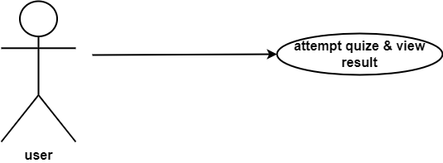

Use case name | Attempted quiz and view result
Actor | User
Overview | Users can attempt the quiz and their can see the result
Pre-condition | - User must login into application  - User must select the course category  - User read the pdf relent course
Description | - User to showing quiz  - User can attempt the quiz  - Showing the result for quiz
Alternative flows | Check the quiz answers are correct or not correct.
Additional Description | Result will be displayed.
Post condition | will show the message” Successfully completed the course” and direct go to the certificate page

Use case 6
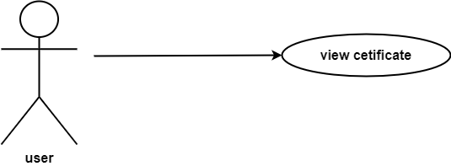

Use case name | View certificate
Actor | User
Overview | View the certificate.
Pre-condition | - User must login into application.  - user must read the pdf relevant the course.  - user must be attempted for the quiz.
Description | - Showing certificate.  - User fill the his/her name on the certificate.
Alternative flows
Additional Description
Post condition | Direct go to the course home page

Use case 7
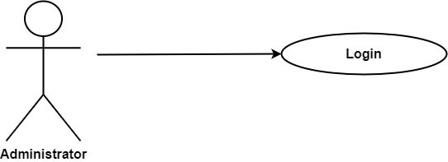

Use case name | Login
Actor | Administrator
Overview | Login into the administrator
Pre-condition | 1. admin must log into the application
Description | 1. Administrator update the database  2. Add course  3. Add pdf  4. Add quiz
Alternative flows | 1. if the user’s name and password are  incorrect showing error message
Additional Description
Post condition | Direct go to the administrator home page

Use case 8
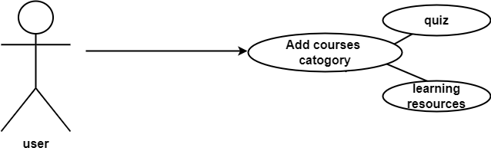

Use case name | Add course category
Actor | Administrator
Overview | Add course category to the application
Pre-condition | - admin must log into the application  - Go to the add course category option
Description | - Add course category name  - Add pdf  - Add zoom session links  - Add you tube video links  - Add quiz
Alternative flows
Additional Description
Post condition | Direct go to the administrator home page

4. Non-Functional Requirement

  - Usability
- The main page has to clearly display items that are in progress and suggested stiles.
- All users can enter the system by entering their username and password.
- Creates simple interfaces that are easy to understand for all users.
- Fields should be designed to appropriately assist users in filling in the fields.
- Interfaces are adapted for smartphones.

  - Security
- Each user is provided with unique system interfaces.
- When exiting the application, all the user’s information is saved in the database and removed from the application.
- Invalid or empty inputs are not accepted and error messages are displayed in case of such input.

  - E-Performance
- The system can be entered and run smoothly without any interruption.
- Determines how many clicks it takes to open a course detail.
- Usually determines how much time it takes a user to find a desired course.

  - Safety
- Full security is provided to protect data during login to system, generated certificate.
- Stores all user information and courses details securely so that no other user can see it.

  - Maintainability
- When a user enters his information and select a course, all that information is saved in the database, and all his information is removed from the interface.
- When the same user logs in again, he will be shown a new interface.
- Uploading new course to the system as soon as they are released.
- Also removing the finished course from the system

- Software requirements & Hardware requirements
Below are the resources we used to complete the project.
1. software requirment
- Using Android studio
- Using vscode
- Pdf reader
- Web browser
- Flutter SDK
    - Dart SDK
2. Hardware requirment
    - Using computer
    - Using wifi router

3. Other requirement
    - An internet connection.

