Nov 10, 2026, version 4.0

- PSXseecon will load fonts for the CDU’s, if wanted, automatically. No user action needed.

Sep 14, 2026, version 3.46

- Added a ctrl var for Qi38:
Qi38 , CfgStdbyBaro , 5038, [74500..110025],
Jun 27, 2026, version 3.45

- Bug in Qs357 Toebrakes fixed.
Jan 20, 2026, version 3.44

- Documentation updated for 2026.
July 6, 2025, version 3.43

- Added 4 SIOC variables:
Qs448, EfisActLBaro , 5686, , Qcode value
Qs448, EfisActLhPa , 5685, , Qcode value
Qs449, EfisActRBaro , 5688, , Qcode value
Qs449, EfisActRhPa , 5687, , Qcode value
April 29, 2025, version 3.42

- Fixed a bug in the coding of SIOC variables for the Yaw damper lights (they did not work!):
YawDamperUpr = 3294 (not 3292)
YawDamperLwr = 3295 (not 3293)

Jan 22, 2025, version 3.41

- Updated Manual and copyright info to 2025
Sep 19, 2024, version 3.40

- Added SIOC variable for Qi274.
June 10, 2024, version 3.39

- Added SIOC variables for Qi269, Qi270, Qi271 and Qi273.
- Var Qs321 made available with 3 new SIOC vars:
  - Qs321, pitchErrorAdd , 4997, , Qcode value
  - Qs483, bankErrorAdd , 4998, , Qcode value
  - Qs483, gyroRpm , 4999, , Qcode value
May 24, 2024, version 3.38

- Var Qs483 made available with 6 new SIOC vars:
  - Qs483, PhysIAS , 4990, , Qcode value
  - Qs483, PhysOAT , 4991, , Qcode value
  - Qs483, PhysTAT , 4992, , Qcode value
Qs483, CompWndDir , 4993, , Qcode value
  - Qs483, CompWndSpd , 4994, , Qcode value
  - Qs483, MagVar , 4995, , Qcode value

July 23, 2023, version 3.37

- New var: Qs118 XprdFail 3055 (integer 0/1)
April 22, 2023, version 3.36
- Made all values of Qs106 MemRcpL, Qs107 MemRcpC and
QS108 MemRcpR available in 42 SIOC variables:
Qs106 starts at 5631, Qs107 starts at 5651 and Qs108 starts at 5671
See the list of SIOC variables.

- Added configuration parameter SQUAWK_AS_INT, see the Manual section 2.2.23

March 27, 2023, version 3.35
- Fixed a nasty bug in the implementation of the DUAL_ENCODER_RCPL, DUAL_ENCODER_RCPC and DUAL_ENCODER_RCPR parameters.

Jan 10, 2023, version 3.34
- Updated copyright statement to 2023
- Checked my C++ code with static analyzer clang-tidy, resulting in a few small changes.

Dec 17, 2022, version 3.33

Upon request:
- Added:
Qh397, ParkBrkLevVirtual , 4748, , Qh value (Virtual Switch position)
- Added the following configuration parameters (see Manual chapter 2):
  - PARKBRKLEV_DOMINANT
  - GEARLOCK_OVERRIDE_DOMINANT
  - FIRE_ENG1_DOMINANT
  - FIRE_ENG2_DOMINANT
  - FIRE_ENG3_DOMINANT
  - FIRE_ENG4_DOMINANT
  - FIRE_APU_DOMINANT
Dec 15, 2022, version 3.32
- Upon request: added a SIOC variable for Qs457 CallPanelDisp.
It is -1 if panel is the display panel is blanked, other values are the index to the message. Read further in the Manual section 3.23.
Dec 12, 2022, version 3.31
- Upon request: added SIOC variables for single encoder with push button implementation of the rotaries of ACP Left, Centre and Right, and three configuration parameters to switch between a dual (default) or single rotary implementation.
See Manual sections 2.2.11, 2.2.12 and 2.2.13.
- Fixed bugs in the MIC Lights variables 2109, 2110 and 2111
Do note that the values in these variables are integers (-1 ... 9) not bits, only one led can be active at a time

Dec 8, 2022, version 3.30
- Upon request: added a parameter PTT_SWITCHES_DOMINANT, see Manual 2.2.11
Dec 4, 2021, version 3.29
- Upon request: re-defined Qs21 “PiBaHeAlTas” : PSXseecon now offers 7 SIOC vars with the (raw) data from PSX:
Qs121, Altitude , 4883, , Qcode value
Qs121, BankRad , 4881, , Qcode value
Qs121, Latitude , 4885, , Qcode value
Qs121, Longitude , 4886, , Qcode value
Qs121, PitchRad , 4880, , Qcode value
Qs121, TAS , 4884, , Qcode value
Qs121, TrueHeading , 4882, , Qcode value
Note that the 64 bit floats are 32 bit in SIOC.

- Upon request: added 7 SIOC variables for Qs429 “ Icing” :
Qs429, IceWingL , 5624, , Qcode value
Qs429, IceWingR , 5625, , Qcode value
Qs429, IceNac1 , 5626, , Qcode value
Qs429, IceNac2 , 5627, , Qcode value
Qs429, IceNac3 , 5628, , Qcode value
Qs429, IceNac4 , 5629, , Qcode value
Qs429, Iced , 5630, , Qcode value
See Hardy’s forum
Oct 8, 2021, version 3.28

- Upon request: added a SIOC ctrl variable for the Refueling Qi220 var:
Qi220, RefuelingCtrl , 5220, A

- Tested under Windows 11, all works fine.

Sep 30, 2021, version 3.27

- Re-implemented the Version check parameter (2.2.8) (was gone).
- Fixed a bug that slipped in, “string” parameters such as WHITELIST, BLACKLIST, Qs_VarList were no longer read…
- Added support for the NG FMC, just add

LCD_CDU=1
to the psxseecon.cfg file.

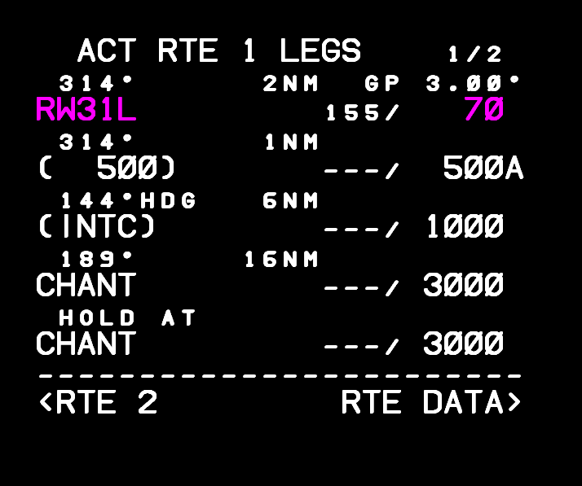

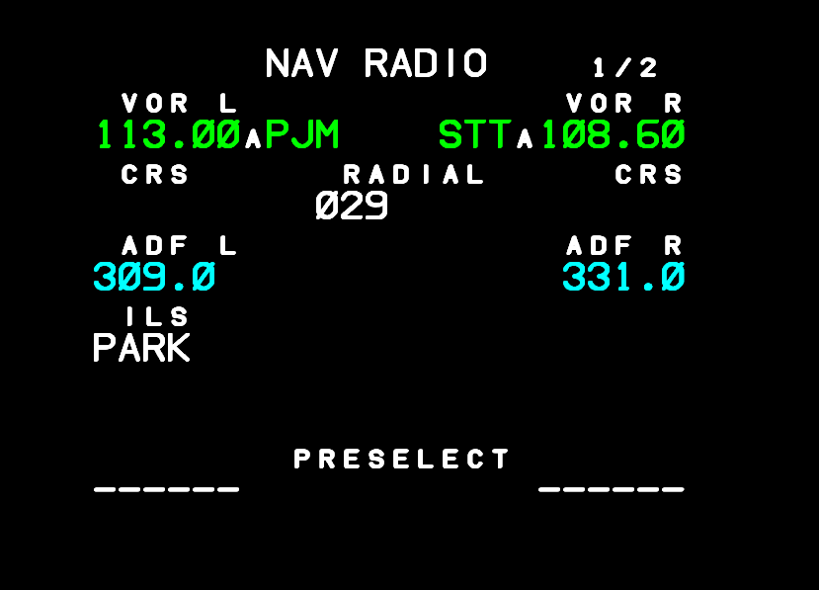

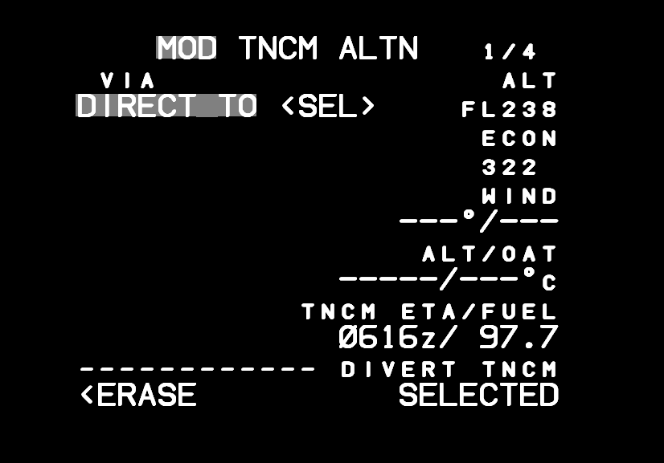

Sep 21, 2021 version 3.26

- Upon special request, added 11 SIOC variables for Qs438:
Qs438, FuelTemp , 5623, , Qcode value
Qs438, RefgPres , 5622, , Qcode value
Qs438, TankAux , 5621, , Qcode value
Qs438, TankCenter , 5619, , Qcode value
Qs438, TankMain1 , 5613, , Qcode value
Qs438, TankMain2 , 5614, , Qcode value
Qs438, TankMain3 , 5615, , Qcode value
Qs438, TankMain4 , 5616, , Qcode value
Qs438, TankReserve2 , 5617, , Qcode value
Qs438, TankReserve3 , 5618, , Qcode value
Qs438, TankStab , 5620, , Qcode value.
All fuel quantities in LBS x 10.
Fuel temperature Celsius x 100.
Aug 2, 2021 version 3.25

- Redesigned the HydDem1 (Qh184) selector while it is also one with a variable number of terminals (AUX or not), see version 3.24.
- After adding this parameter to your PSXseecon.cfg file
ENG_STARTERS_DOMINANT=0
the SIOC variables for the Engine Start Switches Q267 .. Q270 are no longer dominant over the start switches in PSX, which makes it easier if you are using a solenoid to reset your hardware switch based on info from the Virtual start switch vars. See Manual 2.2.10.

July 26, 2021, version 3.24
- Redesigned the implementation of rotary switches with variable terminals, such as the Source selector switches SrceIrsCp (Qh119), SrceIrsFo (Qh124), SrceAdcCp (Qh120) and SrceAdcFo, because in certain configurations the old solution was not correct.
Read more in the new section 3.22 of the Manual.
- Fixed labelling bugs: SrceNavCpCR renamed to SrceNavCpCC, SrceNavFoCL renamed to SrceNavFoCC.
- Relabeled/re-numbered the terminals of the FO source selector switches such that everything reads clockwise.
IMPORTANT: You may need to update the SIOC variable numbers in your SIOC scripts for the Source Selectors! Seen clockwise the first terminal of a rotary switch always has the lowest SIOC variable number, the next one 1 higher and so on.
July 19, 2021, version 3.23
- The indicator lights for the BigActionSwitches AltnFlap (3162), AltnGearNsBd (3163), AltnGearWing (3164), FlapOvrd (3166) , GearOvrd (3167) and TerrOvrd (3168) are now powered with the gT102 bus instead of gR7736 (which was wrong).
- All indicator lights SIOC variables for BigActionSwitches can now also be used in a SIOC program without the corresponding SIOC variable for the controlling the switch.
- Added SIOC variables for Qi259 up/to Qi268 and cleaned up some other Qi variables that were not relevant.

Skipping ancient history …

November 14, 2014: First official Release (version 1.1.0)

