The use of different kind systems is increasing day by day. Different kinds of systems are used in performing different kinds of activities. The main aim of this system is to store information on different kinds of products. The system is a menu-driven system that allows the user to perform different kinds of activities like moving items from one location to another. When transactions occur in any database they should be swift in such a way that there will be no duplication of information that is left behind. This means if the information is moved from one table to another then the information should not remain in the initial table. This means that once a row is moved from one table to another then the information in the initial table should be deleted to avoid data redundancy. This can only be done when correct data structures are used in any given program. In this case we use the array lists to store all the information from the files so that the program can easily handle data. The program first reads the information from the files using some data structures. The information is then stored on the ArrayList. From the ArrayList, the information can easily be added and removed from the database. The following shows the menu of the program.

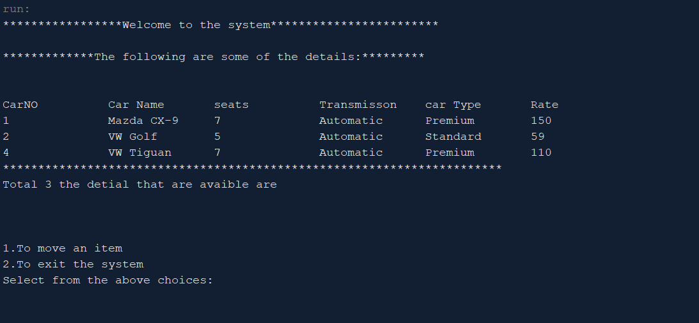

The program prints all the information on the to-do list. from the to-do list, the user of the system can select the information that he wants to move from the to-do table to another table.

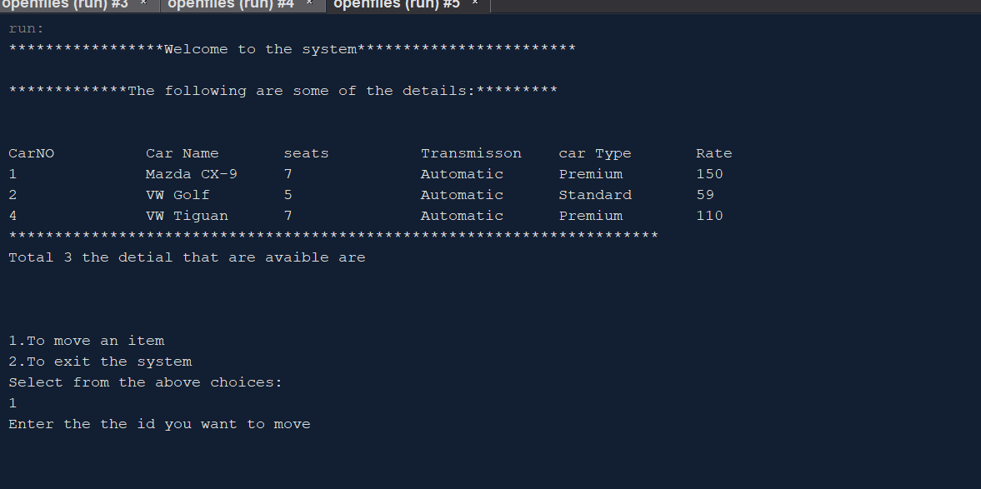

The system is asking the user to enter the kind of car ids that he wants to move from the table. We shall select the last one which is number 4.

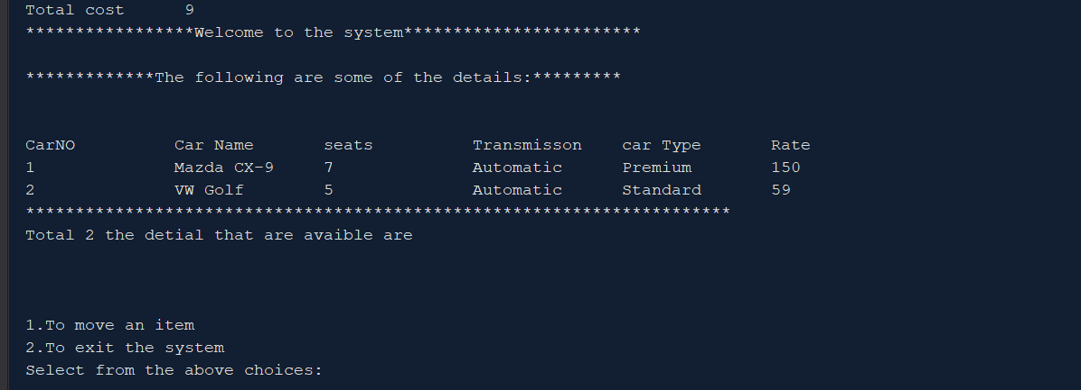

From the attached, we can see that the information is moved from one table to another. This means that all the data on text files were first read and stored on the ArrayList. After the item that is selected is removed from the data structure the information shall then be printed on the file for storage. This cyle continues as long as the system is connected to the text files.