NOC Operations Config Suite SOP

Status
- Environment: Production URL currently used for testing.
- Current production URL: `https://noc-configmaker.nxlink.com`
- Dev URL: Pending URL and DNS approval.
- Current phase: Testing/Beta for selected modules.

Purpose
This SOP defines how to safely use the NOC Operations Config Suite for configuration generation, upgrade workflows, and operational command lookup while the platform is in testing.

Audience
- NOC
- Engineering
- Field support
- DevOps (deployment and release operations)

Access and Safety Rules
- Always validate generated config before deployment.
- Do not assume a generated output is production-ready unless the module is marked production-ready.
- Use maintenance windows for upgrade/activation operations.
- Keep rollback options available before applying live changes.

Tool Overview

Home
- Shows announcements, activity, and high-level usage metrics.
- Use as the launch page and status check.
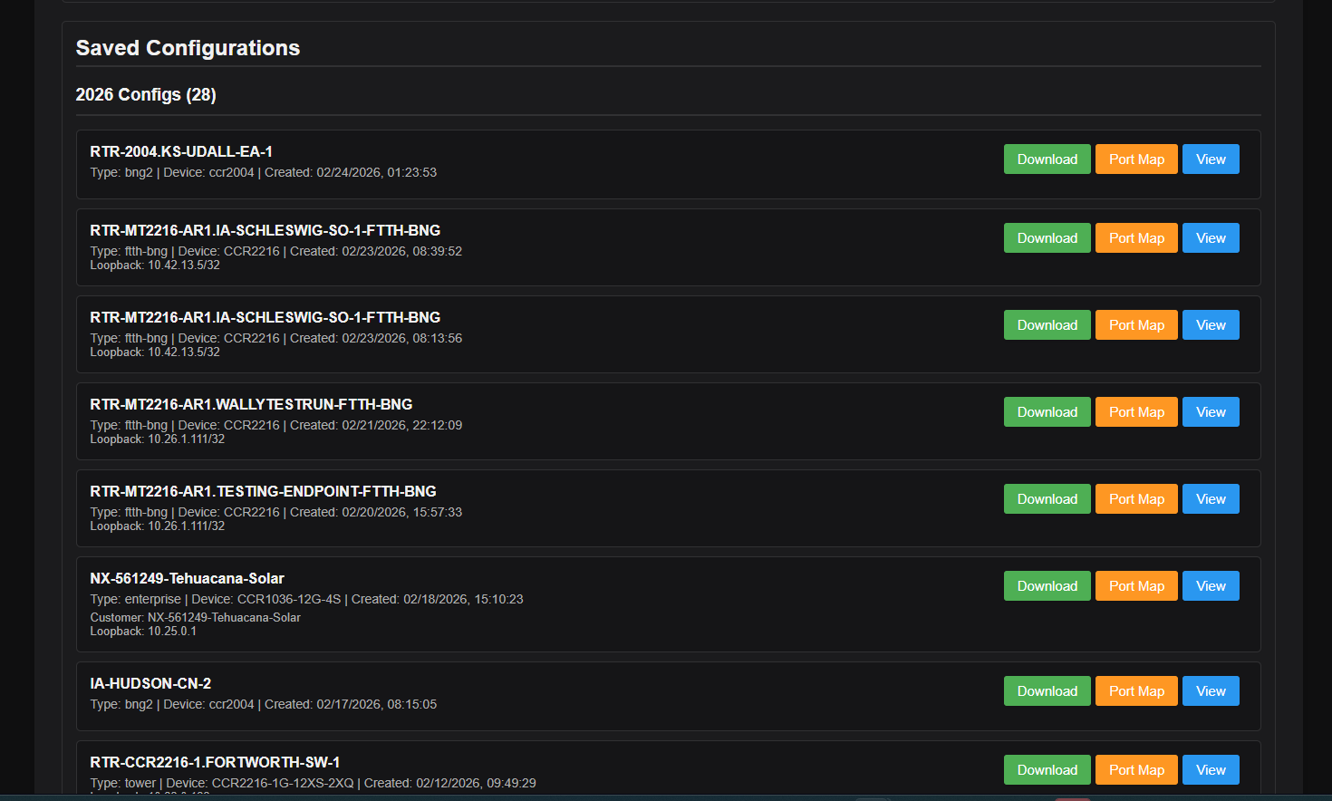
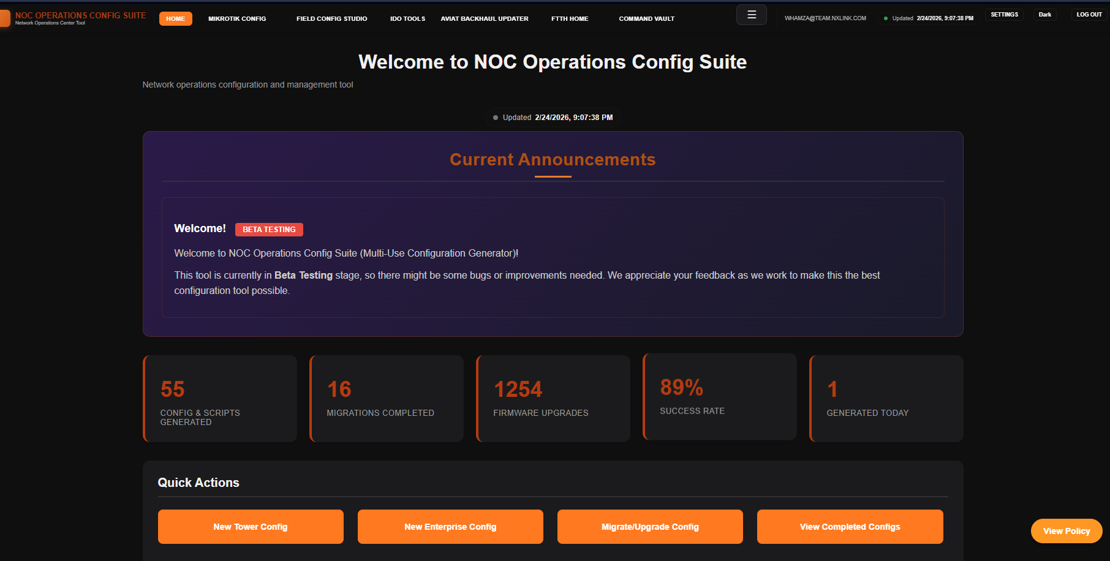

MikroTik Config
- Generates Tower, BNG/BNG2, Enterprise, 6GHz, and related RouterOS configs.
Pulls engineering compliance policy dynamically from GitLab as it should for a dynamic approach.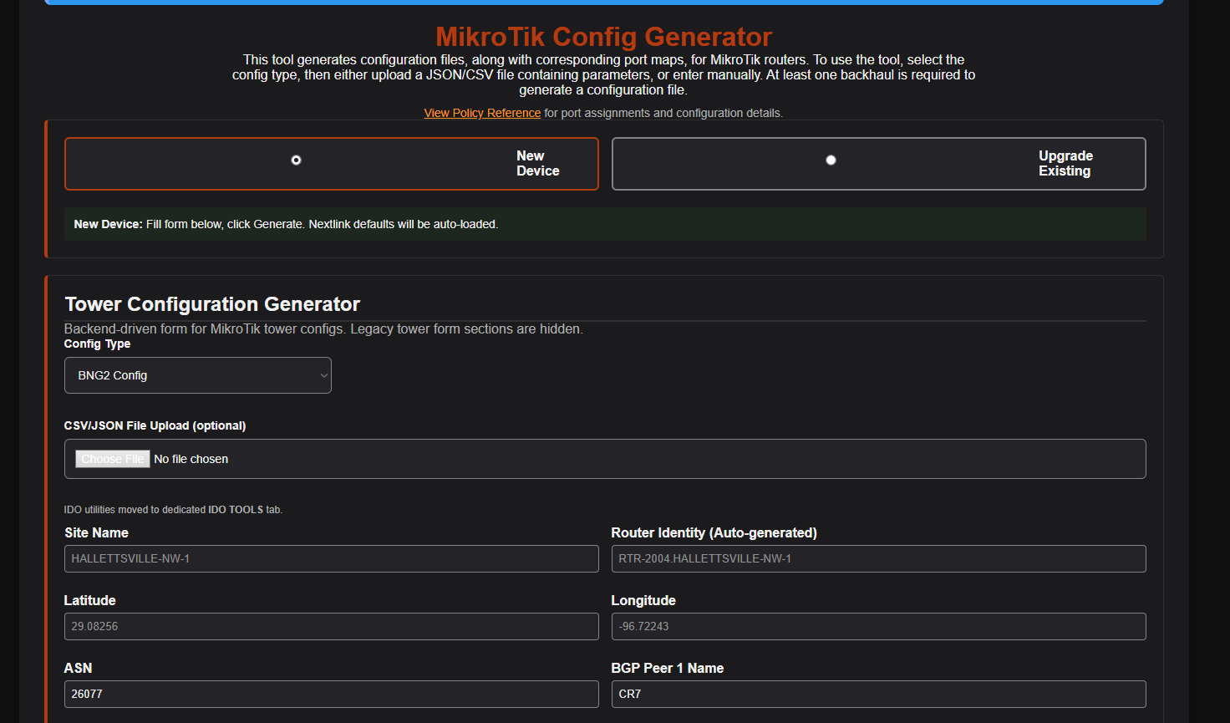

Field Config Studio
- Device utility workspace for operational tasks and config helpers.
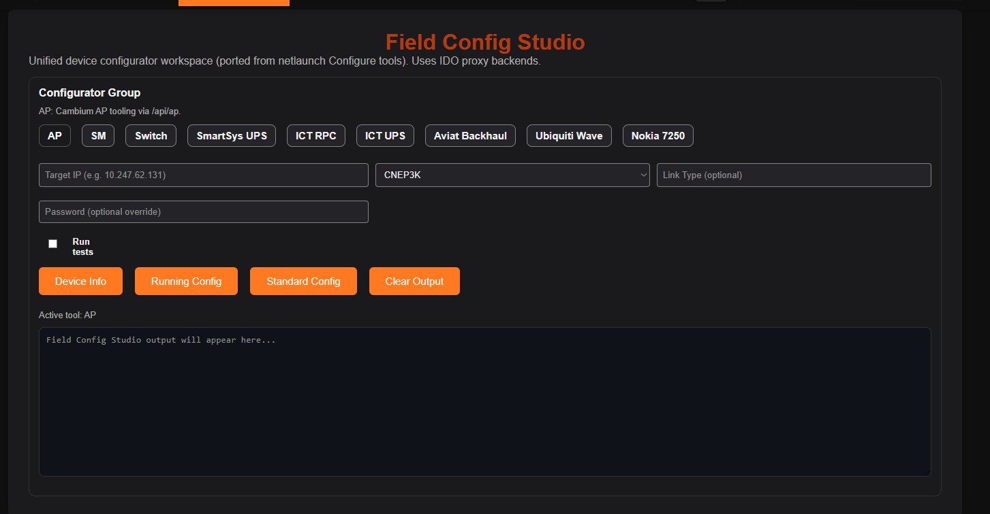

IDO Tools
- Operational helper utilities and integrations migrated into dedicated tab.
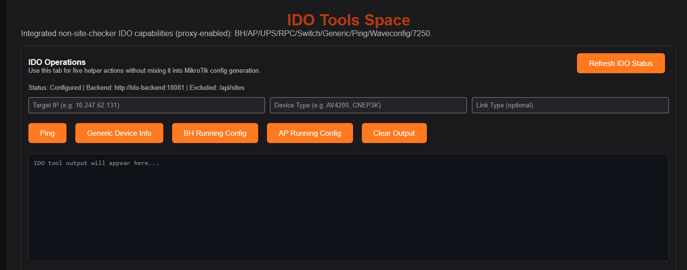

Aviat Backhaul Updater
- Multi-step upgrade flow with prechecks, firmware upload/activation, and recheck.
- Supports scheduled and immediate activation modes.

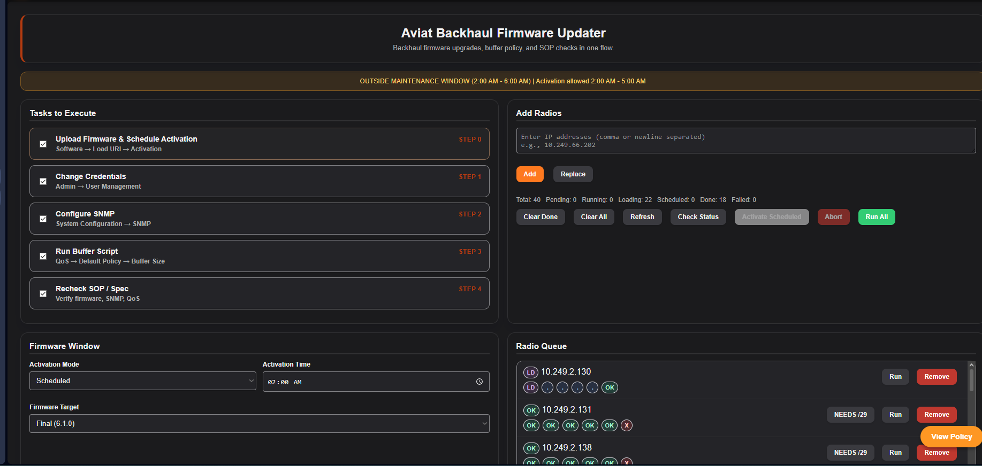

FTTH Home
- FTTH configuration workflows and outputs.
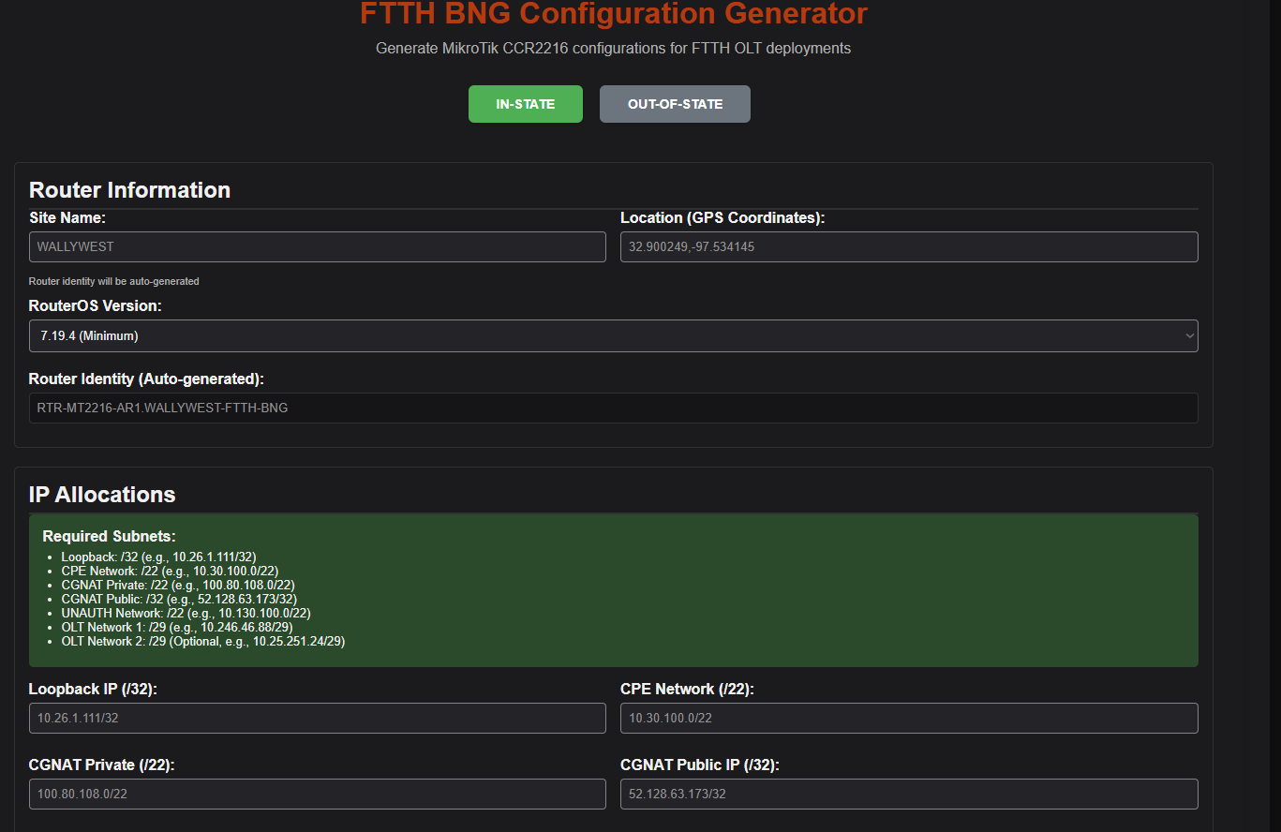

Command Vault
- Searchable command cards for Nokia, Cisco, and MikroTik references.
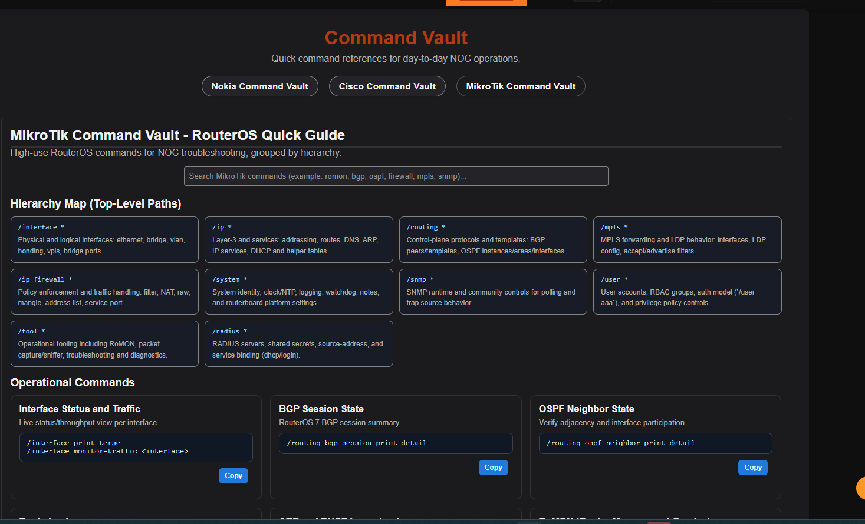

Standard Workflow (Config Generation)
- Select the module/tab for the target device type.
- Enter required site/device fields.
- Confirm auto-generated identity format is correct.
- Generate config.
- Review output for:
- Router identity
- Interface mapping
- OSPF/BGP sections
- State-specific policy content
- Compliance block inclusion
- Save and peer-review before deployment.

Aviat Backhaul Upgrade Workflow
- Add radio IPs.
- Select required tasks (firmware, credentials, SNMP, buffer script, recheck).
- Set activation mode:
- `Scheduled`: command queued to activation window.
- `Activate Now`: execute activation immediately after safety checks.
- Run queue and monitor per-device row states.
- Use `Check Status` during and after activation window.
- Confirm post-check status before closing job.

Dynamic Compliance Source (GitLab)
The platform is expected to fetch compliance content from GitLab and inject it into generated outputs as expected, this is where engineering updates the compliance script and we have now added the ability to pull information directly from there so we have a better dynamic approach and updates can be done in one place.
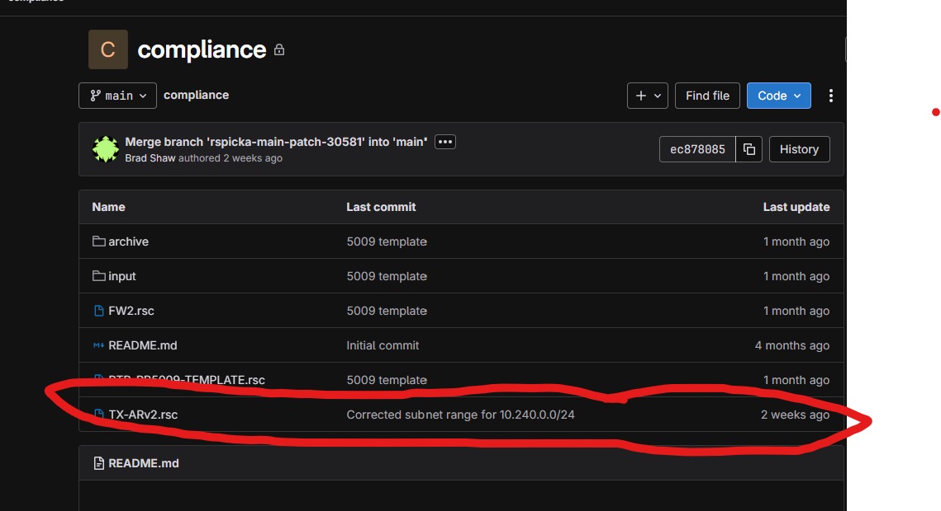

Validation checklist:
- Generate a MikroTik config.
- Confirm compliance block exists in output.
- Confirm current expected lines appear (example: firewall lists, OSPF auth, logging, LDP filter lines).
- If mismatch occurs, check token validity and URL path first.

Known Guardrails While in Testing
- Some modules contain testing notices and may still evolve.
- Use production URL with testing discipline until DEV URL is available.
- Treat all outputs as “review required.”

Troubleshooting Quick Checks

Missing compliance section
- Verify GitLab token.
- Verify raw file URL path and branch.
- Re-run generation and compare output.

Unexpected fields/sections in output
- Confirm selected config type and state profile.
- Confirm module version includes latest backend templates.

Upgrade queue not progressing
- Check maintenance window/time settings.
- Check device reachability and credentials.
- Use `Check Status` and inspect activity log entries.

