ANxxxxx
MCXA34x-based Inductive Encoder

Rev. 1.0 - DD Month YYYY Application note
Document information
Table 1. Document information
Information | Content
Keywords | MCXA34x, MCXA344, inductive encoder, OPAMP, LPADC, MAU, FreeMASTER
Abstract | This application note describes a reference implementation of an inductive encoder based on the MCXA34x family. The demo acquires differential sine and cosine signals with the integrated OPAMP and LPADC peripherals, calibrates the signal ellipse, calculates angle with MAU-assisted atan2, tracks multi-turn position, estimates speed, and visualizes the result with FreeMASTER.

This application note is written for firmware and hardware engineers who evaluate MCXA34x devices for inductive position sensing. It describes the reference demo as a starting point, not as a production accuracy claim.

1 Introduction
Inductive position encoders use coils and a conductive target to convert mechanical rotation into electrical sine and cosine signals. Compared with contact-based sensing, the inductive method can support sealed mechanics, tolerance to dust or oil, and board-level integration. The final accuracy depends on the sensor geometry, analog front end, calibration, mechanical alignment, and system-level validation.
The MCXA34x-based inductive encoder demo shows how the MCU can acquire the conditioned sine and cosine channels, correct typical amplitude and phase errors, calculate an angle at a deterministic rate, and expose the result through FreeMASTER. The implementation is intentionally compact so that it can be reused as a reference for evaluation boards, motor-control fixtures, and industrial encoder experiments.
Figure 1. MCXA34x-based inductive encoder solution block diagram.

2 Inductive Encoder Principles
A rotary inductive encoder typically includes an excitation structure, receiver coil patterns, and a rotor target. As the target rotates, the coupling between the excitation and receiver structures changes periodically. Receiver patterns that are shifted by 90 electrical degrees generate sine and cosine channels. A single mechanical revolution can contain multiple electrical cycles, depending on the coil and rotor geometry.
The reference firmware assumes two conditioned channels: sine and cosine. The channels are sampled as a pair, centered, transformed by a 2x2 calibration matrix, normalized by magnitude, and passed to atan2. The demo uses ENCODER_ELEC_CYCLES_PER_REV = 4, so the electrical angle is converted to mechanical angle by dividing the unwrapped electrical angle by four.
Figure 2. Inductive encoder signal model used by the reference firmware.
Table 2. Encoder signal-processing concepts
Concept | Reference implementation
Differential sine/cosine inputs | The hardware provides OUT_SIN+/OUT_SIN- and OUT_COS+/OUT_COS- style channels. The firmware is generic and only requires ADC-range sine and cosine samples after analog conditioning.
Ellipse correction | Calibration estimates channel centers and a 2x2 transform matrix, stored in encoder_calibration_t as sin_center, cos_center, and transform[2][2].
Magnitude gate | A minimum magnitude threshold prevents angle updates when the signal quality is too low. The reference constant is ENCODER_MIN_MAG_THRESHOLD = 0.6f.
Angle conversion | MAU-assisted atan2 produces electrical angle. The result is unwrapped, divided by ENCODER_ELEC_CYCLES_PER_REV, and normalized to mechanical angle.
Multi-turn tracking | Electrical wrap detection updates an accumulated electrical angle and a mechanical turn counter.

3 MCXA34x Device Fit
The value of the MCXA34x device in this application is the combination of mixed-signal acquisition, deterministic timing, and accelerated math in one MCU. The reference software uses the MCU peripherals as an integrated signal-processing pipeline rather than as independent blocks.
Table 3. Main MCU resources used by the reference demo
MCXA34x resource | Configuration in the demo | Application role
System clock | FROHF 180 MHz through BOARD_BootClockFROHF180M(). | Provides CPU and peripheral timing margin for a 10 kHz sampling loop.
OPAMP0 and OPAMP1 | Configured during Hardware_Init(); source uses OPAMP fit gain and bias configuration from the MCUXpresso driver. | Conditions the sine and cosine channels close to the MCU input path.
LPADC ADC0 and ADC1 | Dual-channel acquisition of OPAMP outputs; ADC0_A2 and ADC1_A2 are used for the main signal path. | Samples sine and cosine data as the input to encoder_process().
CTIMER1 | sampler_init(SAMPLE_FRQ) with SAMPLE_FRQ = 10*1000. | Creates the deterministic 10 kHz sampling interrupt.
MAU0 | Initialized in Hardware_Init(); mau_atan2.c wraps MAU_AtanXDivPIFloat(). | Accelerates atan2-style angle calculation in the encoder path.
LPUART0 | Used by FreeMASTER and the debug console in the default application path. | Exposes real-time variables and control flags to the host dashboard.
LPUART2 and eDMA | Used only by the optional T-Format/Tamagawa demo. | Provides an experimental industrial encoder interface path, separate from the default FreeMASTER demo.

4 Reference Hardware Summary
The application note does not include a schematic image in the main body. The hardware facts in this section are taken from IND_ENC_v1r0.pdf. The default software path remains generic: any front end that delivers conditioned sine and cosine signals within the MCU ADC range can reuse the firmware flow after calibration.
In the v1r0 reference hardware, a third-party inductive sensor front-end device generates differential OUT_SIN and OUT_COS signals. The schematic labels this device as AS5715R. Those labels are useful for understanding the reference board, but the firmware is not tied to that device name.
Table 4. Reference hardware connections from IND_ENC_v1r0.pdf
Signal group | MCXA34x connection | Use in the demo
Sine input path | P2_12/P2_13 feed OPAMP0 inputs; P2_15 is OPAMP0 output and ADC0_A2. | Condition and sample the sine channel.
Cosine input path | P2_16/P2_17 feed OPAMP1 inputs; P2_19 is OPAMP1 output and ADC1_A2. | Condition and sample the cosine channel.
FreeMASTER UART | P2_0/P2_1 are used for LPUART0 RX/TX. | Default host communication and live visualization.
Optional industrial UART | P2_2/P2_3 are shown for LPUART2 TX/RX. | Used by the optional T-Format/Tamagawa experiment, not by the default demo path.
Clock and debug | The schematic includes reset, SWD, and an 8 MHz crystal circuit. | Board bring-up and debug support.

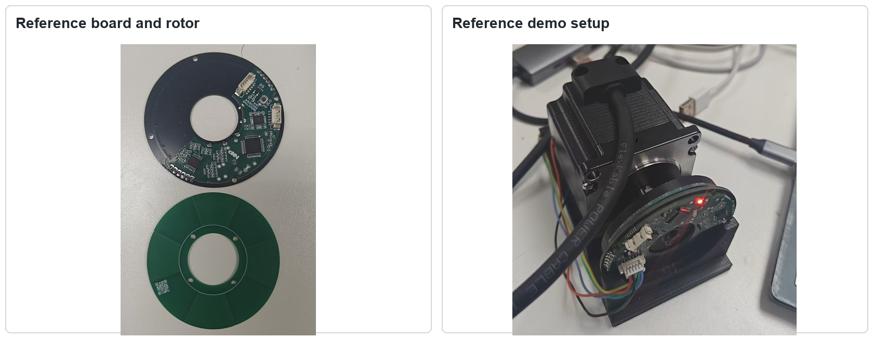
Figure 3. Reference board and demo setup photos.

5 Firmware Framework and Implementation
The firmware is organized around a small set of application modules. main.c initializes the board, starts the sampler, services FreeMASTER, and handles host commands. hardware_init.c configures clocks, pins, OPAMP, LPADC support, MAU, and utility GPIOs. app_sampler.c owns the CTIMER1 interrupt and calls adc_read() followed by encoder_process(). app_encoder.c contains calibration, normalization, angle, speed, zero, direction, and optional industrial-format helpers.
Figure 4. Reference firmware data flow.
Table 5. Key source modules
Module | Main responsibility
source/main.c | Application entry point, SAMPLE_FRQ definition, FreeMASTER command handling, calibration and zero-control orchestration.
source/hardware_init.c | MCXA34x clock, pin, OPAMP, MAU, console, and board utility initialization.
source/app_adc.c and source/app_adc.h | LPADC configuration and raw ADC acquisition for the encoder and temperature paths.
source/app_sampler.c and source/app_sampler.h | CTIMER1 sampling ISR and safe copy-out of the latest raw and processed results.
source/app_encoder.c and source/app_encoder.h | 2x2 calibration, magnitude gate, atan2, unwrap, zero, direction, alpha-beta filtering, and encoder output data.
source/mau_atan2.c and source/mau_atan2.h | MAU-backed atan2 helper used by the encoder algorithm.
source/freemaster_example.c and source/freemaster_example.h | FreeMASTER TSA table, public variables, and host-accessible control flags.
source/app_tformat.c and source/app_tformat.h | Optional T-Format/Tamagawa response demo for ABS, ABM, ENID, SF, and ALMC fields.

5.1 Calibration and Angle Pipeline
The calibration routine collects raw sine and cosine samples while the rotor is moved through the required electrical range. It computes channel centers and an ellipse-to-circle transform, then stores the result in s_calibration. The runtime path subtracts the centers, applies the transform, computes magnitude, normalizes the vector, and freezes angle updates when the magnitude is below the threshold.
The angle core uses the MAU-assisted atan2 helper. The electrical angle is unwrapped across 0/360 degree crossings, converted to mechanical angle using ENCODER_ELEC_CYCLES_PER_REV = 4, and then adjusted by zero and direction settings. An alpha-beta filter estimates speed while limiting spikes and enforcing a small deadband around zero speed.
Table 6. Public data and control variables
Symbol | Access | Purpose
encoder_result_t / encoder_result | Read-only through FreeMASTER TSA | Raw channels, normalized channels, magnitude, electrical angle, mechanical angle, turns, angle counts, speed_dps, and speed_rpm.
adc_sample_result_t / adc_result | Read-only through FreeMASTER TSA | Raw ADC-related values and temperature data used for observation and debug.
perf_metrics_t / g_perf | Read-only through FreeMASTER TSA | adc_us, atan2_us, algo_us, and isr_us timing metrics.
encoder_calibration_t / s_calibration | Read-only through FreeMASTER TSA | Calibration centers and 2x2 transform used by the angle path.
fm_cal_enable | Read-write through FreeMASTER TSA | Starts calibration from the host dashboard.
fm_zero_ctrl | Read-write through FreeMASTER TSA | Controls set-zero and clear-turns actions.
fm_direction | Read-write through FreeMASTER TSA | Selects the output direction sign.

5.2 Optional T-Format/Tamagawa Interface
The optional industrial-interface code is not the default application path. It is provided as a demo for experimenting with T-Format/Tamagawa-style responses over LPUART2 and eDMA. The default bring-up and visualization path remains FreeMASTER over LPUART0.
Table 7. Optional T-Format data fields
Field | Meaning in the demo
ABS | Single-turn position counts derived from encoder_result.angle_counts.
ABM | Multi-turn counter with an application-side offset/tare helper.
ENID | Encoder ID byte, defaulted by the reference implementation.
SF | Status byte placeholder for future product diagnostics.
ALMC | Alarm byte placeholder for future product diagnostics.

6 FreeMASTER Operation
FreeMASTER provides the default host interface. The dashboard reads raw ADC data, calibrated angle, speed, multi-turn count, calibration parameters, and performance counters. It also writes the calibration, zero, clear-turns, and direction controls exposed through the TSA table.
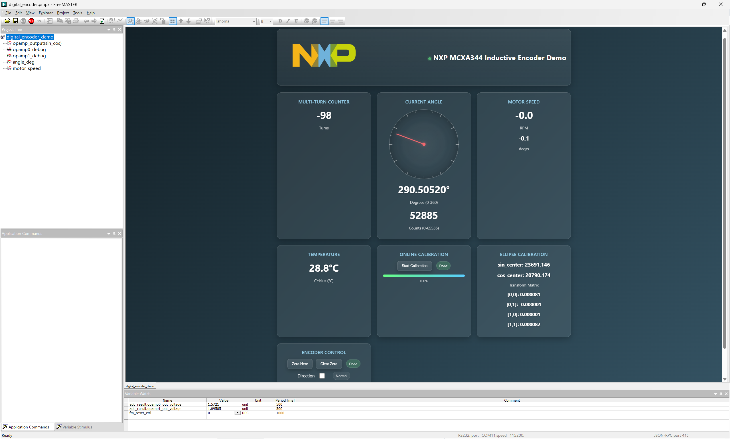
Figure 5. FreeMASTER dashboard used by the reference demo.
Table 8. Typical FreeMASTER workflow
Step | Action | Expected observation
1 | Connect the board to the host and open the FreeMASTER project or the web dashboard. | The dashboard starts showing raw ADC values, temperature, and encoder result variables.
2 | Rotate the target and observe sin_raw, cos_raw, and magnitude. | Signals should change smoothly and remain above the configured magnitude threshold for normal angle updates.
3 | Run calibration while moving through the required electrical range. | s_calibration updates with centers and the 2x2 transform matrix.
4 | Set zero and select direction as needed. | encoder_result.angle_deg, angle_counts, turns, and speed values follow the chosen output convention.
5 | Watch g_perf timing metrics while changing sample rate or algorithm options. | adc_us, atan2_us, algo_us, and isr_us provide immediate timing feedback.

7 Performance Summary
The reference firmware targets a 10 kHz update rate. SAMPLE_FRQ is defined as 10*1000 in main.c, and ENCODER_SAMPLE_PERIOD_S is 0.0001f in app_encoder.h. This gives a 100 us period for acquisition and processing. The README reports typical timing values of approximately 4 us for ADC access, 2 us for the algorithm, and 7 us for the full sampling ISR on the reference setup.
Table 9. Reference performance values
Item | Value | Source and note
Sampling/update rate | 10 kHz | SAMPLE_FRQ = 10*1000 in source/main.c.
Sampling period | 100 us | ENCODER_SAMPLE_PERIOD_S = 0.0001f in source/app_encoder.h.
Electrical cycles per revolution | 4 | ENCODER_ELEC_CYCLES_PER_REV = 4 in source/app_encoder.h.
ADC acquisition time | About 4 us typical | README-reported g_perf.adc_us value for the reference demo.
Algorithm time | About 2 us typical | README-reported g_perf.algo_us value for normalization, angle, unwrap, filtering, and quantization.
Full sampling ISR time | About 7 us typical | README-reported g_perf.isr_us value including ADC and algorithm processing.

These values are reference-demo measurements and should be remeasured on the final board, clock configuration, compiler optimization level, and host interface configuration. Accuracy, noise, latency, and temperature behavior require board-specific validation.

8 Getting Started
Table 10. Bring-up checklist
Step | Detail
Prepare hardware | Use the MCXA34x reference board and inductive encoder hardware. Verify power, ground, OPAMP inputs, ADC outputs, reset, SWD, and the FreeMASTER UART connection.
Open the firmware project | Open the Keil project ind_encoder.uvprojx and confirm that the MCXA34x device support and MCUXpresso SDK paths are available.
Build and flash | Build the ind_encoder target, flash the board, and verify that the debug console and heartbeat/test signals behave as expected.
Connect FreeMASTER | Open freemaster/digital_encoder.pmpx or the web dashboard and connect through the default LPUART0 path.
Check raw signals | Rotate the target and confirm that sine, cosine, and magnitude move smoothly before trusting angle output.
Calibrate | Run calibration through fm_cal_enable. Use the resulting s_calibration values for the current hardware setup.
Set output convention | Use fm_zero_ctrl and fm_direction to set mechanical zero and direction for the demo.

9 Secondary Development Guide
Use the reference demo as a starting point and keep the hardware-dependent assumptions visible. The most common productization tasks are calibration storage, diagnostics, sample-rate tuning, signal-quality monitoring, interface integration, and validation under mechanical and temperature variation.
Table 11. Customization guide
Area | What to change | Validation focus
Sensor geometry | Update ENCODER_ELEC_CYCLES_PER_REV if the coil/rotor design has a different number of electrical cycles per mechanical revolution. | Mechanical angle scale, wrap handling, and multi-turn count.
Sampling rate | Change SAMPLE_FRQ and ENCODER_SAMPLE_PERIOD_S together; review CTIMER1 setup and filter tuning. | ISR margin, speed estimate stability, host update rate, and aliasing.
Analog front end | Adjust OPAMP, LPADC, gain, bias, and pin configuration for the target board. | ADC range, saturation margin, noise, phase shift, and magnitude threshold.
Calibration persistence | Store encoder_calibration_t in nonvolatile memory after production calibration. | Boot-time loading, versioning, invalid-data fallback, and recalibration path.
Diagnostics | Map real fault detection into magnitude checks and optional SF/ALMC fields. | Fault coverage, recovery behavior, and host visibility.
Industrial interface | Enable or adapt the optional T-Format/Tamagawa path only if the product requires it. | Timing, electrical transceiver, protocol compatibility, and isolation from the default FreeMASTER path.

10 Source Code License Note
The reference source code in this repository uses the BSD-3-Clause license. When copying code into another project, retain the required copyright notice, license conditions, and disclaimer text from the source files or repository license. This application note does not change the license terms of the code.

11 References
Table 12. References
No. | Reference
[1] | NXP Semiconductors, MCX A34x product documentation page, https://www.nxp.com/products/MCX-A34
[2] | NXP Semiconductors, AN14682, OPAMP Usage on MCX A3xx, https://www.nxp.com/docs/en/application-note/AN14682.pdf
[3] | NXP Semiconductors, AN14805, MCX A34x Triple-Motor Field-Oriented Control, https://www.nxp.com/docs/en/application-note/AN14805.pdf
[4] | NXP Semiconductors, AN14866, Migrating from MCX A14x to MCX A34x, https://www.nxp.com/docs/en/application-note/AN14866.pdf
[5] | NXP Semiconductors, FreeMASTER run-time debugging tool, https://www.nxp.com/FREEMASTER
[6] | Project files in this repository: README.md, source/*.c, source/*.h, freemaster/*, and doc/IND_EC_v1r0/IND_ENC_v1r0.pdf.

12 Acronyms and Abbreviations
Table 13. Acronyms and abbreviations
Acronym | Description
ADC | Analog-to-digital converter
ABM | Multi-turn absolute position field used by the optional T-Format/Tamagawa demo
ABS | Single-turn absolute position field used by the optional T-Format/Tamagawa demo
ALMC | Alarm code field used by the optional T-Format/Tamagawa demo
CTIMER | Counter/timer peripheral
ENID | Encoder ID field used by the optional T-Format/Tamagawa demo
LPADC | Low-power analog-to-digital converter
MAU | Math accelerator unit
OPAMP | Operational amplifier peripheral
SF | Status field used by the optional T-Format/Tamagawa demo
TSA | Target-side address description used by FreeMASTER

Revision history
Table 14 summarizes revisions to this document.
Table 14. Revision history
Document ID | Release date | Description
ANxxxxx | DD Month YYYY | Initial release.

Legal information

Definitions
Draft — A draft status on a document indicates that the content is still under internal review and subject to formal approval, which may result in modifications or additions. NXP Semiconductors does not give any representations or warranties as to the accuracy or completeness of information included in a draft version of a document and shall have no liability for the consequences of use of such information.

Disclaimers
Limited warranty and liability — Information in this document is believed to be accurate and reliable. However, NXP Semiconductors does not give any representations or warranties, expressed or implied, as to the accuracy or completeness of such information and shall have no liability for the consequences of use of such information. NXP Semiconductors takes no responsibility for the content in this document if provided by an information source outside of NXP Semiconductors.
In no event shall NXP Semiconductors be liable for any indirect, incidental, punitive, special or consequential damages (including - without limitation - lost profits, lost savings, business interruption, costs related to the removal or replacement of any products or rework charges) whether or not such damages are based on tort (including negligence), warranty, breach of contract or any other legal theory.
Notwithstanding any damages that customer might incur for any reason whatsoever, NXP Semiconductors’ aggregate and cumulative liability towards customer for the products described herein shall be limited in accordance with the Terms and conditions of commercial sale of NXP Semiconductors.

Right to make changes — NXP Semiconductors reserves the right to make changes to information published in this document, including without limitation specifications and product descriptions, at any time and without
notice. This document supersedes and replaces all information supplied prior to the publication hereof.

Suitability for use — NXP Semiconductors products are not designed, authorized or warranted to be suitable for use in life support, life-critical or safety-critical systems or equipment, nor in applications where failure or malfunction of an NXP Semiconductors product can reasonably be expected to result in personal injury, death or severe property or environmental damage. NXP Semiconductors and its suppliers accept no liability for inclusion and/or use of NXP Semiconductors products in such equipment or applications and therefore such inclusion and/or use is at the customer’s own risk.

Applications — Applications that are described herein for any of these products are for illustrative purposes only. NXP Semiconductors makes no representation or warranty that such applications will be suitable for the specified use without further testing or modification.
Customers are responsible for the design and operation of their applications and products using NXP Semiconductors products, and NXP Semiconductors accepts no liability for any assistance with applications or customer product design. It is customer’s sole responsibility to determine whether the NXP Semiconductors product is suitable and fit for the customer’s applications and products planned, as well as for the planned
application and use of customer’s third party customer(s). Customers should provide appropriate design and operating safeguards to minimize the risks associated with their applications and products.
NXP Semiconductors does not accept any liability related to any default, damage, costs or problem which is based on any weakness or default in the customer’s applications or products, or the application or use by customer’s third party customer(s). Customer is responsible for doing all
necessary testing for the customer’s applications and products using NXP Semiconductors products in order to avoid a default of the applications and the products or of the application or use by customer’s third party customer(s). NXP does not accept any liability in this respect.

Terms and conditions of commercial sale — NXP Semiconductors products are sold subject to the general terms and conditions of commercial sale, as published at https://www.nxp.com/profile/terms, unless otherwise agreed in a valid written individual agreement. In case an individual agreement is concluded only the terms and conditions of the respective agreement shall apply. NXP Semiconductors hereby expressly objects to applying the customer’s general terms and conditions with regard to the purchase of NXP Semiconductors products by customer.

Export control — This document as well as the item(s) described herein may be subject to export control regulations. Export might require a prior authorization from competent authorities.

Suitability for use in non-automotive qualified products — Unless this document expressly states that this specific NXP Semiconductors product is automotive qualified, the product is not suitable for automotive
use. It is neither qualified nor tested in accordance with automotive testing or application requirements. NXP Semiconductors accepts no liability for inclusion and/or use of non-automotive qualified products in automotive equipment or applications.
In the event that customer uses the product for design-in and use in automotive applications to automotive specifications and standards, customer (a) shall use the product without NXP Semiconductors’ warranty of the product for such automotive applications, use and specifications, and
(b) whenever customer uses the product for automotive applications beyond NXP Semiconductors’ specifications such use shall be solely at customer’s own risk, and (c) customer fully indemnifies NXP Semiconductors for any liability, damages or failed product claims resulting from customer design and use of the product for automotive applications beyond NXP Semiconductors’ standard warranty and NXP Semiconductors’ product specifications.

Translations — A non-English (translated) version of a document, including the legal information in that document, is for reference only. The English version shall prevail in case of any discrepancy between the translated and English versions.

Security — Customer understands that all NXP products may be subject to unidentified vulnerabilities or may support established security standards or specifications with known limitations. Customer is responsible for the design and operation of its applications and products throughout their lifecycles
to reduce the effect of these vulnerabilities on customer’s applications and products. Customer’s responsibility also extends to other open and/or proprietary technologies supported by NXP products for use in customer’s
applications. NXP accepts no liability for any vulnerability. Customer should regularly check security updates from NXP and follow up appropriately.
Customer shall select products with security features that best meet rules, regulations, and standards of the intended application and make the ultimate design decisions regarding its products and is solely responsible for compliance with all legal, regulatory, and security related requirements
concerning its products, regardless of any information or support that may be provided by NXP.
NXP has a Product Security Incident Response Team (PSIRT) (reachable at PSIRT@nxp.com) that manages the investigation, reporting, and solution release to security vulnerabilities of NXP products.

NXP B.V. — NXP B.V. is not an operating company and it does not distribute or sell products.

Trademarks
Notice: All referenced brands, product names, service names, and trademarks are the property of their respective owners.
NXP — wordmark and logo are trademarks of NXP B.V.

MCXA34x-based Inductive Encoder

Please be aware that important notices concerning this document and the product(s) described herein, have been included in section 'Legal information'.

© 2024 NXP B.V. All rights reserved.
For more information, please visit: https://www.nxp.com
Date of release: DD Month YYYY Document identifier: ANxxxxx

