Author: Nguyen Xuan Tan Tai

Vietnam: 05B-07A Duong so 15, KCX Tan Thuan, Q7, Ho Chi Minh City
USA: 1921 Industrial Drive, Niles, MI, United States, 49120
Strike Machine Systems


TECH-LINK

This document provides a guide how to the use TECH-LINK Strike Machine Systems Application. Please refer to the App to understand the function of each component.

Contents
Chapter 1. Production Panels and Function Guide 3
1. Group Page 3
1.1. Monitor Group Page 3
1.2. Temperature Group Page 7
1.3. Operation Guide 9
2. Chart Page 10
2.1. Chart Page 10
2.2. Operation Guide 10
3. Setting Page 11
1.5. Conveyor 12
1.6. Visualization 13
1.7. Advance Setting 14
II. Product Panels and Function Guide 15
1. Catalog 16
2. Details 17
III. Devices Panel and Function Guide 18
1. Robot and PLC Connection Panel 19
IV. Dashboard Panel and Function Guide 20
1. Dashboard Panel 21
2. Dashboard Panel 22
3. Activity Table Panel 23
4. Error Log Table 24
V. Operation Instructions 25
STEP 1: Open the app and initialize connections. 25
STEP 2: Setup Material and Box data. 27
STEP 3: Prepare the Conveyor. 29
STEP 4: Start Packing. 30

Chapter 1. Production Panels and Function Guide

1. Group Page

1.1. Monitor Group Page
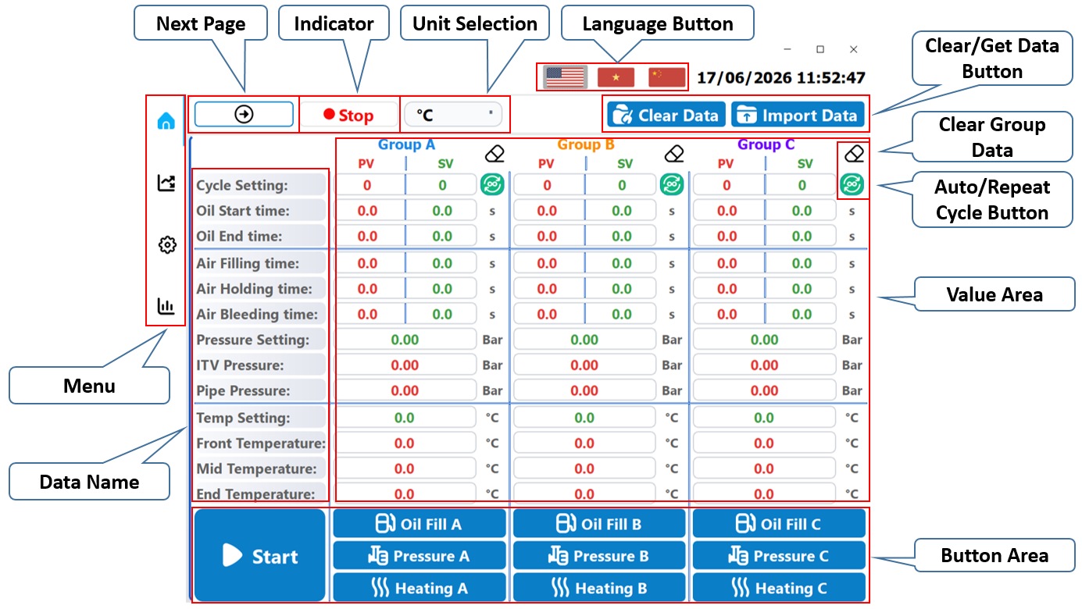
Figure 1.1: Group Page.
1.1.1. Next Page

Function: Move to Temperature Group Page/Monitor Group Page.
1.1.2. Indicator

Function: Show if the machine is running or not.
1.1.3. Unit Selection
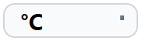
Function: Switch from °C to °F and reverse.
1.1.4. Language Button

Function: Three language available.
- English
- Vietnamese
- Chinese
1.1.5. Clear/Get Data Button

Function: Clear all the data/Import data from the file.
*Note: Import data will always set the Repeat Cycle Button to manual mode.
1.1.6. Clear Group Data

Function: Clear selected group data
1.1.7. Repeat Cycle Button

Function: Set the Machine to auto repeat or repeat according to the preset settings.
1.1.8. Value Area
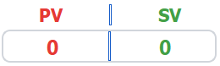
Function: PV is the current value of the Machine, SV is the set value for the Machine.
1.1.9. Menu

Function: Moving between pages.
1.1.10. Data Name
 | PV | SV
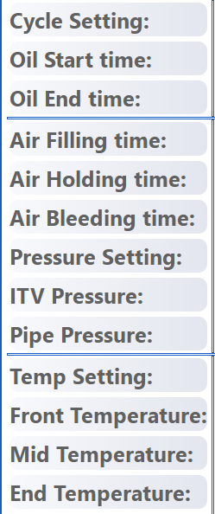 | Show the current Group Cycle. | Set the number of Cycle for the Group.
 | Currently not available. | Currently not available.
 | Currently not available. | Currently not available.
 | Show the current Fill time. | Set the time for Filling up the pressure.
 | Show the current Hold time. | Set the time for Holding the pressure.
 | Show the current Bleed time. | Set the time for Bleeding the pressure.
 | Show the current Pressure value. | Set the Pressure value.
 | Show the ITV Pressure value. | Not available.
 | Show the Pipe Pressure value. | Not available.
 | Show the current Temperature. | Set the Temperature value.
 | Show the Front Temperature. | Not available.
 | Show the Middle Temperature. | Not available.
 | Show the End Temperature. | Not available.

Function: Display the information of the Data.
1.1.11. Button Area
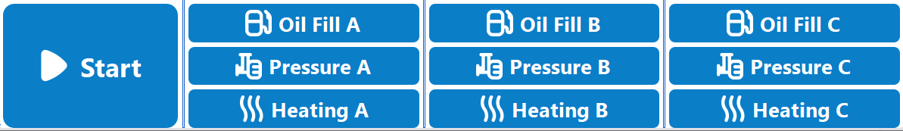
Function: Set the Machine run on different task.
- Start/Stop: Turn ON/OFF the Machine.
- Oil Fill: Turn ON/OFF the oil supply according to the set time.
- Pressure: Turn ON/OFF the pressure valve according to the set time.
- Heating: Turn ON/OFF the heater according to the set value.

*Note: If the Start button is not set, all the button will be disabled. For the Stop button, it will stop all the task immediately.

1.2. Temperature Group Page
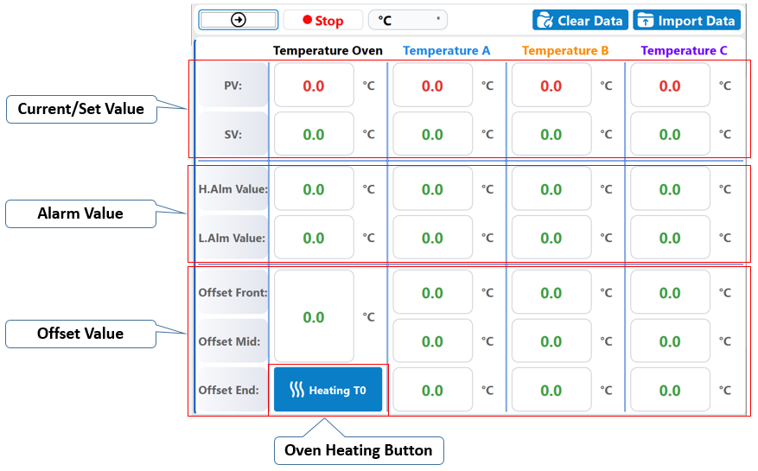
Figure 1.2: Temperature Group Page.
1.2.1. Current/Set Value
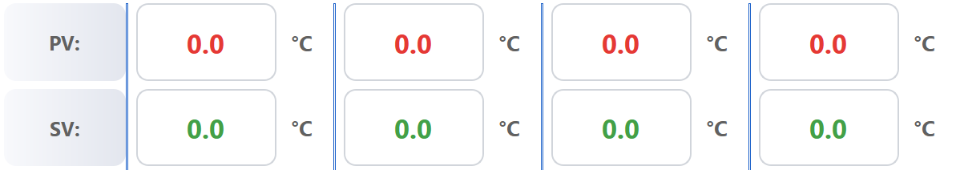
Function: PV value show the overall temperature of the Machine, SV is the set value for the Machine.
*Note: The Temperature SV and Temp Setting are the same value, so if one gets a value, the other will get the same value too.

1.2.2. Alarm Value
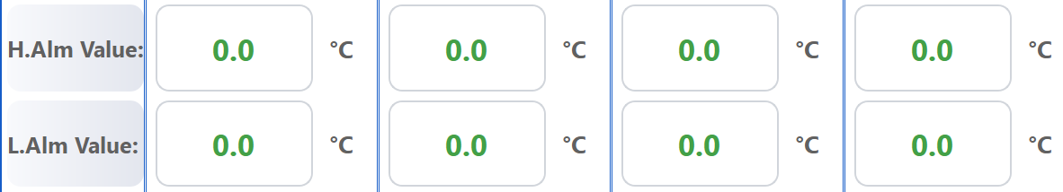
Function: Give an alarm if the Temperature overshoot the H.Alm (High alarm) or drop below L.Alm (Low alarm).
1.2.3. Offset Value
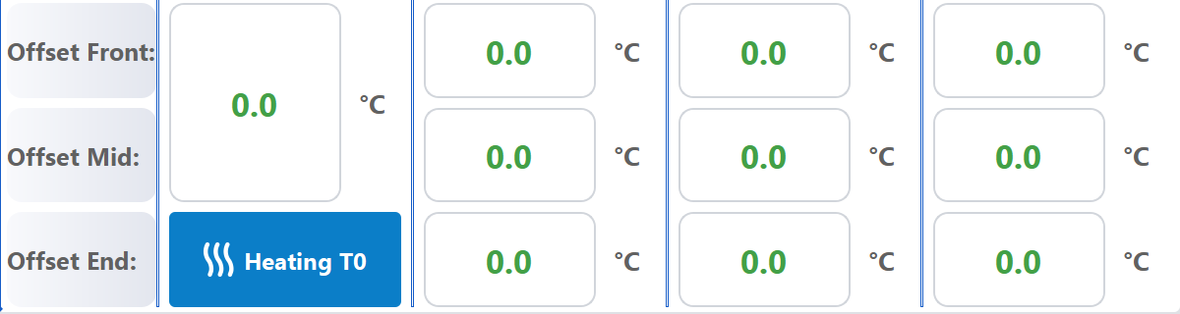
Function: Adjust the actual value by adding or subtracting the Offset Value.
1.2.4. Oven Heating Button

Function: Turn ON/OFF the Oven heater.
*Note: Oven and Group A/B/C are not the same in the Machine.

1.3. Operation Guide

2. Chart Page

2.1. Chart Page
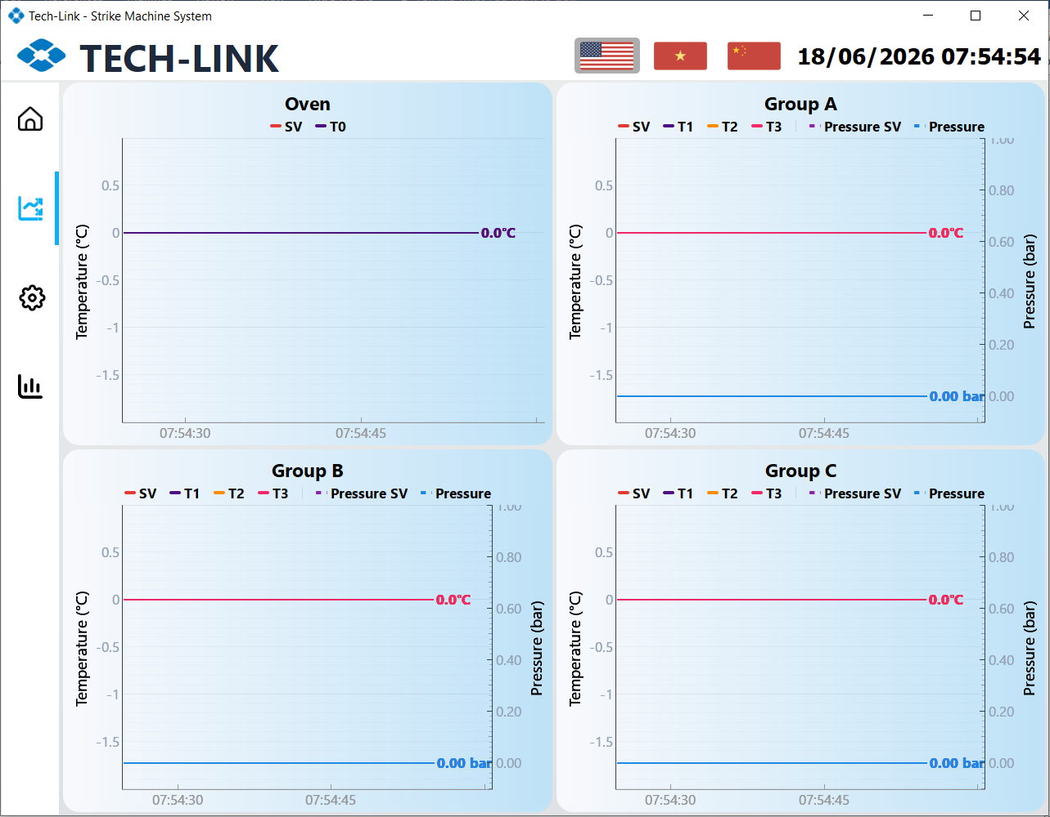
Figure 2: Chart page.
Function: Show the trend of values in real time.

2.2. Operation Guide

3. Setting Page

3.1. Setting Page
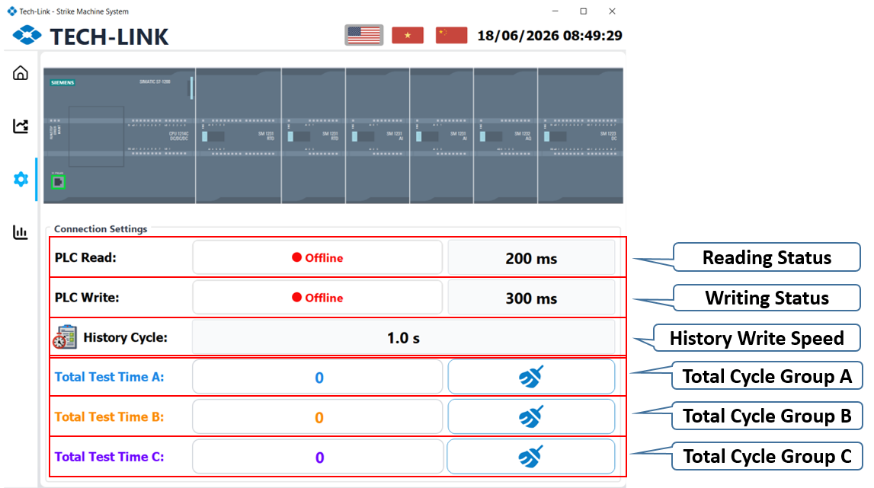
Figure 3: Setting Page.
Function: Displays status and settings of the connection.
*Note: If both Lock button is actived, the system will know it as disable presser in Packing Mode.

3.2. Operation Guide

4. History Page

4.1. History Page

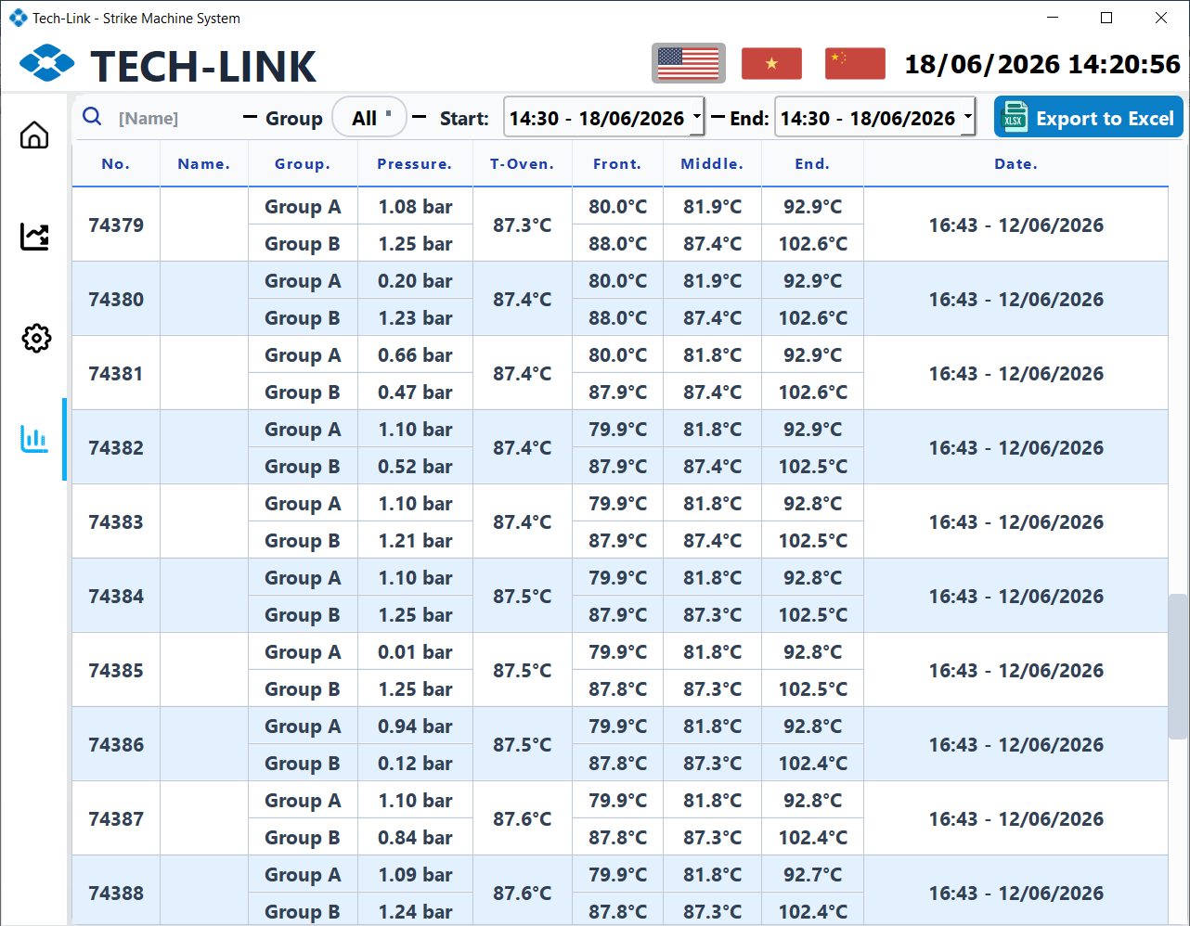
Figure 4: History Page.
- : On/Off Conveyor Sensor.
- 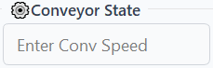: Sets the speed for conveyor (mm/s).
- : Display the state of sensor.
-  : Change the direct of the conveyor.
*Note: When running in Packing mode, the robot arm will move in sync with the conveyor, meaning that this is also the speed in Packing mode.

4.2. Operation Guide
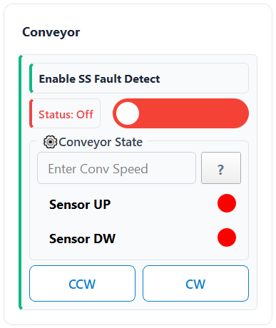
Figure 1.5: Conveyor Tab.
- Displays the current path of the robot arm in real time.
- : Zoom in and out button.
- : Switch to Setting Tab.
- : Reset view.

1.7. Advance Setting
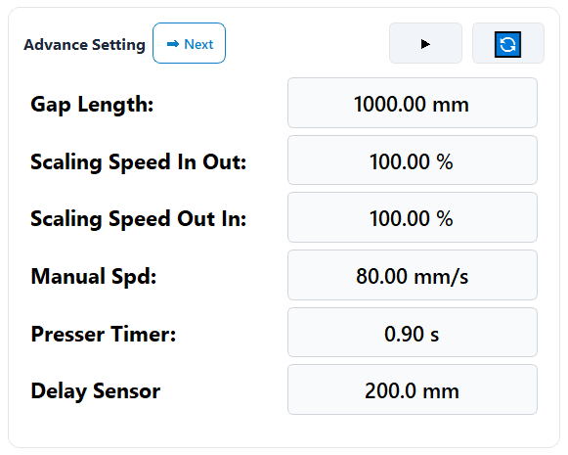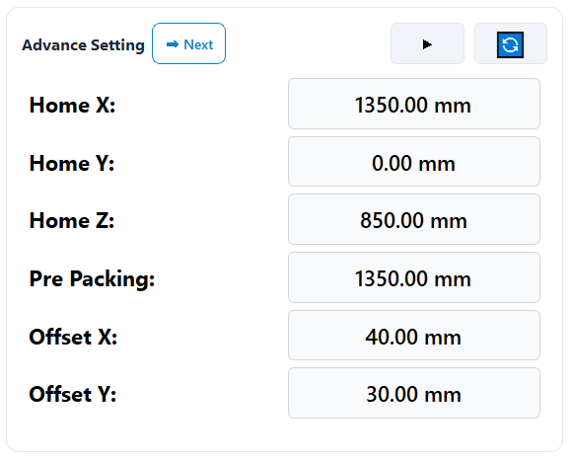
Figure 1.7: Advance Setting Tab.
- Gap Length: Data for calculated.
- Scaling Speed in out: Data for calculated.
- Scaling Speed out in: Data for calculated.
- Manual Speed: Speed of Robot Arm(Only when in Manual Mode).
- Presser Time: Data for calculated .
- Delay Sensor: Data for calculated.
- Home X: Robot Home X.
- Home Y: Robot Home Y.
- Home Z: Robot Home Z.
- Pre Packing: Prepare Position before Packing.
- Offset X: Data for calculated.
- Offset Y: Data for calculated.

II. Product Panels and Function Guide

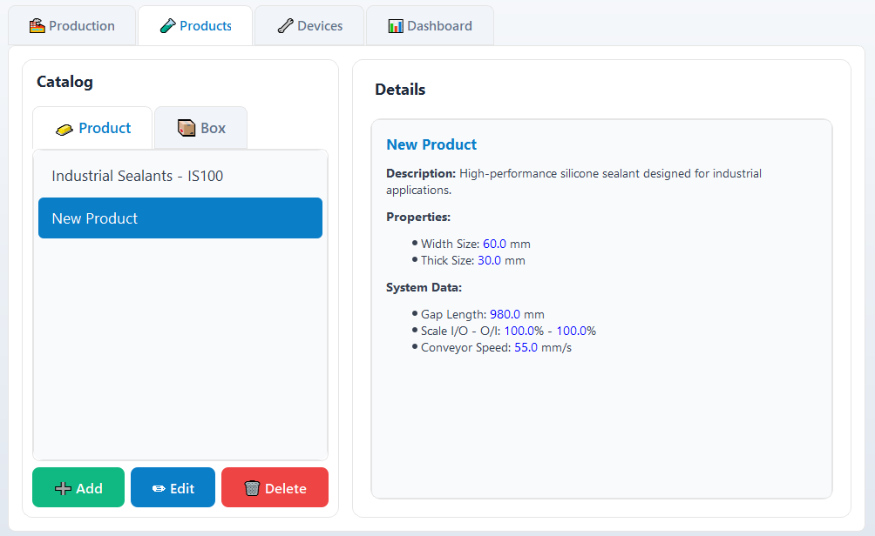
Figure 2: Product Interface Panels.

1. Catalog
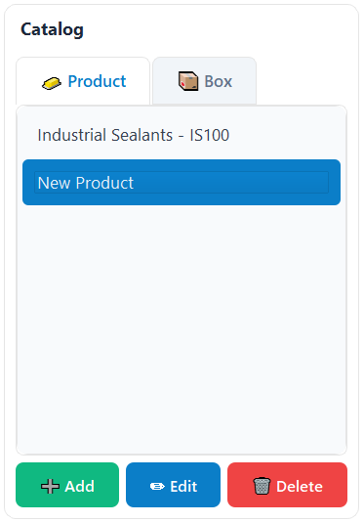
Figure 2.1: Catalog Panel.
- 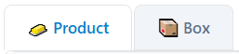: Switch to Box or Product Tab.
- : Add/ Edit/ Delete item in catalog.

2. Details
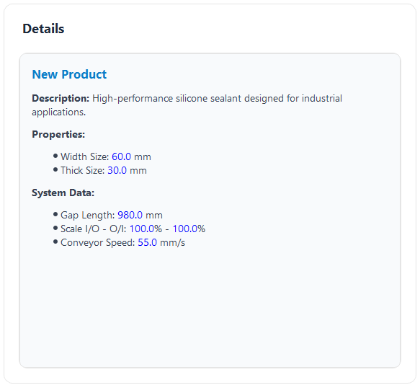
Figure 2.2: Detail Panel.
- Display information of the selected item

III. Devices Panel and Function Guide
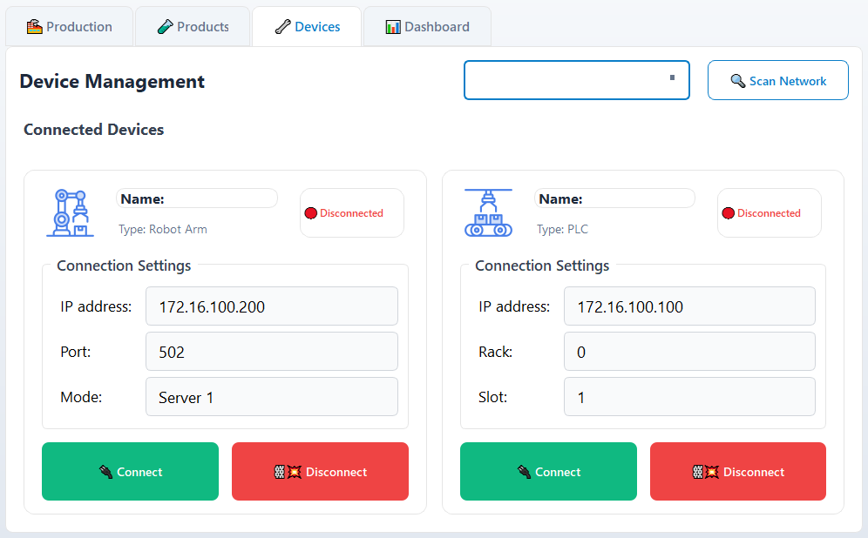
Figure 3: Devices Panel.

1. Robot and PLC Connection Panel
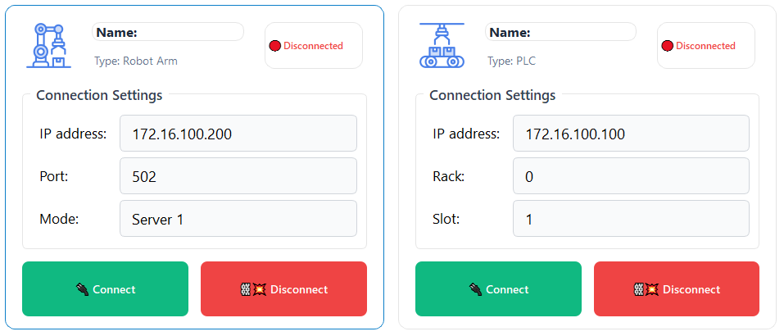
Figure 3.1: Connection Panel
- IP address: Specify the IP address to connect to the device.
- Port: and port
- 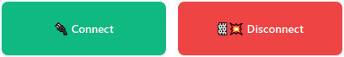: Establish or terminate the connection with the device.

IV. Dashboard Panel and Function Guide
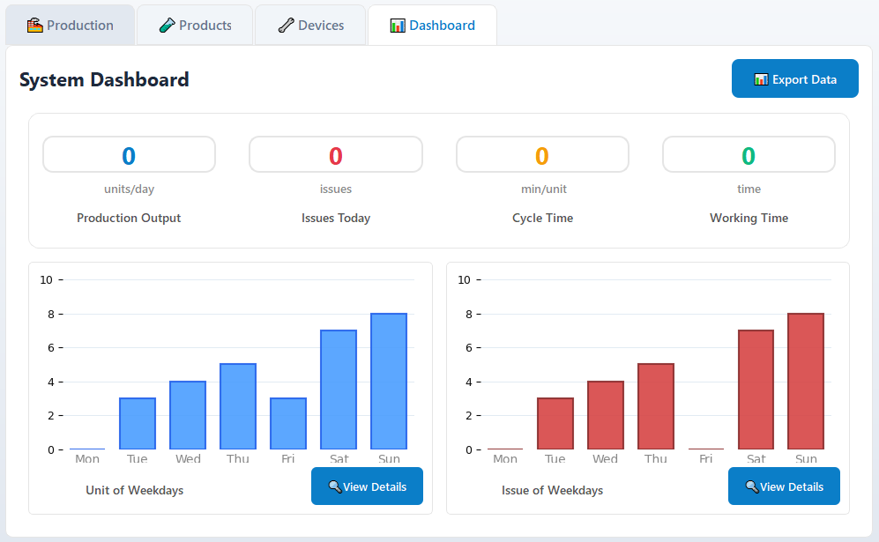
Figure 4: Devices Panel.

1. Dashboard Panel
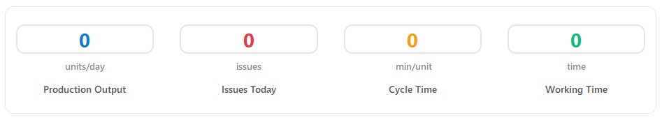
Figure 4.1: Packing Data Panel.
- Production Output: Display total unit today.
- Issue Today: Display total issue today.
- Cycle Time: Display cycle time per unit.
- Working Time: Display total working time.

2. Dashboard Panel
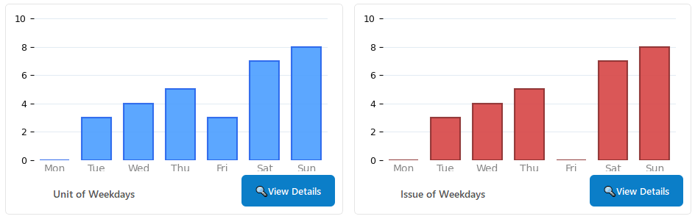
Figure 4.2: Chart Panel.
- Show the total unit or issue in weekdays.
- : Show the Folder contain Excel file.

3. Activity Table Panel
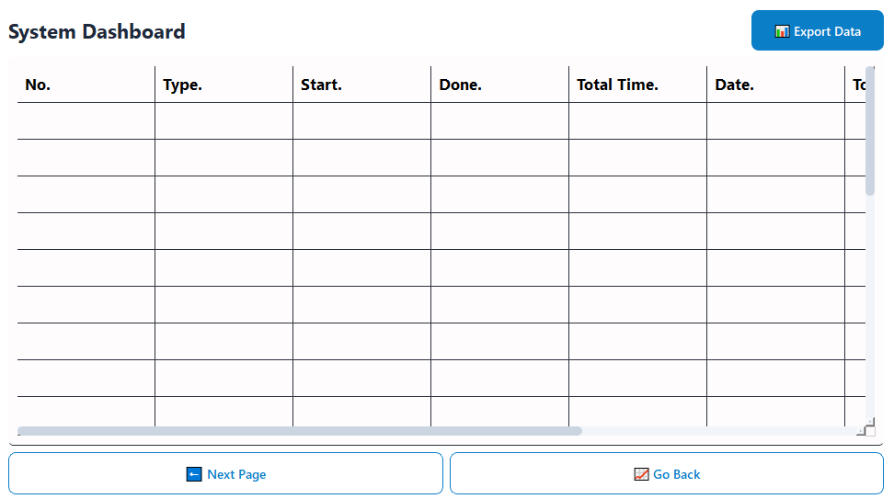
Figure 4.3: Activity Table Panel.
- Columns: No., Type, Start, Done, Total Time, Date, Total Length, Total Weight, Speed.
- Purpose: Log and track the sequence and time duration of packing operations.
- Export File: Export log data to an external file for reports or analysis.

4. Error Log Table
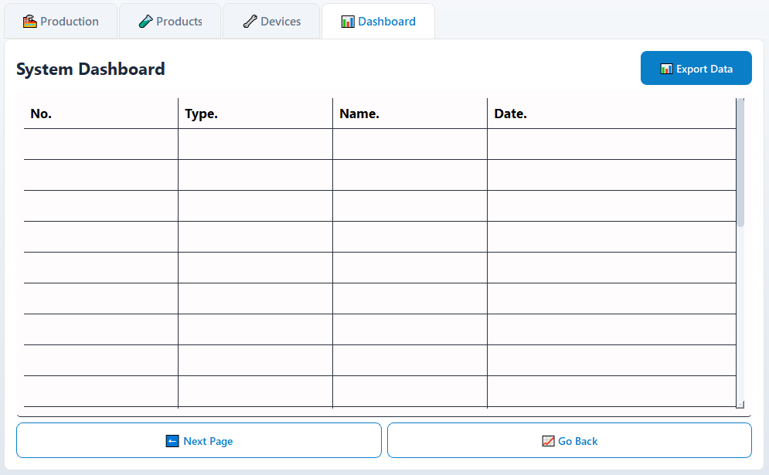
Figure 4.3: Issue Table Panel.
- Columns: No, Type, Name, Date.
- Purpose: Maintain a registry of components used or configured in the packing system.
- Export File: Export log data to an external file for reports or analysis.

V. Operation Instructions

STEP 1: Open the app and initialize connections.
+ Click on the application.
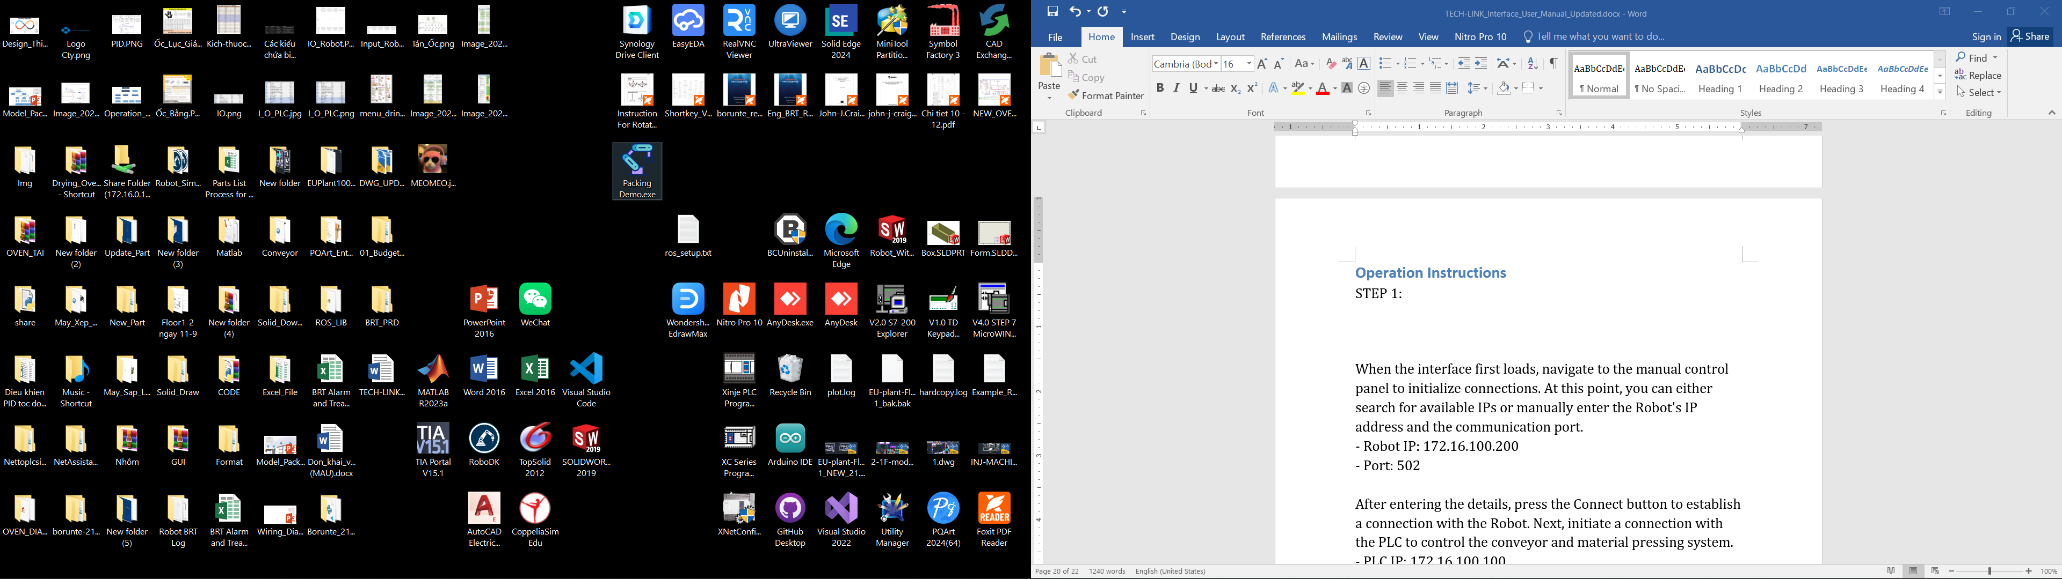
+ When the interface first loads, switch to Devices Tab to initialize connections.
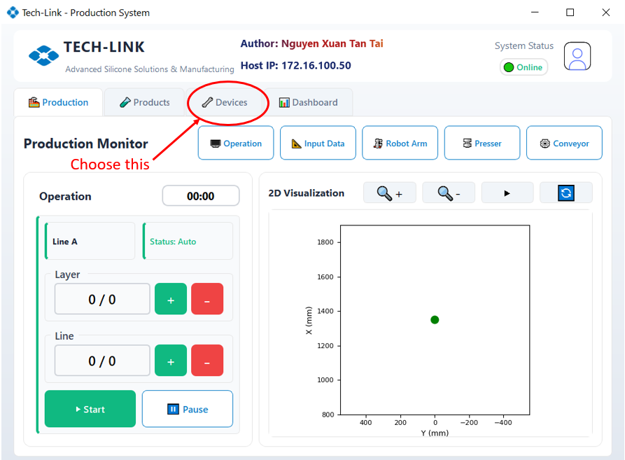
Figure 5.1: Interface first loads.
+ At this point, you can either search for available IPs or manually enter the Robot's IP address and the communication port.
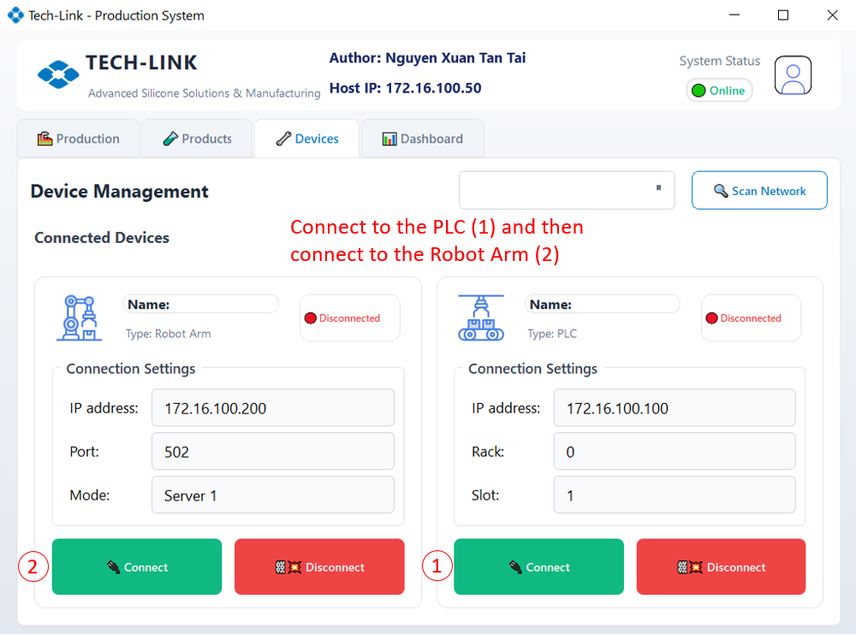
Figure 5.2: Assign IP Address.
- Robot IP: 172.16.100.200 (Can be found in Robot Control Panel).
- Port: 502 (Can be found in Robot Control Panel).
- PLC IP: 172.16.100.100(Base on PLC config).
+ Once all connections are successful, return to the Production Tab.

STEP 2: Setup Material and Box data.
+ At the Production Tab, click on the Input Data button to open Input Data Tab.
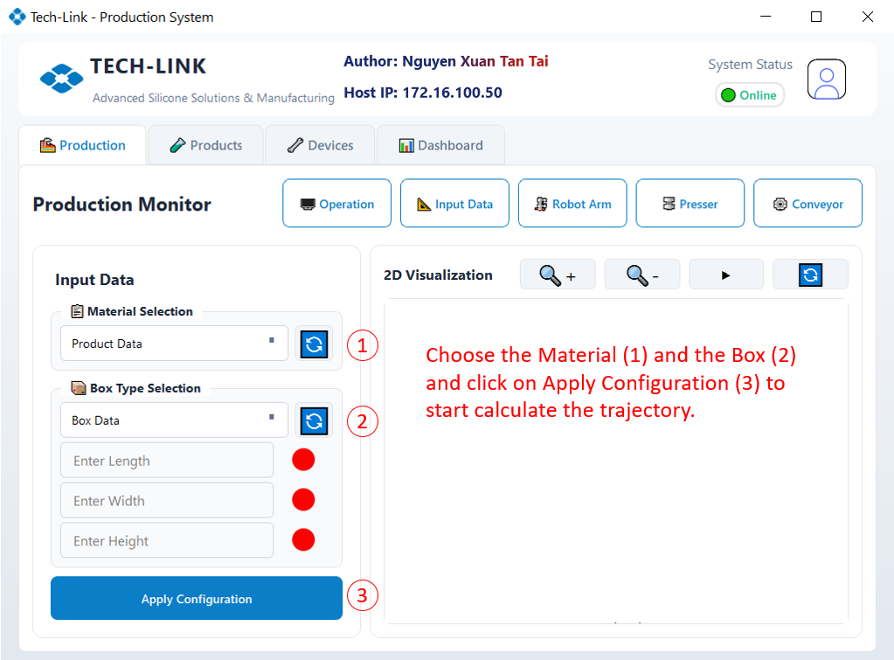
Figure 5.3: Select Item for Packing Mode.
+ After select item, the default values will populate the fields for box shape dimensions. Then, press the Apply Configuration button and the system will start calculate and display the Robot's movement trajectory.
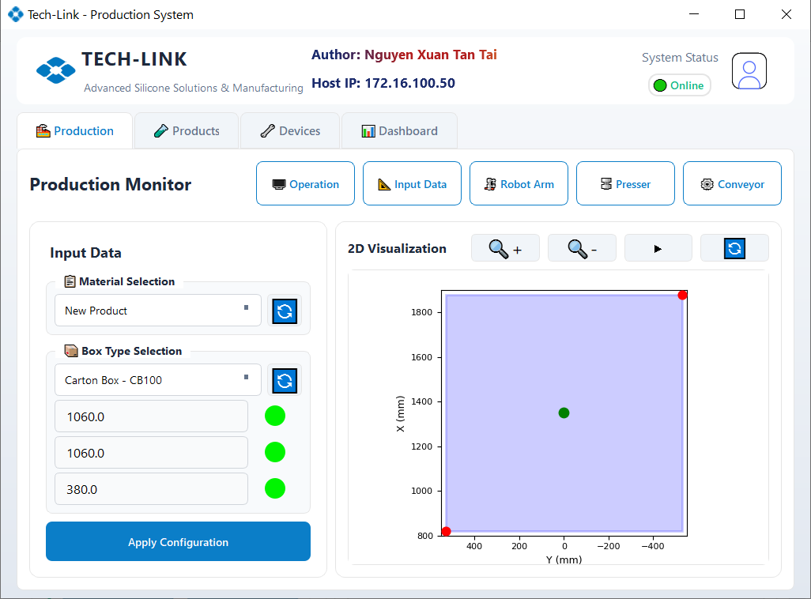
Figure 5.4: After apply data.
+ (If Presser is Active) Ensure the box is placed correctly. Misalignment may cause the pressing unit to damage the box. To adjust, go to the Presser Panel and press R.Presser F.B or L.Presser F.B to extend the press. Then, press either L.Presser U.D or R.Presser U.D (*Only press one if the box needs adjustment) to lower the press.

STEP 3: Prepare the Conveyor.
+ Afterward, test if the conveyor is operational by going back to the Production Tab. In the Option section, choose "Conveyor" to configure conveyor settings.
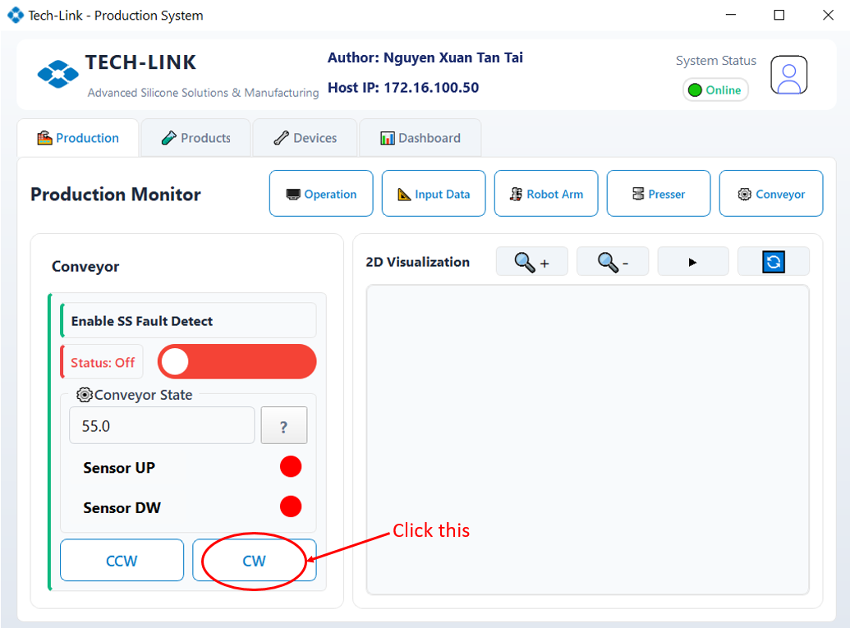
Figure 5.5: Start Conveyor.
+ Adjust the conveyor speed according to Extruder Speed (recommended range: 55 - 150 mm/s for best synchronization). Press CW to pull materials onto the conveyor or CCW to push them backward. Load materials onto the conveyor. Manually toggle the conveyor to avoid material breakage.

STEP 4: Start Packing.
+ Once all preparations are complete, switch to the Operation Tab to begin the operation. Press Start. The Robot will return to its Home position, then move to P1 (starting point). After about 1 seconds, the Packing operation will start.
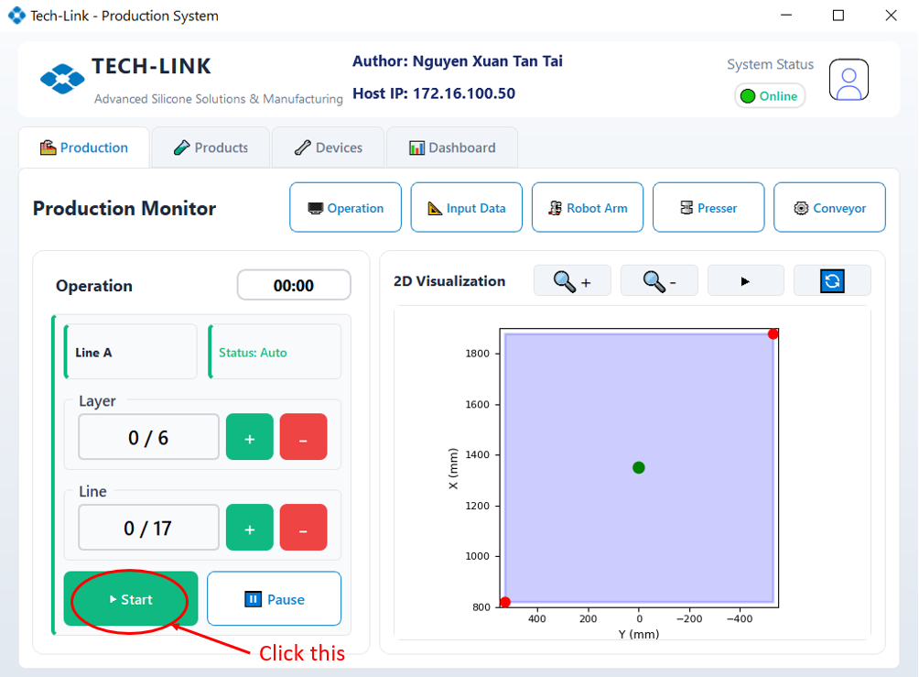
Figure 5.6: Start Packing Mode.
*Warning: Stay at least 1 meters away from the Robot during material stacking operation.
* Optionally: Press the Home button to command the Robot to return to its origin before Packing.
+ Closely observe material extrusion at the Extruder to avoid jamming. If issues rise, press PAUSE to temporarily stop the operation. If necessary, press STOP to cancel the Packing process entirely.

