INTERNSHIP PROJECT REPORT
ON
MODULAR BMS

PROJECT OVERVIEW
The Modular Battery Management System (BMS) is an embedded-system project developed to monitor battery-cell voltages, evaluate battery conditions, detect abnormal operating states, and provide real-time status updates through IoT connectivity. The project aims to demonstrate a scalable battery-monitoring approach in which the number of monitored cells can be configured from 4 to 16, using an ESP32 microcontroller and a CD74HC4067 analog multiplexer.
The system acquires simulated cell-voltage measurements and identifies the cells with the highest and lowest voltages to calculate the overall voltage imbalance. It also estimates the State of Charge (SoC) based on cell-voltage measurements and monitors current-related parameters. An adaptive threshold mechanism uses SoC and current measurements to support decision-making for battery-condition assessment and relay control. In addition, the system incorporates fault monitoring, system-state management, and visual and audible alert mechanisms to indicate abnormal operating conditions.
For local monitoring, an LCD displays important system information, while LEDs and a buzzer provide status indications and alerts. The integration of the Blynk IoT platform enables remote visualization of selected parameters, including voltage imbalance, strongest and weakest cell voltages, relay status, fault status, SoC, risk score, and Wi-Fi signal strength.
The prototype is developed and tested using the Wokwi simulation environment, which enables the system’s functionality and component interactions to be evaluated without requiring a complete physical battery pack. Successful Wi-Fi and Blynk connectivity, together with cell-monitoring and telemetry functions, demonstrates the integration of embedded control and IoT-based monitoring.

Architecture
Simulated Battery Cells (4-16)
Potentiometers representing individual cell voltages

CD74HC4067 Analog Multiplexer
Selects individual cell-voltages inputs

ESP32 Microcontroller
Data acquisition | Voltage calculations | SoC estimation | Imbalance analysis

Adaptive threshold logic | Fault monitoring | System-state management

Local Display
LCD and serial monitor
OUTPUT Control
Relay, LEDs & Buzzer

Wi-Fi Communication
ESP32 connects to network and sends selected telemetry

Blynk IoT Dashboard
Remote visualization of voltage imbalance, cell voltages, Soc, relay status, fault status, system state, WiFi RSSI & risk score

Design of the Complete BMS Code
The software design of the Modular Battery Management System (BMS) is based on embedded programming using Arduino C/C++ and the ESP32 microcontroller. The program integrates battery-cell voltage monitoring, current measurement, voltage-imbalance calculation, State of Charge (SoC) estimation, adaptive threshold calculation, fault detection, finite state machine (FSM) control, relay operation, local alerts, LCD display, and IoT-based monitoring through the Blynk platform. The software is organized into functional modules to improve readability, simplify debugging, and support future modifications. Each module performs a specific task, while the main program coordinates their execution to provide continuous battery-condition monitoring.

Hardware Initialization and Configuration
The program begins by including the required libraries for Wi-Fi communication, Blynk connectivity, I2C communication, and LCD operation. The GPIO pins, multiplexer selection lines, sensor inputs, relay output, LEDs, and buzzer are defined using constants. The ESP32 communicates with the CD74HC4067 analog multiplexer to select and read individual cell-voltage inputs. The current sensor is connected to a separate analog input, while the relay, LEDs, and buzzer provide control and alert functions. The LCD displays important system information locally. During initialization, the setup() function configures the pins, initializes serial communication and the LCD, establishes the initial output states, and attempts to connect to the Wi-Fi network and Blynk server.

Battery-Cell Voltage Acquisition
The voltage acquisition module reads the individual battery-cell voltages through the CD74HC4067 multiplexer. The ESP32 controls the multiplexer selection pins to choose a particular input channel. After selecting the channel, the program reads the analog signal through the multiplexer output pin and converts the ADC reading into an estimated voltage. For a 12-bit ADC, the conversion used in the program is expressed as:
V_{cell}=(ADCreading/4095)x4.2
The calculated voltage is stored for further processing. The same procedure is repeated for each configured cell channel. This approach allows the system to monitor multiple cell inputs using a single analog input on the microcontroller. The number of active cells depends on the cell-count configuration and the available simulated inputs.

Current Measurement and Battery Parameter Calculation
The current-measurement module reads the analog output of the current sensor and converts it into an estimated current value according to the programmed ADC scaling. The current value is used by the adaptive threshold algorithm to modify the system's response under different operating conditions. After acquiring the cell voltages, the program identifies the strongest cell, which has the highest voltage, and the weakest cell, which has the lowest voltage. The voltage imbalance is calculated as the difference between these two values and expressed in millivolts.
Imbalance{mV}=(Vmax-Vmin)x1000
The program also tracks changes in the calculated imbalance to determine whether the difference between the strongest and weakest cells is increasing, decreasing, or remaining stable. These calculations provide the basic information required for battery-condition assessment and subsequent control decisions.

State of Charge Estimation
The SoC estimation module calculates an approximate battery charge percentage using the average voltage of the monitored cells. The program first determines the average cell voltage and then maps it linearly to a percentage between the configured minimum voltage of 3.0 V and maximum voltage of 4.2 V. The calculated value is limited to the range of 0% to 100%.
SoC=(Vavg-3.0)/(4.2-3.0)x100
This method provides a simple voltage-based estimate for demonstration and monitoring purposes. However, it does not represent a fully calibrated battery SoC measurement because actual battery charge estimation depends on battery chemistry, load conditions, temperature, voltage characteristics, and other factors.

Adaptive Threshold Calculation
The adaptive threshold module adjusts the permitted voltage-imbalance threshold according to the estimated SoC and measured current. In the implemented logic, the base threshold is set to 30 mV when SoC is above 80%, 20 mV when SoC is below 20%, and 50 mV for intermediate SoC values. An additional 15 mV is added when the measured current exceeds 1 A. The resulting threshold is used by the relay-control logic to determine whether the observed cell imbalance requires a response.
For example, if the estimated SoC is 52.9% and the measured current is 2.16 A, the base threshold is 50 mV because the SoC is between 20% and 80%. Since the current exceeds 1 A, an additional 15 mV is added, resulting in an adaptive threshold of 65 mV. This mechanism demonstrates how the firmware modifies its decision threshold according to operating conditions.

Fault Detection and Anomaly Monitoring
The fault-detection module continuously evaluates the acquired voltage readings and system operating conditions to identify abnormal behavior. The implemented checks include voltage readings outside the configured operating range, sudden voltage changes between consecutive samples, and frozen readings that remain unchanged for a specified number of samples while other cell readings change significantly. These checks are used to identify possible sensor anomalies or abnormal simulated cell conditions.
When an abnormal condition is detected, the firmware updates the appropriate fault indicators and system-state variables. The fault-handling logic determines the corresponding response based on the detected condition and its severity. The design includes NORMAL, DEGRADED, FAILSAFE, and SHUTDOWN fault-severity states. The exact transition into each state depends on the conditions implemented in the source code; defining a state does not necessarily mean that every possible transition into that state is implemented.

Finite State Machine Design
The software uses finite state machine logic to manage system operation and recovery. The system-level states are NORMAL, FAULT, and RECOVERY. In the NORMAL state, the program performs routine monitoring and updates the battery parameters. When a fault is detected, the system enters the fault-handling state. After the fault condition clears, the system enters RECOVERY and checks whether the system remains free of faults for the configured recovery period of five seconds. If the fault-free condition persists, the system returns to NORMAL. If a fault reappears during recovery, the system returns to fault handling.
The fault-severity logic provides an additional level of protection by distinguishing normal operation from degraded and more severe conditions. In the FAILSAFE and SHUTDOWN states, the relay output is intended to be forced OFF. This design separates routine monitoring from fault-response behavior and provides a structured method for handling abnormal conditions. The actual transitions and output actions must follow the implemented source code.

Relay Control and Hysteresis
The relay-control module uses the calculated voltage imbalance and adaptive threshold to determine the relay output. The activation condition compares the imbalance against the greater of the adaptive threshold and the configured 60 mV limit. The relay is switched ON when the imbalance exceeds this activation threshold, provided no protective state forces it OFF. The relay is switched OFF when the imbalance falls below the configured lower threshold of 40 mV.
The difference between the activation and deactivation thresholds provides hysteresis. Hysteresis helps prevent frequent relay switching when the measured imbalance fluctuates around a single threshold. A debounce interval of approximately 300 milliseconds is also used to reduce unnecessary switching caused by rapid changes in the decision condition. The relay behavior is evaluated in simulation to verify the programmed control logic. It should not be considered a validated physical battery-disconnection or balancing mechanism without suitable hardware and safety testing.

LED, Buzzer, and LCD Interface
The local indication module communicates the operating condition of the BMS through LEDs, a buzzer, and an LCD. The green LED indicates normal operation, while the yellow LED indicates a degraded condition. The red LED and buzzer provide alerts for more severe fault conditions. The buzzer activation pattern varies according to the programmed fault state, allowing different conditions to be distinguished through audible indications.
The LCD displays relevant battery and system information, including cell measurements, imbalance, system state, or telemetry information, depending on the active display page. The program updates the display periodically and can rotate between multiple pages to present different groups of information. These local outputs allow users to observe the system condition without depending entirely on the Blynk dashboard or an active internet connection.

Wi-Fi and Blynk IoT Communication
The IoT communication module connects the ESP32 to a Wi-Fi network and uses the Blynk platform to transmit battery and system information to a remote dashboard. The firmware configures the Blynk authentication settings and attempts to establish a connection with the server. While connected, the program processes Blynk communication and updates the configured virtual datastreams with the latest monitoring values.
The dashboard variables include voltage imbalance, strongest cell voltage, weakest cell voltage, relay status, fault state, Wi-Fi signal strength, telemetry queue depth, system state, estimated SoC, and risk score. These values enable remote observation of the simulated BMS. The firmware also includes communication-retry and offline-handling behavior so that temporary connectivity problems can be managed without treating dashboard communication as the only means of monitoring the system. The actual behavior during disconnection depends on the implemented connection-management logic.

Telemetry Queue and System Analytics
The telemetry module organizes selected system events for reporting and monitoring. The program maintains a queue with a configured capacity of 50 events and records relevant information such as the timestamp, voltage imbalance, SoC, current, relay status, fault state, and event type. Events can be generated when specified monitoring conditions change, including significant changes in voltage imbalance. The firmware periodically processes queued information for transmission when connectivity is available.
The analytics module maintains selected system measurements and calculates a risk score and a corresponding health-status label based on the programmed rules. The displayed risk score summarizes the conditions represented by the implemented algorithm; it is not a validated prediction of battery failure. The queue and analytics functions provide a structured method of collecting monitoring information and presenting it through the serial monitor and Blynk dashboard.

VERIFICATION METHODOLOGY
We test and verify the ESP32 firmware for our modular BMS inside the Wokwi simulation environment using Arduino C/C++. The main goal is to make sure the code behaves exactly as expected—both in normal situations and under fault conditions—covering everything from sensor readings and math calculations to the state machine, relays, and Blynk IoT updates.

Step-by-Step Testing Process
- System Initialization: The test starts by booting up the ESP32, setting up all input/output pins, configuring the LCD and CD74HC4067 analog multiplexer, and connecting to Wi-Fi and the Blynk platform.
- Sensor Input & Math Logic: We feed different cell voltages and current values into the simulator. The ESP32 reads cell voltages via the multiplexer and currents through its ADC. It then crunches the numbers to find the strongest and weakest cells, calculate voltage imbalance, and estimate the State of Charge (SoC).
- Imbalance & Adaptive Thresholds: We double-check the math by comparing results against expected values. For example, if the top cell is 3.67 V and the lowest is 3.61 V, the expected imbalance is 60 mV. We also test adaptive thresholds—like checking that an SoC of 52.9% and a current of 2.16 A correctly triggers a 65 mV threshold.
- Finite State Machine (FSM): We push the system through different states (NORMAL, FAULT, and RECOVERY). When a fault clears, the system must hold steady in RECOVERY for five solid seconds before dropping back to normal. We also check the severity levels (NORMAL, DEGRADED, FAILSAFE, SHUTDOWN) to ensure the protective outputs behave properly.
- Fault Detection & Safety Triggers: We simulate abnormal conditions like out-of-range voltages, sudden spikes, and frozen readings. We verify that warnings show up on the serial monitor, LCD, LEDs, and buzzer, and that relays are forced OFF during FAILSAFE and SHUTDOWN states. (Note: These tests validate the firmware logic in simulation, not the physical safety of real hardware.)
- IoT & Blynk Dashboard: We check that variables like cell imbalances, SoC, risk scores, and system states sync up correctly with Blynk. We also test how the system handles Wi-Fi dropouts—ensuring local monitoring keeps running smoothly in the background while the firmware tries to reconnect.

Documentation & Limitations
- Tracking Results: Every test case is logged with its applied inputs, expected outputs, observed behavior, and a clear pass/fail status. If anything goes off, we fix the code, rerun the tests, and only log a success once it's verified with recorded observations.
- Simulation vs. Reality: Because everything runs in Wokwi, these results only prove the firmware works in a virtual environment. True hardware factors like actual sensor calibration, measurement accuracy, and physical electrical safety would still need bench testing with real components.
- Firmware vs. RTL: This is implemented as embedded C/C++ for an ESP32, rather than synthesizable RTL. If the internship requires RTL verification, a separate Verilog or SystemVerilog design with its own testbench would be needed.
- With cell voltages=0.00
SIMULATION RESULTS
  - With cell voltages=0.00
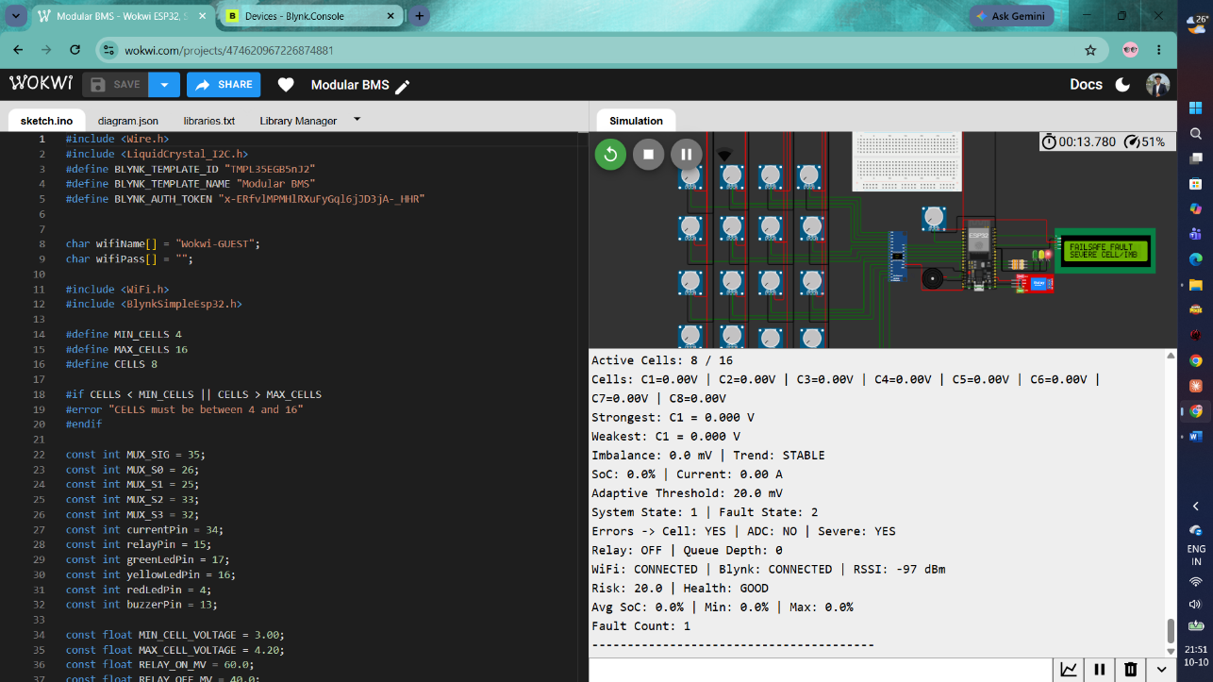

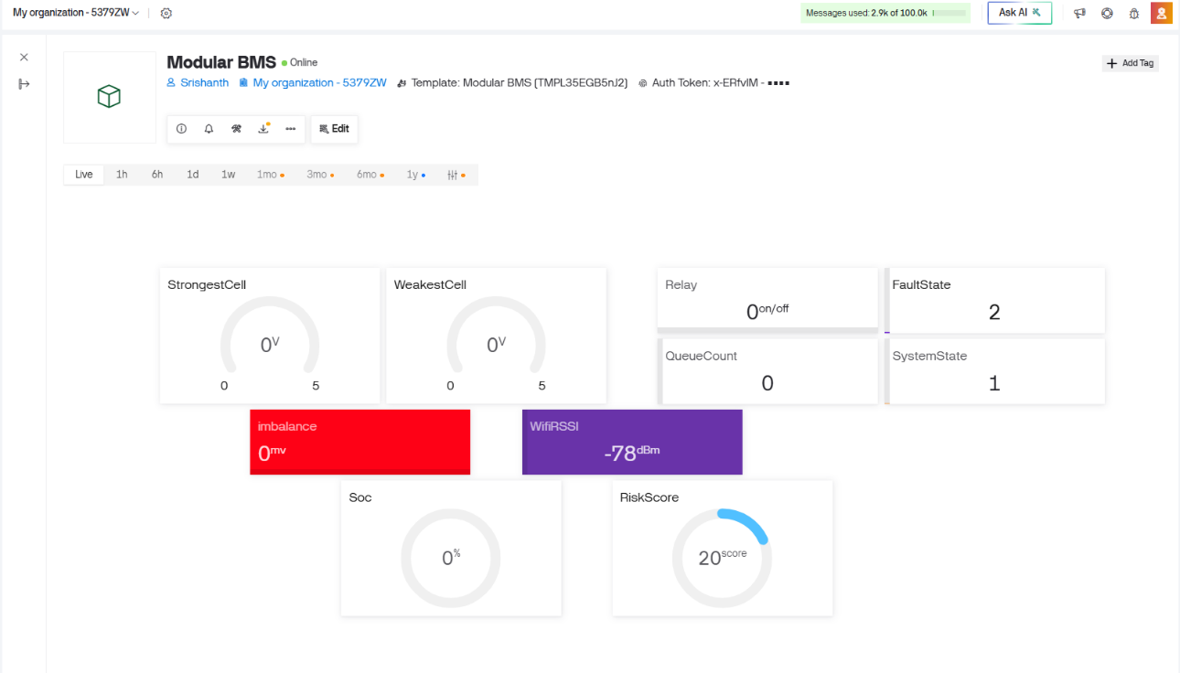

  - Stable state
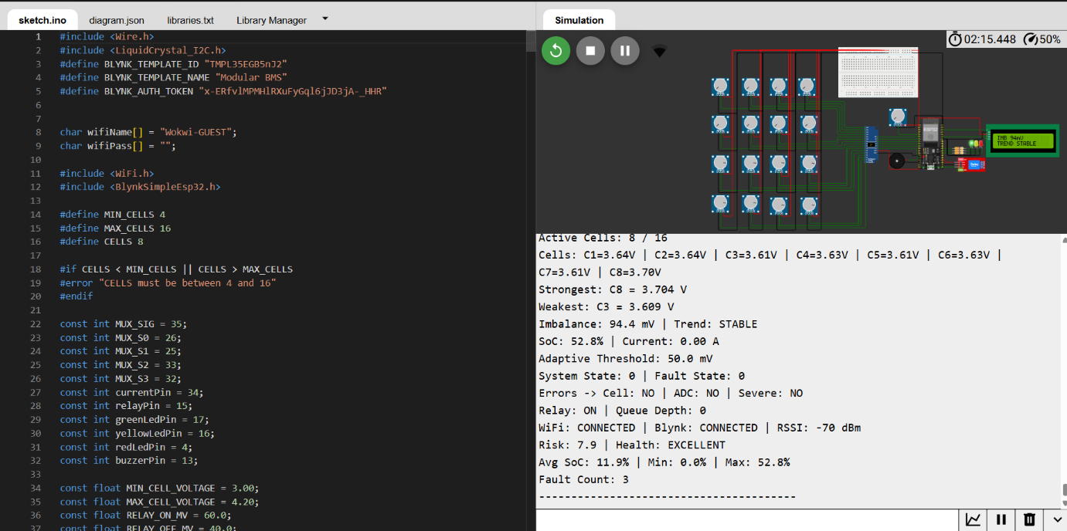

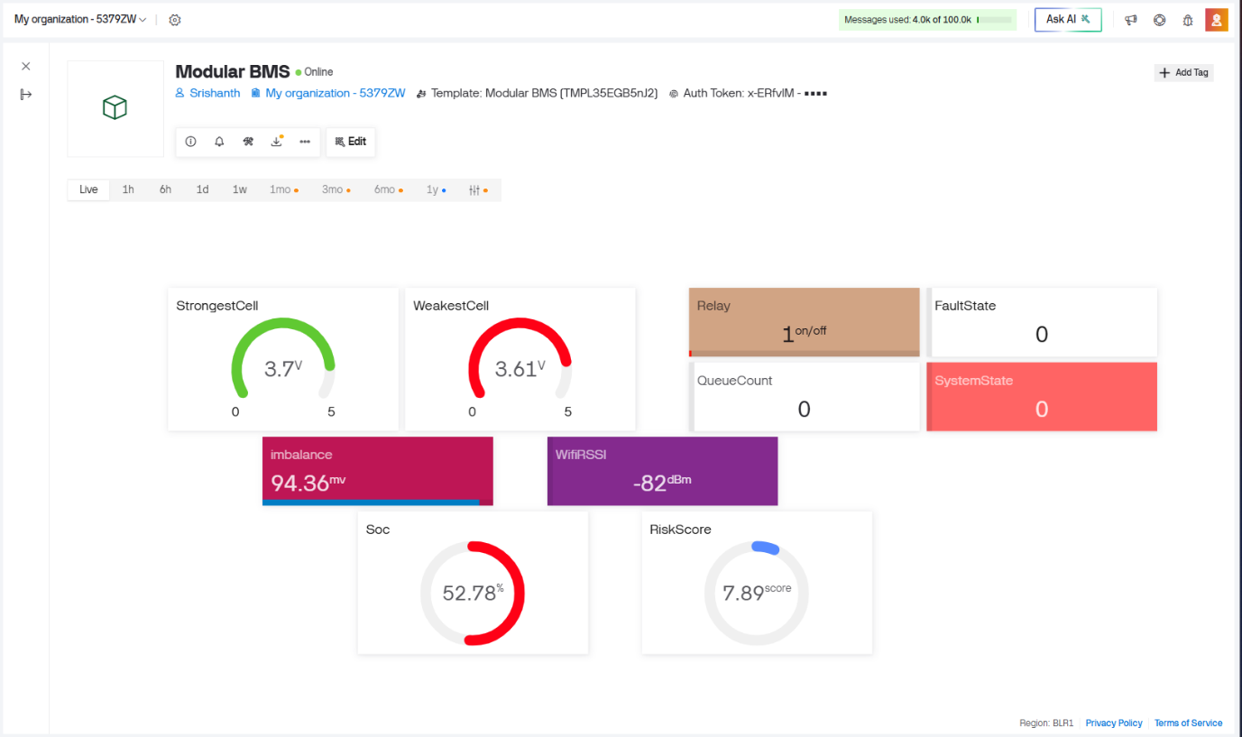

  - System recovery state
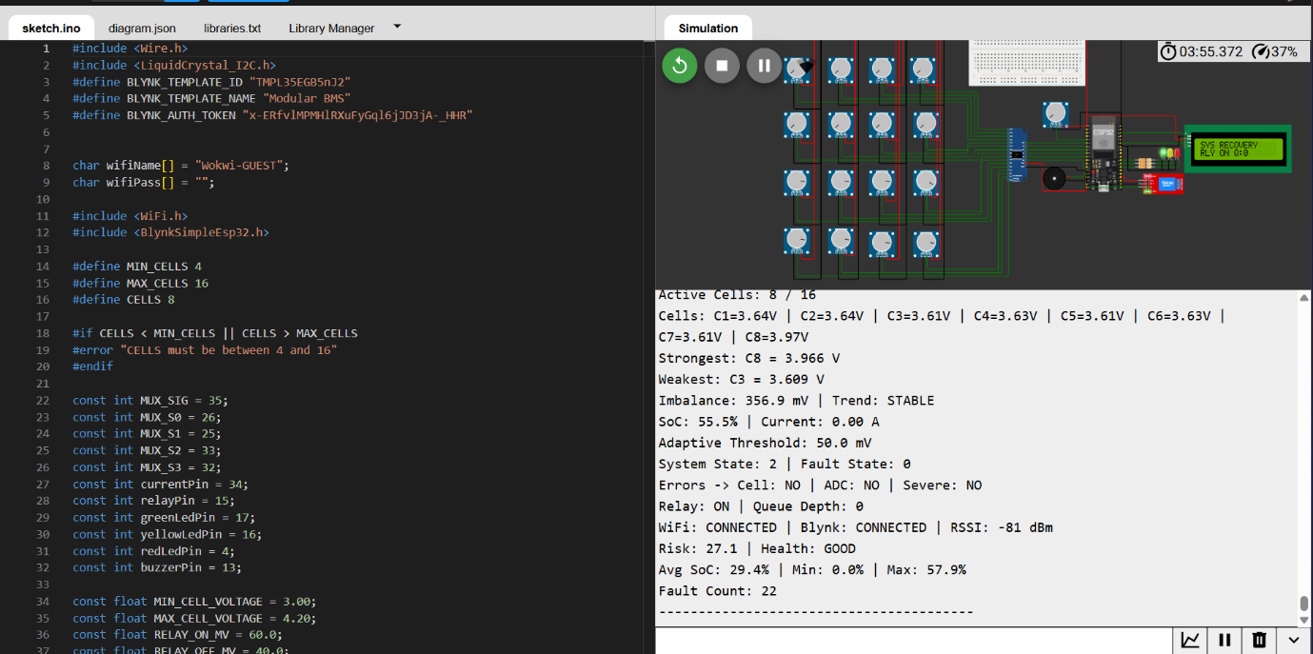

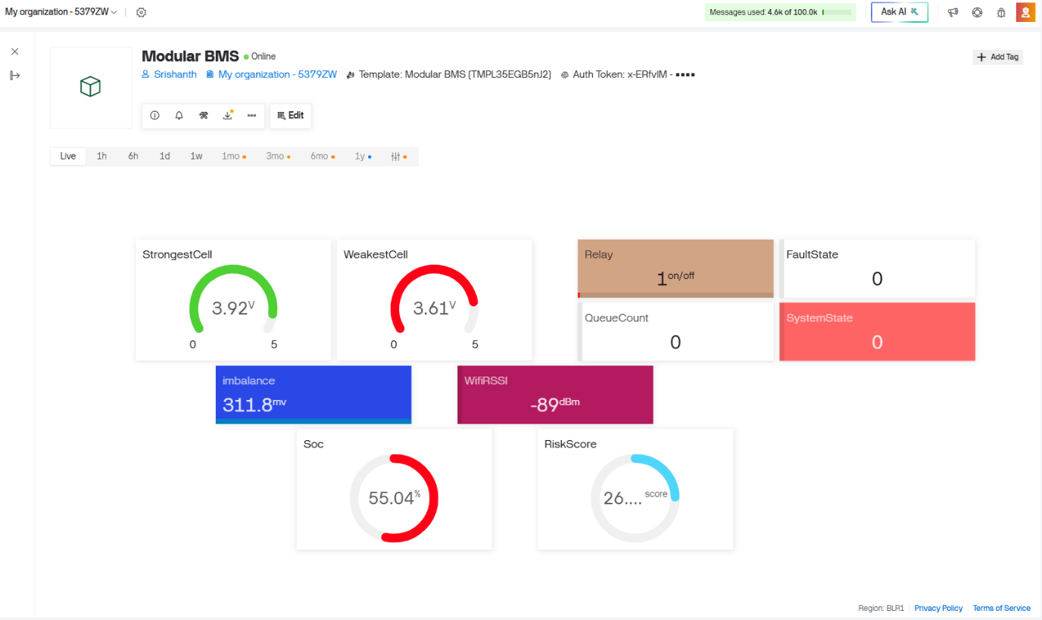

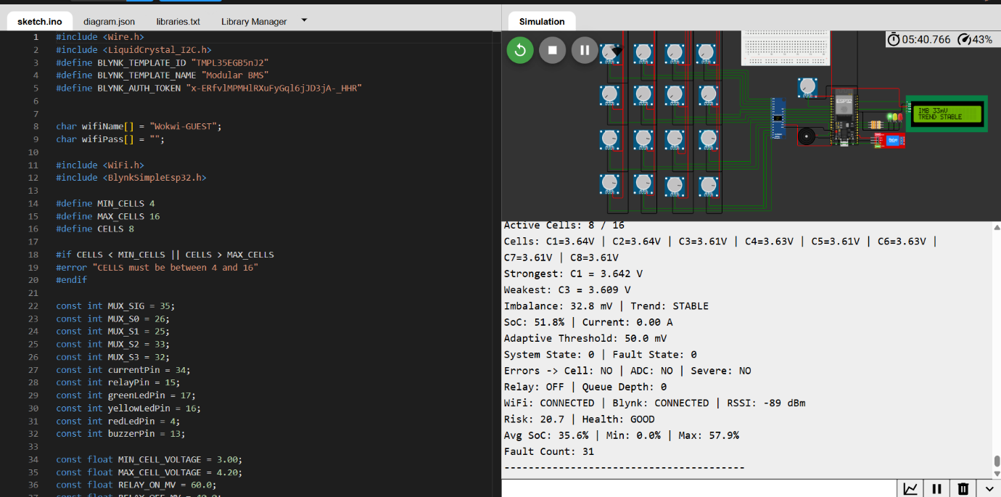
  - Relay off state

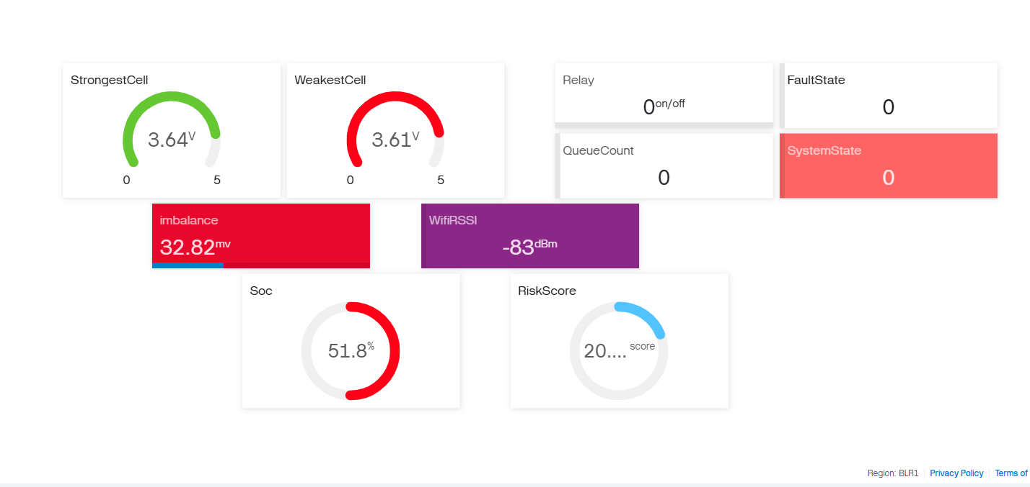

Challenges faced
- Configuring the CD74HC4067 multiplexer to read individual cell voltages.
- Converting ADC readings into voltage values and ensuring correct cell selection.
- Implementing adaptive thresholds and relay hysteresis to prevent frequent switching.
- Estimating battery SoC from average cell voltage.
- Displaying system status and monitoring battery parameters in real time.
- Managing fault severity and system-state transitions with recovery logic.
- Establishing reliable Wi-Fi and Blynk connectivity.
- Sending battery parameters through the correct virtual pins and handling communication interruptions.
- Testing the complete design in Wokwi and recognizing the limitations of simulation compared with physical hardware.

Wokwi link of project

https://wokwi.com/projects/474620967226874881

Blynk dashboard
https://blynk.cloud/dashboard/746747/global/devices/270883/organization/746747/devices/2315589/dashboard
USERNAME:srishanthofficial12@gmail.com
Password:Srishanth@123

Github repository
https://github.com/NYALAKANTISRISHANTH/BMS-Project.git

CONCLUSION
The Modular Battery Management System (BMS) project successfully demonstrates the design and simulation of an intelligent battery monitoring system using the ESP32 microcontroller, CD74HC4067 analog multiplexer, and Blynk IoT platform. The system integrates individual cell-voltage monitoring, voltage imbalance calculation, State of Charge (SoC) estimation, adaptive threshold-based decision-making, relay control, fault detection, and real-time telemetry. The integration of an LCD, LEDs, and a buzzer further enhances local monitoring and fault indication.
The project was developed and evaluated in the Wokwi simulation environment, providing a practical understanding of embedded-system programming, sensor interfacing, control logic, state management, and IoT communication. The implementation also highlighted the importance of reliable measurement, appropriate threshold selection, fault-handling mechanisms, and consistent communication between system components.
Overall, this project strengthened practical knowledge of battery monitoring and embedded-system integration while establishing a foundation for future improvements. Further work can include physical hardware implementation, sensor calibration, validation under real battery operating conditions, and enhancement of safety and protection mechanisms. The project provides a useful foundation for developing a more reliable, scalable, and intelligent Battery Management System for practical applications.

