**Creating Interactive Presentation**

**Steps:**

1. Go to <https://slides.com/> and sign up an account
2. Find this template deck: in progress
3. Make a copy to your own account

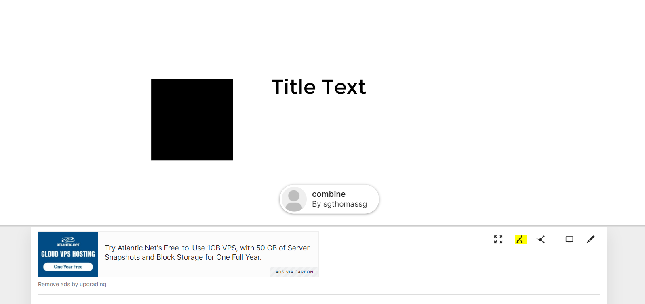

1. Change the deck title to your name and start editing the slides

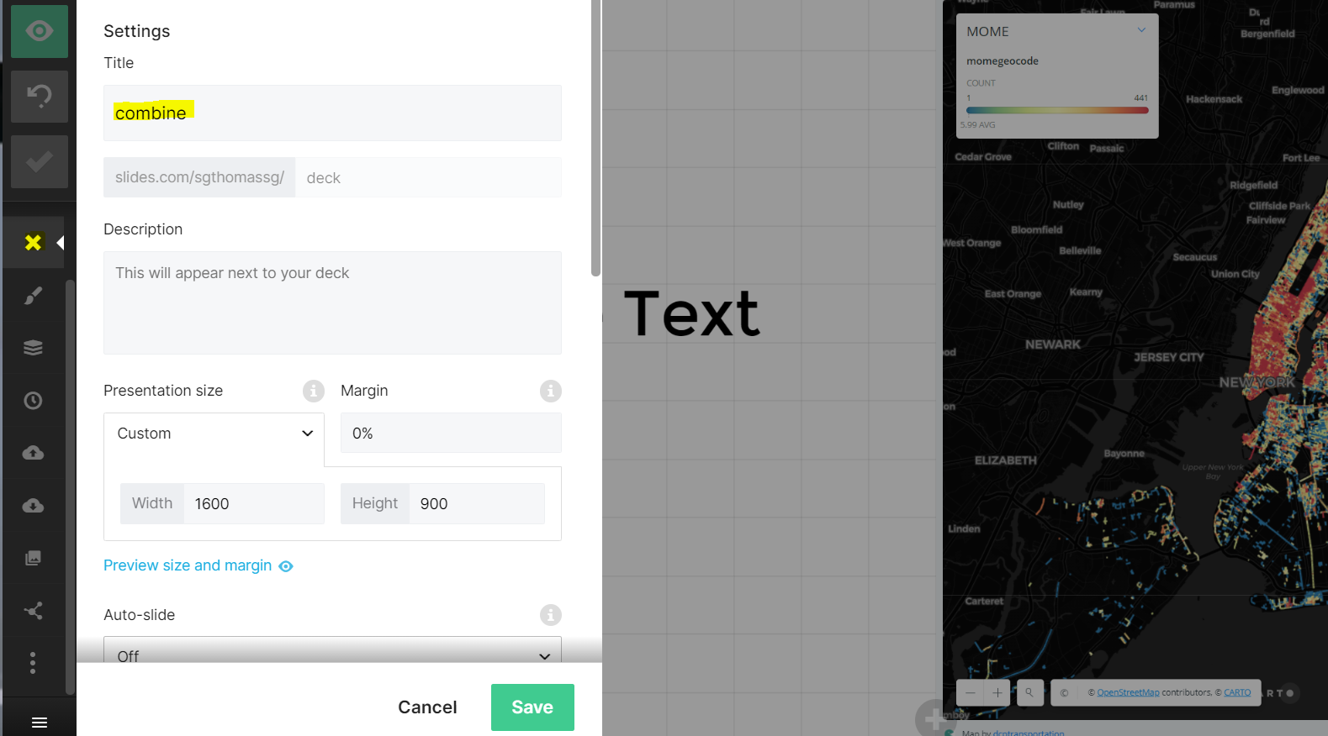

1. Add Laura as collaborator for the final review

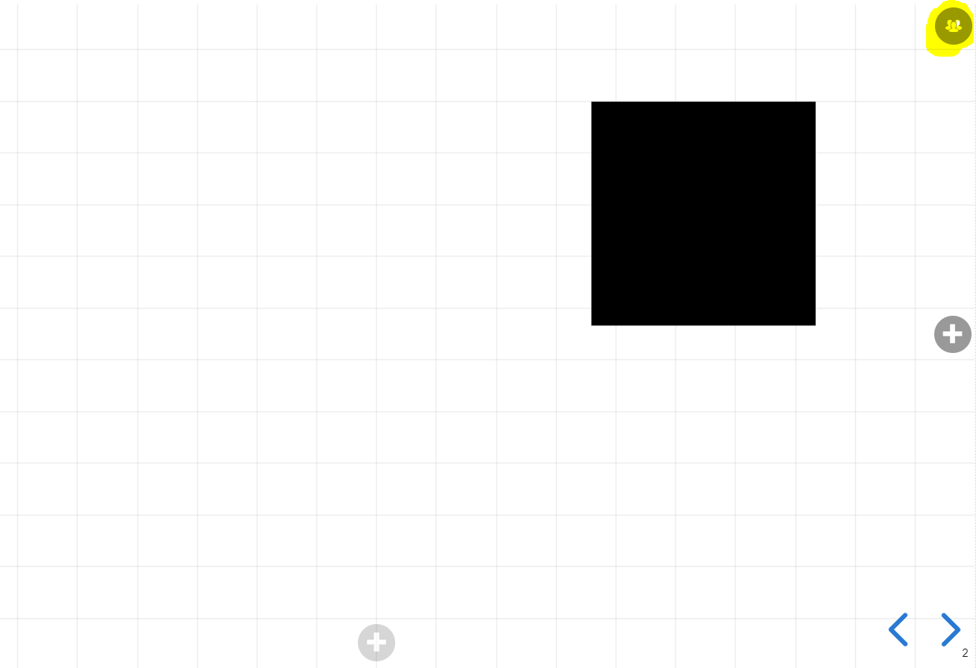

1. Share the link to Yijun for combining decks

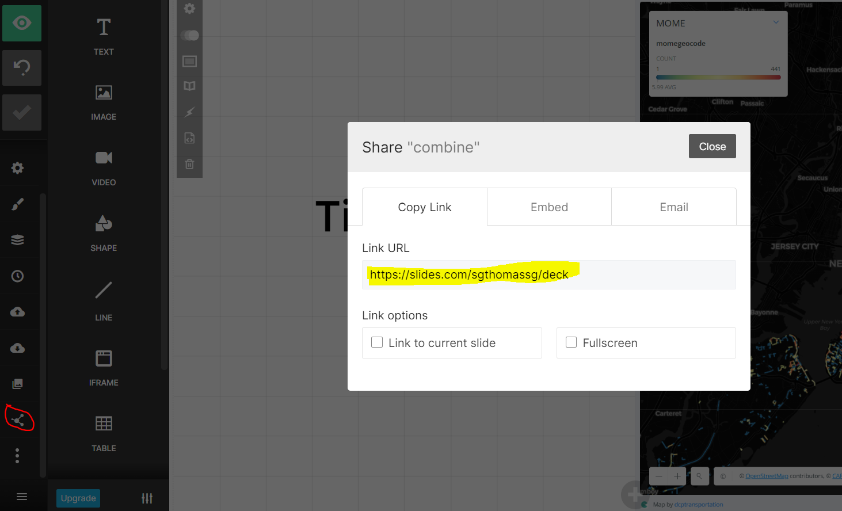

1. Combined the decks and convert them into html and pdf (Yijun)
   1. Make a copy of all the separate decks
   2. Insert slides into the main deck

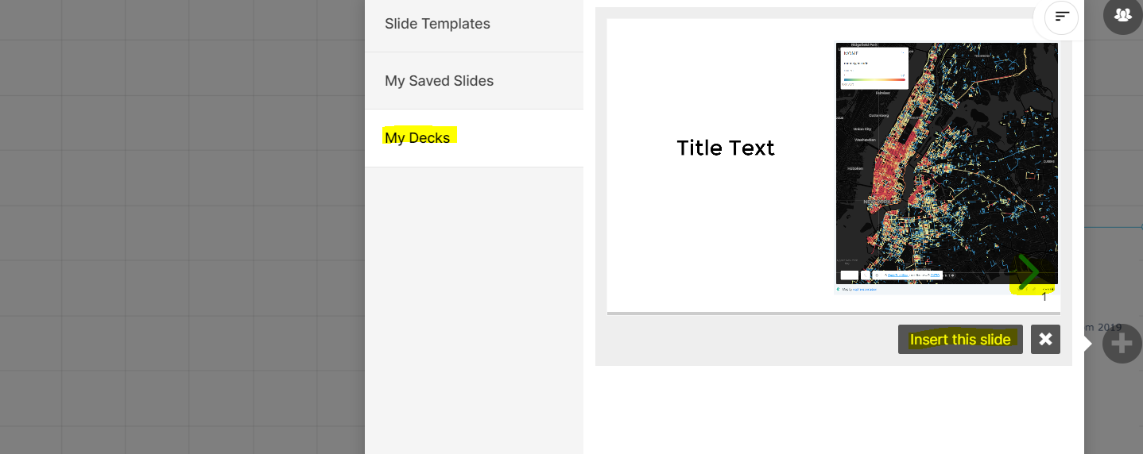

* 1. Copy the body html from export to reveal.js section
  2. Use DeckTape (<https://github.com/astefanutti/decktape>) to export to pdf (add -p 5000 --chrome-arg=--allow-file-access-from-files)

**Tips:**

1. **Embed images:** 
   1. Add the image to this GitHub folder first: <https://github.com/NYCPlanning/td-covid19/tree/master/report/img>

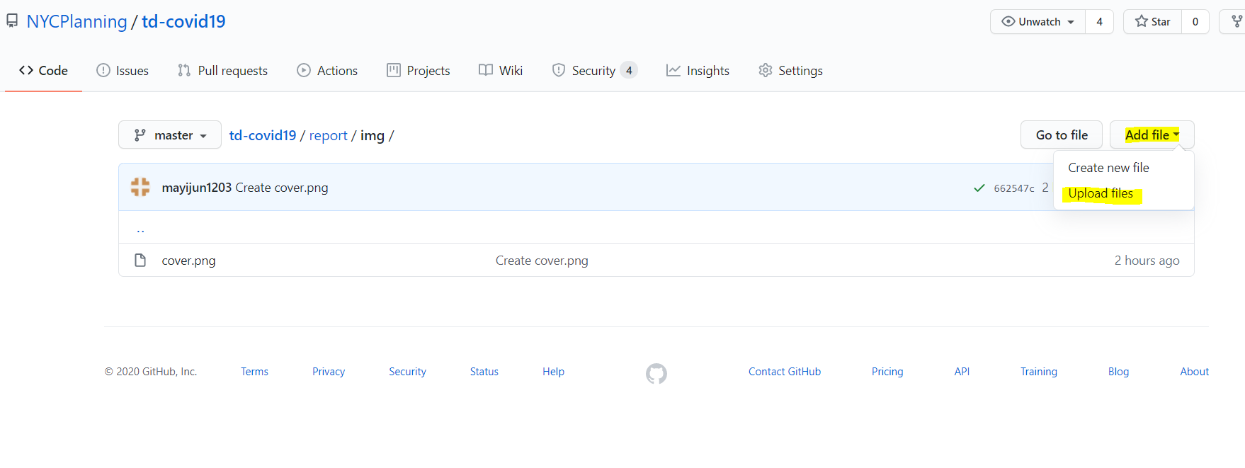

* 1. Click on the uploaded image => click download => copy the link

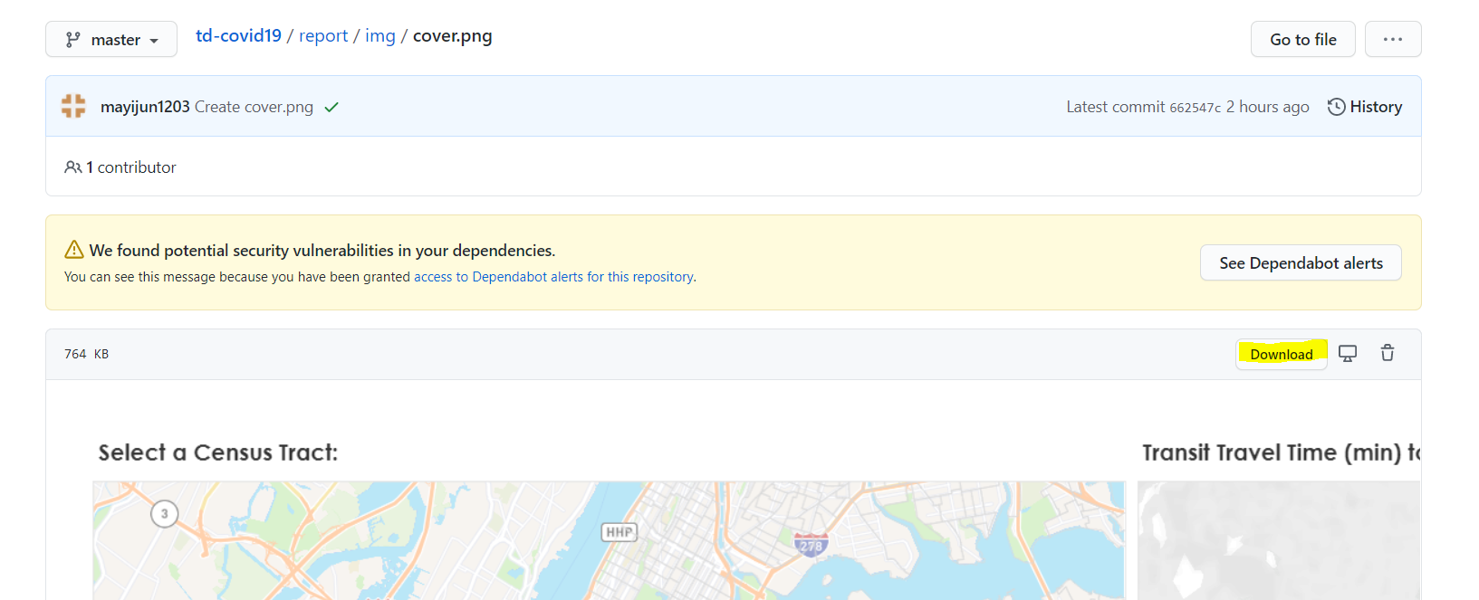

* 1. Click on the image and insert the URL

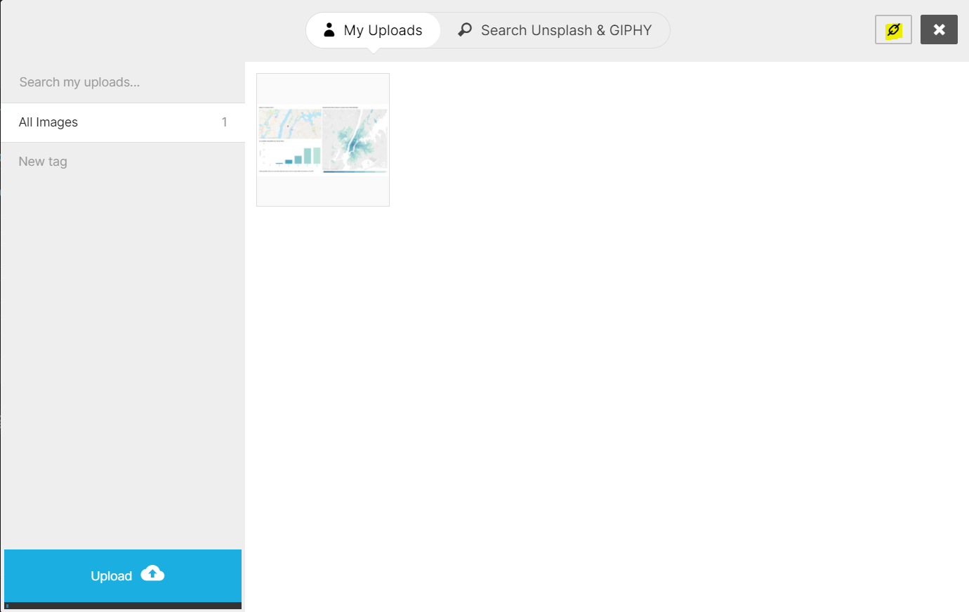

* 1. Edit the HTML and add position: fixed; to the style of the div tag for image

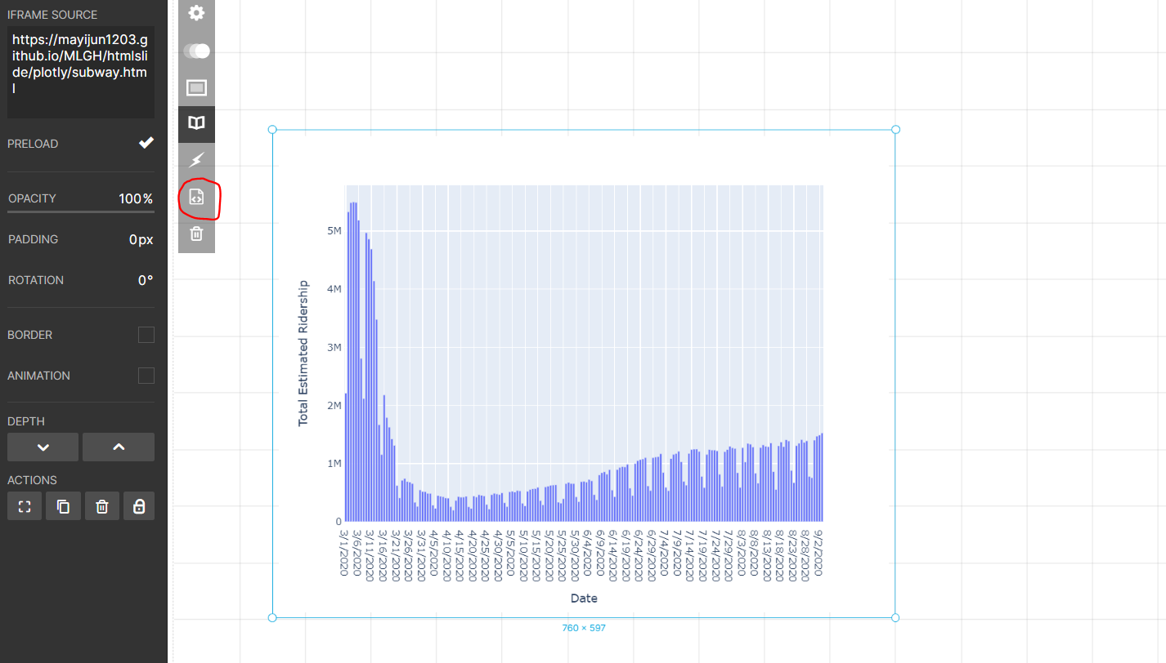

1. **Embed Carto maps:** 
   1. Use iframe to embed the Carto link

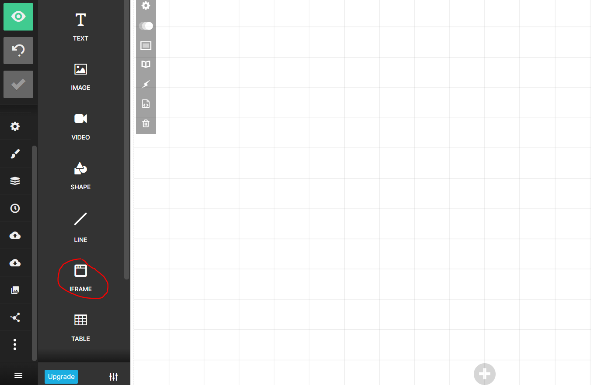

* 1. Adjust the map in Carto to make sure using the link with the actual map view you would like for printing such as <https://nycplanning.carto.com/u/dcptransportation/builder/37b19307-b396-429f-8aff-0a430a7490c6/embed?state=%7B%22map%22%3A%7B%22ne%22%3A%5B40.47202439692057%2C-74.64385986328126%5D%2C%22sw%22%3A%5B40.93374647531059%2C-73.37493896484376%5D%2C%22center%22%3A%5B40.703285532030314%2C-74.00939941406251%5D%2C%22zoom%22%3A11%7D%7D>
  2. Adjust the iframe to make sure the embedded map showing correctly with the legend
  3. Edit the HTML and add position: fixed; to the style of the div tag for iframe

1. **Embed Tableau chart:**
   1. Use sheet or dashboard
   2. Set dashboard as auto sizing
   3. Use iframe to embed the chart link (make sure to add &:showVizHome=no to the end of the link, otherwise it simply won’t work)
   4. Edit the HTML and add position: fixed; to the style of the div tag for iframe
2. **Embed Plotly chart:**
   1. Use either R or Python to create the chart and export to html
      1. Better to turn off drag mode and fix the range by using yaxis_fixedrange=True, xaxis_fixedrange=True, dragmode=False in the layout
      2. Use plotly-white template
      3. When exporting to html, make sure to set include_plotlyjs as ‘cdn’
   2. Add html file to this folder: <https://github.com/NYCPlanning/td-covid19/tree/master/report/plotly>
   3. Test the chart link ([https://nycplanning.github.io/td-covid19/report/plotly/*.html](https://nycplanning.github.io/td-covid19/report/plotly/*.html)) (If the link is not refreshed, try this link <https://nycplanning.github.io/td-covid19/report/plotly/> first and then try it again; or make some small changes to the html file like adding a space and commit the change again)
   4. Use iframe to embed the chart link
   5. Edit the HTML and add position: fixed; to the style of the div tag for iframe
3. **Embed Plotly map:**
   1. Use either R or Python to create the chart and export to html
      1. Set hash to true and make sure the copied link has the map view you want for printout
      2. When exporting to html, make sure to set include_plotlyjs as ‘cdn’
   2. Add this paragraph to the html after importing plotly to enable rendering Mapbox maps:

<script>

var oHCEgC = HTMLCanvasElement.prototype.getContext;

HTMLCanvasElement.prototype.getContext = function () {

console.log(arguments);

if (arguments[1]) {

arguments[1].preserveDrawingBuffer = true

arguments[1].alpha = true

}

return oHCEgC.apply(this, arguments)

}

</script>

* 1. Add html file to this folder: <https://github.com/NYCPlanning/td-covid19/tree/master/report/plotly>
  2. Test the chart link ([https://nycplanning.github.io/td-covid19/report/plotly/*.html](https://nycplanning.github.io/td-covid19/report/plotly/*.html)) (If the link is not refreshed, try this link <https://nycplanning.github.io/td-covid19/report/plotly/> first and then try it again; or make some small changes to the html file like adding a space and commit the change again)
  3. Use iframe to embed the chart link
  4. Edit the HTML and add position: fixed; to the style of the div tag for iframe

1. **Embed Mapbox map**
   1. Mapbox folder
   2. Geojson
   3. preserveDrawingBuffer: true
   4. hash: true
   5. data: 'https://raw.githubusercontent.com/NYCPlanning/td-covid19/master/report/mapbox/test.geojson'
   6. https://nycplanning.github.io/td-covid19/report/mapbox/test.html#9.87/40.732/-73.9623