**Steps:**

1. Go to <https://slides.com/> and sign up an account
2. Find this template deck:
3. Make a copy to your own account

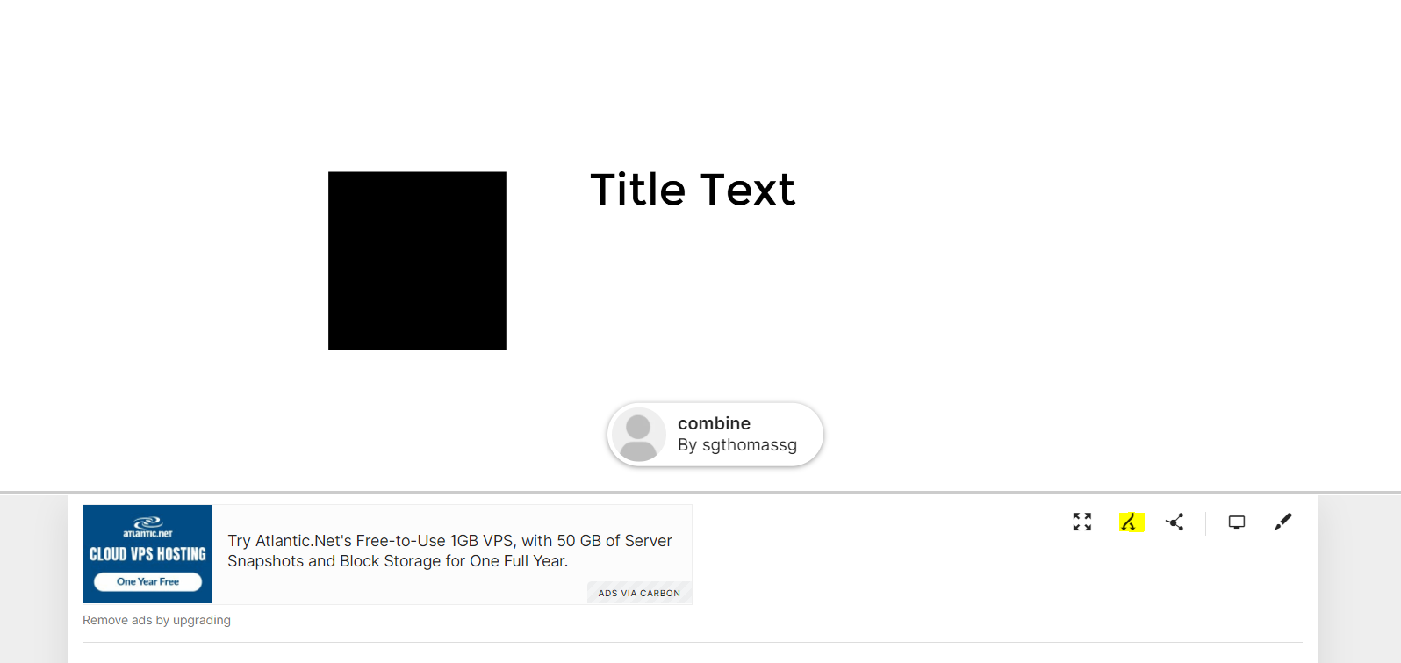

1. Change the deck title to your name and start editing the slides

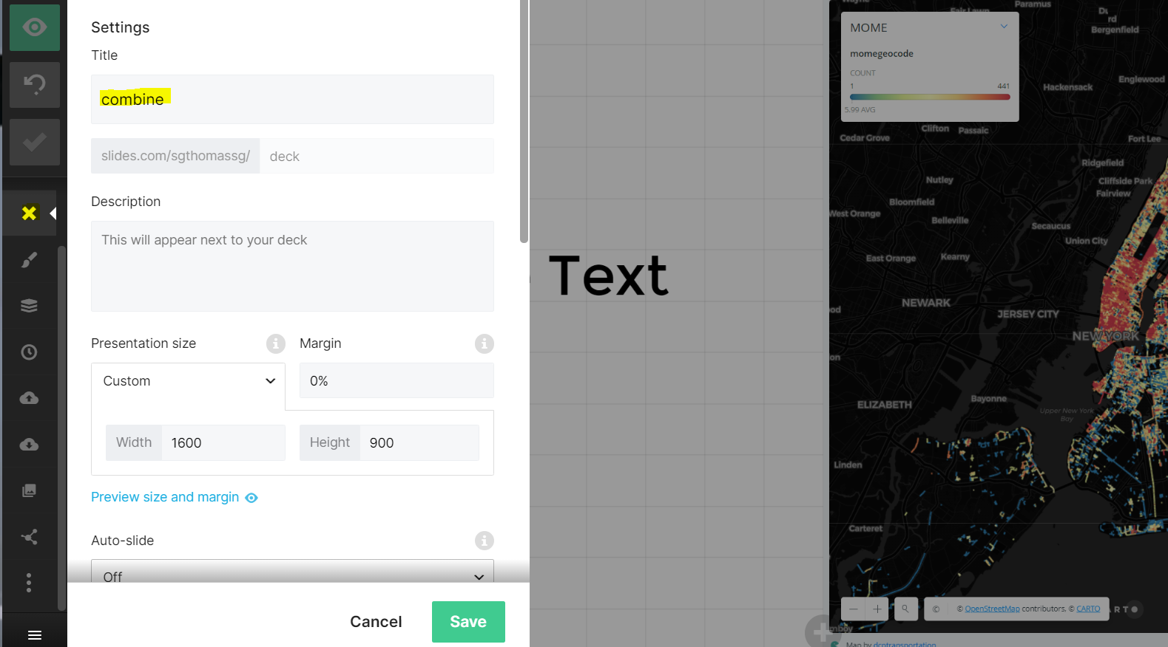

1. Add Laura as collaborator for the final review

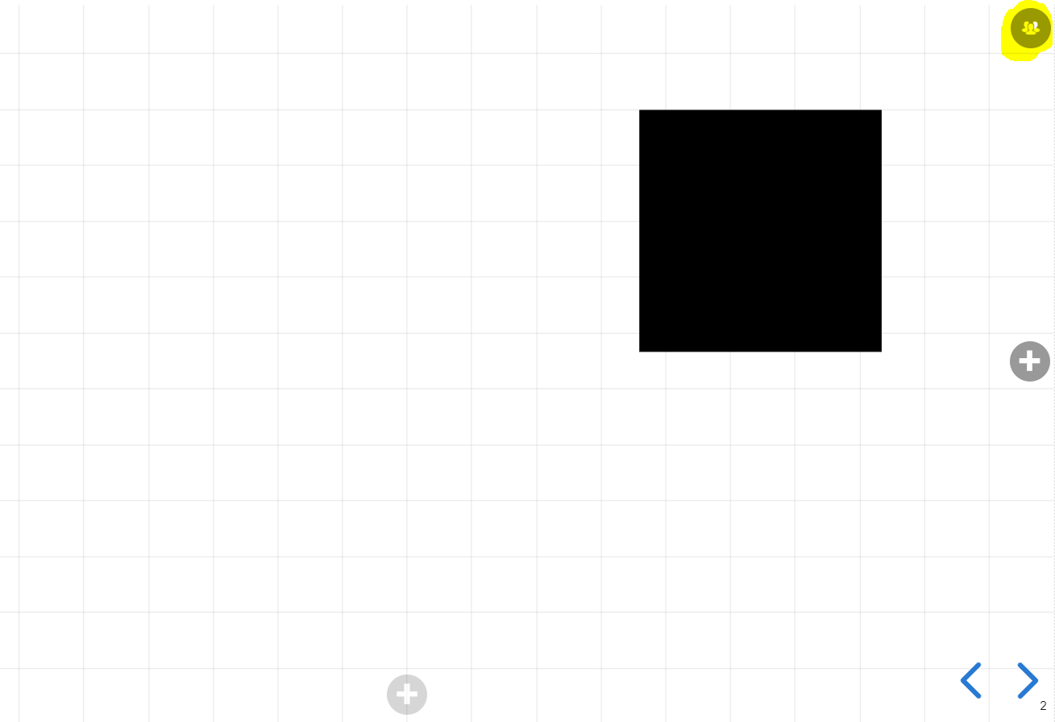

1. Share the link to Yijun for combining decks

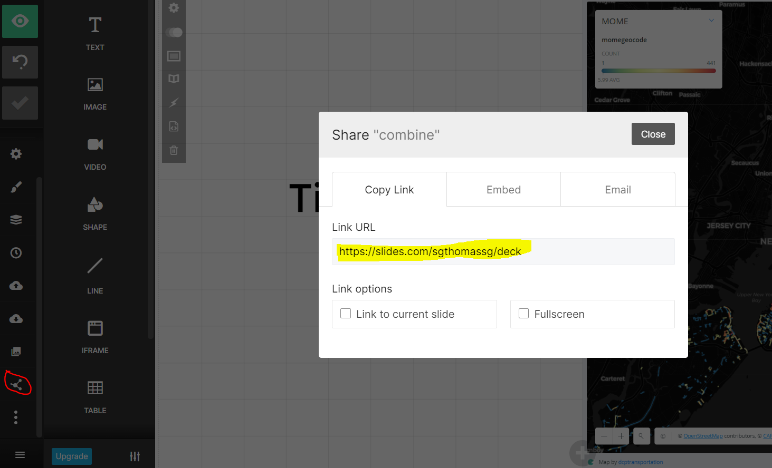

1. Convert combined deck to html and pdf (Yijun)

**Tips:**

1. Embed Carto maps:
   1. Use iframe to embed the Carto link

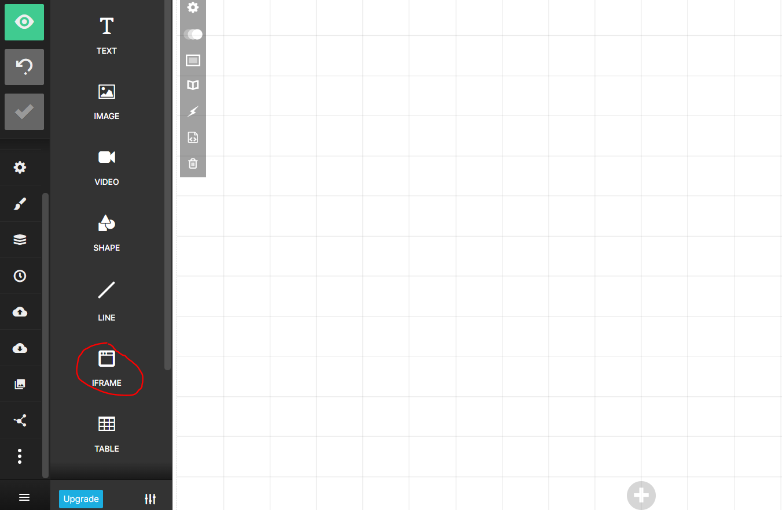

* 1. Adjust the map in Carto to make sure using the link with the actual map view you would like for printing such as <https://nycplanning.carto.com/u/dcptransportation/builder/37b19307-b396-429f-8aff-0a430a7490c6/embed?state=%7B%22map%22%3A%7B%22ne%22%3A%5B40.47202439692057%2C-74.64385986328126%5D%2C%22sw%22%3A%5B40.93374647531059%2C-73.37493896484376%5D%2C%22center%22%3A%5B40.703285532030314%2C-74.00939941406251%5D%2C%22zoom%22%3A11%7D%7D>
  2. Adjust the iframe to make sure the embedded map showing correctly with the legend

1. Embed images:
   1. Add the image to this GitHub folder first: <https://github.com/NYCPlanning/td-covid19/tree/master/report/img>

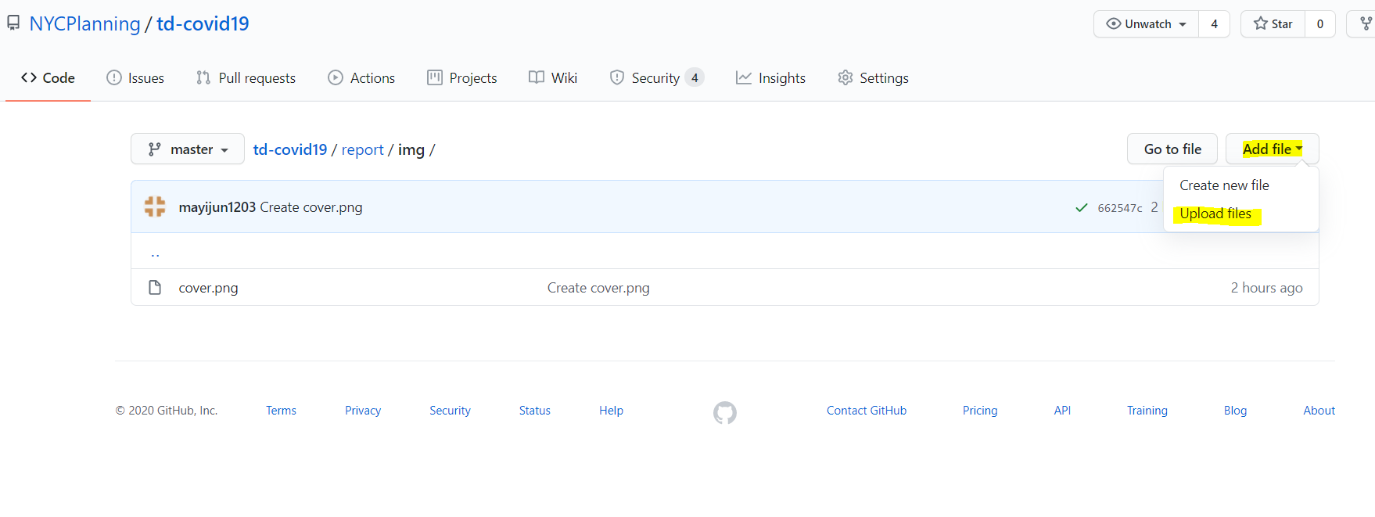

* 1. Click on the uploaded image => click download => copy the link

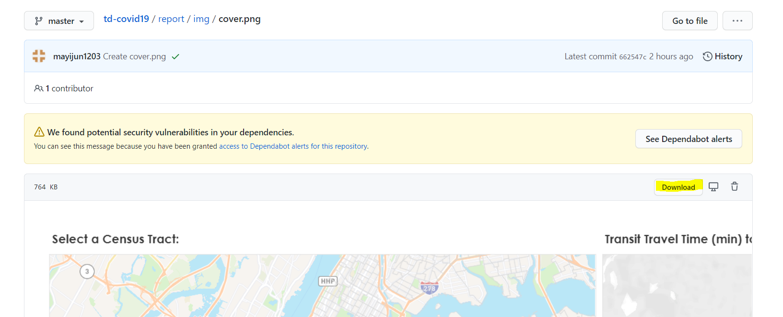

* 1. Click on the image and insert the URL

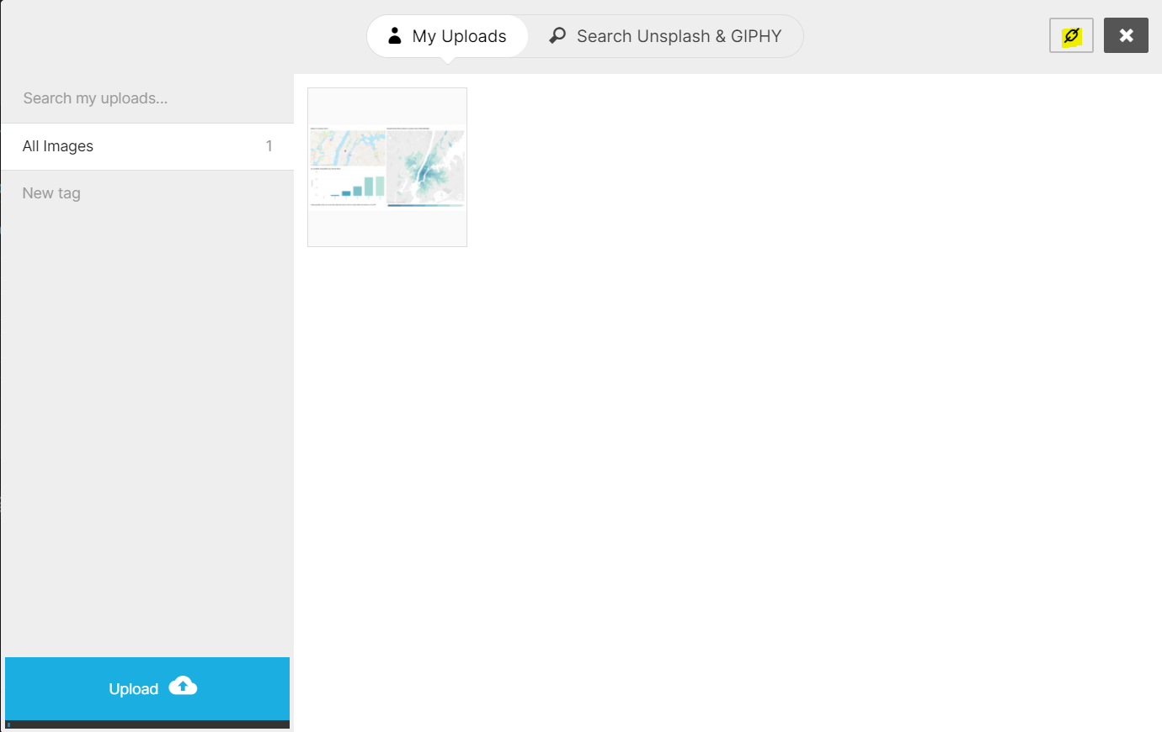

* 1. Make sure to retain the image aspect ratio, otherwise there’ll be issues in the conversion later

