**Instruction for Import MTA Bus GTFS Data into ArcGIS**

1. Create project master folder (make sure no space in the path)
2. Download the GTFS to the master folder from MTA Developer Resources: <http://web.mta.info/developers/developer-data-terms.html#data>

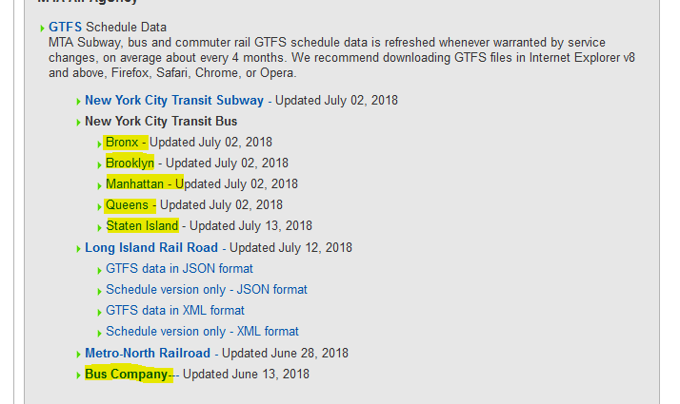

1. Copy busgtfs.R and busgtfs.py to the master folder
2. Open R x64
3. Open busgtfs.R
4. Change the path to the master folder where all the data are stored. **Change all backslashes to forward slashes. Make sure the file path ends with a forward slash.**

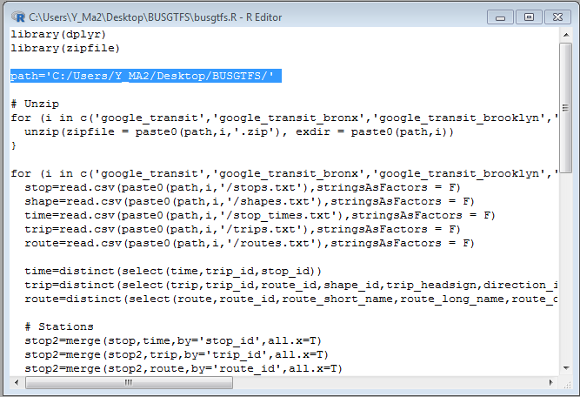

1. Run R script (Edit => Run all) and wait until it shows “Done!”

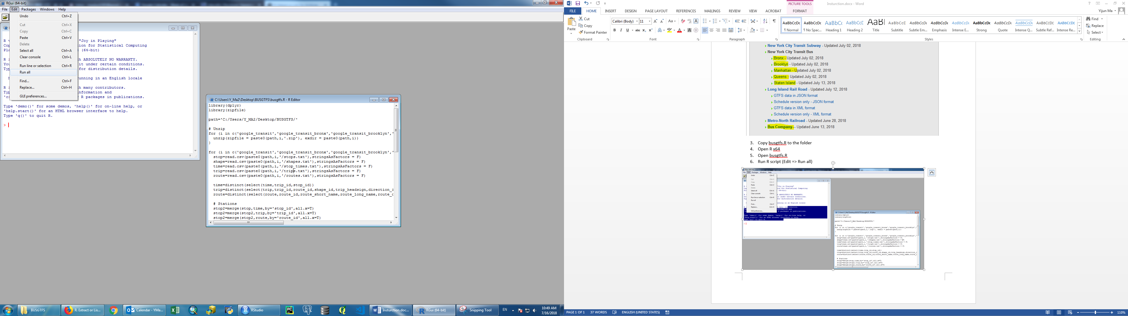

1. Open Python IDLE
2. Open busgtfs.py
3. Change the path to the master folder where all the data are stored. **Use forward slashes.**

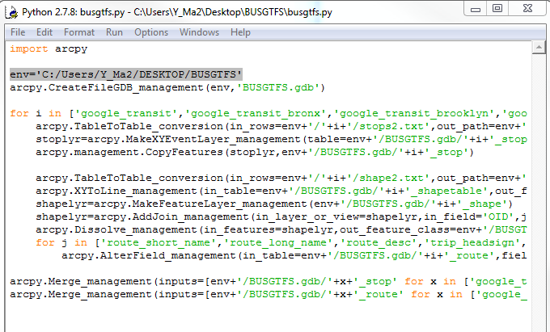

1. Run Module (Run => Run Module) and wait until it shows “Done!”

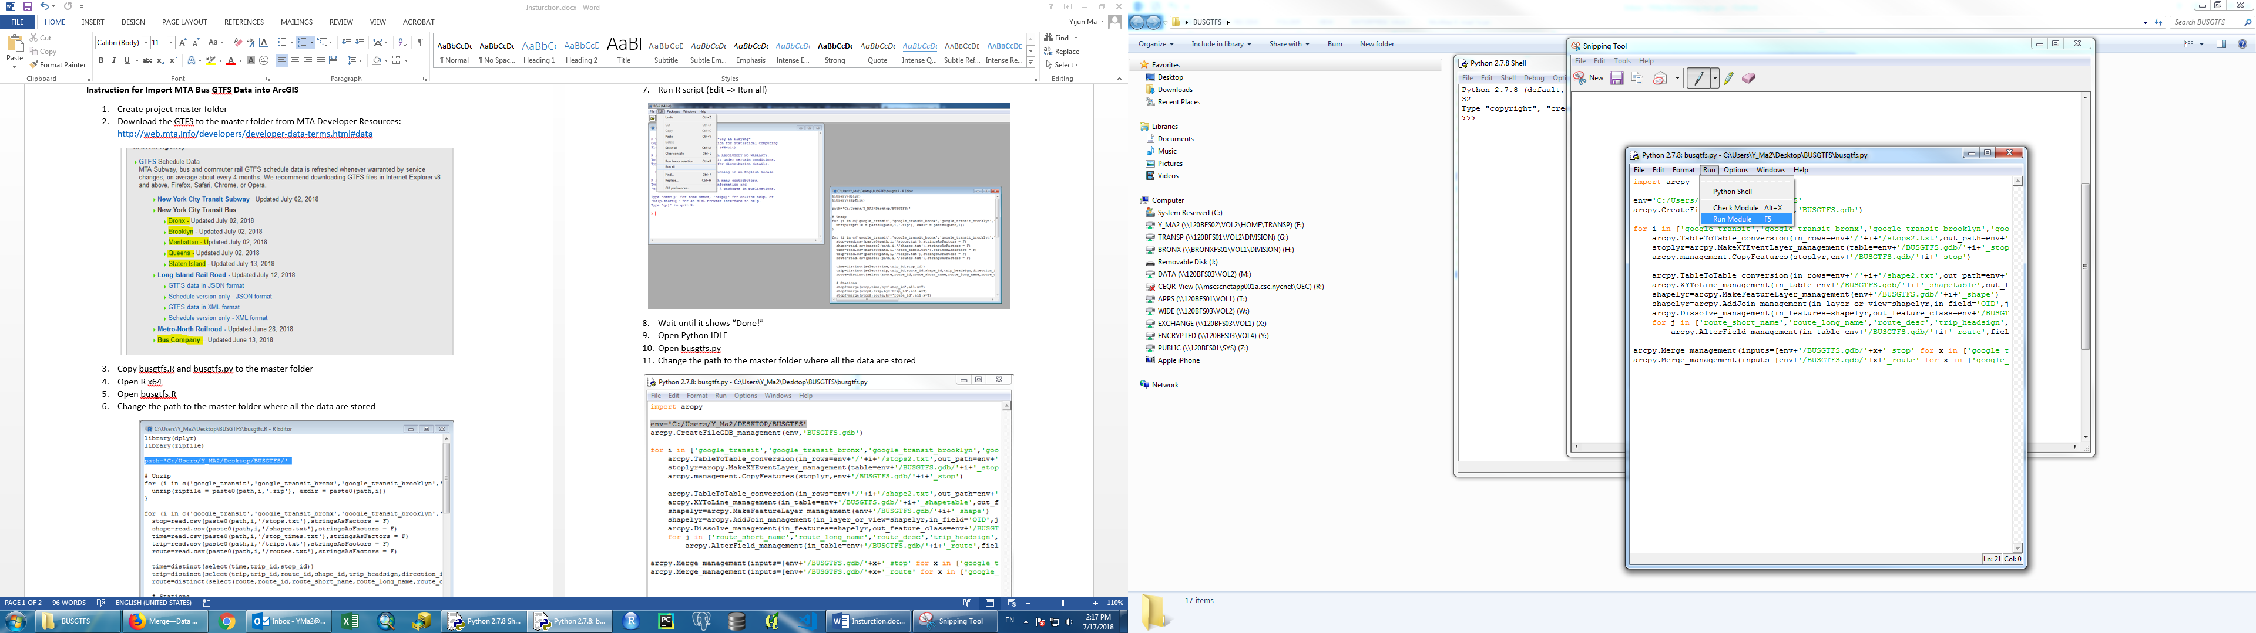

1. Import MTA_NYC_Bus_Stops and MTA_NYC_Bus_Routes files in BUSGTFS.gdb into the sde and edit the metadata