POSTMAN

Table of Contents

Installing and updating Postman 2

Installing Postman on Windows 2

Installing Postman on Mac 2

Installing Postman on Linux 2

Postman supports the distributions 3

Importing Collection into Postman 4

Navigate to where you’ve saved the Postman application and open it 4

Select the Type of Import Method that you want to use. 4

Using Postman collection 5

# Installing and updating Postman

Postman is available on the web at [**go.postman.co/home**](https://go.postman.co/home) and as a native desktop app for Mac (Intel and Apple), Windows (32-bit / 64-bit), and Linux (64-bit) operating systems.

To get the latest version of the Postman desktop app, visit the [download page](https://www.postman.com/downloads/) and select **Download** for your platform.

## Installing Postman on Windows

Postman is available for Windows 7 and later.

1. [Download](https://www.postman.com/downloads/) the latest Postman version.
2. Select and run the .exe file to install Postman.

Postman v9.4 is the last version of Postman that supports both 32-bit and 64-bit Windows. All versions of Postman following v9.4 will only work on 64-bit Windows. You can continue to use Postman v9.4 and earlier on 32-bit Windows.

## Installing Postman on Mac

Postman is available for macOS 10.11 (El Capitan) and later.

1. [Download](https://www.postman.com/downloads/) the latest Postman version. Make sure to download the **Mac Apple Chip** version if you have a Mac with the M1 or M2 processor.
2. If your browser downloads the file as a ZIP file, find the file in the **Downloads** folder and unzip it.
3. In the **Downloads** folder, double-click the Postman file to install it.
4. When prompted, move the file to your **Applications** folder. This will ensure that future updates can be installed correctly.

You may encounter a "Library not loaded" error if you unzip and install Postman using a third-party archiving app. Use the default Archive Utility for Mac to unzip the file.

You can also install Postman using the [Homebrew](https://brew.sh/) package manager:

brew install --cask postman

## Installing Postman on Linux

You can install Postman on Linux by manually downloading it, using the [Snap](https://snapcraft.io/postman) store link, or with the command snap install postman.

To install manually, [download](https://www.postman.com/downloads/) and unzip the app, for example into the *Downloads* directory.

To start the app from a launcher icon, create a desktop file. Name the file Postman.desktop and save it in the following location:

~/.local/share/applications/Postman.desktop

Enter the following content in the file, replacing */path/to/Downloads* with the location of the file, and save it:

[Desktop Entry]

Encoding=UTF-8

Name=Postman

Exec=/path/to/Downloads/Postman/app/Postman %U

Icon=/path/to/Downloads/Postman/app/resources/app/assets/icon.png

Terminal=false

Type=Application

Categories=Development;

## Postman supports the distributions

* Ubuntu 14.04 and newer
* Fedora 24
* Debian 8 and newer

The support of certain Linux distributions depends on if they're supported by Electron. Refer to [Electron's documentation](https://www.electronjs.org/docs/tutorial/support#linux).

It's recommended you install [Snap](https://snapcraft.io/postman) as it includes all the libraries that the app needs and they're bundled with the app itself.

Avoid starting Postman using the sudo command, as it will create permission issues on the files created by Postman.

Make sure you have read/write permission for the ~/.config folder where Postman stores information.

If you are an Ubuntu 18 user, you will also need to install the libgconf-2-4 package with the command apt-get install libgconf-2-4

# Importing Collection into Postman

## Navigate to where you’ve saved the Postman application and open it

Once your app is open, look for the file tab and click on it to open a dropdown menu. In the dropdown menu, look for the import icon and hit it.

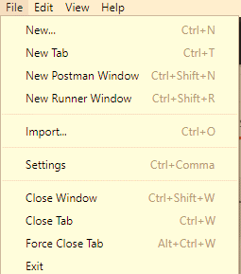

## Select the Type of Import Method that you want to use.

Once you hit the import button, a dialogue box will pop-up on your desktop.

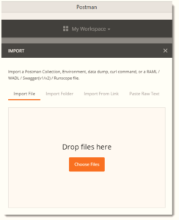

As seen in the image above, programmers have various methods that they can utilize to import collection. These include:

* Importing the file
* Importing the folder
* Importing through link
* Pasting the raw text

**Importing the File**

In our case we use this case because we have the .json file. The steps to follow are these:

* Click the choose file icon, and navigate to the place where you have kept your collections.
* Select the file you want to copy, and once you press open, the file will be imported automatically into Postman.
* Alternatively, you can find the file you want to move in your system, drag and drop it on the space panel provided. The collection will be uploaded into the Postman automatically.

## Using Postman collection

Once you import the .json file, Postman look like that

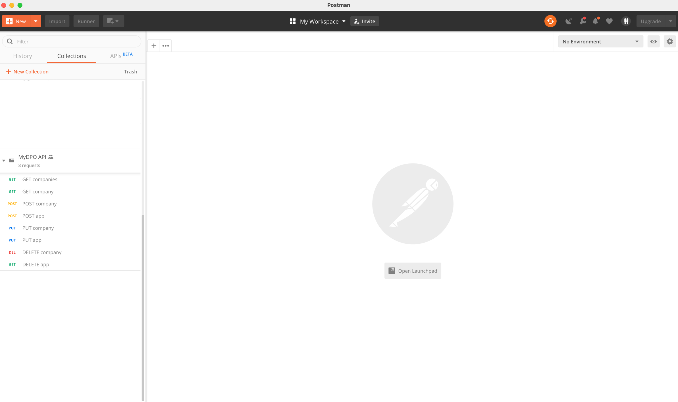

Then we need to change global variables, click on edit and follow these steps:

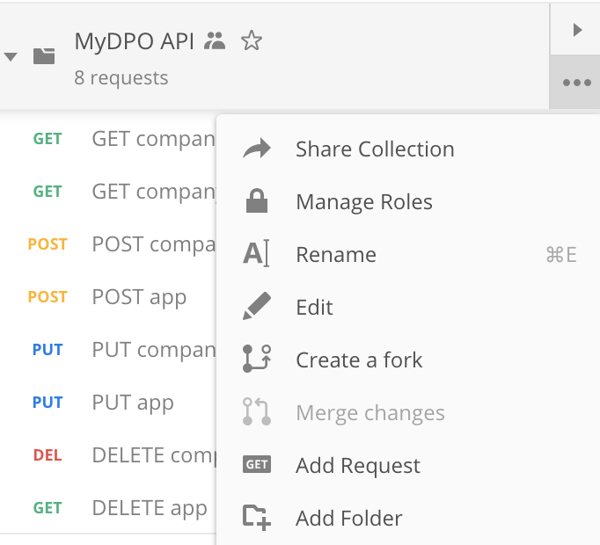

On the popup click over Variables and you can change two constants:

* BASE_URL: URL server where API is located.
* API_KEY: key used to authentication user.

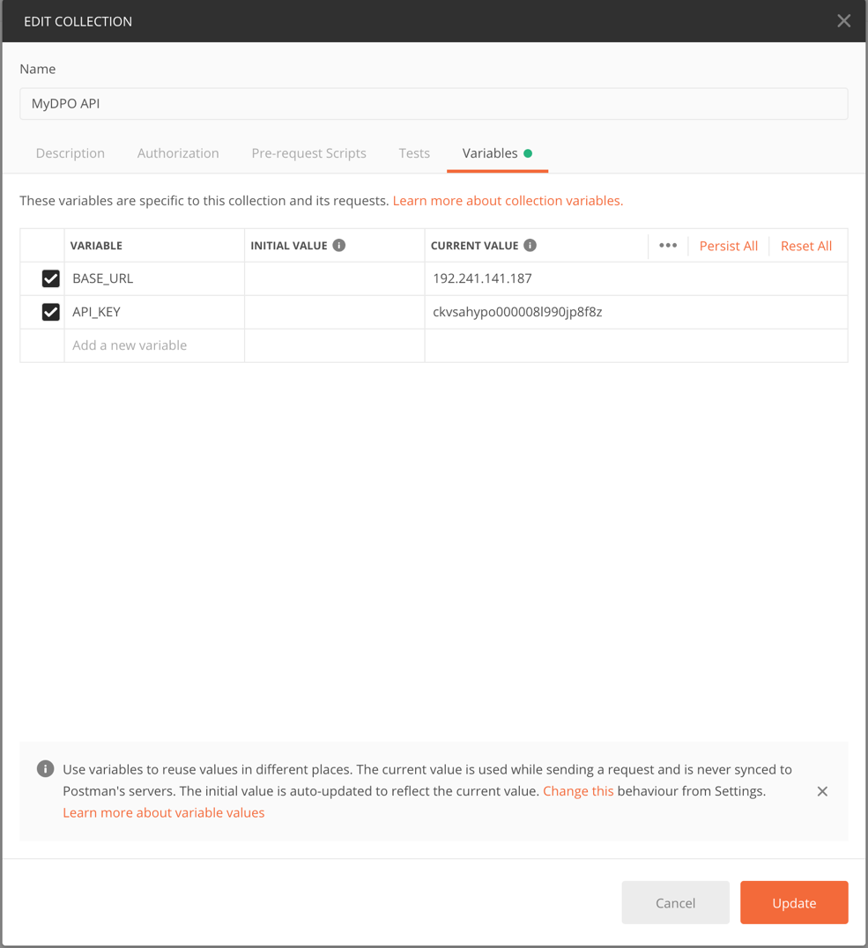

After click Update you can start using Postman to call the request created.

* **GET companies:** get all the business (specified in API_KEY)
* **GET company:** get all the data related to business (and applications created)
* **POST company:** create a new business
* **PUT company:** update data for a specific business.
* **POST app:** create a new application in a specific company.
* **PUT app:** update data for a specific app.
* **DELETE company:** delete a specific business
* **DELETE app:** delete a specific application

*This information is based on postman page documentation (<https://learning.postman.com/>)