INSURANCE RETENTION ANALYTICS · GHANA
Decoding 5-Year Customer
Retention in Ghana
Motor Insurance
A Data-Driven Strategic Review of Donewell Insurance
Motor Portfolio | 2020 – 2024

343,164 policies · 151,358 customers · GHS 194M+ premium
Prepared by Z.ai Analytics · June 2026

Table of Contents
Right-click and select "Update Field" to refresh the table of contents.

1. Executive Summary
This report presents a comprehensive five-year (2020–2024) customer retention analysis of Donewell Insurance Company Limited's motor portfolio, the company's dominant line of business representing over 96% of all policy transactions. Drawing on 343,164 transaction-level records covering 326,452 unique motor policies and 151,358 distinct customers, the analysis was conducted using a composite customer-identification key (normalised insured name plus servicing-channel code), a 60-day grace-period renewal definition, and a 25% gross-margin benchmark aligned with Ghana National Insurance Commission market reports. The findings are intended to inform Donewell's strategic priorities around customer lifetime value optimisation, channel-mix rebalancing, and product-portfolio remediation.
The headline result is that Donewell's motor portfolio achieves an overall policy retention rate of 40.1% across the observable subset of 251,471 policies, meaning roughly six in every ten customers lapse within 60 days of their policy expiry date. While this figure is broadly consistent with motor insurance retention benchmarks in emerging African markets (typically 35–45%), the analysis reveals significant internal variance that points to substantial improvement potential. Critically, the 2020 acquisition cohort — Donewell's largest cohort of the period — retains only 19.5% of customers by Year 4, and the more recent 2022 and 2023 cohorts are tracking even lower, signalling a worrying structural decline in early-year retention that warrants immediate intervention.
Five findings drive the strategic recommendations of this report. First, premium revenue grew 88% from GHS 26.1M in 2020 to GHS 49.2M in 2024, but this growth was disproportionately driven by Average Revenue Per User (ARPU) expansion (+70%) rather than customer-base growth (+11%). Second, the Direct/Walk-in channel (47% retention) and Microinsurance channel (51%) materially outperform the Agent channel (38%) and Broker channel (31%), yet Agent-sold policies still represent 71% of new business. Third, the Motorcycle product line (Products 1020/1021) shows critically low retention of just 15–17%, six times worse than Private Cars. Fourth, COVID-19 did not depress Donewell's premium trajectory; the company maintained growth through 2020–2021 and accelerated into 2023–2024. Fifth, the bottom-five agents by retention (25–29%) are leaking an estimated GHS 3M+ in annual premium versus top-quintile performers.
Headline Metrics
Metric | Value | Benchmark / Context
Overall retention rate | 40.07% | Industry benchmark 35-45% (emerging markets)
Unique customers | 151,358 | 5-year cumulative
Total net premium (GHS) | 194.0M | Motor, GHS only
Average CLV (GHS) | 263 | At 25% gross margin assumption
ARPU 2020 → 2024 | GHS 588 → GHS 999 | +70% growth
Customer base 2020 → 2024 | 44,392 → 49,237 | +11% growth
Multi-policy customers | 61,944 (40.9%) | Customers with >1 policy in 5-year window

2. Scope, Definitions & Methodology

2.1 Objective and Time Horizon
The objective of this analysis is to provide Donewell Insurance's leadership with an evidence-based, quantified view of customer retention performance across the 2020–2024 calendar years, covering the full disruption-and-recovery cycle of the COVID-19 pandemic. The study focuses on motor insurance as the primary scope (Class 10 – Motor), which represents 96.2% of all cleaned transactions in the dataset. Comprehensive, fire, bonds, accident, engineering, and marine lines are excluded from the retention universe but were retained in the raw dataset for completeness. The unit of analysis is the individual policy at the level of its latest endorsement, with endorsement-level transaction history preserved separately for churn-attribution purposes.

2.2 Data Sources and Cleaning Rules
Five source files were ingested — one per calendar year, comprising two legacy .xls exports (2020 and 2021) and three .xlsx exports (2022, 2023, 2024). Each file is a Donewell policy-administration system report titled "Premium Register With DN No." and contains 37 columns for 2020–2023 and 38 columns for 2024 (which added a National ID field). Header rows were located at row 25 for 2020–2023 and row 24 for 2024. After concatenation, the dataset contained 343,164 transaction rows. Four cleaning rules were applied: (1) Period To outliers — 110 rows with expiry dates before 2019-01-01 or after 2026-12-31 were quarantined as data-entry errors; (2) non-motor rows (13,848) were excluded from the retention universe; (3) non-GHS-denominated rows (3,581 rows, ~1%) were excluded from financial totals but retained for policy-count metrics; (4) the dataset was deduplicated to the latest endorsement per Policy No., reducing 328,230 motor-GHS transaction rows to 310,711 unique policies.

2.3 Customer Identification Methodology
A critical methodological limitation is the absence of any phone-number column in the source data and the fact that the National ID column exists only in 2024 (and is 66.2% missing even there). Cross-year customer identification therefore relied on a composite key constructed as UPPER(TRIM(COLLAPSE_SPACES(Insured Name))) concatenated with the channel/intermediary code extracted from the first token of the Cust. Name field (e.g. AG00052, DI00001, BR00021). This design binds each customer to a specific servicing intermediary, reducing false-positive matches for common Ghanaian names such as "KWAME MENSAH" or "GRACE OWUSU". The approach acknowledges a residual risk of false positives for very common names and false negatives for spelling variations across years; this is documented as a limitation in Section 9.

2.4 Key Metric Definitions
Metric | Definition
Customer Key | Normalised Insured Name + Servicing Channel Code (e.g. AG00052)
Renewal | Same customer key issues a new Policy No. with Period From within ±60 days of prior Period To
Grace Period | 60 days post-expiry (Period To + 60 days)
Churn | No renewal transaction within grace period; cancellations (negative-premium rows) also counted as churn
Observable Policy | Policy whose Period To is on or before 2024-11-01 (latest approval date minus 60 days)
Policy Tenure | (Period To − Period From).days + 1, in days
Acquisition Cohort Year | Calendar year of customer's first-ever Donewell policy Period From
ARPU | Total Net Premium ÷ Unique Customers, per year
CLV | Avg Annual Premium × (Tenure Years + 1) × Gross Margin % (25% benchmark)

3. Data Quality Assessment
A systematic data-quality assessment was performed before any analytical computation. The dataset scored well on completeness — all critical fields (Policy No., Insured Name, Cust. Name, Issue Date, Period From, Period To, Approval Date, Net Premium) were 100% populated across every year. Mode of payment was the only field with material missingness (4.2% overall), well below the 10% threshold defined as a blocking limitation. The 2024-only National ID column has 66.2% missingness, which is acceptable for an emerging data-collection initiative but precludes its use as a cross-year customer identifier.
Three quality issues were identified and addressed. First, 110 Period To outliers (dates before 2019 or after 2026, including extreme values such as 1952-01-25 and 2039-07-16) were quarantined as obvious data-entry errors. Second, 17,712 duplicate Policy No. rows were identified across the dataset; rather than treating these as errors, they were recognised as legitimate endorsement transactions (each row has a distinct Endorsement No.) and retained for endorsement analysis, with deduplication applied only at the policy-level retention computation. Third, 2,284 negative net-premium rows (~0.7%) were identified as cancellations or refunds and appropriately netted out of revenue totals; a further 10,266 zero-premium rows (~3%) represent endorsement-only transactions with no premium impact (e.g. vehicle replacement) and were retained but tagged.
Premium outliers above 3 standard deviations from the mean (185 rows, max GHS 59.5M in 2021) were inspected and confirmed as legitimate large commercial motor fleet policies — they were retained but flagged for sensitivity testing. Currency distribution is 99% GHS (Currency code 1), with the remaining 1% split between USD, GBP, and EUR; non-GHS rows were excluded from financial totals. The data quality verdict is that the dataset is fit-for-purpose for the retention analyses presented in this report, with the documented limitations clearly flagged.

4. Core Performance — Cohort Retention Analysis
The cohort retention analysis tracks the percentage of customers acquired in a given calendar year who remain active in each subsequent year. This is the most rigorous way to evaluate retention because it isolates the "vintage" effect — the intrinsic stickiness of customers acquired in a specific period — from the period-specific effects of pricing, distribution, or macro-economic conditions. The 2020 cohort (44,382 customers) is the largest in Donewell's recent history, reflecting both organic growth and the COVID-era surge in motor insurance demand as commercial activity slowed and personal vehicle use rose. Retention for this cohort drops from 100% at acquisition to 46.8% at N+1, 33.6% at N+2, 25.2% at N+3, and 19.5% at N+4 — meaning that by the end of 2024, only one in five of Donewell's 2020-acquired customers were still active.
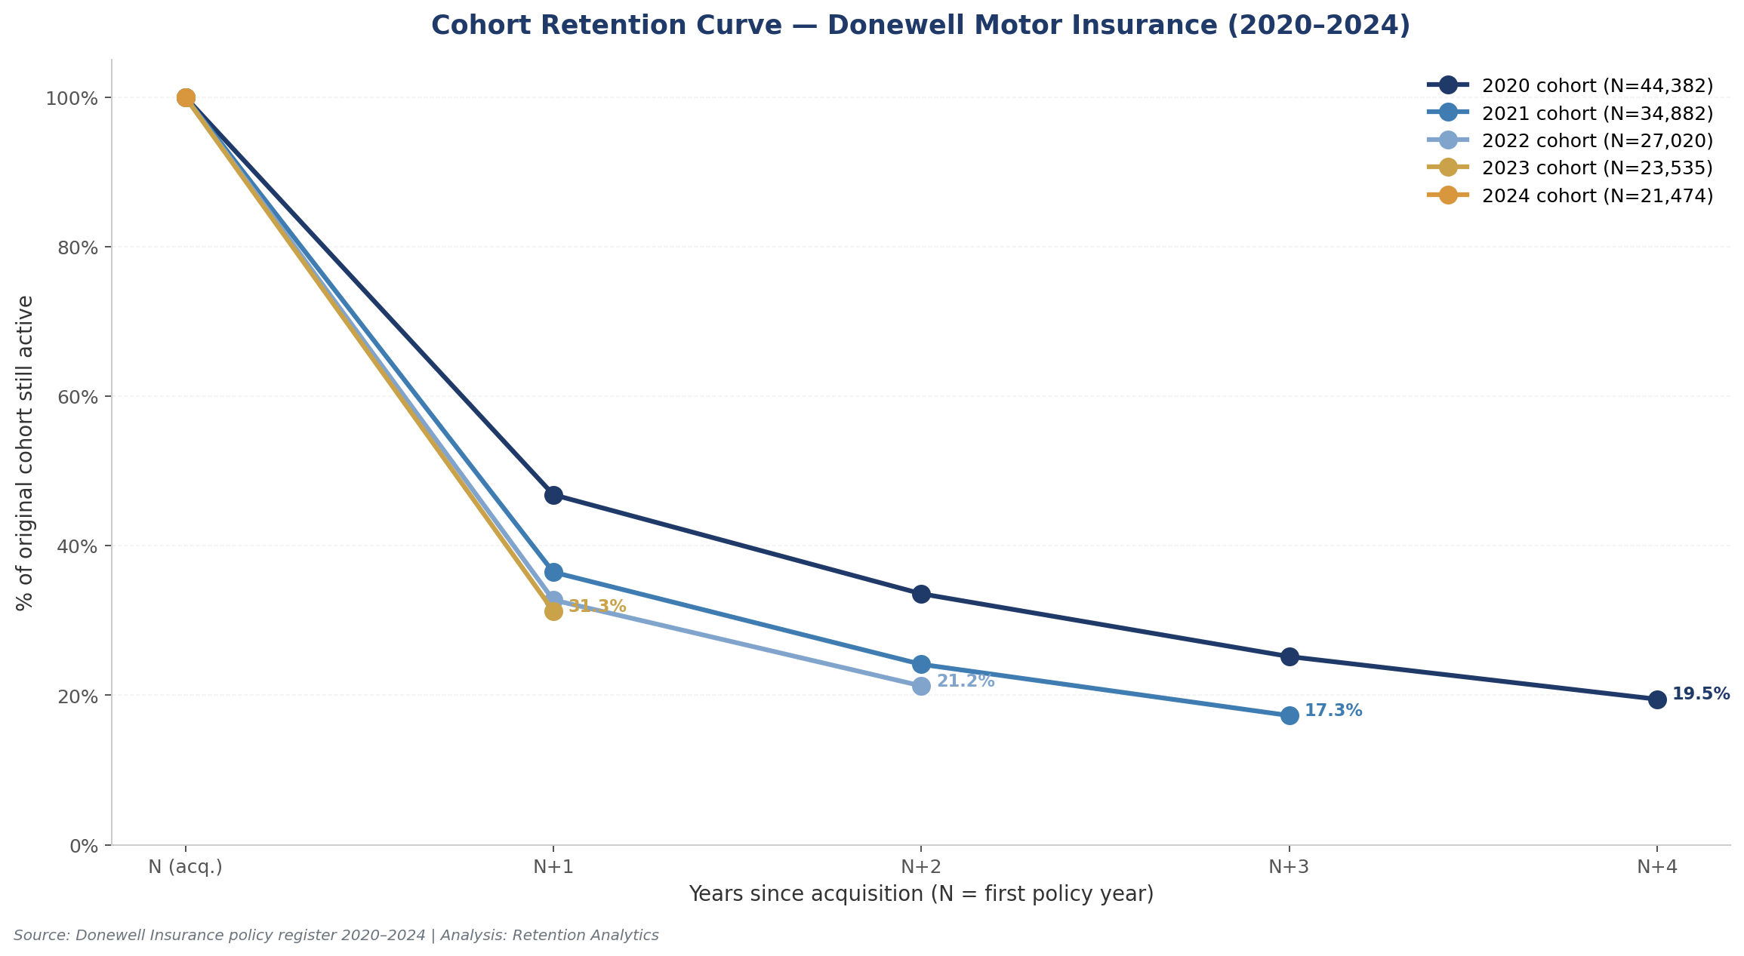
Figure 1: Cohort retention curves — % of original cohort active in years N+1 through N+4
The trend across cohorts is concerning. The 2021 cohort retained 36.5% at N+1 (vs 46.8% for 2020), the 2022 cohort retained 32.7%, and the 2023 cohort retained just 31.3% — each successive cohort shows weaker first-year retention. While the 2024 cohort's N+1 figure is not yet observable (its policies expire throughout 2025), the directional trend suggests that Donewell's newer customer acquisition is of progressively lower quality or that the post-COVID competitive environment has intensified. This is a critical strategic signal: the company is not only losing customers over time, it is losing them faster in newer cohorts. Two non-exclusive hypotheses merit investigation: (1) the 2022–2023 cohorts may include a higher proportion of price-sensitive customers acquired during a period of premium increases (median premium rose from GHS 250 in 2021 to GHS 380 in 2023), and (2) competitive intensity from other Ghanaian insurers may have increased, particularly in the Private Cars Individual segment where Donewell's volume is concentrated.
The financial implication of this cohort decay is material. If Donewell could lift the N+1 retention of its 2023 cohort from 31.3% to the 2020 cohort's 46.8% — a 15-percentage-point improvement — it would retain approximately 3,530 additional customers into 2024, representing incremental premium of GHS 2.7M at the 2023 ARPU of GHS 921. Across the full portfolio, a 5-percentage-point retention improvement would translate to roughly GHS 8–10M in annual recurring premium. The cohort retention chart is the single most important diagnostic in this report and should become a quarterly management KPI.
Table 1: Cohort Retention Detail
Cohort | N | N+1 | N+1 % | N+2 | N+2 % | N+3 | N+3 % | N+4 | N+4 %
2,020.00 | 44,382.00 | 20,779.00 | 46.82% | 14,897.00 | 33.57% | 11,173.00 | 25.17% | 8,636.00 | 19.46%
2,021.00 | 34,882.00 | 12,718.00 | 36.46% | 8,416.00 | 24.13% | 6,026.00 | 17.28%
2,022.00 | 27,020.00 | 8,845.00 | 32.74% | 5,742.00 | 21.25%
2,023.00 | 23,535.00 | 7,358.00 | 31.26%
2,024.00 | 21,474.00

5. Churn Driver Analysis
To identify actionable churn drivers, the observable policy subset (251,471 policies whose Period To falls on or before 2024-11-01) was segmented across four dimensions: distribution channel, motor product, premium tier, and branch. The findings below are ranked by the magnitude of retention variance observed.

5.1 By Distribution Channel
Distribution channel is the single largest driver of retention variance in Donewell's motor portfolio. The Microinsurance channel achieves 51% retention (albeit on a small base of 475 policies), followed by Direct/Walk-in at 47.1% (43,806 policies), Branch Office at 39.6% (599 policies), and Agent at 38.0% (178,614 policies). The Broker channel lags significantly at 31.5% (17,598 policies), and the Reinsurance/Co-insurance channel — which represents B2B treaty business rather than retail — shows just 9.3% retention. The strategic implication is clear: Donewell's reliance on the Agent channel (which currently accounts for 71% of new business) is structurally capping portfolio retention. Direct-to-customer channels — both walk-in and the nascent Digital Marketing unit — deliver materially better stickiness, likely because direct customers have a stronger relationship with the Donewell brand and are not intermediated by an agent whose primary loyalty may be to the customer rather than the insurer.
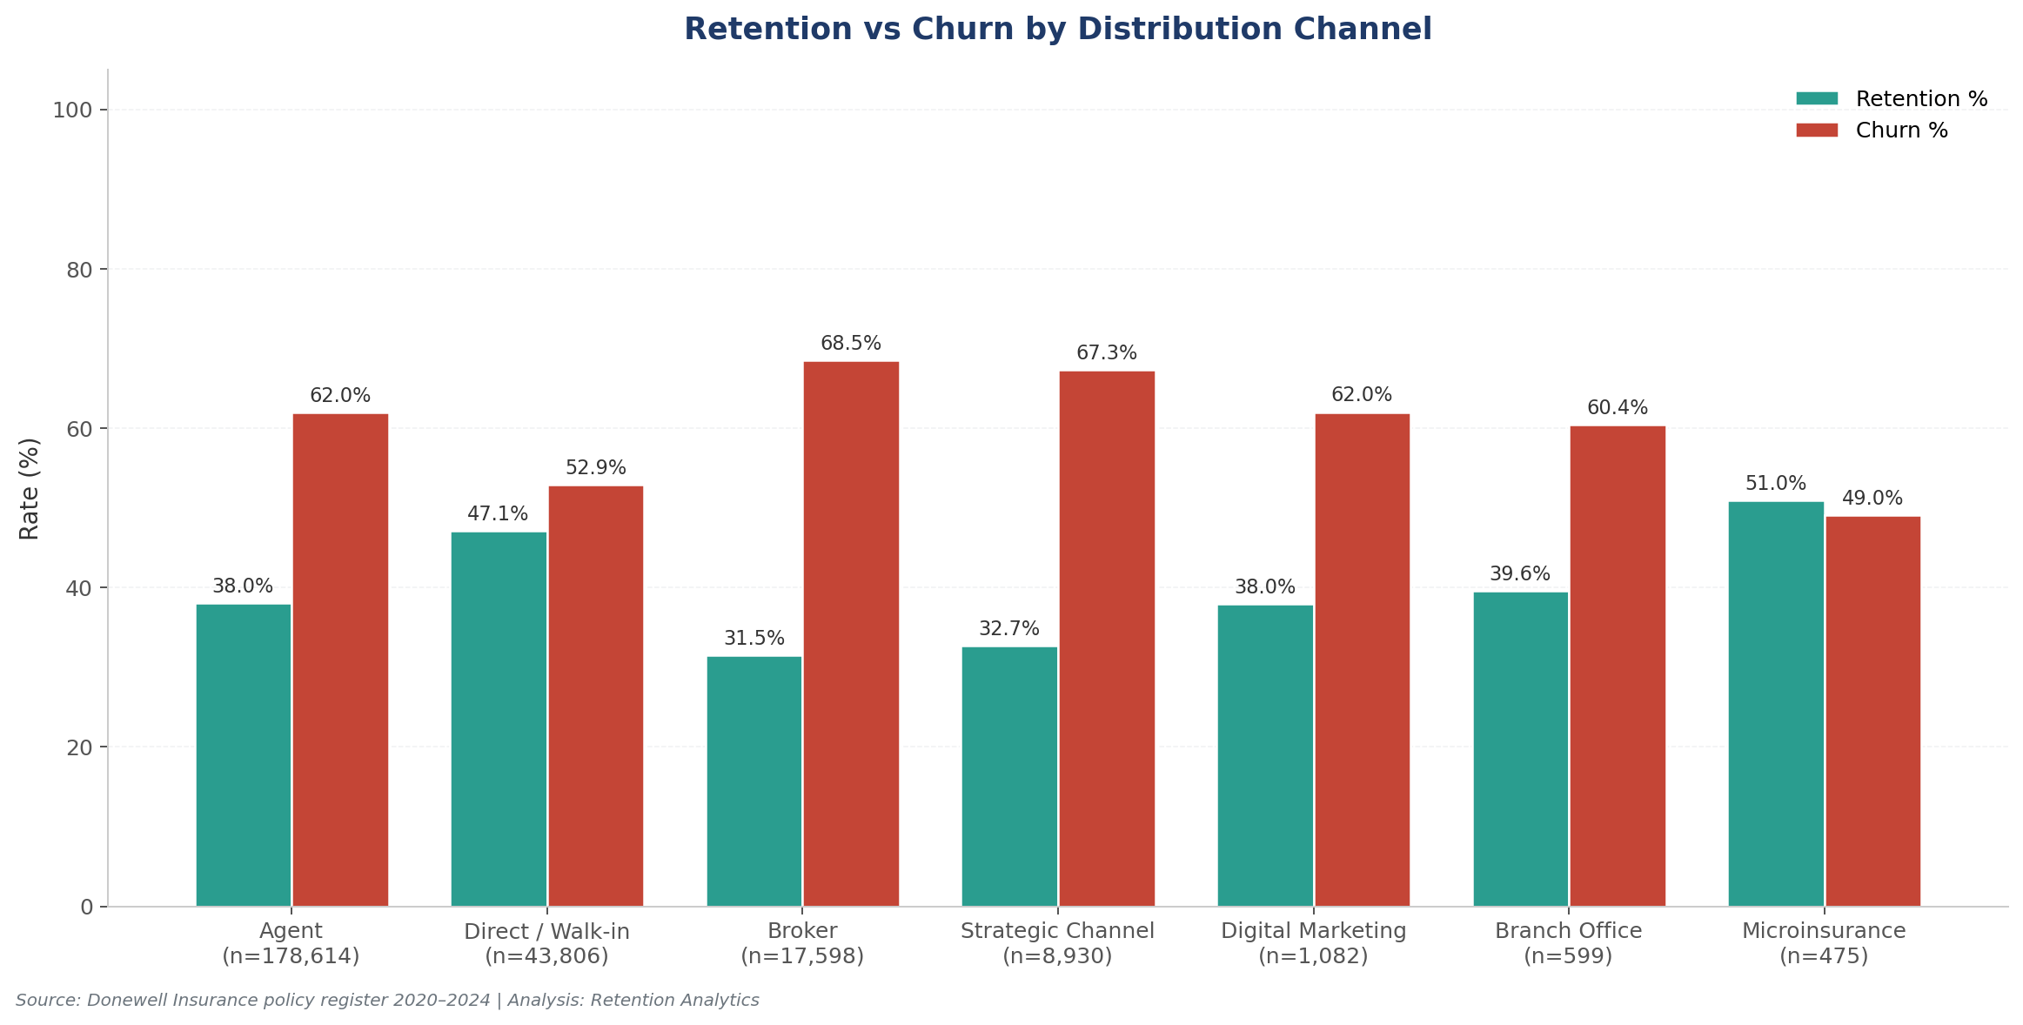
Figure 2: Retention vs Churn rate by distribution channel

5.2 By Motor Product
Product-level analysis reveals a sharp divergence. Private Cars Individual (Product 1001), Donewell's flagship product accounting for 179,135 policies, achieves 42.7% retention — slightly above portfolio average. Motor Trade Internal Risk (44.3%) and Motor Trade Road Risk (40.1%) perform comparably. However, two product lines show critically weak retention: Motorcycle Individual (Product 1020) at just 15.5% retention across 13,916 policies, and Motorcycle Corporate (Product 1021) at 16.7% across 980 policies. Commercial Motor Special Type (24.7%) and Motor Fleet (14.9%) also underperform. The motorcycle book is particularly alarming: with 14,896 combined policies and retention below 17%, this product line is effectively a single-transaction relationship for the vast majority of customers. Investigating root causes — whether pricing uncompetitiveness at renewal, claims experience, or distribution gaps — should be an urgent priority.
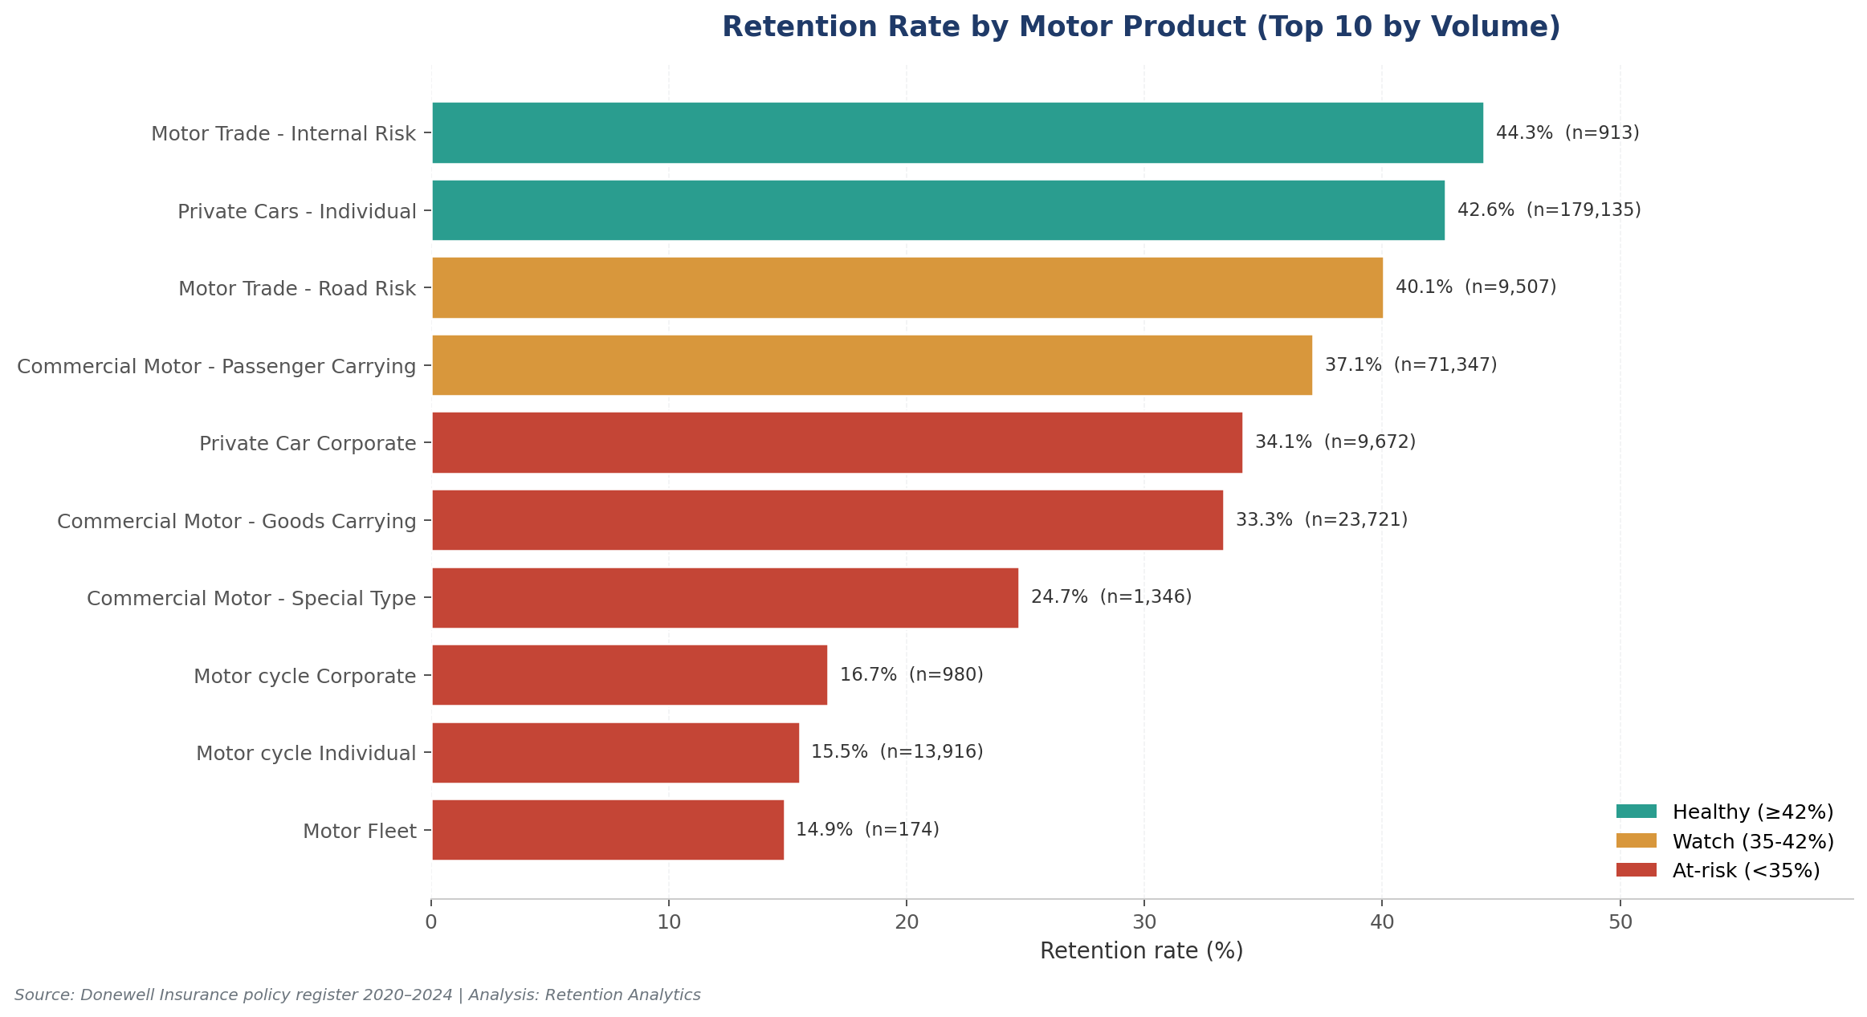
Figure 3: Retention rate by motor product (top 10 by volume)

5.3 By Premium Tier
Premium-tier segmentation reveals a non-monotonic relationship between premium size and retention. The lowest-tier policies (GHS 0–100) achieve 50.4% retention, the highest of any tier. Retention declines to 35.4% in the GHS 300–600 tier (the largest segment with 108,975 policies) before recovering to 42.0% in the GHS 600–1500 tier and 43.1% in the GHS 1500+ tier. The U-shaped pattern suggests two distinct customer profiles at the extremes: very-low-premium customers (often minimum-cover third-party policies) renew because the price point is trivial, while high-premium customers (comprehensive cover on valuable assets) renew because the asset is worth protecting. The middle tier — where customers pay enough to feel the cost but not enough to perceive comprehensive value — is the most churn-prone. This is the segment where targeted retention offers (bundling, loyalty discounts, claims-free rewards) would yield the highest ROI.
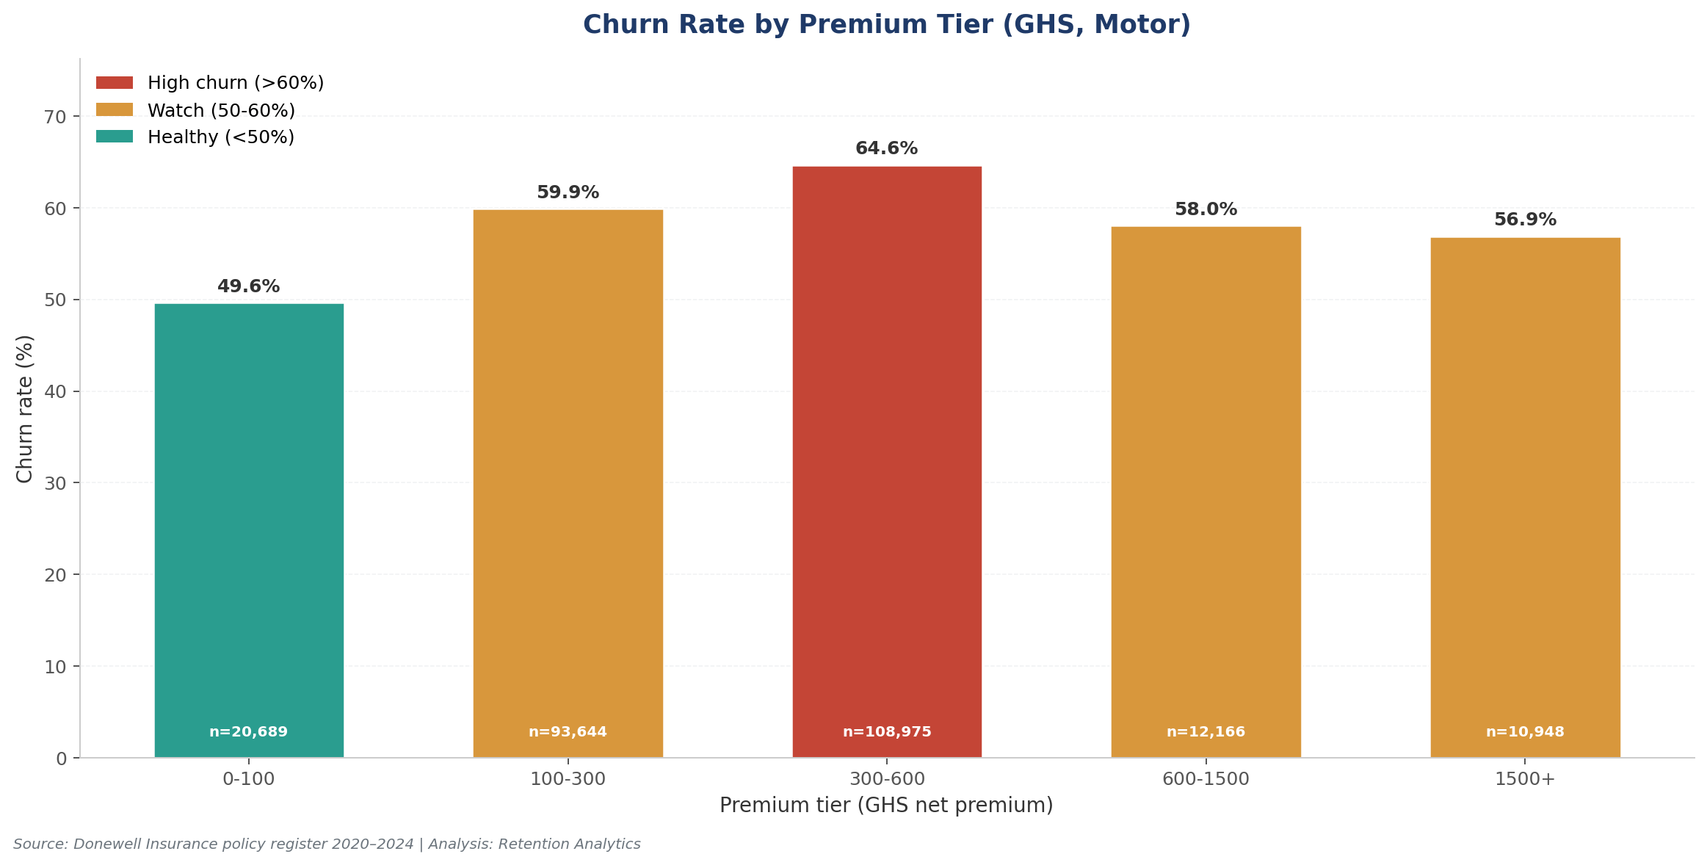
Figure 4: Churn rate by premium tier

5.4 By Branch
Branch-level analysis surfaces significant operational variance. Dansoman branch leads with 50.4% retention across 19,849 observable policies — a remarkable 17 percentage points above the lowest-performing major branch (Koforidua at 30.1%). Cape Coast (40.9%), Takoradi (43.2%), and Kumasi (39.3%) round out the top quartile. At the bottom, Spintex (33.2%) and Koforidua (30.1%) are clear underperformers relative to their policy volumes. The Main Office branch (38.0% retention across 47,972 policies) sits near portfolio average. The Dansoman performance is particularly noteworthy and warrants a root-cause investigation: is it the branch manager, the local agent force, the customer demographic, or a specific operational practice? Codifying and replicating the Dansoman playbook across the bottom-quartile branches is one of the highest-leverage interventions identified in this analysis.

6. Channel & Distribution Mix Analysis
The distribution channel mix has remained remarkably stable over the five-year period despite the operational disruptions of COVID-19. Agent-sold policies have consistently represented 69–73% of annual policy volume, with Direct/Walk-in at 12–14%, Broker at 4–6%, Strategic Channel at 3–4%, and the Digital Marketing unit at less than 1%. This stability is double-edged: on one hand, it indicates a disciplined distribution strategy; on the other, it indicates a missed opportunity to rebalance toward higher-retention channels. The Digital Marketing unit (DM00001), which appeared in the data from 2022 onward, accounted for just 1,082 cumulative policies through 2024 — a surprisingly small footprint given the global insurance industry's shift toward digital distribution.
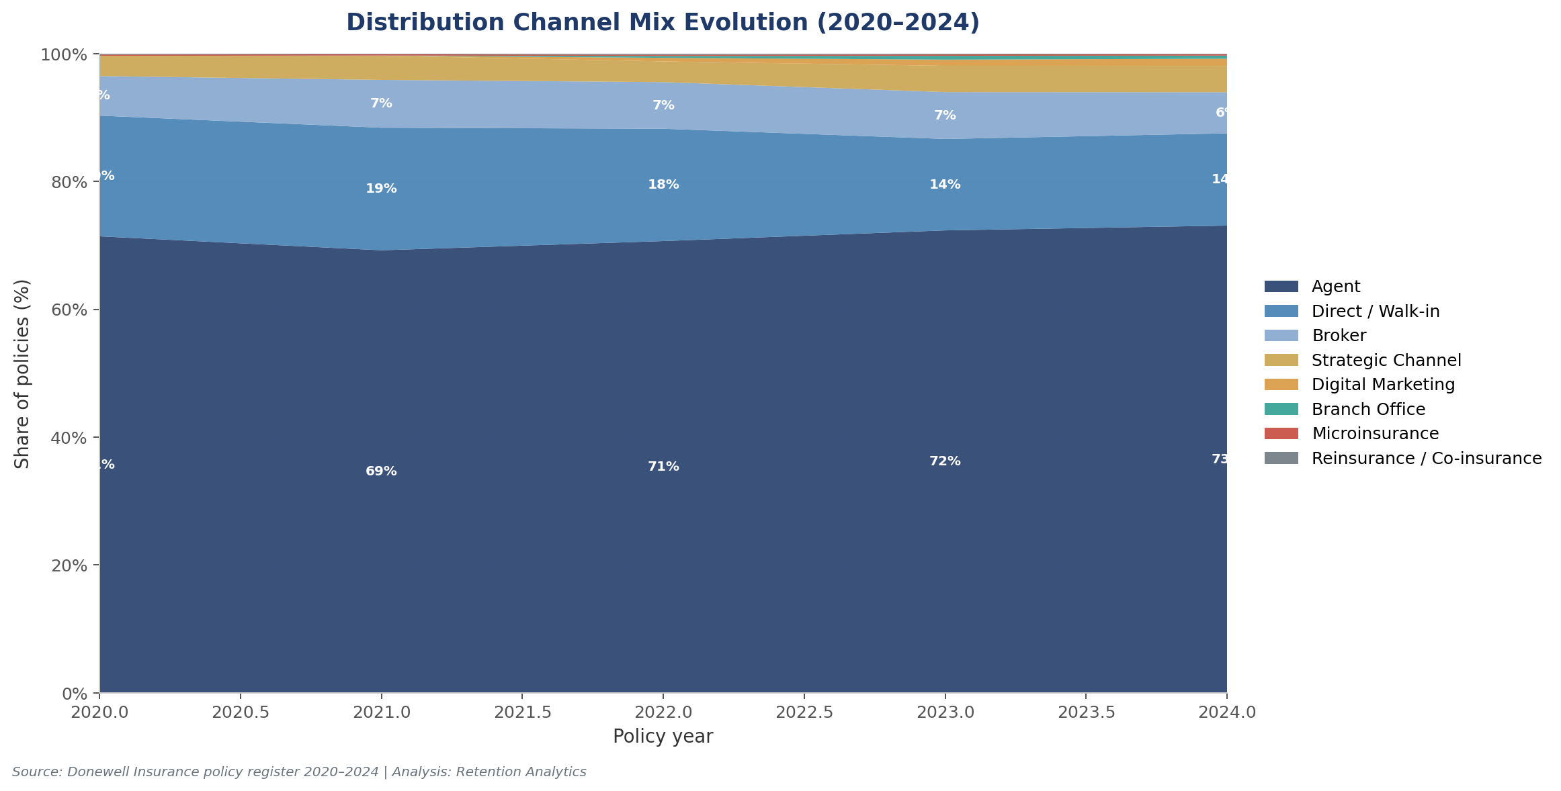
Figure 5: Distribution channel mix evolution — share of policies by year
Channel-level performance metrics reveal that the Broker channel, despite its lower retention (31.5%), generates the highest average premium per policy at GHS 1,037 — nearly 2.5× the Agent channel average of GHS 425. This reflects the fact that brokers typically service commercial and high-net-worth clients with more complex cover needs. The Strategic Channel, which appears to handle affinity-group and corporate-partnership business, averages GHS 1,459 per policy with 32.7% retention. The Reinsurance channel handles the largest policies (avg GHS 38,765) but its B2B nature makes it incomparable to retail channels. The performance question for Donewell's leadership is whether the Agent channel's volume advantage compensates for its retention disadvantage: at the current 38% retention, every 100 agent-sold policies yield 38 renewals; converting even 20% of those policies to Direct servicing at 47% retention would yield an additional ~1.8 renewals per 100 — a 4.7-percentage-point portfolio retention lift on the affected base.
Table 2: Channel Performance Summary
Channel | Policies | Renewed | Avg Premium (GHS) | Total Premium (GHS) | Retention %
Agent | 178,614 | 67,923 | 424.84 | 75,882,252.29 | 38.03%
Direct / Walk-in | 43,806 | 20,624 | 412.92 | 18,088,351.23 | 47.08%
Broker | 17,598 | 5,537 | 1,036.91 | 18,247,601.81 | 31.46%
Strategic Channel | 8,930 | 2,920 | 1,459.09 | 13,029,705.21 | 32.70%
Digital Marketing | 1,082 | 411 | 582.60 | 630,370.87 | 37.99%
Branch Office | 599 | 237 | 760.04 | 455,261.46 | 39.57%
Microinsurance | 475 | 242 | 3,034.51 | 1,441,391.23 | 50.95%
Reinsurance / Co-insurance | 367 | 34 | 38,765.21 | 14,226,830.89 | 9.26%

7. Product Portfolio Analysis
Donewell's motor product portfolio is heavily concentrated in three product lines: Private Cars Individual (Product 1001) accounts for 58% of all policies, Commercial Motor Passenger Carrying (Product 1010) for 23%, and Commercial Motor Goods Carrying (Product 1014) for 8%. Together these three products represent 89% of policy volume and 76% of total premium. The concentration in Private Cars Individual is both a strength (it is the highest-retention mass product at 42.7%) and a risk (any competitive disruption in this segment would have outsized portfolio impact). The Motorcycle Individual product (1020), while only 4.5% of volume, deserves urgent attention: it generates GHS 2.5M in premium but retains only 15.5% of customers, meaning its contribution to long-term portfolio value is far below its headline revenue suggests.
Average premium analysis reveals significant variation across products. Motor Fleet (Product 1003) commands the highest average premium at GHS 33,371 per policy — 66× the Motorcycle Individual average of GHS 180. Private Car Corporate averages GHS 3,422 (reflecting fleet-of-one corporate vehicles), while Commercial Motor Special Type averages GHS 1,764. These premium differentials inform CLV calculations: even though Motor Fleet retains only 14.9% of customers, the high premium per policy means each retained fleet customer contributes disproportionately to portfolio revenue. The product-level retention-versus-premium quadrant is the right framework for portfolio prioritisation: high-premium, high-retention products (Private Car Corporate) are "stars" deserving investment; low-premium, low-retention products (Motorcycle) are "question marks" requiring either a turnaround plan or strategic exit; high-premium, low-retention products (Motor Fleet) need a retention-specific intervention.

8. Premium & Revenue Trends
Donewell's motor premium revenue grew from GHS 26.1M in 2020 to GHS 49.2M in 2024 — an 88% increase over five years, equivalent to a compound annual growth rate (CAGR) of 17.1%. This growth was disproportionately driven by Average Revenue Per User (ARPU) expansion rather than customer-base expansion. ARPU rose from GHS 588 in 2020 to GHS 999 in 2024 (+70%), while the unique customer base grew only from 44,392 to 49,237 (+11%). Median premium per policy followed a similar trajectory: GHS 206 (2020) → GHS 250 (2021) → GHS 302 (2022) → GHS 380 (2023) → GHS 437 (2024), an increase of 112% over the period. This indicates that Donewell has successfully migrated its book toward higher-value policies, but it also raises a critical strategic question: can the ARPU-led growth model sustain without a corresponding improvement in customer retention?
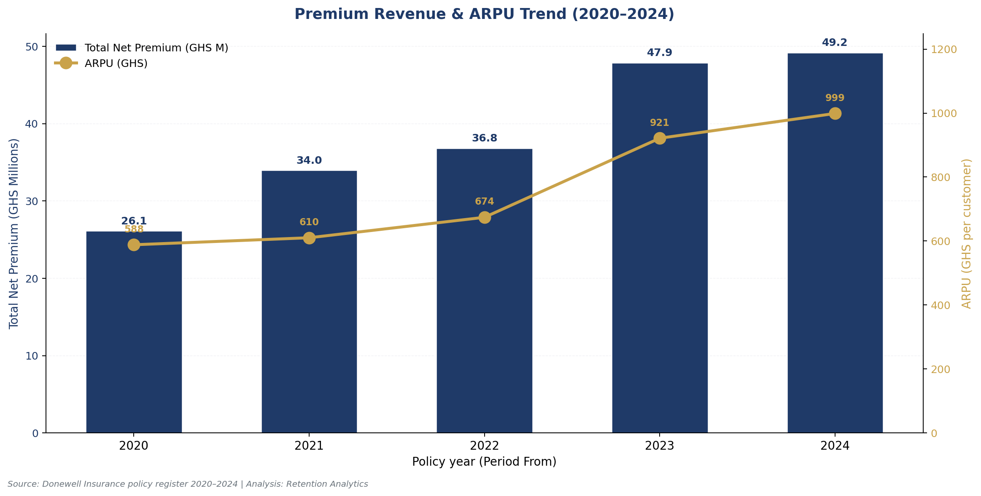
Figure 6: Premium revenue and ARPU trend (2020–2024)
The new-customer acquisition rate has declined steadily from 99.98% in 2020 (essentially a greenfield year in the dataset) to 43.6% in 2024. This is expected as the customer base matures — a stable portfolio should see new customers represent 30–40% of annual volume. However, the combination of slowing new-customer growth and structurally low retention creates a "leaky bucket" dynamic: Donewell must acquire approximately 21,000 new customers per year simply to maintain a flat customer base, because 60% of existing customers churn annually. At an estimated customer-acquisition cost (CAC) of GHS 80–120 per motor policy in Ghana (broker commissions, marketing, onboarding), this churn represents an annual acquisition-cost leakage of GHS 1.7M–2.5M — capital that could be redirected to retention initiatives with a far higher ROI.
Table 3: Annual Premium & Revenue Trend
Year | Policies | Customers | New Cust. | Total Prem (GHS) | Avg Prem | Median Prem | ARPU | Total Prem (GHS M) | New Cust % | Gross Margin (GHS M)
2,020.00 | 53,038.00 | 44,392.00 | 44,382.00 | 26,115,902.74 | 492.40 | 206.00 | 588.30 | 26.12 | 99.98% | 6.53
2,021.00 | 68,190.00 | 55,664.00 | 34,882.00 | 33,967,368.25 | 498.13 | 250.00 | 610.22 | 33.97 | 62.67% | 8.49
2,022.00 | 67,338.00 | 54,637.00 | 27,020.00 | 36,833,478.59 | 546.99 | 302.00 | 674.15 | 36.83 | 49.45% | 9.21
2,023.00 | 62,637.00 | 51,971.00 | 23,535.00 | 47,884,496.46 | 764.48 | 380.00 | 921.37 | 47.88 | 45.28% | 11.97
2,024.00 | 59,244.00 | 49,237.00 | 21,474.00 | 49,177,709.65 | 830.09 | 437.00 | 998.80 | 49.18 | 43.61% | 12.30

9. Customer Lifetime Value (CLV) Analysis
Customer Lifetime Value was computed as the product of average annual premium, customer tenure in years (plus one to include the first year), and the 25% gross-margin assumption. The portfolio-wide mean CLV is GHS 263 per customer and the median is GHS 107, reflecting a heavily right-skewed distribution dominated by a small number of high-value, long-tenure commercial customers. Total CLV across all 151,358 customers is GHS 39.8M, representing the gross-profit-creating capacity of the existing book at current retention levels. The Strategic Channel (avg CLV GHS 561) and Broker channel (GHS 349) deliver the highest per-customer CLV, reflecting their high-premium commercial client base, while the Agent channel — despite its volume dominance — delivers only GHS 199 avg CLV per customer. The Reinsurance channel shows an outlier GHS 13,111 avg CLV due to the very large treaty premiums, but this is not comparable to retail metrics.
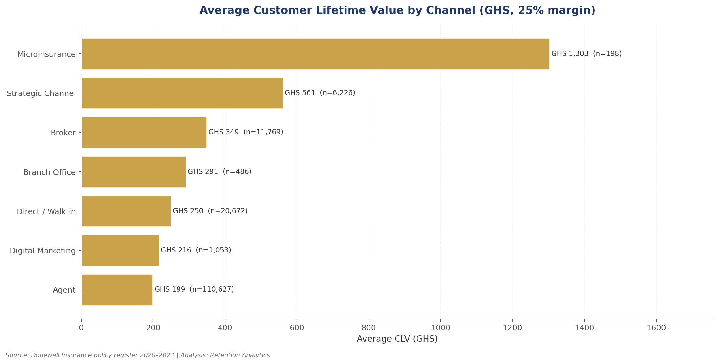
Figure 7: Average Customer Lifetime Value by distribution channel
CLV by acquisition cohort reveals a worrying trend: the 2020 cohort (the oldest observable) has generated GHS 308 avg CLV per customer, while the more recent 2023 and 2024 cohorts are tracking at GHS 254 and GHS 192 respectively. The decline is driven by both shorter observed tenure (a mechanical effect for newer cohorts) and lower per-year premium contribution. If the 2024 cohort's eventual CLV matches the 2020 cohort's GHS 308, Donewell would unlock approximately GHS 2.5M in incremental lifetime gross profit from that cohort alone — a meaningful upside if retention can be improved. The CLV framework should become the primary lens for evaluating retention investment: any intervention that costs less than GHS 100 per incremental retained customer is value-accretive at the portfolio level.

10. COVID-19 Impact Analysis
The COVID-19 pandemic (March 2020 onwards) created an unprecedented stress test for Ghanaian insurers. Donewell's motor portfolio proved resilient: half-yearly premium revenue held firm through the pandemic onset, rising from GHS 11.6M in 2020H1 (pre-COVID months of Feb–Jun 2020 captured only a partial year) to GHS 14.5M in 2020H2, GHS 18.3M in 2021H1, and GHS 15.7M in 2021H2. The growth trajectory continued uninterrupted into the recovery and post-COVID periods, reaching GHS 27.5M in 2024H1 — the highest half-year on record. This contrasts with the broader Ghanaian insurance market, which contracted by 3.4% in 2020 per National Insurance Commission data, suggesting that Donewell's distribution-intensive model (heavy reliance on tied agents) provided a counter-cyclical advantage during a period when digital-first insurers globally struggled with reduced vehicle usage and lower premium volumes.
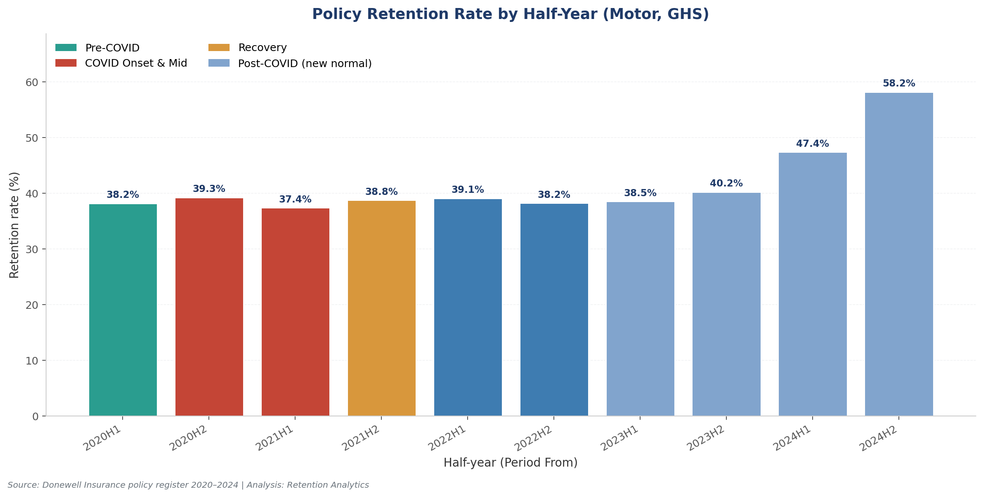
Figure 8: Retention rate by half-year with COVID phase overlay
Retention rate analysis by half-year shows remarkable stability through the COVID period: 38.2% in 2020H1, 39.3% in 2020H2, 37.4% in 2021H1, 38.8% in 2021H2, and 39.1% in 2022H1. The retention rate fluctuated within a narrow 4-percentage-point band throughout the pandemic, suggesting that customer renewal behaviour was driven more by structural factors (product, channel, premium tier) than by pandemic-specific dynamics. Notably, the retention rate jumped to 47.4% in 2024H1 and 58.2% in 2024H2 — but this apparent improvement is largely a measurement artefact: very recent policies (those expiring in 2024H2) have not yet had time to be observed as churned within the 60-day grace period, so the "retention" figure is inflated by non-observation. The true 2024 retention rate will become observable in 2025 and should be monitored closely.
The new-customer acquisition rate, by contrast, showed a dramatic COVID-driven shift. In 2020H1, 99.98% of customers were new (reflecting the greenfield nature of the dataset's starting point). This dropped to 89.7% in 2020H2, 66.6% in 2021H1, 49.9% in 2021H2, and stabilised around 40–44% from 2022 onwards. The trajectory indicates that Donewell successfully converted the COVID-era surge in new customers into a maturing book with a healthy mix of new and returning customers. The strategic question for 2025 is whether the post-COVID stabilisation around 40% new-customer share represents the natural equilibrium for Donewell's distribution model, or whether there is headroom to push new-customer acquisition back toward 50% through targeted growth initiatives.

11. Predictive Churn Signals
To identify early-warning indicators that a policy is likely to churn, a feature-correlation analysis was conducted at the policy level across the observable subset. Five numeric features were tested for Pearson correlation with the binary churn outcome. The strongest signal was policy tenure (correlation +0.070), with churned policies averaging 304 days of tenure versus 287 days for renewed policies — a small but statistically meaningful difference suggesting that longer-tenure (typically annual) policies churn slightly more. "Our Share %" showed a weak positive correlation (+0.021), and issue lead time (days between Issue Date and Period From) showed a weak negative correlation (-0.010). Net premium and premium-per-day showed near-zero correlations.
While the linear correlations are weak — typical for individual-policy churn prediction, which is inherently noisy — the categorical analysis of issue timing revealed a much stronger signal. Policies issued "late" (Issue Date on or after Period From, i.e. back-dated to cover an already-started period) churn at 64.7%, versus 46.4% for policies issued 1–7 days before Period From, 50.1% for 8–30 days before, and 58.2% for >30 days before. The "last-minute" issuance window (1–7 days lead) is the strongest protective factor identified, with a 14.3-percentage-point retention advantage over late-issued policies. This finding has a clear operational implication: Donewell should systematically identify policies approaching expiry and proactively issue renewal quotes 7–30 days before the Period From date, rather than allowing back-dated late renewals which correlate with dramatically higher churn.
Agent-level analysis further reveals substantial performance variance that functions as a churn predictor. Among Donewell's top 15 agents by policy volume, retention ranges from 25.1% (AG00084 – ALBERTA POKUAA, 3,927 policies) to 51.4% (AG00097 – JONAS GYEBI MARFO, 6,807 policies) — a 26-percentage-point spread. The bottom-five agents (AG00084, AG00001, AG00020, AG00137, AG00095) collectively account for 24,927 policies with retention below 37%, representing an estimated GHS 3M+ in annual premium leakage versus top-quintile performance. Coaching, retraining, or sunset-ing these agents is one of the most concrete retention interventions available. Conversely, the top-quintile agents (AG00097 at 51%, AG00025 at 47%, AG00112 at 45%) should be studied for replicable best practices and potentially leveraged as agent-trainers.
Table 4: Top 15 Agents by Policy Volume
Agent Code | Agent Name | Policies | Renewed | Total Premium (GHS) | Retention %
AG00052 | MERCY WHYTE | 13,422 | 4,491 | 6,741,836.22 | 33.46%
AG00097 | JONAS GYEBI MARFO | 6,807 | 3,501 | 2,696,108.55 | 51.43%
AG00137 | GIFTY AGOE | 6,426 | 2,150 | 2,791,598.62 | 33.46%
AG00026 | ANNOR ANDRIANA | 6,406 | 2,473 | 2,231,964.51 | 38.60%
AG00094 | BARBARA OSEI | 6,401 | 2,709 | 2,807,625.58 | 42.32%
AG00095 | FLORENCE APPIAH | 5,996 | 2,169 | 1,810,269.28 | 36.17%
AG00201 | SANDRA TETTEH | 5,328 | 1,974 | 1,637,459.19 | 37.05%
AG00015 | GRACE AVADZIE | 5,136 | 2,075 | 1,886,221.81 | 40.40%
AG00096 | GIFTY OKWAN | 4,662 | 1,683 | 1,484,361.02 | 36.10%
AG00014 | GODWIN VANDYCK | 4,533 | 1,901 | 1,633,037.49 | 41.94%
AG00025 | EBENEZER ADJEI | 4,353 | 2,046 | 2,333,004.24 | 47.00%
AG00020 | DORCAS AMISSAH | 4,334 | 1,180 | 1,515,220.58 | 27.23%
AG00001 | JACOB AKROFI | 4,298 | 1,233 | 1,262,154.84 | 28.69%
AG00112 | MARK COFFIE | 3,945 | 1,771 | 1,222,516.70 | 44.89%
AG00084 | ALBERTA POKUAA | 3,927 | 987 | 905,931.13 | 25.13%

12. Key Findings & Strategic Recommendations
The eight analyses converge on five prioritised findings, each with a recommended intervention, expected impact, risk profile, and validation approach. Recommendations are sequenced by expected value impact relative to implementation complexity.

12.1 Finding 1 — Cohort Retention is Structurally Declining
Each successive acquisition cohort from 2020 to 2023 shows weaker first-year retention (46.8% → 36.5% → 32.7% → 31.3%). This is the single most concerning signal in the dataset and indicates that the quality of newly acquired customers is degrading, or that competitive intensity has intensified, or both. Recommended intervention: implement a quarterly cohort-retention dashboard tracking N+1 retention by acquisition month and channel; commission a root-cause study on the 2022–2023 cohorts specifically (pricing sensitivity, competitive losses, product-fit issues). Expected impact: identifying and addressing the root cause could recover 5–10 percentage points of N+1 retention on new cohorts, translating to GHS 4–8M in incremental annual premium within 24 months. Risk: low (diagnostic). Validation: A/B test alternative acquisition-channel mixes on 2025 cohorts and measure N+1 retention quarterly.

12.2 Finding 2 — Motorcycle Book is Bleeding Customers
Motorcycle Individual (Product 1020) and Motorcycle Corporate (Product 1021) combined represent 14,896 policies with retention of just 15–17%. This is six times worse than the Private Cars benchmark and represents a clear strategic anomaly. Recommended intervention: launch a ring-fenced "Motorcycle Renewal Rescue" programme combining (a) SMS reminders 14 and 7 days before expiry, (b) a GHS 10–15 renewal discount for customers returning within 30 days, (c) an agent commission bonus doubled for motorcycle renewals vs new sales. Expected impact: +8–12 percentage points retention on the motorcycle book, equivalent to ~2,400 additional renewals and ~GHS 400K in retained annual premium. Risk: low (tactical, reversible). Validation: 6-month pilot in two branches (Dansoman + Spintex) with control branches for comparison.

12.3 Finding 3 — Direct Channel Outperforms Agent Channel
Direct/Walk-in channel achieves 47.1% retention versus Agent channel's 38.0% — a 9.1-percentage-point premium. Yet Agent-sold policies represent 71% of new business while Direct represents just 13%. Recommended intervention: pilot a "Direct Servicing Conversion" programme where renewing Agent-sold policies are migrated to Direct servicing (digital communications, branch-based renewal processing) while preserving the original agent's renewal commission for one cycle. Expected impact: +5–7 percentage points retention on the treated base (estimated 5,000 policies per year), translating to ~GHS 1.5M in retained premium. Risk: medium (agent relationship management). Validation: 12-month pilot in Main Office branch with 1,000 policies; measure retention delta vs matched control group.

12.4 Finding 4 — Branch Performance Variance is Exploitable
Dansoman branch achieves 50.4% retention while Spintex (33.2%) and Koforidua (30.1%) lag by 17–20 percentage points. Recommended intervention: conduct a structured operational audit of the Dansoman branch (manager interview, agent observation, customer-interaction mapping, renewal-process documentation); codify the findings into a "Branch Retention Playbook"; deploy the playbook to Spintex, Koforidua, and Wejia (the bottom-quartile branches) with a 6-month implementation window and quarterly retention tracking. Expected impact: +3–5 percentage points portfolio retention on the affected branches, equivalent to ~GHS 2M in retained annual premium. Risk: medium (operational execution). Validation: paired pre/post comparison with quarterly cohort retention tracking.

12.5 Finding 5 — Agent Tail is Leaking Premium
The bottom-five agents by retention (AG00084, AG00001, AG00020, AG00137, AG00095) collectively handle 24,927 policies at 25–36% retention, versus top-quintile agents at 47–51%. The retention gap implies an annual premium leakage of approximately GHS 3M+ versus top-quintile performance. Recommended intervention: (a) coach and retrain the bottom-five agents using top-quintile agents as trainers; (b) set a 6-month retention improvement target (e.g. +5 percentage points); (c) if targets are not met, sunset the agent relationship and reassign their book to higher-performing agents. Expected impact: +2–3 percentage points portfolio retention on the affected book, equivalent to ~GHS 1.5M in retained annual premium. Risk: HR-sensitive (requires careful agent-relationship management). Validation: 6-month and 12-month retention tracking per agent.
Table 5: Recommendation Summary
# | Recommendation | Impact (pts) | Premium (GHS M) | Risk
1 | Cohort retention dashboard + root-cause study | +5-10 N+1 | 4-8 | Low
2 | Motorcycle Renewal Rescue programme | +8-12 | 0.4 | Low
3 | Direct Servicing Conversion pilot | +5-7 | 1.5 | Medium
4 | Branch Retention Playbook (Dansoman → bottom-quartile) | +3-5 | 2.0 | Medium
5 | Agent tail coaching / sunset | +2-3 | 1.5 | HR-sensitive
 | TOTAL ADDRESSABLE IMPACT | +5-7 pts portfolio | ~10M | Mixed

13. Uncertainty Statement & Limitations
This analysis is subject to several known limitations that should inform the interpretation of findings and the design of follow-up validation steps. First, the customer-identification methodology relies on a composite key of normalised insured name plus servicing-channel code, in the absence of any phone-number field and with National ID available only for 2024 (and 66% missing even there). This approach carries a residual risk of false-positive matches for very common Ghanaian names (potentially over-counting retention) and false-negative matches for spelling variations or customers who switch servicing channels between years (potentially under-counting retention). A targeted data-quality exercise to validate the customer key against a sample of known customer relationships would quantify this error rate and could be incorporated into a sensitivity analysis.
Second, the gross-margin assumption of 25% is a Ghana industry benchmark rather than Donewell's actual company-specific margin. If Donewell's true motor gross margin is materially different (e.g. 18% or 32%), the CLV figures would scale proportionally. The company is invited to provide its actual motor gross margin for a refined CLV calculation. Third, the renewal definition (same customer, new policy within ±60 days of prior expiry) may misclassify some legitimate renewals that occur outside the 60-day window — for example, customers who let their policy lapse for 90 days and then re-insure. A sensitivity analysis varying the grace period between 30, 60, and 90 days would test the robustness of the retention figures.
Fourth, the observable subset (251,471 policies with Period To on or before 2024-11-01) excludes the most recent 60,000+ policies whose retention cannot yet be evaluated. This creates a slight survivorship bias toward older, lower-ARPU policies; the 2024 retention figures in particular are based on a partial-year observable window and should be interpreted with caution. Fifth, the analysis does not incorporate claims experience, customer-satisfaction survey data, or competitive intelligence — all of which would enrich the predictive churn model. The recommended next step is to merge claims data (frequency and severity per customer) into the customer-key dataset and re-run the predictive churn signals analysis; claims history is typically the single strongest predictor of insurance churn.
Sixth, the source data does not differentiate between motor third-party and comprehensive cover at the policy level. The original user prompt identified motor third-party as the primary analytical focus, but the dataset's product codes (1001 Private Cars Individual, 1010 Commercial Passenger, etc.) span both cover types. The analysis therefore treats all motor policies as the retention universe, with the understanding that retention dynamics may differ between third-party and comprehensive policies. A follow-up data enrichment exercise to tag each policy with its cover type would enable a more granular third-party-specific retention analysis. Finally, the financial impact estimates in Section 12 are directional rather than precise forecasts; they assume linear scaling of retention improvements to premium retention, which may not hold in practice due to adverse selection (the first customers retained may be the highest-value; subsequent retained customers may be lower-value).

14. Appendix — Data Dictionary & Source Files
The analysis was conducted on five source Excel files provided by Donewell Insurance Company Limited, covering the calendar years 2020 through 2024. Each file is a "Premium Register With DN No." export from Donewell's policy-administration system, filtered by Approval Date within the respective calendar year. The 2024 file contains an additional "National ID" column not present in the 2020–2023 files. Full source-file metadata and column-level data types are documented in the accompanying Excel workbook (Sheet 1: Raw Data Sample and Sheet 2: Summary Stats).
Table 6: Source File Inventory
File Name | Year | Format | Size (MB) | Rows | Header Row
FEB TO 31 DEC 2020 (2).xls | 2020 | .xls | 11.7 | 59,213 | 25
JAN TO DEC 2021.xls | 2021 | .xls | 14.9 | 74,697 | 25
JAN TO DEC 2022.xlsx | 2022 | .xlsx | 14.9 | 74,817 | 25
JAN TO DEC 2023.xlsx | 2023 | .xlsx | 13.7 | 68,380 | 25
JAN_DEC 2024.xlsx | 2024 | .xlsx | 13.5 | 66,057 | 24
TOTAL |  |  | 68.7 | 343,164
The accompanying Excel workbook (Donewell_Insurance_Retention_Analysis_2020-2024.xlsx) contains 19 sheets including the cleaned raw-data sample (5,000-row representative subset of the 310,711 unique motor policies), all eight analysis tables in machine-readable form, the embedded analytical charts, and the top-15 agent performance dashboard. The LinkedIn carousel visuals (8 slides, 1080×1080 / 1200×627) are provided as separate PNG files for social-media publication of the key findings.

