ABSTRACT
Deepfake technology has rapidly evolved with the advancement of generative artificial intelligence, creating a major threat to digital trust in financial Video Know Your Customer (KYC) systems. Financial institutions are increasingly exposed to manipulated identity verification videos, especially in low-resolution environments where compression noise, weak lighting, motion blur, and unstable facial regions reduce the effectiveness of traditional detection methods.

Remote photoplethysmography (rPPG) serves as the foundational component of the proposed deepfake video detection framework designed for low-resolution KYC environments. The architecture follows a two-stage approach in which physiological signal analysis acts as the primary evidence layer, while hybrid quantum-classical classification functions as the final decision-making stage for authentication.
Video preprocessing and physiological feature extraction are performed through frame extraction, frame quality assessment, face detection, tracking, alignment, low-resolution enhancement, and region-of-interest selection. Temporal physiological signals are extracted from facial skin regions such as the cheeks and forehead to evaluate pulse consistency, biological synchronization, and rhythm stability. Generated features are transformed into compact feature vectors and supplied to a hybrid quantum machine learning classifier for final discrimination between genuine and manipulated videos.

Physiological consistency analysis forms the core principle of the proposed framework by emphasizing low-resolution robustness rather than relying solely on benchmark-quality media assumptions. Instead of depending entirely on visible image artifacts, the system evaluates whether facial behavior exhibits characteristics of a real living subject over time through biological signal verification. Confidence-aware prediction outputs such as real, fake, and uncertain are generated, making the architecture suitable for practical financial verification and identity authentication workflows.

TABLE OF CONTENTS
Chapter No. | Title | Page No.
 | ABSTRACT | 1
 | LIST OF FIGURES | 4
 | LIST OF TABLES | 5
1 | INTRODUCTION | 6
1.1 | Overview | 6
1.2 | Motivation | 6
1.3 | Objective | 7
1.4 | Scope | 7
1.5 | Existing System | 8
1.6 | Proposed System | 9
2 | PROBLEM STATEMENT | 10
2.1 | Problem Statement | 11
2.2 | Motivation | 12
2.3 | Objectives | 13
3 | DETAILED LITERATURE SURVEY | 14
4 | SURVEY SUMMARY TABLE | 23
5 | SYSTEM REQUIREMENT SPECIFICATION | 26
5.1 | Functional Requirements | 26
5.2 | Non-functional Requirements | 26
5.3 | Hardware Requirements | 27
5.4 | Software Requirements | 27
6 | SYSTEM DESIGN | 29
6.1 | System Design | 29
6.1.1 | System Architecture | 29
6.1.2 | Module Design | 31
6.2 | Detailed Design | 33
6.2.1 | Class Diagram | 33
6.2.2 | Activity Diagram | 34
6.2.3 | Use Case Diagram | 36
6.2.4 | ER Diagram | 37
6.2.5 | Scenarios | 38
7 | CONCLUSION | 40
 | REFERENCES | 41

LIST OF FIGURES

1.1 | Proposed Framework
6.1 | System Architecture | 30
6.2 | Class Diagram | 33
6.3 | Activity Diagram | 34
6.4 | Use Case Diagram | 35
6.5 | ER Diagram | 36

LIST OF TABLES

4.1 | Survey Summary Table | 24
6.1 | Scenarios | 37

CHAPTER 1

INTRODUCTION

1.1 Overview

Deepfake technology represents Artificial Intelligence (AI) -generated synthetic media that manipulate facial appearance using deep learning techniques. Rapid advancements in this field have created major concerns in identity verification systems, especially in financial video KYC environments where user authentication depends on facial verification through low-resolution videos.

Financial KYC verification forms the primary application focus of the proposed deepfake video detection system, where input videos may contain compression noise, weak lighting, motion blur, unstable face regions, and bandwidth limitations. The system is designed specifically for low-resolution environments where traditional forensic cues become unreliable.

Remote photoplethysmography (rPPG) and hybrid quantum machine learning constitute the core components of the proposed two-stage verification architecture. The first stage uses rPPG for physiological signal analysis, while the second stage performs final classification using hybrid quantum techniques. The architecture combines preprocessing, facial tracking, (Region of Intrest) ROI extraction, temporal signal analysis, feature conditioning, and confidence-aware classification into a unified framework.

1.2 Motivation
Financial institutions increasingly depend on remote video verification systems for customer onboarding and identity validation. However, manipulated deepfake videos can bypass conventional authentication mechanisms and support identity fraud. Existing systems mainly focus on visual artifact analysis and perform poorly under low-resolution conditions.
Project is motivated by the need to:
- Improve fraud prevention in financial verification systems.
- Develop robust low-resolution deepfake detection mechanisms.
- Use physiological consistency instead of only texture analysis.
- Explore hybrid quantum machine learning for subtle feature classification.
- Support confidence-aware decision-making in practical KYC workflows.

1.3 Objective
The objectives of the proposed project are:
- To extract video frames and perform standardization for reliable model input.
- To analyze frame sequences and extract facial cues using tracking and consistency checks.
- To incorporate rPPG-based liveness detection for physiological authentication.
- To integrate a hybrid quantum-classical decision layer for improved classification accuracy
- To support low-resolution financial KYC verification environments.

1.4 Scope
Project focuses specifically on deepfake detection in low-resolution KYC video systems used in financial verification workflows. The architecture is not designed as a general-purpose social media deepfake detector but as a secure identity verification framework.
The scope of the project includes:
- Low-resolution video preprocessing.
- Face detection and alignment.
- rPPG-based physiological analysis.
- Temporal feature extraction.
- Hybrid quantum-classical classification.
- Confidence-aware verification outputs.
Limitations include:
- Dependence on facial visibility.
- Sensitivity of physiological extraction to motion and lighting conditions.
- Experimental nature of hybrid quantum learning frameworks.

1.5 Existing System
Existing deepfake detection systems include Convolutional Neural Network (CNN) based models, Convolutional Neural Network – Gated Recurrent Unit (CNN-GRU) hybrid models, transformer-based systems, and multimodal audio-visual architectures. These methods mainly depend on visual artifacts, temporal inconsistencies, or multimodal fusion for classification.
Major existing approaches include:
- CNN-Based Detection Systems
- Use frame-level texture analysis.
- Limited temporal awareness.
- Weak performance under low-resolution conditions.
- Hybrid CNN-GRU Architectures
- Capture spatial and temporal information.
- Require stable sequential inputs.
- Limited generalization capability.
- rPPG-Based Physiological Systems
- Analyze biological pulse-related signals.
- Sensitive to lighting and motion variations.
- Multimodal Transformer Systems
- Combine audio and visual signals.
- High computational complexity.
- Limited real-time applicability.

1.6 Proposed System
Physiological verification forms the foundation of the proposed deepfake detection framework designed specifically for low-resolution financial KYC video environments using remote photoplethysmography (rPPG) and hybrid quantum machine learning techniques. The architecture follows a structured two-stage verification pipeline that combines physiological signal analysis with advanced hybrid classification to enable reliable deepfake detection under compressed, noisy, and low-quality video conditions.
Remote photoplethysmography (rPPG) analysis constitutes the first stage of the framework, where temporal pulse-related physiological signals are extracted from facial skin regions such as the cheeks and forehead. The extracted signals are analyzed to evaluate biological consistency, temporal rhythm stability, pulse synchronization behavior, and liveness-related characteristics across consecutive video frames. This stage focuses on determining whether the observed facial behavior represents a genuine human physiological pattern or an artificially manipulated deepfake sequence.
Hybrid quantum-classical machine learning serves as the second stage of the framework, where generated physiological and temporal features are transformed into compact normalized feature representations and supplied to the classification module. The classification layer performs final discrimination between genuine and manipulated videos by learning subtle physiological inconsistencies and low-resolution temporal patterns that are difficult to capture using conventional visual-forensic approaches alone.
Low-resolution robustness, physiological liveness verification through rPPG-based temporal biological signal analysis, reliable deepfake detection under compressed KYC video conditions, advanced hybrid quantum-enhanced classification, and confidence-aware authentication outputs collectively represent the key features of the proposed system.
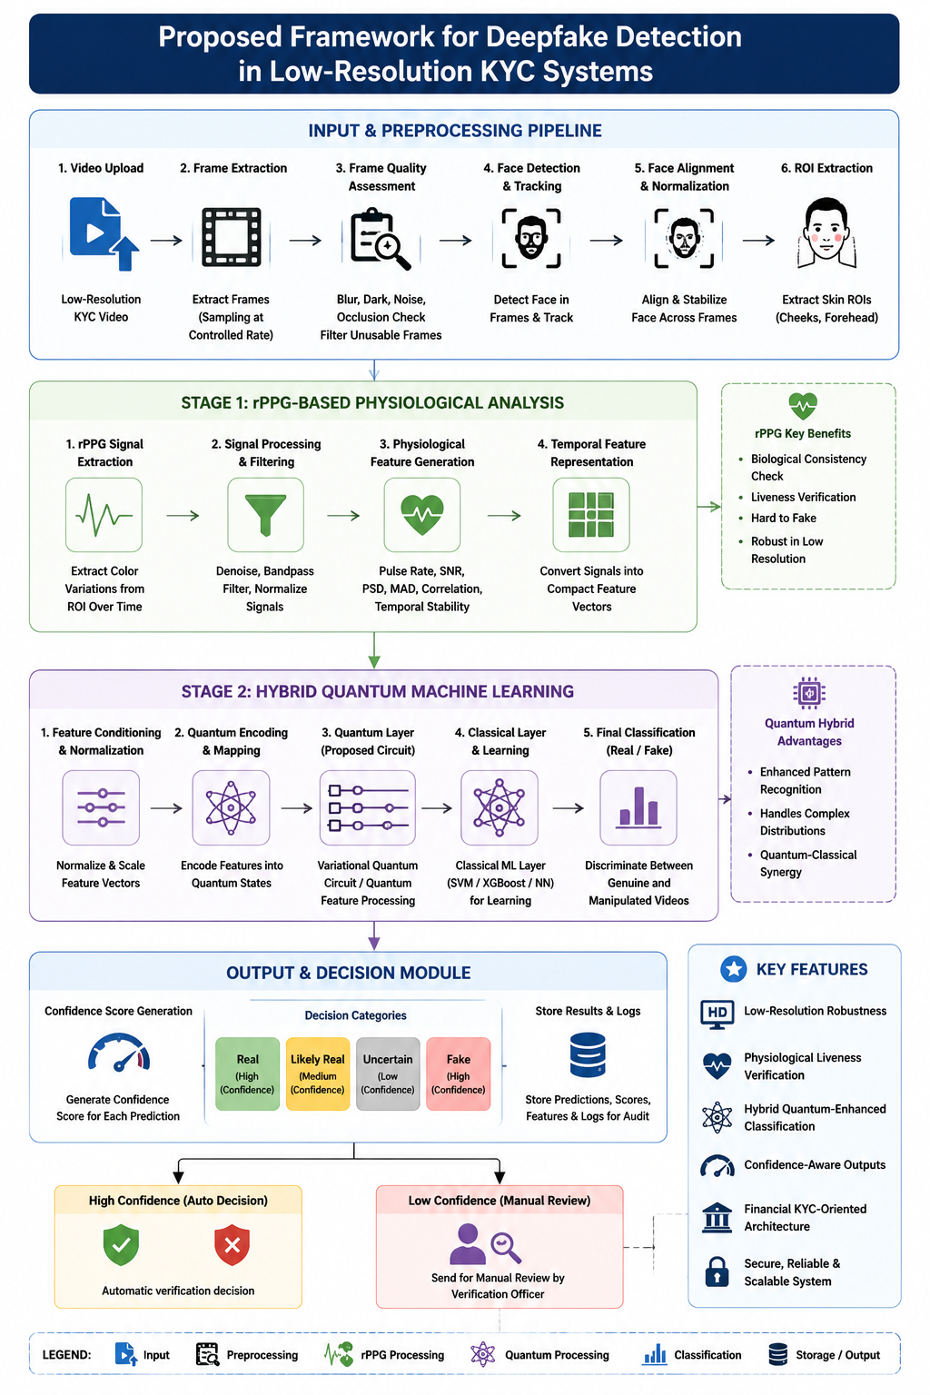
Figure 1.1 - Proposed Framework for Deepfake Detection in Low-Resolution KYC Systems (generated by ChatGPT)

CHAPTER 2

PROBLEM STATEMENT

2.1 Problem Statement
Low-resolution financial KYC environments present significant challenges for deepfake video detection due to factors such as poor video quality, compression artifacts, unstable facial regions, motion blur, weak lighting conditions, and the limited availability of reliable forensic features. Traditional deepfake detection approaches primarily depend on visible texture inconsistencies and spatial visual artifacts; however, these indicators become considerably weaker and less reliable when videos are heavily compressed or captured under degraded real-world conditions.
Mobile-based KYC verification systems frequently generate videos under bandwidth limitations and unstable environmental conditions, resulting in facial information that may contain noise, inconsistent illumination, facial jitter, and temporal distortion. Such degradations negatively affect conventional image-forensics-based detection models and reduce their ability to perform accurate authentication. Existing approaches that focus exclusively on frame-level visual analysis often fail to maintain reliable performance when applied to low-resolution KYC videos.
Financial institutions require robust identity authentication mechanisms capable of operating effectively in real-world low-quality video environments without increasing false acceptance and false rejection rates. False acceptance can facilitate identity fraud and unauthorized access, while false rejection can disrupt legitimate customer verification workflows and reduce operational efficiency. Consequently, there is a growing need for physiologically grounded deepfake detection systems capable of evaluating biological consistency rather than relying entirely on visible appearance artifacts.
Remote photoplethysmography (rPPG)-based physiological verification combined with hybrid quantum-classical machine learning provides a promising solution to these challenges by improving deepfake detection robustness in low-resolution financial KYC systems. The integration of physiological signal analysis with advanced classification techniques enables more reliable authentication by identifying biological inconsistencies that remain difficult for manipulated deepfake videos to reproduce accurately.

2.2 Motivation

Secure financial KYC verification serves as the primary motivation behind the proposed project, with the objective of preventing identity fraud and reducing false authentication decisions in poor-quality video environments. Existing visual-artifact-based detection approaches often become unreliable under degraded low-resolution conditions, creating the need for alternative evidence sources that remain stable and informative even when visual quality is significantly compromised.

Physiological realism forms the central focus of the proposed framework rather than relying entirely on facial texture artifacts and appearance-based forensic cues. Biological signals such as pulse-related temporal colour variations are inherently difficult to reproduce consistently in manipulated videos, making remote photoplethysmography (rPPG)-based analysis a promising solution for practical liveness verification. The framework therefore emphasizes temporal physiological consistency as a stronger and more reliable indicator of authenticity compared to traditional appearance-based detection methods.

Deepfake-enabled financial fraud and the increasing adoption of AI-generated synthetic identities in online verification systems further strengthen the motivation for this research. Real-world KYC environments frequently operate under constraints such as low bandwidth, compression noise, unstable lighting conditions, and inconsistent facial visibility, all of which reduce the effectiveness of conventional deepfake detection pipelines and increase the need for more robust authentication mechanisms.

Increasing deepfake-based fraud attempts targeting financial identity verification systems, the weakness and instability of traditional image-forensics approaches under low-resolution and compressed video conditions, the need for confidence-aware authentication mechanisms capable of supporting practical financial verification workflows, the growing importance of physiological liveness verification through rPPG-based temporal signal analysis, emerging research opportunities in hybrid quantum-classical machine learning for advanced deepfake classification, and the requirement for robust and scalable verification systems suitable for real-world financial applications collectively provide strong motivation for the development of the proposed framework.

2.3 Objectives
Robust deepfake detection in low-resolution financial KYC environments represents the primary objective of the proposed work, which combines physiological signal analysis with hybrid quantum machine learning techniques to improve authentication reliability. The framework aims to enhance verification accuracy by integrating temporal biological validation with advanced classification mechanisms capable of operating effectively under real-world degraded video conditions.
Low-resolution video preprocessing constitutes an essential objective of the proposed system, focusing on preserving critical temporal and physiological information despite compression artifacts, noise, weak lighting, and other forms of video degradation commonly observed in financial KYC environments.
Frame extraction, facial localization, face alignment, and region-of-interest selection are important objectives that enable stable facial analysis and accurate physiological signal acquisition from low-resolution KYC videos. These operations ensure consistent facial positioning and reliable feature generation throughout the processing pipeline.
Remote photoplethysmography (rPPG)-based physiological signal extraction serves as a key objective of the framework by capturing pulse-related biological information from facial skin regions such as the cheeks and forehead. These physiological signals provide valuable evidence for distinguishing genuine videos from manipulated deepfake content.
Temporal physiological analysis focuses on evaluating pulse consistency, biological synchronization behavior, and rhythm stability across consecutive video frames. The objective of this stage is to identify physiological irregularities and temporal inconsistencies that may indicate the presence of deepfake manipulation.
Compact physiological feature representation generation is another important objective that transforms raw physiological signals into structured and normalized feature vectors suitable for efficient machine learning-based classification and decision-making processes.

CHAPTER 3

DETAILED LITERATURE SURVEY

Generative Adversarial Network (GAN)-based forensic analysis, machine learning models, CNN-based architectures, and blockchain-assisted approaches are surveyed in this paper for deepfake detection across multiple domains. The study compares robustness, accuracy, and applicability of different techniques while identifying challenges such as poor generalization to unseen manipulations, low-resolution limitations, lack of standardized datasets, and limited real-time deployment support. The absence of unified multimodal frameworks integrating spatial, temporal, physiological, and frequency-domain analysis remains a significant research challenge. [1]

Convolutional Neural Network (CNN)-based real-time deepfake detection is proposed in this framework trained on approximately 15,000 images for identifying manipulation artifacts and abnormal facial patterns. Feature extraction and adaptive loss functions improve robustness against compression and adversarial attacks; however, the architecture struggles with unseen manipulations, limited temporal learning capability, lack of multimodal understanding, and scalability challenges associated with evolving deepfake attacks. [2]

Multimodal Vision Transformer (MViT)-Forensics combines RGB embeddings, frequency-domain features, and rPPG signals using a cross-attention transformer architecture for deepfake detection. The system generates authenticity confidence scores and demonstrates high accuracy across benchmark datasets, but requires heavy computational resources, offers limited explainability, and faces deployment difficulties under severe compression, lighting variation, and unseen manipulation conditions. [3]

Signal-to-Noise Ratio (SNR), Power Spectral Density (PSD), Pearson Correlation Coefficient (PCC), Mean Absolute Deviation (MAD), and Standard Deviation (SD)-based synchronization analysis is used in this Sync_rPPG framework to evaluate physiological inconsistencies in videos. Discrete Wavelet Transform (DWT), Convolutional Neural Network (CNN), and Long Short-Term Memory Network (LSTM) architectures are integrated for spatial and temporal learning. However, sensitivity to motion blur, facial occlusion, poor lighting, and compressed video quality limits robustness and practical applicability. [4]

Quantum-enhanced deepfake detection architecture integrating Xception CNN, Vision Transformer, and quantum convolutional layers implemented through PennyLane is presented for advanced feature representation learning. Augmentation strategies improve robustness and classification performance, but practical deployment remains challenging due to limited quantum hardware availability, expensive training costs, computational complexity, and lack of benchmark datasets for hybrid quantum-classical systems. [5]

Multi-Stream Convolutional Neural Network (CNN) architecture processes spatial, spectral, and temporal information using face alignment, optical flow analysis, residual mapping, and rPPG feature extraction for deepfake detection. Attention-based feature fusion improves classification capability, although the framework remains computationally intensive, difficult to deploy on edge devices, highly dependent on preprocessing quality, and limited in generalizing to unseen deepfake techniques. [6]

Electronic Know Your Customer (e-KYC)-oriented deepfake detection compares facial embeddings extracted from uploaded videos with registered authentic images to identify identity mismatches and spoofing attempts. The framework effectively detects face swapping and reenactment attacks while maintaining resilience to image degradation; however, dependence on registered images and lack of lightweight privacy-preserving deployment mechanisms reduce practical scalability. [7]

Xception-GRU-based two-branch deepfake detection architecture combines global video analysis with local artifact processing using Face-Cutout augmentation techniques. The framework improves low-resolution and cross-dataset detection performance but struggles under highly compressed conditions while increasing computational complexity and training requirements against advanced GAN-based manipulations. [8]

EffiSwinNet hybrid architecture combines EfficientNetB0 and Swin Transformer models for analyzing StyleGAN-generated deepfake images through local and global contextual feature extraction. Although the framework achieves strong image-level classification performance, high computational requirements and absence of multimodal temporal and physiological analysis limit real-world deployment capability. [9]

Remote photoplethysmography (rPPG)-based deepfake detection approaches are reviewed in this study for distinguishing real and manipulated videos using physiological skin color variations. Spatial, frequency-domain, GAN-based, and autoencoder-based techniques are analyzed; however, poor lighting conditions, motion blur, compression artifacts, and lack of standardized physiological datasets remain major limitations. [10]

Quantum Approximate Optimization Algorithm (QAOA)-based feature selection combined with quantum-inspired attention mechanisms is utilized in this hybrid quantum-classical framework for enhanced deepfake detection. Gradient-weighted Class Activation Mapping (Grad-CAM) improves explainability, while classification performance is strengthened through optimized feature selection. Nevertheless, scalability issues, computational complexity, and limited quantum hardware availability continue to restrict practical implementation. [11]

DeepFake Detection Challenge Dataset (DFDC)-based CNN framework is designed for detecting short-duration and low-resolution deepfake videos using facial feature extraction and manipulation artifact analysis. The framework performs effectively on compressed social-media videos but struggles with extreme compression conditions, limited temporal learning capability, and lack of multimodal physiological and temporal analysis integration. [12]

Long Short-Term Memory Network (LSTM) and Gated Recurrent Unit (GRU)-based recurrent deep learning framework combines convolutional feature extraction with sequential temporal analysis to capture motion inconsistencies in deepfake videos. Although the architecture improves temporal learning compared to traditional recurrent networks, computational complexity and lack of robustness against adversarial and unseen attacks remain important challenges. [13]

Gated Recurrent Unit (GRU)-integrated CNN architectures using EfficientNet-B1, InceptionV3, DenseNet121, and Xception models are investigated for capturing temporal dependencies in manipulated videos. Sequential learning enhances detection accuracy, but high computational cost, reduced generalization capability, and absence of explainability and multimodal fusion strategies limit performance. [14]

EffiSwinNet hybrid deepfake detection framework combines EfficientNetB0 and Swin Transformer architectures to improve local and global contextual learning for StyleGAN-generated image classification. Despite strong detection performance, the framework focuses mainly on image-based analysis and lacks temporal, physiological, and frequency-domain forensic integration required for robust video-level detection. [15]

Two-branch Xception-GRU deepfake detection framework performs global video analysis alongside local artifact processing using augmentation techniques for improved low-resolution detection. While cross-dataset detection capability is improved, highly compressed videos remain difficult to analyze and the dual-branch structure significantly increases computational and memory requirements. [16]

Multi-Stream CNN-based multimodal deepfake detection simultaneously processes spatial, spectral, and temporal information using optical flow analysis, residual mapping, face alignment, and rPPG signal extraction. Attention-based feature fusion improves classification performance, but real-time deployment difficulty and dependence on preprocessing quality limit robustness against unseen manipulations. [17]

Electronic Know Your Customer (e-KYC)-focused deepfake detection compares uploaded video embeddings with registered authentic images to identify identity inconsistencies and spoofing attacks. Although the framework demonstrates resilience against image degradation and reenactment attacks, dependence on authentic registered images and lack of lightweight deployment mechanisms reduce practical feasibility. [18]

Receiver Operating Characteristic - Area Under the Curve (ROC-AUC)-optimized hybrid classical-quantum deepfake detection architecture integrates Xception CNN, Vision Transformer, and Quantum Convolutional Layers for improved feature representation and classification performance. Strong ROC-AUC and F1-score results are achieved, but limited quantum hardware availability, high computational costs, and lack of benchmark datasets remain significant deployment barriers. [19]

enerative Adversarial Network (GAN)-forensic techniques, CNN-based methods, and blockchain-assisted frameworks are surveyed in this study for deepfake detection across multiple application domains. Spatial, temporal, and forensic analysis methods are compared while highlighting weaknesses in handling emerging GAN-based and diffusion-model-generated deepfakes, emphasizing the need for more adaptive detection systems. [20]

CHAPTER 4

SURVEY SUMMARY TABLE
S. No | Paper Title | Methodology | Key Techniques | Research Gap
1 | A Study on Deepfake Detection Methods | Survey and comparative analysis | CNN, GAN, Blockchain | Lack of unified robust systems
2 | CNN-based Authentication Framework | Real-time CNN detection | CNN, adaptive loss | Poor generalization
3 | MViT-Forensics | Multimodal transformer framework | ViT, Swin, rPPG | High computational complexity
4 | Sync_rPPG | Physiological signal synchronization | rPPG, CNN-LSTM, DWT | Sensitive to lighting and motion
5 | Quantum-Enhanced Detection | Hybrid quantum-classical model | Xception, ViT, Quantum layers | Quantum hardware limitations
6 | MS-CNN with Attention Fusion | Multi-stream multimodal CNN | Attention fusion, optical flow | Expensive computation
7 | e-KYC Deepfake Detection | Identity inconsistency analysis | Face embeddings, temporal analysis | Dependence on registered images
8 | Two-Branch Xception | Global-local branch detection | Xception, GRU | Heavy computational cost
9 | EffiSwinNet | Hybrid CNN-transformer model | EfficientNet, Swin Transformer | Limited video-level analysis
10 | rPPG Deepfake Overview | Survey of physiological detection | rPPG, GAN, AE | Lack of hybrid frameworks
11 | Quantum-Hybrid Framework | QAOA-based feature selection | QAOA, CNN, attention | Scalability issues
12 | Low-Resolution CNN Detection | CNN-based low-quality detection | CNN, DFDC, FF++ | Weak temporal learning
13 | Hybrid Recurrent Model | Temporal recurrent learning | CNN, LSTM, GRU | Limited multimodal analysis
14 | Hybrid GRU-CNN Model | CNN-GRU hybrid framework | EfficientNet, GRU | High computational cost
15 | EffiSwinNet | CNN-transformer hybrid model | EfficientNet, Swin Transformer | Limited video analysis
16 | Two-Branch Xception | Global-local branch detection | Xception, GRU | Heavy computation
17 | MS-CNN with Attention Fusion | Multimodal CNN fusion | Optical flow, attention | Expensive computation
18 | e-KYC Deepfake Detection | Identity inconsistency detection | Face embeddings | Dependence on registered images
19 | Quantum-Enhanced Deepfake Detection | Hybrid quantum-classical framework | Xception, ViT, Quantum Layers | Quantum hardware limitations
20 | A Study on Deepfake Detection Methods | Literature survey and analysis | CNN, GAN, Blockchain | Lack of unified robust systems
Table 4.1 - Survey Summary Table

CHAPTER 5

SYSTEM REQUIREMENT SPECIFICATION

5.1 Functional Requirements

The proposed deepfake detection framework is designed to perform secure and reliable authentication of low-resolution financial KYC videos through a structured processing pipeline. The system integrates video preprocessing, physiological signal analysis, feature generation, and hybrid quantum-classical classification to identify manipulated videos while maintaining robustness under real-world verification conditions.
- The system should accept low-resolution KYC video inputs captured from financial verification environments and validate whether the uploaded video is readable, properly formatted, and suitable for further processing.
- The system should perform frame extraction from uploaded videos and conduct frame quality assessment to identify blurred, dark, noisy, or unusable frames before analysis.
- The system should detect facial regions from extracted frames and perform face tracking and alignment to maintain stable facial positioning throughout the temporal sequence.
- The system should extract remote photoplethysmography (rPPG)-based physiological signals from facial skin regions such as cheeks and forehead for biological consistency analysis.
- The system should generate temporal physiological features and compact feature representations from the extracted rPPG signals for further classification processing.
- The system should apply a hybrid quantum-classical machine learning framework to classify videos as genuine or manipulated based on the generated physiological and temporal features.
- The system should produce confidence-aware authentication outputs such as real, fake, or uncertain to support secure and practical financial KYC verification workflows.

5.2 Non-functional Requirements

The proposed deepfake detection framework must maintain reliability, security, and scalability while operating in real-world financial KYC environments. Since the system processes low-resolution videos and sensitive user information, the architecture should ensure stable performance, accurate physiological analysis, secure data handling, and adaptability for future enhancements.
- The system should maintain reliable performance under low-resolution video conditions involving compression noise, weak lighting, and unstable facial regions commonly present in KYC environments.
- The preprocessing pipeline should remain stable and consistent while preserving important physiological and temporal information required for accurate rPPG signal analysis.
- The architecture should support scalability and modular expansion so that additional preprocessing, feature extraction, or classification modules can be integrated in future stages.
- The system should support confidence-aware verification mechanisms to reduce false acceptance and false rejection during financial identity authentication.
- The system should ensure secure handling and processing of sensitive KYC video data throughout all stages of preprocessing, analysis, classification, and result generation.

5.3 Hardware Requirements
The proposed deepfake detection framework requires suitable hardware resources to support video preprocessing, physiological signal extraction, feature generation, and hybrid quantum-classical classification. Adequate computational capability is necessary to ensure efficient processing of low-resolution KYC videos and reliable execution of machine learning experiments.
- Processor: Intel Core i5, AMD Ryzen 5, or higher processor capable of supporting machine learning preprocessing and video analysis operations efficiently.
- RAM: Minimum 8 GB RAM is required for preprocessing, frame extraction, feature generation, and model execution under experimental conditions.
- Storage: Minimum 50 GB available storage space is required for storing datasets, extracted frames, processed outputs, trained models, and experimental results.
- GPU: NVIDIA GPU support is optional but recommended for accelerating deep learning training, feature extraction, and hybrid model experimentation.
- Internet Connection: A stable internet connection is required for dataset access, framework installation, dependency management, and research-related updates.

5.4 Software Requirements
The proposed system relies on a combination of software platforms, programming languages, libraries, and development tools to support preprocessing, physiological signal analysis, model training, and experimental evaluation. These software components collectively provide the environment necessary for implementing and validating the proposed deepfake detection framework.
- Operating System: Windows 10 or Windows 11 operating system for development, preprocessing, and experimental implementation and environment for machine learning experimentation, framework compatibility, and model execution support.
- Programming Languages
Python programming language for preprocessing, rPPG extraction, feature engineering, model development, and experimental evaluation.
JavaScript for interface-level integration and optional frontend interaction support.
- Libraries and Frameworks
  - OpenCV for video processing, frame extraction, image normalization, and face-related preprocessing operations.
  - TensorFlow for deep learning model development, training, and classification experimentation.
  - PyTorch for neural network implementation and temporal feature learning experiments.
  - Qiskit for hybrid quantum machine learning implementation and quantum-enhanced classification experiments.
  - NumPy for numerical computation, matrix operations, and feature vector manipulation.
  - Scikit-learn for preprocessing utilities, feature conditioning, evaluation metrics, and baseline machine learning models.
- Development Tools: Visual Studio Code (VS Code) for project development, debugging, and code management.
- Dataset: FaceForensics++ Dataset for training, preprocessing, validation, and experimental evaluation of deepfake detection performance under different conditions.

CHAPTER 6

SYSTEM DESIGN
6.1 System Design
Architecture of the proposed deepfake detection framework is organized as a structured multi-layer system optimized for low-resolution financial KYC environments. The framework follows a sequential processing pipeline in which each layer performs a dedicated operation before forwarding refined information to the next stage. The design aims to progressively reduce noise, stabilize facial information, preserve temporal consistency, and improve classification reliability without affecting the weak physiological signals required for rPPG analysis.
Processing layers within the architecture consist of the Input Acquisition Layer, Frame Sampling and Quality Assessment Layer, Face Detection and Alignment Layer, Low-Resolution Preprocessing Layer, rPPG Feature Generation Layer, Feature Conditioning Layer, Hybrid Quantum Classification Layer, and Decision Support Layer. Each layer contributes to improving robustness against compression artifacts, unstable lighting conditions, facial motion, and low-resolution degradation commonly encountered in practical KYC video systems.
6.1.1 System Architecture
Input acquisition begins with the collection of low-resolution KYC video data from the user or financial verification interface. During the initial stage, the uploaded video undergoes metadata validation to verify readability, supported format, duration, and frame accessibility. Following successful validation, the video is decomposed into frame sequences using a controlled sampling rate suitable for temporal analysis.
Frame quality assessment is performed on the extracted frames to identify and remove blurred, dark, noisy, or otherwise unusable frames. The remaining frames are then processed through face detection and alignment stages to maintain stable facial positioning across consecutive frames. Facial landmarks are utilized to reduce motion-induced inconsistencies and preserve temporal continuity required for physiological analysis.
Low-resolution preprocessing is applied after facial stabilization and includes operations such as resizing, normalization, controlled denoising, and brightness correction while preserving original temporal information. Region-of-interest (ROI) extraction is subsequently performed to isolate skin-rich facial regions such as the cheeks and forehead, which are important for remote photoplethysmography (rPPG)-based physiological signal extraction.
Physiological signal analysis is carried out on the extracted temporal signals to generate compact feature representations describing pulse consistency, temporal rhythm stability, and inter-region synchronization behavior. These features are conditioned and normalized before being supplied to the hybrid quantum-classical classification layer. The classification stage performs final discrimination between genuine and manipulated videos using physiological evidence generated from earlier processing stages.
Confidence-aware decision generation represents the final stage of the framework, where outputs such as real, fake, or uncertain are produced. These results can be integrated into practical financial KYC verification workflows to support fraud prevention, identity authentication, and manual review processes when necessary.
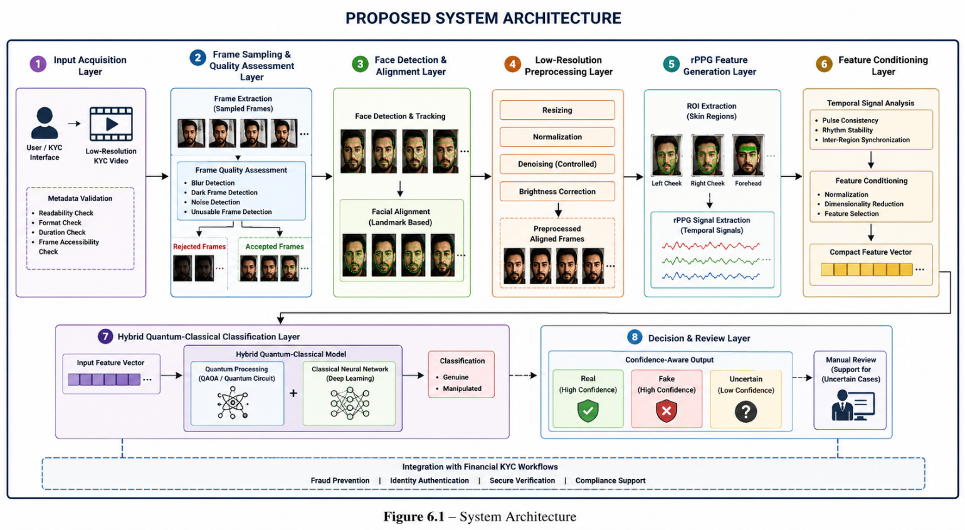
6.1 – System Architecture (generated by ChatGPT)

6.1.2 Module Design
Input acquisition is responsible for accepting low-resolution KYC videos from users or verification systems. The module validates video readability, file structure, frame accessibility, and metadata properties such as duration, frame rate, and resolution before processing begins. Invalid or corrupted video files are rejected during this stage to prevent unreliable downstream analysis.
Frame sampling and quality assessment extracts frames from uploaded videos at a controlled sampling rate suitable for temporal physiological analysis. The module additionally performs frame quality evaluation by identifying blurred frames, low-brightness frames, excessive motion distortion, and unusable facial regions. Only stable and usable frames are forwarded to subsequent processing stages.
Face detection and tracking identify facial regions from extracted video frames and tracks facial movement throughout the temporal sequence. The module focuses on maintaining consistent facial localization while minimizing background interference and unstable cropping behavior.
Face alignment stabilizes facial landmarks such as the eyes, nose, and mouth across consecutive frames. Alignment improves temporal consistency and reduces motion-induced distortion that can negatively affect physiological signal extraction and temporal analysis.
Low-resolution preprocessing standardizes all facial crops into a fixed input format suitable for physiological signal extraction and classification. The preprocessing stage includes resizing, normalization, mild denoising, and brightness stabilization while preserving weak biological and temporal information required for accurate rPPG analysis.
Region-of-interest (ROI) extraction isolates skin-rich facial areas such as the left cheek, right cheek, and forehead for physiological signal analysis. ROI consistency across frames is maintained to improve the stability of temporal physiological feature extraction.
Remote photoplethysmography (rPPG) signal extraction performs physiological analysis by extracting pulse-related temporal colour variation patterns from selected facial regions. The generated physiological signals are analyzed for rhythm stability, temporal synchronization, and biological consistency behavior.
Feature conditioning converts raw physiological outputs into compact and normalized feature vectors suitable for machine learning classification. The module may include normalization, dimensionality reduction, feature selection, and temporal consistency conditioning operations.
Hybrid quantum classification acts as the final decision-making stage of the architecture. Conditioned physiological features are processed using a hybrid quantum-classical machine learning framework to classify the input video as genuine or manipulated. The module focuses on learning subtle discriminative patterns from low-resolution physiological evidence.
Decision support converts classification outputs into confidence-aware verification results such as real, fake, likely fake, likely real, or uncertain. This stage supports practical financial verification workflows by enabling manual review support for uncertain authentication cases.
6.2 Detailed Design
Detailed design describes the structural and behavioral representation of the proposed system using diagrams and interaction models. These diagrams provide a conceptual understanding of the system workflow, module interactions, entity relationships, and operational sequence involved in low-resolution deepfake detection using rPPG and hybrid quantum machine learning.
6.2.1 Class Diagram
Class diagram representation illustrates the structural organization of the proposed system and describes the interaction between major processing components involved in the deepfake detection pipeline. The architecture includes classes such as Video Input, Frame Extractor, Face Detector, ROI Extractor, rPPG Analyzer, Feature Conditioner, Quantum Classifier, and Decision Engine.
Component interaction within the architecture enables efficient execution of the complete detection workflow. The Video Input class handles uploaded KYC video management and metadata validation. The Frame Extractor class manages frame decomposition and temporal sequencing operations. The Face Detector and ROI Extractor classes perform facial localization and physiological region selection respectively. The rPPG Analyzer class extracts and processes temporal physiological signals from facial skin regions. The Feature Conditioner class prepares normalized feature vectors for classification, while the Quantum Classifier performs hybrid quantum-classical decision-making.
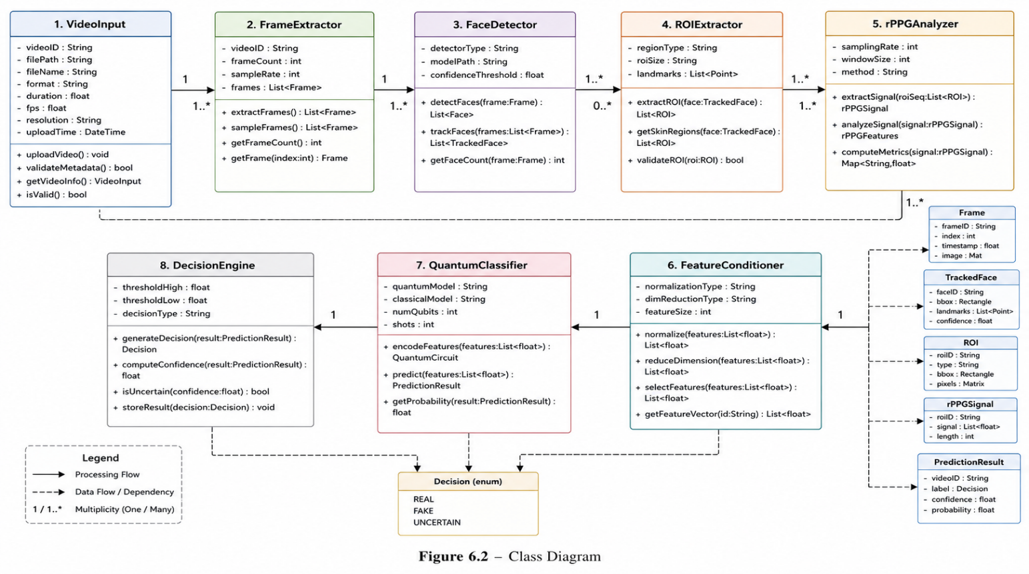
Figure 6.2 – Class Diagram (generated by ChatGPT)

6.2.2 Activity Diagram
Activity diagram workflow illustrates the operational sequence followed by the proposed deepfake detection framework from video acquisition to final prediction generation. The process begins when a user uploads a low-resolution KYC video into the system. The uploaded video undergoes validation and is subsequently decomposed into individual frames before frame quality assessment is performed.
Facial processing and physiological analysis are carried out after unusable frames have been removed from the sequence. Facial regions are detected and aligned to maintain stable temporal positioning across consecutive frames. Region-of-interest (ROI) extraction is then performed to isolate physiological regions suitable for remote photoplethysmography (rPPG) analysis. The extracted temporal physiological signals are transformed into compact feature representations and supplied to the hybrid quantum-classical classifier for deepfake detection.
Confidence-aware decision generation represents the final stage of the workflow, where classification outputs and authentication decisions are produced. The system generates verification results based on physiological evidence and classification confidence levels to support reliable financial KYC authentication.
Manual review support is incorporated into the activity flow to handle uncertain predictions where confidence levels are insufficient for automatic verification. Such cases can be flagged for rejection or further review to improve decision reliability and reduce authentication risks.
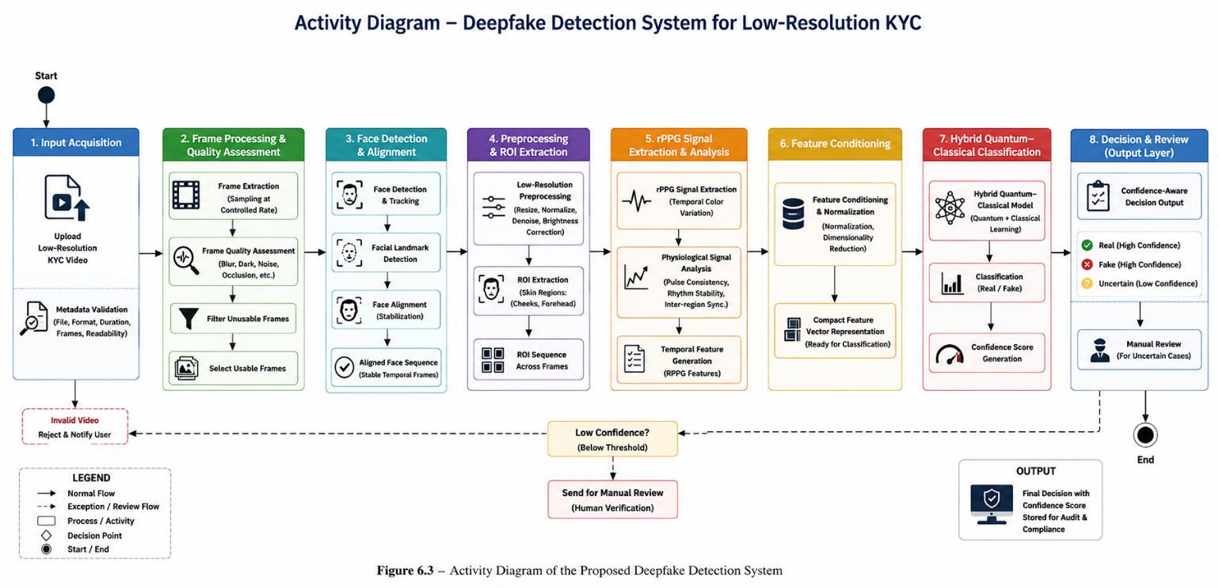
Figure 6.3 – Activity Diagram (generated by ChatGPT)

6.2.3 Use Case Diagram
Use case diagram representation describes the interaction between system actors and the major functionalities provided by the proposed deepfake detection framework. The primary actors involved in the system include the User, Financial Verification Officer, and System Administrator, each responsible for specific activities within the verification workflow.
User interaction occurs through the submission of low-resolution KYC videos for authentication analysis. The uploaded videos are processed by the system to perform preprocessing, physiological signal extraction, feature generation, and deepfake classification for identity verification purposes.
Financial verification management is performed by the Financial Verification Officer, who reviews confidence-aware outputs generated by the system, handles uncertain verification cases, and monitors fraud-related predictions to support secure authentication decisions.
System administration is managed by the System Administrator, who oversees system configuration, preprocessing parameters, dataset maintenance, performance monitoring, and overall operational management to ensure reliable system functionality.
Core use cases include uploading KYC videos, performing facial preprocessing, extracting physiological signals, generating hybrid quantum-classification outputs, producing confidence scores, and reviewing uncertain authentication cases within the financial verification workflow.
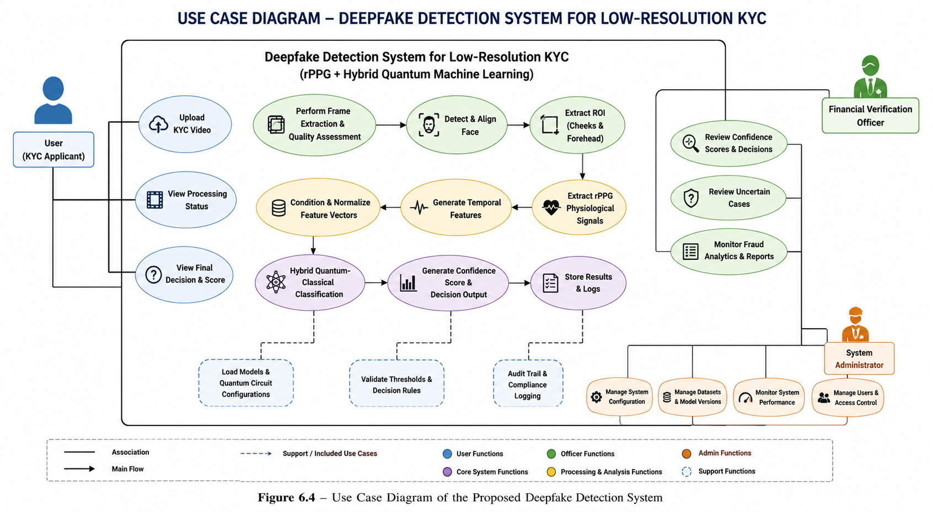
Figure 6.4 – Use Case Diagram (generated by ChatGPT)

6.2.4 ER Diagram
Entity Relationship (ER) Diagram represents the data-level organization of the proposed deepfake detection framework and illustrates how information is stored, managed, and interconnected throughout the authentication process. The system consists of entities such as User, Video, Frame, Feature Vector, Prediction Result, and Review Log, which collectively support the complete deepfake detection workflow.
User entity stores verification-related information associated with individuals who upload KYC videos for authentication. This entity acts as the primary source of user-specific records and maintains the connection between users and their submitted verification data.
Video entity manages uploaded video metadata and processing status throughout different stages of analysis. Information such as video identifiers, upload details, resolution parameters, and processing outcomes are maintained within this entity.
Frame entity stores extracted frame sequences generated from uploaded videos and supports frame-level processing operations. Each frame is associated with a specific video instance and serves as the foundation for facial analysis and physiological signal extraction.
Feature Vector entity contains physiological and temporal features generated through remote photoplethysmography (rPPG) analysis. These features represent biological consistency information and are utilized by the classification framework for deepfake detection.
Prediction Result entity stores classification outputs and confidence scores generated by the hybrid quantum-classical classifier. The entity maintains records of authentication decisions and supports confidence-aware verification processes.
Review Log entity maintains records associated with uncertain predictions, manual verification activities, and authentication review outcomes. This entity supports auditability and facilitates decision validation when automatic verification confidence is insufficient.

Entity relationships enable structured management of preprocessing results, physiological feature generation, classification outputs, and verification records across the complete authentication workflow. These relationships ensure efficient data organization and support reliable operation of the proposed deepfake detection framework.
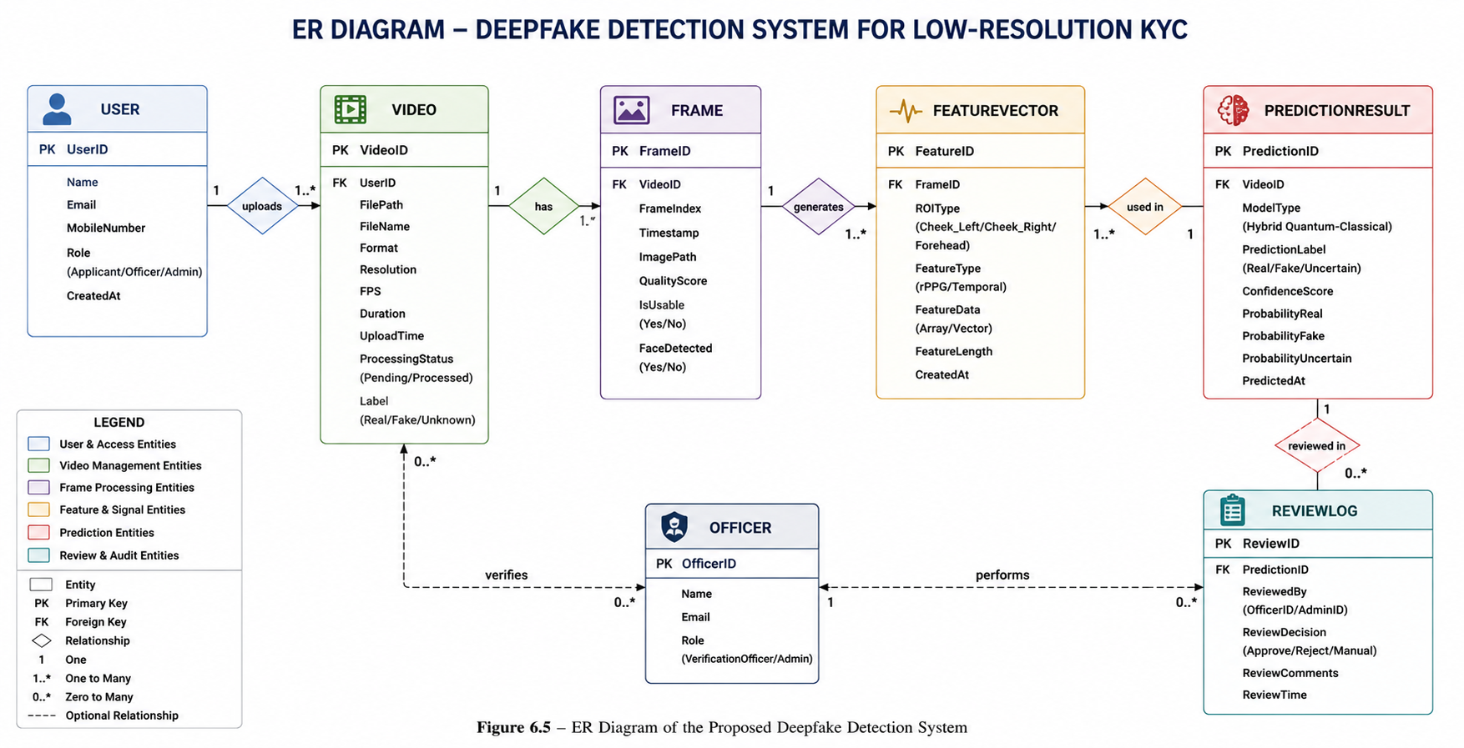
Figure 6.5 – ER Diagram (generated by ChatGPT)

6.2.5 Scenarios
System scenarios describe practical operational situations in which the proposed framework performs financial KYC deepfake detection tasks. These scenarios provide a clear understanding of how different modules interact throughout the authentication workflow while processing low-resolution KYC videos in real-world verification environments.
Video upload and validation represent the initial scenario where users submit KYC videos for authentication. The system verifies video readability, metadata integrity, format compatibility, and frame accessibility before allowing further processing.
Frame quality filtering and physiological analysis constitute the core processing scenario in which extracted video frames undergo quality assessment, facial detection, alignment, and region-of-interest extraction. Remote photoplethysmography (rPPG)-based physiological signals are subsequently generated and analyzed to evaluate biological consistency and temporal stability.
Hybrid classification and verification support from the final operational scenario where physiological features are processed through the hybrid quantum-classical classification framework to generate authentication results. Confidence-aware outputs such as real, fake, likely real, likely fake, or uncertain are produced to support secure verification decisions.
Manual review assistance is provided for uncertain predictions where confidence levels are insufficient for automatic authentication. These scenarios enable verification officers to review flagged cases, ensuring reliable fraud detection and secure identity verification under low-resolution KYC conditions.
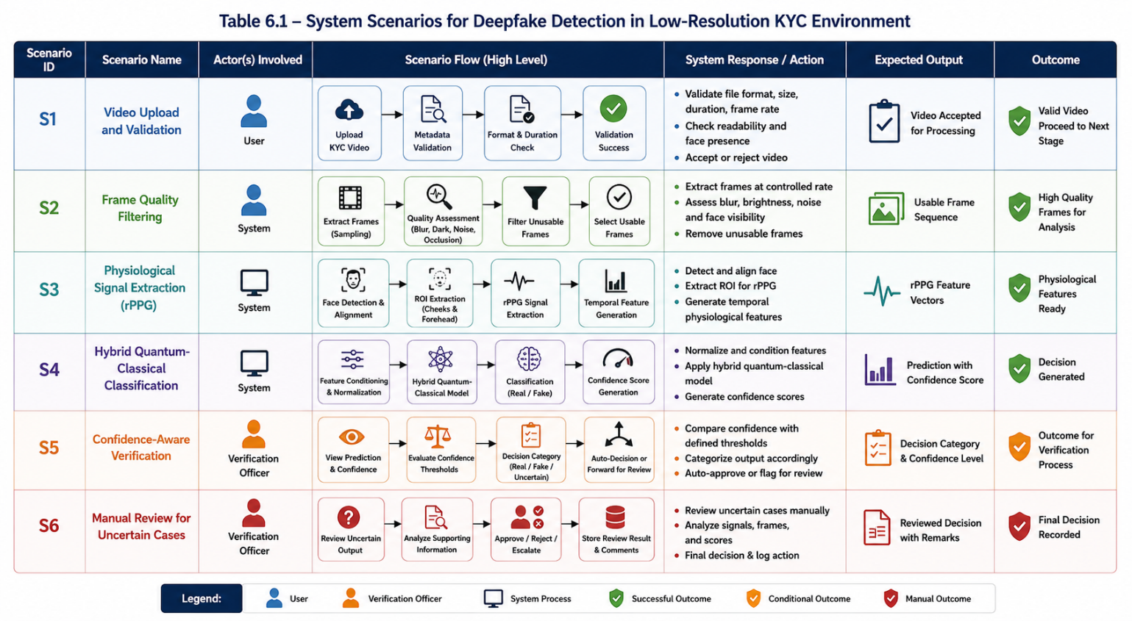
Table 6.1 – System Scenarios (generated by ChatGPT)

CHAPTER 7

CONCLUSION
Physiological signal analysis forms the foundation of the proposed deepfake detection framework designed specifically for low-resolution financial e-KYC and KYC verification environments. The framework combines remote photoplethysmography (rPPG)-based physiological verification with hybrid quantum machine learning techniques to improve authentication reliability under challenging real-world conditions. Unlike conventional deepfake detection approaches that rely primarily on visible facial artifacts and image inconsistencies, the proposed system emphasizes biological realism, temporal consistency, and physiological authenticity, which are considerably more difficult to reproduce accurately in manipulated videos. This capability enables reliable verification even when input videos are affected by compression artifacts, bandwidth limitations, camera noise, motion blur, and low-cost mobile device constraints commonly encountered in financial authentication systems.
Multi-stage verification architecture integrates video preprocessing, facial stabilization, region-of-interest extraction, physiological signal generation, feature conditioning, and hybrid quantum-enhanced classification into a unified detection pipeline. The incorporation of temporal physiological analysis enables the framework to identify subtle inconsistencies in blood-flow-related facial variations that are generally absent or incorrectly synthesized in deepfake content. Furthermore, hybrid quantum-classical learning mechanisms enhance feature representation and classification capability by capturing complex physiological patterns that may not be effectively modelled using traditional machine learning approaches alone. This contributes to improved detection performance while maintaining computational efficiency suitable for practical deployment scenarios.
Confidence-aware authentication support enhances the practical applicability of the framework within banking and financial verification workflows where reliability, security, and fraud prevention are critical requirements. The system generates authentication outputs such as real, fake, and uncertain, enabling informed decision-making and supporting manual review processes when required.

REFERENCES
[1] S. Ahirwar and A. Pandey, “A Study on Deepfake Detection Methods,” Department of Electronics and Communication Engineering, Maulana Azad National Institute of Technology, Bhopal, India, 2024.
[2] K. R. Talwalkar, A. Khade, K. Navale, and A. Ashok, “Design and Analytical Performance of a Hybrid Model Using Deep Learning Techniques for the Detection of Deepfake Videos,” in Proc. 2024 International Conference on Artificial Intelligence and Quantum Computation-Based Sensor Application (ICAIQSA), 2024, pp. 1–7.
[3] S. Basu, P. Yanduri, S. Sharma, and A. Banerjee, “EffiSwinNet: A Cross-Architecture Deepfake Detection with Style GAN Generated Faces,” 2025.
[4] T. Amada, K. Kakizaki, T. Miyagawa, A. F. Ebihara, K. Shiohara, and T. Yamasaki, “Robust Deepfake Detection for Electronic Know Your Customer Systems Using Registered Images,” in Proc. 19th International Conference on Automatic Face and Gesture Recognition (FG), 2025, pp. 1–10.
[5] X. Wang, G. Zhong, and Q. Song, “FakeFormer: Transformer-Based Lightweight Deepfake Video Detection Model,” 2024.
[6] G. Jaiswal, “Hybrid Recurrent Deep Learning Model for DeepFake Video Detection,” in Proc. IEEE Conference, 2021, pp. 1–5.
[7] A. Rahman, N. Siddique, M. J. Moon, T. Tasnim, M. Islam, M. Shahiduzzaman, and S. Ahmed, “Short And Low Resolution Deepfake Video Detection Using CNN,” 2022.
[8] M. Sankaran, M. Alwbaidy, L. K. R., S. D. Govardhan, and P. P. Selvam, “Deepfake Detection using Multi-Stream Convolutional Neural Networks with Attention-based Fusion,” in Proc. 2025 International Conference on Intelligent Communication Networks and Computational Techniques (ICICNCT), 2025, pp. 1–6.
[9] T. Rao, S. Saklani, D. K. Chohan, and R. Sharma, “Multimodal Vision Transformer Forensics for Deepfake Resistant Secure Authentication,” 2025.
[10] A. Dass and M. Jangid, “Quantum-Enhanced Deepfake Detection: A Hybrid Classical-Quantum Deep Learning Approach,” 2025.
[11] S. Babitha, K. Yadavamuthiah, D. H. J. V., and J. Hariharan, “Real-Time Deepfake Video Detection using Machine Learning: A CNN-based Authentication Framework,” 2025.
[12] B. Yilmaz and S. Vatansever, “An Overview of Deepfake Video Detection Using Remote Photoplethysmography,” in Proc. 8th International Artificial Intelligence and Data Processing Symposium (IDAP’24), 2024, pp. 1–8.
[13] A. Susi, V. Akila, and V. Govindasamy, “Utilizing rPPG Signal Synchronization and Deep Learning Techniques for Deepfake Video Detection,” IEEE Access, vol. 13, pp. 160786–160798, 2025.
[14] R. Zhang, Z. Jiang, and C. Sun, “Two-Branch Deepfake Detection Network Based on Improved Xception,” 2023.
[15] F. Khan, A. Sareen, A. S. Kumar, and M. Bhuvaneswari, “A Quantum-Hybrid Framework for Enhanced Deepfake Detection: Integrating QAOA-Based Feature Selection With Quantum-Inspired Attention Mechanisms,” IEEE Access, vol. 14, pp. 17853–17873, 2026.
[16] S. Basu, P. Yanduri, S. Sharma, and A. Banerjee, “EffiSwinNet: A Cross-Architecture Deepfake Detection with Style GAN Generated Faces,” International Research Paper, 2025.
[17] K. R. Talwalkar, A. Khade, K. Navale, and A. Ashok, “Hybrid CNN-GRU Models for Deepfake Video Detection,” in ICAIQSA, 2024.
[18] G. Jaiswal, “Temporal Hybrid Recurrent Deep Learning Models for Deepfake Video Detection,” IEEE Research Paper, 2021.
[19] A. Rahman et al., “Low Resolution Deepfake Detection using CNN on DFDC and FaceForensics++ Datasets,” 2022.
[20] R. Zhang, Z. Jiang, and C. Sun, “Improved Xception-Based Two-Branch Deepfake Detection Framework,” 2023.

