VISVESVARAYA TECHNOLOGICAL UNIVERSITY

"Jnana Sangama", Belagavi-590 018
A Project Phase I(BCD685) Report on
“RedMap: AI-Powered Attack Path Automation with MITRE ATT&CK”
A Dissertation work submitted in partial fulfillment of the requirement for the award of the degree

Bachelor of Engineering
in

Computer Science and Engineering (Data Science)
Submitted by

Shashank C R 1AY22IS093
Prajwal H P 1AY22IS065
Rahul Police Patil 1AY22IS071
Prashanth S 1AY22IS066
Under the Guidance of Prof. Vinutha Raghu Assistant Professor/Associate Professor


DEPARTMENT OF COMPUTER SCIENCE AND ENGINEERING (DATA SCIENCE)
ACHARYA INSTITUTE OF TECHNOLOGY
(AFFILIATED TO VISVESVARAYA TECHNOLOGICAL UNIVERSITY, BELAGAVI)
Acharya Dr. Sarvepalli Radhakrishnan Road, Soldevanahalli, Bengaluru - 560107

2025-2026

DEPARTMENT OF COMPUTER SCIENCE AND ENGINEERING (DATA SCIENCE)
ACHARYA INSTITUTE OF TECHNOLOGY
(Affiliated to Visvesvaraya Technological University, Belagavi)
Acharya Dr. Sarvepalli Radhakrishnan Road, Soldevanahalli, Bengaluru-560107
2025-2026



Certificate
This is to certify that the Project Phase I (BCD685) entitled “RedMap: AI-Powered Attack Path Automation with MITRE ATT&CK” carried out by Shashank C R (1AY22IS093), Prajwal H P (1AY22IS065), Rahul Police Patil (1AY22IS071), and Prashanth S (1AY22IS066), are bonafide students of Acharya Institute of Technology, Bengaluru in partial fulfillment for the award of the degree of Bachelor of Engineering in Computer Science and Engineering (Data Science) of the Visvesvaraya Technological University, Belagavi during the year 2025-26. It is certified that all corrections/suggestions indicated for Internal Assessment have been incorporated in the report deposited in the departmental library. The Project Phase I report has been approved as it satisfies the academic requirements in respect of Project Phase I prescribed for the said degree.

Signature of the Guide Signature of the HOD

Guide Name Dr. Vijayashekhar S S

Name of the Project Coordinator: Signature with Date
- Dr. Kavitha Nair R
- Mr. Mohammad Tahir Mirji

SHASHANK C R (1AY22IS093), PRAJWAL H P (1AY22IS065), RAHUL POLICE
PATIL (1AY22IS070) and PRASHANTH S (1AY22IS066), students of B.E. Computer Science and Engineering (Data Science), Acharya Institute of Technology, Bangalore, hereby declare that the Project Phase I entitled “ENERGY EFFICIENT DATA AGGREGATION TECHNIQUES IN WIRELESS SENSOR NETWORK” is an authentic work carried out under the supervision and guidance of Guide Name, Designation, Department of Computer Science and Engineering (Data Science), Acharya Institute of Technology, Bangalore. We have not submitted the matter embodied to any other university or institution for the award of any other degree.

Place:

Date:
Name | USN | Signature
Shashank C R | 1AY22IS093 | ……………...
Prajwal H P | 1AY22IS065 | ………………
Rahul Police Patil | 1AY22IS071 | ………………
Prashanth S | 1AY22IS066 | ………………

The satisfaction that accompanies the successful completion of Project Phase I (BCD685) report would be incomplete without the mentioning the people who made it possible through their constant guidance and encouragement.

We would take this opportunity to express our gratitude to Sri. B. Premnath Reddy, Founder Chairman, Acharya Institutes, Dr. C K Marigowda, Principal, Acharya Institute of Technology for providing the necessary infrastructure to complete this Project Phase I report.

We wish to express our deepest gratitude to Dr. Vijayashekhar S Sankannanavar,Professor and Head of the Department, Computer Science and Engineering (Data Science) , and also would like to thank the Project Coordinators, Dr. Kavitha Nair R and Mr. Mohammad Tahir Mirji , for their constant support.

We wish to express our sincere thanks to our guide, Guide Name, Assistant Professor, Department of Computer Science and Engineering (Data Science) for helping us throughout and guiding us from time to time.

A warm thanks to all the faculty of the Department of Computer Science and Engineering (Data Science), who have helped us with their views and encouraging ideas.

Shashank C R 1AY22IS093
Prajwal H P 1AY22IS065 Rahul Police Patil 1AY22IS071 Prashanth S 1AY22IS066

This system is all about Diary application to makes ease the work of users by this computerized software. By this application a user can store employee details, retrieve contact details, maintain notes, to-do lists, personal data, set events for important meetings of works on single platform. Thus the user can manage his contacts and daily working schedules through this application. This application avoids user to make manual contact diaries to store the contact address.
A user who is working on system can set events for the important work while doing some another work. Events will remind him about that work. So, this application is convenient platform for a user to manage, contacts, daily work schedules and to enhance the punctuality of the user.
As manual computing system becomes more numerous, complex the need for the systematic approaches development becomes increasingly apparent. The objective of project work- Diary is designing a convenient framework including Address Book, to-do lists and Events Application to the user on one platform. A primary goal of this project is to develop good software to overcome the existing problem caused by manual systems.

TABLE OF CONTENTS

Acknowledgement |  |  | i
Abstract |  |  | ii
List of Figures |  |  | iii
List of Tables |  |  | iv
1 | INTRODUCTION |  | 1
 | 1.1 | Overview | 1
 | 1.2 | Motivation | 1
 | 1.3 | Objective | 2
 | 1.4 | Scope | 2
 | 1.5 | Existing System | 3
 | 1.6 | Proposed System | 4
2 | PROBLEM STATEMENT |  | 5
 | 2.1 | Problem Statement | 5
 | 2.2 | Motivation | 5
 | 2.3 | Objectives | 5
3 | DETAILED LITERATURE SURVEY |  | 15
4  5 | SURVEY SUMMARY TABLE  SYSTEM REQUIREMENT SPECIFICATION |  | 17
 | 5.1 | Functional Requirements | 17
 | 5.2 | Non-functional Requirements | 17
 | 5.3 | Hardware Requirements | 18
 | 5.4 | Software Requirements | 18
6  7 | SYSTEM DESIGN  6.1 System Design 20  6.1.1 System Architecture 20  6.1.2 Module Design 21  6.2 Detailed Design 22  6.2.1 Class Diagram 22  6.2.2 Activity Diagram 23  6.2.3 Use Case Diagram 24  6.2.4 ER Diagram 25  6.2.5 Scenarios  CONCLUSION 27  Appendices 28  - Sample Code 30  - Screenshots 30  References |  | 20

LIST OF FIGURES

6.1 | System Architecture | 20
6.2 | Class Diagram | 22
6.3 | Activity Diagram | 23
6.4 | Use Case Diagram | 24

iii
LIST OF TABLES

4.1 | Survey Summary Table | 16
6.1 | Scenarios | 26

iv

CHAPTER 1 [sample]

INTRODUCTION

Overview

The cybersecurity landscape is continuously evolving with new threats emerging regularly. Organizations often struggle to visualize and understand potential attack vectors, making proactive defense a complex challenge. RedMap bridges this gap by providing an AI-powered system that integrates the MITRE ATT&CK framework to automatically identify, visualize, and document attack paths while simultaneously scanning for vulnerabilities.
RedMap is designed with two core functionalities:

    - Attack Path Mapping and Reporting: By leveraging MITRE ATT&CK, RedMap simulates potential attacker behavior and provides a detailed report of the techniques and tactics an attacker might use.
    - Website Vulnerability Scanner: Upon providing a domain or IP address, the tool scans for common vulnerabilities such as SQL Injection, XSS, open ports, and insecure headers. This functionality is geared toward developers and testers, helping them proactively fix security flaws before deployment.
Through automation and integration of standard security frameworks, RedMap ensures faster vulnerability detection, reduced manual workload, and better situational awareness for security professionals.

Motivation

Manual security assessments are time-consuming, prone to human error, and often overlook complex attack chains. With the rising sophistication of cyber threats, especially in web-based applications, there is a pressing need for automated tools that provide a comprehensive understanding of attack vectors. RedMap aims to fill this gap by automating both the attack path analysis using MITRE ATT&CK and vulnerability scanning, making it easier for security analysts and developers to detect, understand, and remediate threats swiftly.

Objective

    - To develop an AI-powered tool that:

      - Automatically maps attack paths using the MITRE ATT&CK framework.

      - Scans websites (via IP/domain) for security vulnerabilities.

    - To provide automated, easy-to-understand reports for both functionalities.

    - To assist developers, testers, and security professionals in early-stage detection and prevention of potential cyber threats.

Scope

RedMap targets two crucial cybersecurity needs:

    - Security Visualization: Generates a dynamic view of attack paths mapped to the MITRE ATT&CK framework based on user-provided system or network behavior data.
    - Web Vulnerability Detection: Conducts automated scanning for known vulnerabilities in web applications.
The tool is primarily designed for:

    - Developers and testers working on web applications.

    - Security analysts seeking faster reconnaissance and analysis.

    - Educational use for demonstrating ATT&CK-based attack simulations.

Limitations:

    - Primarily focuses on web-based targets and structured attack simulation.

    - Requires internet access for database lookups and vulnerability libraries.

    - Limited zero-day vulnerability detection (based on known patterns).

Existing System

Current systems and tools include:

- Metasploit Framework – Popular penetration testing tool, but requires expert knowledge and manual operation.
- Nmap and Nikto – Effective for scanning but lacks integration with attack frameworks like MITRE.
- Burp Suite – Extensive vulnerability scanning but is GUI-heavy, expensive, and less suited for automated reporting.
- ATT&CK Navigator – Visualizes techniques and tactics but doesn’t perform real-time mapping or scanning.
Challenges:

  - Lack of automation in mapping threat behavior.

  - Fragmented toolsets with no unified reporting.

  - High learning curve for non-security experts.

  - Incomplete or complex documentation.

Proposed System

RedMap proposes an integrated system that:

    - Accepts input in the form of IP/domain or simulated system behavior.

    - Uses AI/ML to analyze and correlate events with MITRE ATT&CK techniques.

    - Automatically builds a visual attack path.

    - Runs a deep scan of websites and highlights OWASP Top 10 vulnerabilities.

    - Generates a combined report in PDF/HTML for sharing and analysis.

Key Features:

    - Automated Path Mapping – AI identifies links between tactics, techniques, and procedures.
    - Web Scanner – Incorporates tools/libraries like nmap, sqlmap, or custom scanners via APIs.
    - Dev/Test Friendly Interface – Simple UI to upload data or scan targets.

    - Modular & Scalable Design – Easily extendable for internal networks or other frameworks like D3FEND.

CHAPTER-2

PROBLEM STATEMENT

Problem Statement
Manual attack simulation and vulnerability identification are time-intensive and prone to error. There's a lack of unified systems that can map the attacker journey and simultaneously detect system vulnerabilities, especially from the perspective of developers and testers.

Motivation
As threat actors evolve, so should the defensive strategies. Current tools are either too niche or not automated. This motivated us to build an intelligent, dual-functional tool that supports secure development practices and proactive security.

Objectives
    - Build an AI-driven system that maps attacker behavior to MITRE ATT&CK.

    - Provide automated, user-friendly reports of attack paths.

    - Enable real-time vulnerability scanning of websites.

    - Improve vulnerability management and remediation workflows.

CHAPTER-3

DETAILED SURVEY

[1] RAF-AG: Report Analysis Framework for Attack Path Generation [2025]
Author: K. Mai, J. Lee, R. Beuran, R. Hotchi, S. E. Ooi, T. Kuroda, and Y. Tan
The RAF-AG framework presents a significant advancement in the automation of cybersecurity threat analysis. This system leverages natural language processing (NLP) to interpret unstructured threat intelligence reports. By applying techniques such as dependency parsing and named entity recognition (NER), it extracts crucial information such as threat actors, tactics, techniques, and procedures (TTPs). It serves as a powerful tool for analysts and incident responders to predict and understand adversarial behaviors. Evaluations using real-world APT attack reports have shown the tool’s efficiency in automatically generating meaningful attack paths, greatly reducing manual workload. This aligns well with the first goal of RedMap, which is to automate attack path visualization using structured threat intelligence.

Minimum 25 papers in chronological order

CHAPTER-4

SURVEY SUMMARY TABLE
Table 4.1: Survey Summary Table [Minimum 25 papers in chronological order ]

Sl.No | Title of the Paper and Journal | Year | Problem Addressed | Authors Approach | Results
1
2
3
4
5
6
7
8
9

CHAPTER-5

SYSTEM REQUIREMENT SPECIFICATION

Functional Requirements
    - Accept input as IP address, domain name, or simulated log files.
    - Map observed behaviours to MITRE ATT&CK techniques using AI or rule-based logic.
    - Generate and display a visual attack path based on the mapped techniques.
    - Perform website vulnerability scanning with focus on OWASP Top 10.
    - Generate a unified report in PDF/HTML format combining scan and attack path results.

Non-functional Requirements
    - The system should respond with results within 2–3 minutes per input.
    - User interface must be simple, clean, and usable by developers/testers.
    - Should support multiple scans simultaneously without performance degradation.
    - Ensure sandboxed execution to prevent misuse or security risks.
    - System must be extensible and maintainable for future feature integration.

Hardware Requirements
    - Processor: Minimum Intel i5 / AMD Ryzen 5 or equivalent (Quad-core)
    - RAM: Minimum 8 GB (Recommended: 16 GB for smoother AI processing and scans)
    - Storage: At least 50 GB free space (for logs, reports, scan data)
    - Network: Stable internet connection for live scans and API usage
    - GPU (Optional): For accelerated AI tasks (NVIDIA GPU with CUDA support)

Software Requirements

Operating System:

      - Development: Windows 10+, Ubuntu 20.04+, or macOS

      - Deployment: Ubuntu Server (preferred), Docker-compatible environments

Programming Languages:

      - Python 3.8+ for backend and analysis logic

      - JavaScript/TypeScript for frontend interface

      - Bash scripting for tool automation

Web Frameworks:

      - Backend: Flask / FastAPI (Python) or Express.js (Node.js)

      - Frontend: React.js, HTML5, CSS3, Bootstrap/Tailwind

Security & Scanning Tools:

      - OWASP ZAP (automated vulnerability scanner)

      - Nmap (port and service scanning)

      - Nikto (web server vulnerability scanner)

      - SQLMap (SQL injection testing)

      - Subfinder / Amass (for subdomain enumeration if extended)

Libraries & APIs:

      - AI/NLP: Scikit-learn, spaCy, pyATTCK

      - Visualization: Cytoscape.js, Mermaid.js, D3.js

      - PDF/HTML Report Generation: PDFKit, ReportLab, WeasyPrint

      - Database: SQLite / MongoDB / PostgreSQL (for storing logs and reports)

Other Tools:

      - Git for version control

      - Postman for API testing

      - Docker for containerized deployment (optional but recommended)

      - VS Code / PyCharm for development

CHAPTER-6

SYSTEM DESIGN

System Design
    - System Architecture
RedMap's architecture is organized into three main layers: frontend, backend, and external integrations. The frontend, built with Vue.js, offers a user-friendly interface for developers and testers to input IP addresses or domain names and view detailed reports. All user requests are sent via REST APIs to the backend, which is implemented using Flask or FastAPI. The backend handles input validation, authentication, and session management, and then triggers the appropriate scanning tools such as Nmap, Nikto, and Nuclei to detect vulnerabilities based on the OWASP Top 10.
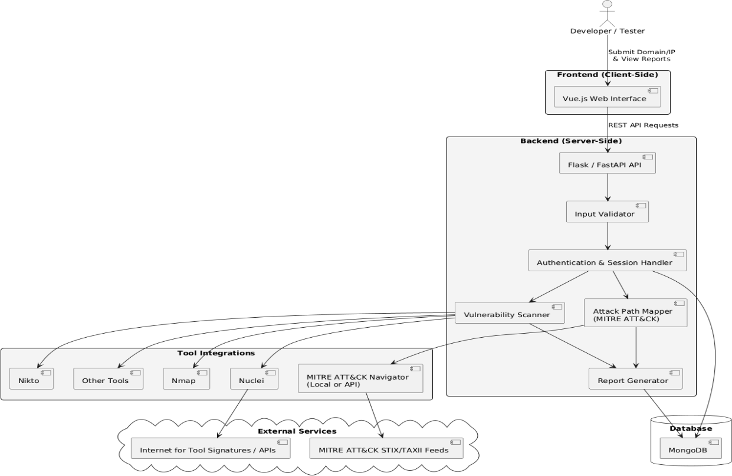

Figure 6.1: System Architecture

Module Design
The User Interface Module serves as the primary point of interaction for developers and testers, offering a clean, intuitive platform to input IP addresses, domain names, or upload behaviour logs. Built using Vue.js or standard HTML/CSS/JavaScript, this module sends user inputs to the backend via RESTful APIs and displays the resulting vulnerability reports and MITRE ATT&CK path visualizations in an interactive format.
The Input Validation Module ensures that all user-submitted data, including domains, IPs, and logs, are properly sanitized and formatted before being processed. This layer acts as a protective filter to prevent injection attacks and improper execution, safeguarding the backend system. Alongside it, the Authentication and Session Management Module handles user login, access control, and session persistence using secure techniques such as JWT or session cookies, ensuring that only authorized users can access critical functions of the platform.
The Vulnerability Scanner Module automates the scanning of submitted IPs or domains using tools like Nikto, Nmap, Nuclei, and SQLMap. This module focuses on detecting common vulnerabilities, especially those aligned with the OWASP Top 10. In parallel, the Attack Path Mapping Module analyzes submitted logs or behavioral data and correlates them with tactics and techniques from the MITRE ATT&CK framework. Using AI or rule-based processing, it generates a visual attack map, often integrated with the MITRE ATT&CK Navigator.
The Report Generation Module collects results from both the scanning and attack mapping processes and compiles them into a structured and professional report in PDF or HTML format. These reports are tailored for developers and security teams to assist in quick vulnerability mitigation. All user data, reports, and logs are handled by the Database Management Module, which uses MongoDB or PostgreSQL to ensure secure and efficient data storage.
Finally, the External Integrations Module keeps the system up-to-date by pulling in the latest tool signatures, threat intelligence, and MITRE ATT&CK data via APIs and STIX/TAXII feeds. This ensures that RedMap continuously evolves to detect the most recent vulnerabilities and map modern attack techniques effectively.

Detailed Design
    - Class Diagram
The class diagram of RedMap shows how users interact with the system through a web interface that sends inputs to the backend via an API handler. The API validates and authenticates requests, then triggers either the vulnerability scanner or the attack path mapper. The scanner uses tools like Nmap and Nikto to identify security issues, while the mapper links behaviors to MITRE ATT&CK techniques.
The results from both modules are compiled by the report generator, which formats and stores reports in a MongoDB database. These reports are then accessible to users for review and analysis, ensuring an automated and organized approach to threat detection

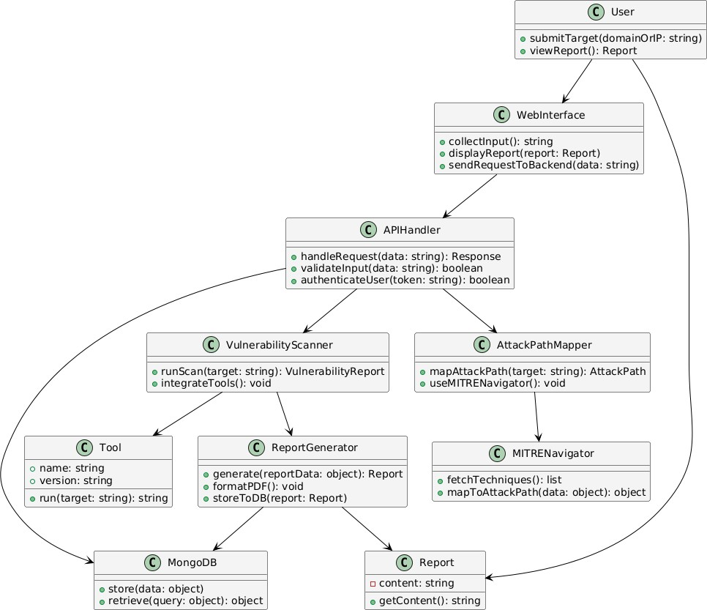
Figure 6.2: Class Diagram

Activity Diagram
The activity diagram for RedMap illustrates the sequential flow of operations from user login to report generation. Once the user submits a domain or IP address, the input is validated. If valid, the request is sent to the backend API for authentication.
Following successful authentication, two parallel processes begin: a vulnerability scan using tools like Nmap or Nuclei, and an attack path mapping using MITRE ATT&CK Navigator. The results from both processes are stored, and a combined report is generated and saved in MongoDB. Users can then choose to view the report through the UI or download it in PDF/HTML format.
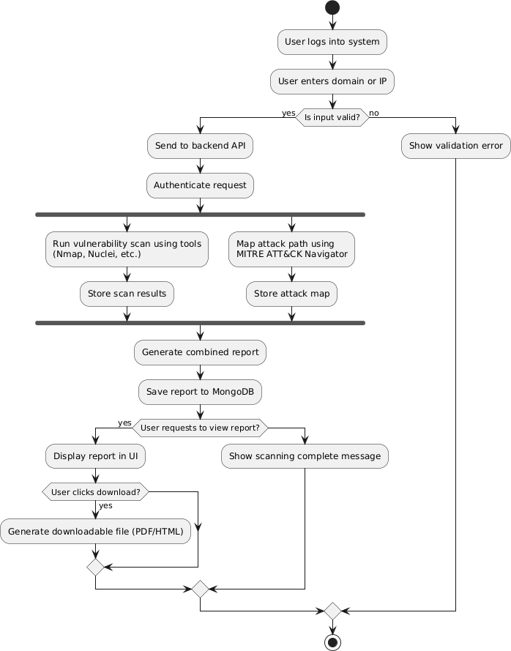

Figure 6.3: Activity Diagram

Use Case Diagram
The use case diagram for the RedMap System illustrates the primary interactions between two types of users—Developer and Tester—and the functionalities offered by the system. Developers are responsible for tasks such as generating the MITRE ATT&CK path, uploading logs or event data, integrating the system into CI/CD pipelines, and initiating vulnerability scans.
Both developers and testers have access to core functionalities including entering IP/domain information, exporting reports in PDF/HTML format, and viewing detailed results. This diagram highlights the collaborative usage of the system for security analysis and automation across the software development lifecycle.

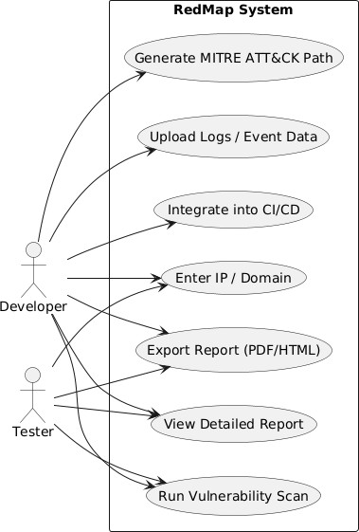

Figure 6.4: Use Case Diagram

Scenarios

Scenario No. | Title | Actor(s) | Objective | Steps Involved | Expected Outcome
1 | Attack Path Mapping for Red Team | Red Team | Simulate and identify attack paths using MITRE ATT&CK | - Log into RedMap  - Upload event logs  - AI analyzes data  - System maps  techniques  - Report generated | Red team receives a visual report of potential attack paths and techniques
2 | Vulnerability Scanning of Website | Developer, Tester | Identify vulnerabilities in a web application | - Enter IP/domain  - Start scan  - System detects  vulnerabilities  - Categorizes issues  - Generates detailed report | Developers/Testers receive an actionable report to fix security flaws
3 | Report Exporting | Developer, Tester, Red Team | Save or share analysis results | - Choose report type  - Click "Export"  - Select format  (PDF/HTML)  - Download or send | Report is saved or shared for documentation or audit

Scenario No. | Title | Actor(s) | Objective | Steps Involved | Expected Outcome
4 | Uploading Logs for Analysis | Red Team | Provide data for accurate attack mapping | - Prepare log files  - Upload via interface  - RedMap parses events  - Aligns with MITRE ATT&CK | System successfully maps events to techniques and creates a traceable path
5 | Integration into CI/CD Pipeline | Developer | Automate vulnerability scanning during deployments | - Connect RedMap to  CI/CD  - Define trigger point  - On build, scan runs  - Report generated  automatically | Scanning becomes part of automated pipeline; alerts generated during development cycle

CHAPTER-7

CONCLUSION
The RedMap system represents a significant step forward in integrating artificial intelligence with cybersecurity analysis, providing both automation and precision in identifying potential threats and vulnerabilities. By offering two core functionalities—automated MITRE ATT&CK-based attack path mapping and intelligent website vulnerability scanning—RedMap addresses the practical needs of red team operators as well as developers and testers within a secure development lifecycle. The attack path mapping module aids red teams in simulating adversary behaviors and visualizing how an attacker might progress through a network using known tactics and techniques, empowering organizations to proactively fortify their defenses. On the other hand, the vulnerability scanning feature allows developers and testers to detect and resolve website security flaws early in the development or testing phases, minimizing the risk of exploitation post- deployment.
Through an intuitive user interface and support for log-based input, RedMap enhances the efficiency of threat detection and reporting, generating comprehensive outputs in accessible formats like PDF and HTML. The integration of MITRE ATT&CK not only standardizes threat interpretation but also ensures that the outputs align with industry-recognized frameworks. Moreover, the system’s potential for CI/CD integration and report export makes it suitable for modern DevSecOps environments, encouraging continuous security assessment throughout the software development lifecycle.
In conclusion, RedMap delivers a dual-purpose, AI-powered security automation platform that bridges the gap between offensive simulation and defensive remediation. Its adaptability, clarity of reporting, and strategic use of the MITRE ATT&CK framework make it a valuable asset for both proactive security testing and reactive vulnerability management. As the cybersecurity landscape continues to evolve, tools like RedMap are essential in empowering teams to stay ahead of threats with speed, intelligence, and structure.

Appendices

- Sample Code
- Screenshots

REFERENCES

- K. Mai, J. Lee, R. Beuran, R. Hotchi, S. E. Ooi, T. Kuroda, and Y. Tan, “RAF-AG: Report analysis framework for attack path generation,” Computers & Security, vol. 148, p. 104125, 2025. [Online]. Available: https://doi.org/10.1016/j.cose.2024.104125. (Base Paper)
- I. Branescu, O. Grigorescu, and M. Dascalu, “Automated mapping of common vulnerabilities and exposures to MITRE ATT&CK tactics,” Information, vol. 15, no. 4, p. 214, 2024. [Online]. Available: https://doi.org/10.3390/info15040214.
- B. Pappila, “Automated profiling of cyber attacks based on MITRE ATT&CK,” M.S. thesis, School of Electrical Engineering and Computer Science, 2024.
- E. Iturbe, O. Llorente-Vazquez, and N. Toledo Gandarias, “Unleashing offensive artificial intelligence: Automated attack technique code generation,” Computers & Security, vol. 147, p. 104077, 2024. [Online]. Available: https://doi.org/10.1016/j.cose.2024.104077
- Y. Gao, C. Yuan, X. Guo, and B. Li, “Dynamic cyberattack simulation: Integrating improved deep reinforcement learning with the MITRE-ATT&CK framework,” Electronics, vol. 13, no. 14,
p. 2831, 2024. [Online]. Available: https://www.mdpi.com/2079-9292/13/14/2831
- L. H. Zhang, M. Chen, R. Iyer, and S. Narayanan, “ThreatPath: Visualizing multi-step attack paths using MITRE ATT&CK framework,” 2024. [Online]. Available: https://doi.org/10.1109/ThreatPath.2024.00123
- M. Rosso, M. Campobasso, G. Gankhuyag, and L. Allodi, “SAIBERSOC: Synthetic attack injection to benchmark and evaluate the performance of security operation centers,” arXiv preprint, arXiv:2010.08453, 2020. [Online]. Available: https://arxiv.org/abs/2010.08453
- H. C. Nguyen, S. Tariq, M. B. Chhetri, and B. Q. Vo, “Towards effective identification of attack techniques in cyber threat intelligence reports using large language models,” arXiv preprint, arXiv:2505.03147, 2025. [Online]. Available: https://arxiv.org/abs/2505.03147
- E. Aghaei and E. Al-Shaer, “CVE-driven attack technique prediction with semantic information extraction and a domain-specific language model,” arXiv preprint, arXiv:2309.02785, 2023. [Online]. Available: https://arxiv.org/abs/2309.02785
- M. T. Alam, D. Bhusal, Y. Park, and N. Rastogi, “Looking beyond IoCs: Automatically extracting attack patterns from external CTI,” arXiv preprint, arXiv:2211.01753, 2022. [Online]. Available: https://arxiv.org/abs/2211.01753

